

Functional Safety Concept Lane Assistance

**Document Version: [Version]**

**Template Version 1.0, Released on 2017-06-21**



# Document history

**[Instructions: Fill in the date, version and description fields. You can fill out the Editor field with your name if you want to do so. Keep track of your editing as if this were a real world project.**

**For example, if this were your first draft or first submission, you might say version 1.0. If this is a second submission attempt, then you'd add a second line with a new date and version 2.0]**

|  |  |  |  |
| --- | --- | --- | --- |
| Date | Version | Editor | Description |
| 02/11/2018 | 1.0 | Anatolii Volkodav | Initial version |
|  |  |  |  |
|  |  |  |  |
|  |  |  |  |
|  |  |  |  |

# Table of Contents

**[Instructions: We have provided a table of contents. If you change the document structure, please update the table of contents accordingly. The table of contents should show each section of the document and page numbers or links. Most word processors can do this for you. In** [**Google Docs**](https://support.google.com/docs/answer/116338?co=GENIE.Platform%3DDesktop&hl=en)**, you can use headings for each section and then go to Insert > Table of Contents.** [**Microsoft Word**](https://support.microsoft.com/en-us/help/285059/how-to-create-a-table-of-contents-by-marking-text-in-word) **has similar capabilities]**

Document history

Table of Contents

Purpose of the Functional Safety Concept

Inputs to the Functional Safety Analysis

Safety goals from the Hazard Analysis and Risk Assessment

Preliminary Architecture

Description of architecture elements

Functional Safety Concept

Functional Safety Analysis

Functional Safety Requirements

Refinement of the System Architecture

Allocation of Functional Safety Requirements to Architecture Elements

Warning and Degradation Concept

# Purpose of the Functional Safety Concept

**[Instructions: Answer what is the purpose of a functional safety concept?]**

This is the document that helps us identify subsystems that describe high levels of risk and what's needed to prevent accidents, transform that information into safety requirements and put it to its appropriate place in the item architecture.

# Inputs to the Functional Safety Concept

## Safety goals from the Hazard Analysis and Risk Assessment

**[Instructions:**

**REQUIRED:**

**Provide the lane departure warning and lane keeping assistance safety goals as discussed in the lessons and derived in the hazard analysis and risk assessment.**

**OPTIONAL:**

**If you expanded the hazard analysis and risk assessment to include other safety goals, include them here.**

**]**

|  |  |
| --- | --- |
| **ID** | **Safety Goal** |
| Safety_Goal_01 | The oscillating steering torque from the lane departure warning function shall be limited. |
| Safety_Goal_02 | The lane keeping assistance function shall be time limited, and the additional steering torque shall end after a given time interval so that the driver cannot misuse the system for autonomous driving. |

## Preliminary Architecture

**[Instructions: Provide a preliminary architecture for the lane assistance item. Hint: See Lesson 3: Item Definition]**

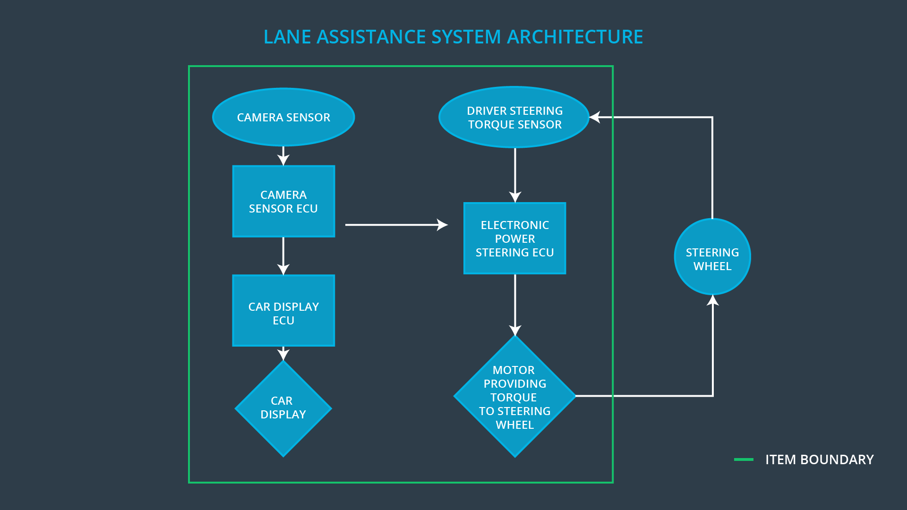

### Description of architecture elements

**[Instructions: Provide a description for each of the item elements; what is each element's purpose in the lane assistance item? ]**

|  |  |
| --- | --- |
| **Element** | **Description** |
| Camera Sensor | Make picture of the road |
| Camera Sensor ECU | Detecting lane lines and determining when the vehicle leaves the lane by mistake |
| Car Display | Display status of Lane Keeping Assistance |
| Car Display ECU | Update display based on Lane Keeping Assistance state |
| Driver Steering Torque Sensor | Measure the torque provided by the driver |
| Electronic Power Steering ECU | Adding an appropriate amount of torque based on a lane assistance system torque request |
| Motor | Turns the steering wheel based on feedback from Electronic Power Steering ECU |

# Functional Safety Concept

The functional safety concept consists of:

* Functional safety analysis
* Functional safety requirements
* Functional safety architecture
* Warning and degradation concept

## Functional Safety Analysis

**[Instructions: Fill in the functional safety analysis table below.]**

|  |  |  |  |
| --- | --- | --- | --- |
| **Malfunction ID** | **Main Function of the Item Related to Safety Goal Violations** | **Guidewords (NO, WRONG, EARLY, LATE, MORE, LESS)** | **Resulting Malfunction** |
| Malfunction_01 | Lane Departure Warning (LDW) function shall apply an oscillating steering torque to provide the driver a haptic feedback | MORE | The Lane Departure Warning (LDW) function applies an oscillating torque with very high torque amplitude (above limit) |
| Malfunction_02 | Lane Departure Warning (LDW) function shall apply an oscillating steering torque to provide the driver a haptic feedback | MORE | The Lane Departure Warning (LDW) function applies an oscillating torque with very high torque amplitude (above limit) |
| Malfunction_03 | Lane Keeping Assistance (LKA) function shall apply the steering torque when active in order to stay in ego lane | NO | The Lane Keeping Assistance (LKA) is misused for autonomous driving |

## Functional Safety Requirements

**[Instructions: Fill in the functional safety requirements for the lane departure warning ]**

Lane Departure Warning (LDW) Requirements:

|  |  |  |  |  |
| --- | --- | --- | --- | --- |
| **ID** | **Functional Safety Requirement** | **ASIL** | **Fault Tolerant Time Interval** | **Safe State** |
| Functional  Safety  Requirement  01-01 | The lane keeping item shall ensure that the lane departure oscillating torque amplitude is below Max_Torque_Amplitude | C | 50 ms. | Amplitude set to 0 |
| Functional  Safety  Requirement  01-02 | The lane keeping item shall ensure that the lane departure oscillating torque frequency is below Max_Torque_Frequency | C | 50 ms. | Frequency set to 0 |

Lane Departure Warning (LDW) Verification and Validation Acceptance Criteria:

|  |  |  |
| --- | --- | --- |
| **ID** | **Validation Acceptance**  **Criteria and Method** | **Verification Acceptance**  **Criteria and Method** |
| Functional  Safety  Requirement  01-01 | Lane departure oscillating torque amplitude is below Max_Torque_Amplitude | The lane keeping system turned off when amplitude exceeded Max_Torque_Amplitude |
| Functional  Safety  Requirement  01-02 | Lane departure oscillating torque frequency is below Max_Torque_Frequency | The lane keeping system turned off when frequency exceeded Max_Torque_Frequency |

**[Instructions: Fill in the functional safety requirements for the lane keeping assistance]**

Lane Keeping Assistance (LKA) Requirements:

|  |  |  |  |  |
| --- | --- | --- | --- | --- |
| **ID** | **Functional Safety Requirement** | **ASIL** | **Fault Tolerant Time Interval** | **Safe State** |
| Functional  Safety  Requirement  02-01 | The electronic power steering ECU shall ensure that the lane keeping assistance torque is applied for only Max_Duration | B | 500 ms. | Lane Keeping Assistance (LKA) torque set to 0 |

Lane Keeping Assistance (LKA) Verification and Validation Acceptance Criteria:

|  |  |  |
| --- | --- | --- |
| **ID** | **Validation Acceptance**  **Criteria and Method** | **Verification Acceptance**  **Criteria and Method** |
| Functional  Safety  Requirement  02-01 | Lane keeping assistance torque is applied for only Max_Duration | Lane keeping assistance torque turned off after being used longer than Max_Duration |

## Refinement of the System Architecture

**[Instructions: Include the refined system architecture. Hint: The refined system architecture should include the system architecture from the end of the functional safety lesson including all of the ASIL labels.]**

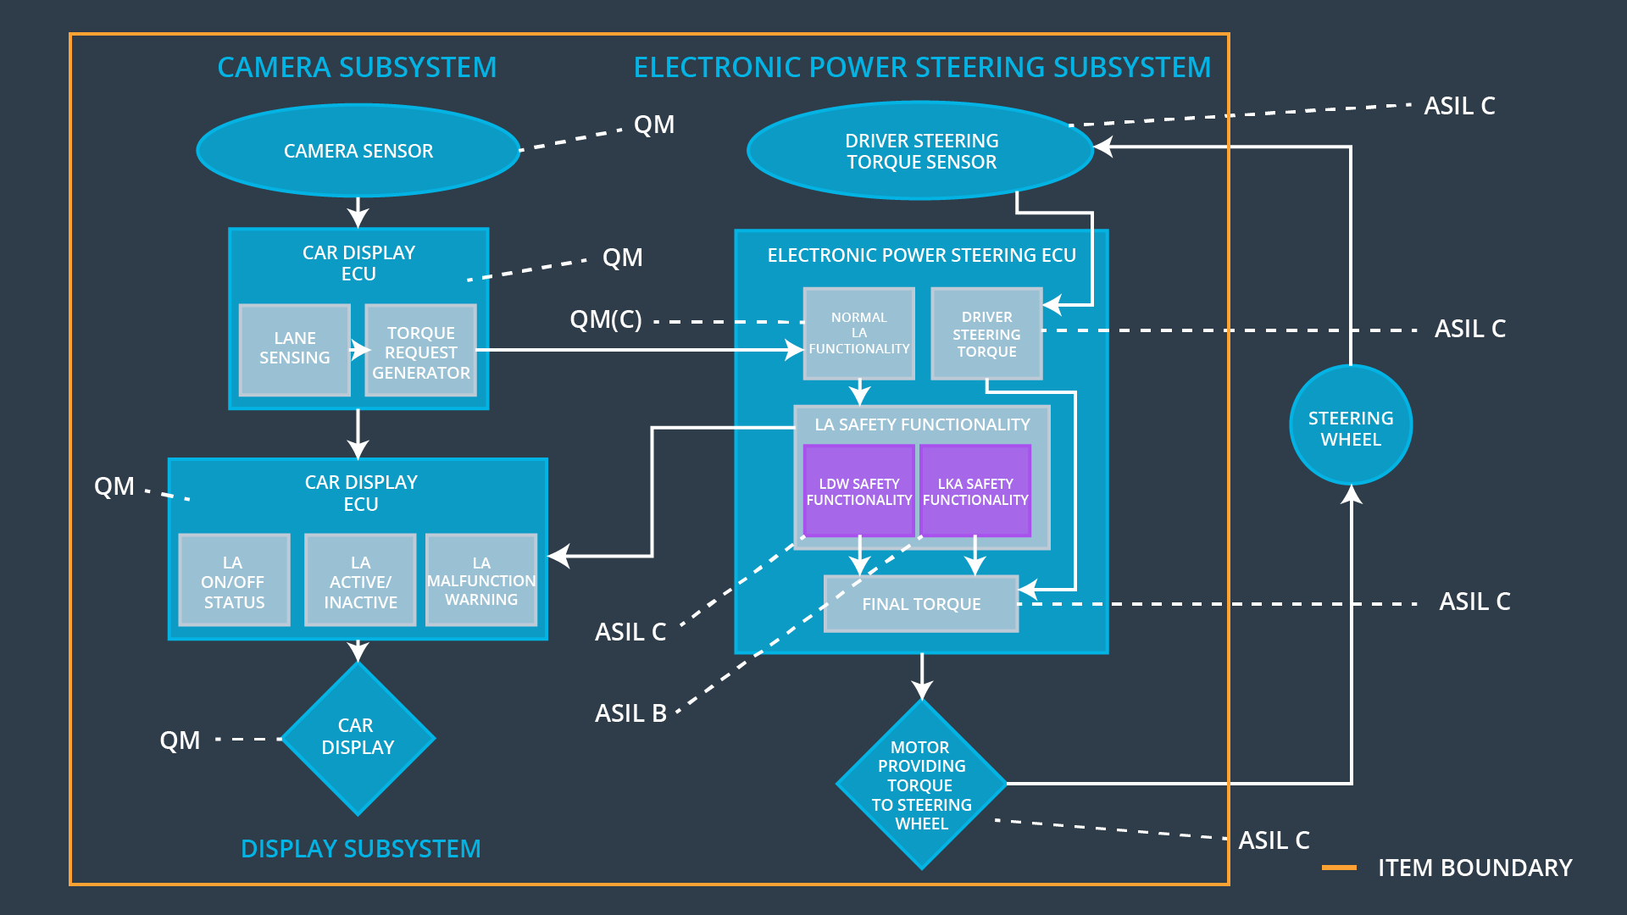

## Allocation of Functional Safety Requirements to Architecture Elements

**[Instructions: Mark which element or elements are responsible for meeting the functional safety requirement. Hint: Only one ECU is responsible for meeting all of the requirements.]**

|  |  |  |  |  |
| --- | --- | --- | --- | --- |
| **ID** | **Functional Safety Requirement** | **Electronic Power Steering ECU** | **Camera ECU** | **Car Display ECU** |
| Functional  Safety  Requirement  01-01 | The lane keeping item shall ensure that the lane departure oscillating torque amplitude is below Max_Torque_Amplitude | **X** |  |  |
| Functional  Safety  Requirement  01-02 | The lane keeping item shall ensure that the lane departure oscillating torque frequency is below Max_Torque_Frequency | **X** |  |  |
| Functional  Safety  Requirement  02-01 | The electronic power steering ECU shall ensure that the lane keeping assistance torque is applied for only Max_Duration | **X** |  |  |

## Warning and Degradation Concept

**[Instructions: Fill in the warning and degradation concept.]**

|  |  |  |  |  |
| --- | --- | --- | --- | --- |
| **ID** | **Degradation Mode** | **Trigger for Degradation Mode** | **Safe State invoked?** | **Driver Warning** |
| WDC-01 | The lane keeping system turned off | Malfunction_01, Malfunction_02 | YES | The lane keeping system status showed on car display |
| WDC-02 | Lane Keeping Assistance turned off | Malfunction_03 | YES | Lane Keeping Assistance status showed on car display |