Tables and Figures

Kalmenovitz, Lowry, Volkova

2020-07-20

# **Figure 1: Topic Clouds**

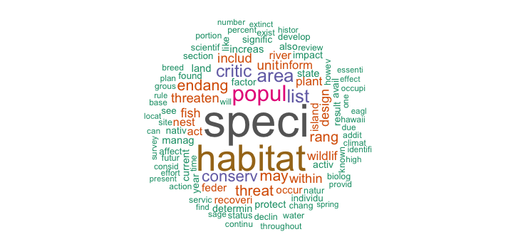

## NULL



## NULL



## NULL

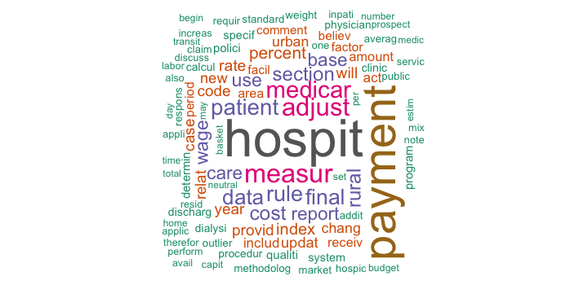

## NULL

# **Figure 2: Histograms**

*Panel A: Dispersion of agencies per topic*

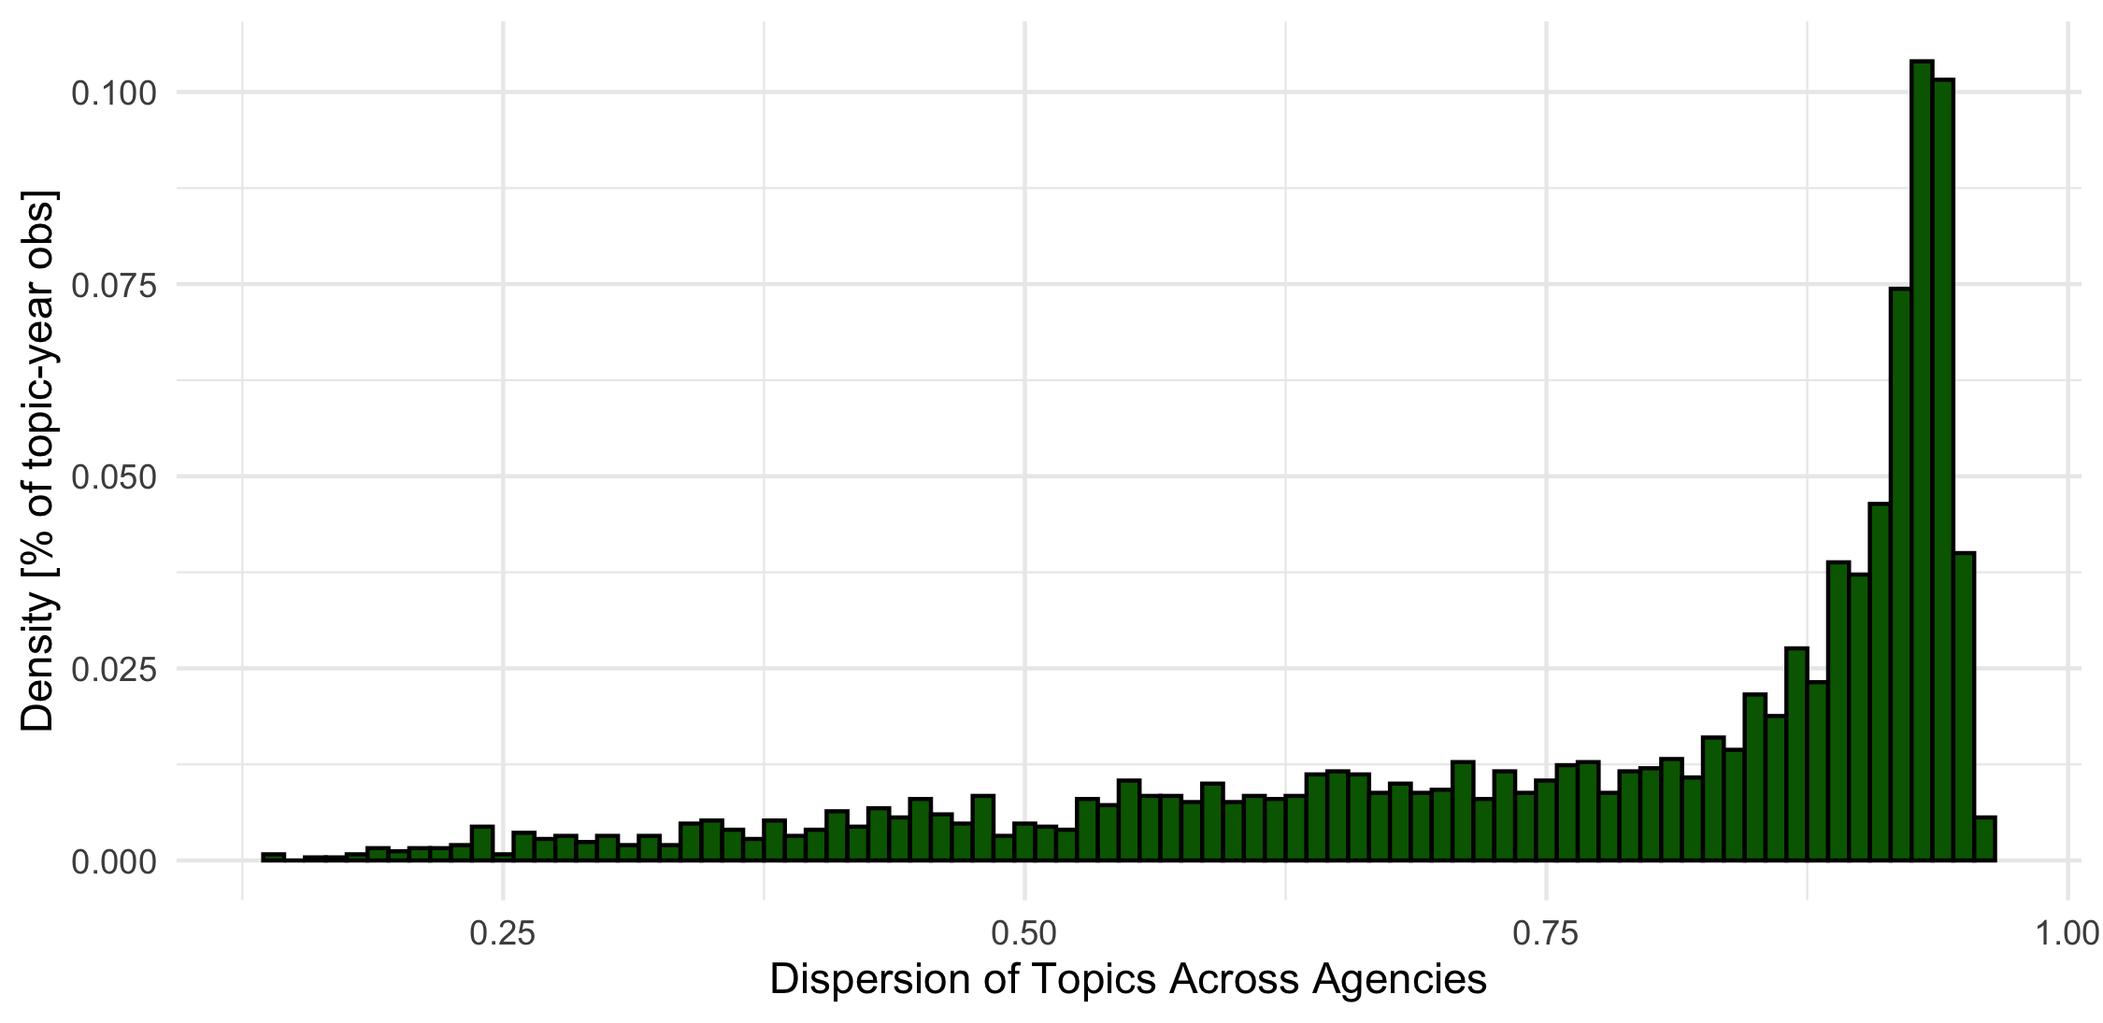

*Panel B: Dispersion of Topics per firm-year*

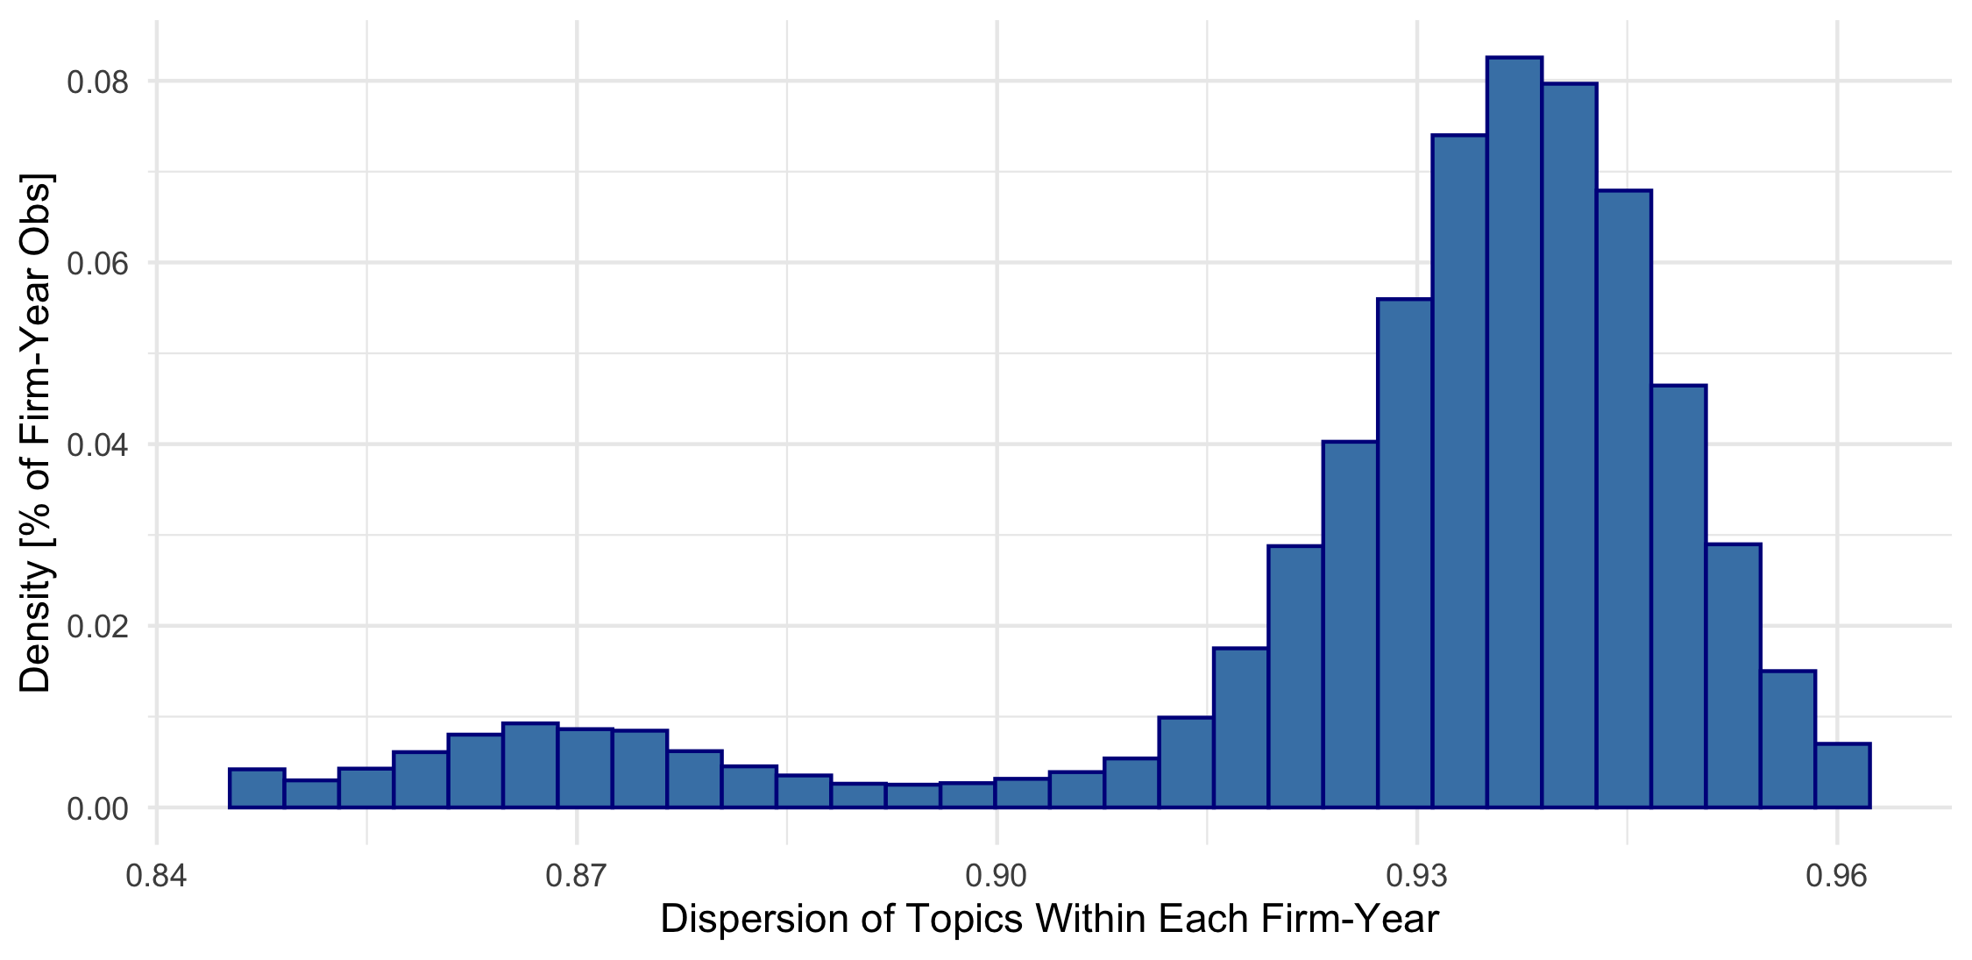

*Panel C: Dispersion of Agencies per Firm-year*

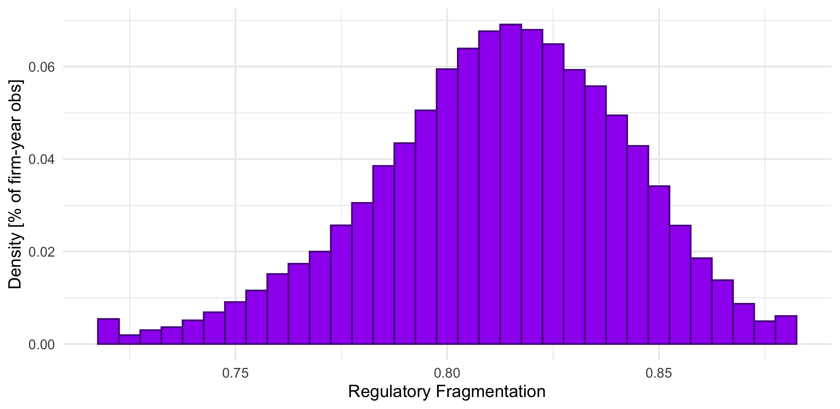

# **Figure 3: Time Trend**

## Panel A: 12 Industries

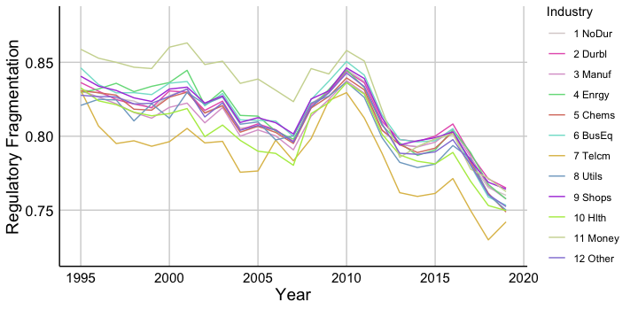

## Panel B: FF12 == 1

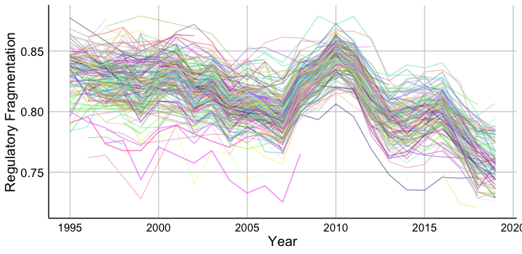

# **Figure 4:** Regulation Dispersion

## *Panel B: Topics with biggest change around 2016 presidential election*

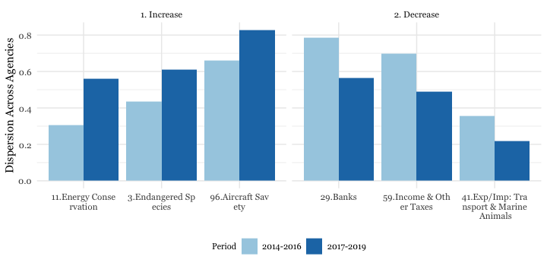

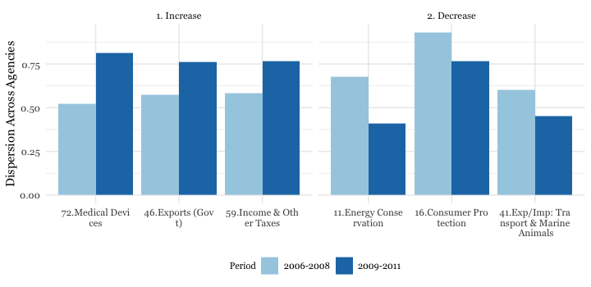

## Panel C: Agencies the biggest , Trump

## Panel D: Agencies the biggest , GFC

# **Table 1:**

# **Table 2: Past and Future**

# **Table 3: Descriptive statistics**

|  |  |  |  |  |  |  |  |  |  |  |
| --- | --- | --- | --- | --- | --- | --- | --- | --- | --- | --- |
| Variable | T1 | T2 | T3 | T4 | T5 | R1 | R2 | R3 | R4 | R5 |
|  | Topic | Topic | Topic | Topic | Topic | Regul | Regul | Regul | Regul | Regul |
| Quant | 0%-20% | 20%-40% | 40%-60% | 60%-80% | 80%-100% | 0%-20% | 20%-40% | 40%-60% | 60%-80% | 80%-100% |
| # Obs. | 12,108 | 12,107 | 12,107 | 12,107 | 12,108 | 12,108 | 12,107 | 12,107 | 12,107 | 12,108 |
| Topic Dispersion | 0.889 | 0.928 | 0.935 | 0.942 | 0.95 | 0.93 | 0.932 | 0.933 | 0.932 | 0.917 |
| Regulation Dispersion | 0.821 | 0.809 | 0.81 | 0.811 | 0.811 | 0.768 | 0.798 | 0.814 | 0.829 | 0.852 |
| Sale | 2853.354 | 4081.539 | 2855.96 | 2022.924 | 2252.204 | 3513.473 | 2834.119 | 2617.644 | 2426.317 | 2674.34 |
| TFP | -0.24 | -0.28 | -0.314 | -0.378 | -0.381 | -0.313 | -0.334 | -0.34 | -0.344 | -0.314 |
| N segments | 1.106 | 1.297 | 1.233 | 1.197 | 1.156 | 1.222 | 1.238 | 1.211 | 1.184 | 1.134 |
| PPE/AT | 0.109 | 0.274 | 0.258 | 0.238 | 0.233 | 0.242 | 0.238 | 0.236 | 0.229 | 0.168 |
| EBITDA/AT | 0.062 | 0.111 | 0.1 | 0.082 | 0.049 | 0.068 | 0.082 | 0.086 | 0.086 | 0.081 |
| MB | 2.674 | 3.245 | 3.022 | 3.252 | 3.849 | 3.75 | 3.158 | 3.204 | 3.04 | 2.89 |
| Sales Growth, % | 8.4 | 10.265 | 11.235 | 11.845 | 14.381 | 12.877 | 11.814 | 10.868 | 11.019 | 9.548 |
| Assets Growth, % | 9.359 | 10.285 | 11.618 | 12.608 | 13.774 | 12.864 | 12.042 | 11.083 | 10.526 | 11.128 |
| Tobin’s Q | 1.519 | 2.012 | 2.082 | 2.26 | 2.666 | 2.351 | 2.112 | 2.133 | 2.096 | 1.848 |
| SGA/AT | 0.091 | 0.25 | 0.292 | 0.334 | 0.375 | 0.24 | 0.265 | 0.286 | 0.304 | 0.245 |
| EMP/AT | 0.002 | 0.007 | 0.007 | 0.007 | 0.007 | 0.004 | 0.006 | 0.007 | 0.008 | 0.006 |
| INVST/AT | 0.024 | 0.078 | 0.089 | 0.102 | 0.115 | 0.076 | 0.084 | 0.088 | 0.09 | 0.068 |
| ROA, % | 1.824 | 1.671 | 0.215 | -1.457 | -4.348 | -1.233 | -0.186 | -0.514 | -0.748 | 0.586 |

# **Table 4 SGA_AT, TFP, ROA next year**

|  | 1.lead.sga_at | 2.lead.tfp | 3.lead.roa | 4.lead.sga_at | 5.lead.tfp | 6.lead.roa |
| --- | --- | --- | --- | --- | --- | --- |
| Regulation Dispersion | 0.381*** | -0.603** | -37.735*** | 0.486*** | -0.539* | -34.069*** |
|  | (0.136) | (0.270) | (8.301) | (0.125) | (0.313) | (9.400) |
| Topic Dispersion | 0.488** | -0.542 | -9.278 | 0.505** | -0.685* | -7.236 |
|  | (0.189) | (0.416) | (16.646) | (0.210) | (0.373) | (14.732) |
| Regulation Complexity | 0.036 | 0.037 | 3.182 | 0.058 | 0.041 | 4.735** |
|  | (0.035) | (0.062) | (3.480) | (0.044) | (0.068) | (2.335) |
| Log(Word,10K) | -0.006 | -0.014 | -3.961*** | -0.006 | -0.015* | -3.839*** |
|  | (0.004) | (0.009) | (0.936) | (0.005) | (0.008) | (0.918) |
| PPE/AT | 0.083** | -0.552*** | -6.745*** | 0.080** | -0.588*** | -6.432*** |
|  | (0.033) | (0.092) | (1.698) | (0.035) | (0.083) | (2.189) |
| EBITDA/AT | -0.036** | 1.177*** | 40.224*** | -0.038** | 1.224*** | 39.779*** |
|  | (0.016) | (0.079) | (3.563) | (0.016) | (0.081) | (3.711) |
| Log(Sale) | -0.040*** | 0.098*** | 3.191*** | -0.042*** | 0.094*** | 3.159*** |
|  | (0.006) | (0.010) | (0.352) | (0.007) | (0.010) | (0.369) |
| Tobin's Q | 0.013*** | 0.048*** | -0.480*** | 0.013*** | 0.049*** | -0.467*** |
|  | (0.001) | (0.004) | (0.092) | (0.001) | (0.005) | (0.075) |
| Num.Obs. | 60537 | 38925 | 60537 | 60537 | 38925 | 60537 |
| R2 | 0.867 | 0.729 | 0.637 | 0.872 | 0.740 | 0.653 |
| R2 Adj. | 0.848 | 0.688 | 0.584 | 0.850 | 0.691 | 0.593 |
| Std. Errors | Clustered (FF48) | Clustered (FF48) | Clustered (FF48) | Clustered (FF48) | Clustered (FF48) | Clustered (FF48) |
| FE: cik | X | X | X | X | X | X |
| FE: FF48 | X | X | X | X | X | X |
| FE: FF48_year |  |  |  | X | X | X |
| FE: year | X | X | X |  |  |  |
| * p < 0.1, ** p < 0.05, *** p < 0.01 | | | | | | |

# **Table 5 Sales growth, assets growth, emp next year**

|  | 1.lead.growth | 2.lead.growth.at | 3.lead.emp_at | 4.lead.growth | 5.lead.growth.at | 6.lead.emp_at |
| --- | --- | --- | --- | --- | --- | --- |
| Regulation Dispersion | -146.768*** | -199.418*** | 0.000 | -163.501*** | -193.542*** | 0.004** |
|  | (25.813) | (33.590) | (0.005) | (32.829) | (37.993) | (0.002) |
| Topic Dispersion | -21.551 | 39.433 | 0.006 | 5.579 | 53.072 | 0.002 |
|  | (38.357) | (30.739) | (0.005) | (34.880) | (35.244) | (0.005) |
| Regulation Complexity | -41.662*** | -53.961*** | 0.002** | -44.303*** | -52.366*** | 0.001 |
|  | (12.016) | (9.018) | (0.001) | (10.560) | (9.023) | (0.001) |
| Log(Word,10K) | 5.145*** | 6.241*** | 0.000* | 4.595*** | 5.661*** | 0.000* |
|  | (1.536) | (1.059) | (0.000) | (1.471) | (1.187) | (0.000) |
| PPE/AT | -17.540*** | -38.782*** | 0.003*** | -13.521** | -35.774*** | 0.003*** |
|  | (4.531) | (7.428) | (0.001) | (6.185) | (9.636) | (0.001) |
| EBITDA/AT | -0.719 | 13.952*** | 0.002*** | -2.440 | 12.733*** | 0.001*** |
|  | (8.332) | (3.697) | (0.000) | (7.830) | (3.824) | (0.000) |
| Log(Sale) | 12.400*** | 9.914*** | 0.000 | 12.904*** | 10.095*** | 0.000 |
|  | (1.111) | (0.880) | (0.000) | (1.167) | (0.921) | (0.000) |
| Tobin's Q | 0.943*** | -0.895*** | 0.000*** | 0.883*** | -0.919*** | 0.000*** |
|  | (0.179) | (0.228) | (0.000) | (0.199) | (0.234) | (0.000) |
| Num.Obs. | 60537 | 60537 | 60537 | 60537 | 60537 | 60537 |
| R2 | 0.363 | 0.277 | 0.919 | 0.399 | 0.305 | 0.923 |
| R2 Adj. | 0.270 | 0.171 | 0.907 | 0.296 | 0.185 | 0.910 |
| Std. Errors | Clustered (FF48) | Clustered (FF48) | Clustered (FF48) | Clustered (FF48) | Clustered (FF48) | Clustered (FF48) |
| FE: cik | X | X | X | X | X | X |
| FE: FF48 | X | X | X | X | X | X |
| FE: FF48_year |  |  |  | X | X | X |
| FE: year | X | X | X |  |  |  |
| * p < 0.1, ** p < 0.05, *** p < 0.01 | | | | | | |

# **Table 6 RD: Notices, Pr. Rules, Rules**

Correlation matrix between four measures of regulation dispersion (across all documents, notices, proposed rules and rules)

## Panel A *Correlations*

*Notice are less correlation with rules and proposed rules. But other things are correlated.*

|  |  |  |  |  |
| --- | --- | --- | --- | --- |
|  | regul.disp | regul.disp_Notice | regul.disp_PRule | regul.disp_Rule |
| regul.disp | 1.0000000 | 0.7610614 | 0.7136761 | 0.7453047 |
| regul.disp_Notice | 0.7610614 | 1.0000000 | 0.2470057 | 0.2823496 |
| regul.disp_PRule | 0.7136761 | 0.2470057 | 1.0000000 | 0.6645406 |
| regul.disp_Rule | 0.7453047 | 0.2823496 | 0.6645406 | 1.0000000 |

## Panel B *Notices*

|  | lead.sga_at | lead.tfp | lead.roa | lead.growth | lead.growth.at | lead.emp_at |
| --- | --- | --- | --- | --- | --- | --- |
| regul.disp_Notice | 0.414** | -1.113*** | 8.542 | -164.691*** | -180.600*** | 0.004 |
|  | (0.186) | (0.361) | (9.954) | (34.905) | (36.789) | (0.003) |
| Num.Obs. | 60537 | 38925 | 60537 | 60537 | 60537 | 60537 |
| R2 | 0.872 | 0.740 | 0.652 | 0.399 | 0.304 | 0.923 |
| R2 Adj. | 0.850 | 0.691 | 0.593 | 0.295 | 0.184 | 0.910 |
| Std. Errors | Clustered (FF48) | Clustered (FF48) | Clustered (FF48) | Clustered (FF48) | Clustered (FF48) | Clustered (FF48) |
| FE: cik | X | X | X | X | X | X |
| FE: FF48 | X | X | X | X | X | X |
| FE: FF48_year | X | X | X | X | X | X |
| * p < 0.1, ** p < 0.05, *** p < 0.01 | | | | | | |

## Panel C *Pr Rules*

|  | lead.sga_at | lead.tfp | lead.roa | lead.growth | lead.growth.at | lead.emp_at |
| --- | --- | --- | --- | --- | --- | --- |
| regul.disp_PRule | 0.398*** | -0.061 | -46.406*** | -109.233*** | -142.481*** | 0.003** |
|  | (0.101) | (0.194) | (8.997) | (25.617) | (27.977) | (0.002) |
| Num.Obs. | 60537 | 38925 | 60537 | 60537 | 60537 | 60537 |
| R2 | 0.872 | 0.740 | 0.653 | 0.399 | 0.305 | 0.923 |
| R2 Adj. | 0.850 | 0.691 | 0.594 | 0.296 | 0.185 | 0.910 |
| Std. Errors | Clustered (FF48) | Clustered (FF48) | Clustered (FF48) | Clustered (FF48) | Clustered (FF48) | Clustered (FF48) |
| FE: cik | X | X | X | X | X | X |
| FE: FF48 | X | X | X | X | X | X |
| FE: FF48_year | X | X | X | X | X | X |
| * p < 0.1, ** p < 0.05, *** p < 0.01 | | | | | | |

## Panel D *Rules*

|  | lead.sga_at | lead.tfp | lead.roa | lead.growth | lead.growth.at | lead.emp_at |
| --- | --- | --- | --- | --- | --- | --- |
| regul.disp_Rule | 0.476*** | 0.022 | -65.682*** | -115.378*** | -137.395*** | 0.005** |
|  | (0.118) | (0.275) | (10.627) | (29.271) | (31.474) | (0.002) |
| Num.Obs. | 60537 | 38925 | 60537 | 60537 | 60537 | 60537 |
| R2 | 0.872 | 0.740 | 0.654 | 0.399 | 0.305 | 0.923 |
| R2 Adj. | 0.850 | 0.691 | 0.594 | 0.296 | 0.185 | 0.910 |
| Std. Errors | Clustered (FF48) | Clustered (FF48) | Clustered (FF48) | Clustered (FF48) | Clustered (FF48) | Clustered (FF48) |
| FE: cik | X | X | X | X | X | X |
| FE: FF48 | X | X | X | X | X | X |
| FE: FF48_year | X | X | X | X | X | X |
| * p < 0.1, ** p < 0.05, *** p < 0.01 | | | | | | |

# **Table 7 RD: New vs Old Rules**

Correlation matrix between four measures of regulation dispersion (across all documents, notices, proposed rules and rules)

## Panel A *Correlations*

*Notice are less correlation with rules and proposed rules. But other things are correlated.*

|  |  |  |  |
| --- | --- | --- | --- |
|  | regul.disp_Rule | regul.disp_RIN | regul.disp_old_RIN |
| regul.disp_Rule | 1.0000000 | 0.6160422 | 0.6772419 |
| regul.disp_RIN | 0.6160422 | 1.0000000 | 0.5382758 |
| regul.disp_old_RIN | 0.6772419 | 0.5382758 | 1.0000000 |

## Panel B *RIN*

|  | lead.sga_at | lead.tfp | lead.roa | lead.growth | lead.growth.at | lead.emp_at |
| --- | --- | --- | --- | --- | --- | --- |
| regul.disp_RIN | 0.487*** | -0.183 | -62.065*** | -104.931*** | -139.175*** | 0.001 |
|  | (0.102) | (0.160) | (8.736) | (27.249) | (23.310) | (0.003) |
| Num.Obs. | 60537 | 38925 | 60537 | 60537 | 60537 | 60537 |
| R2 | 0.872 | 0.740 | 0.654 | 0.399 | 0.305 | 0.923 |
| R2 Adj. | 0.850 | 0.691 | 0.594 | 0.295 | 0.185 | 0.910 |
| Std. Errors | Clustered (FF48) | Clustered (FF48) | Clustered (FF48) | Clustered (FF48) | Clustered (FF48) | Clustered (FF48) |
| FE: cik | X | X | X | X | X | X |
| FE: FF48 | X | X | X | X | X | X |
| FE: FF48_year | X | X | X | X | X | X |
| * p < 0.1, ** p < 0.05, *** p < 0.01 | | | | | | |

## Panel C *Old RIN*

|  | lead.sga_at | lead.tfp | lead.roa | lead.growth | lead.growth.at | lead.emp_at |
| --- | --- | --- | --- | --- | --- | --- |
| regul.disp_old_RIN | 0.374*** | -0.077 | -45.571*** | -95.487*** | -126.135*** | 0.005*** |
|  | (0.096) | (0.230) | (10.668) | (27.944) | (29.605) | (0.002) |
| Num.Obs. | 60537 | 38925 | 60537 | 60537 | 60537 | 60537 |
| R2 | 0.872 | 0.740 | 0.653 | 0.399 | 0.305 | 0.923 |
| R2 Adj. | 0.850 | 0.691 | 0.593 | 0.295 | 0.185 | 0.910 |
| Std. Errors | Clustered (FF48) | Clustered (FF48) | Clustered (FF48) | Clustered (FF48) | Clustered (FF48) | Clustered (FF48) |
| FE: cik | X | X | X | X | X | X |
| FE: FF48 | X | X | X | X | X | X |
| FE: FF48_year | X | X | X | X | X | X |
| * p < 0.1, ** p < 0.05, *** p < 0.01 | | | | | | |

# **Table 8 Lobby next year**

Dependent variable: log of (1 + lobby expenses next year).

* Average of lobby expenses next year = 749701.9 dollars
* Average of log 1 + lobby expenses next year = 7.694968 dollars
* standard deviation of log 1 + lobby expenses next year = 6.295143 dollars

|  | 1.lead.log_lobby | 2.I(lead.lobby/10^6) | 3.lead.log_lobby | 4.I(lead.lobby/10^6) |
| --- | --- | --- | --- | --- |
| Regulation Dispersion | -22.301*** | -6.678*** | -21.617** | -5.827** |
|  | (6.832) | (2.255) | (8.147) | (2.218) |
| Topic Dispersion | -8.688 | 0.647 | -14.730 | -2.184 |
|  | (13.303) | (2.980) | (13.542) | (2.698) |
| Regulation Complexity | -1.971 | -0.812 | -2.719 | -1.321* |
|  | (2.505) | (0.838) | (2.679) | (0.769) |
| Log(Word,10K) | 0.686** | 0.107 | 0.441 | 0.058 |
|  | (0.327) | (0.099) | (0.322) | (0.109) |
| PPE/AT | 0.163 | 0.013 | -0.384 | 0.040 |
|  | (0.955) | (0.229) | (1.053) | (0.287) |
| EBITDA/AT | -1.007** | -0.420*** | -0.457 | -0.360*** |
|  | (0.471) | (0.094) | (0.566) | (0.124) |
| Log(Sale) | 1.023*** | 0.248*** | 1.049*** | 0.238*** |
|  | (0.236) | (0.057) | (0.259) | (0.073) |
| Tobin's Q | -0.015 | -0.003 | -0.038 | -0.010 |
|  | (0.037) | (0.008) | (0.039) | (0.007) |
| Num.Obs. | 14986 | 14986 | 14986 | 14986 |
| R2 | 0.611 | 0.874 | 0.649 | 0.887 |
| R2 Adj. | 0.559 | 0.857 | 0.571 | 0.862 |
| Std. Errors | Clustered (FF48) | Clustered (FF48) | Clustered (FF48) | Clustered (FF48) |
| FE: cik | X | X | X | X |
| FE: FF48 | X | X | X | X |
| FE: FF48_year |  |  | X | X |
| FE: year | X | X |  |  |
| * p < 0.1, ** p < 0.05, *** p < 0.01 | | | | |

# **Table 9.Topic Groups**

## Panel A: 70 Topics

|  | lead.sga_at | lead.tfp | lead.roa | lead.growth | lead.growth.at | lead.emp_at |
| --- | --- | --- | --- | --- | --- | --- |
| regul.disp_group.JK | 0.570*** | -0.583** | -34.680*** | -193.456*** | -230.394*** | 0.008*** |
|  | (0.122) | (0.285) | (10.148) | (34.507) | (38.226) | (0.003) |
| Num.Obs. | 60537 | 38925 | 60537 | 60537 | 60537 | 60537 |
| R2 | 0.872 | 0.740 | 0.653 | 0.399 | 0.305 | 0.923 |
| R2 Adj. | 0.850 | 0.691 | 0.593 | 0.296 | 0.185 | 0.910 |
| Std. Errors | Clustered (FF48) | Clustered (FF48) | Clustered (FF48) | Clustered (FF48) | Clustered (FF48) | Clustered (FF48) |
| FE: cik | X | X | X | X | X | X |
| FE: FF48 | X | X | X | X | X | X |
| FE: FF48_year | X | X | X | X | X | X |
| * p < 0.1, ** p < 0.05, *** p < 0.01 | | | | | | |

## Panel B: 57 Topics

|  | lead.sga_at | lead.tfp | lead.roa | lead.growth | lead.growth.at | lead.emp_at |
| --- | --- | --- | --- | --- | --- | --- |
| regul.disp_group.KV | 0.473*** | -0.441 | -24.445 | -184.724*** | -176.154*** | 0.010** |
|  | (0.142) | (0.412) | (14.868) | (49.103) | (47.379) | (0.004) |
| Num.Obs. | 60537 | 38925 | 60537 | 60537 | 60537 | 60537 |
| R2 | 0.872 | 0.740 | 0.653 | 0.399 | 0.304 | 0.923 |
| R2 Adj. | 0.850 | 0.691 | 0.593 | 0.295 | 0.184 | 0.910 |
| Std. Errors | Clustered (FF48) | Clustered (FF48) | Clustered (FF48) | Clustered (FF48) | Clustered (FF48) | Clustered (FF48) |
| FE: cik | X | X | X | X | X | X |
| FE: FF48 | X | X | X | X | X | X |
| FE: FF48_year | X | X | X | X | X | X |
| * p < 0.1, ** p < 0.05, *** p < 0.01 | | | | | | |

#Appendix

Table A1. Full Agency Names

|  |  |
| --- | --- |
| agency | label |
| commodity futures trading commission | CFTC |
| department of agriculture | USDA |
| department of commerce | Commerce |
| department of energy | DOE |
| department of health and human services | DHHS |
| department of housing and urban developm | HUD |
| department of interior | DOI |
| department of justice | DOJ |
| department of labor | DOL |
| department of transportation | Transportation |
| department of treasury | Treasury |
| department of veteran affairs | DVA |
| environmental protection agency | EPA |
| federal communications commission | FCC |
| federal energy regulatory commission | FERC |
| federal reserve system | FRS |
| international trade commission | ITC |
| nuclear regulatory commission | NRC |
| securities and exchange commission | SEC |