Tables and Figures

Kalmenovitz, Lowry, Volkova

2023-01-28

# **Figure 1: Topic Clouds**



## NULL



## NULL



## NULL



## NULL

# **Figure 2: Histograms**

*Panel A: Dispersion of agencies per topic*

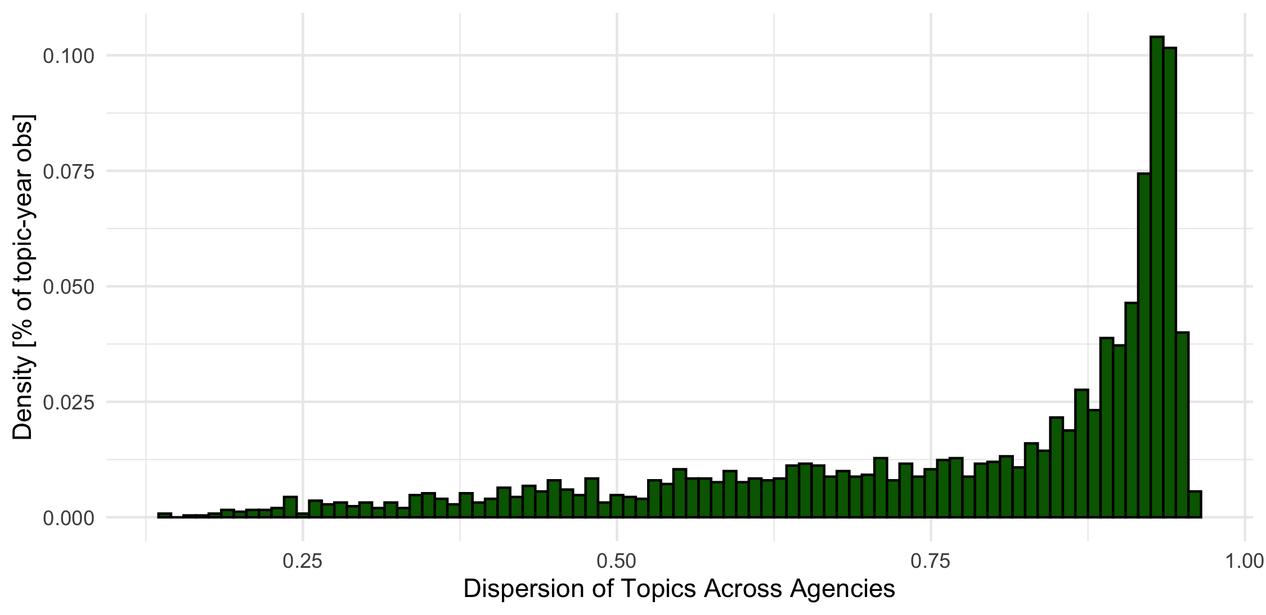

*Panel B: Dispersion of Topics per firm-year*

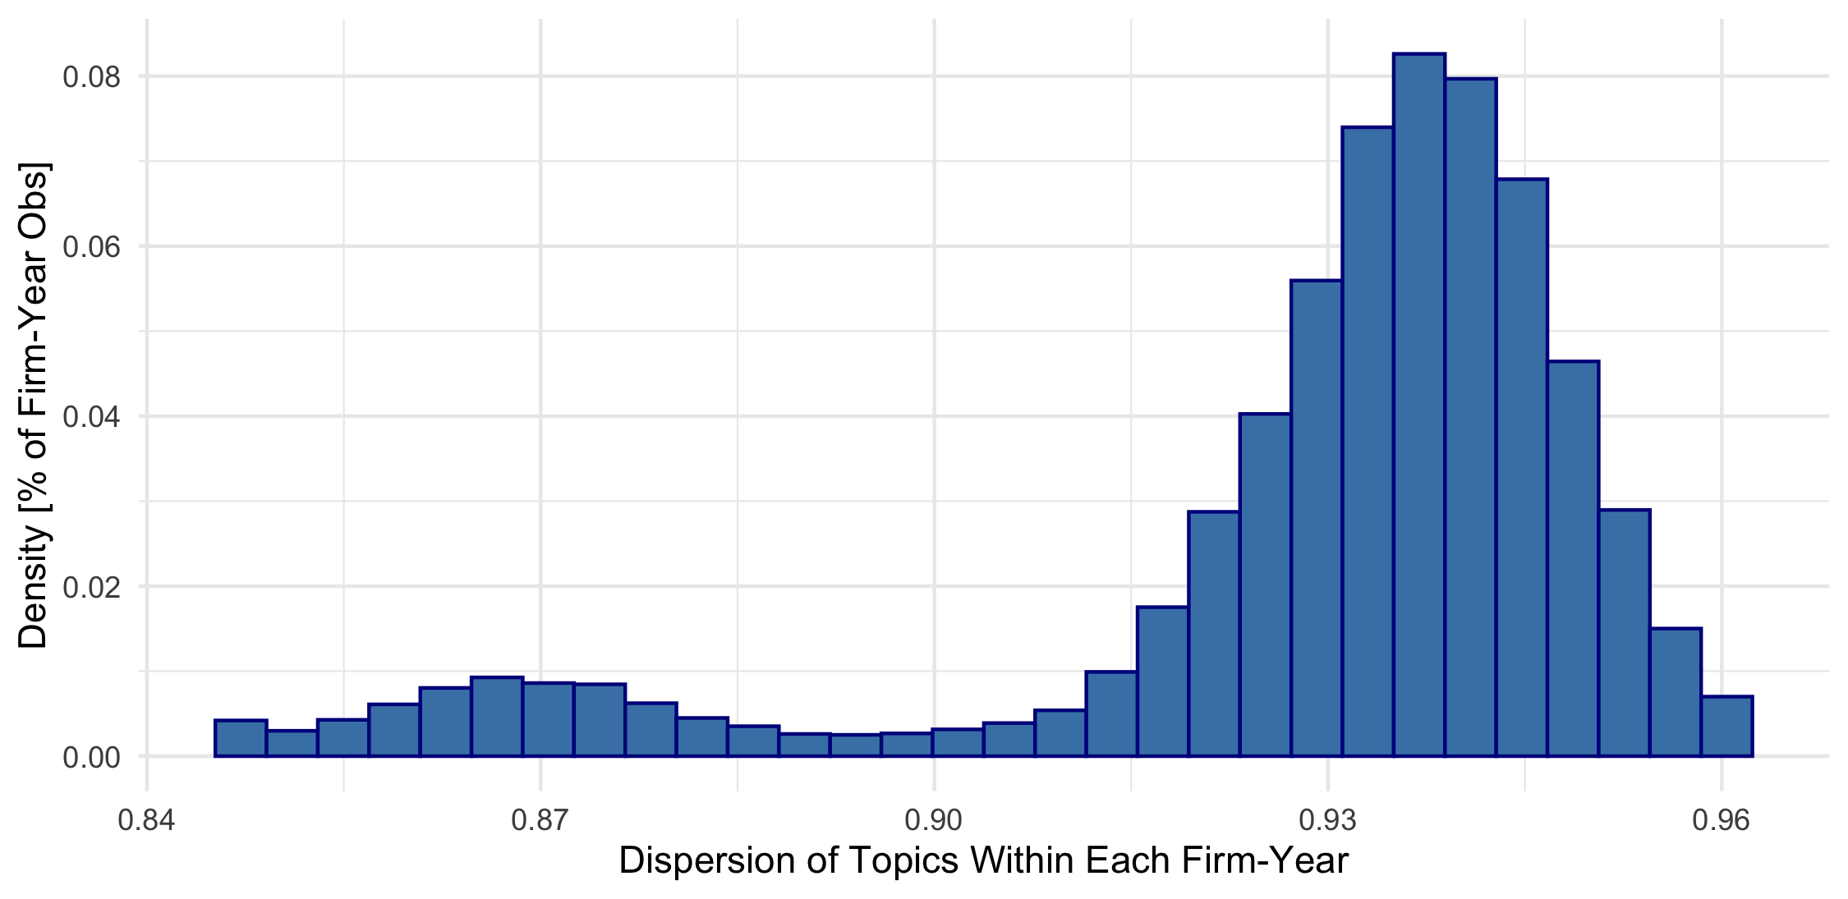

*Panel C: Dispersion of Agencies per Firm-year*

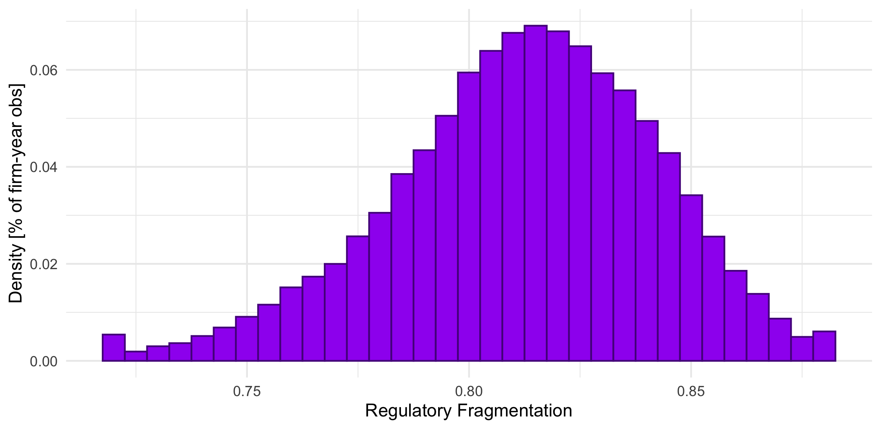

# **Figure 3: Time Trend**

## Panel A: 12 Industries

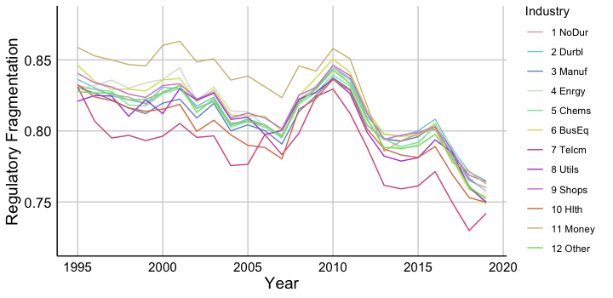

## Panel B: FF12 == 1

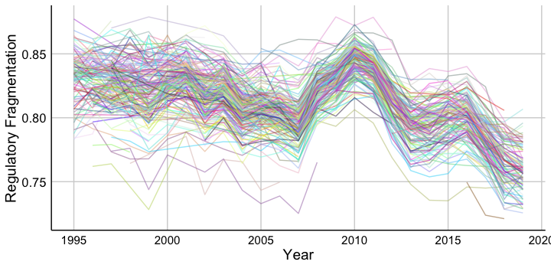

# **Figure 4:** Regulation Dispersion

## *Panel B: Topics with biggest change around 2016 presidential election*

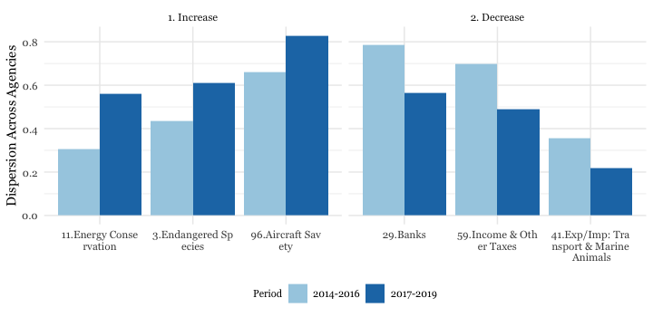

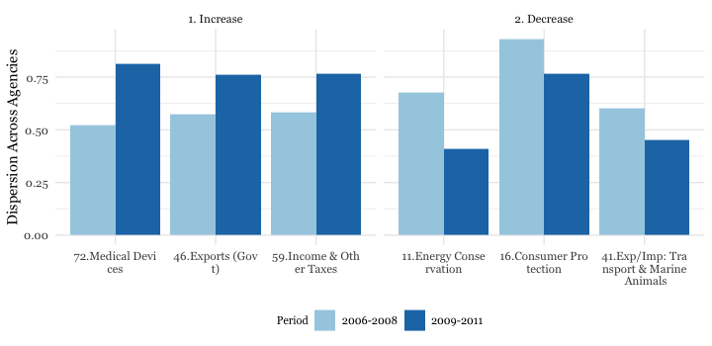

## Panel C: Agencies the biggest , Trump

## Panel D: Agencies the biggest , GFC

# **Table 1:**

# **Table 2: Verification**

All variables are normalized

|  | **company_FR.frag_norm** | **agencies_10K.frag_norm** |
| --- | --- | --- |
| Regulation Dispersion | 0.047** | 0.002 |
|  | (0.022) | (0.009) |
| Topic Dispersion | -0.062** | 0.134*** |
|  | (0.025) | (0.017) |
| Regulation Complexity | -0.061 | -0.076*** |
|  | (0.038) | (0.017) |
| Log(Word,10K) | 0.026 | 0.300*** |
|  | (0.018) | (0.009) |
| Nsegments | 0.014** | -0.002 |
|  | (0.007) | (0.004) |
| PPE/AT | -0.023 | -0.020** |
|  | (0.030) | (0.010) |
| EBITDA/AT | -0.064*** | -0.003 |
|  | (0.019) | (0.004) |
| Log(Sale) | 0.275*** | 0.064*** |
|  | (0.038) | (0.013) |
| Tobin's Q | 0.002 | -0.005 |
|  | (0.012) | (0.004) |
| Num.Obs. | 14592 | 60534 |
| R2 | 0.628 | 0.772 |

# **Table 3: Descriptive statistics**

# **Table 4: SGA_AT, TFP, ROA next year**

All variables are normalized

|  | **1.lead.sga_at_norm** | **2.lead.tfp_norm** | **3.lead.roa_norm** | **4.lead.sga_at_norm** | **5.lead.tfp_norm** | **6.lead.roa_norm** |
| --- | --- | --- | --- | --- | --- | --- |
| Regulation Dispersion | 0.043*** | -0.036** | -0.059*** | 0.055*** | -0.032* | -0.053*** |
|  | (0.015) | (0.016) | (0.013) | (0.014) | (0.018) | (0.015) |
| Topic Dispersion | 0.044** | -0.030 | -0.012 | 0.046** | -0.037** | -0.009 |
|  | (0.017) | (0.020) | (0.021) | (0.019) | (0.018) | (0.018) |
| Regulation Complexity | 0.021 | 0.004 | 0.025 | 0.034 | 0.005 | 0.038* |
|  | (0.020) | (0.019) | (0.028) | (0.026) | (0.021) | (0.019) |
| Log(Word,10K) | -0.015 | -0.019 | -0.135*** | -0.015 | -0.021* | -0.131*** |
|  | (0.009) | (0.012) | (0.032) | (0.011) | (0.012) | (0.031) |
| Nsegments | 0.000 | 0.004 | -0.009** | 0.003 | 0.000 | -0.008** |
|  | (0.004) | (0.005) | (0.003) | (0.004) | (0.005) | (0.004) |
| PPE/AT | 0.071** | -0.239*** | -0.080*** | 0.068** | -0.254*** | -0.076*** |
|  | (0.028) | (0.041) | (0.020) | (0.030) | (0.037) | (0.026) |
| EBITDA/AT | -0.022** | 0.371*** | 0.339*** | -0.023** | 0.385*** | 0.336*** |
|  | (0.010) | (0.025) | (0.030) | (0.010) | (0.026) | (0.031) |
| Log(Sale) | -0.303*** | 0.376*** | 0.336*** | -0.318*** | 0.362*** | 0.332*** |
|  | (0.047) | (0.039) | (0.037) | (0.050) | (0.041) | (0.039) |
| Tobin's Q | 0.107*** | 0.204*** | -0.055*** | 0.111*** | 0.209*** | -0.054*** |
|  | (0.010) | (0.017) | (0.011) | (0.008) | (0.020) | (0.009) |
| Num.Obs. | 60534 | 38922 | 60534 | 60534 | 38922 | 60534 |
| R2 | 0.867 | 0.719 | 0.637 | 0.872 | 0.730 | 0.653 |
| R2 Adj. | 0.848 | 0.676 | 0.584 | 0.850 | 0.679 | 0.593 |
| RMSE | 0.36 | 0.53 | 0.60 | 0.36 | 0.52 | 0.59 |
| Std.Errors | by: FF48 | by: FF48 | by: FF48 | by: FF48 | by: FF48 | by: FF48 |
| FE: FF48 | X | X | X | X | X | X |
| FE: cik | X | X | X | X | X | X |
| FE: FF48_year |  |  |  | X | X | X |
| FE: year | X | X | X |  |  |  |

# **Table 5: Sales growth, assets growth, emp next year**

All variables are normalized

|  | **1.lead.growth_norm** | **2.lead.growth.at_norm** | **3.lead.emp_at_norm** | **4.lead.growth_norm** | **5.lead.growth.at_norm** | **6.lead.emp_at_norm** |
| --- | --- | --- | --- | --- | --- | --- |
| Regulation Dispersion | -0.099*** | -0.143*** | 0.001 | -0.110*** | -0.139*** | 0.012** |
|  | (0.017) | (0.024) | (0.015) | (0.022) | (0.027) | (0.006) |
| Topic Dispersion | -0.012 | 0.022 | 0.015 | 0.003 | 0.030 | 0.004 |
|  | (0.021) | (0.018) | (0.012) | (0.019) | (0.020) | (0.012) |
| Regulation Complexity | -0.145*** | -0.201*** | 0.032** | -0.155*** | -0.195*** | 0.014 |
|  | (0.042) | (0.034) | (0.016) | (0.037) | (0.034) | (0.015) |
| Log(Word,10K) | 0.076*** | 0.099*** | -0.021* | 0.068*** | 0.090*** | -0.020* |
|  | (0.023) | (0.017) | (0.012) | (0.022) | (0.019) | (0.010) |
| Nsegments | 0.002 | -0.005 | -0.003 | -0.003 | -0.009 | -0.002 |
|  | (0.005) | (0.005) | (0.004) | (0.004) | (0.006) | (0.003) |
| PPE/AT | -0.089*** | -0.210*** | 0.068*** | -0.069** | -0.194*** | 0.073*** |
|  | (0.023) | (0.040) | (0.017) | (0.031) | (0.052) | (0.020) |
| EBITDA/AT | -0.003 | 0.054*** | 0.027*** | -0.009 | 0.049*** | 0.023*** |
|  | (0.030) | (0.014) | (0.007) | (0.029) | (0.015) | (0.007) |
| Log(Sale) | 0.559*** | 0.477*** | -0.034 | 0.583*** | 0.487*** | -0.033 |
|  | (0.051) | (0.043) | (0.025) | (0.053) | (0.045) | (0.024) |
| Tobin's Q | 0.047*** | -0.048*** | 0.029*** | 0.044*** | -0.049*** | 0.031*** |
|  | (0.009) | (0.012) | (0.006) | (0.010) | (0.012) | (0.006) |
| Num.Obs. | 60534 | 60534 | 60534 | 60534 | 60534 | 60534 |
| R2 | 0.363 | 0.277 | 0.919 | 0.399 | 0.305 | 0.923 |
| R2 Adj. | 0.270 | 0.171 | 0.907 | 0.296 | 0.185 | 0.910 |
| RMSE | 0.80 | 0.85 | 0.29 | 0.78 | 0.83 | 0.28 |
| Std.Errors | by: FF48 | by: FF48 | by: FF48 | by: FF48 | by: FF48 | by: FF48 |
| FE: FF48 | X | X | X | X | X | X |
| FE: cik | X | X | X | X | X | X |
| FE: FF48_year |  |  |  | X | X | X |
| FE: year | X | X | X |  |  |  |

# **Table 6: Subsamples**

All variables are normalized

## Panel A

Model 1 keeps observations in the same icode-500 HP industry code. Model 2 keeps observations with the same number of segments, Model 3 keep observations with the change in total assets below 20%

|  | **SGA|ind** | **SGA|seg** | **SGA|size** | **TFP|ind** | **TFP|seg** | **TFP|size** | **Grwoth|ind** | **Growth|seg** | **Growth|size** |
| --- | --- | --- | --- | --- | --- | --- | --- | --- | --- |
| regul.disp_norm | 0.041** | 0.041** | 0.034** | -0.033** | -0.038** | -0.030* | -0.100*** | -0.100*** | -0.056*** |
|  | (0.017) | (0.016) | (0.014) | (0.016) | (0.016) | (0.017) | (0.018) | (0.017) | (0.014) |
| Num.Obs. | 54259 | 56444 | 44207 | 34473 | 35755 | 28785 | 54259 | 56444 | 44207 |
| R2 | 0.874 | 0.870 | 0.904 | 0.725 | 0.722 | 0.746 | 0.383 | 0.376 | 0.400 |

## Panel B Interactions

|  | **SGA|ind** | **SGA|seg** | **SGA|size** | **TFP|ind** | **TFP|seg** | **TFP|size** | **Grwoth|ind** | **Growth|seg** | **Growth|size** |
| --- | --- | --- | --- | --- | --- | --- | --- | --- | --- |
| regul.disp_norm | 0.042** | 0.043** | 0.047*** | -0.036** | -0.035** | -0.034** | -0.099*** | -0.099*** | -0.110*** |
|  | (0.016) | (0.016) | (0.015) | (0.014) | (0.014) | (0.016) | (0.022) | (0.021) | (0.022) |
| change | 0.011 | 0.007 | 0.045*** | -0.003 | -0.007 | 0.084*** | 0.000 | 0.011 | 0.079*** |
|  | (0.008) | (0.008) | (0.008) | (0.012) | (0.014) | (0.015) | (0.010) | (0.015) | (0.017) |
| regul.disp_norm × change | 0.007 | 0.005 | -0.009 | 0.001 | -0.004 | 0.001 | 0.006 | 0.011 | 0.046* |
|  | (0.008) | (0.014) | (0.006) | (0.019) | (0.015) | (0.012) | (0.015) | (0.025) | (0.025) |
| Num.Obs. | 60534 | 60534 | 60534 | 38922 | 38922 | 38922 | 60534 | 60534 | 60534 |
| R2 | 0.867 | 0.867 | 0.868 | 0.719 | 0.719 | 0.720 | 0.363 | 0.363 | 0.364 |

# **Table 7: Industry Composition**

All variables are normalized

|  | **lead.n_ipo_norm** | **lead.n_join_norm** | **lead.n_left_norm** | **lead.n_peers_norm** |
| --- | --- | --- | --- | --- |
| regul.disp_norm | -0.049*** | -0.024* | 0.026** | -0.035*** |
|  | (0.013) | (0.014) | (0.011) | (0.008) |
| Num.Obs. | 60534 | 60534 | 56364 | 60534 |
| R2 | 0.786 | 0.604 | 0.119 | 0.915 |

# **Table 8 Coauthored Topics**

|  | **lead.sga_at_norm** | **lead.tfp_norm** | **lead.roa_norm** | **lead.growth_norm** | **lead.growth.at_norm** | **lead.emp_at_norm** |
| --- | --- | --- | --- | --- | --- | --- |
| regul.disp_norm | 0.060*** | -0.033 | -0.062*** | -0.111*** | -0.153*** | 0.022*** |
|  | (0.014) | (0.020) | (0.017) | (0.026) | (0.027) | (0.007) |
| coauthored | 0.014 | -0.023 | -0.021 | -0.011 | -0.027 | -0.011 |
|  | (0.009) | (0.017) | (0.015) | (0.017) | (0.027) | (0.007) |
| regul.disp_norm × coauthored | -0.014** | 0.008 | 0.019 | 0.006 | 0.038** | -0.019*** |
|  | (0.006) | (0.011) | (0.014) | (0.019) | (0.015) | (0.007) |
| Num.Obs. | 60534 | 38922 | 60534 | 60534 | 60534 | 60534 |
| R2 | 0.872 | 0.730 | 0.653 | 0.400 | 0.306 | 0.923 |

# **Table 9 Lobby next year**

All variables are normalized

Dependent variable: log of (1 + lobby expenses next year).

* Average of lobby expenses next year = 749775.2 dollars
* Average of log 1 + lobby expenses next year = 7.694036 dollars
* standard deviation of log 1 + lobby expenses next year = 6.29541 dollars

|  | **1.lead.log_lobby_norm** | **2.lead.lobby_norm** | **3.lead.log_lobby_norm** | **4.lead.lobby_norm** |
| --- | --- | --- | --- | --- |
| Regulation Dispersion | -0.106*** | -0.091*** | -0.102** | -0.080** |
|  | (0.032) | (0.031) | (0.038) | (0.030) |
| Topic Dispersion | -0.033 | 0.007 | -0.056 | -0.025 |
|  | (0.050) | (0.033) | (0.051) | (0.029) |
| Regulation Complexity | -0.048 | -0.057 | -0.067 | -0.093* |
|  | (0.062) | (0.060) | (0.066) | (0.055) |
| Log(Word,10K) | 0.071** | 0.031 | 0.045 | 0.015 |
|  | (0.034) | (0.030) | (0.033) | (0.033) |
| Nsegments | 0.005 | 0.015* | 0.004 | 0.014 |
|  | (0.011) | (0.009) | (0.012) | (0.010) |
| PPE/AT | 0.006 | 0.001 | -0.014 | 0.004 |
|  | (0.034) | (0.024) | (0.038) | (0.030) |
| EBITDA/AT | -0.026** | -0.031*** | -0.012 | -0.026*** |
|  | (0.012) | (0.007) | (0.015) | (0.009) |
| Log(Sale) | 0.324*** | 0.224*** | 0.333*** | 0.215*** |
|  | (0.076) | (0.053) | (0.083) | (0.068) |
| Tobin's Q | -0.005 | -0.002 | -0.013 | -0.010 |
|  | (0.013) | (0.008) | (0.014) | (0.007) |
| Num.Obs. | 14983 | 14983 | 14983 | 14983 |
| R2 | 0.611 | 0.874 | 0.649 | 0.887 |
| R2 Adj. | 0.559 | 0.857 | 0.570 | 0.862 |
| RMSE | 0.62 | 0.36 | 0.59 | 0.34 |
| Std.Errors | by: FF48 | by: FF48 | by: FF48 | by: FF48 |
| FE: FF48 | X | X | X | X |
| FE: cik | X | X | X | X |
| FE: FF48_year |  |  | X | X |
| FE: year | X | X |  |  |

# **Table 10: Relationship between Rules and Notices**

All variables are normalized

Here we take a log(1 + words) in rules and notice. Then we also standarise it: mean = 0 and st.dev = 1.

|  | **(1)** | **(2)** | **(3)** | **(4)** |
| --- | --- | --- | --- | --- |
| lag1_notice | 0.248*** |  | 0.138*** | 0.113*** |
|  | (0.046) |  | (0.031) | (0.009) |
| lag2_notice | 0.161*** |  | 0.085*** | 0.102*** |
|  | (0.028) |  | (0.023) | (0.009) |
| lead1_notice |  | 0.234*** | 0.144*** | 0.122*** |
|  |  | (0.050) | (0.032) | (0.009) |
| lead2_notice |  | 0.201*** | 0.138*** | 0.142*** |
|  |  | (0.025) | (0.018) | (0.010) |
| Num.Obs. | 203800 | 203800 | 203800 | 203800 |
| R2 | 0.830 | 0.832 | 0.835 | 0.898 |

# **Table 11 RD: Notices, Pr. Rules, Rules**

All variables are normalized

Correlation matrix between four measures of regulation dispersion (across all documents, notices, proposed rules and rules)

## Panel A *Correlations*

*Notice are less correlation with rules and proposed rules. But other things are correlated.*

| **regul.disp_norm** | **regul.disp_Notice_norm** | **regul.disp_PRule_norm** | **regul.disp_Rule_norm** |
| --- | --- | --- | --- |
| 1.00 | 0.76 | 0.71 | 0.74 |
| 0.76 | 1.00 | 0.25 | 0.28 |
| 0.71 | 0.25 | 1.00 | 0.67 |
| 0.74 | 0.28 | 0.67 | 1.00 |

## Panel B *Notices*

|  | **sga** | **tfp** | **roa** | **growth** | **growth_at** | **emp** |
| --- | --- | --- | --- | --- | --- | --- |
| regul.disp_Notice_norm | 0.045** | -0.066*** | 0.019 | -0.105*** | -0.127*** | 0.011 |
|  | (0.020) | (0.021) | (0.015) | (0.023) | (0.026) | (0.009) |
| Num.Obs. | 60534 | 38922 | 60534 | 60534 | 60534 | 60534 |
| R2 | 0.872 | 0.730 | 0.653 | 0.399 | 0.304 | 0.923 |

## Panel C *Pr Rules*

|  | **sga** | **tfp** | **roa** | **growth** | **growth_at** | **emp** |
| --- | --- | --- | --- | --- | --- | --- |
| regul.disp_PRule_norm | 0.052*** | -0.003 | -0.085*** | -0.088*** | -0.119*** | 0.011** |
|  | (0.013) | (0.012) | (0.017) | (0.021) | (0.024) | (0.005) |
| Num.Obs. | 60534 | 38922 | 60534 | 60534 | 60534 | 60534 |
| R2 | 0.872 | 0.730 | 0.653 | 0.399 | 0.305 | 0.923 |

## Panel D *Rules*

|  | **sga** | **tfp** | **roa** | **growth** | **growth_at** | **emp** |
| --- | --- | --- | --- | --- | --- | --- |
| regul.disp_Rule_norm | 0.050*** | 0.001 | -0.095*** | -0.074*** | -0.093*** | 0.012** |
|  | (0.012) | (0.014) | (0.015) | (0.019) | (0.021) | (0.005) |
| Num.Obs. | 60534 | 38922 | 60534 | 60534 | 60534 | 60534 |
| R2 | 0.872 | 0.730 | 0.654 | 0.399 | 0.305 | 0.923 |

# **Table 12 RD: New vs Old Rules**

All variables are normalized

Correlation matrix between four measures of regulation dispersion (across all documents, notices, proposed rules and rules)

## Panel A *Correlations*

*Notice are less correlation with rules and proposed rules. But other things are correlated.*

| **regul.disp_Rule** | **regul.disp_RIN** | **regul.disp_old_RIN** |
| --- | --- | --- |
| 1.00 | 0.62 | 0.68 |
| 0.62 | 1.00 | 0.54 |
| 0.68 | 0.54 | 1.00 |

## Panel B *RIN*

|  | **sga** | **tfp** | **roa** | **growth** | **growth_at** | **emp** |
| --- | --- | --- | --- | --- | --- | --- |
| regul.disp_RIN_norm | 0.069*** | -0.015 | -0.120*** | -0.088*** | -0.122*** | 0.004 |
|  | (0.014) | (0.012) | (0.017) | (0.023) | (0.021) | (0.009) |
| Num.Obs. | 60534 | 38922 | 60534 | 60534 | 60534 | 60534 |
| R2 | 0.872 | 0.730 | 0.654 | 0.399 | 0.305 | 0.923 |

## Panel C *Old RIN*

|  | **sga** | **tfp** | **roa** | **growth** | **growth_at** | **emp** |
| --- | --- | --- | --- | --- | --- | --- |
| regul.disp_old_RIN_norm | 0.040*** | -0.005 | -0.068*** | -0.065*** | -0.090*** | 0.014*** |
|  | (0.011) | (0.013) | (0.016) | (0.019) | (0.020) | (0.005) |
| Num.Obs. | 60534 | 38922 | 60534 | 60534 | 60534 | 60534 |
| R2 | 0.872 | 0.730 | 0.653 | 0.399 | 0.305 | 0.923 |

# Online Appendix

# **Table A1. Cost and Time Compliance**

|  | **company_FR.frag_norm** | **agencies_10K.frag_norm** |
| --- | --- | --- |
| Regulation Dispersion | 0.085 | 0.112*** |
|  | (0.067) | (0.019) |
| Topic Dispersion | -0.097** | -0.033** |
|  | (0.049) | (0.015) |
| Regulation Complexity | -0.054 | -0.115*** |
|  | (0.122) | (0.036) |
| Log(Word,10K) | 0.004 | 0.190*** |
|  | (0.049) | (0.015) |
| Nsegments | 0.054 | 0.009 |
|  | (0.033) | (0.016) |
| PPE/AT | -0.081 | -0.036 |
|  | (0.229) | (0.029) |
| EBITDA/AT | -0.184 | -0.039 |
|  | (0.145) | (0.024) |
| Log(Sale) | -0.056 | 0.107*** |
|  | (0.132) | (0.028) |
| Tobin's Q | 0.032 | -0.007 |
|  | (0.121) | (0.014) |
| Num.Obs. | 1593 | 9688 |
| R2 | 0.628 | 0.810 |

# **Table A2. Alternative LDAs**

## *Panel A, MD&A Section*

|  | **sga** | **tfp** | **roa** | **growth** | **growth_at** | **emp** |
| --- | --- | --- | --- | --- | --- | --- |
| regul.disp_item7_norm | 0.039*** | -0.021** | -0.044*** | -0.006 | -0.047*** | 0.018** |
|  | (0.010) | (0.010) | (0.009) | (0.011) | (0.013) | (0.008) |
| Num.Obs. | 57275 | 36934 | 57275 | 57275 | 57275 | 57275 |
| R2 | 0.873 | 0.732 | 0.655 | 0.403 | 0.310 | 0.923 |

## *Panel B, Item1 Section*

|  | **sga** | **tfp** | **roa** | **growth** | **growth_at** | **emp** |
| --- | --- | --- | --- | --- | --- | --- |
| regul.disp_item1_norm | -0.004 | -0.015 | -0.009 | 0.017 | 0.006 | -0.010 |
|  | (0.009) | (0.019) | (0.010) | (0.021) | (0.022) | (0.008) |
| Num.Obs. | 60152 | 38698 | 60152 | 60152 | 60152 | 60152 |
| R2 | 0.871 | 0.730 | 0.654 | 0.399 | 0.304 | 0.922 |

## *Panel C, Most Intensive Topic*

|  | **sga** | **tfp** | **roa** | **growth** | **growth_at** | **emp** |
| --- | --- | --- | --- | --- | --- | --- |
| regul.disp_main_norm | 0.015*** | 0.002 | -0.032*** | -0.035*** | -0.047*** | 0.000 |
|  | (0.004) | (0.007) | (0.003) | (0.006) | (0.008) | (0.004) |
| Num.Obs. | 60534 | 38922 | 60534 | 60534 | 60534 | 60534 |
| R2 | 0.872 | 0.730 | 0.653 | 0.399 | 0.304 | 0.923 |

## *Panel D, Drop 3 Most Common Topics*

|  | **sga** | **tfp** | **roa** | **growth** | **growth_at** | **emp** |
| --- | --- | --- | --- | --- | --- | --- |
| regul.disp_no3_norm | 0.030** | -0.036** | 0.004 | -0.070*** | -0.083*** | 0.011 |
|  | (0.012) | (0.017) | (0.016) | (0.021) | (0.025) | (0.006) |
| Num.Obs. | 60534 | 38922 | 60534 | 60534 | 60534 | 60534 |
| R2 | 0.872 | 0.730 | 0.653 | 0.399 | 0.305 | 0.923 |

# **Table A3, Different Number of Topics**

## *Panel A, 57 topics*

|  | **sga** | **tfp** | **roa** | **growth** | **growth_at** | **emp** |
| --- | --- | --- | --- | --- | --- | --- |
| regul.disp_57_norm | 0.048*** | -0.027 | -0.039** | -0.093*** | -0.096*** | 0.023** |
|  | (0.013) | (0.019) | (0.018) | (0.025) | (0.024) | (0.009) |
| Num.Obs. | 60534 | 38922 | 60534 | 60534 | 60534 | 60534 |
| R2 | 0.872 | 0.730 | 0.653 | 0.399 | 0.304 | 0.923 |

## *Panel B, 70 topics*

|  | **sga** | **tfp** | **roa** | **growth** | **growth_at** | **emp** |
| --- | --- | --- | --- | --- | --- | --- |
| regul.disp_70_norm | 0.059*** | -0.030* | -0.049*** | -0.117*** | -0.148*** | 0.022*** |
|  | (0.013) | (0.015) | (0.014) | (0.021) | (0.024) | (0.008) |
| Num.Obs. | 60534 | 38922 | 60534 | 60534 | 60534 | 60534 |
| R2 | 0.872 | 0.730 | 0.653 | 0.399 | 0.305 | 0.923 |

## *Panel C, 200 topics*

|  | **sga** | **tfp** | **roa** | **growth** | **growth_at** | **emp** |
| --- | --- | --- | --- | --- | --- | --- |
| regul.disp_200_norm | 0.053*** | -0.014 | -0.084*** | -0.048** | -0.046** | 0.015** |
|  | (0.011) | (0.016) | (0.013) | (0.018) | (0.020) | (0.007) |
| Num.Obs. | 60534 | 38922 | 60534 | 60534 | 60534 | 60534 |
| R2 | 0.872 | 0.730 | 0.654 | 0.398 | 0.303 | 0.923 |

## *Panel D, 300 topics*

|  | **sga** | **tfp** | **roa** | **growth** | **growth_at** | **emp** |
| --- | --- | --- | --- | --- | --- | --- |
| regul.disp_300_norm | 0.044*** | -0.013 | -0.082*** | -0.038** | -0.059*** | -0.004 |
|  | (0.010) | (0.013) | (0.016) | (0.015) | (0.017) | (0.009) |
| Num.Obs. | 60534 | 38922 | 60534 | 60534 | 60534 | 60534 |
| R2 | 0.872 | 0.730 | 0.653 | 0.398 | 0.304 | 0.923 |

## *Panel E, 1000 topics*

|  | **sga** | **tfp** | **roa** | **growth** | **growth_at** | **emp** |
| --- | --- | --- | --- | --- | --- | --- |
| regul.disp_1000_norm | 0.032*** | -0.002 | -0.060*** | -0.024* | -0.017 | -0.001 |
|  | (0.009) | (0.009) | (0.013) | (0.013) | (0.014) | (0.006) |
| Num.Obs. | 60534 | 38922 | 60534 | 60534 | 60534 | 60534 |
| R2 | 0.872 | 0.730 | 0.653 | 0.398 | 0.303 | 0.923 |

# Rolling 5 and Rolling 10 year

|  | **sga** | **tfp** | **roa** | **growth** | **growth_at** | **emp** |
| --- | --- | --- | --- | --- | --- | --- |
| regul.disp_rolling5_norm | 0.055*** | -0.037** | -0.055*** | -0.069*** | -0.102*** | 0.011 |
|  | (0.013) | (0.018) | (0.014) | (0.021) | (0.026) | (0.007) |
| Num.Obs. | 53866 | 34040 | 53866 | 53866 | 53866 | 53866 |
| R2 | 0.877 | 0.740 | 0.660 | 0.395 | 0.296 | 0.929 |

|  | **sga** | **tfp** | **roa** | **growth** | **growth_at** | **emp** |
| --- | --- | --- | --- | --- | --- | --- |
| regul.disp_rolling10_norm | 0.045*** | -0.028 | -0.065*** | -0.049** | -0.084*** | 0.003 |
|  | (0.013) | (0.020) | (0.013) | (0.022) | (0.028) | (0.008) |
| Num.Obs. | 42241 | 26550 | 42241 | 42241 | 42241 | 42241 |
| R2 | 0.893 | 0.766 | 0.683 | 0.409 | 0.303 | 0.943 |

# **Table A4. Recent IPOs and Old Companies**

## Panel A. Recept IPOs

This table only includes companies that went public less than 10 years ago

|  | **sga** | **tfp** | **roa** | **growth** | **growth_at** | **emp** |
| --- | --- | --- | --- | --- | --- | --- |
| regul.disp_norm | 0.069** | -0.034 | -0.122*** | -0.128** | -0.160** | 0.023 |
|  | (0.026) | (0.043) | (0.044) | (0.050) | (0.063) | (0.015) |
| Num.Obs. | 20893 | 12597 | 20893 | 20893 | 20893 | 20893 |
| R2 | 0.908 | 0.794 | 0.724 | 0.534 | 0.462 | 0.954 |