Internet Appendix

Kalmenovitz, Lowry, Volkova

2021-11-20

**Figure A1**

*Panel Ai: Distribution across top10 topics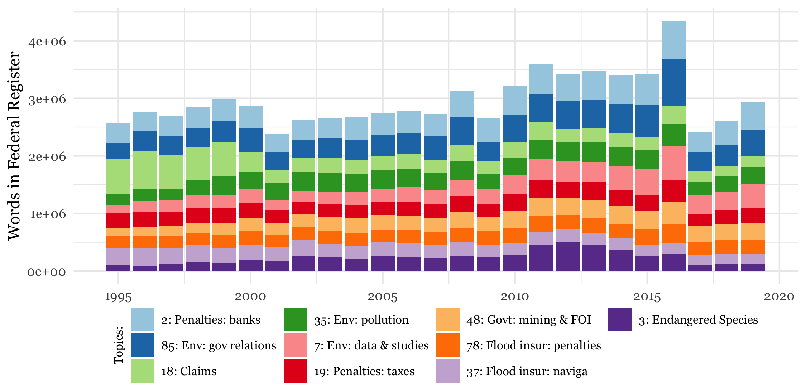Panel Aii: Distribution across top10 topics, notices only*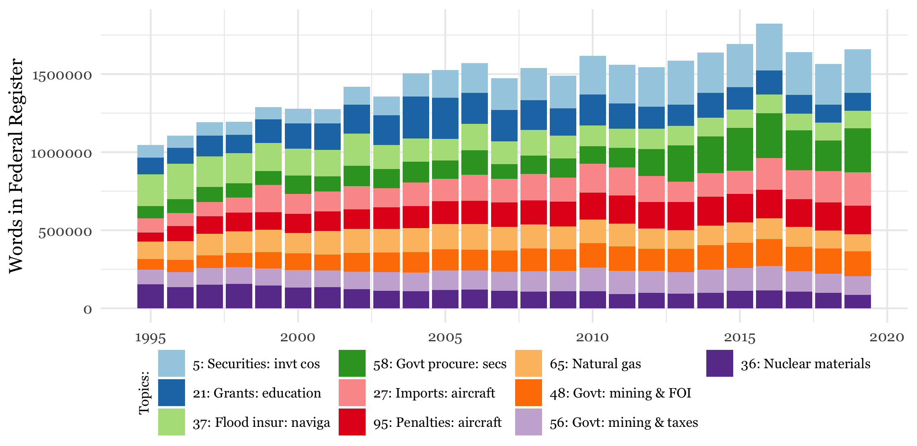

*Panel Aiii: Distribution across top10 topics, proposed rules only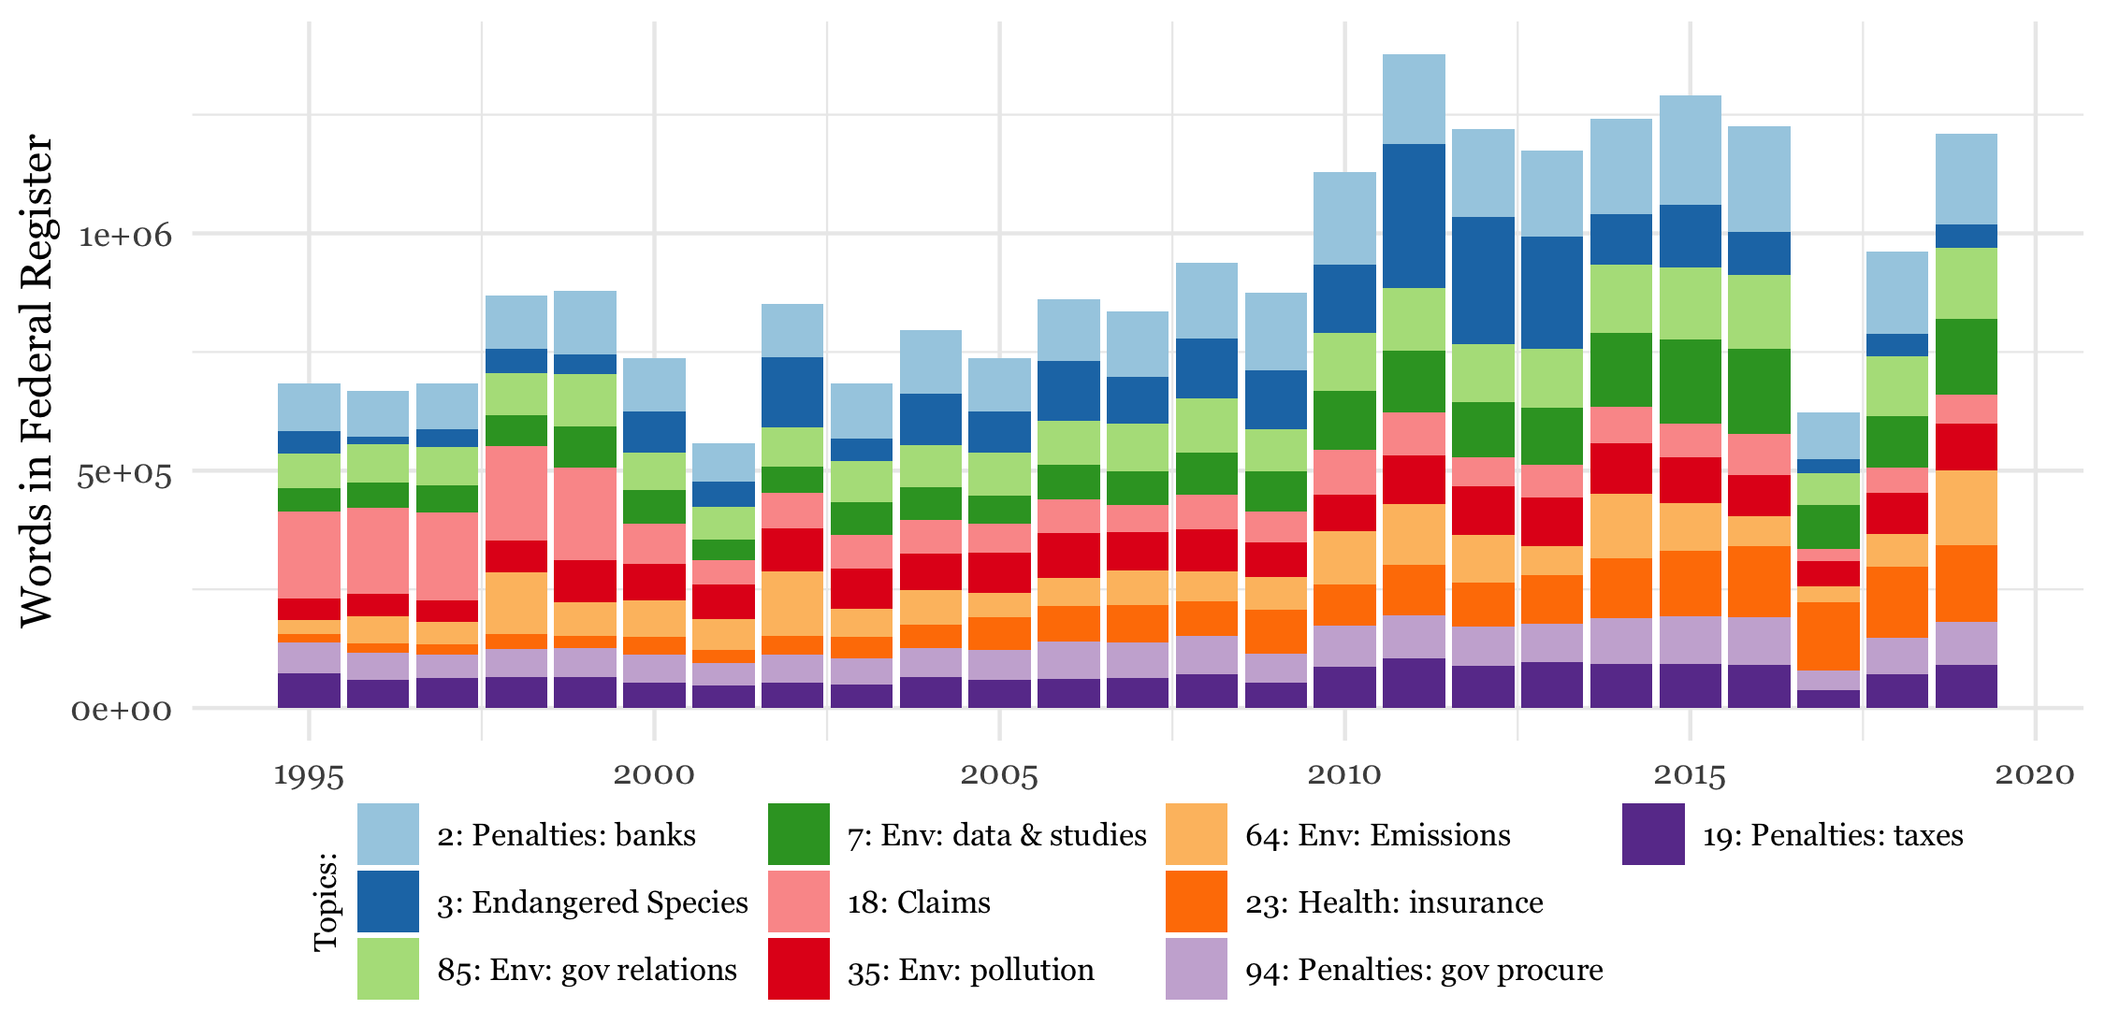Panel Aiv: Distribution across top10 topics, rules only*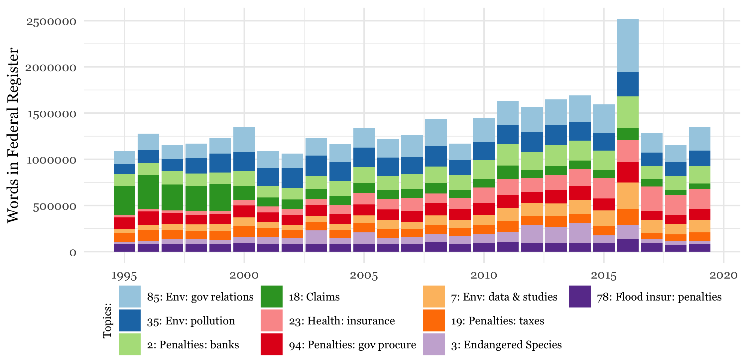

**Figure A2**

*Panel A: Topics with greatest overall decrease or increase, over sample period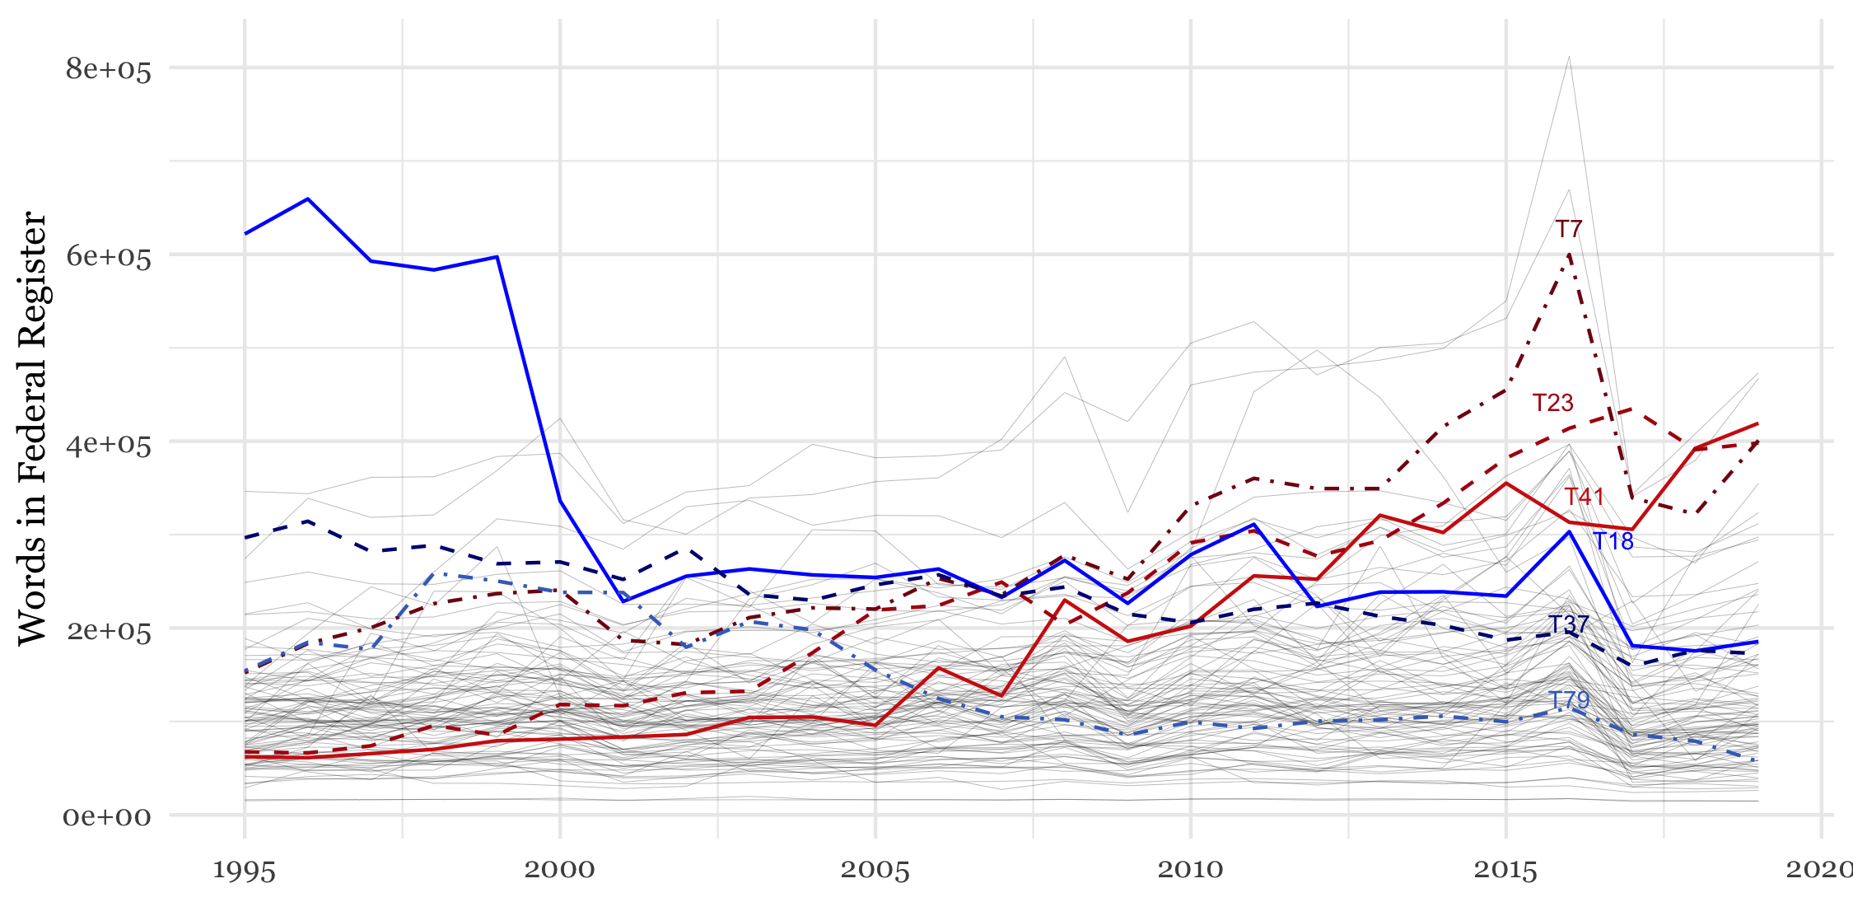Topics with highest increase:*

|  |  |  |  |  |  |
| --- | --- | --- | --- | --- | --- |
| Topic | Label | Words 1995 | Words 2019 | Abs Change | % Change |
| 41 | Exp/Imp: Transport & Marine Animals | 62,164 | 419,219 | 357,055 | 574% |
| 23 | Health: insurance | 67,467 | 398,078 | 330,611 | 490% |
| 7 | Env: data & studies | 152,173 | 400,818 | 248,645 | 163% |

*Topics with highest decrease:*

|  |  |  |  |  |  |
| --- | --- | --- | --- | --- | --- |
| Topic | Label | Words 1995 | Words 2019 | Abs Change | % Change |
| 18 | Claims | 621,714 | 185,605 | -436,109 | -70% |
| 37 | Flood insur: naviga | 296,645 | 172,487 | -124,158 | -42% |
| 79 | Aviation Safety: inspection | 154,147 | 57,095 | -97,052 | -63% |

**Figure A3**

*Panel B: Topics with biggest change around 2016 presidential election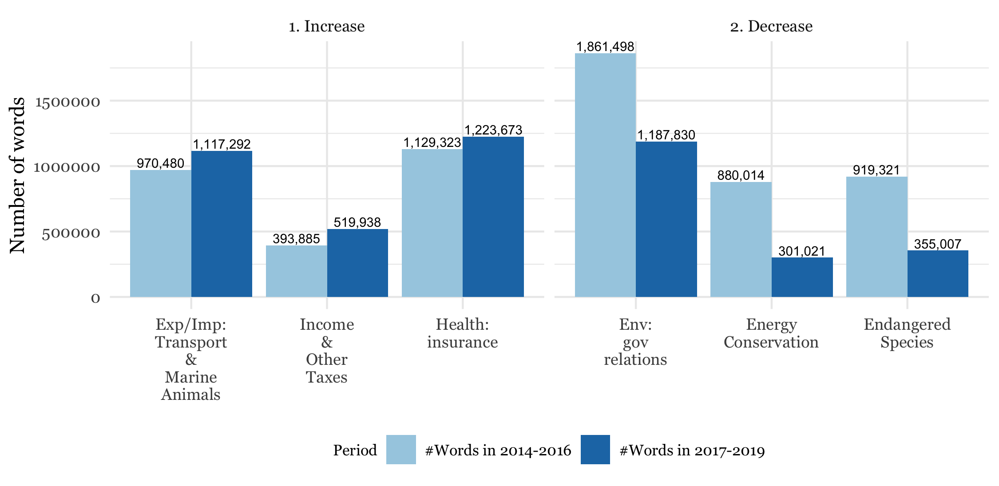Panel C: Topics with biggest change around 2008-09 financial crisis*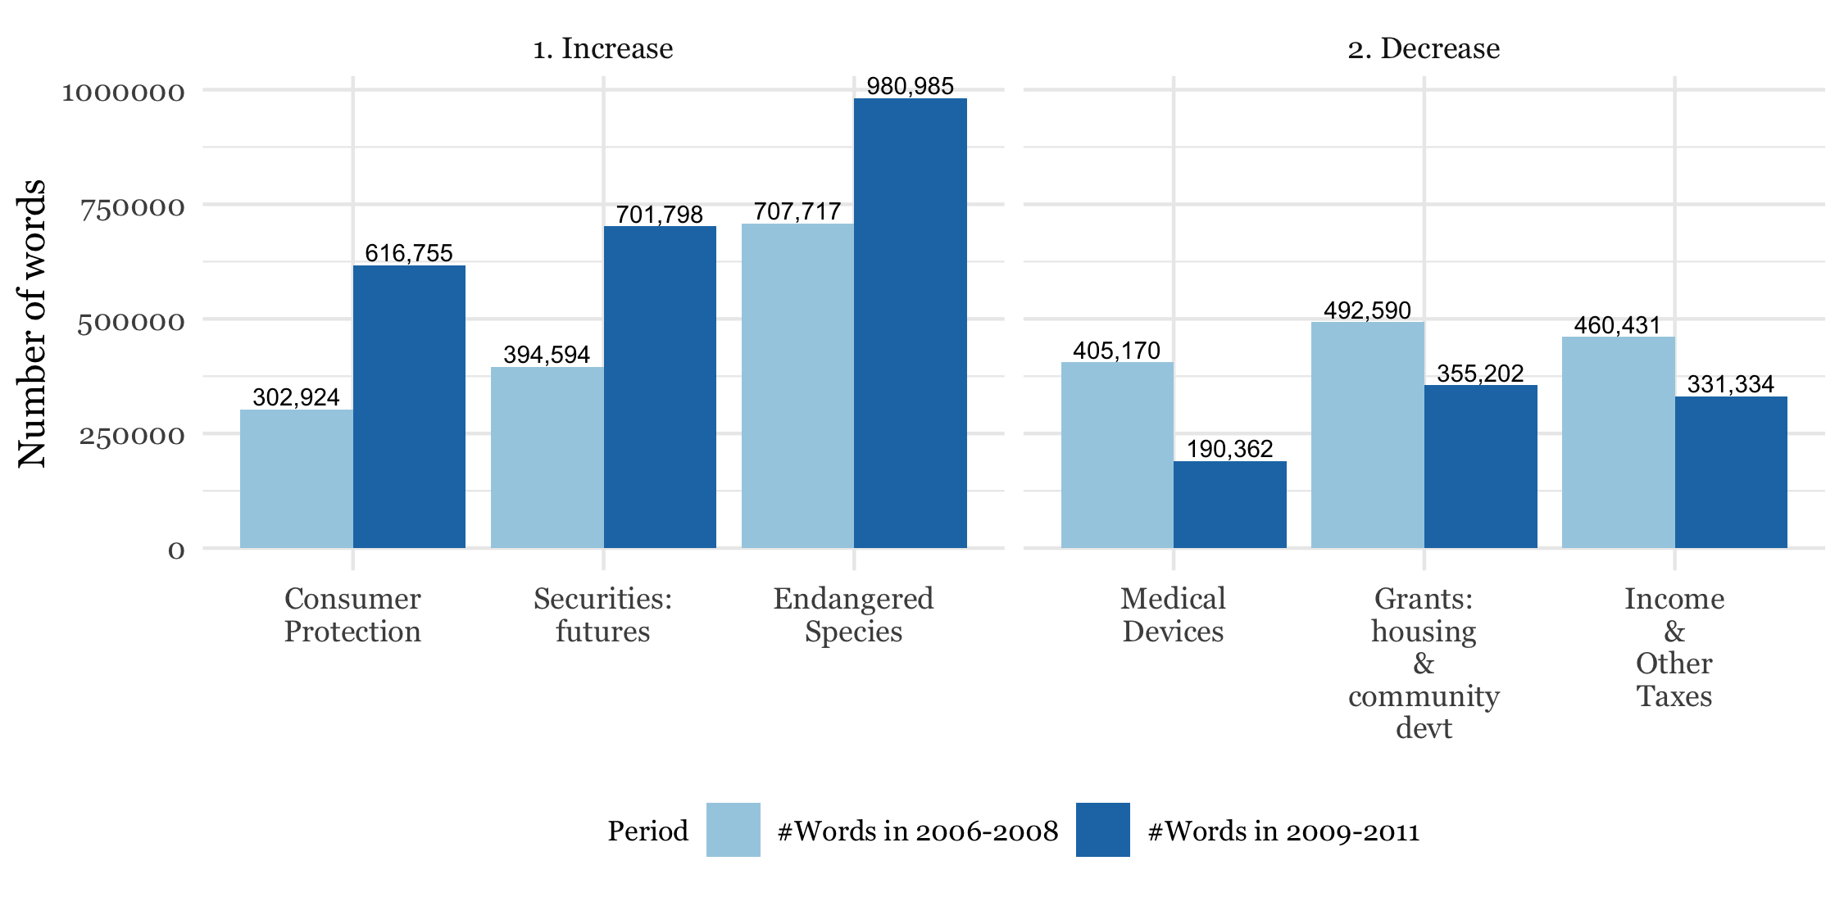

**Figure A4: Time-series Trends in Agencies**

*Panel A: Agencies with greatest overall decrease or increase, over sample period*

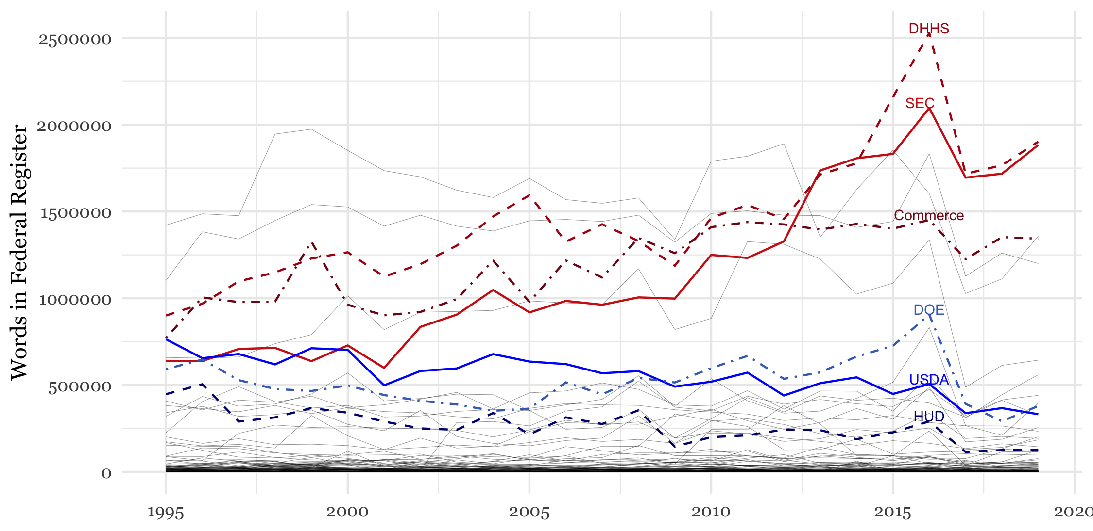*Agencies with highest increase:*

|  |  |  |  |  |  |
| --- | --- | --- | --- | --- | --- |
| Agency | Label | Words 1995 | Words 2019 | Abs Change | % Change |
| securities and exchange commission | SEC | 639,490 | 1,883,208 | 1,243,718 | 194% |
| department of health and human services | DHHS | 900,503 | 1,902,242 | 1,001,739 | 111% |
| department of commerce | Commerce | 771,123 | 1,343,368 | 572,245 | 74% |

*Agencies with highest decrease:*

|  |  |  |  |  |  |
| --- | --- | --- | --- | --- | --- |
| Agency | Label | Words 1995 | Words 2019 | Abs Change | % Change |
| department of agriculture | USDA | 763,756 | 331,946 | -431,810 | -57% |
| department of housing and urban developm | HUD | 447,571 | 125,876 | -321,695 | -72% |
| department of energy | DOE | 591,957 | 379,722 | -212,235 | -36% |

*Panel B: Agencies with biggest change around 2016 presidential election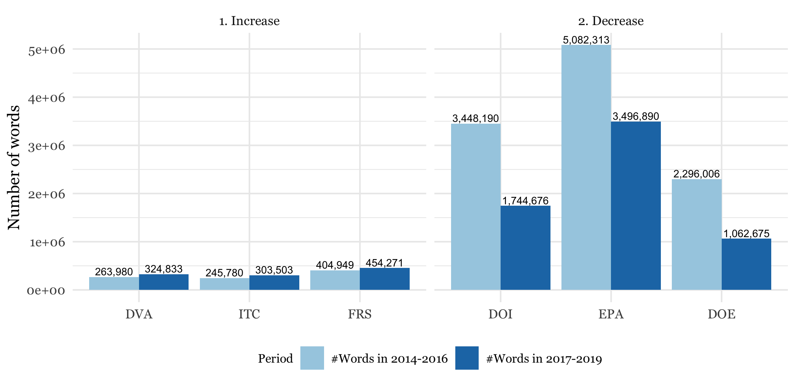Panel C: Agencies with biggest change around 2008-09 financial crisis*