**Дневник работ по учебной практике**

|  |  |  |  |  |  |
| --- | --- | --- | --- | --- | --- |
| **№** | **Тема** | **Дата** | **Кол-во часов** | **Оценка** | **Подпись руководителя** |
| **18** | «Создание и настройка проекта» | **13.05.2021** | **6** |  |  |

**Содержание работ**

Создал код проекта в HTML и CSS:

HTML:

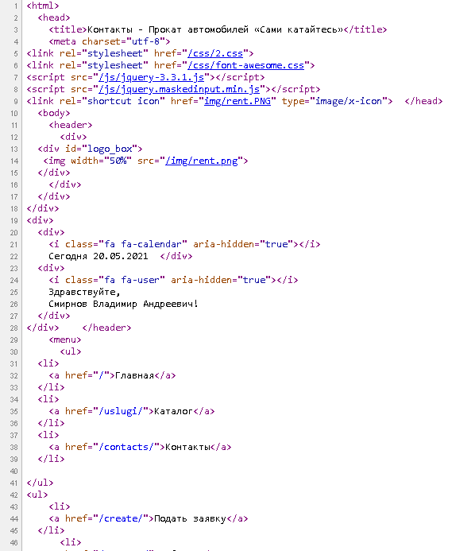

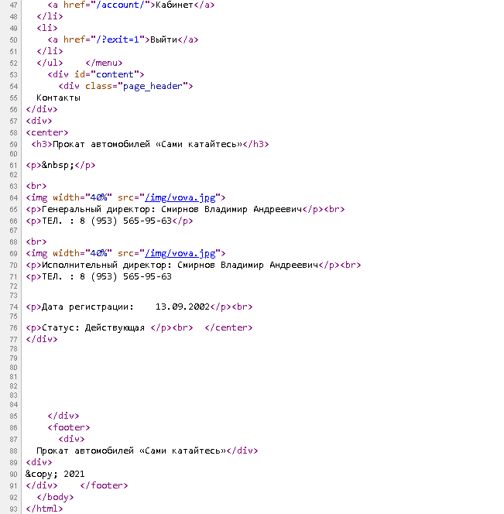

CSS:

@font-face {

font-family: 'Museo Sans 100';

src: url("../fonts/MuseoSansCyrl.otf") format("opentype");

}

@font-face {

font-family: 'Museo Sans 300';

src: url("../fonts/MuseoSansCyrl_0.otf") format("opentype");

}

@font-face {

font-family: 'Museo Sans 500';

src: url("../fonts/MuseoSansCyrl_1.otf") format("opentype");

}

@font-face {

font-family: 'Museo Sans 700';

src: url("../fonts/MuseoSansCyrl_2.otf") format("opentype");

}

@font-face {

font-family: 'Museo Sans 900';

src: url("../fonts/MuseoSansCyrl_3.otf") format("opentype");

}

.justify {

text-align: justify;

}

.center {

text-align: center;

}

p {

padding: 0;

margin: 0;

margin-bottom: 10px;

font-size:14pt;

}

li {

font-size:14pt;

}

.tx {

font-style:italic;

}

.blue {

color: #0055A6;

}

.underline {

text-decoration: underline;

}

.Museo_Sans_100 {

font-family: "Museo Sans 100",Geneva,Arial,Verdana,sans-serif;

}

.Museo_Sans_300, * {

font-family: "Museo Sans 300",Geneva,Arial,Verdana,sans-serif;

}

.Museo_Sans_500 {

font-family: "Museo Sans 500",Geneva,Arial,Verdana,sans-serif;

}

.Museo_Sans_700 {

font-family: "Museo Sans 700",Geneva,Arial,Verdana,sans-serif;

}

.outline {

border: 2px groove green;

padding:10px 10px;

list-style-type: square;

}

body {

margin: 0 auto;

max-width: 1200px;

background:#d6d2d262;;

}

/* Шапка */

header {

height: 120px;

position: relative;

display: flex;

align-items: center;

justify-content: space-between;

padding: 5px;

}

header > div:first-child {

position: relative;

display: flex;

align-items: center;

padding: 5px;

}

header #logo_box {

height: 100%;

width: 200px;

display: flex;

justify-content: center;

align-items: center;

position: relative

}

header #logo_box > img {

max-height: calc(100% - 10px);

max-width: calc(100% - 10px);

}

header > div:first-child > div:nth-child(1) {

margin-right: 10px;

}

header > div:first-child > div:nth-child(2) > div:nth-child(1) {

font-size: 34pt;

font-family: "Museo Sans 500",Geneva,Arial,Verdana,sans-serif;

}

header > div:first-child > div:nth-child(2) > div:nth-child(2) {

font-size: 16pt;

font-style: italic;

font-family: "Museo Sans 100",Geneva,Arial,Verdana,sans-serif;

}

header > div:last-child > div:first-child {

margin-bottom: 10px;

}

/* Меню */

menu {

padding: 0;

margin: 0;

display: flex;

justify-content: space-between;

background: #a67100;

}

menu > ul {

display: flex;

justify-content: space-between;

flex-wrap: wrap;

padding: 0;

margin: 0;

list-style: none;

}

menu > ul > li > a {

padding: 10px 20px;

text-decoration: none;

color: rgb(255, 255, 255);

display: block;

}

menu > ul > li > a:hover {

background: #34aace;

}

/* Подвал */

footer {

background: #a67100;

padding: 10px;

text-align: center;

color: rgb(255, 255, 255);

}

/* Содержимое сайта */

#content {

min-height: 300px;

padding: 5px;

}

.page_header {

font-size: 16pt;

font-family: "Museo Sans 500",Geneva,Arial,Verdana,sans-serif;

text-align: center;

margin-top: 20px;

margin-bottom: 15px;

padding-bottom: 5px;

border-bottom: 1px solid black;

}

.two_cols {

display: flex;

justify-content: space-between;

position: relative;

}

.two_cols > div {

width: 48%;

}

.col_header {

font-size: 14pt;

font-family: "Museo Sans 500",Geneva,Arial,Verdana,sans-serif;

text-align: center;

margin-top: 5px;

margin-bottom: 10px;

}

/*

.news_box {

display: flex;

flex-direction: column;

align-items: center;

}

.news_box > .news_img {

position: relative;

max-width: 500px;

display: flex;

justify-content: center;

align-items: flex-start;

margin: 10px;

margin-bottom: 20px;

}

.news_box > .news_text {

flex-grow: 1;

padding: 5px;

}

.news_box > .news_img > img {

max-height: calc(100% - 10px);

max-width: calc(100% - 10px);

}*/

.news_conteiner {

margin-bottom: 10px;

}

.news_text {

flex-grow: 1;

padding: 5px 0;

}

.news_header {

font-size: 16pt;

font-family: "Museo Sans 500",Geneva,Arial,Verdana,sans-serif;

text-align: left;

margin-bottom: 5px;

}

.news_header a {

text-decoration: none;

color: #a67100;

}

.news_header a:hover {

cursor: pointer;

text-decoration: underline;

}

.news_info {

text-align: left;

padding: 5px 0;

color: #808080;

margin-bottom: 5px;

font-size: 10pt;

}

/* Форма */

.form {

max-width: 500px;

}

.form > div {

margin-bottom: 10px;

display: flex;

flex-direction: column;

}

.form > div > label {

margin-right: 5px;

color: #404040;

font-size: 11pt;

}

.form > div > input, .form > div > textarea, .form > div > select {

padding: 5px;

width: 100%;

}

.form > div > textarea {

min-height: 6em;

}

.form > div > input[type="submit"] {

background: #ff0000;

color: black;

padding: 5px 10px;

border: none;

}

.form > div > input[type="submit"]:hover {

cursor: pointer;

opacity: 0.8;

}

.table {

text-align: center;

border-spacing: 0;

width: 100%;

font-size:14pt;

}

.table td, .table th {

padding: 5px;

border: 1px solid black;

border-right: none;

border-bottom: none;

}

.table th {

border-bottom: 1px solid black;

}

.table td:last-child, .table th:last-child {

padding: 5px;

border-right: 1px solid black;

}

.table tr:last-child td {

padding: 5px;

border-bottom: 1px solid black;

}

.table tr:nth-child(2) td {

padding: 5px;

border-top: none;

}

@media only screen and (max-width: 860px) {

header > div:first-child > div:nth-child(2) > div:nth-child(1) {

font-size: 26pt;

font-family: "Museo Sans 500",Geneva,Arial,Verdana,sans-serif;

}

header > div:first-child > div:nth-child(2) > div:nth-child(2) {

font-size: 12pt;

font-style: italic;

font-family: "Museo Sans 100",Geneva,Arial,Verdana,sans-serif;

}

header {

height: 80px;

}

header #logo_box {

height: 100%;

width: 140px;

display: flex;

justify-content: center;

align-items: center;

position: relative

}

header #logo_box > img {

max-height: calc(100% - 10px);

max-width: calc(100% - 10px);

}

menu {

display: block;

}

.two_cols {

flex-direction: column;

}

.two_cols > div {

width: 100%;

}

}

@media only screen and (max-width: 640px) {

header > div:first-child > div:nth-child(2) > div:nth-child(1) {

font-size: 20pt;

font-family: "Museo Sans 500",Geneva,Arial,Verdana,sans-serif;

}

header > div:first-child > div:nth-child(2) > div:nth-child(2) {

font-size: 10pt;

font-style: italic;

font-family: "Museo Sans 100",Geneva,Arial,Verdana,sans-serif;

}

header {

height: 60px;

}

header #logo_box {

height: 100%;

width: 100px;

display: flex;

justify-content: center;

align-items: center;

position: relative

}

header #logo_box > img {

max-height: calc(100% - 10px);

max-width: calc(100% - 10px);

}

}

@media only screen and (max-width: 520px) {

header {

display: block;

height: auto;

}

header > div:last-child {

display: flex;

justify-content: space-between;

margin-top: 5px;

}

header > div:last-child > div:first-child {

margin-bottom: 0;

}

}

Убедился в работоспособности:

