ShopSphere — SQL Data Preparation
Block 1 — five named queries, tested against the full dataset in SQLite. Each query was run and validated; result previews below match the exported CSVs used for Tableau.

1.1 revenue_orders_aov_by_region_year
Total net revenue, order count and average order value (AOV) per region per year. Joins orders with customers to bring in the region attribute.
SELECT
c.region AS region,
o.order_year AS order_year,
COUNT(o.order_id) AS order_count,
ROUND(SUM(o.net_amount), 2) AS total_net_revenue,
ROUND(AVG(o.net_amount), 2) AS avg_order_value
FROM shopsphere_orders o
JOIN shopsphere_customers c ON o.customer_id = c.customer_id
GROUP BY c.region, o.order_year
ORDER BY o.order_year, total_net_revenue DESC;

Result preview

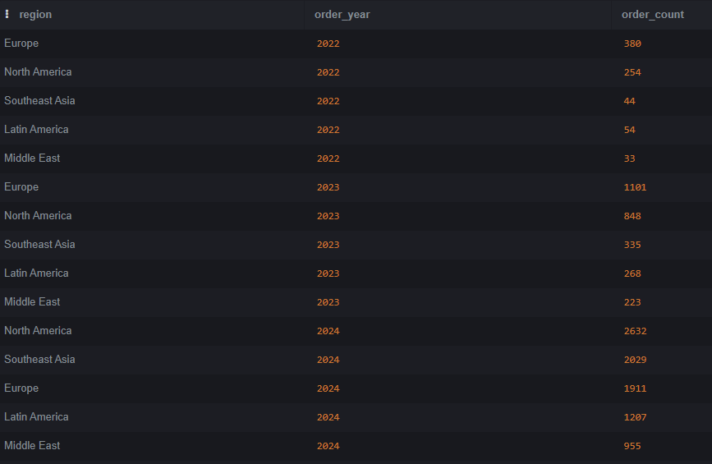

1.2 top10_customers_by_spend
Top 10 customers by total net spend, with region, acquisition channel and order count.
SELECT
c.customer_id AS customer_id,
c.region AS region,
c.acquisition_chan AS acquisition_chan,
COUNT(o.order_id) AS order_count,
ROUND(SUM(o.net_amount), 2) AS total_spend
FROM shopsphere_orders o
JOIN shopsphere_customers c ON o.customer_id = c.customer_id
GROUP BY c.customer_id, c.region, c.acquisition_chan
ORDER BY total_spend DESC
LIMIT 10;

Result preview


1.3 category_revenue_margin_returns
Revenue, average margin and return rate per product category. Joins order_items with products (for margin) and orders (for the return flag).
SELECT
p.category AS category,
ROUND(SUM(oi.line_total), 2) AS total_revenue,
ROUND(AVG(p.margin_pct), 2) AS avg_margin_pct,
ROUND(100.0 * SUM(CASE WHEN o.is_returned = 1 THEN 1 ELSE 0 END)
/ COUNT(DISTINCT o.order_id), 2) AS return_rate_pct
FROM shopsphere_order_items oi
JOIN shopsphere_products p ON oi.product_id = p.product_id
JOIN shopsphere_orders o ON oi.order_id = o.order_id
GROUP BY p.category
ORDER BY total_revenue DESC;

Result preview

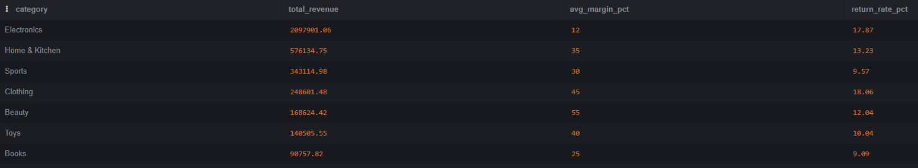

1.4 above_average_spenders
Customers whose total spend exceeds the average total spend across all customers, using a subquery. Reports their count and share of total revenue.
SELECT
COUNT(*) AS above_avg_customer_count,
ROUND(SUM(customer_total.total_spend), 2) AS above_avg_total_revenue,
ROUND(100.0 * SUM(customer_total.total_spend)
/ (SELECT SUM(net_amount) FROM shopsphere_orders), 2) AS pct_of_total_revenue
FROM (
SELECT customer_id, SUM(net_amount) AS total_spend
FROM shopsphere_orders
GROUP BY customer_id
) AS customer_total
WHERE customer_total.total_spend > (
SELECT AVG(customer_spend.total_spend)
FROM (
SELECT customer_id, SUM(net_amount) AS total_spend
FROM shopsphere_orders
GROUP BY customer_id
) AS customer_spend
);

Result preview


1.5 channel_budget_revenue_roi
Total budget, total attributed revenue and ROI (revenue / budget) per marketing channel.
SELECT
channel,
ROUND(SUM(budget), 2) AS total_budget,
ROUND(SUM(attributed_reven), 2) AS total_attributed_revenue,
ROUND(1.0 * SUM(attributed_reven) / SUM(budget), 2) AS roi
FROM shopsphere_marketing
GROUP BY channel
ORDER BY roi DESC;

Result preview
