Sample and Hold Time (SHTIM) versus Source Output Impedance

Question:
Sample and Hold Time (SHTIM) versus Source Output Impedance

Answer:
When a device is connected to any AT91SAM ADC input, its source output impedance has to be taken into account. Otherwise the ADC does not provide correct converted data.

Here is the Simplified Acquisition Path:

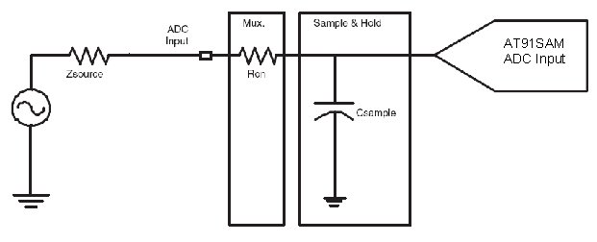

The user can drive properly any AT91SAM ADC input up to maximum Zsource impedance.
This maximum value can be compute thanks to a formula.

This formula depends on the Sample and Hold Time.

Please check the ADC Electrical Characteristics within AT91SAM device datasheet to get the formula.

Note: Csample and Ron are taken into account in formulas.

SAM3U example:

User can drive ADC input with impedance of Zsource up to:

• In 10-bit mode: SHTIM = 0.042 x Zsource + 160
• In 12-bit mode: SHTIM = 0.054 x Zsource + 205

With SHTIM (Sample and Hold Time) expressed in ns and ZSOURCE expressed in ohms.

Example 1

Zsource = 50ohm
ADC clock of 5MHz
10-bit mode

Theoric SHTIM = 0.042 x 50 + 160 = 162.1 ns

Now, you need to compute the SHTIM field register for a Theoric Sample & Hold Time of 162.1 ns.
You can find the formula at the ADC Mode Register description:

Sample & Hold Time = SHTIM field register / ADCClock

SHTIM field register = 162.1 x 10e-9 x 5 x 10e6 = 0.8105
SHTIM field register is between 1 and 15.
=> SHTIM = 1

So you will have a real Sample & Hold Time of (1 / (5 x 10e6)) = 200ns

Note: If the SHTIM field register required is higher than 15, you need to reduce the ADC Clock.

