Document which show PCB and schematic modification between Laboratory Supplier revision V3_0 (prototype version C) and V4_0 (prototype version D)

Table of contenents:

- Document abstract
- Founded mistakes and error in last revision
- New updates
- Table with comparison between current and last revision
- Conclusions

- Document abstract

This document is summarise last V3_0 prototype revision of Schematic and PCB. Document also have information which part of circuit must be redesign, change, recalculated. During third revision V3_0 some error occur. For this reason some part must be check and design again.

- Founded mistakes and error in last revision

Comparator LM358 must be reworked like on figure below.

Some elements must be change according as following:

R56 47k → 10kOhm

R55 560k → 56kOhm

R52 24k → 15kOhm

R53 3k3 → 470Ohm

R54 2k2 → 4k7

Add components:

D18 → BZX55C12V

R68 → 2k2

Missing connection on schematic:

Missing power 8V to +15[V] step-up switch voltage regulator

Main controller board:

    - New updates.

Due to significant heating of Q1 power transistor circuit must be redesign. On Q1 transistor power losses is to high. This to much power losses on this component is main reason to redesign this part of circuit.

Solution:

To decrease power losses below modification shall be made. To reduce power losses use relay to change main transformer branches which supply Q1 transistor according to below picture:

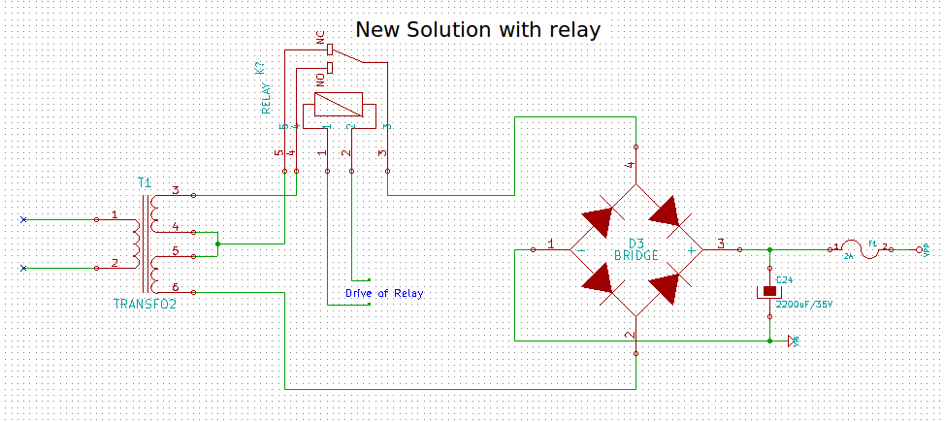

Picture 1. Transformer branches switches

In power board also ua723 shall be replace LM358. Due this changes is ua723 is not rail to rail operation amplifier.

In power board a few addition fuses shall be add to protect for instance digital part power supply.

- Table which comparision Rev V1_0 and V2_0

Item | Part in V1_0 | Part in V2_0 | Reason | Solution | Change applied
1 | Q1 | Q1 | Bad footprint | Change footprint and component layer
2 | U3 | U3 | Change ua723 to lm358 | Ua723 is not rail to rail oper. Amp. Change also component layer place
3 | U2 | U2 | Bad layer placed | Change from SMD to Discrete component layer
4 | P1 | P1 | Bad footprint | Change footprint and choose component layer place
5 | C2 | C2 | Change place of element due to bad outline of PCB according to main chassis | Change capacitor place and layer site
6 | R22 | R22 | Bad layer choosed | Choose proper component layer
7 | - | K3 | Redesign of power circuit. Add relay | Add new component according to design
8 | - | Txx1 | Transistor BD139 must be add to drive 2N3055 | Add transistor according to design
9 | - | Txx2 | Add transistor BC8xx to drive a relay | Add transistor according to design
10 | - | Rxx1 | Drive base Txx2 | Add resistor
11 | - | Rxx2 | To much voltage level to drive Relay K3. Consider power disapation of this resistor | Add power resistor
12 | - | Dxx1 | Transistor Txx2 protection | Diode must be added to protect transistor
13
14

