Key and Actions functional description

Abstraction:

Function is responisble for analyze keyboard action and should take necessary preparation to proper manage menu structures of the device.

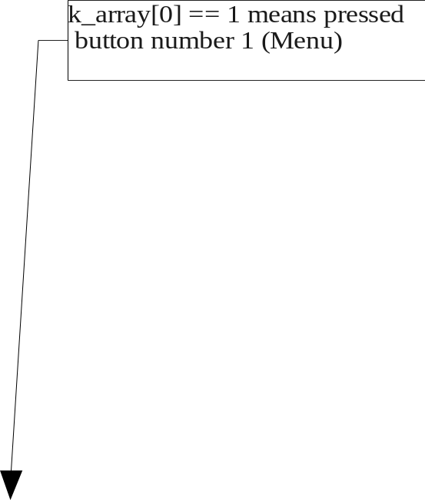
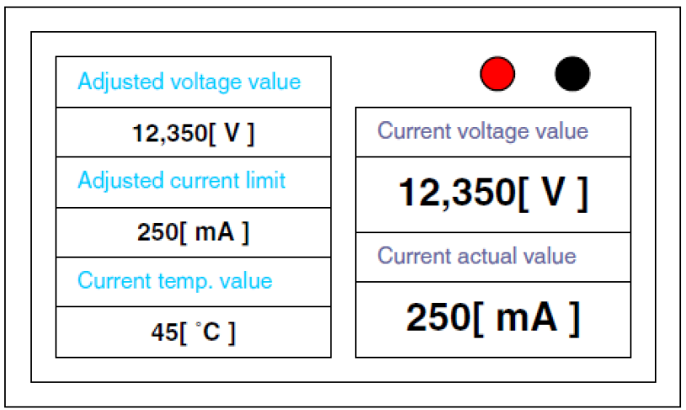
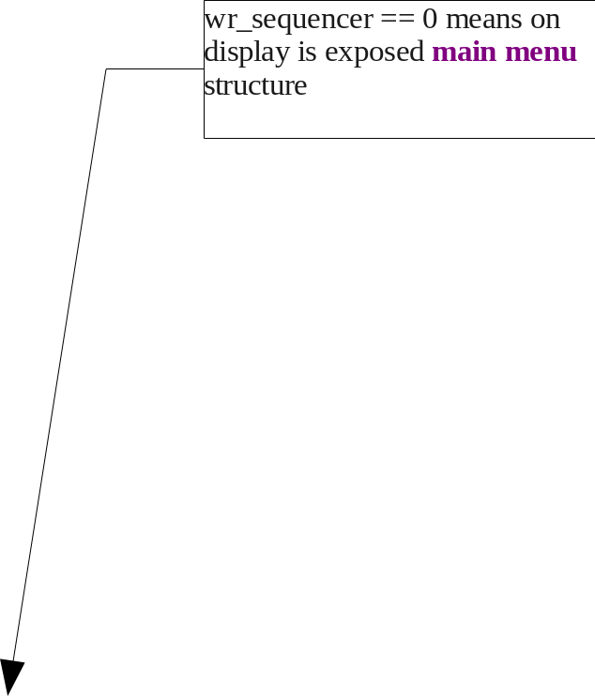

Algorithm:

Start
Function Key_state(...) take current
keyboard action and storage
it to k_array variable
if (
k_array[0] == 1
)
Yes
if (
wr_sequencer == 0
)
ClrScr(wr_sequencer);
wr_sequencer++;
Yes
No
if (
wr_sequencer == 1
)
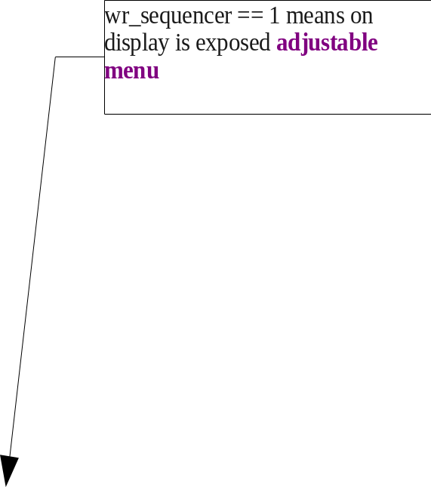
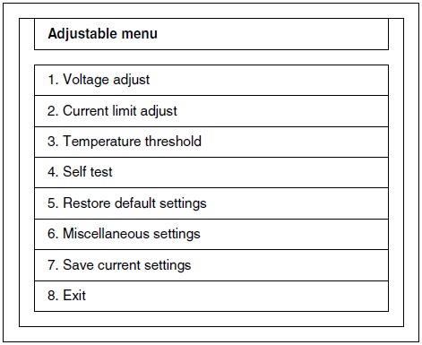
if (
wr_sequencer == 2
)
Show adjustable menu
ClrScr(wr_sequencer);
wr_sequencer = 0;
Stop - Exit
No
Show main menu
if (
k_array[1] == 1
)
No
if (
k_array[2] == 1
)
Yes
No

