Key and Actions functional description

Abstraction:

Function is responsible for analyze keyboard action and should take necessary preparation to proper manage menu structures of the device.

Block screen relation between functional keys and LCD screens.
Screen 1

Complete dialog box is depicted below:

Voltage Setup
12,5 [V]
Menu +
button
Menu -
button
Current limit
12,5 [mA]
Temp. threshold
85 [ºC]
Self test
Start test
Restore def. settings
Restore
Menu +
button
Menu -
button
Menu +
button
Menu -
button
Menu -
button
Menu +
button
Miscellaneous settings
Misc.
Menu -
button
Menu +
button
Menu -
button
Menu +
button
Menu +
button
Menu -
button
Save current settings
Save
Menu +
button
Menu -
button
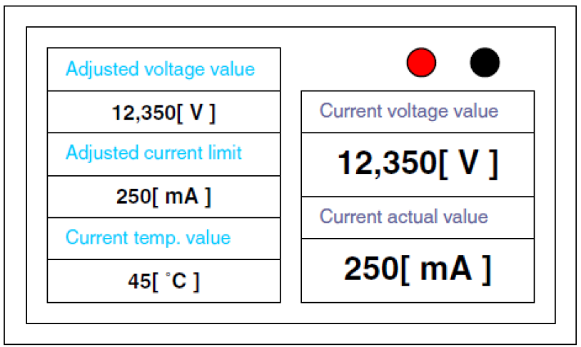

Screen 2

Screen 3

Screen 8

Screen 4

Screen 7

Screen 5

Screen 6

Screen 1 view explanation:

Current voltage measured on supply pins

Adjusted voltage value

Adjusted voltage
12,5 [V]
Current limit
200 [mA/A]
Temp 2N Trans.
85 [ºC]
Current voltage
Actual current
12,5 [V]
250[mA]

Adjusted current limit

Temperature of 2N3055 main power transistor
Actual value of current which external device get from supply

Remark:

Only keys “menu +” and “menu -” work for this screen.

Screen 2 view explanation:

Key action befor „Menu +”
First adjustable menu
Setup voltage

Voltage setup
12,5 [V]

Voltage setup
12,5 [V]
To adjust first digit use „+” button and to change digit value use „Menu+” or „Menu-”. If You want to go back to previous screen press button „-”

To adjust second digit use „+” button and to change digit value use „Menu+” or „Menu-”. If You want to go back to previous digit press button „-”
Voltage setup
12,5 [V]

Voltage setup
12,5 [V]
To adjust third digit use „+” button and to change digit value use „Menu+” or „Menu-”. If You want to go back to previous digit press button „-”

If type „+” button four time exist menu change and ask to save or not adujsted value. To save adujsted value type „+” button or „-” to discard. If you go to next screen type „Menu-” or „Menu+”
Do You want save adjustment
12,5 [V]

Remark:
Adjusted voltage may change according to range from 1[V] up to 30[V] with step 0,5 [V].

