Laboratory supply keyboard and menu configuration structure

Document issue 1.0A
Author: Michał Wołowik
Date: 11.X.2010 Rzeszów

Keyboard have 5 buttons (S1-S5) like on Figure 1.

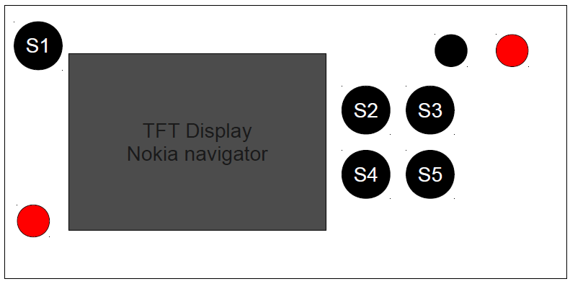
Figure 1. Front panel overview

Buttons description:

S1 – power up / standby supply

S2 – enter menu

S3 – increment button („+”)

S4 – acceptation button

S5 – decrement button („-”)

Decrement / Increment buttons menans move up / down in screen menu and increment / decrement adjusted value.

Acceptation button aproved entered value and enter to submenu.

Enter menu button invoke first adjustable menu.

Power up / standby supply button switch on supply and go to sleep mode.
Front panel shall be look in real like in figure 2.

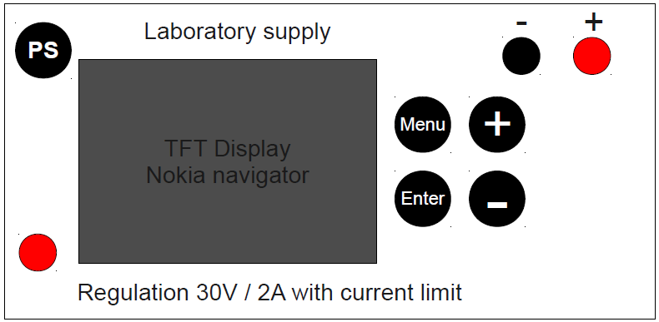
Figure 2. Front panel with button description

Context menu of laboratory supply.

Main menu – dispaly adjusted value and current value of voltage and current.

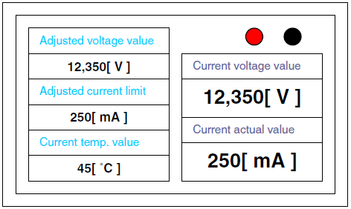

Figure 2. Main menu

Main menu shall be invoke after supply power up and if exit with submenu.

In this screen shall be expose adjusted voltage, current limit, 2N3055 transistor temperature, current voltage on power pins and actual current.
Menu structure

Start – power up

Menu button pressed
Menu

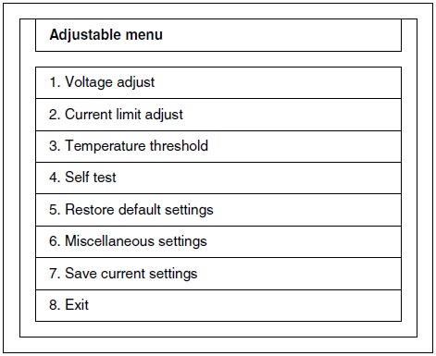
- button pressed
Menu
Menu button pressed
1. Voltage adjust
+ button pressed
+
-
+ button pressed
+
3. Temperature threshold
+ button pressed a few times
+
8. Exit
3. Self test
Each press + button move from point to point upper line do lower line
2. Current limit adjust
Go to last position in menu
- button pressed
+
Go to earlier position in menu from point 3 to point 2.

Figure 3. Adjustable menu structure

If „+” or „-” button was pressed cursor shall change backgroun color from whit to yellow, change oitline selected field to bold and text to bold. If press „+” button cursor go from high line to lower line if press „-” go from lower line to higher line etc.
Go to submenu of „Adjustable menu”

If on selected position was pressed button „Enter” „Adjustable menu” shall be dissapear and shall be appear screen like on Figure 4.
Enter button pressed
Enter
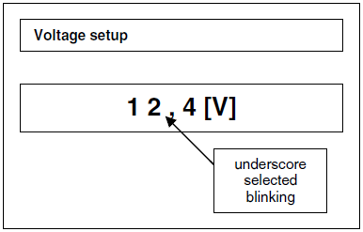
1. Voltage adjust

Figure 4. Adjustable menu structure

On Figure 5. show how to change parameter (voltage, current limit, etc.) value using „+”, „-”, „Menu”, „Enter” buttons.

