ISLAND SCIENTIFIC LTD |  | Reply to:  Unit 9  Ventnor Industrial Estate  Station Road  Ventnor  Isle of Wight  PO38 1DX  England  Tel No: (0) 1983 855822  Fax No: (0) 1983 852146
 | Vacuum Equipment, Used and Reconditioned for Technology, Industry, Research and Education
E-Mail Address: sales@island-scientific.co.uk
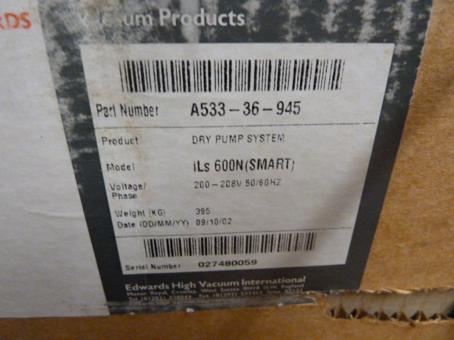
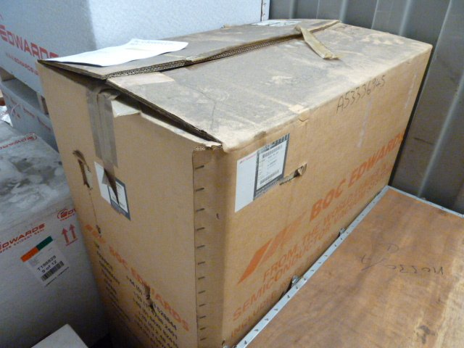
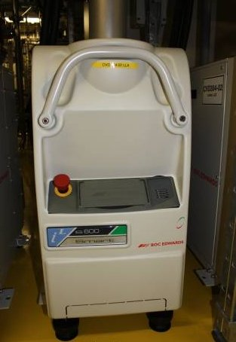
Web Site: http://www.island-scientific.co.uk

Make: Edwards
Model: iLS600N Smart Pump
Part No. A533-36-945
Pumping speed: 600 CMH
Ultimate Vacuum: 3x10⁻³ m/bar
Inlet flange: ISO100
Outlet flange: NW40
Cooling: Water
Voltage: 208v
Motor Power: 4.4kw
Overall Dimensions: 916mm long x 529mm high x 390mm wide
Weight: 405Kg
Condition: Unused

