|  |
| --- |
| MCGRAW HILL FINANCIAL |
| User Manual |
| Raising Serena Request Test\Stag |
|  |
| **Shubham Joshi** |
| **4/21/2016** |

Table of Contents

1. **Need\Purpose**Any request that comes to TestDBTeamProdJobs must come via Serena Request (SR).
2. **How to Submit Request**
3. **Open Serena**   
   <https://serena.corp.mhfi.com/tmtrack/tmtrack.dll?>  
   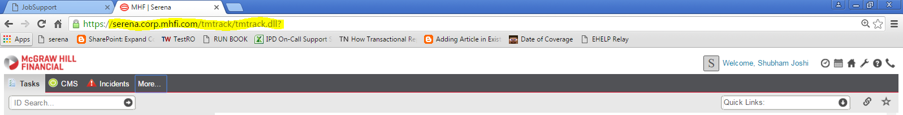
4. **Select Serena Request**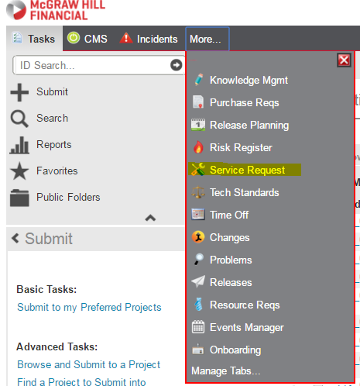
5. **Submit**  
   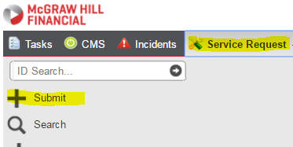
6. **Choose Browse Submit Tree to choose from various available requests**
7. **Expand Service Request. These are the available service requests. Choose Database Request for DB related request.**

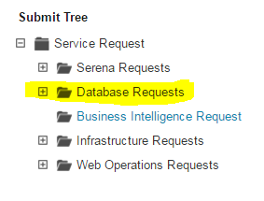

1. **Choose from below Database Requests and press Submit**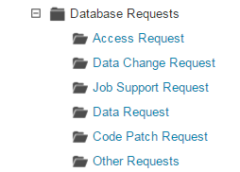

**3. Types of Requests**

1. **Access Request**For access to Server/Database and permissions like read/ write or any other special permission
2. **Data Change**

All kinds of updates, insert, delete queries

1. J**ob Support Request**

Job failures, start/stop, and enable/disable

1. **Data Request** –

Results for query (query must only have select statements )

1. **Code Patch**

Patching code from SVN

**Creating Access Request  
Choose Access Request by going through above explained procedure.( 2. How to Submit Request)**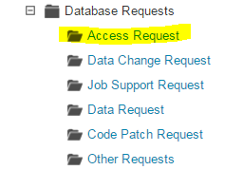

This form will pop up.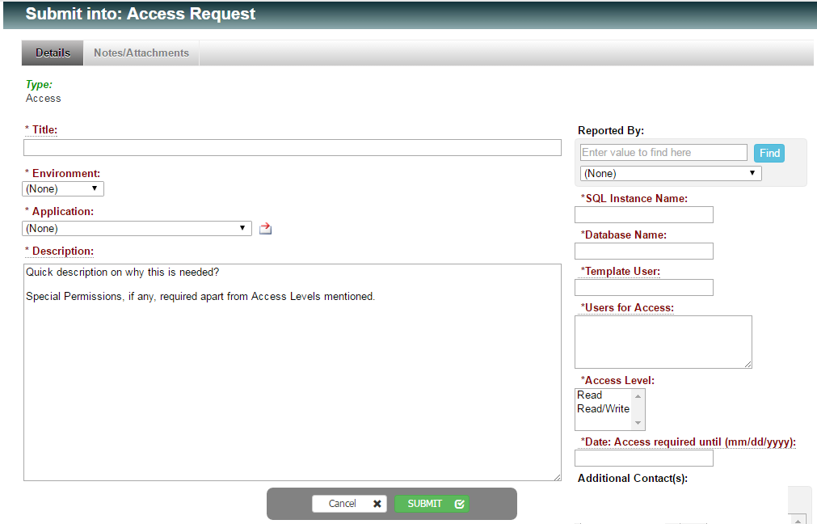

Give a suitable title to the request

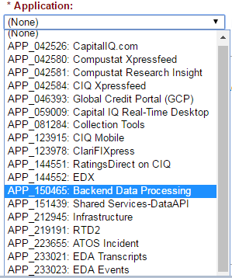

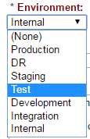

Select Application

Choose Environment

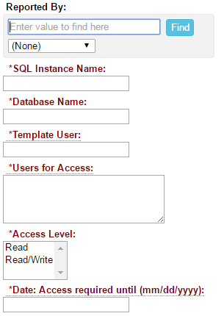

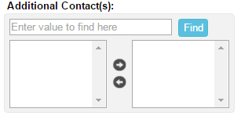

For access other than these please mention in   
description Field

Mention all the access users.

If available mention else none

Mention DB name. Do not put all here

Give Instance/(es) or Role name

Find name here

Will also get notified

**More Info for Access Request:**Before a request is fulfilled we require few more information that may vary from one request to another. It is better if these are already provided while raising a request to avoid delay in fulfillment.   
Please include these in description. 1. What is the Business Purpose?  
 2. Mention database and type of permission read\write\execute or any other.

3. What will be the impact of the query execution?  
 3. Can't this request come to Test DB Support team and we can provide you the results obtained?  
 4. How long this access is required?   
 5. Mention template user (if known) whose access will be mirrored for this request.   
For write access please provide use case also or mention sample queries to be used.  
  
note* If access was granted earlier but now it is wiped off please mention serene request Id.

**Creating Data Request  
Choose Access Request by going through above explained procedure.( 2. How to Submit Request)**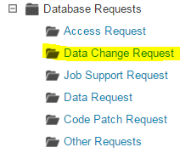

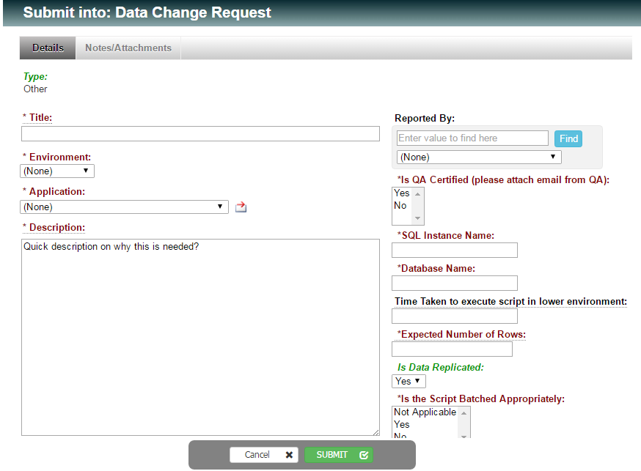

Give a suitable title





Choose Environment

Select Application

Find name here

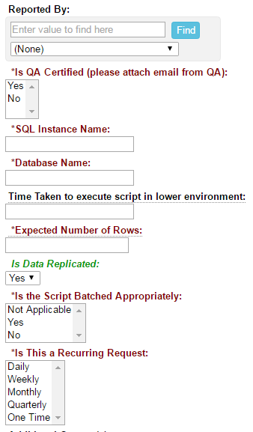

For large DML operations batch appropriately

If data being modified is a part of replication if so mention details

Time taken in Dev/Test ENV.

QA signoff is required for staging request

How frequently this occurs

**More Info for Data Change Request:**Before a request is fulfilled we require few more information that may vary from one request to another. It is better if these are already provided while raising a request to avoid delay in fulfillment.   
Please include these in **description**.

1. Why can’t this go via build? (For Test\Stag)
2. Let us know if it was run in Dev environment. If yes mention developer(For Test)
3. Let us know if it was run in Test and Dev environment. If yes include QA signoff and mention QA\Team who will be validating this in staging. (For Stag)
4. How many rows were affected? (For Test\Stag)
5. Time taken to execute. (For Test\Stag)
6. If this is for production issue please mention Bug ID.
7. Whether tables affected are part of replication or not?

**Creating Job Support Request  
Choose Job Support Request by going through above explained procedure.( 2. How to Submit Request)**

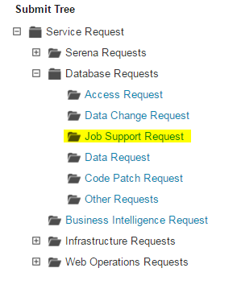

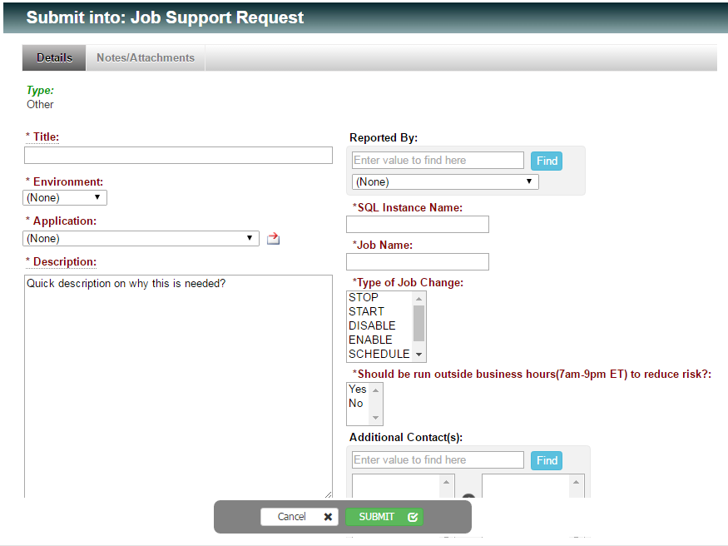



Choose Environment

Select Application



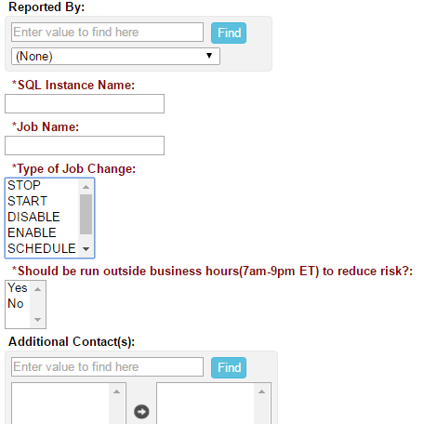

Run in Off business hours(Night hours IST) to reduce impact

Select job change type

Find name here

Add additional contact Will also get notified notified

**More Info for Job Support Request:**Before a request is fulfilled we require few more information that may vary from one request to another. It is better if these are already provided while raising a request to avoid delay in fulfillment.   
Please include these in **description**.

1. Purpose.
2. Why this can’t run at its schedule?
3. Mention Impact.

**Creating Data Request  
Choose Data Request by going through above explained procedure.( 2. How to Submit Request)**

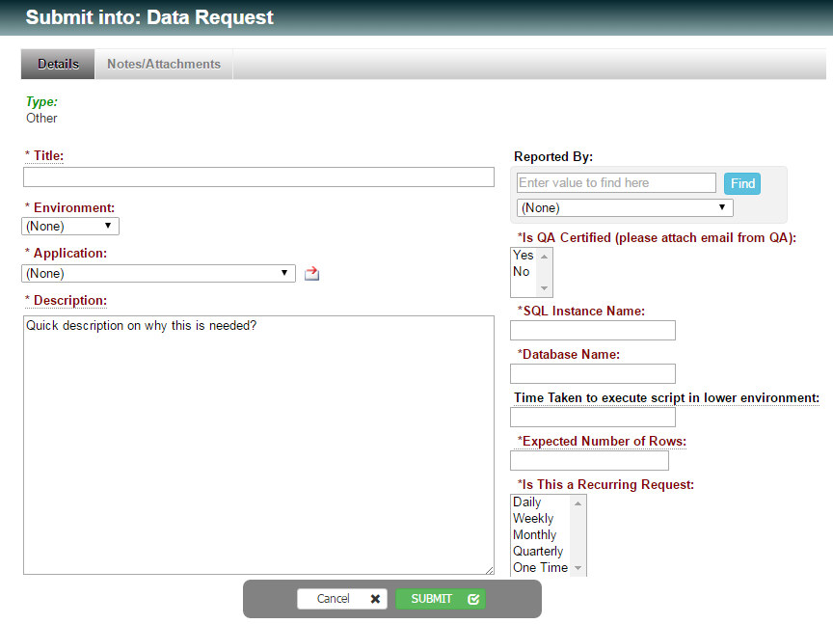

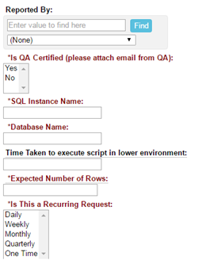

Find name here

Time taken in Dev/Test ENV.



Select Application

Choose Environment



**More Info for Data Request:**Before a request is fulfilled we require few more information that may vary from one request to another. It is better if these are already provided while raising a request to avoid delay in fulfillment.   
Please include these in **description**.

1. Purpose.
2. What is the impact?
3. Number of rows affected.
4. Time taken to execute.

**Creating Code Patch Request  
Choose Code Patch Request by going through above explained procedure.( 2. How to Submit Request)**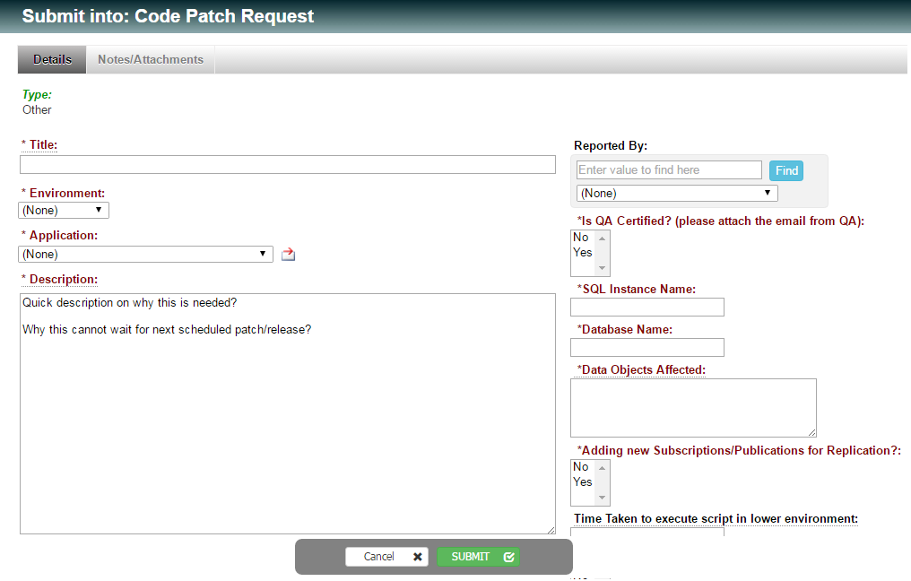

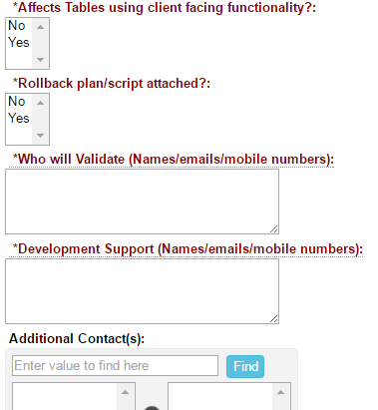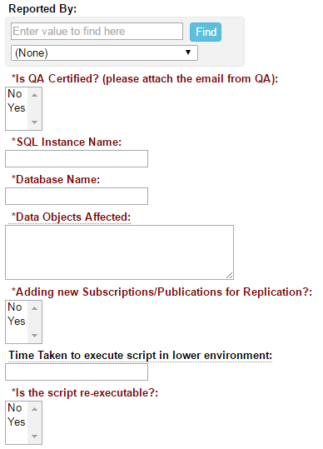



Select Application

Choose Environment

**More Info for Code Patch Request:**Before a request is fulfilled we require few more information that may vary from one request to another. It is better if these are already provided while raising a request to avoid delay in fulfillment.   
Please include these in **description**.

1. Purpose.
2. Why can’t it go via partial build?
3. Why this has missed the last partial build?
4. If there are more than one please do mention the order in which these are to executed.
5. If it was a part of build but failed due to build burst please mention Build Burst Id.

**Creating Code Patch Request  
Choose Code Patch Request by going through above explained procedure.( 2. How to Submit Request)**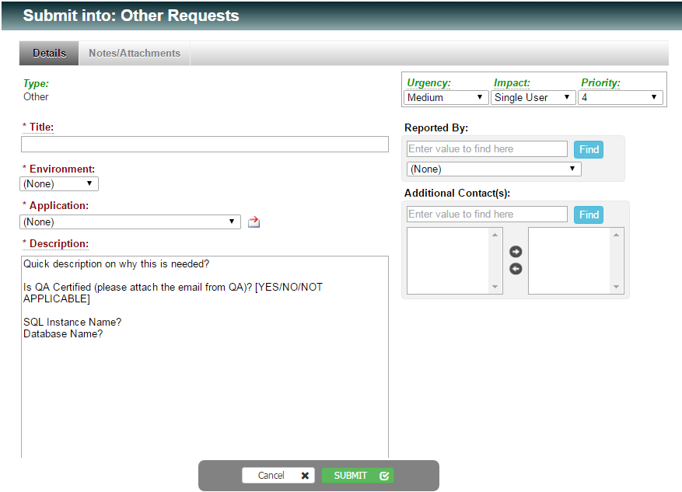

Select Application



Choose Environment

Mention all the required details **Tracking Fulfillment Process :**Once request is created and till it is fulfilled it goes through following states.

1. **Classification**
2. **Fulfillment**
3. **More Info Requested/Waiting on User**
4. **Resolved**
5. **Rejected**
6. **Closed**
7. **Classification**

Request is in the queue but yet to be assigned.

1. **Fulfillment**

Someone has picked up the request and is working on it. Just like below one is in fulfillment and is being worked upon by Rahul.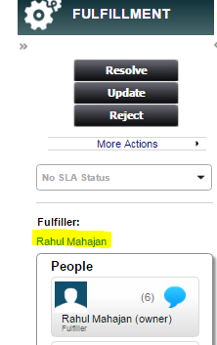

1. **More Info Requested/Waiting on User**

If more information is required for proceeding with the request or given information is incorrect. A mail is dropped from serene seeking required info and the status is changed to Waiting on user.   
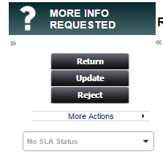

1. **Resolved**

Request has been fulfilled. Refer to Serena for results and resolution.  
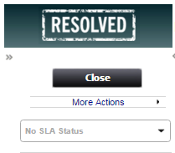

Resolution:  
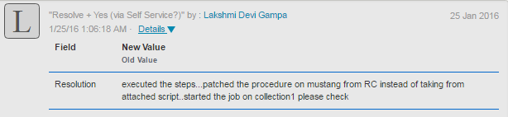

1. **Closed**Request is closed once issue is resolved and after user’s confirmation.