**Logitech G502 X|Lightspeed**





F15

**F17**

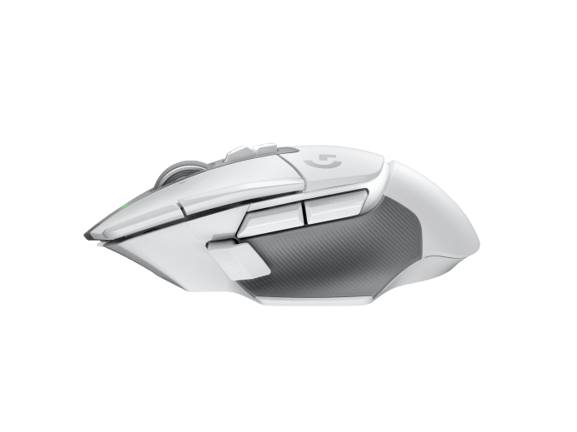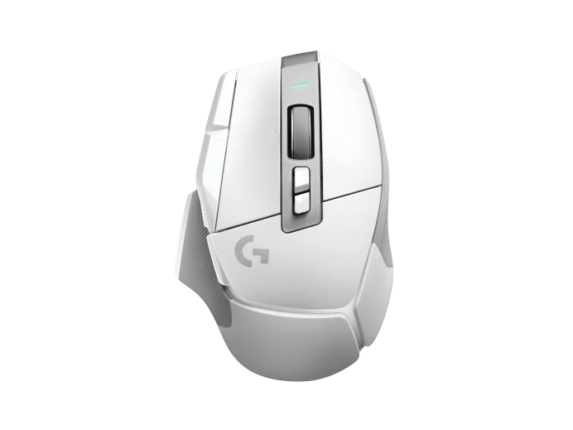

**F23**



**F18**





**F14**



**F19**



**F22**

**F13**



**F21**



**F24**



**F16**

**F20**

**Forward**

**Back**

