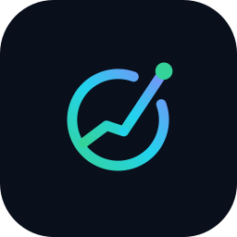 Quantra AI
Outreach Email Template — Meeting Request
Reusable cold-outreach email for pitching Quantra AI. Replace the [bracketed fields] before sending. Keep it short — under ~120 words gets the best reply rate.

Subject line (choose one)
- Quantra AI — a 15-min idea for [Company]’s clients
- AI analysis layer for [Company] — quick intro?
- Helping [Company] clients read any chart with confidence

Email body
Hi [First name],
I’m [Your name], founder of Quantra AI — a market-intelligence engine that turns price, fundamental and news data into one clear, plain-language verdict for any stock or crypto, with an explicit probability and a single 1–99 score that ranks the market.
I’m reaching out because [Company] serves exactly the kind of active, multi-asset investors Quantra is built for, and I think an embedded analysis layer could lift engagement and activation on your platform.
Would you be open to a 15-minute call in the next week or two? I’ll show a live demo — no slides needed — and we can see if a short paid pilot makes sense.
Either way, thanks for the great work [Company] does in the region.
Best,
[Your name]
[Title] · Quantra AI
[email] · [phone] · [website]
Quantra AI is an educational analysis tool — not investment advice.

Follow-up (after ~4–5 business days, no reply)
Hi [First name] — quick nudge on the note below. Happy to keep it to 15 minutes and work around your calendar. Worth a look? [calendar booking link]

How to make it land
Do
- Personalise line 2 every time — name something specific about the firm (a product, market, or recent launch). One real detail lifts reply rates sharply.
- Send to a real person, not info@ — find the Head of Product / Digital / Partnerships on LinkedIn.
- Keep one ask only — the 15-minute meeting. Nothing else.
Don’t
- Don’t attach the deck or proposal to a cold email — it hurts deliverability and reads as a pitch-dump. Offer the live demo first; send materials after they reply.
- Don’t imply returns or “accurate predictions.” Keep the “not investment advice” line and stay honest.
Compliance (UAE)
B2B cold email is generally permitted under the UAE PDPL and TDRA marketing rules, but identify yourself clearly, keep the disclaimer, and honour opt-out requests immediately. Record the source and date of each contact.
Quantra AI · Educational analysis tool — not investment advice. © 2026.

