Project title:
Generate QR codes with Arduino on OLED display

Creator:
Ruis Santos

Source:
https://randomnerdtutorials.com/esp32-web-server-arduino-ide/

Tag:
Arduino Nano, Arduino IDE.

Project Description:
A standalone web server with an ESP32 that controls output (two LEDs) using the Arduino IDE programming environment. The web server is mobile responsive and can be accessed with any device that is a browser on the local network. We’ll show you how to create the web server and how the code works step-by-step.
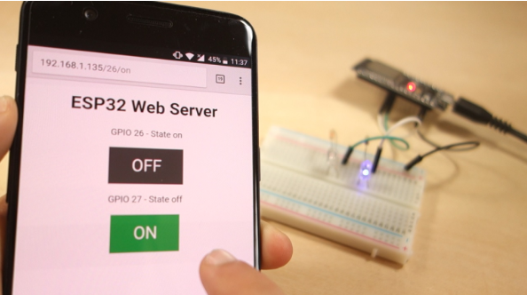
ESP32-web-server.png

Components:
- ESP32 development board
- 2x 5mm LED
- 2x 330 Ohm resistor

Circuit Diagram:
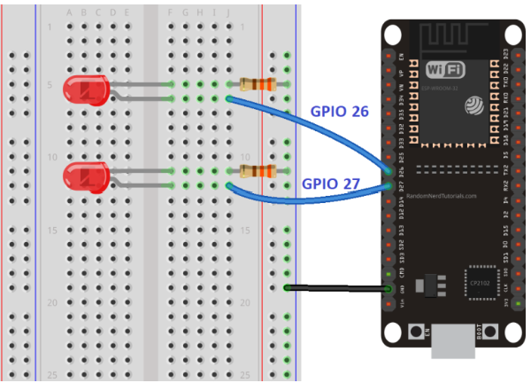

3D Print (.stl) files:
Not applicable

Code (.ino C++):
- Generate QR code for a given text
here

/*********
Rui Santos
Complete project details at https://randomnerdtutorials.com
*********/

// Load Wi-Fi library
#include <WiFi.h>

// Replace with your network credentials
const char* ssid = "REPLACE_WITH_YOUR_SSID";
const char* password = "REPLACE_WITH_YOUR_PASSWORD";

// Set web server port number to 80
WiFiServer server(80);

// Variable to store the HTTP request
String header;

// Auxiliar variables to store the current output state
String output26State = "off";
String output27State = "off";

// Assign output variables to GPIO pins
const int output26 = 26;
const int output27 = 27;

// Current time
unsigned long currentTime = millis();
// Previous time
unsigned long previousTime = 0;
// Define timeout time in milliseconds (example: 2000ms = 2s)
const long timeoutTime = 2000;

void setup() {
Serial.begin(115200);
// Initialize the output variables as outputs
pinMode(output26, OUTPUT);
pinMode(output27, OUTPUT);
// Set outputs to LOW
digitalWrite(output26, LOW);
digitalWrite(output27, LOW);

// Connect to Wi-Fi network with SSID and password
Serial.print("Connecting to ");
Serial.println(ssid);
WiFi.begin(ssid, password);
while (WiFi.status() != WL_CONNECTED) {
delay(500);
Serial.print(".");
}
// Print local IP address and start web server
Serial.println("");
Serial.println("WiFi connected.");
Serial.println("IP address: ");
Serial.println(WiFi.localIP());
server.begin();
}

void loop(){
WiFiClient client = server.available(); // Listen for incoming clients

if (client) { // If a new client connects,
currentTime = millis();
previousTime = currentTime;
Serial.println("New Client."); // print a message out in the serial port
String currentLine = ""; // make a String to hold incoming data from the client
while (client.connected() && currentTime - previousTime <= timeoutTime) { // loop while the client's connected
currentTime = millis();
if (client.available()) { // if there's bytes to read from the client,
char c = client.read(); // read a byte, then
Serial.write(c); // print it out the serial monitor
header += c;
if (c == '\n') { // if the byte is a newline character
// if the current line is blank, you got two newline characters in a row.
// that's the end of the client HTTP request, so send a response:
if (currentLine.length() == 0) {
// HTTP headers always start with a response code (e.g. HTTP/1.1 200 OK)
// and a content-type so the client knows what's coming, then a blank line:
client.println("HTTP/1.1 200 OK");
client.println("Content-type:text/html");
client.println("Connection: close");
client.println();

// turns the GPIOs on and off
if (header.indexOf("GET /26/on") >= 0) {
Serial.println("GPIO 26 on");
output26State = "on";
digitalWrite(output26, HIGH);
} else if (header.indexOf("GET /26/off") >= 0) {
Serial.println("GPIO 26 off");
output26State = "off";
digitalWrite(output26, LOW);
} else if (header.indexOf("GET /27/on") >= 0) {
Serial.println("GPIO 27 on");
output27State = "on";
digitalWrite(output27, HIGH);
} else if (header.indexOf("GET /27/off") >= 0) {
Serial.println("GPIO 27 off");
output27State = "off";
digitalWrite(output27, LOW);
}

// Display the HTML web page
client.println("<!DOCTYPE html><html>");
client.println("<head><meta name=\"viewport\" content=\"width=device-width, initial-scale=1\">");
client.println("<link rel=\"icon\" href=\"data:,\">");
// CSS to style the on/off buttons
// Feel free to change the background-color and font-size attributes to fit your preferences
client.println("<style>html { font-family: Helvetica; display: inline-block; margin: 0px auto; text-align: center;}");
client.println(".button { background-color: #4CAF50; border: none; color: white; padding: 16px 40px;");
client.println("text-decoration: none; font-size: 30px; margin: 2px; cursor: pointer;}");
client.println(".button2 {background-color: #555555;}</style></head>");

// Web Page Heading
client.println("<body><h1>ESP32 Web Server</h1>");

// Display current state, and ON/OFF buttons for GPIO 26
client.println("<p>GPIO 26 - State " + output26State + "</p>");
// If the output26State is off, it displays the ON button
if (output26State=="off") {
client.println("<p><a href=\"/26/on\"><button class=\"button\">ON</button></a></p>");
} else {
client.println("<p><a href=\"/26/off\"><button class=\"button button2\">OFF</button></a></p>");
}

// Display current state, and ON/OFF buttons for GPIO 27
client.println("<p>GPIO 27 - State " + output27State + "</p>");
// If the output27State is off, it displays the ON button
if (output27State=="off") {
client.println("<p><a href=\"/27/on\"><button class=\"button\">ON</button></a></p>");
} else {
client.println("<p><a href=\"/27/off\"><button class=\"button button2\">OFF</button></a></p>");
}
client.println("</body></html>");

// The HTTP response ends with another blank line
client.println();
// Break out of the while loop
break;
} else { // if you got a newline, then clear currentLine
currentLine = "";
}
} else if (c != '\r') { // if you got anything else but a carriage return character,
currentLine += c; // add it to the end of the currentLine
}
}
}
// Clear the header variable
header = "";
// Close the connection
client.stop();
Serial.println("Client disconnected.");
Serial.println("");
}
}

