Project title:
Self-balancing Cube with Arduino Nano or ESP32

Creator:
Rem-RC

Source:
https://github.com/remrc/Self-Balancing-Cube

Tag:
Arduino Nano, ESP32, Arduino IDE, 3D print.

Project Description:
Self-balancing devices are electronic devices that use sensors and motors to keep themselves balanced while in use. They use gyroscopic sensors and accelerometers to detect the movement of the balanced object and adjust the speed and direction of the wheels, accordingly, allowing them to control the device through shifts in their weight.
Codes for Arduino Nano and ESP32 are provided

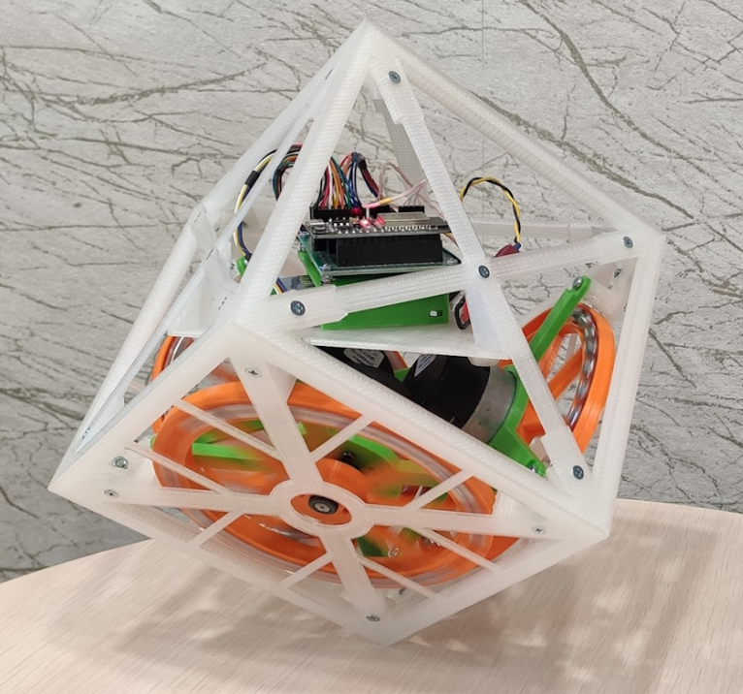
self-balancing-cube-image1.png

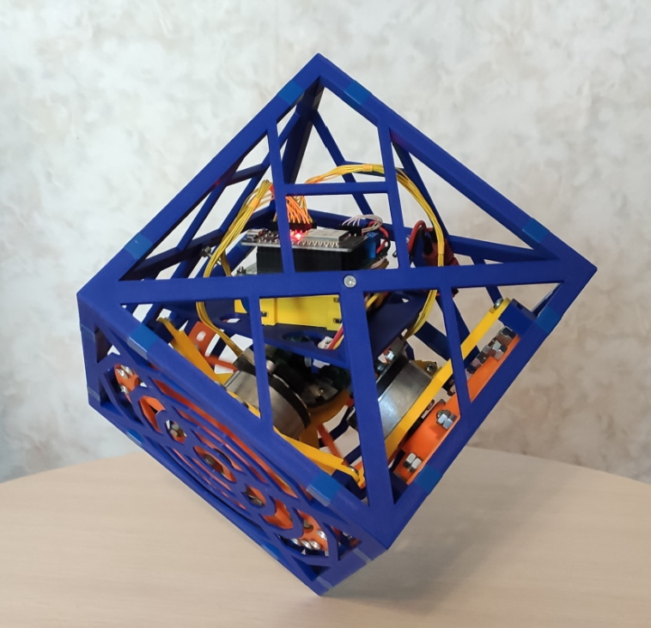
self-balancing-cube-image2.png
Components:
- Arduino Nano microcontroller board or with ESP32
- MPU6050 Gyroscope and Accelerometer module
- NPN Transistor: 2N2222
- Active Buzzer, 5V
- three resistors: 6.8k, 10k, 33k
- capacitor: 100nF, 100uF
- Battery: 3S1P LiPo
- Voltage regulator: 7805

Circuit Diagram:
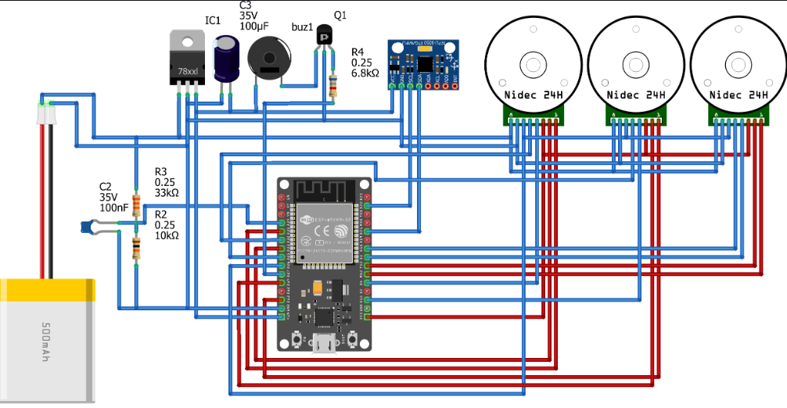

3D Print (.stl) files:
here

Code (.ino C++):
here

