Project title:
Arduino UNO with BME280 Temperature, Humidity, Pressure sensor module

Tag:
Arduino UNO, Arduino IDE, C++, BME280 sensor module

Component List:
- Arduino UNO board
- BME280 sensor module
- Breadboard
- Jumper wires
Circuit Diagram
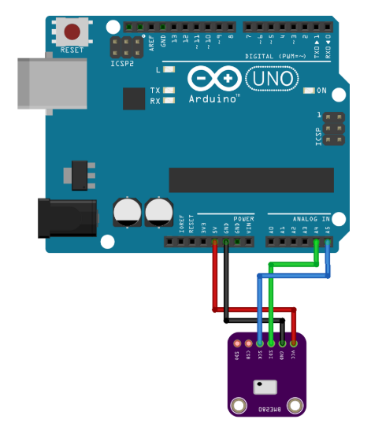
Image-1: Circuit Diagram

Library:
- Wire.h
- SPI.h
- Adafruit_sensor.h
- Adafruit_BME280.h
Instructions:
- Wire up BME280 module to Arduino UNO board as per the above circuit diagram
Take note that the example here uses Arduino UNO:
- pin A4 for SDA (I2C data line)
- pin A5 for SCK (I2C clock line)
- 5V and GND.
- Run Arduino IDE, install the above libraries and its respective dependencies (if required).
- Connect Arduino UNO board to USB port. In this example the board is connected as COM7 port.
- Copy the code below and save it to local file as .ino file.
Take note that in this example we set:
- the baud rate: 9600
- Upload the code to the Arduino UNO board.
- Once successfully uploaded without error, open the Serial Monitor. Ensure that it is set to baud rate 9600, NewLine and Autoscroll selected.
Code

/* Complete Project Details https://randomnerdtutorials.com */

#include <Wire.h>
#include <SPI.h>
#include <Adafruit_Sensor.h>
#include <Adafruit_BME280.h>

#define BME_SCK 13
#define BME_MISO 12
#define BME_MOSI 11
#define BME_CS 10
#define SEALEVELPRESSURE_HPA (1013.25)

Adafruit_BME280 bme; // I2C
unsigned long delayTime;

void setup() {
Serial.begin(9600);
Serial.println(F("BME280 test"));

bool status;
status = bme.begin();
if (!status) {
Serial.println("Could not find a valid BME280 sensor, check wiring!");
while (1);
}

Serial.println("-- Default Test --");
delayTime = 1000;
Serial.println();
}

void loop() {
printValues();
delay(delayTime);
}

void printValues() {
Serial.print("Temperature = ");
Serial.print(bme.readTemperature());
Serial.println(" *C");

// Convert temperature to Fahrenheit
/*Serial.print("Temperature = ");
Serial.print(1.8 * bme.readTemperature() + 32);
Serial.println(" *F");*/

Serial.print("Pressure = ");
Serial.print(bme.readPressure() / 100.0F);
Serial.println(" hPa");

Serial.print("Approx. Altitude = ");
Serial.print(bme.readAltitude(SEALEVELPRESSURE_HPA));
Serial.println(" m");

Serial.print("Humidity = ");
Serial.print(bme.readHumidity());
Serial.println(" %");

Serial.println();
}

Images
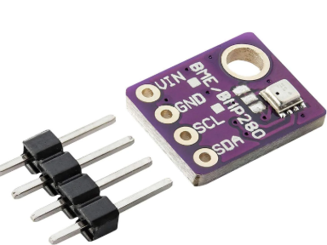
Image-2: BME280 sensor module

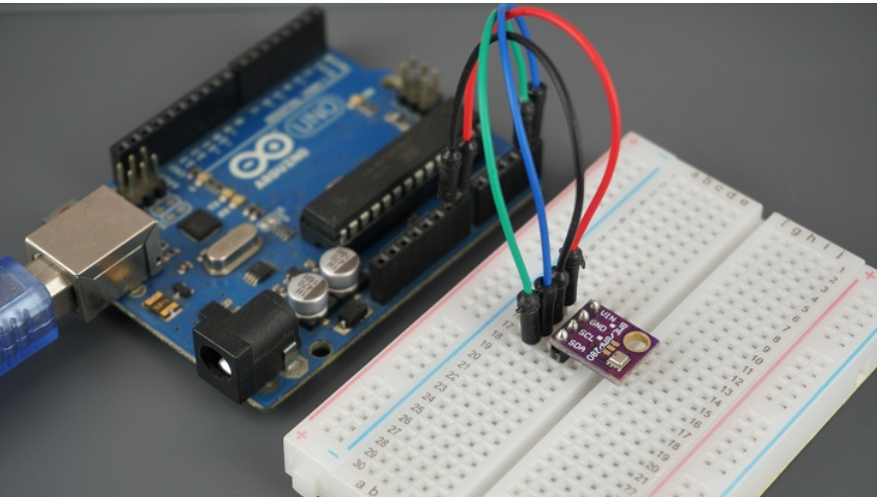
Image-3: Complete setup

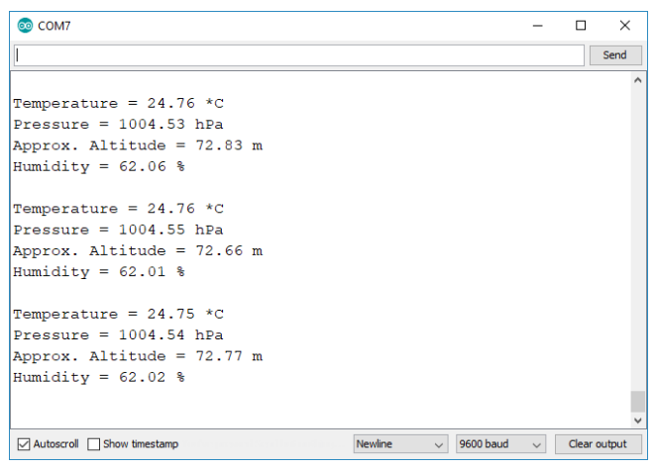
Image-4: Results on Serial Monitor
Other build files:
None

