Tab 1

VoltraBloom: Conceptual Design of a Portable Hybrid Renewable Emergency Power System Integrating Solar, Wind, and Soil Energy



COMPILED BY
NAUFALES ALIFTA NUGRAHA
ARFI DIMAS WIKRAMA
AURELIA AZZAHRA INAYAH SANTOSO
AVRIL INDAH KIRANA
MARISA SALMA
ZALFA AZZAHRA HIDAYAH

SMA NEGERI CAHAYA MADANI BANTEN BOARDING SCHOOL
2026

TABLE OF CONTENTS
TABLE OF CONTENTS i
ABSTRACT 1
CHAPTER I 2
INTRODUCTION 2
1.1 Background 2
1.2 Problem Formulation 3
1.3 Research Objectives 3
1.4 Scope and Limitations 3
1.5 Research Benefits 4
CHAPTER II 5
LITERATURE REVIEW 5
2.1 Theoretical Foundations 5
2.1.1 Basic Electrical Concepts 5
2.1.2 Renewable Energy 5
2.1.3 Solar Panels 5
2.1.4 Batteries 5
2.1.5 Vertical-Axis Wind Turbine 5
2.1.6 Soil Microbial Fuel Cell 6
2.1.7 Quantification Basis: Power, Energy, and Efficiency 6
2.1.8 MPPT Charge Controller and Inverter 6
2.1.9 IoT-Based Monitoring System 7
2.1.10 VoltraBloom as a Hybrid System 7
2.2 Review of Previous Research 7
2.3 Conceptual Framework 8
CHAPTER III 9
RESEARCH METHODS 9
3.1 Type and Research Approach 9
3.2 Research Site and Period 9
3.3 Research Stages 9
3.4 Data Collection Techniques 9
3.5 Design Tools 10
3.6 Concept Analysis Techniques 10
3.7 Physical Proof-of-Concept Development 10
CHAPTER IV 12
RESULTS AND DISCUSSION 12
4.1 Overall System Design 12
4.2 System Block Diagram 12
4.4 Operational Flowchart 14
4.5 Mechanical Design and Dimension Drawing 14
4.6 Component Layout 15
4.7 Electrical Wiring Diagram 16
4.8 Analysis of Concept and Implementation Potential 16
4.9 Capacity and Performance Estimation (Implementation Scale) 17
4.10 Physical Proof-of-Concept Prototype 18
4.10.1 What the Prototype Currently Demonstrates 19
4.10.2 What the Prototype Currently Demonstrates 20
4.10.3 What the Prototype Does Not Yet Demonstrate 20
CHAPTER V 22
CONCLUSION 22
REFERENCES 23

Abbreviations: HEMS – Hybrid Energy Management System; MPPT – Maximum Power Point Tracking; SMFC – Soil Microbial Fuel Cell; IoT – Internet of Things; DoD – Depth of Discharge; ATS – Automatic Transfer Switch.

ABSTRACT
This study aims to design VoltraBloom, a portable hybrid renewable power system developed at an implementation scale to supply electricity for a dormitory or small building, while also serving as a backup power source for the wider community. The background of this research is the limited electrical capacity in dormitory buildings, which often causes frequent power interruptions, as well as dependence on diesel generators that are expensive and environmentally unfriendly. The method used is Conceptual Design Research (Research by Design). At the implementation scale, the study focuses on system design without physical fabrication or full-scale testing; however, a small physical proof-of-concept has since been built to verify the basic architecture of the design before it is scaled up.
VoltraBloom, at implementation scale, integrates a solar panel array of approximately 3.2 kWp, a vertical-axis wind turbine rated at 800 W, and a Soil Microbial Fuel Cell (SMFC) as an additional energy source. These are combined with a 48 V 200 Ah LiFePO4 battery bank, a 48V/80A MPPT charge controller, a Hybrid Energy Management System (HEMS) based on ESP32, and a 5 kW pure sine wave inverter that delivers 220 V AC to the building distribution panel. The system is also equipped with an IoT-based monitoring system to track energy conditions in real time. These figures remain the implementation-scale target: the physical proof-of-concept currently uses four selected solar panels, a DC-motor wind-generation demonstrator, a simplified two-cell (2S) storage configuration, an Arduino controller, and does not yet reproduce the full-scale ratings above.
The research outputs show the potential of VoltraBloom as a portable and eco-friendly hybrid backup power system at the building scale, now supported by an initial physical proof of concept that demonstrates the intended relationship between renewable energy input, conditioning/storage, control, and mechanical deployment.
Keywords: VoltraBloom, renewable energy, hybrid system, building backup power, IoT monitoring, soil microbial fuel cell, proof of concept.

CHAPTER I

INTRODUCTION

1.1 Background
Electricity, according to the U.S. Energy Information Administration (EIA, 2025), is the flow of charge and is one of the most fundamental forms of energy in everyday life. The alternating current (AC) system, pioneered by Nikola Tesla and commercialised by George Westinghouse at the end of the 19th century, began replacing the earlier direct current system.
In practice, however, this condition is not always achieved. In one school dormitory environment, a setting marked by continuous residential and academic energy demand (Manaf, 2022), the electricity supply often experiences sudden outages. These outages occur unpredictably, in the morning, afternoon, or at night, indicating that the allocated power capacity for the building is insufficient to support daily operations reliably, thereby causing repeated disruptions to learning activities and the use of basic electronic devices.
Ideally, this issue could be resolved by increasing the building’s electrical network capacity. However, such a solution requires comprehensive remapping and large-scale installation upgrades, which are complex and costly to implement in a school environment. A more realistic alternative is a building-scale independent backup power system capable of converting surrounding renewable energy into additional electricity, thereby reducing the load on the main grid and minimising the risk of breaker trips.
VoltraBloom is a portable, hybrid renewable power system inspired by Smartflower, combining solar panels, a vertical-axis wind turbine, and a Soil Microbial Fuel Cell (SMFC). Integrated with LiFePO4 batteries and IoT monitoring, it serves as both a backup power solution for buildings with unstable grid supply and an independent energy source for diesel-dependent communities, many of which still rely heavily on diesel generators due to limited grid infrastructure (Saleh, 2026).
Since the concept was first formulated, the design team has proceeded to build a small physical proof-of-concept alongside the implementation-scale design presented in this paper. The proof-of-concept uses accessible materials and components — four selected solar panels, a DC-motor wind demonstrator, a simplified 2S storage path, and ESP32-based control — to verify that the intended architecture can be assembled and operated as one coordinated system before the full-scale ratings described below are pursued.

1.2 Problem Formulation
- How can VoltraBloom be designed as a renewable-energy-based backup power source for dormitories, small buildings, and the wider community?
- How can a portable floral structure be designed to house all system components?
- How can an IoT-based monitoring system be designed to monitor VoltraBloom performance in real time?
- How can the intended architecture be verified through a small physical proof-of-concept prior to implementation-scale development?

1.3 Research Objectives
- To produce a conceptual design of VoltraBloom as a renewable-energy-based backup power system.
- To design an IoT-based monitoring system for real-time performance monitoring.
- To build and document a physical proof-of-concept prototype that verifies the source, storage, control, and mechanical architecture at a small scale.

1.4 Scope and Limitations
This study covers two development levels. The first is the implementation-scale conceptual design, which defines the intended architecture, component specifications, energy capacity, and operational concept of VoltraBloom as a future hybrid renewable emergency power system. The second is the physical proof-of-concept prototype, which uses simplified and accessible components to demonstrate selected mechanical, electrical, and control principles of the proposed architecture.
The physical prototype is not intended to reproduce the electrical capacity, structural dimensions, battery capacity, or performance of the implementation-scale system. Its primary function is to demonstrate that the proposed floral structure, photovoltaic arrangement, wind-energy representation, energy storage pathway, and basic control mechanism can be physically realised. Therefore, prototype observations are interpreted as proof-of-concept evidence rather than as full-scale performance results.

1.5 Research Benefits
Theoretical Benefits. Contribute references on the design of building-scale hybrid renewable energy systems that integrate soil microbial fuel cells and IoT-based monitoring, together with a documented pathway from conceptual design to a verified physical proof of concept.
Practical Benefits. Provide an alternative portable, efficient, and environmentally friendly backup power system for boarding schools and the wider community. SMAN CMBBS will serve as the initial site for problem identification.

CHAPTER II

LITERATURE REVIEW

2.1 Theoretical Foundations

2.1.1 Basic Electrical Concepts
Electricity is the flow of charge utilised as an energy source (KBBI, 2016). VoltraBloom uses a 48 V DC system on the generation and storage side, which is then converted to 220 V AC via an inverter to supply building loads at the implementation scale; the physical proof-of-concept uses a lower, prototype-appropriate DC voltage rather than the full 48 V bus.

2.1.2 Renewable Energy
Renewable energy comes from natural sources that can be replenished and is more environmentally friendly than fossil energy (Mayasari et al., 2022). Its utilisation underpins the development of sustainable backup power systems.

2.1.3 Solar Panels
Solar panels convert sunlight into electricity through the photovoltaic effect (Mayasari et al., 2022). In VoltraBloom, solar panels are the primary energy source for charging the battery bank; the proof-of-concept demonstrates this principle using four selected panels chosen after basic light-response checks of nine available units.

2.1.4 Batteries
Batteries store electrical energy so it can be used when the primary energy sources are unavailable (Utomo et al., 2023). VoltraBloom's implementation-scale concept uses a 48 V 200 Ah LiFePO₄ battery bank because of its long service life and high safety; the proof-of-concept instead uses a simplified two-cell (2S) storage path pending verification of chemistry and specification.

2.1.5 Vertical-Axis Wind Turbine
Wind turbines convert the kinetic energy of wind into electricity. VoltraBloom employs a vertical-axis wind turbine as a complementary energy source to enhance system reliability, especially when solar irradiance is low (Wang et al., 2023). At prototype scale, a DC motor operated in reverse is used as a small generator demonstrator to validate the conversion principle.

2.1.6 Soil Microbial Fuel Cell
Soil Microbial Fuel Cells (SMFCs) generate electricity from the activity of electrogenic bacteria in soil (Simeon et al., 2022). Recent engineering guidelines for soil-powered computing indicate that individual SMFC units typically generate power in the milliwatt range, making them suitable for low-power applications such as environmental sensors rather than a primary power supply (Yen et al., 2024). In VoltraBloom, the Soil Microbial Fuel Cell (SMFC) functions as a low-power supplementary energy source to support sensors and the monitoring system, both at implementation scale and in the prototype.

2.1.7 Quantification Basis: Power, Energy, and Efficiency
To keep the Physics and Engineering contribution explicit and to support quantitative testing of the prototype (Section 3.7), this paper uses the following governing relations. Any numerical value derived from these relations is labelled either as a measured prototype result or as an implementation-scale estimate, and the two are never merged in the same table without a label.
Electrical power: P = V × I, where P is power in watts (W), V is voltage in volts (V), and I is current in amperes (A).
Energy over an interval: E = ∫ P(t) dt; for measurements taken at fixed intervals, this is approximated as E ≈ Σ Pᵢ Δt.
Conversion efficiency: η = (P output / P input) × 100%.
Battery energy (first-order estimate): E battery ≈ V nominal × Ah, where the nominal voltage depends on the specific cell chemistry used; this value is not assumed for the prototype’s 2S configuration until the cell type, capacity, and charge limits are confirmed.
These relations are applied to the raw voltage and current readings collected in the subsystem tests of Table 3.7 and to the implementation-scale component specifications of Table 4.1; results calculated from specifications are reported as design targets, and results calculated from prototype measurements are reported as observed values.

2.1.8 MPPT Charge Controller and Inverter
An MPPT charge controller optimises battery charging, while an inverter converts 48 V DC to 220 V AC for building loads at the implementation scale. Neither the MPPT charge controller nor mains-level inversion has yet been validated in the physical prototype.

2.1.9 IoT-Based Monitoring System
The IoT-based monitoring system uses sensors and an ESP32 microcontroller to monitor voltage, current, battery state-of-charge, irradiance, wind speed, and temperature in real time at implementation scale. This layer is treated as a future addition once the prototype's electrical and mechanical hardware has been verified.

2.1.10 VoltraBloom as a Hybrid System
VoltraBloom integrates solar panels, a wind turbine, a Soil Microbial Fuel Cell (SMFC), a battery bank, MPPT charge controllers, and IoT-based monitoring into a single efficient and sustainable backup power system (Kassem et al., 2024). This integrated approach aligns with recent developments in hybrid solar-wind systems designed for in-house power generation, which demonstrate improved reliability through source diversification (Alnaimi et al., 2024). The physical proof-of-concept realises the same architecture at a reduced scale to verify that the subsystems can be assembled and controlled as one coherent system.

2.2 Review of Previous Research
Previous studies have generally developed hybrid solar-wind systems for building energy needs. However, most of them have not integrated Soil Microbial Fuel Cells, foldable design, and IoT monitoring within one system. This gap forms the basis for developing VoltraBloom.

Aspect | VoltraBloom | Smartflower | Conventional EPK/Diesel Generator
Energy source | Solar+wind+ground | Solar | Solar/battery/Fossil/fuel
Power capacity | ±3.2 kWp + 800 W (wind), 5 kW AC output | ±3,2 kWp (solar only) | Varies, typically generator-dependent
Portability | High (foldable, wheeled) | Medium | Low
Emissions | None | None | High (Diesel Generator)
Estimates cost | Medium-high | High | Medium-high
Monitoring | Real-time IoT | Limited | Typically none
Table 2.1 Comparison of VoltraBloom with Existing Backup Power Solutions

2.3 Conceptual Framework
This research originates from limited electricity supply in boarding schools and dependence on diesel generators. Based on renewable energy, hybrid systems, HEMS, and IoT monitoring, VoltraBloom is designed as a renewable backup power system at the implementation scale. The expected outputs are the system design, block diagram, flowchart, mechanical design, layout, wiring diagram, dimension drawing, exploded view, and component specifications. A physical proof-of-concept prototype, built with accessible materials and simplified components, verifies the same architecture prior to full-scale implementation and provides the evidence basis for further development.

CHAPTER III

RESEARCH METHODS

3.1 Type and Research Approach
This study uses a Conceptual Design Research (Research by Design) approach. The focus is on designing a system to solve the research problem at the implementation scale, complemented by a physical proof-of-concept prototype used to verify the intended architecture without yet claiming full-scale performance.

3.2 Research Site and Period
The research was carried out by the SMAN CMBBS team from June to July 2026 as preparation for the Indonesia International Invention Expo (IIIEX) 2026. Design activities were conducted digitally using design and online communication software, and the physical proof-of-concept was subsequently fabricated using accessible materials and components available to the team.

3.3 Research Stages
- Literature review and problem identification.
- System requirements analysis.
- Overall system design, including block diagrams and flowcharts.
- Mechanical design, component layout, and wiring diagram.
- Preparation of component specifications and technical drawings.
- Concept analysis and design evaluation based on literature and technical specifications.
- Fabrication of a physical proof-of-concept prototype and documentation of component-level observations.

3.4 Data Collection Techniques
The research data consist of secondary data obtained from scientific literature, component datasheets, and technical references used to support the implementation-scale system design. Prototype-level data consist of component-selection records, fabrication observations, mechanical observations, and basic functional observations of the physical prototype.
At the current stage, the prototype has not yet produced a controlled quantitative dataset covering voltage, current, power output, energy yield, charging efficiency, battery runtime, or long-term operating performance. Therefore, numerical performance values presented for the implementation-scale system are treated as calculated estimates or design targets and are not presented as experimental results from the physical prototype.

3.5 Design Tools
The design process used Draw.io for diagrams, Canva for conceptual illustrations, and SketchUp for 3D visualisation. The physical proof-of-concept was fabricated using PVC pipe, lightweight board/plywood, hinges, and an Arduino microcontroller programmed in the Arduino IDE.

3.6 Concept Analysis Techniques
The analysis was conducted by evaluating design conformity with the research problem, comparing it with similar technologies, and assessing feasibility based on component capacities and specifications.

3.7 Physical Proof-of-Concept Development
To verify that the design architecture is physically realisable, the team decomposed the system into source, conditioning/storage, mechanical, control, and switching subsystems and fabricated a small-scale demonstrator. Each subsystem was intended to be checked individually before integrated testing, following the stages below.
Subsystem | Planned Testing | Data / Verification Criteria
Solar Panel | Measured under the same light conditions using a multimeter and current sensor | Open-circuit voltage, loaded voltage, current, and power per panel
Wind generator (DC motor demonstrator) | Rotated at several mechanical speed levels | Output voltage, current, and power at each speed level
Soil Microbial Fuel Cell (SMFC) | Measured on a single pot and parallel combination, both unloaded and loaded | Open-circuit voltage, loaded voltage, current, and power under load
Battery (2S configuration) | Controlled charging and discharging using multimeter/logger | Voltage, current, and charging/discharging duration
Control (ESP32) | Sensor readings and control logic status tested separately | Sensor values and stability of readings
Mechanics (petal open-close) | Repeated open-close cycles using servo actuator | Cycle time, success rate, and structural stability
Table 3.7 Physical proof-of-concept development stages
The distinction between observed, calculated, specified, and targeted values is maintained throughout this paper: a value is presented as a prototype result only if it has actually been observed or measured on the physical prototype; otherwise it is identified as an implementation-scale target.

CHAPTER IV

RESULTS AND DISCUSSION

4.1 Overall System Design
VoltraBloom is designed to resemble a flower, featuring four solar panel petals, a vertical-axis wind turbine at the top, a telescopic pole, and a base that houses all electronic components and caster wheels for mobility. In open mode, the petals unfold to maximise sunlight absorption, while in closed mode they fold inward to make the system more compact and portable. This is the implementation-scale concept; Section 4.10 presents the equivalent architecture as realised in the current five-petal physical proof-of-concept.
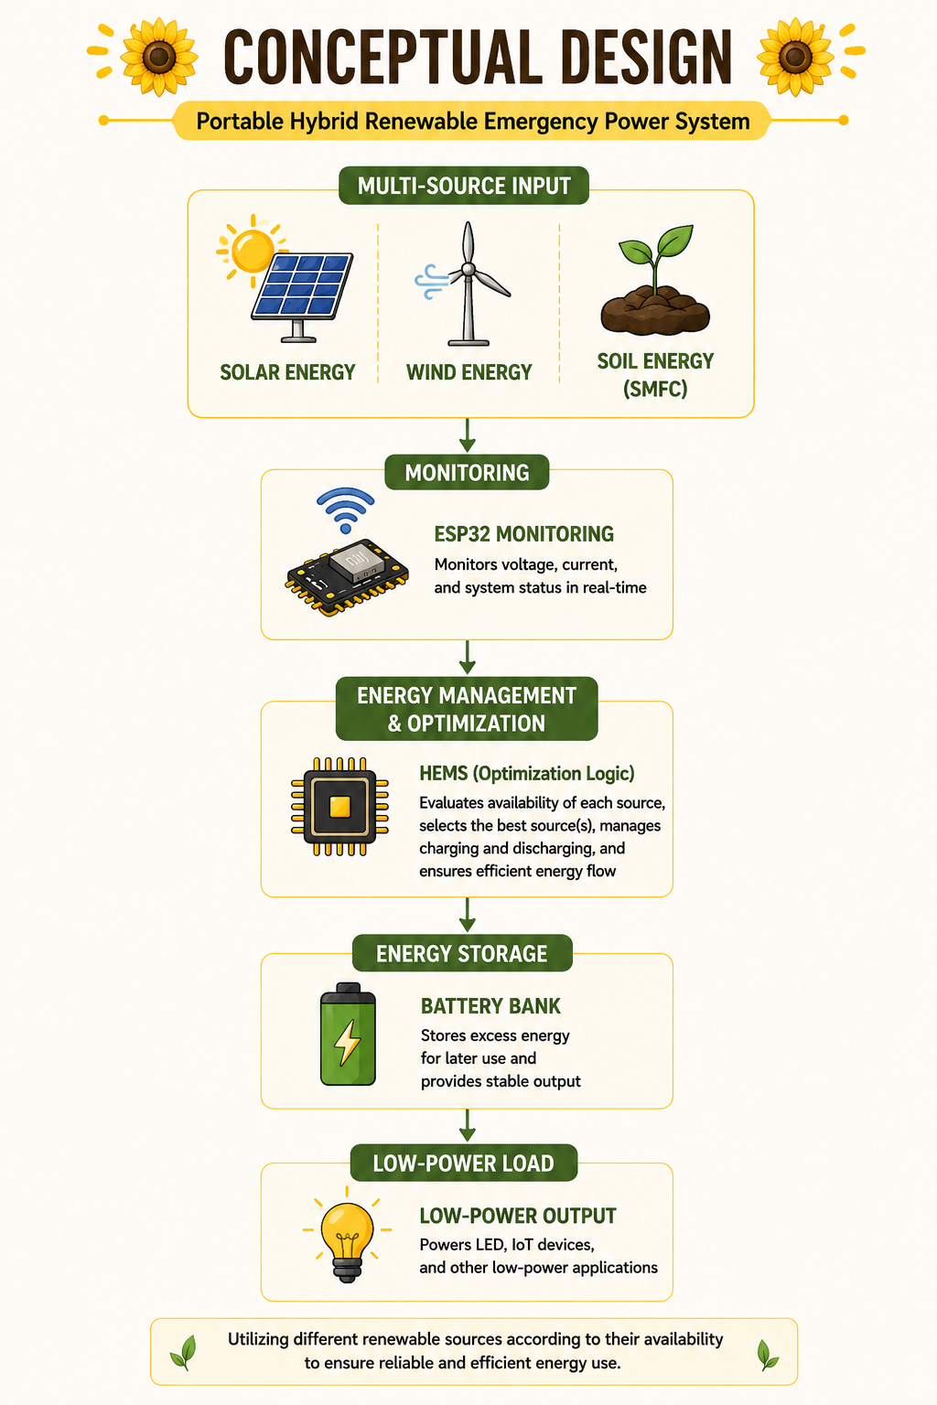
Figure 4.1: VoltraBloom Conceptual Design

4.2 System Block Diagram
VoltraBloom uses three energy sources: solar panels, vertical-axis wind turbines, and a soil module. The harvested energy is regulated by a charge controller and managed by the HEMS before being stored in the battery bank. The inverter then converts DC into 220 V AC to supply building loads, and the entire process is monitored through an IoT-based system. This block diagram reflects the implementation-scale target; the proof-of-concept realises the same energy-and-control logic using simplified conditioning, 2S storage, and Arduino-based control rather than a full MPPT/HEMS/IoT stack (see Figure 4.6).

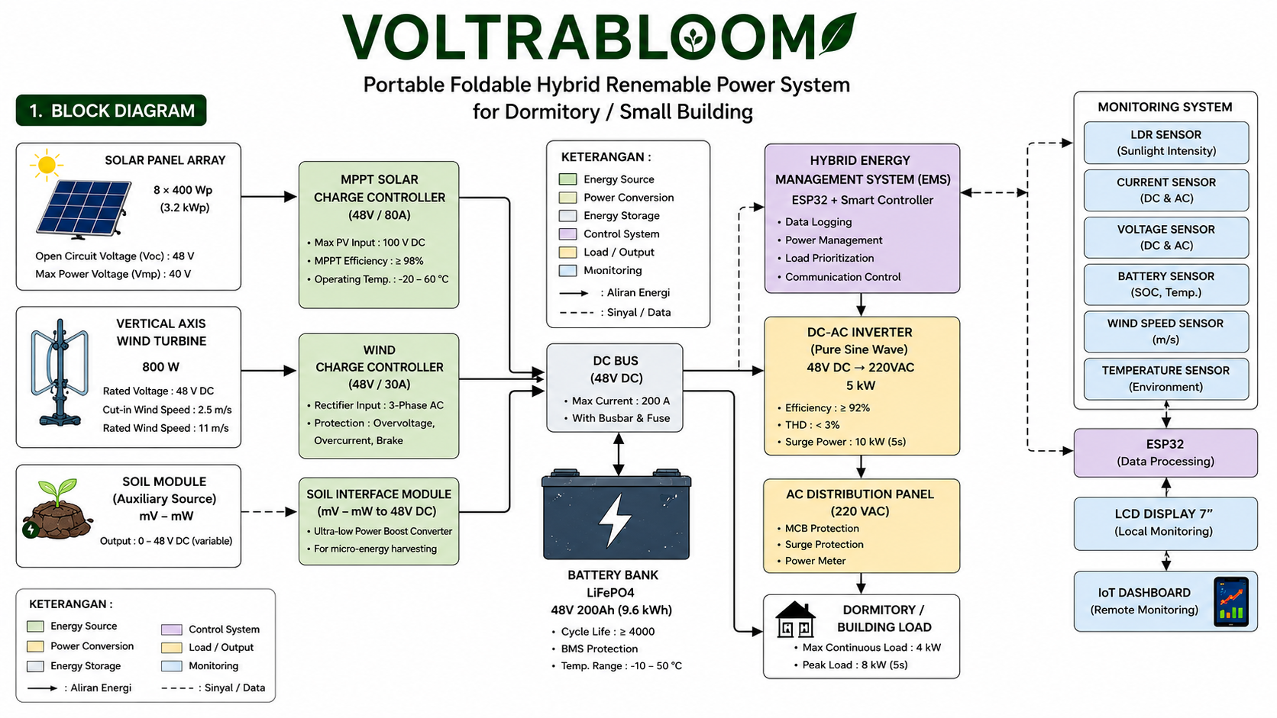
Figure 4.2: VoltraBloom System Block Diagram
4.3 Component Specification (Implementation Scale)
No | Component | Specification | Amount
1 | Solar Panel | 400 Wp | 8 units
2 | Wind Turbine | 800 W | 1 unit
3 | MPPT Solar Charge Controller | 48V/80A | 1 unit
4 | AC Rectifer | 48 V DC output | 1 unit
5 | Battery Bank (LifePO4) | 48V 200Ah (9,6 kWh) | 1 unit
7 | Hybrid EMS Controller | ESP32+Smart Controller | 1 set
8 | AC Distribution Panel | 220VAC | 1 unit
9 | DC Breaker | 63A | 2 unit
10 | AC Breaker (MCB) | 32A | 1 unit
11 | LCD Display | 7 inci TFT | 1 unit
12 | Caster Wheel (Lockable) | Heavy Duty | 4 unit
13 | Main Cabinet Material | Alumunium+steel | 1 set
14 | Pole Material | Aluminium Telescopic | 1 unit
15 | Protection | Fuse, SPD, Grounding | 1 set
Table 4.1: VoltraBloom Component Specification (Implementation-Scale Target)

4.4 Operational Flowchart
The system starts when the solar panels and wind turbines generate energy. The HEMS then manages battery charging and selects the distribution path based on system conditions. Energy is delivered either to DC loads or converted to AC through the inverter, and all parameters are monitored in real time. At prototype scale, the equivalent control sequence (initialise → read input → decide state → actuate servo/relay → repeat, with a fault state defaulting to safe-off) is implemented on the Arduino, as shown in Figure 4.7.
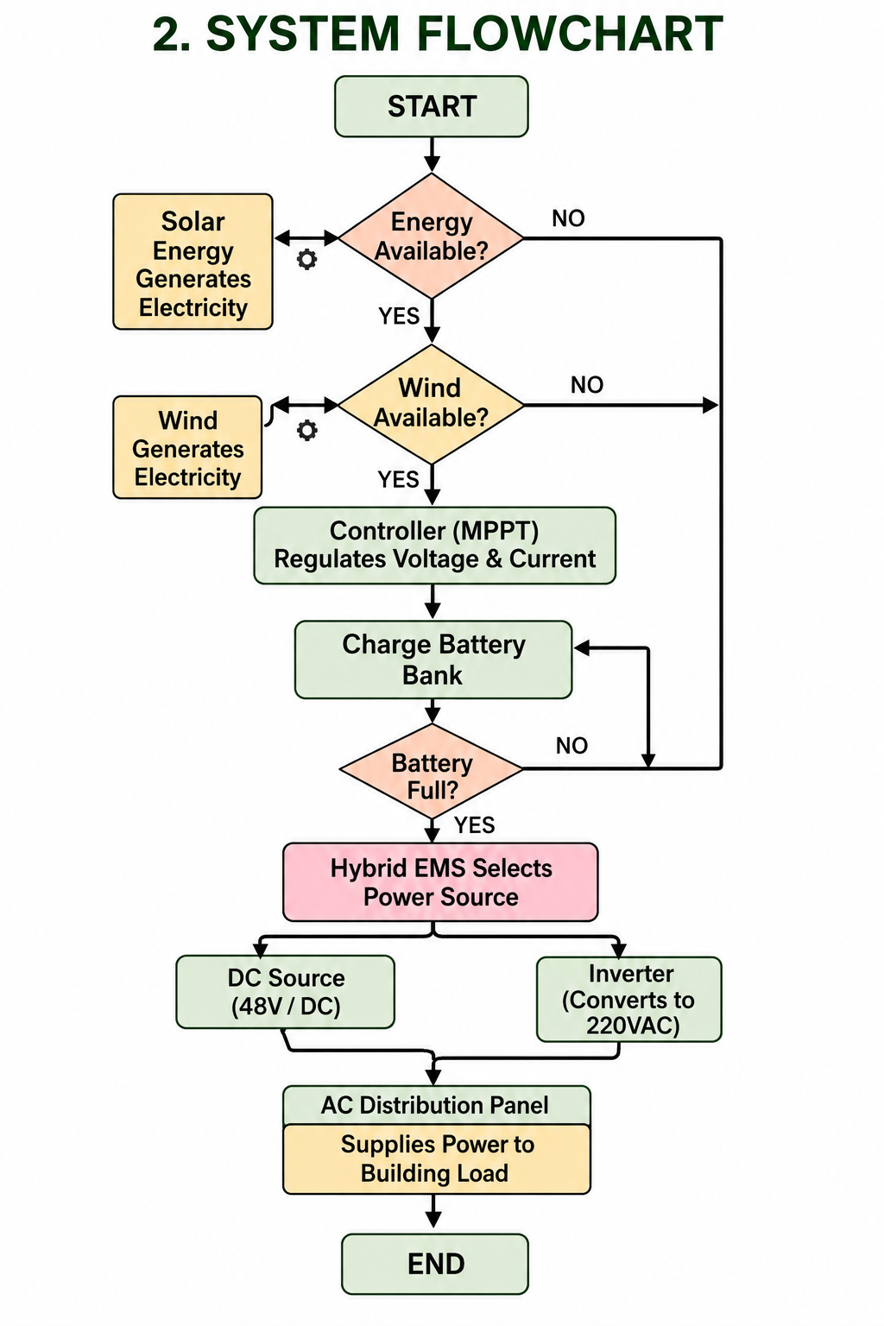
Figure 4.3: VoltraBloom Operational Flowchart
Note: This figure represents the proposed implementation-scale design and is not a photograph or measurement result from the current physical prototype.

4.5 Mechanical Design and Dimension Drawing
The mechanical design is shown in front, side, top. The foldable floral structure makes the system efficient and portable. Based on typical component weights, the estimated total system weight is approximately 250–300 kg. The physical proof-of-concept instead uses a lightweight PVC-and-plywood structure sized for five panels, described in Section 4.10.

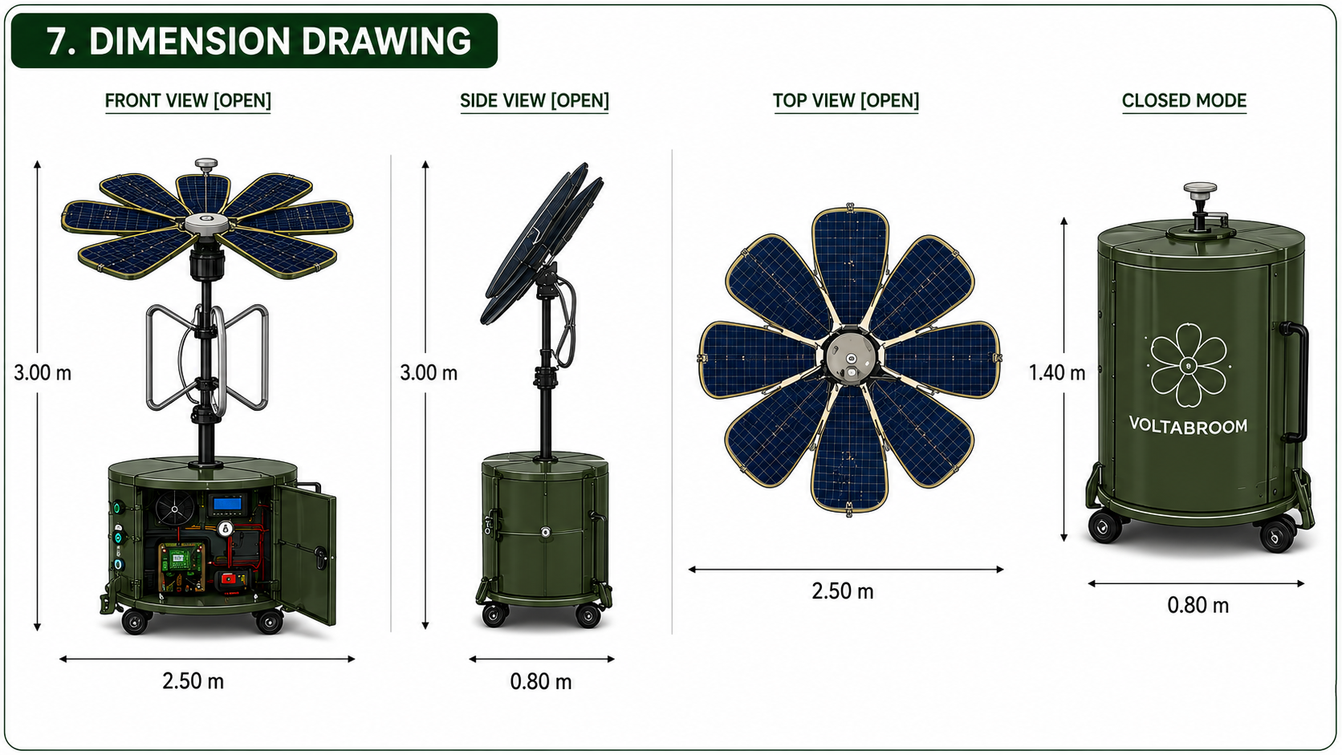
Figure 4.4: VoltraBloom Dimension Drawing (Front, Side, Top View, dan Closed Mode)
Note: This figure represents the proposed implementation-scale design and is not a photograph or measurement result from the current physical prototype.

4.6 Component Layout
At implementation scale, all major components, including the battery bank, charge controller, HEMS, distribution panel, and LCD, are housed in the base. This layout supports easier installation, maintenance, and cable routing. In the proof-of-concept, the equivalent low-voltage components (2S storage and Arduino) are housed at the base of the PVC stem.
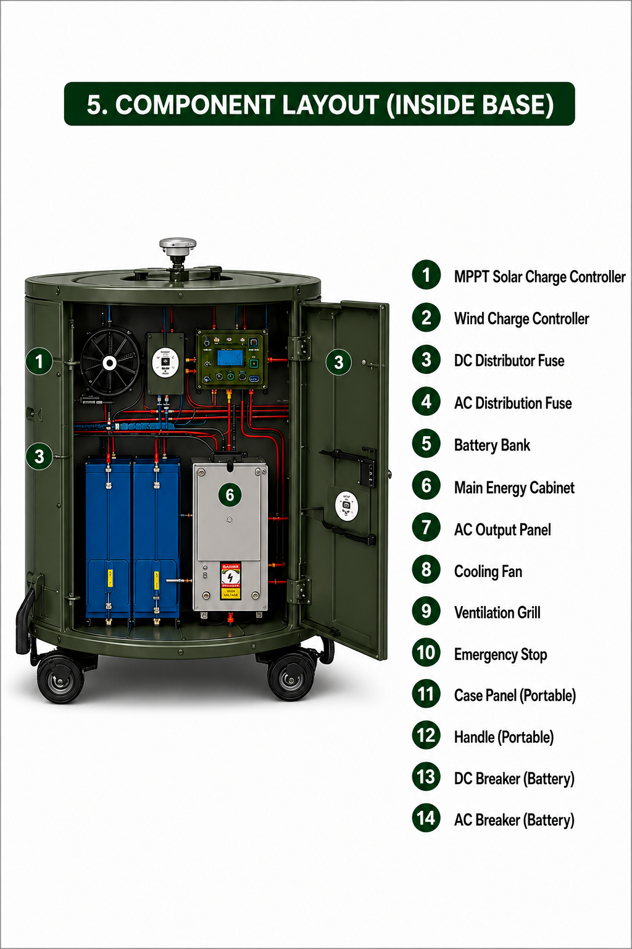
Figure 4.5: VoltraBloom Component Layout inside the VoltraBloom Base
Note: This figure represents the proposed implementation-scale design and is not a photograph or measurement result from the current physical prototype.

4.7 Electrical Wiring Diagram
The implementation-scale wiring diagram shows the electrical connections between the energy sources, charge controller, battery bank, inverter, distribution panel, and sensors, with power lines and data lines separated to improve safety and simplify maintenance. Figure 4.6 in Section 4.10 shows the corresponding system-level wiring concept used in the physical proof-of-concept.
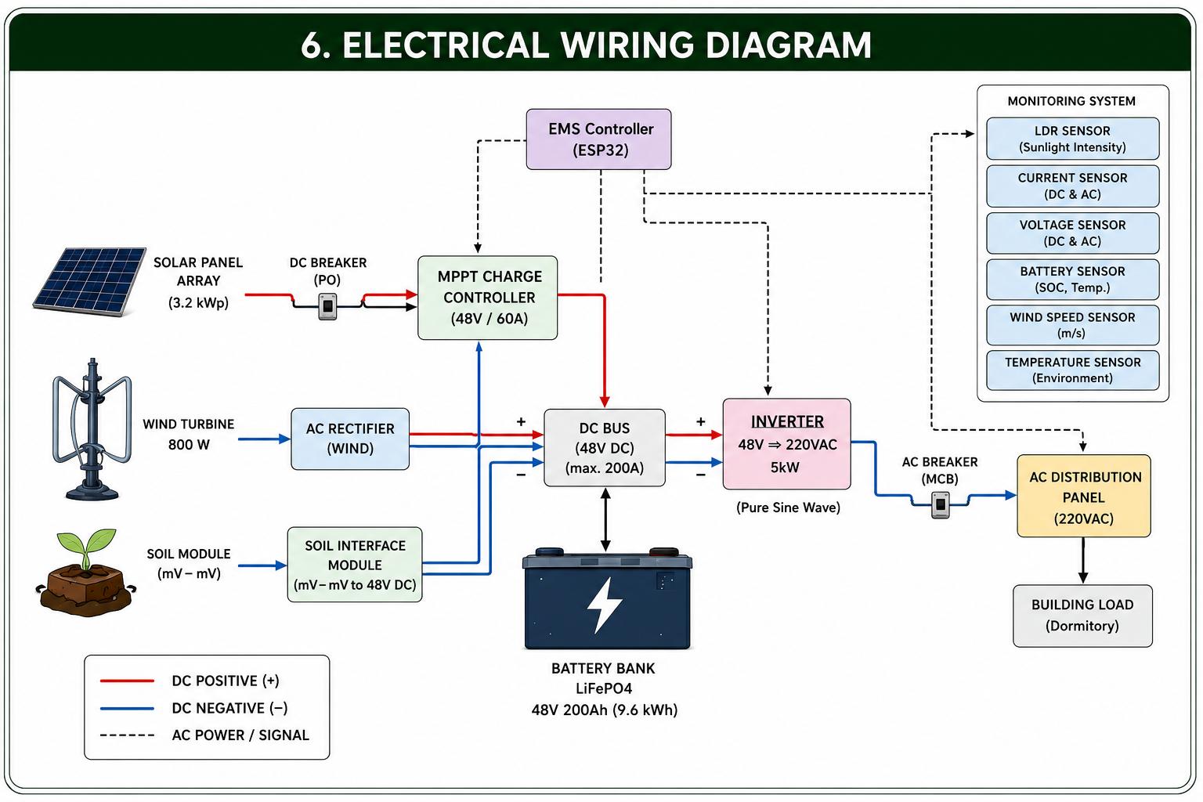
Figure 4.6: VoltraBloom Electrical Wiring Diagram
Note: This figure represents the proposed implementation-scale design and is not a photograph or measurement result from the current physical prototype.

4.8 Analysis of Concept and Implementation Potential
The design indicates that VoltraBloom has strong potential as an efficient, environmentally friendly backup power system, integrating solar panels, wind turbines, and a soil module, with HEMS enabling automatic energy management and the foldable design improving portability. Compared with similar systems, VoltraBloom offers greater energy-source diversity, portability, and integrated real-time monitoring. Economically, against a typical diesel generator's estimated fuel cost of IDR 1,500,000–2,500,000/month, VoltraBloom's total investment of approximately IDR 98,100,000 (USD 6,131) could theoretically reach cost parity within 3–5 years, after which it would operate at near-zero marginal cost with no direct emissions, though this estimate excludes maintenance costs and requires further validation. The physical proof-of-concept described in Section 4.10 is the first step toward that validation: it demonstrates that the source, storage, control, and mechanical subsystems can be integrated and operated together, ahead of any economic or full-scale performance claim.

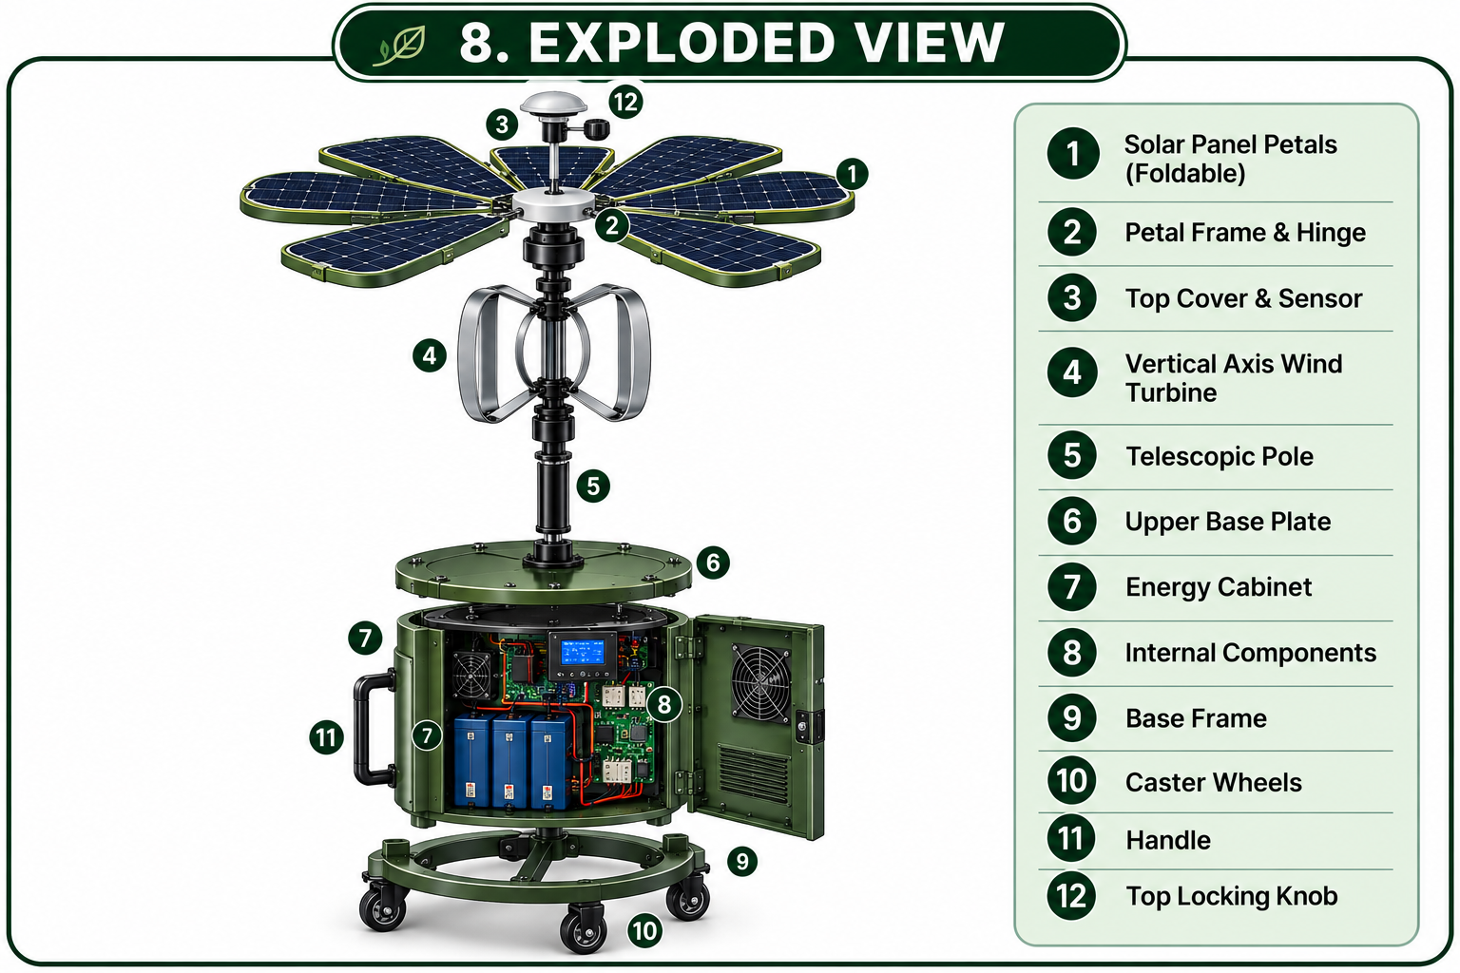
Figure 4.7: VoltraBloom Exploded View
Note: This figure represents the proposed implementation-scale design and is not a photograph or measurement result from the current physical prototype.

4.9 Capacity and Performance Estimation (Implementation Scale)
Based on component specifications and reference literature, the solar array serves as the primary energy source and the wind turbine as a supplementary one. Assuming 4 peak sun hours/day and an 80% derating factor, the 3.2 kWp solar array is estimated to yield approximately 10.2 kWh/day; the 800 W wind turbine, at a 15% capacity factor, contributes a further 2.9 kWh/day, for a combined estimated harvest of ~13 kWh/day. The SMFC module produces only milliwatt-to-watt-level output (Yen et al., 2024) and is allocated solely to low-power sensors and monitoring rather than the main load. The 9.6 kWh LiFePO₄ battery bank, at 80% DoD, provides ~7.7 kWh of usable capacity — sufficient for approximately 7–8 hours of backup autonomy at a 1 kW critical dormitory load without concurrent generation, and considerably longer with daytime charging. These figures remain theoretical estimations based on standard literature assumptions and require validation through prototype testing; they have not yet been measured on the physical proof-of-concept.
Component | Estimated Unit Price (IDR) | Estimated Unit Price (USD) | Qty | Estimated Subtotal (IDR) | Estimated Subtotal (USD)
Solar Panel Monocrystalline 400 Wp | Rp2,200,000 | $138 | 8 | Rp17,600,000 | $1,100
Wind Turbine, Vertical Axis, 800 W | Rp9,000,000 | $563 | 1 | Rp9,000,000 | $563
MPPT Charge Controller 48V/80A | Rp3,500,000 | $219 | 1 | Rp3,500,000 | $219
Battery Bank LiFePO4, 48V 200Ah | Rp30,000,000 | $1,875 | 1 | Rp30,000,000 | $1,875
Inverter, Pure Sine Wave, 5 kW | Rp17,000,000 | $1,063 | 1 | Rp17,000,000 | $1,063
Hybrid EMS Controller (ESP32 + Relay) | Rp1,500,000 | $94 | 1 | Rp1,500,000 | $94
IoT Monitoring Sensor Set | Rp1,500,000 | $94 | 1 | Rp1,500,000 | $94
Breaker, Fuse, SPD, Grounding | Rp3,000,000 | $188 | 1 | Rp3,000,000 | $188
Frame, Pole, Base, Wheel, Hinge | Rp12,000,000 | $750 | 1 | Rp12,000,000 | $750
Cable, Connector, etc. | Rp3,000,000 | $188 | 1 | Rp3,000,000 | $188
Total |  |  |  | Rp98,100,000 | $6,131
*USD values are approximate conversions using an assumed exchange rate of IDR 16,000 = USD 1 for reference purposes only; actual costs will vary with market prices and prevailing exchange rates at the time of implementation.
Table 4.2: VoltraBloom Estimated Cost Feasibility of VoltraBloom Components (Implementation Scale)

4.10 Physical Proof-of-Concept Prototype
To verify the architecture described in Sections 4.1–4.9 before implementation-scale fabrication, the team built a small physical proof-of-concept. Four solar panels were selected after nine available panels were individually checked for basic response to light. A DC motor is used as a small wind-generator demonstrator, while the SMFC is treated as a low-power supplementary source. The prototype employs a simplified 2S storage configuration and an Arduino controller programmed in the Arduino IDE. The mechanical structure uses accessible materials including PVC pipe, lightweight board/plywood, hinges, and a simple linkage.

4.10.1 What the Prototype Currently Demonstrates
The project record supports three qualitative, component-level observations: the available solar panels responded to light, and four were selected for the prototype; the available DC motor/turbine arrangement can demonstrate wind-to-electric conversion when mechanically driven; and the proposed mechanical/control architecture is feasible as a proof-of-concept assembly using PVC, board/plywood, and hinges. These are feasibility observations rather than measured performance results, and they are not converted into numerical efficiency, power, runtime, or energy-yield claims until a controlled measurement dataset is recorded.
Aspect | Target Design (Implementation Scale) | Current Prototype (Proof of Concept)
Solar | Target 8 x 400 Wp (≈ 3,2 kWp) | 4 panels selected from 9 units tested for light response, arranged in 2 series strings
Wind | Vertical-axis wind turbine 800 W | DC motor operated as wind generator demonstrator
SMFC | Additional low-power module for sensors/monitoring | Small pots (carbon felt electrodes), connected in parallel; initial reading ≈ 0.030 V (measurement condition needs confirmation: open-circuit/loaded, single pot/combined)
Storage | 48V 200Ah LiFePO4 (≈ 9,6 kWh) | Li-ion 18650, 2S configuration, with battery holder
Controller | HEMS based on ESP32 + smart controller | ESP32 programmed via Arduino IDE
Mechanics/Actuation | 8-panel petals, aluminium + steel frame, estimated 250–300 kg | PVC and plywood structure, servo actuator, dual-channel relay
Table 4.10.1 Comparison of Implementation-Scale Target and Current Prototype

4.10.2 What the Prototype Currently Demonstrates
The project record supports three qualitative, component-level observations: the available solar panels responded to light, and five were selected for the prototype; the available DC motor/turbine arrangement can demonstrate wind-to-electric conversion when mechanically driven; and the proposed mechanical/control architecture is feasible as a proof-of-concept assembly using PVC, board/plywood, hinges, servo actuation, and ESP32-based control. These are feasibility observations rather than measured performance results, and they are not converted into numerical efficiency, power, runtime, or energy-yield claims until a controlled measurement dataset is recorded.

4.10.3 What the Prototype Does Not Yet Demonstrate
Aspect Not Yet Proven | Reason / Data Still Needed
Capacity and electrical performance at implementation scale (3.2 kWp; 800 W; 5 kW) | No controlled measurements of V, I, and P on the prototype; these figures are design targets based on component specifications
Conversion efficiency of each energy source (η) | Requires simultaneous measurement of input power and output power; not yet performed
Battery backup capacity and duration | Prototype only uses simple 2S cells; 48V 200Ah LiFePO4 configuration has not yet been fabricated or tested
Performance of MPPT, inverter, and full-scale HEMS | These components have not been installed in the prototype; the prototype uses Arduino and a dual-channel relay instead
SMFC power output under real conditions | Only known from literature (microwatt–milliwatt range); not yet directly measured on prototype SMFC pots
Long-term periodic monitoring (6–24 hours) | Not yet conducted; requires defined logging intervals, environmental conditions, and sensors
Economic validation and payback period | Estimate of Rp98,100,000 does not include maintenance costs and has not been validated in the field
The most defensible contribution of the current prototype is integration: multiple renewable inputs are represented in one architecture, the flower structure provides a physical energy-collection form, and the control layer connects electrical conditions to mechanical and switching actions. The next research value comes from quantitative measurement of the prototype, followed by an evidence-based scale-up toward the implementation-scale targets described in Sections 4.1–4.9.

CHAPTER V

CONCLUSION
VoltraBloom is a conceptual design of a hybrid renewable power system at an implementable scale, intended as a backup power source for dormitories or small buildings when the main electricity supply is interrupted or insufficient. The system integrates solar panels, a vertical-axis wind turbine, and a soil microbial fuel cell as energy sources, then regulates the generated power through an MPPT charge controller, battery bank, HEMS, and IoT-based monitoring system.
Since the original conceptual design was formulated, the team has built and documented a small physical proof-of-concept that realises the same source – conditioning/storage – control – mechanical architecture at a reduced scale, using four selected solar panels, a DC-motor wind demonstrator, a 2S storage path, and ESP32-based control. This prototype confirms that the intended architecture can be physically assembled and operated as one coordinated system, without yet establishing the electrical performance, capacity, or runtime figures associated with the implementation-scale concept.
Based on the conceptual analysis, VoltraBloom has the potential to become a more environmentally friendly backup power alternative than diesel generators and can support basic electrical loads in dormitories or small buildings. However, because the implementation-scale system remains at the conceptual stage and the physical prototype has not yet undergone controlled quantitative testing, its performance and efficiency must be validated through further prototype measurement, refinement, and scale-up before implementation-scale claims can be made.

REFERENCES

Jamaaluddin, J., Ayuni, S. D., & Wulandari, I. A. S. (2023). Design of automatic transfer switch system solar power plant - PLN. Journal of Electrical Technology UMY, 7(2).
Kassem, Y., Camur,Alnaimi, F. B. I., Kazem, H. A., Alzakri, A. B., & Alatir, A. M. (2024). Design and implementation of smart integrated hybrid solar-Darrieus wind turbine system for in-house power generation. Renewable Energy and Environmental Sustainability, 9, 2.
H., & Ghoshouni, E. G. (2024). Assessment of a hybrid (wind-solar) system at high-altitude agriculture regions for achieving Sustainable Development Goals. Engineering, Technology & Applied Science Research, 14(1), 12595-12607.
KBBI. (2016). Kamus Besar Bahasa Indonesia. Jakarta: Badan Pengembangan dan Pembinaan Bahasa.
Manaf, A. (2022). Rekonstruksi pendidikan boarding school di Indonesia. Jurnal Ad-Dawah, 20(1).
Mayasari, F., Samman, F. A., Muslimin, Z., Waris, T., Dewiani, Salam, A. E. U., Gunadin, I. C., Areni, I. S., Akil, Y. S., & Rachmaniar, I. (2022). Pengenalan panel surya sebagai salah satu sumber energi terbarukan. Jurnal Tepat (Teknologi Terapan untuk Pengabdian Masyarakat), 5(2).
Saleh, M. (2026, June 5). Potensi besar energi terbarukan desa sia-sia: 658 ribu keluarga hidup tanpa listrik, jutaan warga masih andalkan diesel. The Conversation. Retrieved from https://theconversation.com
Saputro, J. S., dkk. (2023). Energy monitoring and control of automatic transfer switch between grid and solar panel for home system. 3(1), 59-73.
Simeon, I. M., Weig, A., & Freitag, R. (2022). Optimisation of soil microbial fuel cell for sustainable bio-electricity production. Biotechnology for Biofuels and Bioproducts, 15, 124.
U.S. Energy Information Administration. (2025, July 8). Electricity explained. Retrieved from https://www.eia.gov/energyexplained/electricity/
Utomo, M. S., Nugrahanto, I., & Sungkono. (2023). Sistem penyimpanan energi menggunakan baterai sel sekunder pada photovoltaic. Jurnal Elkolind, 10(1), 85-92.
Wang, H., Xiong, B., Zhang, Z., Zhang, H., & Azam, A. (2023). Small wind turbines and their potential for internet of things applications. iScience, 26(9), 107674.
Yen, B., Jaliff, L., Gutierrez, L., Sahinidis, P., Bernstein, S., Madden, J., Taylor, S., Josephson, C., Pannuto, P., Shuai, W., Wells, G., Arora, N., & Hester, J. (2024).
Soil-powered computing: The engineer's guide to practical soil microbial fuel cell design. Proceedings of the ACM on Interactive, Mobile, Wearable and Ubiquitous Technologies, 7(4), 1.

