VoltraBloom: Conceptual Design of a Portable Hybrid Renewable Emergency Power System Integrating Solar, Wind, and Soil Energy

COMPILED BY
NAUFALES ALIFTA NUGRAHA
ARFI DIMAS WIKRAMA
AURELIA AZZAHRA INAYAH SANTOSO
AVRIL INDAH KIRANA
MARISA SALMA
ZALFA AZZAHRA HIDAYAH
SMA NEGERI CAHAYA MADANI BANTEN BOARDING SCHOOL
2026

TABLE OF CONTENT
ABSTRACT3
CHAPTER I: INTRODUCTION4
1.1 Background4
1.2 Problem Formulation5
1.3 Research Objectives5
1.4 Scope and Limitations5
1.5 Research Benefits5
CHAPTER II: LITERATURE REVIEW6
2.1 Theoretical Foundations6
2.2 Review of Previous Research7
2.3 Conceptual Framework8
CHAPTER III: RESEARCH METHODS9
3.1 Type and Research Approach9
3.2 Research Site and Period9
3.3 Research Stages9
3.4 Data Collection Techniques9
3.5 Design Tools9
3.6 Concept Analysis Techniques9
3.7 Physical Proof-of-Concept Development10
CHAPTER IV: RESULTS AND DISCUSSION11
4.1 Overall System Design11
4.2 System Block Diagram11
4.3 Component Specification (Implementation Scale)11
4.4 Operational Flowchart12
4.5 Mechanical Design and Dimension Drawing12
4.6 Component Layout12
4.7 Electrical Wiring Diagram12
4.8 Analysis of Concept and Implementation Potential12
4.9 Capacity and Performance Estimation13
4.10 Physical Proof-of-Concept Prototype13
CHAPTER V: CONCLUSION17
REFERENCES18

ABSTRACT
This study aims to design VoltraBloom, a portable hybrid renewable power system developed at an implementation scale to supply electricity for a dormitory or small building, while also serving as a backup power source for the wider community. The background of this research is the limited electrical capacity in dormitory buildings, which often causes frequent power interruptions, as well as dependence on diesel generators that are expensive and environmentally unfriendly. The method used is Conceptual Design Research (Research by Design). At the implementation scale, the study focuses on system design without physical fabrication or full-scale testing; however, a small physical proof-of-concept has since been built to verify the basic architecture of the design before it is scaled up.
VoltraBloom, at implementation scale, integrates a solar panel array of approximately 3.2 kWp, a vertical-axis wind turbine rated at 800 W, and a Soil Microbial Fuel Cell (SMFC) as an additional energy source. These are combined with a 48V 200Ah LiFePO4 battery bank, a 48V/80A MPPT charge controller, a Hybrid Energy Management System (HEMS) based on ESP32, and a 5 kW pure sine wave inverter that delivers 220 V AC to the building distribution panel. The system is also equipped with an IoT-based monitoring system to track energy conditions in real time. These figures remain the implementation-scale target: the physical proof-of-concept currently uses five selected solar panels, a DC-motor wind-generation demonstrator, a simplified two-cell (2S) storage configuration, an Arduino controller, a servo actuator, and a two-channel relay, and does not yet reproduce the full-scale ratings above.
The research outputs show the potential of VoltraBloom as a portable, foldable, and eco-friendly hybrid backup power system at the building scale, now supported by an initial physical proof of concept that demonstrates the intended relationship between renewable energy input, conditioning/storage, control, and mechanical deployment.

Keywords: VoltraBloom, renewable energy, hybrid system, building backup power, IoT monitoring, soil microbial fuel cell, proof of concept.

CHAPTER I
INTRODUCTION

1.1 Background
Electricity, according to the U.S. Energy Information Administration (EIA, 2025), is the flow of charge and is one of the most fundamental forms of energy in everyday life. The alternating current (AC) system, pioneered by Nikola Tesla and commercialised by George Westinghouse at the end of the 19th century, began replacing the earlier direct current system.
In practice, however, this condition is not always achieved. In one school dormitory environment, a setting marked by continuous residential and academic energy demand (Manaf, 2022), the electricity supply often experiences sudden outages. These outages occur unpredictably, morning, afternoon, or night, indicating that the allocated power capacity for the building is insufficient to support daily operations reliably, thereby causing repeated disruptions to learning activities and the use of basic electronic devices.
Ideally, this issue could be resolved by increasing the building's electrical network capacity. However, such a solution requires comprehensive remapping and large-scale installation upgrades, which are complex and costly to implement in a school environment. A more realistic alternative is a building-scale independent backup power system capable of converting surrounding renewable energy into additional electricity, thereby reducing the load on the main grid and minimising the risk of breaker trips.
VoltraBloom is a portable, foldable hybrid renewable power system inspired by Smartflower, combining solar panels, a vertical-axis wind turbine, and a Soil Microbial Fuel Cell (SMFC). Integrated with LiFePO4 batteries, HEMS for automatic source switching, and IoT monitoring, it is intended as both a backup power solution for buildings with unstable grid supply and an independent energy source for diesel-dependent communities, many of which still rely heavily on diesel generators due to limited grid infrastructure (Saleh, 2026).
Since the concept was first formulated, the design team has proceeded to build a small physical proof-of-concept alongside the implementation-scale design presented in this paper. The proof-of-concept uses accessible materials and components — five selected solar panels, a PVC-and-triplek foldable structure, a DC-motor wind demonstrator, a simplified 2S storage path, and Arduino-based control — to verify that the intended architecture can be assembled and operated as one coordinated system before the full-scale ratings described below are pursued.

1.2 Problem Formulation
- How can VoltraBloom be designed as a renewable-energy-based backup power source for dormitories, small buildings, and the wider community?
- How can the HEMS automatically manage energy supply from solar panels, wind turbines, soil module, and battery bank?
- How can a portable foldable floral structure be designed to house all system components?
- How can an IoT-based monitoring system be designed to monitor VoltraBloom performance in real time?
- How can the intended architecture be verified through a small physical proof-of-concept prior to implementation-scale development?

1.3 Research Objectives
- To produce a conceptual design of VoltraBloom as a renewable-energy-based backup power system.
- To design a HEMS capable of automatically managing energy supply.
- To design a portable and efficient foldable floral structure.
- To design an IoT-based monitoring system for real-time performance monitoring.
- To build and document a physical proof-of-concept prototype that verifies the source, storage, control, and mechanical architecture at a small scale.

1.4 Scope and Limitations
This study covers two development levels. The first is the implementation-scale conceptual design, which defines the intended architecture, component specifications, energy capacity, and operational concept of VoltraBloom as a future hybrid renewable emergency power system. The second is the physical proof-of-concept prototype, which uses simplified and accessible components to demonstrate selected mechanical, electrical, and control principles of the proposed architecture.
The physical prototype is not intended to reproduce the electrical capacity, structural dimensions, battery capacity, or performance of the implementation-scale system. Its primary function is to demonstrate that the proposed floral structure, photovoltaic arrangement, wind-energy representation, energy storage pathway, and basic control mechanism can be physically realised. Therefore, prototype observations are interpreted as proof-of-concept evidence rather than as full-scale performance results.

1.5 Research Benefits
Theoretical Benefits. Contribute references on the design of building-scale hybrid renewable energy systems that integrate soil microbial fuel cells, HEMS, and IoT-based monitoring, together with a documented pathway from conceptual design to a verified physical proof of concept.
Practical Benefits. Provide an alternative portable, efficient, and environmentally friendly backup power system for boarding schools and the wider community. SMAN CMBBS will serve as the initial site for problem identification.

CHAPTER II
LITERATURE REVIEW

2.1 Theoretical Foundations

2.1.1 Basic Electrical Concepts
Electricity is the flow of charge utilised as an energy source (KBBI, 2016). VoltraBloom uses a 48 V DC system on the generation and storage side, which is then converted to 220 V AC via an inverter to supply building loads at the implementation scale; the physical proof-of-concept uses a lower, prototype-appropriate DC voltage rather than the full 48 V bus.

2.1.2 Renewable Energy
Renewable energy comes from natural sources that can be replenished and is more environmentally friendly than fossil energy (Mayasari et al., 2022). Its utilisation underpins the development of sustainable backup power systems.

2.1.3 Solar Panels
Solar panels convert sunlight into electricity through the photovoltaic effect (Mayasari et al., 2022). In VoltraBloom, solar panels are the primary energy source for charging the battery bank; the proof-of-concept demonstrates this principle using five selected panels chosen after basic light-response checks of nine available units.

2.1.4 Batteries
Batteries store electrical energy so it can be used when the primary energy sources are unavailable (Utomo et al., 2023). VoltraBloom's implementation-scale concept uses a 48 V 200 Ah LiFePO₄ battery bank because of its long service life and high safety; the proof-of-concept instead uses a simplified two-cell (2S) storage path pending verification of chemistry and specification.

2.1.5 Vertical-Axis Wind Turbine
Wind turbines convert the kinetic energy of wind into electricity. VoltraBloom employs a vertical-axis wind turbine as a complementary energy source to enhance system reliability, especially when solar irradiance is low (Wang et al., 2023). At prototype scale, a DC motor operated in reverse is used as a small generator demonstrator to validate the conversion principle.

2.1.6 Soil Microbial Fuel Cell
Soil Microbial Fuel Cells (SMFCs) generate electricity from the activity of electrogenic bacteria in soil (Simeon et al., 2022). Recent engineering guidelines for soil-powered computing indicate that individual SMFC units typically generate power in the milliwatt range, making them suitable for low-power applications such as environmental sensors rather than a primary power supply (Yen et al., 2024). In VoltraBloom, the Soil Microbial Fuel Cell (SMFC) functions as a low-power supplementary energy source to support sensors and the monitoring system, both at implementation scale and in the prototype.

2.1.7 Hybrid Energy Management System
The Hybrid Energy Management System (HEMS) automatically manages energy distribution from solar panels, the wind turbine, the Soil Microbial Fuel Cell (SMFC), and the battery bank to maintain a stable power supply (Jamaaluddin et al., 2023). Similar automatic switching mechanisms have been implemented in Automatic Transfer Switch (ATS) systems that monitor and toggle between grid and solar power sources in real time (Saputro et al., 2023), a principle VoltraBloom adopts to manage its multiple energy sources. At prototype scale, this function is represented by a deterministic Arduino state machine driving a servo and a two-channel relay rather than a full optimisation algorithm.

2.1.8 MPPT Charge Controller and Inverter
An MPPT charge controller optimises battery charging, while an inverter converts 48 V DC to 220 V AC for building loads at the implementation scale. Neither the MPPT charge controller nor mains-level inversion has yet been validated in the physical prototype.

2.1.9 Foldable Floral Design
The foldable floral design allows solar panels to open during operation and fold when moved or stored. This concept improves space-use efficiency while preserving system portability. The proof-of-concept realises this principle with a central PVC stem, a lightweight board/triplek base, hinges, and a servo-driven linkage that opens and closes five petals.

2.1.10 IoT-Based Monitoring System
The IoT-based monitoring system uses sensors and an ESP32 microcontroller to monitor voltage, current, battery state-of-charge, irradiance, wind speed, and temperature in real time at implementation scale. This layer is treated as a future addition once the prototype's electrical and mechanical hardware has been verified.

2.1.11 VoltraBloom as a Hybrid System

2.2 Review of Previous Research
Previous studies have generally developed hybrid solar-wind systems for building energy needs. However, most of them have not integrated Soil Microbial Fuel Cells, foldable design, and IoT monitoring within one system. This gap forms the basis for developing VoltraBloom.
Aspect | VoltraBloom | Smartflower | Conventional EPK/Diesel Generator
Energy source | Solar+wind+ground | Solar | Solar/battery/Fossil fuel
Power capacity | ±3.2 kWp + 800 W (wind), 5 kW AC output (target) | ±3.2 kWp (solar only) | Varies, typically generator-dependent
Portability | High (foldable, wheeled) | Medium | Low
Emissions | None | None | High (diesel generator)
Estimated cost | Medium-high | High | Medium-high
Automatic control | Yes (HEMS+ATS, target) | Yes | Varies/manual
Monitoring | Real-time IoT (target) | Limited | Typically none
Validation status | Proof-of-concept built; full ratings pending | Commercial product | Commercial product
Table 2.1 Comparison of VoltraBloom with Existing Backup Power Solutions

2.3 Conceptual Framework
This research originates from limited electricity supply in boarding schools and dependence on diesel generators. Based on renewable energy, hybrid systems, HEMS, foldable design, and IoT monitoring, VoltraBloom is designed as a renewable backup power system at the implementation scale. The expected outputs are the system design, block diagram, flowchart, mechanical design, layout, wiring diagram, dimension drawing, exploded view, and component specifications. A physical proof-of-concept prototype, built with accessible materials and simplified components, verifies the same architecture prior to full-scale implementation and provides the evidence basis for further development.

CHAPTER III
RESEARCH METHODS

3.1 Type and Research Approach
This study uses a Conceptual Design Research (Research by Design) approach. The focus is on designing a system to solve the research problem at the implementation scale, complemented by a physical proof-of-concept prototype used to verify the intended architecture without yet claiming full-scale performance.

3.2 Research Site and Period
The research was carried out by the SMAN CMBBS team from June to July 2026 as preparation for the Indonesia International Invention Expo (IIIEX) 2026. Design activities were conducted digitally using design and online communication software, and the physical proof-of-concept was subsequently fabricated using accessible materials and components available to the team.

3.3 Research Stages
- Literature review and problem identification.
- System requirements analysis.
- Overall system design, including block diagrams and flowcharts.
- Mechanical design, component layout, and wiring diagram.
- Preparation of component specifications and technical drawings.
- Concept analysis and design evaluation based on literature and technical specifications.
- Fabrication of a physical proof-of-concept prototype and documentation of component-level observations.

3.4 Data Collection Techniques
The research data consist of secondary data obtained from scientific literature, component datasheets, and technical references used to support the implementation-scale system design. Prototype-level data consist of component-selection records, fabrication observations, mechanical observations, and basic functional observations of the physical prototype.
At the current stage, the prototype has not yet produced a controlled quantitative dataset covering voltage, current, power output, energy yield, charging efficiency, battery runtime, or long-term operating performance. Therefore, numerical performance values presented for the implementation-scale system are treated as calculated estimates or design targets and are not presented as experimental results from the physical prototype.
3.5 Design Tools
The design process used Draw.io for diagrams, Canva for conceptual illustrations, and SketchUp for 3D visualisation. The physical proof-of-concept was fabricated using PVC pipe, lightweight board/triplek, hinges, a servo actuator, an Arduino microcontroller programmed in the Arduino IDE, and a two-channel relay.

3.6 Concept Analysis Techniques
The analysis was conducted by evaluating design conformity with the research problem, comparing it with similar technologies, and assessing feasibility based on component capacities and specifications.

3.7 Physical Proof-of-Concept Development
To verify that the design architecture is physically realisable, the team decomposed the system into source, conditioning/storage, mechanical, control, and switching subsystems and fabricated a small-scale demonstrator. Each subsystem was intended to be checked individually before integrated testing, following the stages below.

Stage | Activity | Expected Evidence
1 | Freeze minimum prototype requirements. | Functional requirement list
2 | Check nine available solar panels and select five. | Panel selection record
3 | Fabricate base, PVC stem, hub, hinges and mounts. | Mechanical assembly
4 | Install servo and linkage. | Repeatable petal movement
5 | Connect Arduino and 2-channel relay. | Control demonstration
6 | Integrate the available source, storage, control, and low-voltage components where applicable. | Demonstrate subsystem-level integration.
7 | Measure electrical and mechanical behaviour. | Quantitative dataset (planned)
Table 3.1 Physical proof-of-concept development stages

The distinction between observed, calculated, specified, and targeted values is maintained throughout this paper: a value is presented as a prototype result only if it has actually been observed or measured on the physical prototype; otherwise it is identified as an implementation-scale target.

CHAPTER IV
RESULTS AND DISCUSSION

4.1 Overall System Design
VoltraBloom is designed to resemble a flower, featuring eight solar panel petals, a vertical-axis wind turbine at the top, a telescopic pole, and a base that houses all electronic components and caster wheels for mobility. In open mode, the petals unfold to maximise sunlight absorption, while in closed mode they fold inward to make the system more compact and portable. This is the implementation-scale concept; Section 4.10 presents the equivalent architecture as realised in the current five-petal physical proof-of-concept.

4.2 System Block Diagram
VoltraBloom uses three energy sources: solar panels, vertical-axis wind turbines, and a soil module. The harvested energy is regulated by a charge controller and managed by the HEMS before being stored in the battery bank. The inverter then converts DC into 220 V AC to supply building loads, and the entire process is monitored through an IoT-based system. This block diagram reflects the implementation-scale target; the proof-of-concept realises the same energy-and-control logic using simplified conditioning, 2S storage, and Arduino-based control rather than a full MPPT/HEMS/IoT stack (see Figure 4.6).

4.3 Component Specification (Implementation Scale)
No | Component | Specification | Amount
1 | Solar Panel | 400 Wp | 8 units
2 | Wind Turbine | 800 W | 1 unit
3 | MPPT Solar Charge Controller | 48V/80A | 1 unit
4 | AC Rectifier | 48 V DC output | 1 unit
5 | Battery Bank (LiFePO4) | 48V 200Ah (9.6 kWh) | 1 unit
6 | Inverter (Pure Sine Wave) | 48V → 220VAC, 5kW | 1 unit
7 | Hybrid EMS Controller | ESP32 + Smart Controller | 1 set
8 | AC Distribution Panel | 220VAC | 1 unit
9 | DC Breaker | 63A | 2 unit
10 | AC Breaker (MCB) | 32A | 1 unit
11 | LCD Display | 7 inch TFT | 1 unit
12 | Caster Wheel (Lockable) | Heavy Duty | 4 unit
13 | Main Cabinet Material | Aluminium + steel | 1 set
14 | Pole Material | Aluminium Telescopic | 1 unit
15 | Protection | Fuse, SPD, Grounding | 1 set
Table 4.1 VoltraBloom Component Specification (Implementation-Scale Target)

4.4 Operational Flowchart
The system starts when the solar panels and wind turbines generate energy. The HEMS then manages battery charging and selects the distribution path based on system conditions. Energy is delivered either to DC loads or converted to AC through the inverter, and all parameters are monitored in real time. At prototype scale, the equivalent control sequence (initialise → read input → decide state → actuate servo/relay → repeat, with a fault state defaulting to safe-off) is implemented on the Arduino, as shown in Figure 4.7.

4.5 Mechanical Design and Dimension Drawing (Implementation Scale)
The mechanical design is shown in front, side, top, and closed views. The foldable floral structure makes the system efficient and portable, as the panels open during operation and close during transport. Based on typical component weights, the estimated total system weight is approximately 250–300 kg; the lockable heavy-duty caster wheels therefore position VoltraBloom as “wheeled-portable” rather than a lightweight, hand-carried device. The physical proof-of-concept instead uses a lightweight PVC-and-triplek structure sized for five panels, described in Section 4.10.

4.6 Component Layout
At implementation scale, all major components, including the battery bank, charge controller, inverter, HEMS, distribution panel, LCD, and cooling system, are housed in the base. This layout supports easier installation, maintenance, and cable routing. In the proof-of-concept, the equivalent low-voltage components (2S storage, Arduino, relay, and servo) are housed at the base of the PVC stem.

4.7 Electrical Wiring Diagram
The implementation-scale wiring diagram shows the electrical connections between the energy sources, charge controller, battery bank, inverter, distribution panel, and sensors, with power lines and data lines separated to improve safety and simplify maintenance. Figure 4.6 in Section 4.10 shows the corresponding system-level wiring concept used in the physical proof-of-concept.
4.8 Analysis of Concept and Implementation Potential
The design indicates that VoltraBloom has strong potential as an efficient, environmentally friendly backup power system, integrating solar panels, wind turbines, and a soil module, with HEMS enabling automatic energy management and the foldable design improving portability. Compared with similar systems, VoltraBloom offers greater energy-source diversity, portability, and integrated real-time monitoring. Economically, against a typical diesel generator's estimated fuel cost of IDR 1,500,000–2,500,000/month, VoltraBloom's total investment of approximately IDR 98,100,000 (USD 6,131) could theoretically reach cost parity within 3–5 years, after which it would operate at near-zero marginal cost with no direct emissions, though this estimate excludes maintenance costs and requires further validation. The physical proof-of-concept described in Section 4.10 is the first step toward that validation: it demonstrates that the source, storage, control, and mechanical subsystems can be integrated and operated together, ahead of any economic or full-scale performance claim.

4.9 Capacity and Performance Estimation (Implementation Scale)
Based on component specifications and reference literature, the solar array serves as the primary energy source and the wind turbine as a supplementary one. Assuming 4 peak sun hours/day and an 80% derating factor, the 3.2 kWp solar array is estimated to yield approximately 10.2 kWh/day; the 800 W wind turbine, at a 15% capacity factor, contributes a further 2.9 kWh/day, for a combined estimated harvest of ~13 kWh/day. The SMFC module produces only milliwatt-to-watt-level output (Yen et al., 2024) and is allocated solely to low-power sensors and monitoring rather than the main load. The 9.6 kWh LiFePO₄ battery bank, at 80% DoD, provides ~7.7 kWh of usable capacity — sufficient for approximately 7–8 hours of backup autonomy at a 1 kW critical dormitory load without concurrent generation, and considerably longer with daytime charging. These figures remain theoretical estimations based on standard literature assumptions and require validation through prototype testing; they have not yet been measured on the physical proof-of-concept.
No. | Component | Est. Unit Price (IDR) | Est. Unit Price (USD) | Qty | Est. Subtotal (IDR) | Est. Subtotal (USD)
1 | Solar Panel Monocrystalline 400 Wp | Rp2,200,000 | $138 | 8 | Rp17,600,000 | $1,100
2 | Wind Turbine, Vertical Axis, 800 W | Rp9,000,000 | $563 | 1 | Rp9,000,000 | $563
3 | MPPT Charge Controller 48V/80A | Rp3,500,000 | $219 | 1 | Rp3,500,000 | $219
4 | Battery Bank LiFePO4, 48V 200Ah | Rp30,000,000 | $1,875 | 1 | Rp30,000,000 | $1,875
5 | Inverter, Pure Sine Wave, 5 kW | Rp17,000,000 | $1,063 | 1 | Rp17,000,000 | $1,063
6 | Hybrid EMS Controller (ESP32 + Relay) | Rp1,500,000 | $94 | 1 | Rp1,500,000 | $94
7 | IoT Monitoring Sensor Set | Rp1,500,000 | $94 | 1 | Rp1,500,000 | $94
8 | Breaker, Fuse, SPD, Grounding | Rp3,000,000 | $188 | 1 | Rp3,000,000 | $188
9 | Frame, Pole, Base, Wheel, Hinge | Rp12,000,000 | $750 | 1 | Rp12,000,000 | $750
10 | Cable, Connector, etc. | Rp3,000,000 | $188 | 1 | Rp3,000,000 | $188
 | Total |  |  |  | Rp98,100,000 | $6,131
Table 4.2 Estimated Cost Feasibility of VoltraBloom Components (Implementation Scale). USD values use an assumed rate of IDR 16,000 = USD 1 for reference only.

4.10 Physical Proof-of-Concept Prototype
To verify the architecture described in Sections 4.1–4.9 before implementation-scale fabrication, the team built a small physical proof-of-concept. Five solar panels were selected after nine available panels were individually checked for basic response to light. A DC motor is used as a small wind-generator demonstrator, while the SMFC is treated as a low-power supplementary source. The prototype employs a simplified 2S storage configuration, an Arduino controller programmed in the Arduino IDE, a servo actuator for opening and closing the solar petals, and a two-channel relay for low-voltage switching. The mechanical structure uses accessible materials including PVC pipe, lightweight board/triplek, hinges, and a simple linkage.
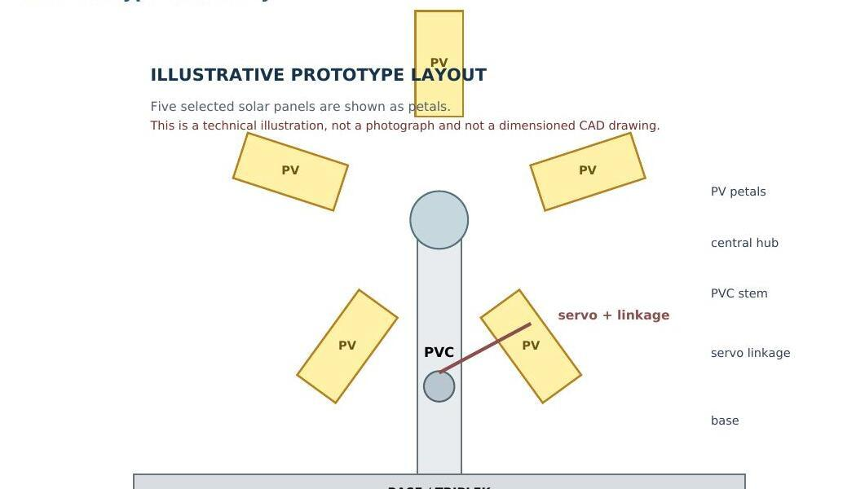
Figure 4.6: Illustrative Proof-of-Concept Layout — five PV petals, central hub, PVC stem, servo linkage, and triplek base (technical illustration, not a dimensioned drawing).
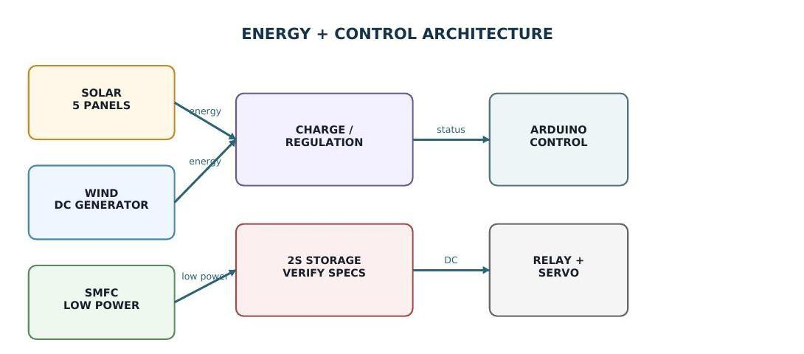
Figure 4.7: Proof-of-Concept Energy and Control Architecture — energy paths (solar, wind, SMFC → conditioning → 2S storage) are separated from the low-power Arduino → relay/servo control path.
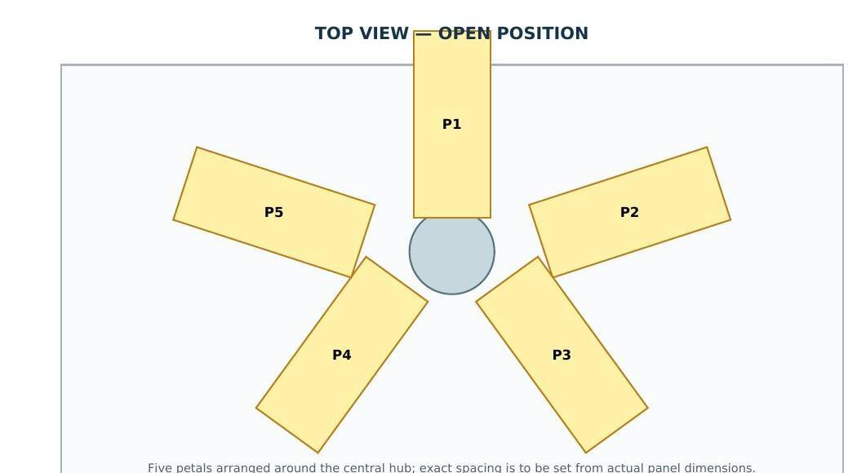
Figure 4.8: Top-view layout of the five solar petals (P1–P5) around the central hub, open position.
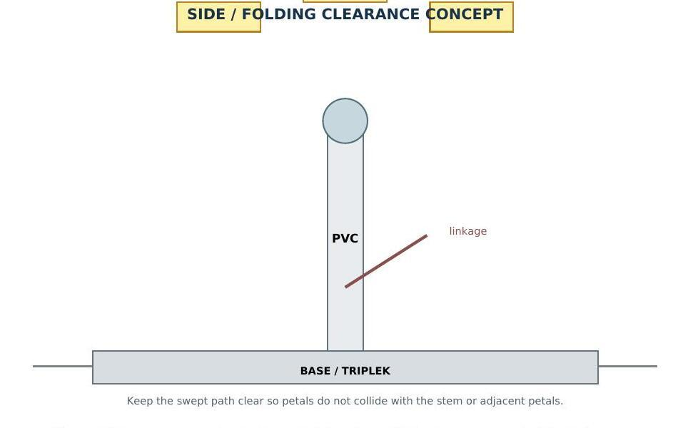
Figure 4.9: Side-view folding-clearance concept showing the PVC stem, servo linkage, and triplek base.
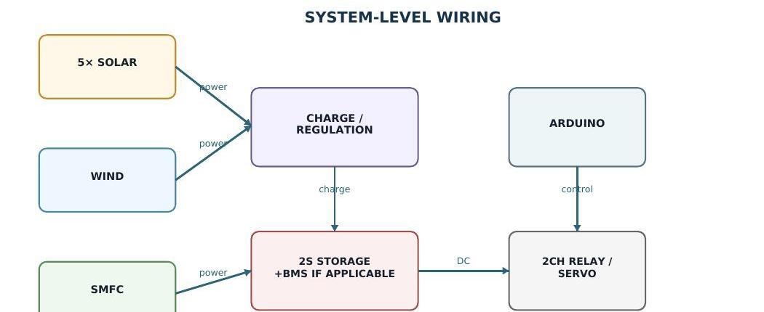
Figure 4.10: Prototype system-level wiring concept (not a mains-installation diagram). Verify polarity, battery chemistry, and protection ratings from the actual hardware before energising.

4.10.1 Prototype vs. Implementation-Scale Target
Parameter | Current Prototype | Implementation-Scale Target
Solar | 5 selected panels | 8 × 400 Wp ≈ 3.2 kWp
Wind | DC motor/generator demonstrator | ≈800 W vertical-axis turbine
Storage | 2S configuration; chemistry/specs to verify | 48 V 200 Ah LiFePO4
Inverter | Not validated in the prototype | 5 kW pure sine wave, 48V → 220VAC
Control | Arduino IDE + servo + 2-channel relay | ESP32-based HEMS + IoT monitoring
Structure | PVC + board/triplek + hinges | Aluminium/steel + telescopic pole
Purpose | Physical proof of concept | Building-scale backup power system
Table 4.3 Comparison between the current physical proof-of-concept and the implementation-scale target.
4.10.2 What the Prototype Currently Demonstrates
The project record supports three qualitative, component-level observations: the available solar panels responded to light and five were selected for the prototype; the available DC motor/turbine arrangement can demonstrate wind-to-electric conversion when mechanically driven; and the proposed mechanical/control architecture is feasible as a proof-of-concept assembly using PVC, board/triplek, hinges, servo actuation, and Arduino control. These are feasibility observations rather than measured performance results, and they are not converted into numerical efficiency, power, runtime, or energy-yield claims until a controlled measurement dataset is recorded.

4.10.3 What the Prototype Does Not Yet Demonstrate

Claim | Status
Continuous backup of a dormitory/building | Not validated
220 V AC output | Not validated
3.2 kWp solar generation | Implementation-scale target, not a prototype result
800 W wind generation | Implementation-scale target, not a prototype result
48 V 200 Ah battery performance | Implementation-scale target / specification to verify
5 kW inverter performance | Implementation-scale target, not a prototype result
Significant SMFC contribution to the main power bus | Not validated
Table 4.4 Claims not yet validated by the physical proof-of-concept.
The most defensible contribution of the current prototype is integration: multiple renewable inputs are represented in one architecture, the flower structure provides a physical energy-collection form, and the control layer connects electrical conditions to mechanical and switching actions. The next research value comes from quantitative measurement of the prototype, followed by an evidence-based scale-up toward the implementation-scale targets described in Sections 4.1–4.9.

CHAPTER V
CONCLUSION
VoltraBloom is a conceptual design of a hybrid renewable power system at an implementable scale, intended as a backup power source for dormitories or small buildings when the main electricity supply is interrupted or insufficient. The system integrates solar panels, a vertical-axis wind turbine, and a soil microbial fuel cell as energy sources, then regulates the generated power through an MPPT charge controller, battery bank, inverter, HEMS, and IoT-based monitoring system. Its foldable floral design provides portability and ease of deployment in limited spaces.
Since the original conceptual design was formulated, the team has built and documented a small physical proof-of-concept that realises the same source – conditioning/storage – control – mechanical architecture at a reduced scale, using five selected solar panels, a DC-motor wind demonstrator, a 2S storage path, Arduino control, servo actuation, and a two-channel relay within a PVC-and-triplek foldable structure. This prototype confirms that the intended architecture can be physically assembled and operated as one coordinated system, without yet establishing the electrical performance, capacity, or runtime figures associated with the implementation-scale concept.
Based on the conceptual analysis, VoltraBloom has the potential to become a more environmentally friendly backup power alternative than diesel generators and can support basic electrical loads in dormitories or small buildings. However, because the implementation-scale system remains at the conceptual stage and the physical prototype has not yet undergone controlled quantitative testing, its performance and efficiency must be validated through further prototype measurement, refinement, and scale-up before implementation-scale claims can be made.

REFERENCES

Alnaimi, F. B. I., Kazem, H. A., Alzakri, A. B., & Alatir, A. M. (2024). Design and implementation of smart integrated hybrid solar-Darrieus wind turbine system for in-house power generation. Renewable Energy and Environmental Sustainability, 9, 2.
Jamaaluddin, J., Ayuni, S. D., & Wulandari, I. A. S. (2023). Design of automatic transfer switch system solar power plant - PLN. Journal of Electrical Technology UMY, 7(2).
Kassem, Y., Camur, H., & Ghoshouni, E. G. (2024). Assessment of a hybrid (wind-solar) system at high-altitude agriculture regions for achieving Sustainable Development Goals. Engineering, Technology & Applied Science Research, 14(1), 12595-12607.
KBBI. (2016). Kamus Besar Bahasa Indonesia. Jakarta: Badan Pengembangan dan Pembinaan Bahasa.
Manaf, A. (2022). Rekonstruksi pendidikan boarding school di Indonesia. Jurnal Ad-Dawah, 20(1).
Mayasari, F., Samman, F. A., Muslimin, Z., Waris, T., Dewiani, Salam, A. E. U., Gunadin, I. C., Areni, I. S., Akil, Y. S., & Rachmaniar, I. (2022). Pengenalan panel surya sebagai salah satu sumber energi terbarukan. Jurnal Tepat (Teknologi Terapan untuk Pengabdian Masyarakat), 5(2).
Saleh, M. (2026, June 5). Potensi besar energi terbarukan desa sia-sia: 658 ribu keluarga hidup tanpa listrik, jutaan warga masih andalkan diesel. The Conversation. Retrieved from https://theconversation.com
Saputro, J. S., dkk. (2023). Energy monitoring and control of automatic transfer switch between grid and solar panel for home system. 3(1), 59-73.
Simeon, I. M., Weig, A., & Freitag, R. (2022). Optimisation of soil microbial fuel cell for sustainable bio-electricity production. Biotechnology for Biofuels and Bioproducts, 15, 124.
U.S. Energy Information Administration. (2025, July 8). Electricity explained. Retrieved from https://www.eia.gov/energyexplained/electricity/
Utomo, M. S., Nugrahanto, I., & Sungkono. (2023). Sistem penyimpanan energi menggunakan baterai sel sekunder pada photovoltaic. Jurnal Elkolind, 10(1), 85-92.
Wang, H., Xiong, B., Zhang, Z., Zhang, H., & Azam, A. (2023). Small wind turbines and their potential for internet of things applications. iScience, 26(9), 107674.
Yen, B., Jaliff, L., Gutierrez, L., Sahinidis, P., Bernstein, S., Madden, J., Taylor, S., Josephson, C., Pannuto, P., Shuai, W., Wells, G., Arora, N., & Hester, J. (2024). Soil-powered computing: The engineer's guide to practical soil microbial fuel cell design. Proceedings of the ACM on Interactive, Mobile, Wearable and Ubiquitous Technologies, 7(4), 1.
Internal project records (2026). VoltraBloom prototype development notes, component checks, mechanical design iterations, wiring concepts, and Arduino control planning. SMA Negeri Cahaya Madani Banten Boarding School.

