THOMAS MORE · ELECTRONICS-ICT
ADVANCED PCB PROJECT
Smart Home Hub
Four-layer STM32F746 environmental, connected-weather and alert platform
STUDENT | Mahmoud Mostafa
PROGRAMME | Professional Bachelor Electronics-ICT
COURSE | Advanced PCB: Lab · B-TM-YT6250 · 3 ECTS
LECTURER | Jurre De Weerdt
ACADEMIC YEAR | 2025–2026
AS-BUILT TECHNICAL REPORT · REVISION 2.1

Document summary
Field | Value
Document | Smart Home Hub — Advanced PCB Project Technical Report
Revision / date | 2.1 / 16 August 2026
Project stage | Manufactured, assembled and integrated prototype; full core system demonstrated
Design tools | Altium Designer; STM32CubeMX / STM32CubeIDE
Board | Four-layer rigid PCB: Top signal / GND plane / 3V3 plane / Bottom signal
Primary MCU | STM32F746BGT6

Abstract
This report documents the design, manufacture, assembly and bench verification of a smart-home hub developed for the Advanced PCB laboratory. The custom four-layer board is centred on an STM32F746BGT6 microcontroller and integrates a 4.3-inch RGB display, SCD41 and BME688 environmental sensors, a flame-detection front end, an audible alarm, Wi-Fi connectivity, a USB service interface and two external memories.
The final system presents location-aware outdoor information and the important indoor measurements on a QSPI-themed graphical dashboard. The SCD41 provides the compensated room temperature, relative humidity and CO₂ concentration; the BME688 provides pressure and relative gas-resistance diagnostics. Flame and persistent gas-change monitoring remain active in the background and can raise a priority on-screen warning and sound the buzzer independently of the cloud connection.
Bench testing confirms the protected 5 V input, regulated 3.3 V rail, MCU, RGB display and backlight, SCD41, BME688, flame detector, buzzer, ESP-01 Wi-Fi/Blynk link, internet time/date/outdoor temperature, W25Q128 QSPI flash, the full 8 MB IS42S16400 SDRAM and the MCP2221A USB-to-UART console. The USB bridge originally failed because the USBLC6-2SC6 D+ protection path was shorted to ground; after rework it enumerated and carried bidirectional USART3 traffic. The only remaining unavailable function is touch input because the display assembly's external GT911 flex tail is mechanically torn.
SAFETY SCOPE
This is an educational prototype. The flame and gas-change functions are not certified fire, gas-leak or life-safety detectors and must not replace approved alarms.

Project outcome at a glance
Area | Status | Evidence
Core environmental dashboard | PASS | Live compensated SCD41 values and BME688 pressure shown on the RGB display
Local alarm path | PASS | Priority warning screen and controlled buzzer verified
Cloud and weather data | PASS | Blynk plus Brussels outdoor temperature, time and date
External graphics storage | PASS | W25Q128 ID EF 40 18; themed backgrounds, fonts and icons
External frame memory | PASS | All 8 MB repeatedly verified and used for GUI double buffering
USB service console | PASS | MCP2221A enumerates and exchanges terminal commands over USART3
Capacitive touch | NOT TESTABLE | External GT911 FPC mechanically torn

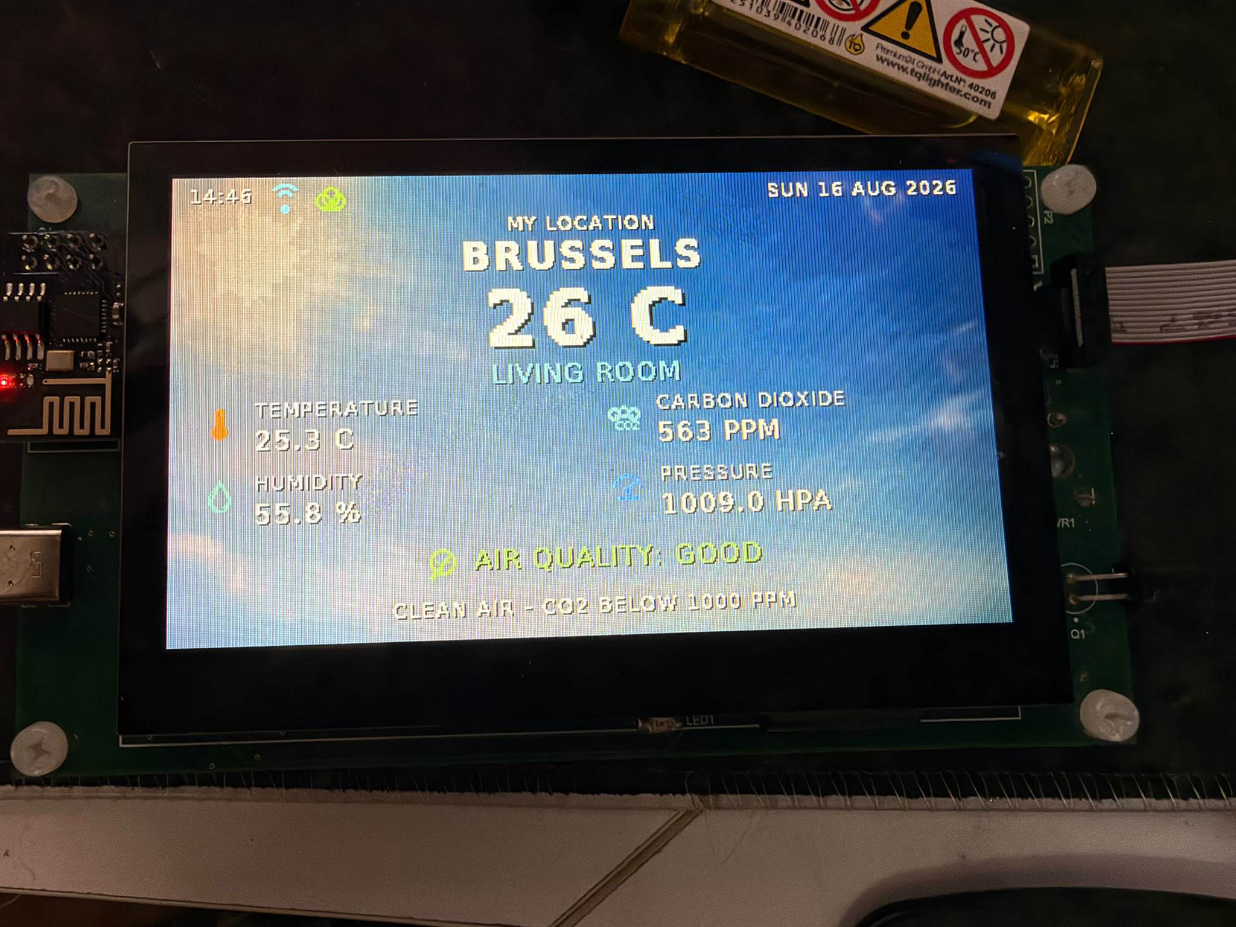
Figure 1 — Final working dashboard with network/cloud status, outdoor temperature, indoor measurements and evaluated air quality.

Contents
1 | Introduction and scope
2 | Requirements and success criteria
3 | System architecture
4 | Hardware design
5 | PCB implementation
6 | Manufacture and assembly
7 | Firmware and graphical interface
8 | Verification and test results
9 | Problems, corrections and lessons
10 | Improvement plan for Rev B
11 | Conclusion
Appendix A | Delivered project data
Appendix B | References
READING GUIDE
Sections 4–7 explain the implementation. Sections 8–10 contain the strongest evaluation evidence because they distinguish verified behaviour from remaining technical risks.

1 Introduction and scope
A single PCB that senses, informs, communicates and warns
The Smart Home Hub was conceived as a compact wall-mounted room controller and environmental monitor. It collects indoor measurements, presents them locally on a 480 × 272 display, publishes selected values remotely, retrieves location-aware outdoor information and raises an alert when an abnormal condition persists. The project deliberately combines digital buses, analog sensing, a high-pin-count RGB interface, switch-mode power conversion, external memory, USB and radio communication so that the PCB exercises the complete Advanced PCB workflow.

1.1 Functional scope
- Measure CO₂ concentration, temperature and humidity using the SCD41 on I²C4.
- Measure barometric pressure and relative gas resistance using the BME688 on I²C3; retain its temperature as a PCB/heater diagnostic.
- Monitor a phototransistor flame channel through ADC1/PA1 and an active-low comparator output on PH2.
- Show compensated room temperature/humidity, CO₂, pressure, air-quality interpretation, Wi-Fi/cloud state, local time/date and outdoor temperature on the 4.3-inch RGB display.
- Maintain flame and persistent gas-change monitoring in the background; display a warning and sound the buzzer when alarm criteria are met.
- Connect the ESP-01 through USART1 for Wi-Fi, Blynk and weather/time HTTP; use the MCP2221A on USART3 for PC service commands.

1.2 Deliberate limitations
The board is a laboratory prototype rather than a certified appliance. No claim is made for calibrated gas identification, fire-alarm compliance, long-term environmental accuracy, EMC or electrical-safety certification. The BME688 gas channel is a relative baseline-change detector and does not report a validated gas concentration in ppm. Plain HTTP is used only as a laboratory compatibility workaround for the installed ESP-01 firmware.

1.3 Evaluation evidence
Evidence comes from the archived Altium project, production data, schematic and PCB documentation, assembly observations, firmware source and repeatable bench tests. PASS is reserved for an observed end-to-end path. The GT911 touch function is marked NOT TESTABLE because its external flex is torn rather than because the PCB interface failed.

2 Requirements and success criteria
ID | Requirement | Acceptance evidence | Status
R1 | 5 V input and stable 3.3 V rail | Power-up without overheating; regulated rail present | PASS
R2 | STM32 boots and can be programmed | SWD programming and integrated firmware execution | PASS
R3 | Environmental sensing | Credible SCD41 and BME688 data | PASS
R4 | Local display | Legible dashboard; smooth double-buffered updates | PASS
R5 | Abnormal-condition alert | Priority screen and controlled buzzer | PASS
R6 | Wi-Fi/cloud link | ESP-01 joins AP; Blynk update succeeds | PASS
R7 | QSPI asset storage | JEDEC ID plus read/write and asset loading | PASS
R8 | SDRAM | Repeated full 8 MB test at 0xC0000000 | PASS
R9 | Capacitive touch | GT911 enumeration and coordinate reports | NOT TESTABLE
R10 | USB-to-UART contingency | COM enumeration and bidirectional terminal commands | PASS

DEFINITION OF DONE
The prototype is demonstrable when the MCU, display, environmental sensors, local alarm, Wi-Fi telemetry, memories and PC service interface operate together. Touch remains an external mechanical limitation and is disclosed separately.

3 System architecture
Domain separation simplifies design, bring-up and fault isolation
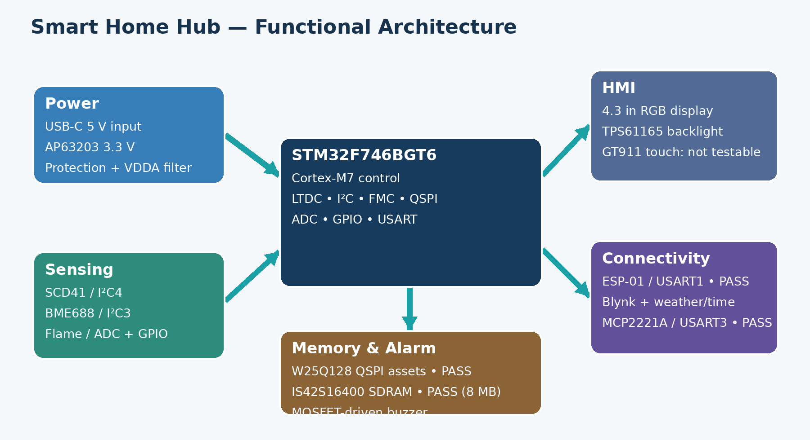
Figure 2 — Functional architecture and final verification state.

3.1 Interface allocation
MCU resource | Connected block | Purpose
LTDC / RGB | MDT0430A01ISC-RGB | 480 × 272 parallel pixel data and timing
I²C4 | SCD41 | Compensated room CO₂, temperature and humidity
I²C3 | BME688 | Pressure, gas resistance and PCB thermal diagnostics
ADC1 IN1 / PA1 | Flame A0 | Continuous analog optical response
GPIO PH2 | Flame D0 | Active-low comparator alarm
USART1 | ESP-01 | AT commands, Wi-Fi, Blynk and weather/time HTTP
USART3 | MCP2221A | Bidirectional USB PC service console
QUADSPI | W25Q128JV | Background themes, font glyphs and icons
FMC SDRAM | IS42S16400J | 8 MB framebuffers and working memory
GPIO | Buzzer MOSFET | Default-off low-side alarm switching

4 Hardware design
Power, processing, sensing, HMI, alarm, connectivity and memory

4.1 Power entry, protection and conversion
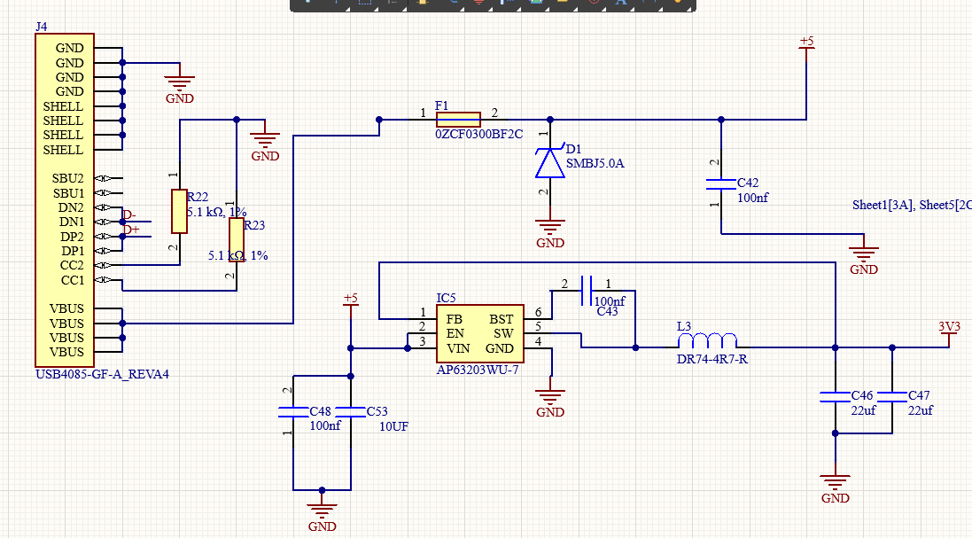
Figure 3 — USB-C power entry, protection and AP63203 3.3 V buck converter.
The hub is powered from a 5 V adapter rated for 3–5 A. The USB-C receptacle is configured as a sink with 5.1 kΩ pull-downs on CC1 and CC2. Joined VBUS pins feed a resettable fuse and 5 V TVS device before the protected rail reaches the load. The AP63203 synchronous buck converts 5 V to 3.3 V using local ceramic input, bootstrap and output capacitors and a shielded inductor.
The 5 V rail also supplies the display backlight and buzzer. The 3.3 V plane supplies the STM32 digital domain, sensors, memories, MCP2221A I/O and ESP-01. A ferrite-bead branch supplies VDDA to reduce switching noise before the ADC/reference domain.
BRING-UP RULE
Fit the MCU decoupling capacitors before functional testing. A Cortex-M7 may appear to boot without every 100 nF capacitor, but that is not a robust or valid hardware test.

4.2 MCU supply, clocking and display backlight
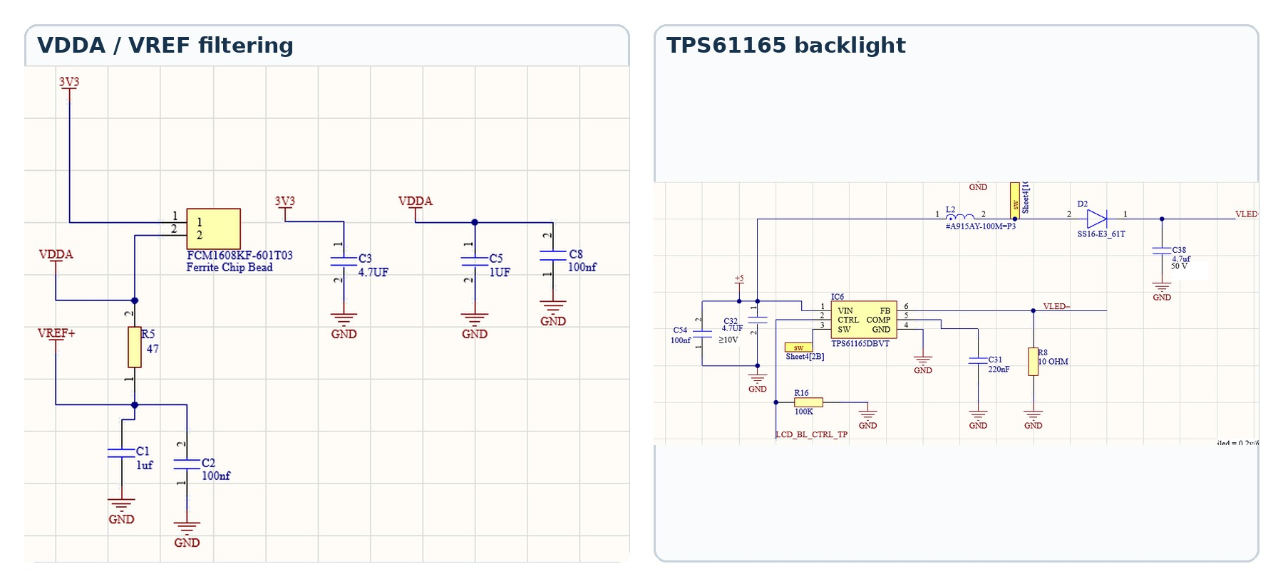
Figure 4 — Analog-supply filtering and the TPS61165 constant-current backlight stage.

MCU and analog reference
The STM32F746BGT6 is powered at 3.3 V with one 100 nF ceramic capacitor per VDD group and nearby bulk capacitance. VDDA is fed through the FCM1608KF-601T03 ferrite bead and locally decoupled. VREF+ is derived through 47 Ω and separately filtered, providing a quiet reference for the flame-sensor ADC.
The clock tree uses a 32.768 kHz low-speed crystal and an 8 MHz oscillator module. The final system runs at 200 MHz HCLK, while the FMC SDRAM clock is approximately 66 MHz.

Display and backlight
The 40-contact display flex carries 24-bit RGB, pixel clock, display enable and synchronization. The TPS61165 regulates LED-string current. CTRL is driven by the STM32 and has a 100 kΩ pull-down, so the backlight remains off while the MCU is unpowered. The boost output capacitor is rated for the LED-string voltage.
ASSEMBLY CORRECTION
The first backlight test failed because the external Schottky diode was fitted with reversed polarity. Correcting its orientation restored operation; the 4.7 µF / 50 V output capacitor was not the root cause.

4.3 Environmental sensing and compensation
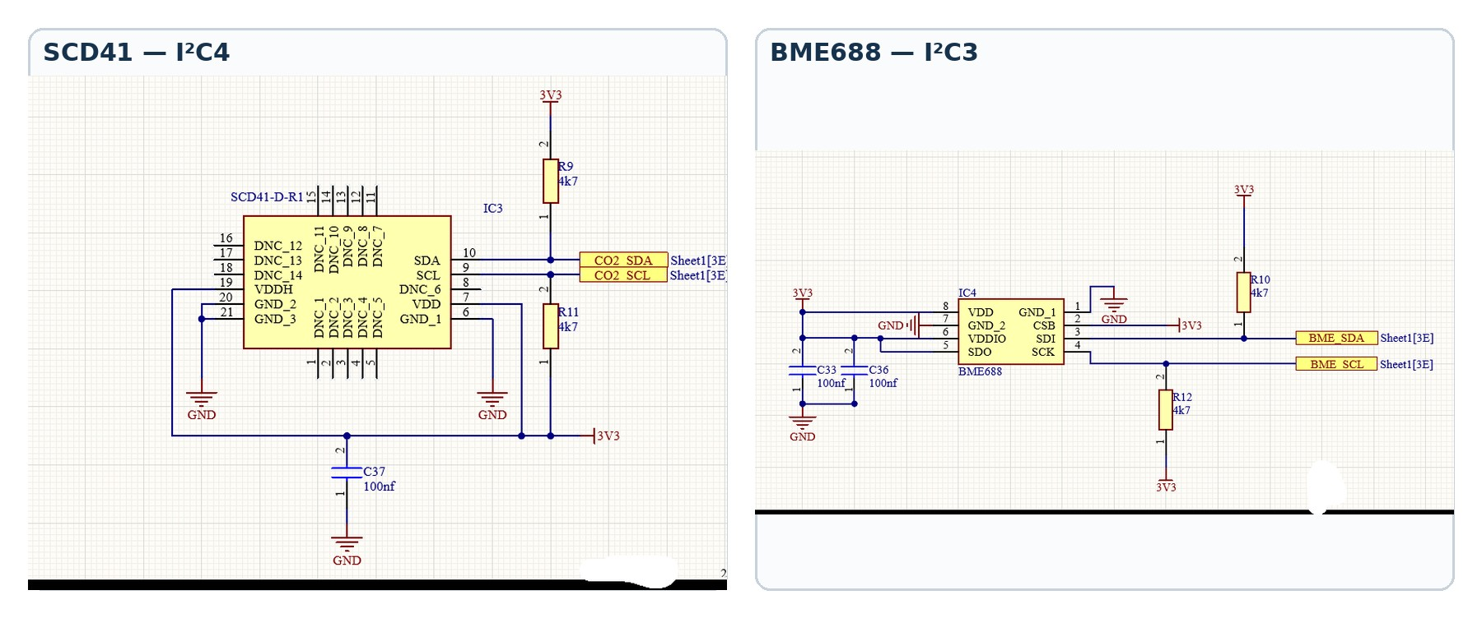
Figure 5 — Separate I²C buses and local pull-ups for the SCD41 and BME688.
The SCD41 is powered from 3.3 V and connected to I²C4 with 4.7 kΩ pull-ups. It is the authoritative source for room CO₂, temperature and relative humidity. Because the assembled display/PCB heats the local air, firmware programs a board-specific 9.3 °C SCD4x temperature offset at boot and applies 1/4 IIR smoothing. The compensated SCD41 values drive the dashboard, Blynk V4/V5 and room temperature/humidity alarms.
The BME688 is connected to I²C3 with independent VDD/VDDIO decoupling. CSB selects I²C mode, and firmware checks addresses 0x76 and 0x77. Pressure and gas resistance are used operationally. BME688 temperature remains visible in diagnostics as an indicator of PCB/heater conditions rather than the displayed room temperature.

Relative gas-change interpretation
After 60 valid heater-stable samples at 5 s intervals (about 5 min in clean air), the firmware establishes a baseline. An alarm requires a persistent change of roughly 30% from baseline for four consecutive samples (about 20 s). It clears only after the value returns within roughly 15% for six samples (about 30 s). This persistence and hysteresis suppress nuisance alarms while retaining sensitivity to a sustained change.
CALIBRATION CAUTION
The 9.3 °C SCD41 offset is installation-specific and must be recalibrated if the enclosure, display heating, airflow or sensor placement changes. Neither sensor result is a traceable calibration certificate.

4.4 Flame detector and audible alarm
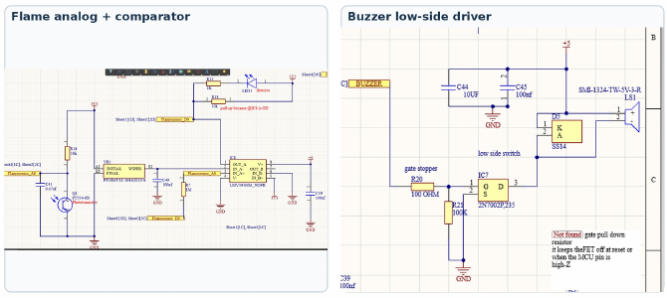
Figure 6 — Dual analog/digital flame path and default-off buzzer driver.
The PT334-6B phototransistor creates a light-dependent voltage at Flamesensor_A0. A 10 kΩ pull-up converts photocurrent to voltage and a 0.47 µF capacitor reduces high-frequency noise. PA1 samples this node using ADC1. The LMV393 compares the signal with the potentiometer threshold and generates an open-drain active-low D0 signal on PH2; a 10 kΩ pull-up defines the logic level and a local LED indicates detection.
The buzzer is supplied from 5 V and switched on the low side by a 2N7002 MOSFET. A 100 Ω gate resistor limits edge current, while the essential 100 kΩ gate-to-ground resistor keeps the MOSFET off during reset so the buzzer does not sound immediately at power-up.
Condition | Analog observation | Comparator | System response
No flame | A0 ≈ 3.19 V / ADC ≈3950 | D0 high | Buzzer off
Lighter presented | A0 ≈ 1.5 V / ADC ≈1730 | D0 low | Priority alarm logic active

SENSOR LIMITATION
A phototransistor can respond to sunlight, lamps and infrared sources. The dual analog/digital path aids diagnosis but is not a certified flame detector.

4.5 Connectivity and service interfaces
Interface | Electrical link | Purpose | Observed state
ESP-01 | USART1 | Wi-Fi AT command link | PASS — WLAN, TCP, Blynk and weather/time
MCP2221A | USB D+/D−; USART3 | PC service/debug console | PASS — enumerates and exchanges commands
SWD | SWDIO / SWCLK / NRST | Programming and debug | PASS — essential bring-up path
Test pads | Power/control nets | Probe access and rework | Included where practical

ESP-01 and cloud path
The ESP-01 operates at 3.3 V on USART1. Firmware confirms AT operation, joins the configured access point, opens TCP connections, updates Blynk and retrieves Brussels weather/time data. The working laboratory build uses plain HTTP on port 80 because the installed ESP AT firmware could not complete current TLS negotiation.

MCP2221A USB service console — resolved
The MCP2221A initially stopped enumerating and D+ measured shorted to ground. Continuity inspection isolated the fault to the USBLC6-2SC6 protection pin/path. After removing the short/reworking the device, Windows enumeration returned, the Microchip utility read the bridge configuration and bidirectional UART traffic was verified. PC10/USART3_TX drives MCP2221A URX; PC11/USART3_RX receives MCP2221A UTX at 115200 8N1.
The service console accepts HELP, PING, INFO, STATUS, SENSORS, NETWORK and MEMORY. A PING→PONG round trip proves the complete PC→USB→MCP2221A→STM32→MCP2221A→USB→PC path.
SECURITY IMPROVEMENT
Plain HTTP is acceptable only as a laboratory diagnostic. A deployable product should use current TLS, certificate validation and secure credential provisioning.

4.6 External memory
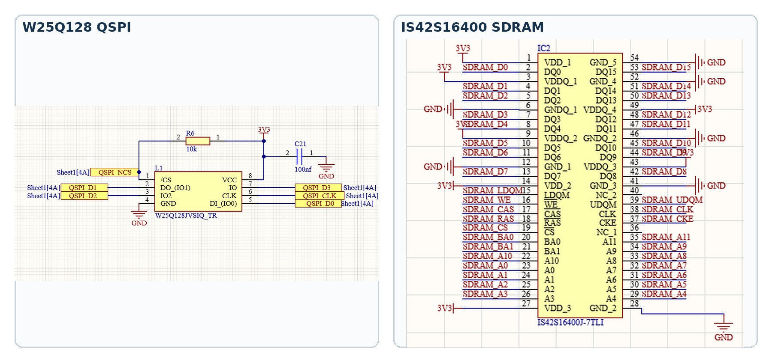
Figure 7 — External W25Q128 QSPI flash and 16-bit IS42S16400 SDRAM interfaces.

W25Q128JV QSPI flash
The 128-Mbit W25Q128JV provides 16 MB of non-volatile storage. /CS has a 10 kΩ pull-up so the flash remains deselected during reset. Firmware read JEDEC ID EF 40 18 and verified erase/program/read in a reserved region. The final build stores time/condition-themed backgrounds, the modern font and GUI icons in QSPI.

IS42S16400J SDRAM
The 64-Mbit SDR SDRAM is connected to the FMC through a 16-bit data bus plus address, bank, byte-mask, clock, enable and command signals. Startup issues clock-enable, precharge-all, auto-refresh and mode-register commands before programming refresh. Rework and a clean CubeMX FMC pin/timing configuration converted an early mismatch into a repeatable full-capacity PASS.
Item | Verified result
Base address | 0xC0000000
Capacity exercised | 8 MB / complete address range
Diagnostic clock | Approximately 66 MHz
Test | Address + multiple data patterns, repeated
Production use | Two 480 × 272 L8 GUI buffers plus working memory

MEMORY ROLE SEPARATION
QSPI is persistent asset storage; SDRAM is volatile framebuffer/working memory; internal SRAM holds stacks, drivers and compact control state.

5 PCB implementation
Four-layer stack, plane strategy, routing and design-rule control
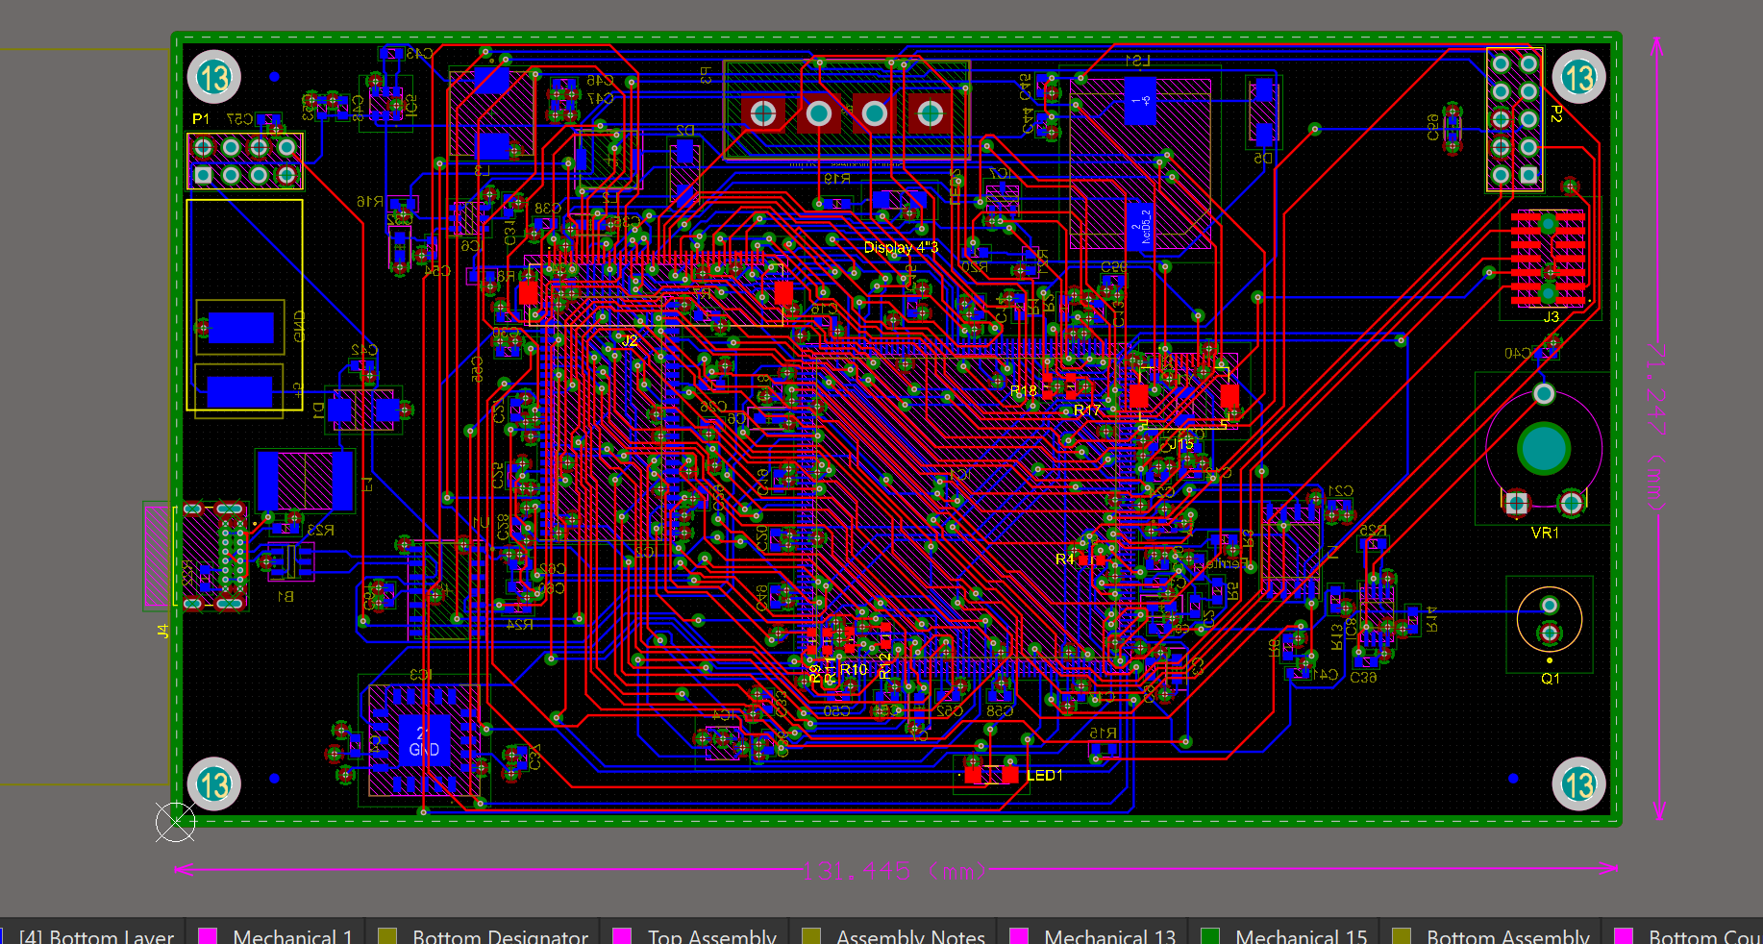
Figure 8 — Altium PCB view with top/bottom routing and internal planes visible.
Layer | Assignment | Design intent
Top | Signal + components | Dense STM32, memory and display escape routing
Layer 1 | GND plane | Low-impedance return path and reference plane
Layer 2 | 3V3 plane | Main low-voltage distribution
Bottom | Signal + components | Secondary routing, connectors and peripheral circuits

5.1 Placement and routing strategy
The STM32, SDRAM and QSPI flash occupy the dense central region to minimize parallel-bus length. The display connector sits at the edge to suit the flex direction. Power conversion remains near USB-C, while the optical flame sensor and threshold control are near the perimeter. Situs autorouting provided a starting point, followed by visual review and manual cleanup of power distribution, plane connections and constrained areas.
- Reference high-frequency signals to an uninterrupted ground plane and avoid return-current detours.
- Place each 100 nF decoupler beside its supply pin group with a short pad-to-via loop.
- Keep the backlight SW/inductor loop compact and away from analog/sensor signals.
- Use wide copper for 5 V backlight/buzzer current and the 3.3 V regulator output.

5.2 Design-rule and manufacturing checks
The board was checked for electrical clearance, routing width, via geometry, solder-mask slivers, silkscreen-to-mask clearance, component clearance and power-plane relief. Rules that generated excessive warnings were aligned with the selected fabricator's published capability; individual geometry errors were corrected rather than hidden by globally disabling checks.
Review item | Final treatment
Copper clearance / width | Checked against the selected fabricator's limits
Solder-mask slivers | Rule aligned with process capability; dense-pad cases manually reviewed
Silkscreen clearance | Overlay moved where it could interfere with soldering
Plane thermal relief | Blocked-spoke warnings reviewed at USB-C and plane-connected pads
Hole geometry | Four overlapping NPTH features corrected after CAM feedback

PLANE CONNECTIVITY
Layer 1 is assigned to GND and Layer 2 to 3V3. Plane-net assignment, repour, zero unrouted nets and final DRC are all required; a visually filled plane alone does not prove connectivity.

6 Manufacture and assembly
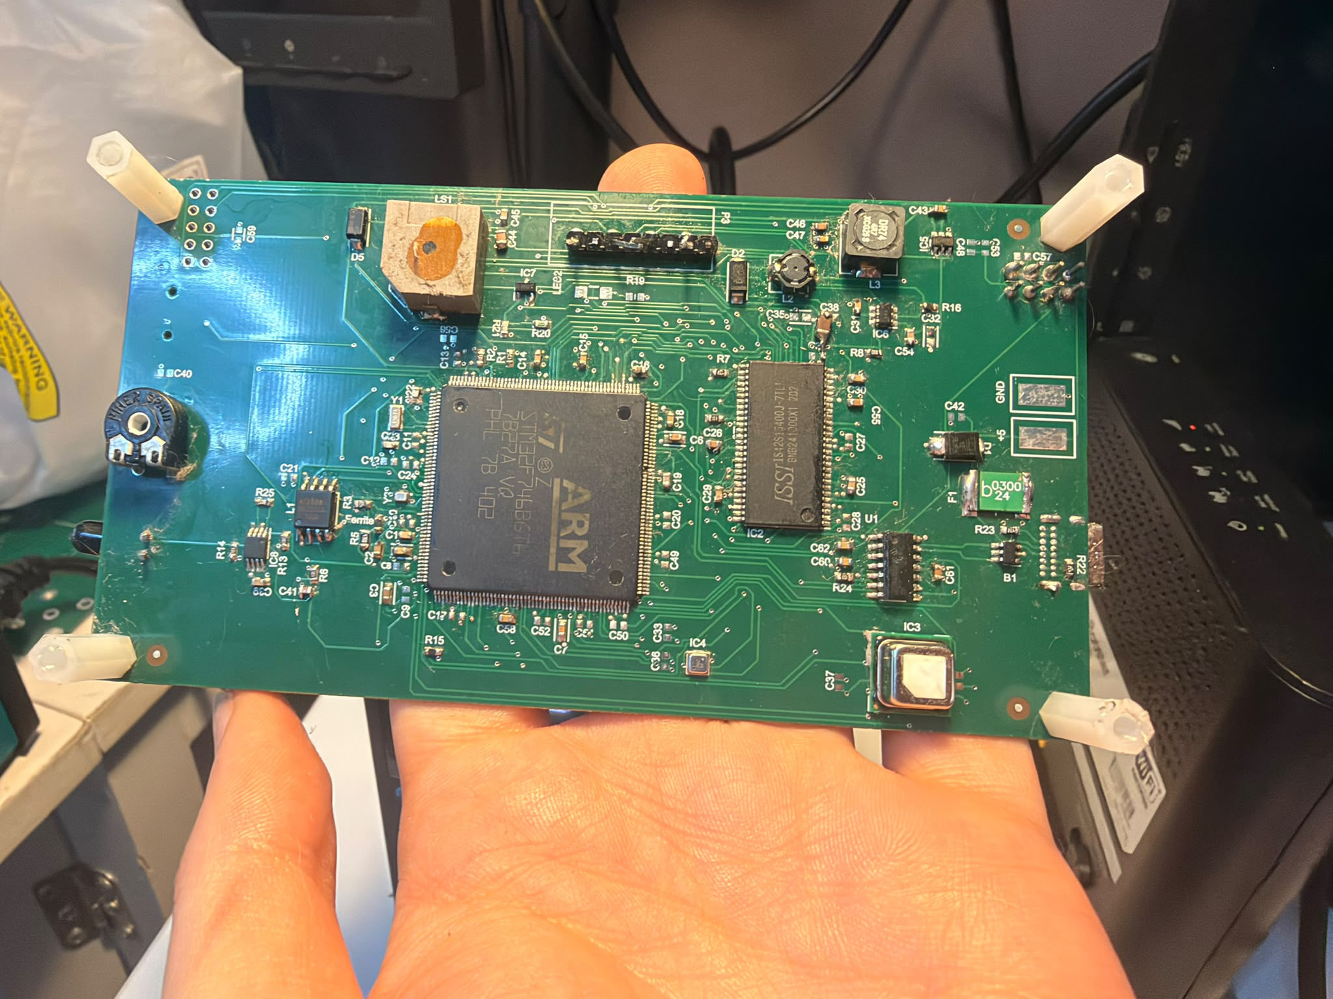  (a) Component side of the functional PCB. | 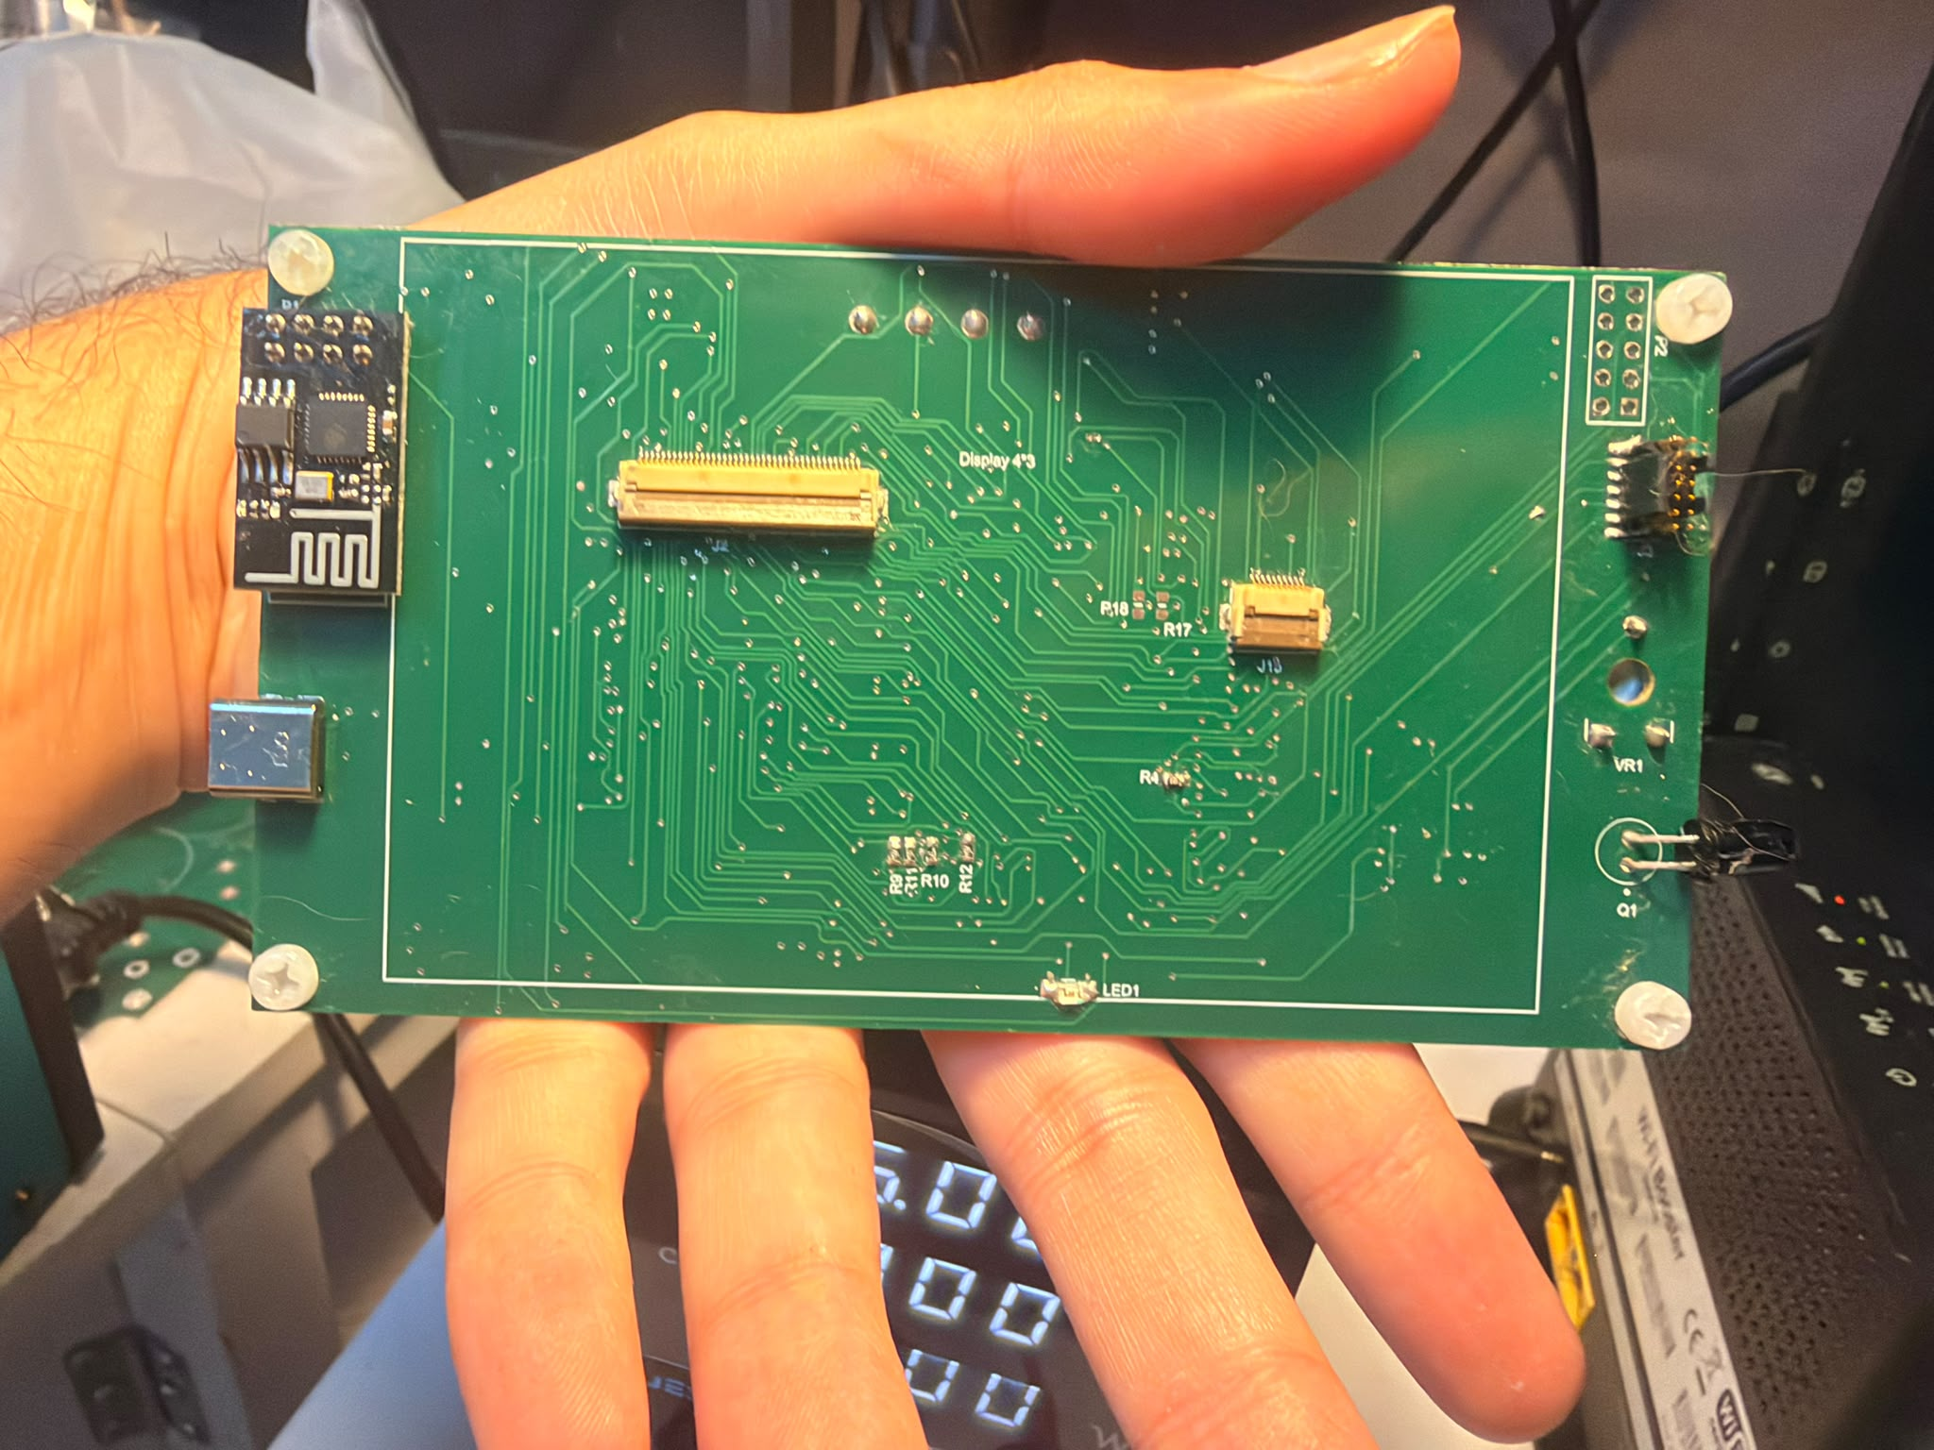  (b) Rear/connector side with display interfaces, ESP-01 and USB.

Figure 9 — Assembled four-layer prototype, shown from both sides.

6.1 Production package
Output | Purpose
Gerber / layer outputs | Copper, mask, overlay, paste and mechanical data
NC drill | Plated, non-plated, round and slot holes
Pick-and-place + BOM | Centroids/orientations and fitted-part information
Draftsman | Fabrication, assembly and drill drawings
DRC / ERC / differences | Design verification records
STEP | Board-level 3D exchange model

6.2 Fabrication query and assembly lessons
The fabricator identified four overlapping non-plated holes and asked whether the final diameter should be 3.45 mm or 3.2 mm. The source geometry was corrected before production. The most important component-level faults were also diagnosed systematically: the reversed TPS61165 Schottky diode, FMC/SDRAM solder/configuration issues and the USBLC6-2SC6 D+ short.

7 Firmware and graphical interface
Non-blocking acquisition, compensated values, local alarms and external-memory graphics
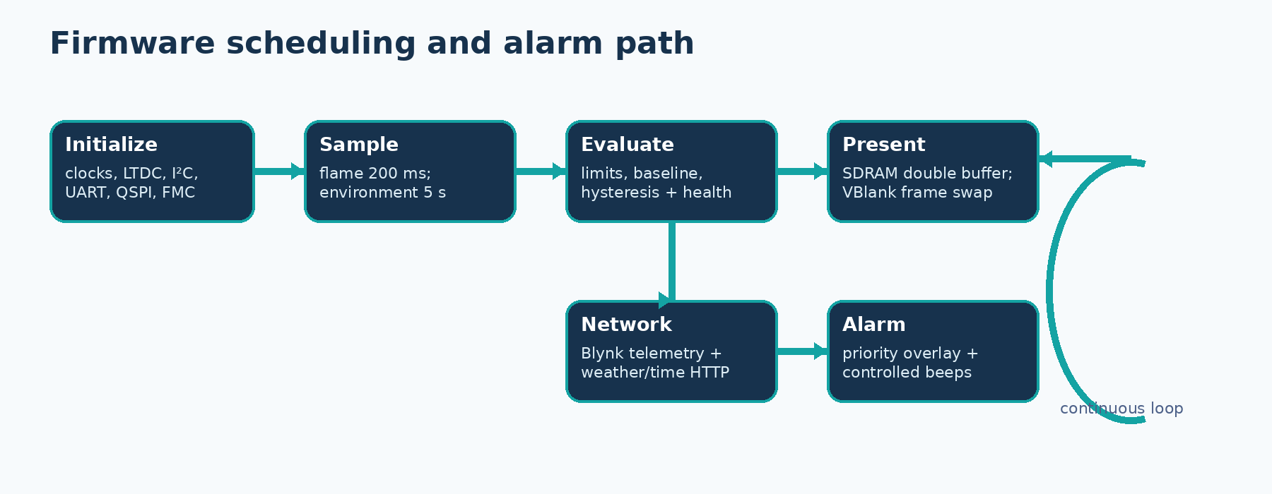
Figure 10 — Cooperative time-based scheduler used by the integrated firmware.

7.1 Peripheral configuration
Peripheral | Role
LTDC | 480 × 272 RGB timing with SDRAM-backed L8 layers
I²C3 / I²C4 | BME688 and SCD41 on separate buses
ADC1 / GPIO | Flame analog PA1, D0 PH2 and buzzer control
USART1 | ESP-01 AT commands and internet services
USART3 | MCP2221A bidirectional PC service console
QUADSPI | W25Q128 background/font/icon assets
FMC | 8 MB SDRAM diagnostics and GUI framebuffers

7.2 Timing and fault isolation
HAL_GetTick() schedules the cooperative main loop. Flame sampling runs every 200 ms; environmental acquisition approximately every 5 s; GUI refresh every 500 ms; Blynk upload every 10 s; Wi-Fi retry every 30 s; and weather/time retrieval at a slower interval. Each service owns an independent status so a failed cloud request does not disable local sensing or alarms.

7.3 Final graphical dashboard

Figure 11 — Final QSPI-themed, SDRAM-double-buffered dashboard with live local and internet data.
The top bar shows the clock, Wi-Fi/cloud icons and date. The centre shows the configured location and outdoor temperature. Indoor values use a two-column layout: compensated SCD41 room temperature/humidity on the left, and SCD41 CO₂ plus BME688 pressure on the right. The air-quality state and explanation remain visible below. Raw flame, gas and BME temperature continue in diagnostics/background monitoring and do not clutter the normal screen.
Flicker was removed by drawing the next dynamic layer into the inactive 480 × 272 L8 buffer in SDRAM, cleaning the relevant Cortex-M7 cache range and swapping the LTDC layer address during vertical blanking. QSPI supplies the themed background, modern font and icons; only a complete, ready frame is presented.
MEMORY USAGE
Two L8 GUI buffers consume about 255 KiB of SDRAM. QSPI supplies persistent assets without enlarging internal flash, and internal SRAM remains available for the scheduler, network parser and drivers.

7.4 Cloud data and alarm policy
Blynk datastream | Content | Representation
V0–V2 | Flame state, ADC and voltage | Boolean / raw / V
V3 | SCD41 CO₂ | ppm
V4 / V5 | Compensated SCD41 room T / RH | °C / %RH
V6 / V7 | BME688 temperature / humidity diagnostics | °C / %RH
V8 | BME688 pressure | hPa
V9–V11 | Gas resistance, ratio and alarm | Ω / % / Boolean

Measurements are batched where possible; flame state changes can be sent immediately. A separate HTTP request obtains Brussels outdoor temperature and the HTTP Date header supplies local date/time. The parser anchors on the actual HTTP/1.x header within the ESP-01 transcript, skips the header terminator and parses the signed body value.

Alarm philosophy
- Local indication and buzzer control never depend on Wi-Fi or Blynk availability.
- SCD41 compensated values drive room temperature/humidity decisions; BME temperature is diagnostic only.
- Gas detection arms only after a stable baseline and uses persistence plus clear hysteresis.
- The physical MOSFET gate pull-down guarantees buzzer-off during reset.
- Flame has priority; severe persistent environmental conditions can also produce a priority screen and buzzer pattern.

8 Verification and test results
Bench evidence for every major subsystem

8.1 Incremental method
Power rails and control pins were measured before firmware integration. Each digital peripheral was first tested with a narrow diagnostic program and only then added to the combined dashboard. The display was an immediate local test surface; the MCP2221A/USART3 console provided persistent diagnostic responses.
- Power — verify 5 V, regulated 3.3 V, acceptable current and repeatable MCU boot.
- Sensors — confirm I²C acknowledgement, manufacturer command sequence and plausible live values.
- Flame/buzzer — compare ADC voltage and D0/LED state, then verify controlled sounder behaviour.
- Connectivity — verify ESP AT responses, WLAN, Blynk, weather/time parsing and MCP terminal round trips.
- Memory — read QSPI ID and repeat complete 8 MB SDRAM address/data-pattern tests.
- HMI — verify backlight, QSPI assets, cache maintenance, VBlank buffer swapping and alarm priority.

8.2 Integrated demonstration snapshots
Snapshot | Outdoor | Room T / RH | CO₂ | Pressure | Air quality
Normal GUI photo | 22 °C | 34.3 °C / 31.9 % | 675 ppm | 1005.5 hPa | GOOD
Second stable state | 24 °C | 26.3 °C / 52.7 % | 600 ppm | 1009.2 hPa | GOOD

INTERPRETATION
These snapshots prove the complete acquisition/display path. They are not calibration certificates. The installation-specific SCD41 compensation should be verified against a reference after enclosure thermal equilibrium.

8.3 Verification matrix
Subsystem | Status | Evidence
5 V input / AP63203 3.3 V | PASS | Rails present; MCU/peripherals operate
STM32F746 boot / SWD | PASS | Firmware programs and runs
RGB LCD + TPS61165 | PASS | Image and backlight stable after diode correction
SCD41 on I²C4 | PASS | Compensated CO₂/T/RH integrated
BME688 on I²C3 | PASS | Pressure/gas and diagnostics acquired
Flame A0 / D0 | PASS | ADC and active-low D0 respond
Buzzer driver | PASS | Controlled by STM32; silent at reset
ESP-01 / Blynk / weather | PASS | AT, AP, TCP, Blynk and outdoor data
W25Q128 QSPI | PASS | EF 40 18; verified data and assets
IS42S16400 SDRAM | PASS | All 8 MB repeatedly verified at ~66 MHz
MCP2221A USB-UART | PASS | USBLC6 fault repaired; enumeration and two-way commands
GT911 touch | NOT TESTABLE | External touch FPC completely torn

8.5 Priority alarm evidence
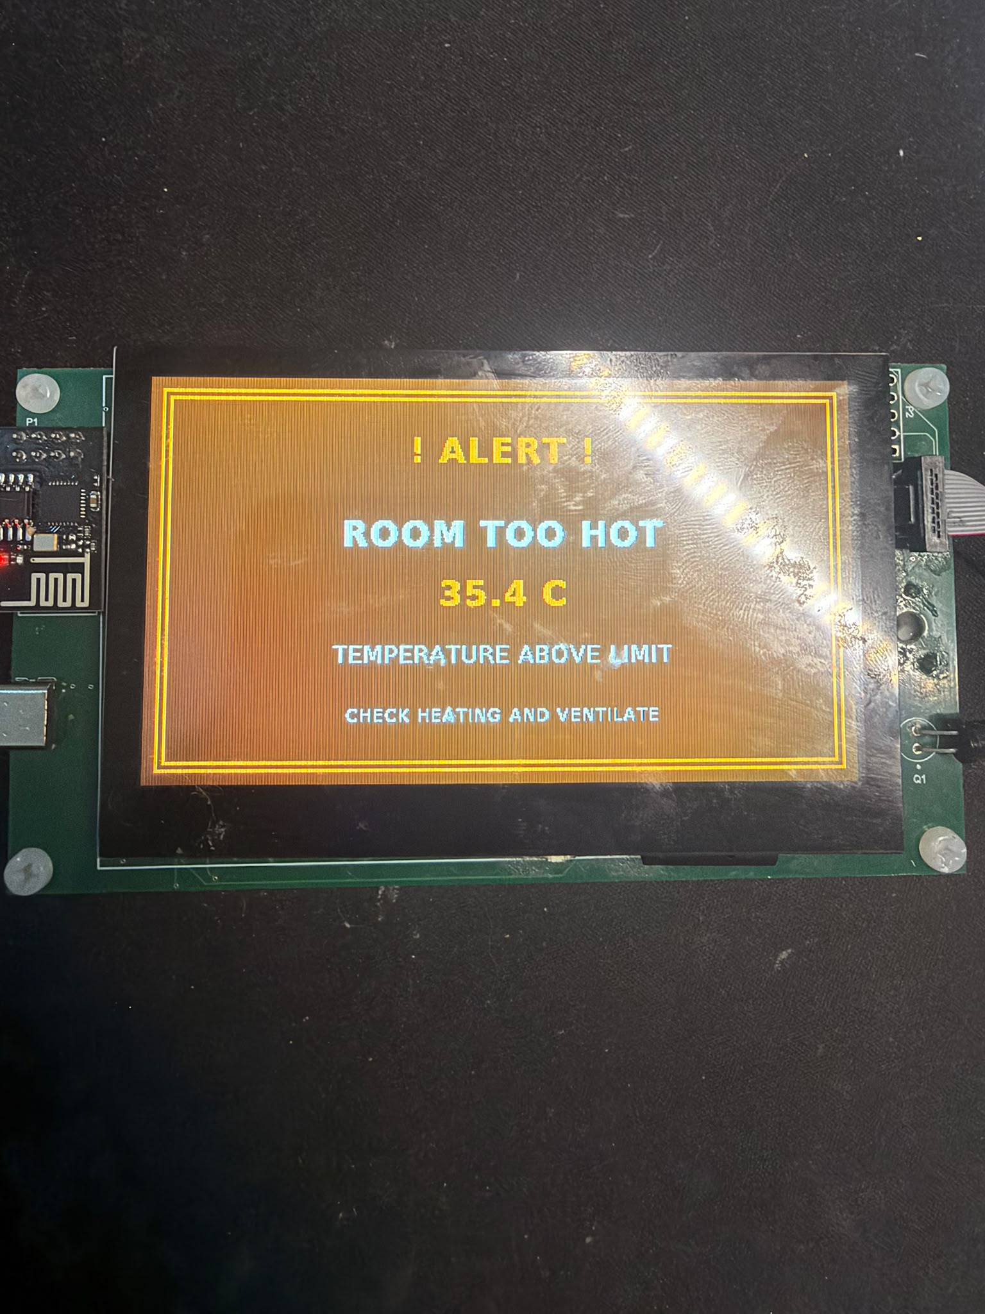
Figure 12 — Persistent high-temperature condition produces a priority warning screen and simultaneously activates the controlled buzzer.
The screen explicitly identifies the active condition, measured value and recommended response. The dashboard is restored after the alarm clears. This behaviour verifies the complete sensor decision → GUI priority → GPIO/MOSFET → buzzer chain rather than only an isolated buzzer test.
SAFETY STATEMENT
Alarm functions are valuable course demonstrations but remain non-certified. The hub must not replace approved smoke, flame, gas or carbon-monoxide alarms.

9 Problems, corrections and lessons
Failures were retained as structured engineering evidence
Symptom | Cause / status | Action | Rev-B prevention
Backlight remained off | External Schottky reversed | Corrected polarity | Larger cathode marking + checklist
Display flashed | Whole frame exposed while drawing | SDRAM double buffer + VBlank swap | Retain cache/VBlank discipline
ESP weather/SSL failed | Old TLS path; parser start wrong | HTTP and bounded HTTP-body parser | Current TLS-capable radio/firmware
MCP2221A did not enumerate | USBLC6-2SC6 D+ path shorted to GND | Continuity diagnosis + rework; full UART PASS | Verify ESD footprint; isolation/loopback pads
SDRAM mismatch | FMC conflicts plus solder/contact | Rework + clean FMC config; 8 MB PASS | Preserve production self-test
Touch unavailable | External flex mechanically torn | Removed from demonstration | Replaceable FFC + strain relief
Fabricator hole query | Four overlapping NPTH features | Corrected before production | Explicit hole-to-hole review

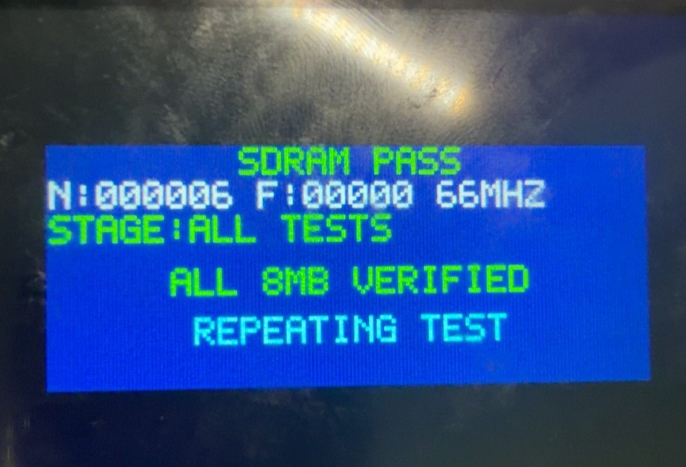
Figure 13 — Repeated full 8 MB SDRAM diagnostic after FMC correction and rework.
ENGINEERING LESSON
The SDRAM fault was not solved by adding bus pull-ups, and the MCP fault was not software. Repeatable electrical measurements, narrow subsystem tests and controlled rework converted both faults into repeatable PASS results.

10 Improvement plan for Rev B
Priority | Change | Implementation | Benefit
P1 | Touch serviceability | Replaceable FFC/assembly, strain relief and no copper at bend | Restores and protects input
P1 | Secure radio | Current TLS, certificate validation and supply margin | Removes plain-HTTP dependency
P2 | USB robustness | Keep ESD, add labelled D+/D−/TX/RX loopback and 0 Ω isolation | Faster deterministic diagnosis
P2 | Sensor thermal layout | Vented edge/peninsula away from display, MCU and inductors | Improves accuracy/response
P2 | Memory robustness | Preserve 8 MB self-test and optional series footprints | Protects framebuffer path
P2 | Manufacturing clarity | Stronger polarity/pin-1/NPTH checks and assembly drawings | Reduces rework/CAM queries
P3 | Firmware resilience | Watchdog, fault log, alarm latching, OTA and self-test | Improves maintainability

10.1 Validation additions
A second revision should include a written test specification covering supply current/ripple, sensor warm-up, reference-instrument comparison, gas-baseline repeatability, alarm thresholds, Wi-Fi reconnect behaviour, extended run time, temperature exposure and ESD/EMI pre-compliance. The present board proves the architecture but does not provide statistical product-validation evidence.
HIGHEST-VALUE NEXT ACTION
Replace the damaged touch assembly and improve touch-flex strain relief, then repeat sensor compensation inside the intended enclosure. Preserve the passing SDRAM and MCP service tests as production self-tests.

11 Conclusion
The Smart Home Hub achieved the central objective of the Advanced PCB course: a custom manufactured four-layer PCB that boots, senses the room, presents information locally, warns through an independently controlled buzzer and communicates over both Wi-Fi and USB service links. The design integrates a high-pin-count STM32, parallel RGB display, multiple I²C buses, analog comparator/ADC path, switch-mode conversion, external serial flash, parallel SDRAM and a complete production-data workflow.
Every populated/core PCB subsystem now passes end-to-end testing: stable power, STM32/SWD, display/backlight, SCD41, BME688, flame detector, buzzer, ESP-01/Blynk, internet weather/time, W25Q128 QSPI, full 8 MB SDRAM and the repaired MCP2221A/USART3 service console. The final firmware assigns memory correctly: QSPI holds persistent backgrounds, fonts and icons; SDRAM provides double-buffered GUI layers and working space; internal SRAM retains control state.
The only unavailable feature is GT911 touch input because the display assembly's external flex tail is mechanically torn. The operating hub does not depend on that input. Plain HTTP, installation-specific temperature compensation and non-certified flame/gas algorithms remain explicit development limitations rather than hidden product claims.
FINAL ASSESSMENT
The prototype is demonstrable and functionally useful for the course. Core paths, external memories, cloud data, alarm behaviour and the USB service console are verified; the remaining touch limitation and Rev-B risks are clearly documented.
.

Appendix A Delivered project data
ID | Deliverable | Content | State
A1 | Archived Altium project | PrjPcb, SchDoc, PcbDoc, OutJob and STEP | READY
A2 | Production package | Factory Gerber/layer files and NC drill | READY
A3 | Smart schematic PDF | Compiled hierarchical schematic set | READY
A4 | Draftsman | Assembly, fabrication and drill drawings | READY
A5 | Bill of materials | Standalone XLSX export | READY
A6 | Verification | DRC, ERC and differences reports | READY
A7 | Firmware | STM32CubeIDE project/source and build notes | READY
A8 | Technical report | This Rev 2.1 DOCX and PDF | READY
A9 | Presentation | Project PPT for oral demonstration | READY
A10 | A4 poster | Concise project overview | READY

Submission folder
Folder | Contents
01_Altium_Source | Archived source project and libraries
02_Production_Data | Exact factory-accepted package
03_Schematic_PDF | Smart PDF
04_Draftsman | Assembly/fabrication/drill PDF
05_BOM | XLSX and optional PDF
06_Verification | DRC, ERC and differences
07_ Electrical Rules Check Report
08_ PCB Differences | Differences
09_Firmware | STM32CubeIDE project/source and notes
10_Report | DOCX and PDF
11_Presentation_Poster | PPTX and A4 poster

Appendix B References
[1] STMicroelectronics, STM32F746BG product page and device documentation. https://www.st.com/en/microcontrollers-microprocessors/stm32f746bg.html
[2] Sensirion, SCD41 product page, SCD4x data sheet and temperature-offset guidance. https://sensirion.com/products/catalog/SCD41
[3] Bosch Sensortec, BME688 gas sensor product documentation. https://www.bosch-sensortec.com/en/products/environmental-sensors/gas-sensors/bme688/
[4] Texas Instruments, TPS61165 high-brightness LED driver data sheet. https://www.ti.com/product/TPS61165
[5] Diodes Incorporated, AP63203 synchronous buck converter. https://www.diodes.com/part/view/AP63203
[6] Microchip Technology, MCP2221A USB-to-I²C/UART bridge. https://www.microchip.com/en-us/product/mcp2221a
[7] Integrated Silicon Solution Inc., IS42S16400J SDR SDRAM family. https://www.issi.com/US/product-dram-SDR.shtml
[8] Winbond Electronics, W25Q128JV QSPI NOR flash family. https://www.winbond.com/hq/product/code-storage-flash/qspi-nor/
[9] Blynk documentation. https://docs.blynk.io/
[10] Altium Designer documentation. https://www.altium.com/documentation/altium-designer
[11] Project evidence: archived Altium design, factory outputs, schematics, STM32CubeIDE firmware, final dashboard photographs and bench observations.

Component naming note
Part numbers in this report follow the design and assembled prototype evidence available during preparation. The fabrication BOM, schematic libraries and fitted-component inspection remain authoritative for package, tolerance and ordering-suffix details.

