WiFi Based Secure Wireless Communication Using RSA

The WiFi based secured wireless communication using RSA encryption allows us to communicate wirelessly with security feature. The data transfer during communication between two system is encrypted using RSA encryption which is highly secure.

The data can be decrypted with correct key only, otherwise it returns some garbage value. This is two way communication system where we can transmit as well as receive at both ends. We have used Atmega microcontroller interfaced with xbee along with LCD display to send message and key, also have USB keyboards connected to each system and powered by 12V supply.

After starting system, we will able to enter message on system. The maximum limit of message is 32 character. After that system asks for key, the key limit is 16character it can be number or alphabet. Entering key will send the encrypted message to other system. Then the other system ask key to view the message. If the users enter correct key the message gets decrypted otherwise it will show garbage value thus securing the wireless communication.

Block Diagram :

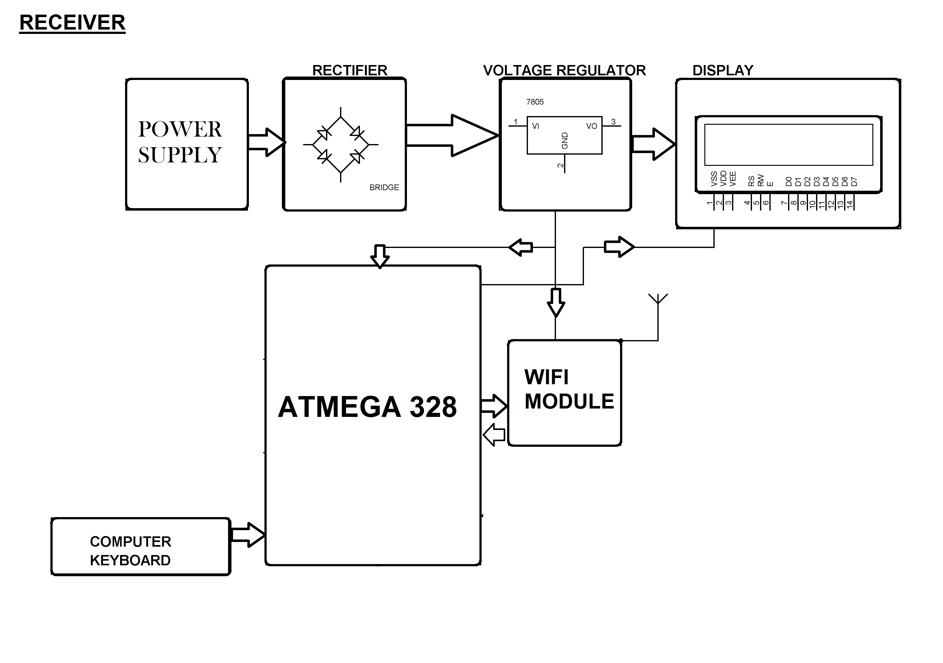

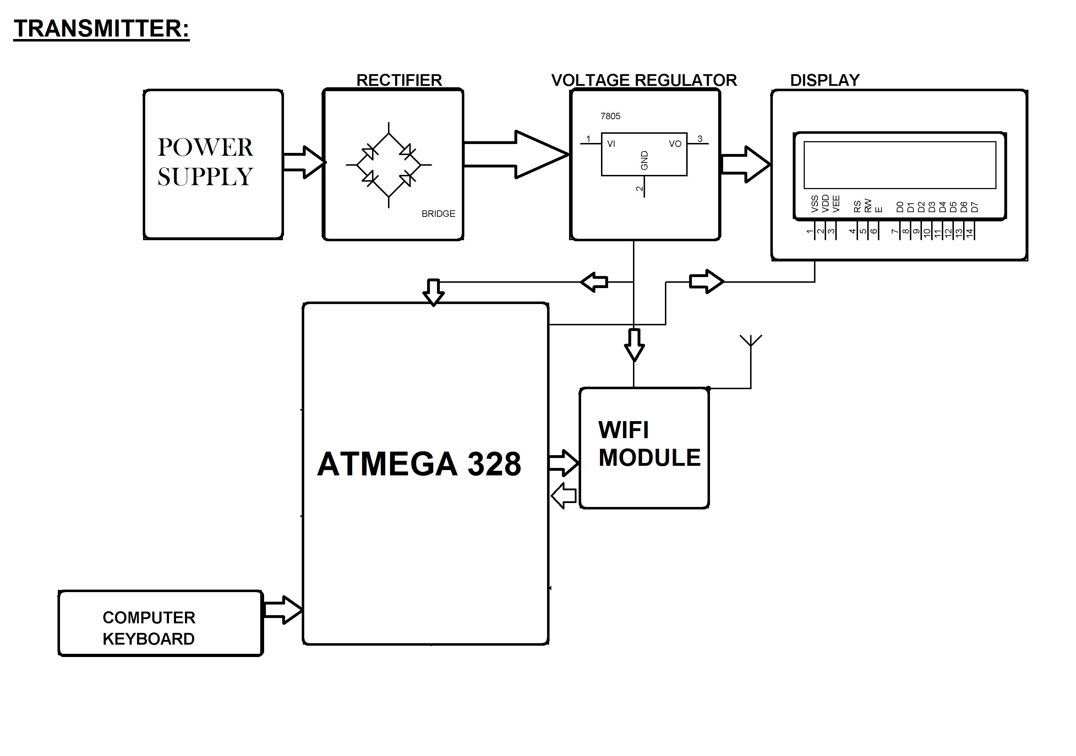

Hardware Specifications :
- Atmega 328 Microcontrollers
- 2 wifi modules
- LCD Displays
- USB Keyboards
- 12V Transformers
- Resistors
- Capacitors
- Diodes

Software Specifications :
- Arduino Compiler
- MC Programming Language: C

