**Web 103 Guide**

This document will provide a background on the fundamentals of programming.

Some of the most important fundamental parts of programming include:

* **Variables** are nothing more than places in memory. These are the specific items within a program which assigned variables can be changed while the program is running to create the desired effect.
* **Loops** are a programming structure to iterate (loop) information. The items in the array are indexed starting with the value 0.
* **Arrays** are variables that allow a list of common items in an arrangement for use in code.

**V = “Variables”**

We all know what variables are. You have used them for quite some time in school. Algebra relies on variables to be effective. Some examples of variables are items such as X=15, Y=X, Z > 30, and x = blue. Variables can be basically anything you want them to be from strings, integers, and even calculations.

Different coding styles use different syntax to create the places in memory. Let’s assume that I would to create a place in memory called taxRate which is assigned the value of 10%.

In JavaScript this would be assigned as follows:

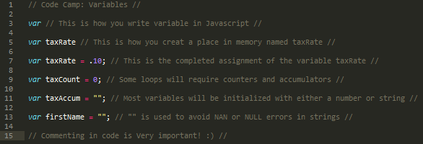

As you can see it is wise to initiate your variables before setting up the program. Not only is it good coding practice but also it reduces overall debugging time. As you program you will notice that the solution is always done first and the variables are derived from this solution so by the time you actually end up coding the program most of the variables should already be known.

There are plenty of learning opportunities on the web to better understand variables including:

[JavaScript variables examples](http://www.w3schools.com/js/js_variables.asp)

[PHP variables examples](http://www.w3schools.com/php/php_variables.asp)

[Python variables examples](http://www.tutorialspoint.com/python/python_variable_types.htm)

[C++ variables examples](http://www.cplusplus.com/doc/tutorial/variables/)

You will notice that while the syntax for defining the variables in each program may be different, the end results are all the same. You are simply naming a place in memory that holds a value!

**While (Loops == “yes”)**

**{** //begin loops

There are 3 forms of loops in programming languages. The While Loop, For Loop, and Do.. While Loop. The Do.. While Loop is rarely used so I will leave it up to you to research the necessity and usability for using this type of loop.

**While Loop**

**{** // begin while loops

The While Loop is used whenever you want to continue looping a block of code until a conditional objective is met. This kind of loop is best used when you don’t have a specific number of times that you intend the code to loop.

Let’s say that you want to create a program that will add names to a guest list until there are no more guests. This loop could have been a For Loop if the number of guests had a cutoff number but for this example you can have an unlimited amount of guests.

The first part of a While Loop is the entrance. In general you will initiate a variable with a true value to facilitate this.



After the variable has been initiated you ask if it is true to enter into your loop.



Regardless of the programming language used to enter into the loop, it is very important to remember to not reassign the loop. For instance, in JavaScript, it requires two = signs to evaluate a variable while one = sign assigns a new value to a variable.

Thirdly, it is important to establish a way out of the loop by contradicting the true condition. In this instance, you would simply make sure that you prompt the user to evaluate whether or not there are more guests. A value of “no” (or in this very simple, if/else condition, example anything other than yes) will take you out of the loop.



This is the complete set of code in JavaScript to complete the aforementioned guest list program. Often while creating a program the easiest part generally ends up being the code itself. Always keep in mind that the solution first leads to a program to obtain the desired results.

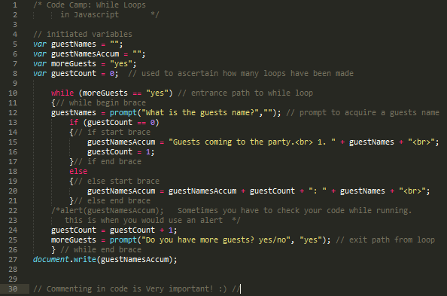

[JavaScript While Loop](http://www.w3schools.com/js/js_loop_while.asp)

[C++ while loop examples](http://www.cplusplus.com/doc/tutorial/control/)

[PHP while loop examples](http://www.w3schools.com/php/php_looping.asp)

[Python while loop examples](http://www.tutorialspoint.com/python/python_while_loop.htm)

**}** // end while loops

**For Loop**

**{ //begin for loops**

The For Loop is primarily used to output an Array which was lightly discussed earlier and more thoroughly discussed later. Let’s revisit the guest list program to demonstrate how a For Loop is used. In this case, we’ll assume that the guest’s names were added to the code through inputting information into a variable.

Here are some concepts with For Loops that are unique from while loops.

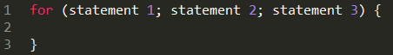

As you can see with the above image, for loops require three statements to function.

* **Statement 1.**
  + This statement is executed at the beginning of the loop. It sets the parameters of the code block which will be executed. Generally it assigns a variable. An example is *i = 0*
* **Statement 2.**
  + This statement defines the running conditions for the code block. This statement is often seen as the previous variable starting at 0 (statement 1) to begin a count based on the length of the amount of items in an array. An example is

*i < arrayname.length;*

* **Statement 3.**

Finally, the third statement sets the iterations. Generally we will see this as a counter which runs through the amount of steps to meet statement 2’s requirements. This is the actual looping. While you can loop by any amount such as 3 it’s generally seen as 1 which in JavaScript is shown as i++



This example above uses an array that houses names of guests. Arrays are used because you can assign more than one value to a variable.



The above example shows what is needed for an array to print out a guest list. ***Statement 1*** is the variable var i=0; ***Statement 2*** shows the running conditions. This basically says for i run the loop so long as i is less than the length (amount of variables within guestNames) of the array named guestNames. i < guestNames.length; ***Statement 3*** shows the way that you plan to iterate. i++ in JavaScript tells the loop to run in increments of 1 until the condition is met.



The above example sets a number for each name within the variable. Notice that you can insert an HTML line break within the JavaScript code so long as it is within quotes.

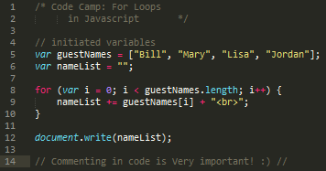

The above example shows the complete script to print out the guest list.

} **//end for loops**

Loops and arrays are very commonly used while coding so it’s a good idea to do as much research and practice as possible. Here are some great references for loops.

[JavaScript loop examples](http://webcheatsheet.com/javascript/loops.php)

[C++ loop examples](http://www.tutorialspoint.com/cplusplus/cpp_loop_types.htm)

[PHP for loop examples](http://www.php.net/manual/en/control-structures.for.php)

[PHP while loop examples](http://www.php.net/manual/en/control-structures.while.php)

[PHP do while loop examples](http://www.php.net/manual/en/control-structures.do.while.php)

[Python loop examples](http://www.tutorialspoint.com/python/python_loops.htm)

} **//end loops**

**Arrays[a,b,c]**

Arrays are nothing more than a structure for arranging more than one equally spaced object to the same variable. An example for this follows.



An important thing to remember about the array is that the first objects spatial value within the array always begins with 0. See example for a better understanding.



[JavaScript array examples](https://developer.mozilla.org/en-US/docs/Web/JavaScript/Reference/Global_Objects/Array)

[PHP array examples](http://us3.php.net/manual/en/language.types.array.php)

[C++ array examples](http://www.cplusplus.com/doc/tutorial/arrays/)

[Python Array examples](http://www.i-programmer.info/programming/python/3942-arrays-in-python.html)

**Wow!** This seems like a lot of information to take in at one time. Don’t let this weigh down your thoughts though. You will often find that problem solving takes up the majority of the work when it comes to code preparation.

If you are completely new to the programming field, work a little bit on your problem solving abilities, as this is a very important part of this line of work. Here are some great online resources to help yourself with these skills.

[Problem Solving Basics and Computer Programming](http://www.cs.iit.edu/~cs100/ProblemSolving.pdf)

[Overview of Programming and Problem Solving](http://computerscience.jbpub.com/vbnet/pdfs/mcmillan01.pdf)

[Jim’s Computer Science Topics](http://www.cs.utah.edu/~germain/PPS/Topics/index.html)

[Problem Solving with Algorithms and Data Structures](http://interactivepython.org/runestone/static/pythonds/Introduction/introduction.html)

[Problem Solving Skills](http://www.palgrave.com/skills4study/studyskills/thinking/problem.asp)