**Scud Hunt for Volunteer Science: Proposed Research Design**

*Proposed Milestones*

**Q1:** Alpha/prototype of single player Scud Hunt.

**Q2:** Collect single player data on 100+ participants. Develop prototype of multi-player Scud Hunt.

**Q3:** Analyze single player data. Begin multi-player data collection (goal of 50-75 teams). Develop additional features, such as a dashboard w/analytics condition.

**Q4:** Write-up collaborative paper on single-player Scud Hunt. Continue running multi-player Scud Hunt and add new manipulations. Begin analysis of multi-player data.

*Research Design*

Scud Hunt was a Mission Command game developed by the Center for Naval Analyses to study team performance and shared situation awareness. The goal of the game is to locate hidden Scud missile launchers on a grid map. To find the missiles, four players have control of distinct units (e.g., satellite, spy) with unique capabilities. Because unit resources are limited it is not possible for players to independently search every square, thus success in finding the missiles increases with coordination and collaboration between players.

We propose using the Scud Hunt to investigate individual and team performance for different presentations of information (e.g., a visual common operating picture of asset locations, text message updates, and/or real-time chat) and possibly different team configurations (e.g., the Commander issues orders to other players).

*Game Details*

The original version of Scud Hunt was played on a 5 x 5 grid with four players controlling their own units. Each unit has trade-offs for information gathering capabilities and coverage of the map. The game is turn-based. In the original version there were five turns.

*Open Questions*:

* We need a catchier name.
* Should the task be changed to something along the lines of finding weapons caches and seizing them? Calling in air strikes is not politically correct.
* The game could be incentivized with points (a score at the end) and/or badges. Maybe units could be leveled-up in capabilities as points are accumulated, with difficulty also increased. This is how most tower defense games are structured. Maybe the multi-player version can have a team score?

1. Original Scud Hunt

**

1. Original Unit Capabilities



The game could be simplified by providing each player with only one asset.

To simplify the game, initially, one asset can either determine a square is clear or a square may have a target. If the square might have a target, the second asset provides cross-cuing to determining either the square is clear or confirming there is a target.

In the original version, at the end of turn 5, the players were required to reach a group decision on the missile locations for air strikes. Here, we propose each individual makes their own decisions on the missile locations and their recommendations are provided to the Commander/Space Asset Manager for their final decision. In the initial multi-player version no hierarchical structure will be imposed, players will be able to chat to coordinate. In future versions, different structures will be added.

*Tutorial*

Create a brief interactive tutorial for players learn to use the interface and learn how to play the game. Example the capabilities of the different units controlled by each player using examples.

*Interface*

Grid map of the area of operations. Move units by clicking on the unit and then clicking on the square it will be moved to (grey out moves that cannot be made). Grid squares can be marked with icons representing their status as possible target locations (either by clicking the square itself and cycling through the possible icons, or by having a set of icons that can be dragged to the map). In the condition with no shared Common Operating Picture, the player will see an icon of their asset’s location and coverage. In the condition with a shared COP, the player will see the locations and coverage of all assets.

Player’s asset reports. On each turn, the asset assigned to the player will generate a report from each grid square where it has coverage. For example, the satellite can search an entire column in one turn, so it will generate a report on each grid square of the column it is in.

Situation Reports. This is where information from other players will be displayed. When a multiplayer version is developed, this can just be chat between the players. In the single player version, this would be automated messages from each “player” on describing the reports from their assets on that turn, and also where there asset will move to on the following turn.

Crude mock-up of interface in condition without shared Common Operating Picture (COP):

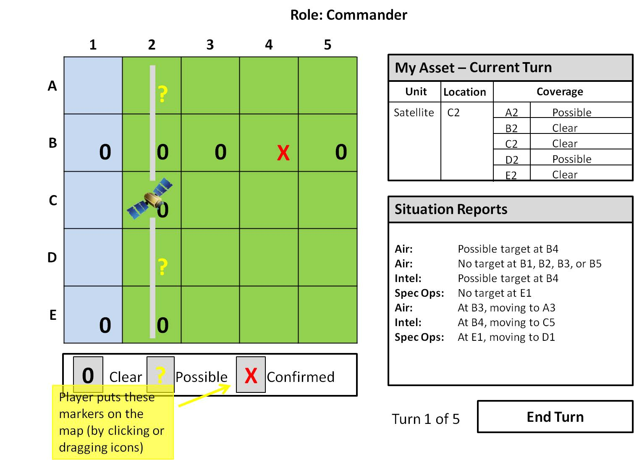

With shared Common Operating Picture (COP):

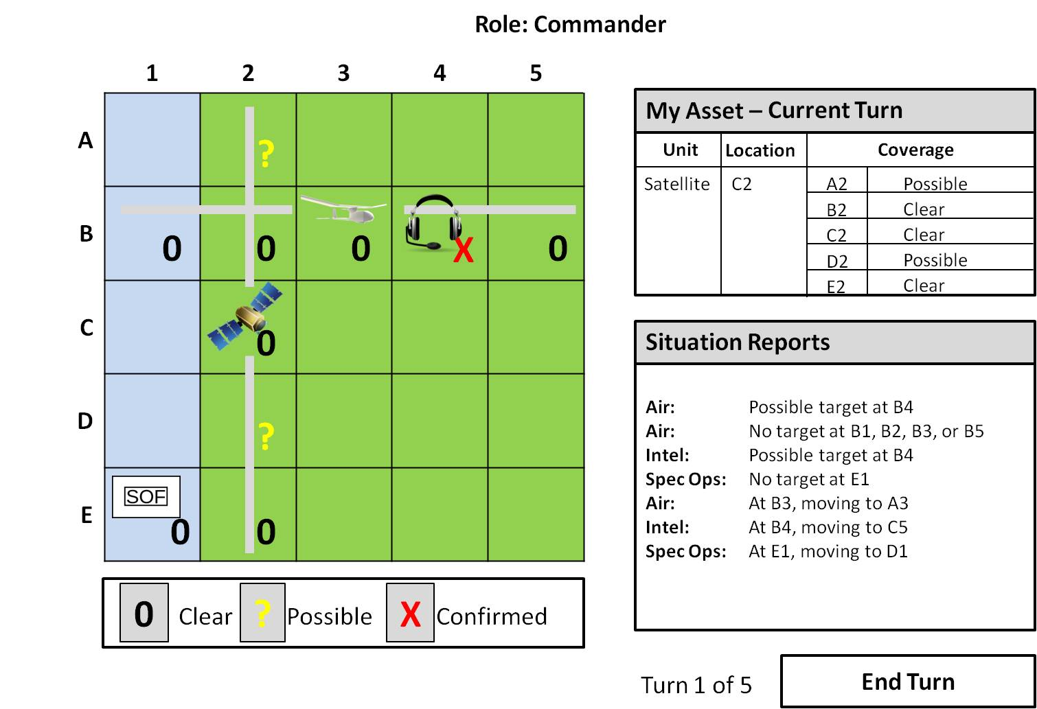

Do we want a toggle to turn on/off the assets being used by other players? Otherwise, the map will be busy. Manipulate this in the future?

*Game Play (first pass)*

* Goal: Determine the location of three SCUDs over 5 turns.
* The player is assigned a single asset with a specified amount of map coverage.
* On each turn, the player decides where to send that asset, and receives a report about the status of the grid squares included in the coverage. Report is either “possible target” or “clear.”
* On each turn, the player will also receive messages about what the other “players’” assets reported, as well as where the other “players” are sending their assets on the next turn.
* As a starting point, we can say that all assets are 100% accurate at ruling out targets. So, if the report is “clear,” the square is definitely clear.
* However, the assets do generate false alarms. So, if the report is “possible,” it only 50% (?) likely that the square contains a target.
* If at least two assets report “possible” at the same grid square, then it is 100% certain that a target is present there.
* There will be a time limit of 1 minute (?) for each turn to allow the player to read and process the reports from his asset and from the other “players,” and to update the map. They will be able to end the turn themselves (at least in the single player version) if they don’t need the full minute.
* Or permit players to change their move until the one minute is up? A standardized time is better research design, but may be annoying to players and increase the study duration. Especially in the multi-player version. Also, how much time a player takes may be a useful DV.
* At the end of turn 5, players will indicate their belief of each missile location by clicking on the appropriate square. After each click, a Likert scale confidence rating will pop-up (1 = guessing, … , 7 = completely sure).

*Players and Assets*

* Commander/Space Asset Manager: Recon satellite
  + Can search an entire column on each turn
  + Can be sent to any grid square
* Air Asset Manager: UAV
  + Can search an entire row on each turn
  + Can be sent to any grid square
* Intelligence Manager: Communications (or Human?) Intelligence
  + Can search a single square
  + Can be sent to any square initially, can only move one square away from current location on each turn
* Special Operations Manager: Joint Special Ops
  + Can search a single square
  + Can be sent to any square initially, can only move one square away from current location on each turn

*Configurable Parameters*

Grid size, number of turns, number of human or AI players, type of AI (rule/heuristic-based, random, or predetermined?), scenario (random missile location or predetermined missile locations), probabilities (false positive for manned aircraft, UAV shot down, communications fooled by deception operations), unit capabilities (information gathering, movements, and map coverage), timing (time limit for each turn, time limit for selecting missile locations), and map properties (text file with types of squares: land or water).

*Single Player Study*

Display Elements:

* Grid map (player can mark squares as “Clear,” “Possible,” or “Confirmed” target locations
* Coverage report from the player’s asset on that turn
* Situation reports from three other “players” listing their assets’ reports and planned location for next turn. This could be replaced by text chat in a multi-player version.

1. *Condition 1 – No Shared COP:*

The map is only populated with the location and coverage of the player’s asset. Information on other assets is only available through situation reports.

1. *Condition 2 – Shared COP:*

The map is populated with the location and coverage of all assets.

*Missile accuracy:*

We hypothesize greater accuracy for the common operating picture vs. no common operating picture.

*Search efficiency measure?*

*Multi-Player Study*

Details TBD.

*Data Dictionary and Database Schema*

**Primary Key: ParticipantID?**

1. Data dictionary: List of variable names (measures) with descriptions.
2. Schema
3. Sample data tables

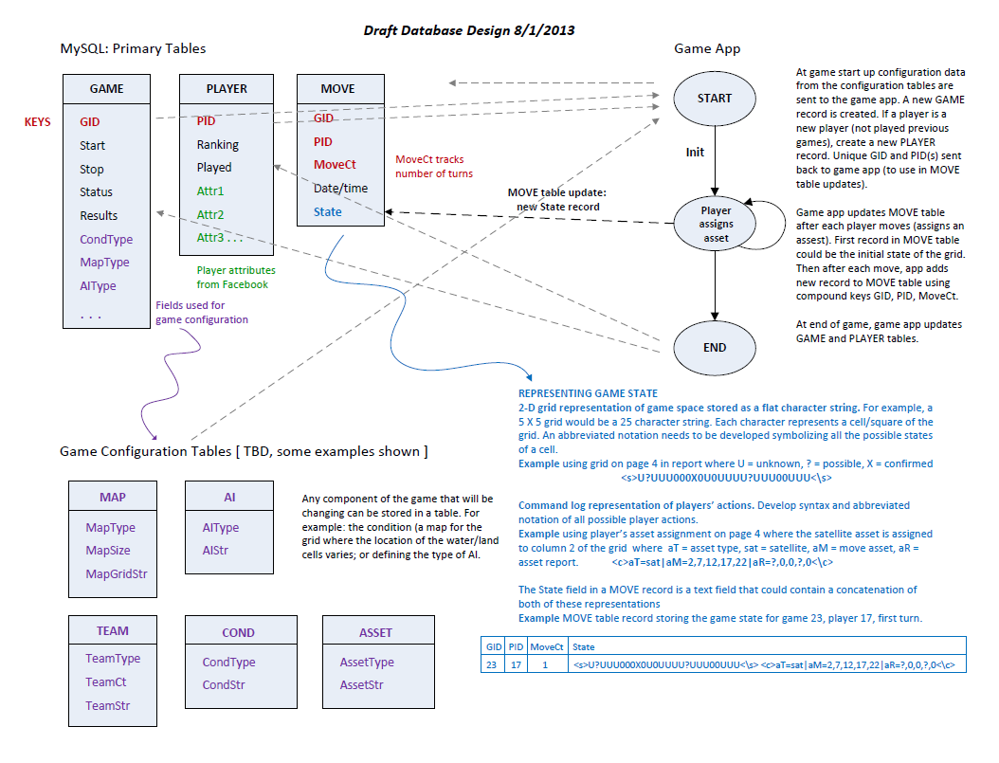

JB: Also have a game state is table with separate variables (e.g., ParticipantID, Role, Turn, AssetType, MoveAsset, and AssetReport)? This will make analysis easier than parsing log data.