EXPERIMENT NO. 9

Design of Rectangular Microstrip Antenna using line feeding technique to operate over ISM frequency band, using HFSS.

EXPERIMENT NO. 9

AIM: To design Rectangular Microstrip Antenna using line feeding technique at a frequency of 2.4 GHz, using HFSS.
EQUIPMENTS: HFSS Software.

THEORY:
A feed line is used to excite to radiator by direct or indirect contact. Feeding techniques for Microstrip patch antennas can be classified into two main categories i.e. Contacting and Non-contacting. In the contacting method, the RF power is fed directly to the radiating patch using a connecting element while in the non-contacting scheme electromagnetic field coupling is done to transfer power between the microstrip line and the radiating patch. There are many different techniques of feeding and four most popular techniques are coaxial probe feed, microstrip line, aperture coupling and proximity coupling.

A microstrip antenna in its simplest form consists of a radiating patch on one side of a dielectric substrate and a ground plane on the other side. The top and side view of a rectangular MSA (RMSA) is shown in Figure 1.
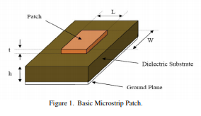
Figure 2 shows microstrip antenna fed by a microstrip transmission line. The patch, microstrip transmission line and ground plane are made of high conductivity metal (typically copper). The patch is of length ‘L’ and width ‘W’, etched on top of a substrate of thickness ‘h’ with permittivity ‘єr’. Typically, the height h is much smaller than the wavelength of operation, but not much smaller than 0.05 of a wavelength.
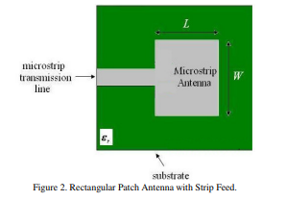
The types of MSA line feeding methods includes microstrip inset line feed and microstrip quaterwave line feed.
Microstrip inset line feed:
Microstrip line feed is one of the easier methods to fabricate as it is a just conducting strip connecting to the patch and therefore can be consider as extension of patch. It is simple to model and easy to match by controlling the inset position. Since the current is low at the ends of a half-wave patch and increases in magnitude towards the center, the input impedance (Z=V/I) could be reduced if the patch was fed closer to the center. One method of doing this is by using an inset feed (a distance R from the end) as shown in Figure 3.
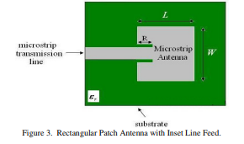

Microstrip quarter wave line feed
The microstrip antenna can also be matched to a transmission line of characteristic impedance Z0 by using a Quarter-wave transmission line of characteristic impedance Z1 as shown in below Figure 4.
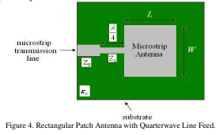

Design equations of RMSA

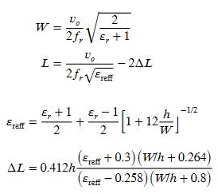

The simulation results are as obtained in figure 5and 6 below.

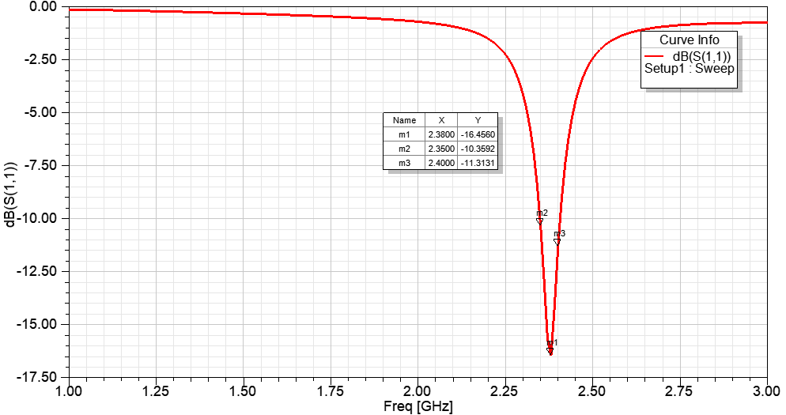

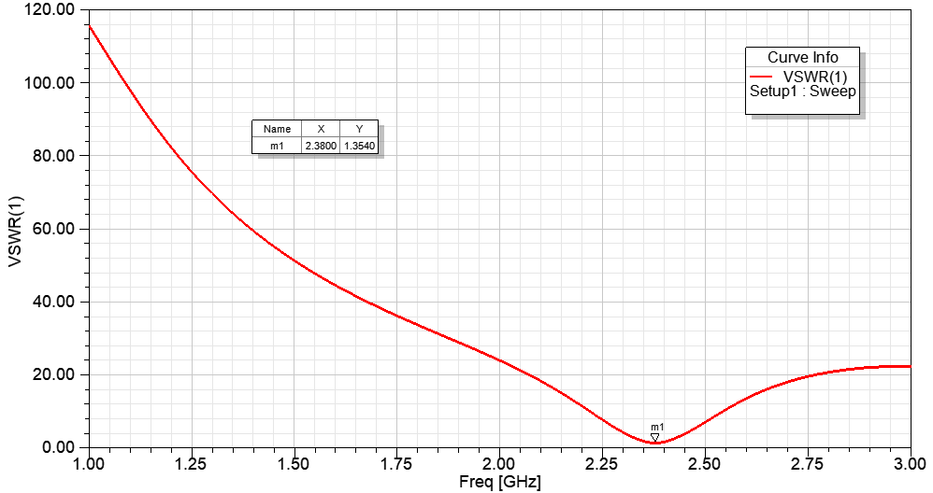

Figure5: Plot of return loss versus frequency and VSWR versus frequency

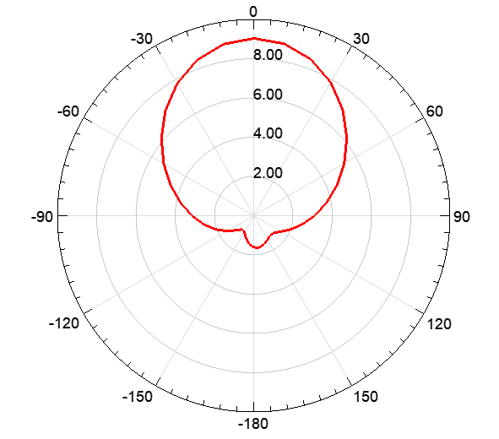

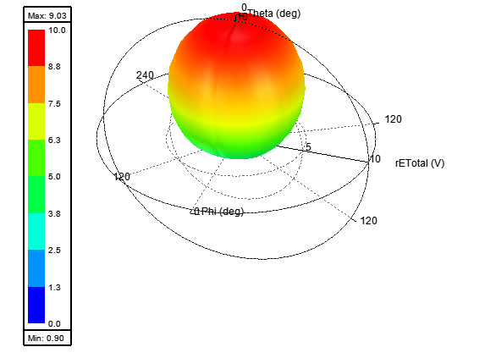

Figure6: Radiation pattern and gain plot

FR4 is lossy substrate, therefore, dielectric efficiency is less, this in turns reduces overall antenna efficiency and gain of the antenna.

OUTPUT:
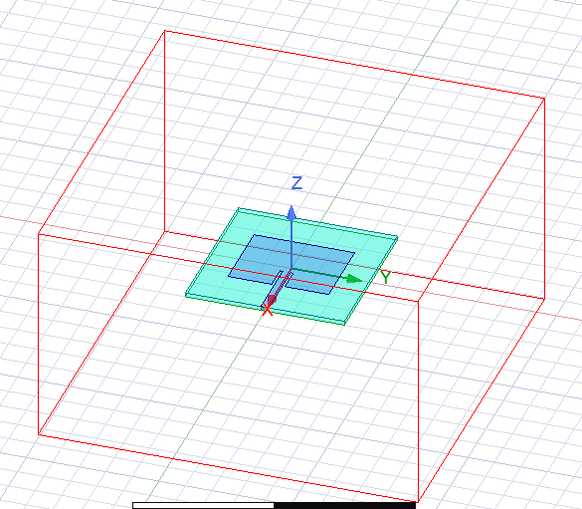
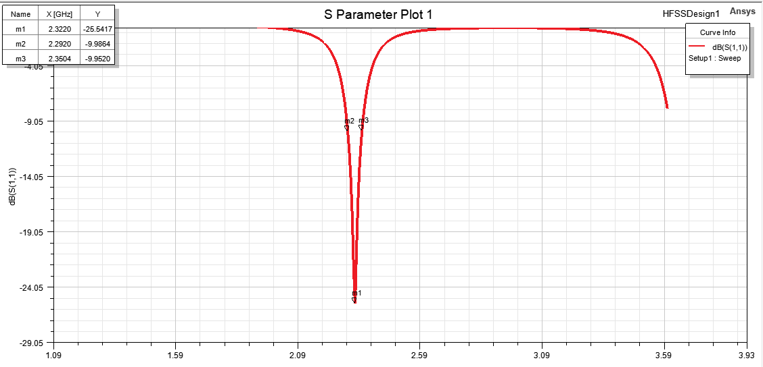
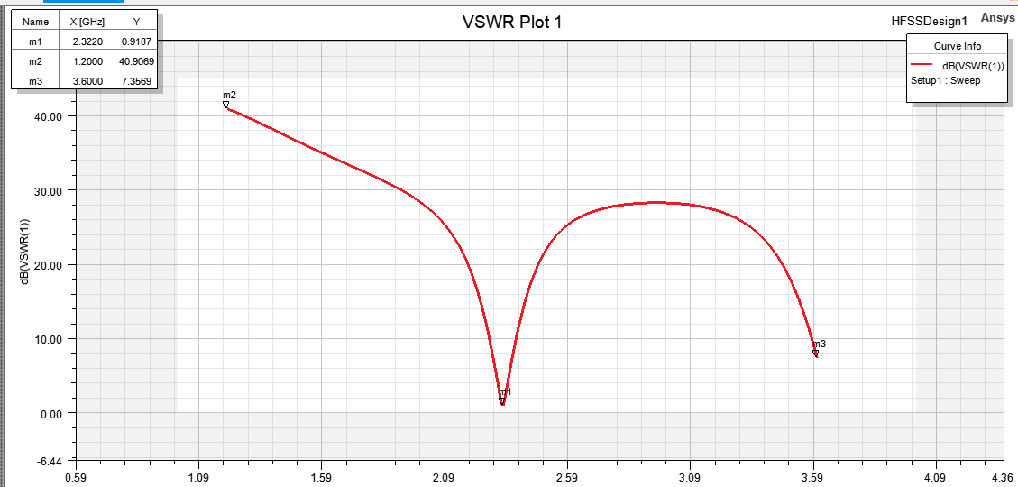

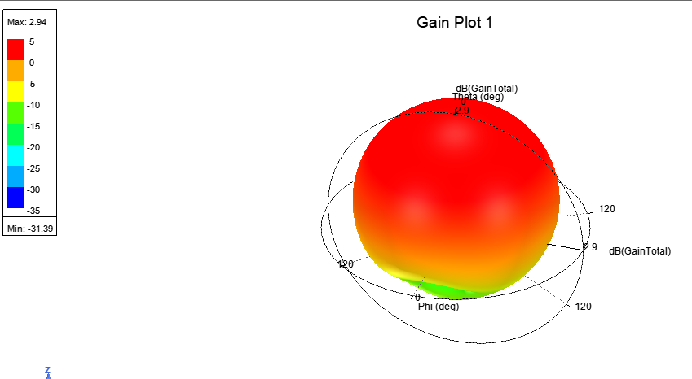
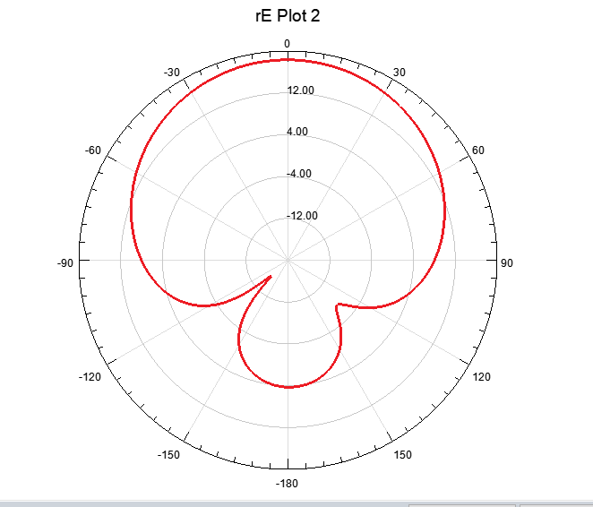
CONCLUSION:
Design of Rectangular Microstrip Antenna using line feeding technique to operate over ISM frequency band, using HFSS was performed successfully. The maximum gain was found out to be 2.94. Results shows a good impedance matching between the feed line and the antenna.
For the microstrip line feeding impedance matching depends on the inset depth. The radiation pattern of microstrip or patch antenna is broad.

EXPERIMENT NO. 10

Design and analysis of Dipole antenna using HFSS.

EXPERIMENT NO. 10

AIM: Design and analysis of Dipole antenna using HFSS.
EQUIPMENTS: HFSS Software.
THEORY: The dipole antenna or dipole aerial is one of the most important and commonly used types of RF antenna. It is made up of two radiators oriented in the same direction, sharing a common axis, and separated by an air gap. The two radiators are excited by a feed line in the center of the antenna as shown in fig1.1.
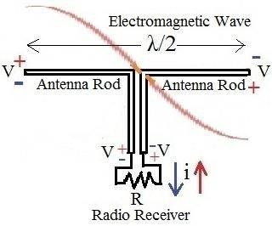

There are three main parameters that govern the operation of this antenna, they are dipole length, air gap, and dipole radius. The air gap and the dipole radius have only minor effects on the performance of the dipole. Because of this, their size is typically determined based on the antenna manufacturer’s requirements, within a reasonable range. That leaves the dipole length as the primary concern when designing antennas of this type. Although the dipole has a physical length, when designing antennas it is often much more convenient to refer to the electrical length of the antenna rather than the nominal value. Electrical length is the distance from one end of the antenna to the other measured in wavelengths of the signal at a specified frequency. Thus, at differing frequencies the same electrical length refers to different nominal lengths. Electrical length is usually stated in terms of wavelengths, denoted by the greek letter lambda, λ. The most common dipoles for practical use are half-wavelength dipole antennas. One of the primary advantages of half-wavelength dipoles is that their characteristic impedance is 73 Ω, which is very close to the characteristic impedance of commercially available 75 Ω transmission lines.
In order to design the half-wavelength dipole depicted in Figure 1.1, the electrical length of λ/2 must be converted to a nominal value. This can be accomplished through equation (1).
LD = 𝝺/2 (1)
The electric and magnetic field components of a half-wavelength dipole can be obtained from (2) by letting l = λ/2.

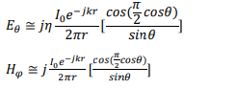
The directivity of the half-wavelength dipole antenna is given by:
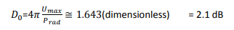
And the radiation resistance, for a free-space medium (𝜂 = 120𝜋) is given by
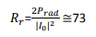
Another advantages of dipole antenna is its radiation pattern. Due their shape and design, dipole antennas can be excited by incident electromagnetic waves from a wide range of angles. In the azimuth, a dipole is a perfectly symmetrical cylinder. This results in a completely Omni-directional (toroidal) radiation pattern.

Design Problem Design and analysis of Dipole antenna at 0.7 GHz.
Design Procedure using HFSS software:
1. Start ANSYS Electronics Desktop. Check (and change if necessary) that the working mode is Driven Modal, HFSS > Solution Type > Modal.
2. Set Modeler length units to mm, Modeler > Units > mm.
3. To draw a dipole element, select Draw > Cylinder and enter calculated values at radius and height position.

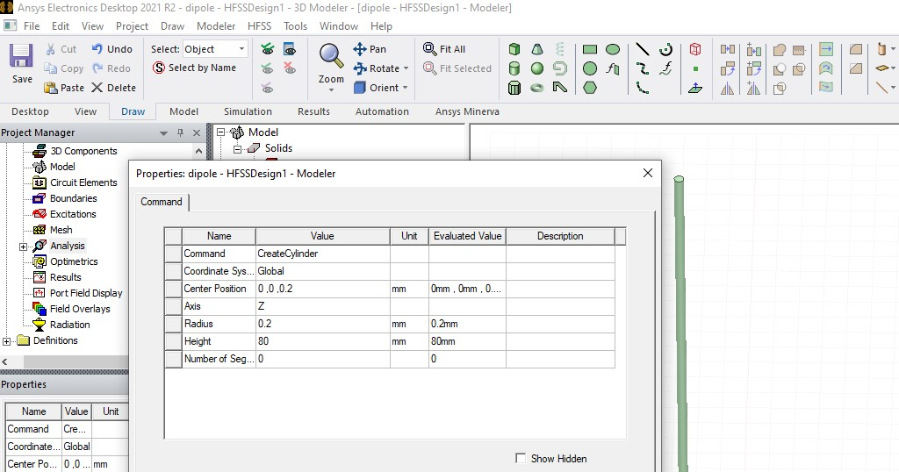
4. After drawing the first element of the dipole we will create the second one by symmetry.

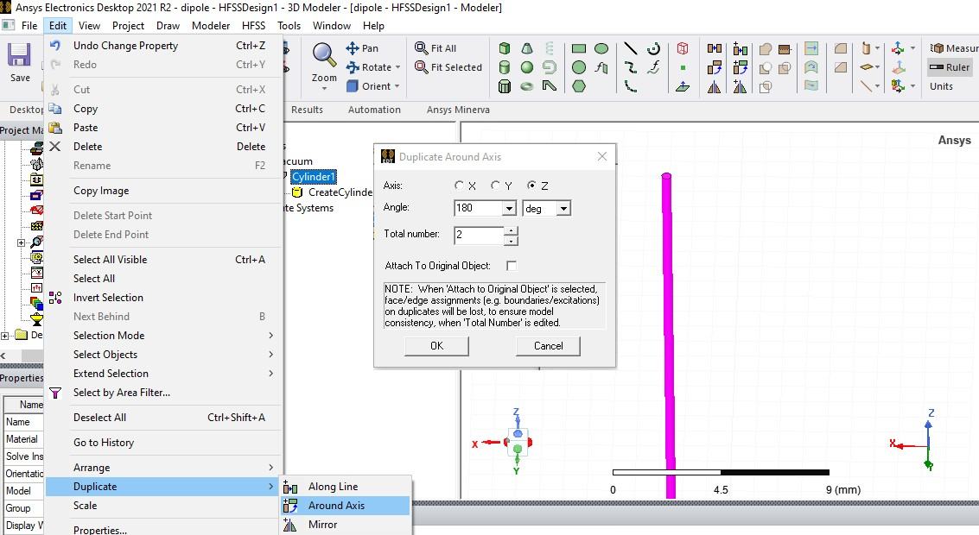
5. Select the first cylinder and then select Edit > Duplicate > Around Axis, choose the axis X or Y and enter the angle of 180°, Total number 2.
6. To provide an input source to perform the simulation. Select Draw > Rectangle and draw a rectangle (! it’s a surface model not a volume one) between the two wires, as in the figures below.
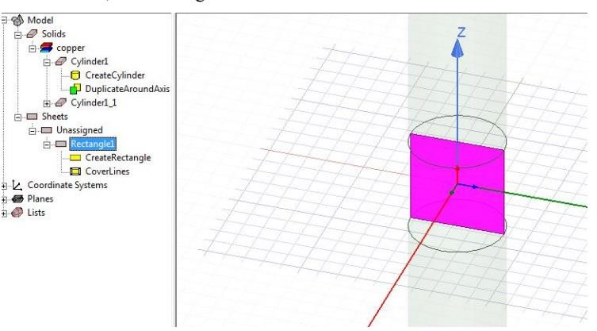
7. Select the drawn rectangle and define it as the input signal area/port HFSS > Excitations > Assign > Lumped Port.
8.Select HFSS > Model > Create Open Region. Choose the frequency of interest (around 900 MHz) and Radiation boundary.
9. Add a solution. Select HFSS > Analysis Setup > Add Solution Setup
10. After meshing, we define a broadband analysis. Select the previously defined solution (Project Manager > Analysis > Setup1) and add a broadband solution around the frequency corresponding to the single frequency solution HFSS > Analysis Setup > Add Frequency Sweep.
10. Select HFSS > Validation Check to verify that all required steps have been completed.
11. Select HFSS > Analyze All to start the simulation. Click the Show Progress button to view the progress of the solver.
12. Select HFSS > Results > Create Modal Solution Data Report > Rectangular Plot to display the S parameter corresponding to input port P1 (in dB).
13. Similarly plot far-fields parameters of the antenna.

OUTPUT:
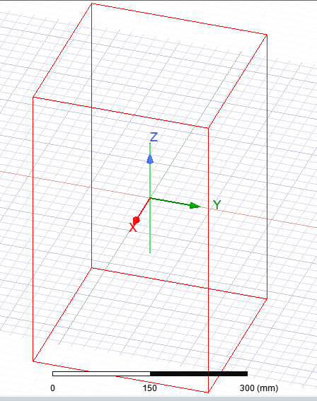
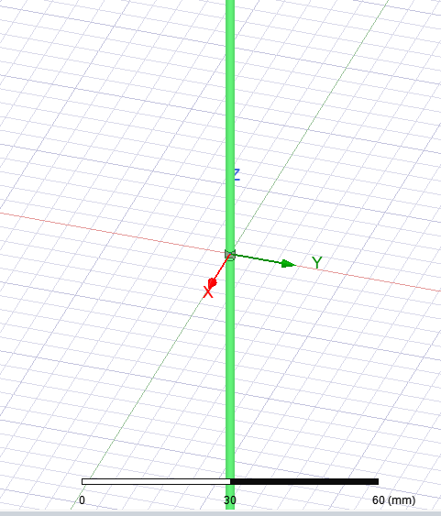

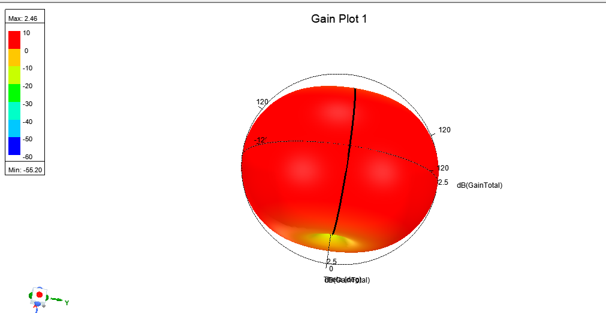

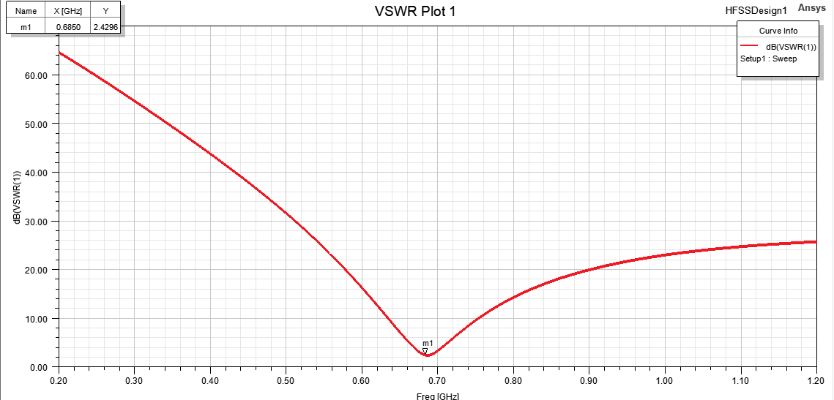
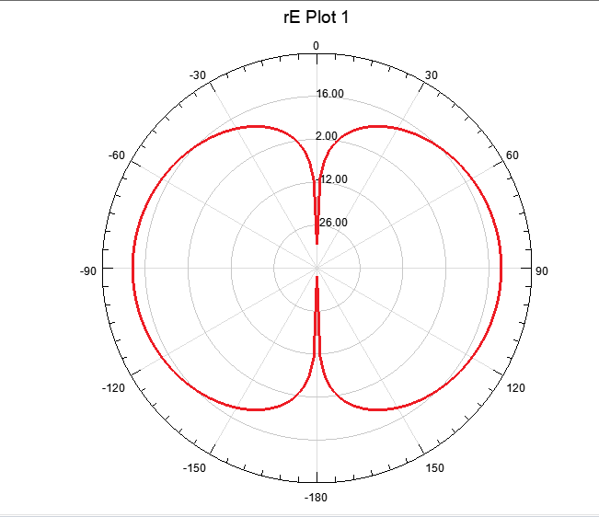
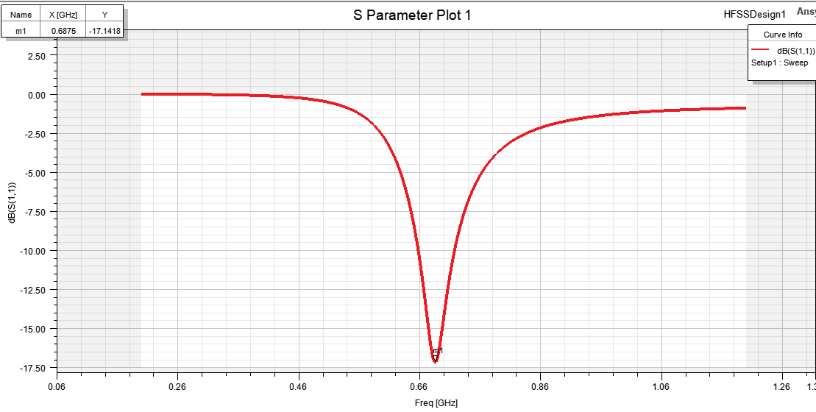

CONCLUSION:
Design and analysis of Dipole antenna using HFSS where impedance, directivity, gain and other factors are simulated and experiment was performed successfully. The radiation pattern of dipole antenna is omni-directional.

