EXPERIMENT NO. 3

AIM: To draw radiation pattern for half wave dipole and folded dipole antenna to find the HPBW, FNBW and directivity.
EQUIPMENTS:
S-54 Receiver, synthesizer, antenna stepper, λ antenna, λ/2 antenna, folded dipole antenna, antenna position controller, PC, printer
THEORY:

Half wave dipole: Half wave dipole antenna is usually fed from a two-wire transmission line. Each arm of antenna is very near to one quarter wavelength long. It can be found that the current distribution on this half wave dipole antenna is closely approximate by a sinusoidal standing wave of the form
I=Io cos(kz), -λo/4 ≤z≤λo/4
The current is 0 at the ends where z=± λo/4. The far zone radiated field from the half wave dipole antenna is given by using
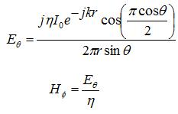
The radiation pattern in E plane is as shown in fig. the half wave power beam width is formed to be 78˚. It is also found that when dipole is half wave long, the input impedance is equal to radiation resistance
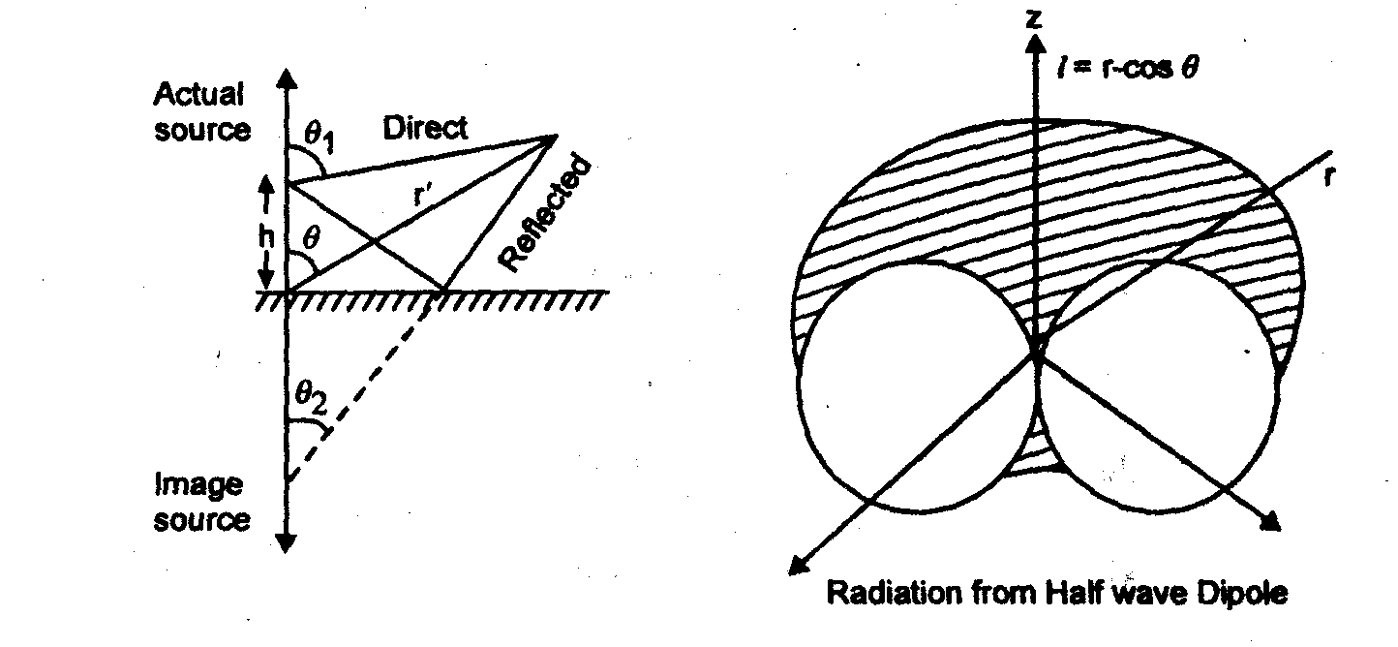

Folded dipole: A folded dipole is a half-wave dipole with an additional wire connecting its two ends.
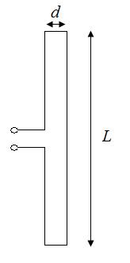
If the additional wire has the same diameter and cross-section as the dipole, two nearly identical radiating currents are generated. The resulting far-field emission pattern is nearly identical to the one for the single-wire dipole described above; however, at resonance its input (feedpoint) impedance is four times the radiation resistance of a single-wire dipole. This is because for a fixed amount of power, the total radiating current is equal to twice the current in each wire and thus equal to twice the current at the feed point. Equating the average radiated power to the average power delivered at the feedpoint, we may write
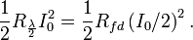
It follows that
The folded dipole is therefore well matched to 300-Ohm balanced transmission lines. The T2FD antenna is a folded dipole. Another common place one can see dipoles is as antennas for the FM band; these are folded dipoles. The tips of the antenna are folded back until they almost meet at the feedpoint, such that the antenna comprises one entire wavelength. This arrangement has a greater bandwidth than a standard half-wave dipole. If the conductor has a constant radius and cross-section, at resonance the input impedance is four times that of a half-wave dipole.
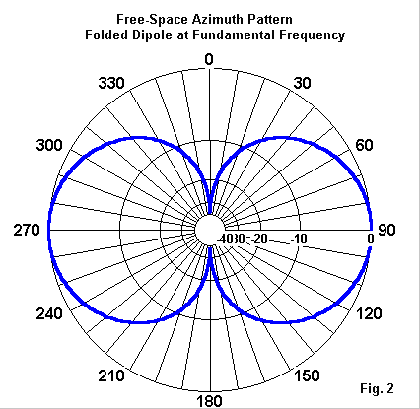
PROCEDURE:
- Fix the transmitting side antenna clamp on the table at a distance 2-3 mts from Rx antenna clamp.
- Mount the Tx antenna on top of antenna rod at the Tx end and half wave in vertical plane at the Rx.
- Connect the interface cable from receiver synthesizer to position controller and RS232 to second port of PC.
- Switch on the transmitting generator and set the desired frequency by pressing frequency mode button.
- Switch on the receiver via an adaptor.
- Switch on the position controller.
- Press position stepper ON-OFF button from front panel and press1 from antenna stepper.
- Press capture data key from front panel followed by enter and then press 1 or 2 for selection of array.
- Set manually the zero-degree position of the receiver with respect to Tx antenna and then select 1 of rotation 1or 5˚.
- Stepper motor starts rotating by the given step by 360˚ and power reading are displayed on the LCD screen.
- Switch on the PC and double click on PLOT in S/W.
- Press the function key followed by RS232 key and press enter to continue.
- Select RS 232 button from plot S/W menu and select port 1, connect receiver. A message will be displayed indicating receiver connected successfully press OK
- Select capture button from the menu of plot in S/W for getting the data transferred to PC.
- Using plot function Plot the graph, take printout and reading.
- Follow the same procedure for folded dipole and measure half power beamwidth and first null beamwidth.

OUTPUT:
- Half wave dipole:
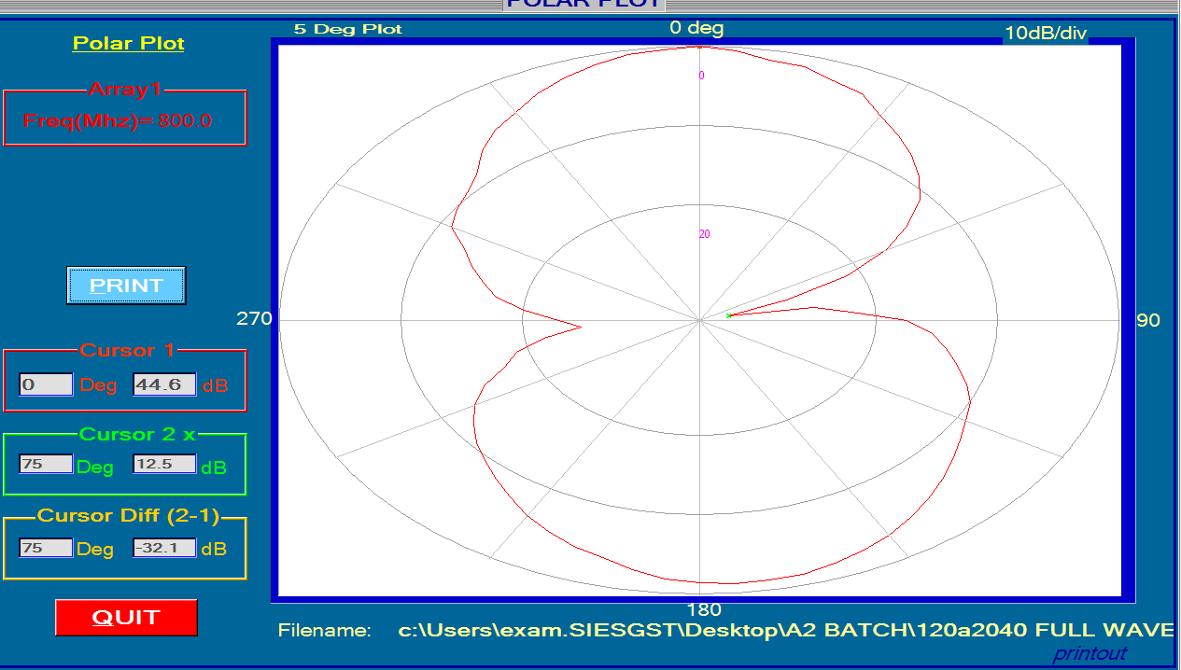
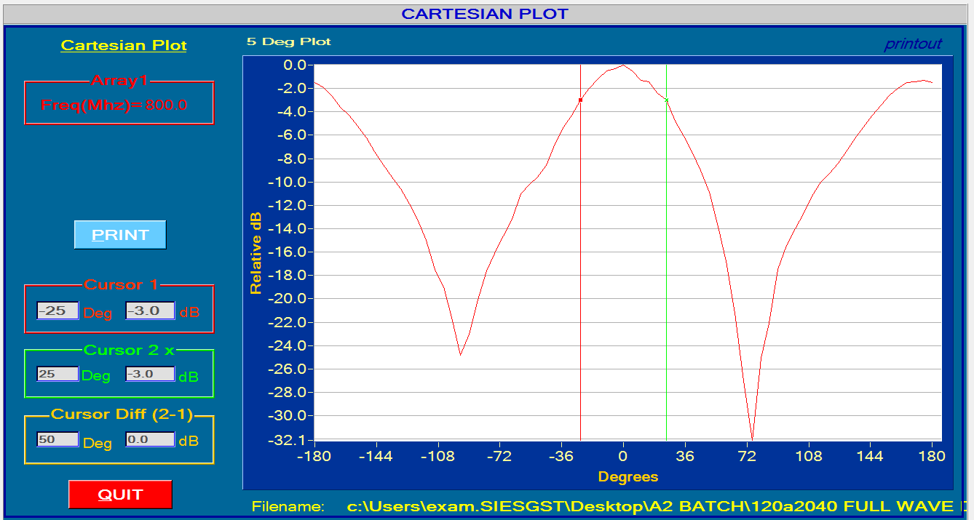
Observation:
Half power beam width = 50⁰
First null beam width = 170⁰
Beam Area = 18,000
Directivity = 2.27
Directivity in db = 3.560 db
- Folded Dipole:
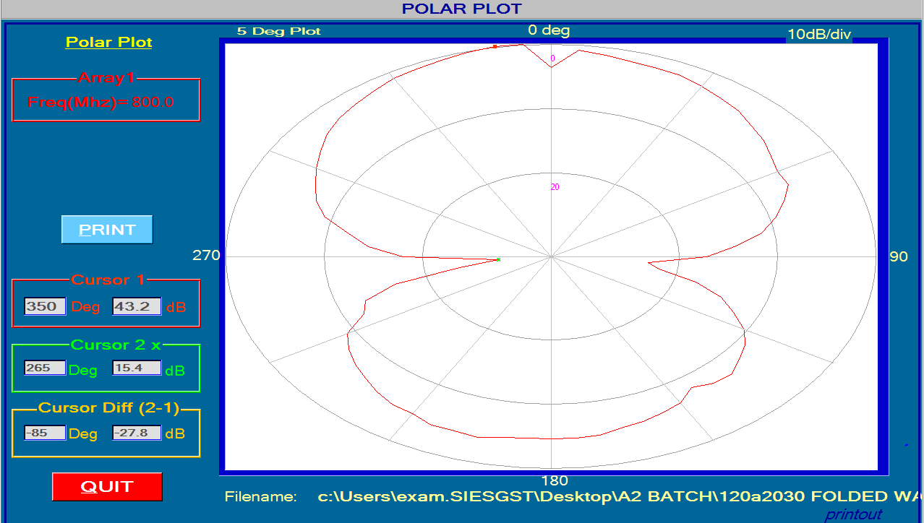
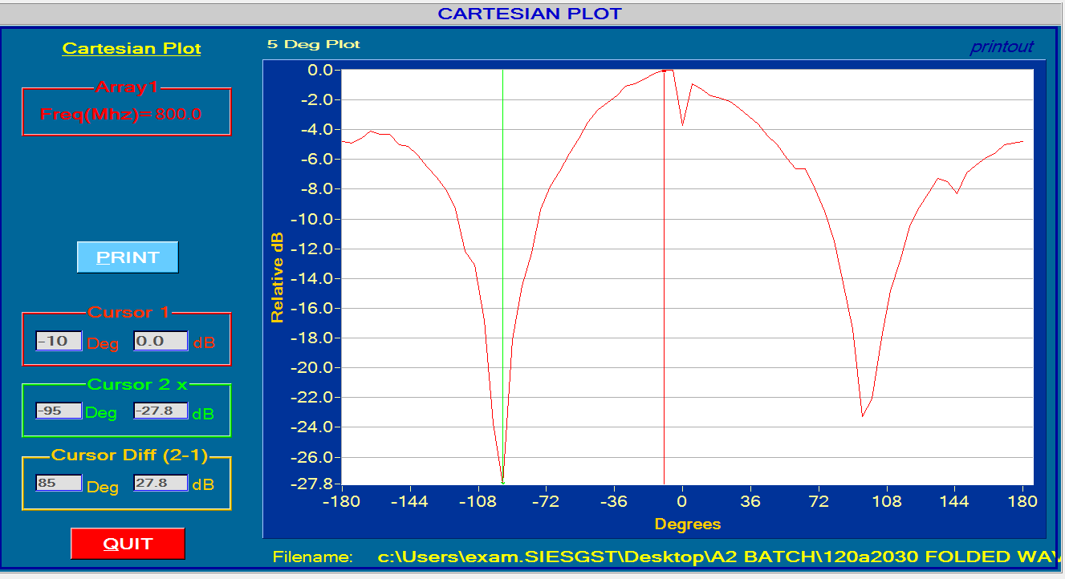
Observation:
Half power beam width = 80⁰
First null beam width = 190⁰
Beam Area = 28,800
Directivity = 1.423
Directivity in db = 1.533 db

CONCLUSION:
The radiation pattern for half wave dipole and folded dipole antenna to find the HPBW, FNBW and directivity was performed successfully. For half power dipole, it is also found that when dipole is half wave long, the input impedance is equal to radiation resistance. Folded dipole has a constant radius and cross-section, at resonance the input impedance is four times that of a half-wave dipole.

EXPERIMENT NO. 4

AIM: To draw radiation pattern for Helical antenna and to find the HPBW and FNBW.
EQUIPMENTS:
S-54 Receiver synthesizer, S-54 Receiver, antenna stepper, λ antenna and Helical antenna, antenna position controller, PC, printer
THEORY:
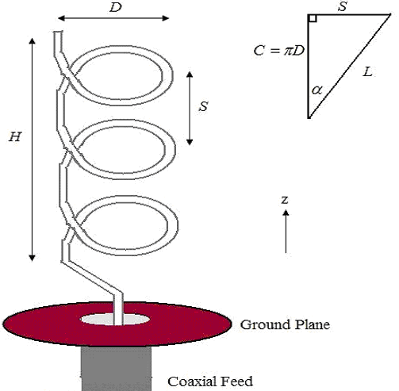
Radiating at 90 degrees from the axis of the helix this design is efficient as a practical reduced-length radiator when compared with the operation of other types such as base-loaded, top-loaded or centre-loaded whips. They are typically used for applications where reduced size is a critical operational factor.
These simple and practical "Helical" were primarily designed to replace very large antennas. Their reduced size is therefore most suitable for Mobile and Portable High-frequency (HF) communications in the 1 MHz to 30 MHz operating range.
A common form of normal-mode helical antenna is the Rubber Ducky antenna used in portable radios. The loading provided by the helix allows the antenna to be shorter than its electrical length of a quarter-wavelength.
Usually wound in a linear "spiroidal" pattern (constant parallel spaced turns) providing consistent uniform radiation as a reduced sized equivalent in respect to the standard λ /4 wave antenna. This concept was proven practical by an Australian design.
An effect of this type of concertinaed 'reduced size λ /4 wave' is that the matching impedance is changed from the nominal 50 ohms to between 25 to 35 ohms base impedance. This does not seem to be adverse to operation or matching with a normal 50 ohm transmission line, provided the connecting feed is the electrical equivalent of a λ /2 wave at the frequency of operation.
Axial-mode helical
End fire helical satellite communications antenna, Scott Air Force base, Illinois, USA. Satellite communication systems often use circularly polarised radio waves, because the satellite antenna may be oriented at any angle in space without affecting the transmission, and axial mode (end fire) helical antennas are often used as the ground antenna.
In the axial mode, the helix dimensions are at or above the wavelength of operation. The antenna produces radio waves with circular polarization. The main lobes of the radiation pattern are along the axis of the helix, off both ends. Since in a directional antenna only radiation in one direction is wanted, the other end of the helix is terminated in a flat metal sheet or screen reflector to reflect the waves forward.
In radio transmission, circular polarization is often used where the relative orientation of the transmitting and receiving antennas cannot be easily controlled, such as in animal tracking and spacecraft communications, or where the polarization of the signal may change, so end-fire helical antennas are frequently used for these applications. Since large helices are difficult to build and unwieldy to steer and aim, the design is commonly employed only at higher frequencies, ranging from VHF up to microwave.
The helix in the antenna can twist in two possible directions: right-handed or left-handed, as defined by the right hand rule. In an axial-mode helical antenna the direction of twist of the helix determines the polarization of the radio waves: a left-handed helix radiates left-circularly-polarized radio waves, a right-handed helix radiates right-circularly-polarized radio waves. Helical antennas can receive signals with any type of linear polarization, such as horizontal or vertical polarization, but when receiving circularly polarized signals the handedness of the receiving antenna must be the same as the transmitting antenna; left-hand polarized antennas suffer a severe loss of gain when receiving right-circularly-polarized signals, and vice versa.
The dimensions of the helix are determined by the wavelength λ of the radio waves used, which depends on the frequency. In axial-mode operation, the spacing between the coils should be approximately one-quarter of the wavelength (λ/4), and the diameter of the coils should be approximately the wavelength divided by pi (λ/π). The length of the coil determines how directional the antenna will be as well as its gain; longer antennas will be more sensitive in the direction in which they point.
Terminal impedance in axial mode ranges between 100 and 200 ohms. The resistive part is approximated by:
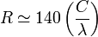
where R is resistance in ohms, C is the circumference of the helix, and λ is the wavelength. Impedance matching to the cable C is often done by a short stripline section between the helix and the cable termination.
Helical antenna for WLAN communication, working frequency app. 2.4 GHz
The maximum directive gain is approximately:
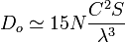
where N is the number of turns and S is the spacing between turns.
The half-power beam width is:
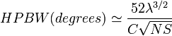
The beam width between nulls is:
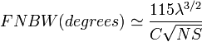
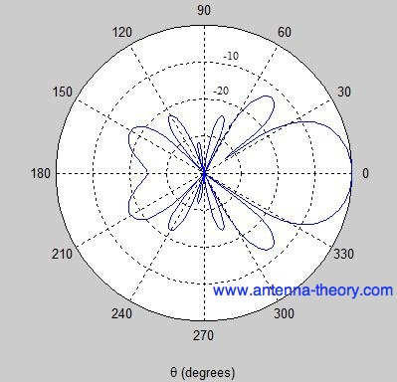
PROCEDURE:
- Fix the transmitting side antenna clamp on the table at a distance 2-3 mts from Rx antenna clamp.
- Mount the Tx antenna on top of antenna rod at the Tx end and Helical Antenna in vertical plane at the Rx.
- Connect the interface cable from receiver synthesizer to position controller and RS232 to second port of PC.
- Switch on the transmitting generator and set the desired frequency by pressing frequency mode button.
- Switch on the receiver via an adaptor. Switch on the position controller.
- Press position stepper ON-OFF button from front panel and press1 from antenna stepper.
- Press capture data key from front panel followed by enter and then press 1 or 2 for selection of array.
- Set manually the zero degree position of the receiver with respect to Tx antenna and then select 1 of rotation 1or 5˚.
- Stepper motor starts rotating by the given step by 360˚ and power reading are displayed on the LCD screen.
- Switch on the PC and double click on PLOT in S/W.
- Press the function key followed by RS232 key and press enter to continue.
- Select RS 232 button from plot S/W menu and select port 1, connect receiver. A message will be displayed indicating receiver connected successfully press OK
- Select capture button from the menu of plot in S/W for getting the data transferred to PC.
- Using plot function Plot the graph, take printout and reading.

OUTPUT:
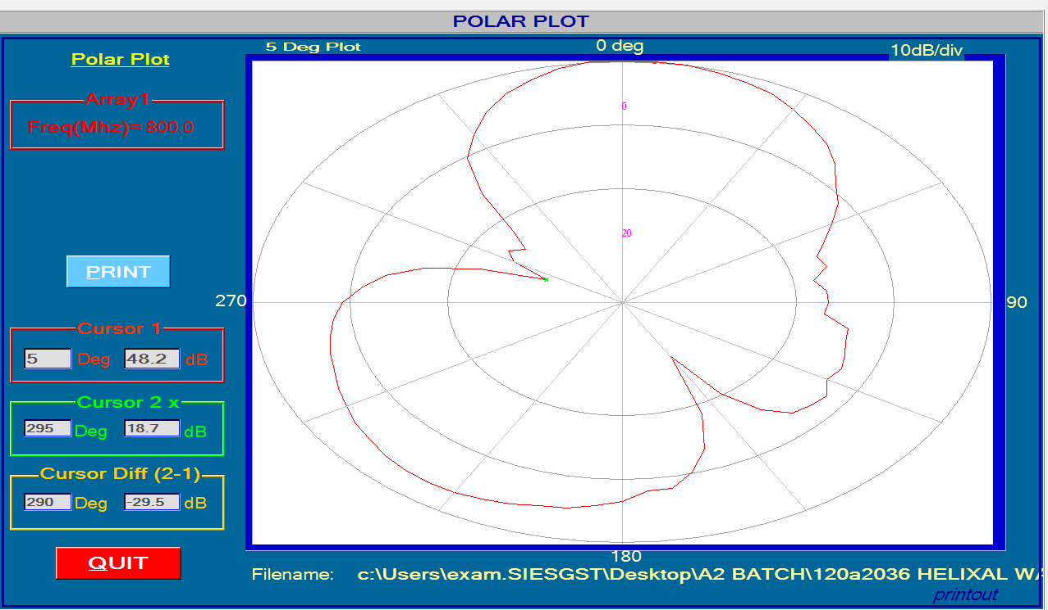
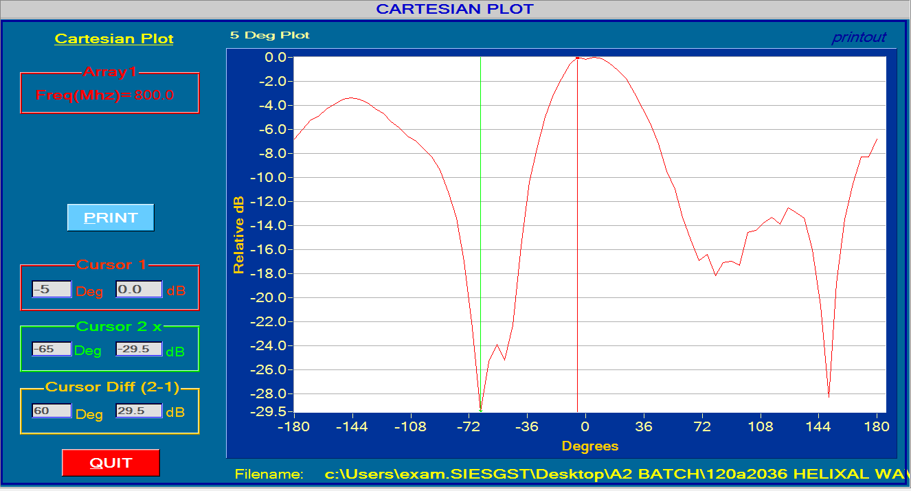

Observation:
Half power beam width = 50⁰
First null beam width = 215⁰
Beam Area = 18000
Directivity = 2.27
Directivity in db = 3.56 db

CONCLUSION:
The radiation pattern for Helical antenna and HPBW and FNBW was found and the experiment was performed sucessfully. The loading provided by the helix allows the antenna to be shorter than its electrical length of a quarter-wavelength.

EXPERIMENT NO. 5

AIM: To draw radiation pattern for Yagi Uda antenna and to find the HPBW and FNBW.
EQUIPMENTS:
S-54 Receiver synthesizer, S-54 Receiver, antenna stepper, λ antenna and Helical antenna, antenna position controller, PC, printer
THEORY:
Yagi-Uda antenna is the most commonly used type of antenna for TV reception over the last few decades. It is the most popular and easy-to-use type of antenna with better performance, which is famous for its high gain and directivity. The frequency range in which the Yagi-Uda antennas operate is around 30 MHz to 3GHz which belong to the VHF and UHF bands.
A Yagi-Uda array, commonly known simply as a Yagi antenna, its Configuration normally consists of a number of directors and reflectors that enhance radiation in one direction when properly arranged on a supporting structure. Yagi-uda antenna is a directional antenna system consisting of an array of dipoles and additional closely coupled parasitic elements usually a reflector and one or more directors
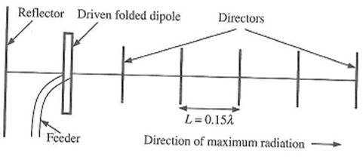
Figure1: Yagi Uda antenna
The Yagi antenna's basic design is a "resonant" fed dipole with one or more parasitic elements. These parasitic elements are called the "reflector" and the "director." A dipole will be "resonant" when its electrical length is 1/2 of the wavelength of the frequency applied to its feed point. The yagi-uda array can be summarised by its performance considering in three parts
i) Reflector
ii) Feeder or dipole
iii) director
The length and spacing of the reflector do affect the forward gain but have large effects on the backward gain (F/B ratio) and input impedance (Zin). Thus they can be used to control or optimize antenna parameters.
The driven element is typically a λ/2 dipole or folded dipole and is the only member of the structure that is directly excited -electrically connected to the feedline. All the other elements are considered parasitic. The feeder length and radius has small effects on the forward gain but a large effect on the backward gain and input impedance. Its geometry is usually chosen to control the input impedance that most commonly is made real (resonant element).The length and spacing of the directors have large effects on the forward gain, backward gain ratio and input impedance. They are considered to be the most critical elements of the array.
As an example of Yagi-antenna radiation patterns, a 6-element Yagi antenna (with axis along the +x-axis) is simulated (1 reflector, 1 driven half-wavelength dipole, 4 directors). The resulting antenna has a 12.1 dBi gain, and the plots are given in Figures 1-3.
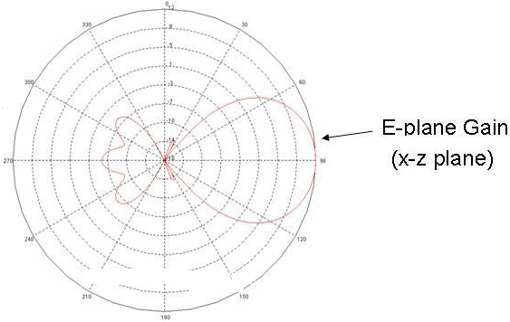
The above plot give an idea of what the radiation pattern of the Yagi-Uda antenna resembles. The gain can be increased (and the pattern made more directional) by adding more directors or optimizing spacing (or rarely, adding another reflector). The front-to-back ratio is approximately 19 dB for this antenna, and this can also be optimized if desired.
PROCEDURE:
- Fix the transmitting side antenna clamp on the table at a distance 2-3 mts from Rx antenna clamp.
- Mount the Tx antenna on top of antenna rod at the Tx end and Helical Antenna in vertical plane at the Rx.
- Connect the interface cable from receiver synthesizer to position controller and RS232 to second port of PC.
- Switch on the transmitting generator and set the desired frequency by pressing frequency mode button.
- Switch on the receiver via an adaptor.
- Switch on the position controller.
- Press position stepper ON-OFF button from front panel and press1 from antenna stepper.
- Press capture data key from front panel followed by enter and then press 1 or 2 for selection of array.
- Set manually the zero degree position of the receiver with respect to Tx antenna and then select 1 of rotation 1or 5˚.
- Stepper motor starts rotating by the given step by 360˚ and power reading are displayed on the LCD screen.
- Switch on the PC and double click on PLOT in S/W.
- Press the function key followed by RS232 key and press enter to continue.
- Select RS 232 button from plot S/W menu and select port 1, connect receiver. A message will be displayed indicating receiver connected successfully press OK
- Select capture button from the menu of plot in S/W for getting the data transferred to PC.
- Using plot function Plot the graph, take printout and reading.

OUTPUT:
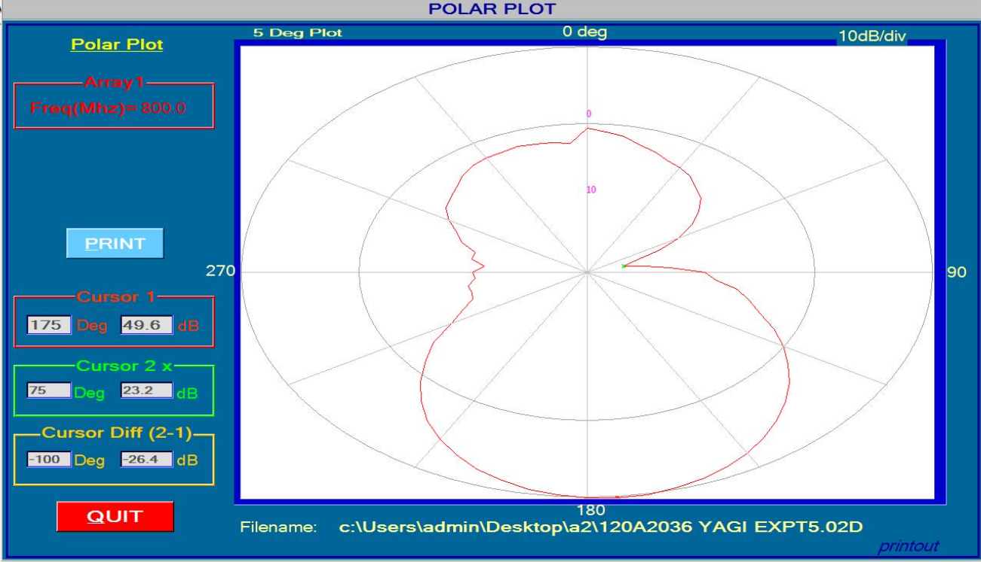
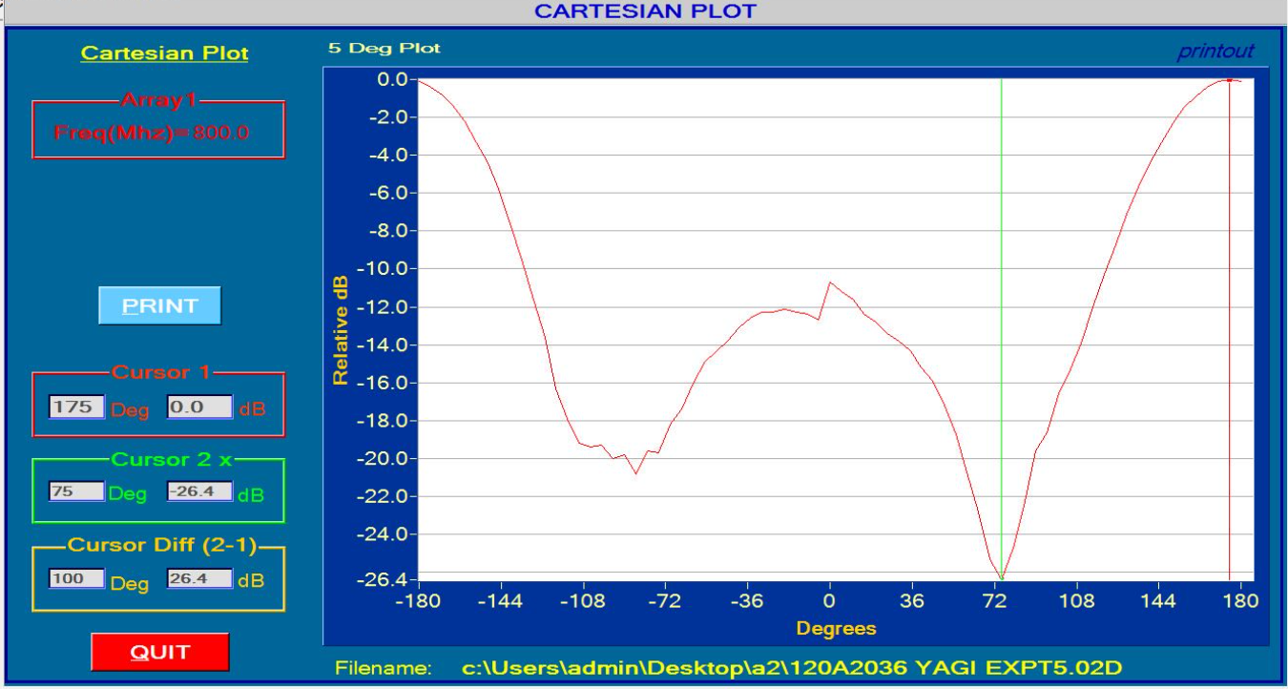
Observation:
Half power beam width = 60⁰
First null beam width = 155⁰
Beam Area = 21600
Directivity = 1.898
Directivity in db = 2.783 db
CONCLUSION:
The Experiment to find radiation pattern for Yagi Uda antenna,HPBW and FNBW was performed Successfully. The gain can be increased by adding more directors or optimizing spacing.

