Store the original MP3 file in the cloud storage (or its emulation).
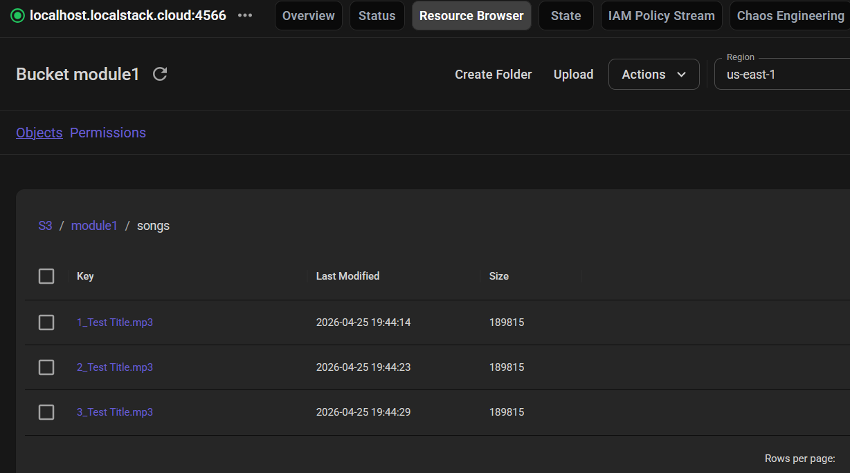

Save the file's location (i.e., the link in cloud storage) in the database.
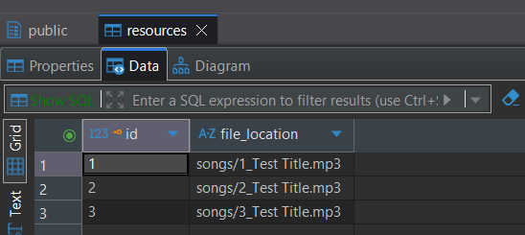

Resource Service should not call any other services during this process.
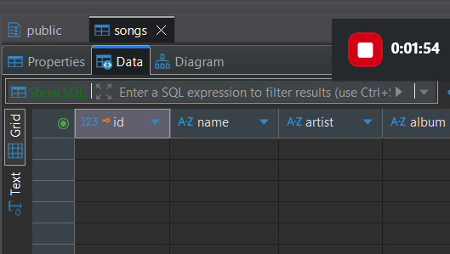

Remove the file from the Cloud Storage (S3 bucket).
After sending Delete Resource by id=3 I have only two songs
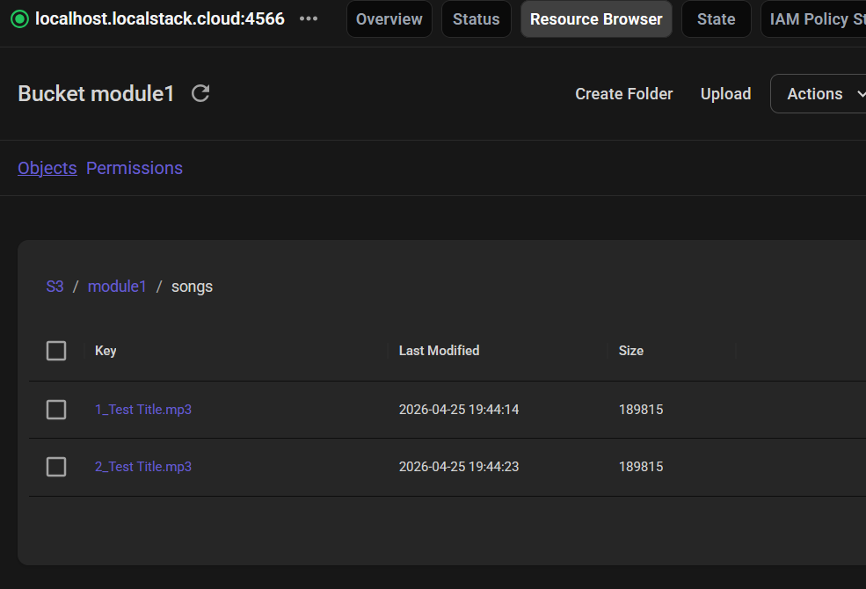

Delete the record from the Resource DB.
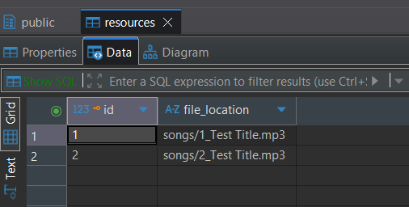

Call Song Service to cascade-delete the related song metadata.
