Add asynchronous messaging

Resource publisher
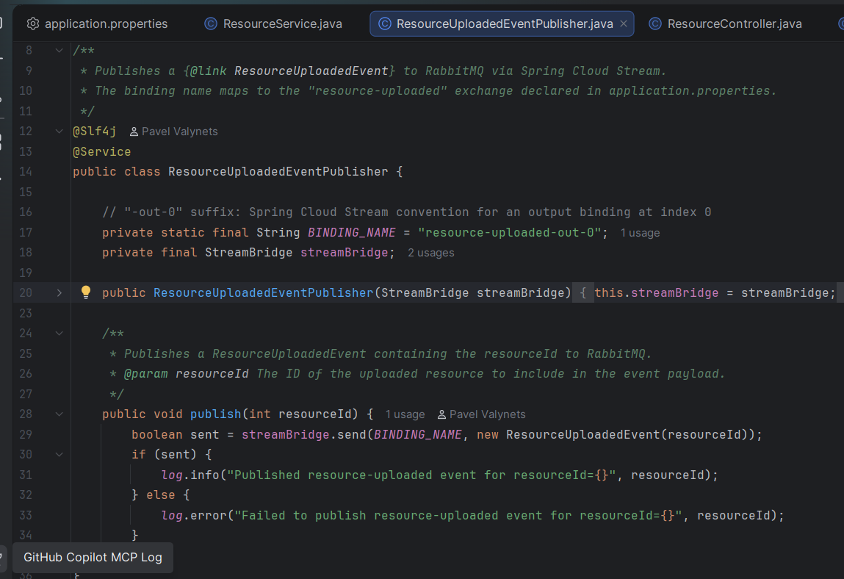

Resource consumer
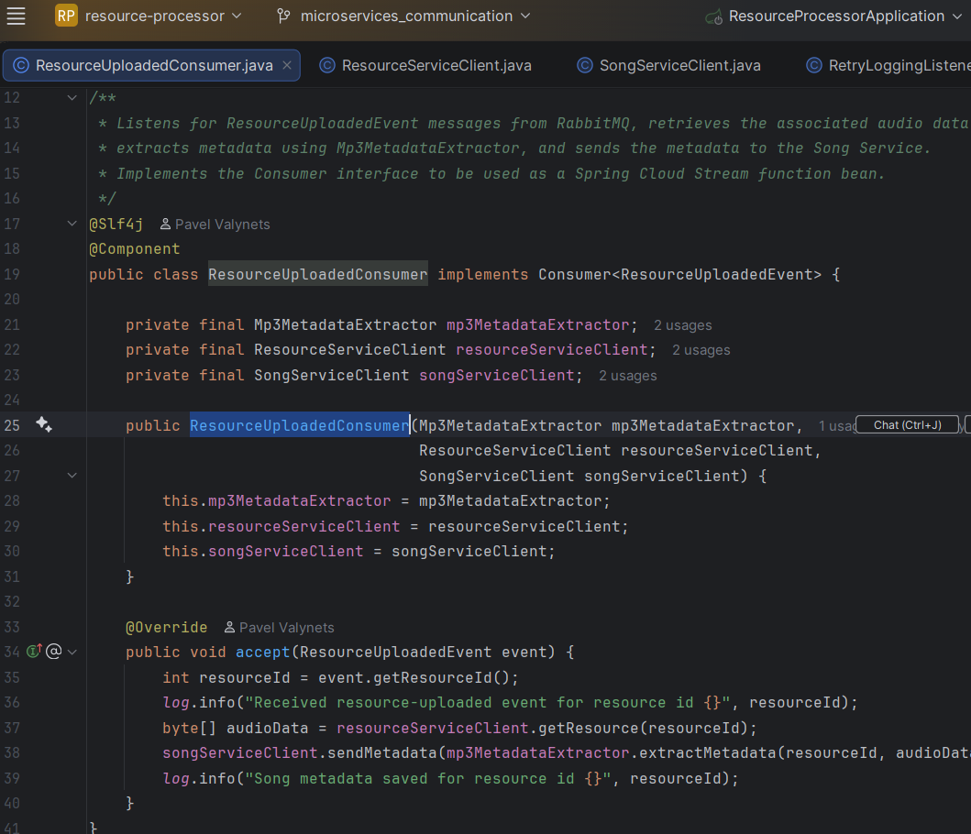
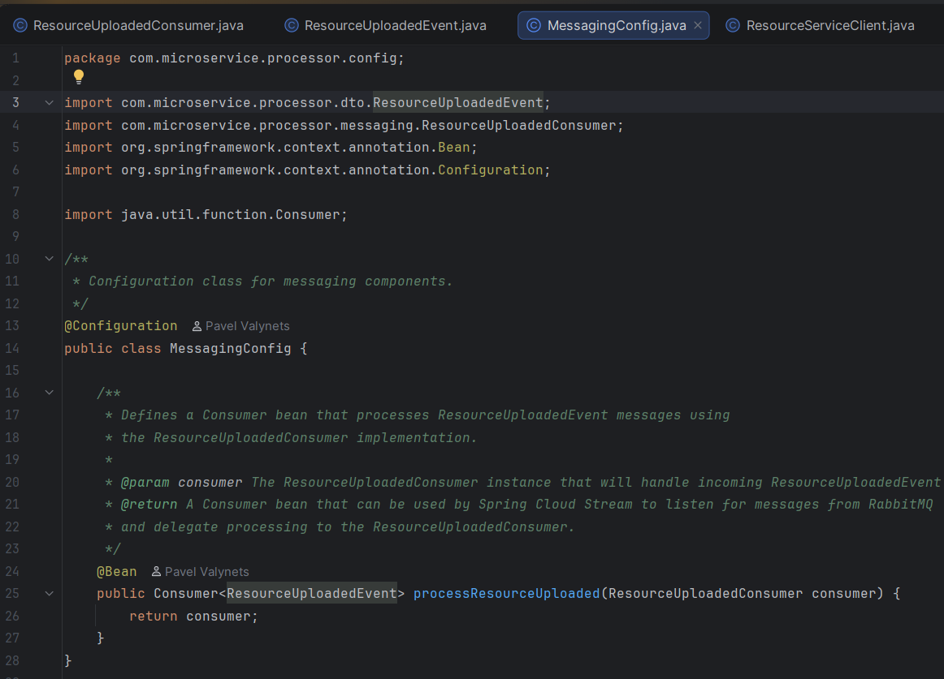

Event-triggered processing
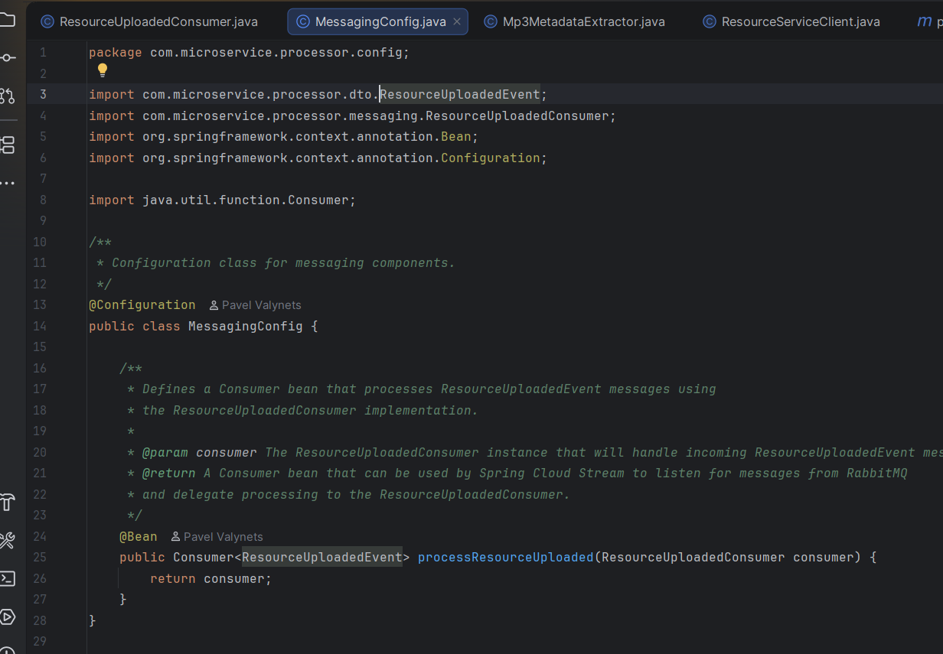
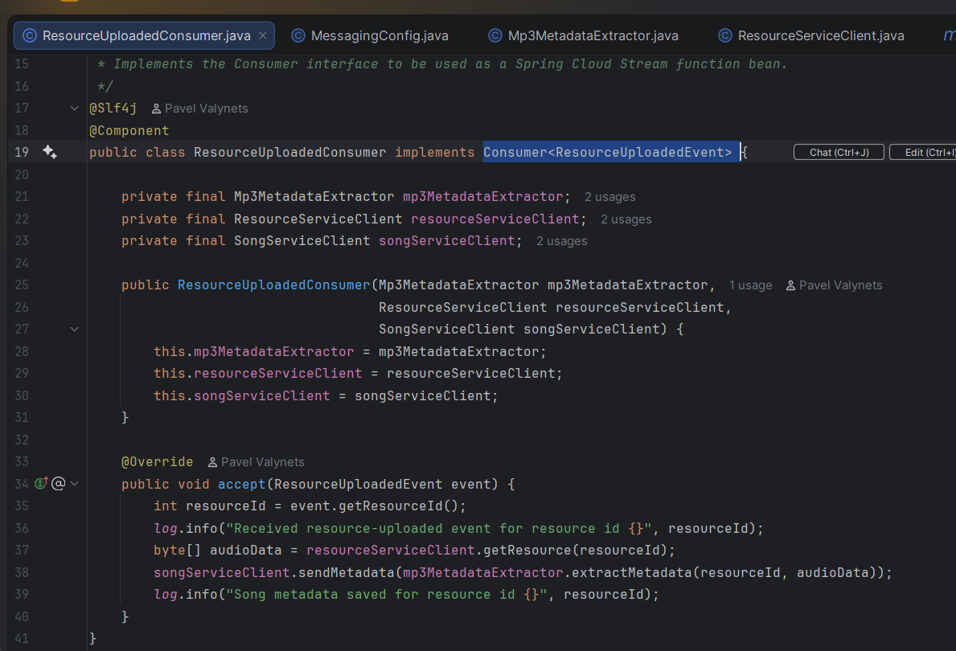

Event from logs perspective
From Resuorce
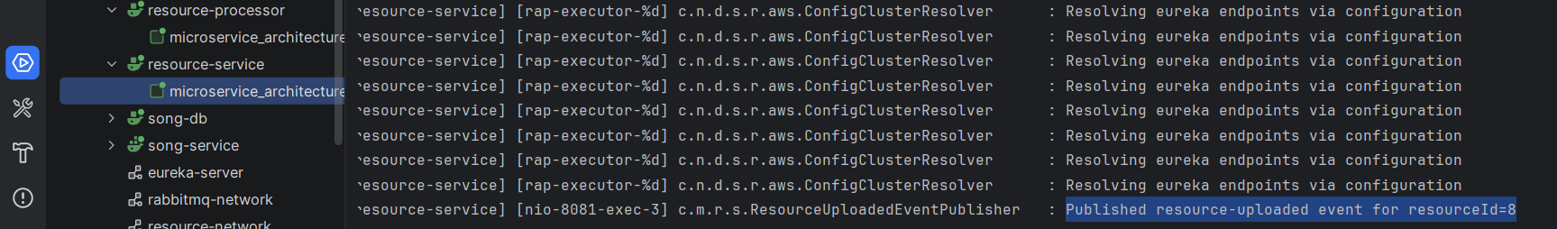
To Processor

Make a synchronous call to the Resource Service to retrieve the resource data (in binary format).
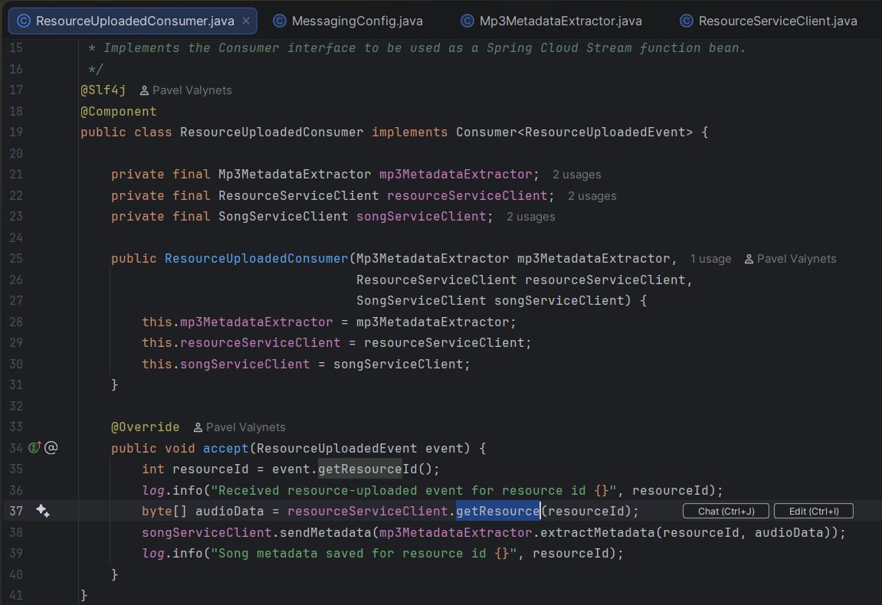
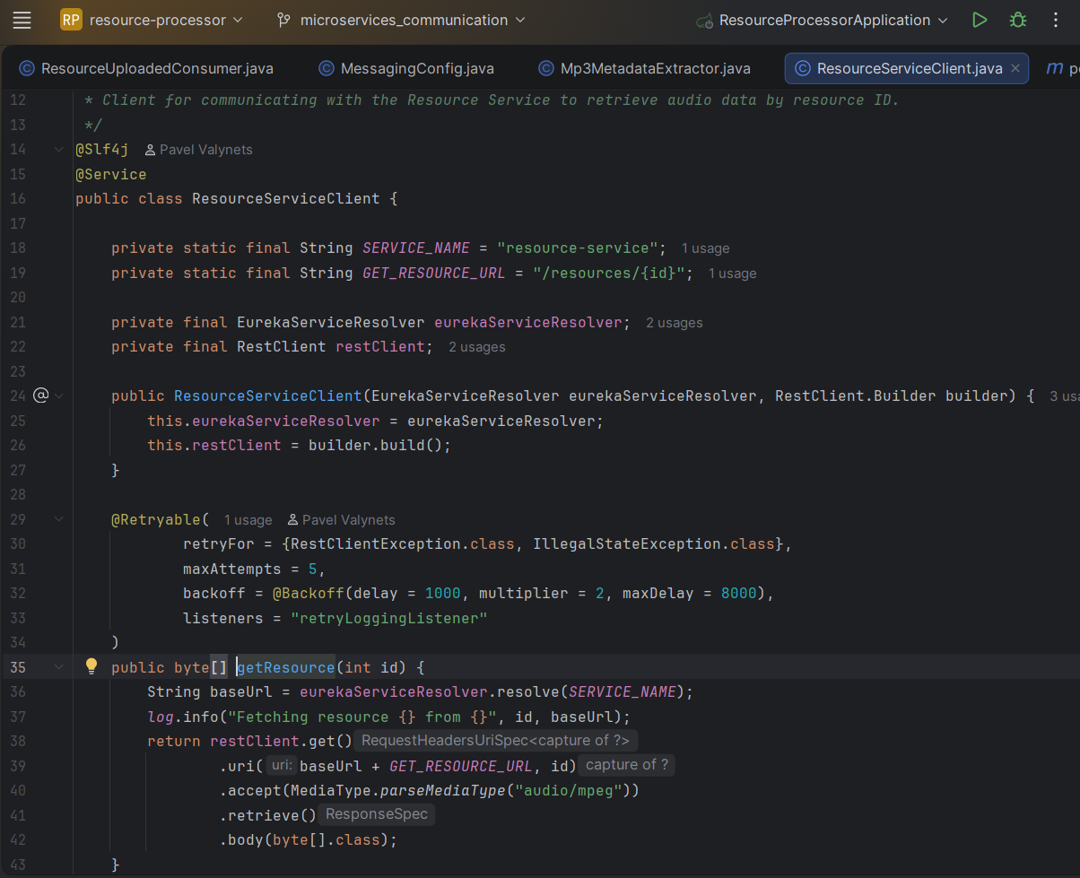

Extract the metadata from the resource.
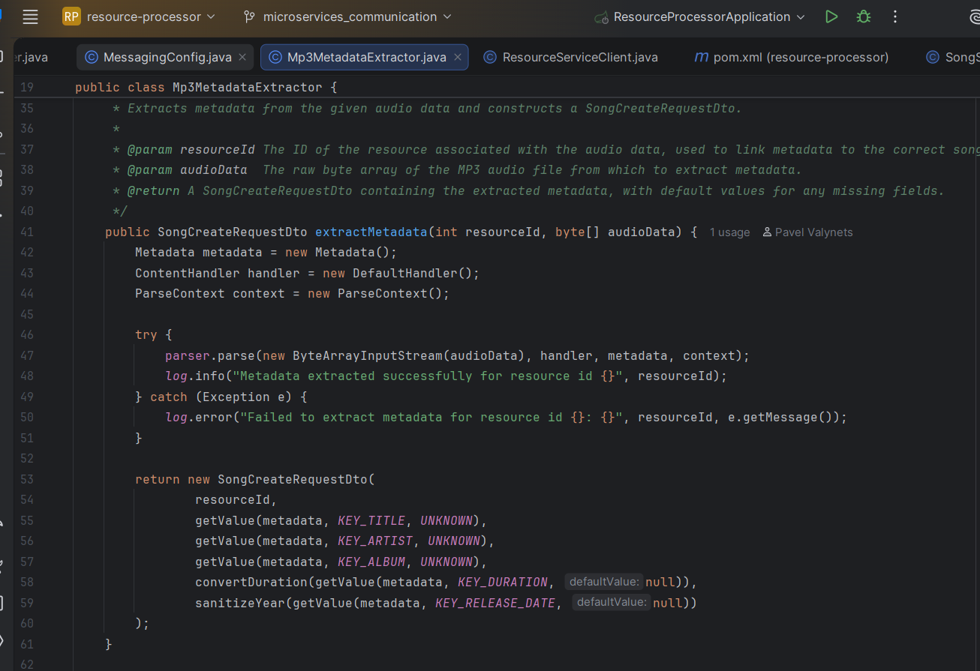

Make another synchronous call to the Song Service to save the extracted song metadata.
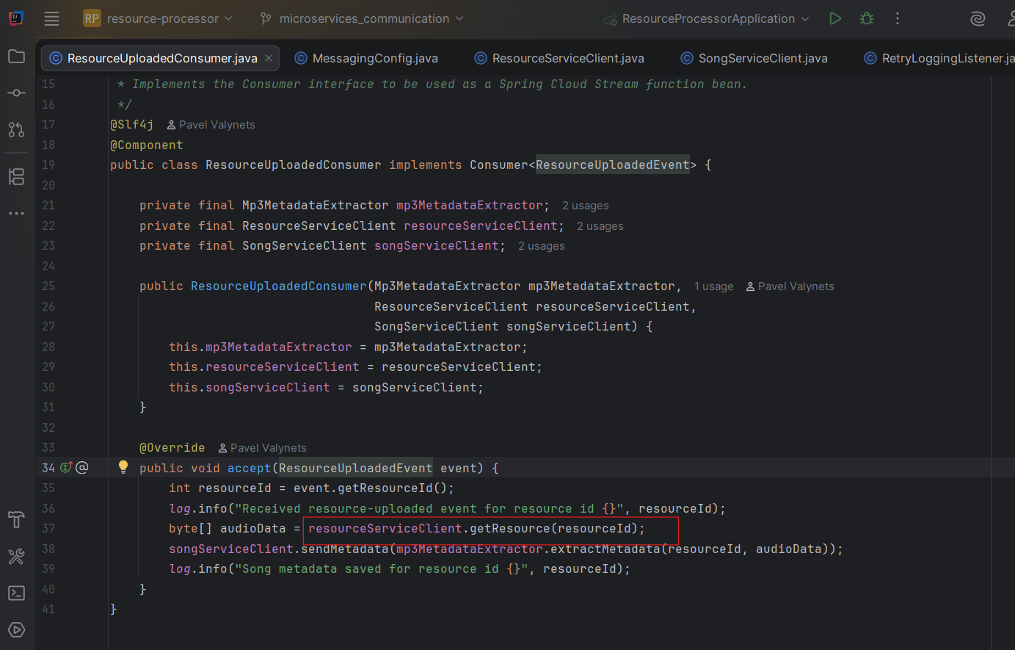
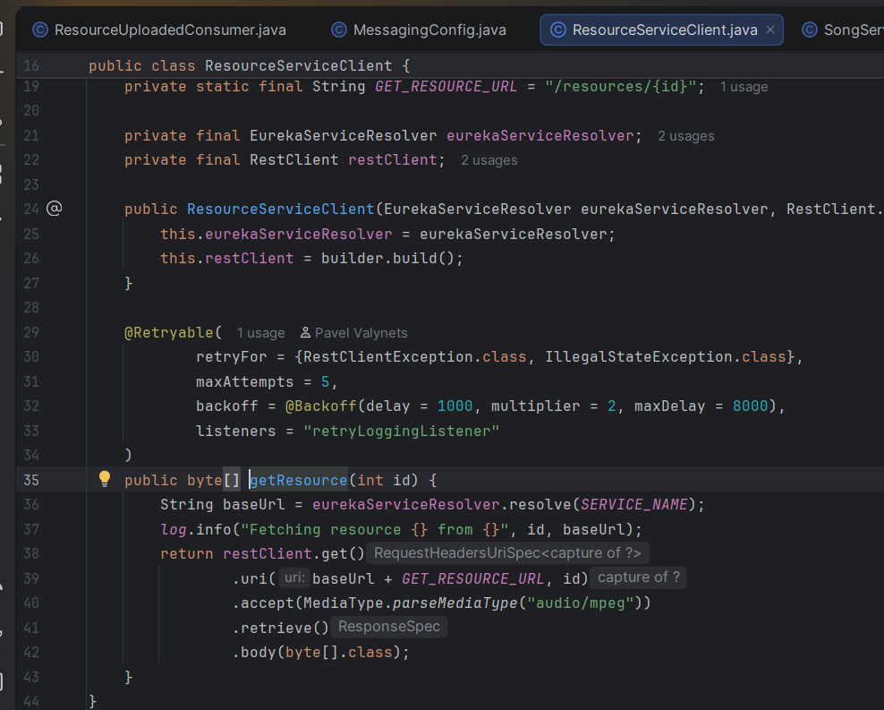

Queue listening/subscription
From Resource properties
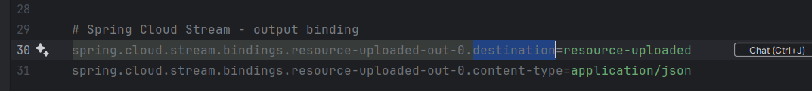
To Processor properties
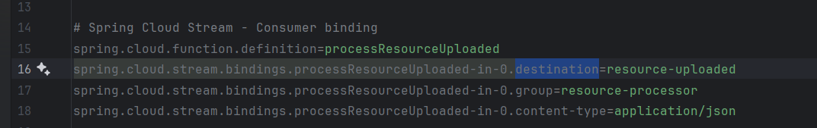

Implement a retry mechanism

Retry when send metadata to song service
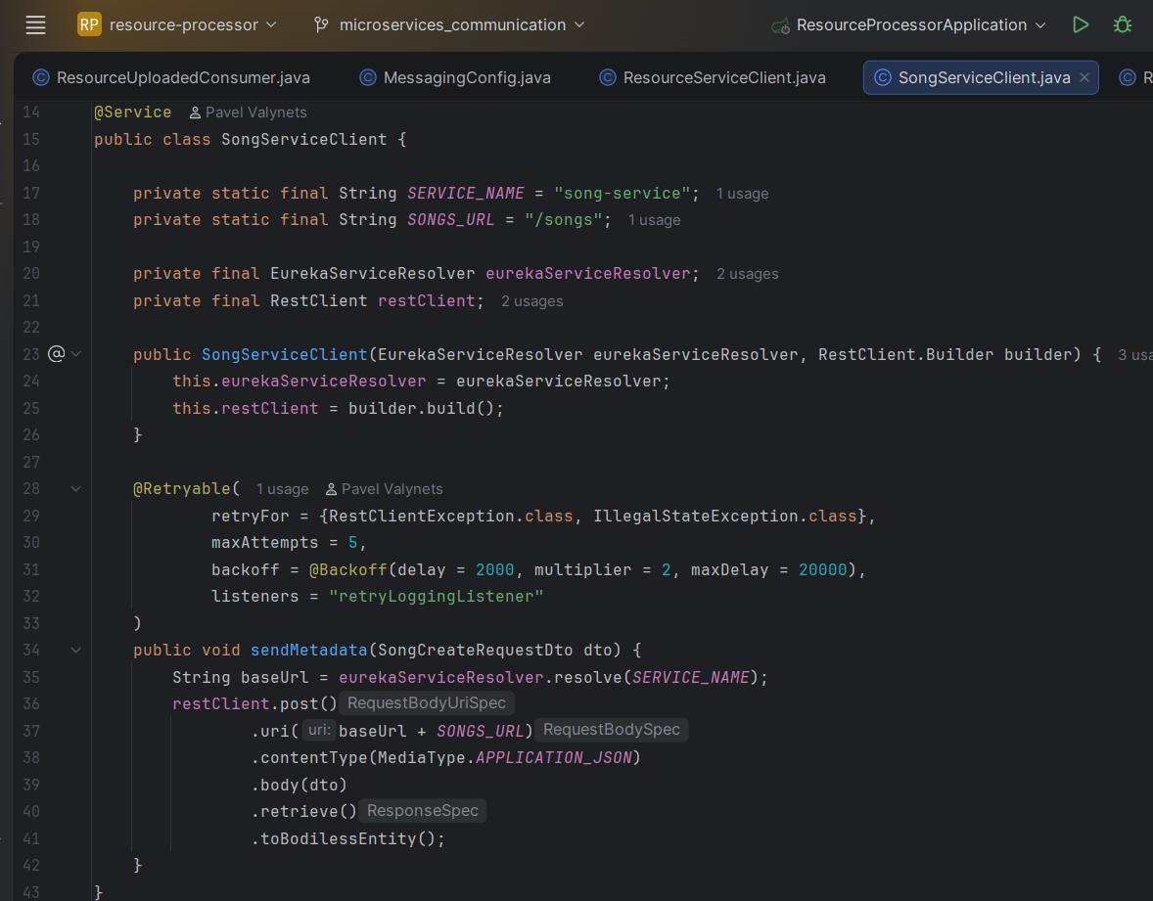

Retry when send metadata to resource service
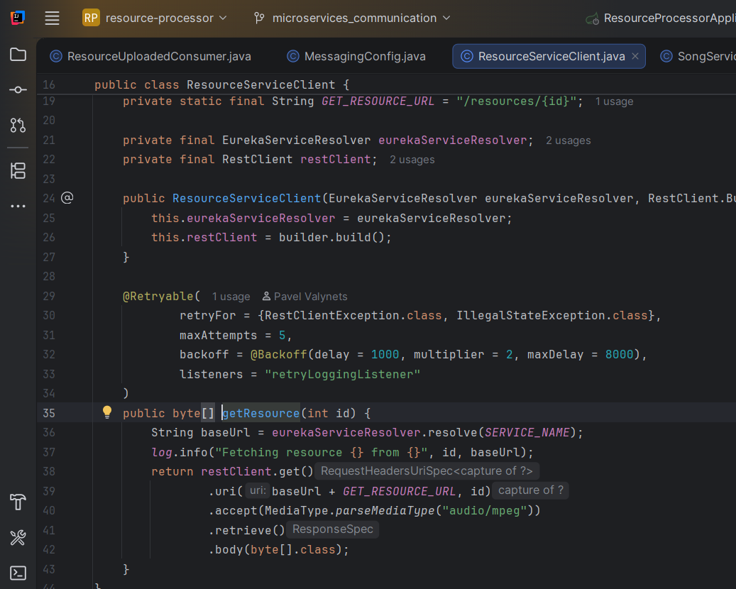

Retry configuration

Dependencies
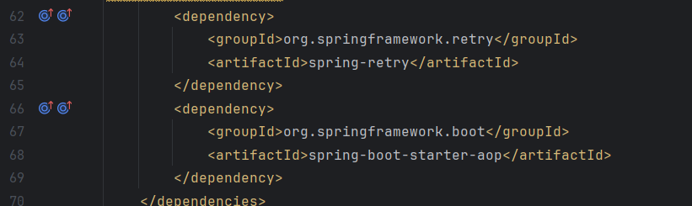

Listener
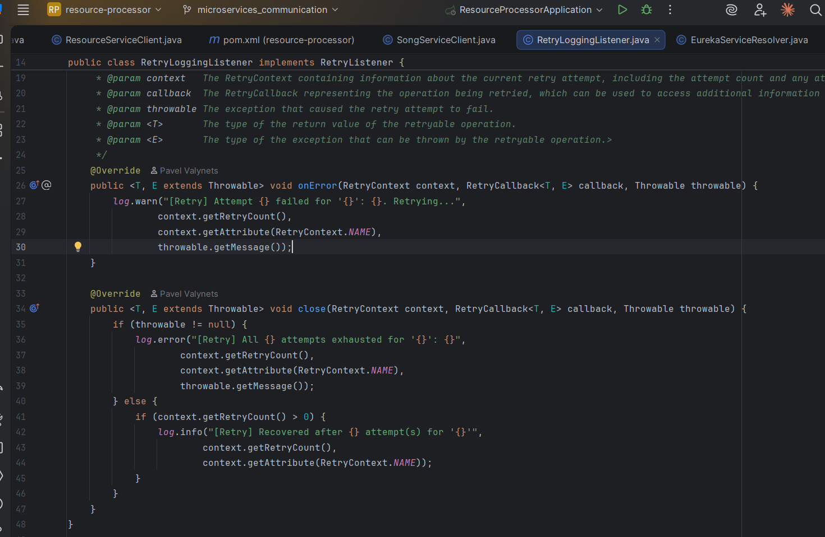

Properties
