Cyber Security Project: The IoTMon framework

Implementation of the paper “On safety of IoT Device Physical Interaction Control” by Wenbo Ding and Hongxin Hu. This report aim to cover the main aspects of the Cyber Security project, describing different design choices and finally showing up the result obtained.

This project is based on the implementation of a framework, called IoTMon, proposed in the paper of Ding and Hu, designed to discover any possible physical interactions between different IoT devices. Starting from a given set of Official Samsung application known as SmartThings, the framework is able to address the problems caused by unexpected physical interactions.
In details, with the terminology “physical interaction” are identified all the information that can be transported by a physical channel (for example air, pressure, temperature, light, etc… ) instead with “system interaction” are identified all the information correlated to sensor shared by two (or more) different applications.
I want to underline that in the implementation of this project are analyzed also the aspect related to “system interactions”, unlike the IoTMon developed by Ding and Hu, because this synthesis want to cover all the possible interactions about a wide and heterogeneous IoT scenario.
The projects (and its implementation) is essentially subdivided into two phases:
- the application analysis with:
  - the Intra-app analysis
  - the physical (and system) channel identification
- the interaction chain discovery

1. APPLICATION ANALYSIS
This phase is focused on the analysis of an Official Samsung SmartThings set of applications, in order to extrapolate the information (such as triggers, inputs, and actions) from each app, elaborate them and finally give an order relation.
The first part of this phase is called “Intra-app analysis” and is focused on a static program analysis.
To do that was used the Groovy programming language, in particular the CompilationUnit class of this language, that provided the possibility of doing a semantic analysis and then extrapolate an AST (abstract syntax tree) directly from the app code.
In order to correctly process every Official Samsung SmartThings app, they must follow the same code structure, in particular, the presence of:
A) the preference method: where inside are listed all the section that manage a specific input correlated to a specific trigger capability.
B) installed/updated method: this method owns a list of all trigger handler called by the dedicated subscribe method, defined like:
subscribe( trigger name, “trigger channel”, trigger handler method ).
C) the handler method, that directly modify the environment by the set of its outputs.
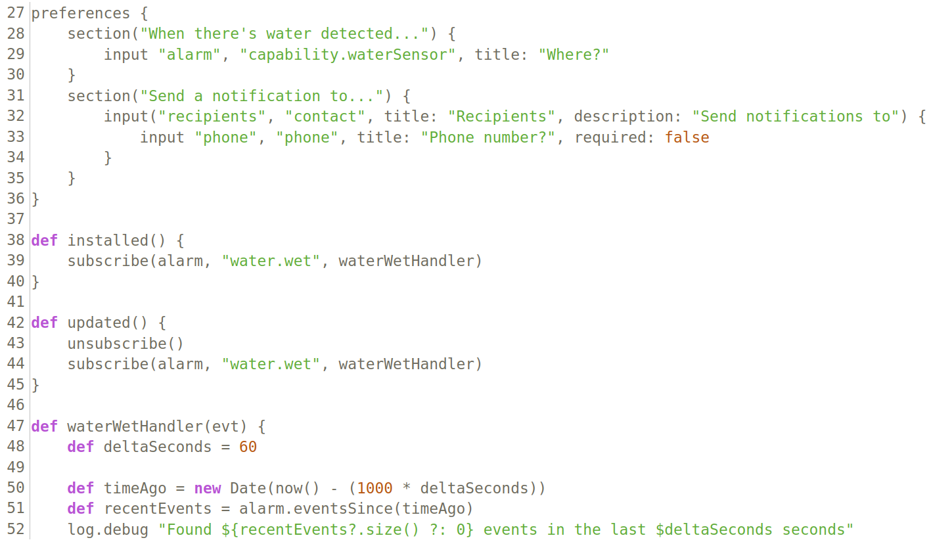
Illustration 1: example of an Official Samsung SmartApp - flood alert
So, from the parse of the AST was extracted the runMethod, where are present the application description and the preference method, recursively every MethodCallExpression (the sections) and, inside every sections, every ExpressionStatement, in order to extrapolate every inputs and its correlated trigger capabilities.
When the parse tool got all the inputs (and correlated trigger capability), it was able to checked the installed (or updated) method and verify if the subscribe method manage one of the inputs. In the case it managed one of them, the parse tool recursively analyze the handler method associated to that input and save the managed output with its associate action capability.
Finally, the parse tool provides:
- a list of every Samsung SmartThings app description
- a list of tuple made by: all trigger capabilities (inputs), action capabilities and the actions (outputs).
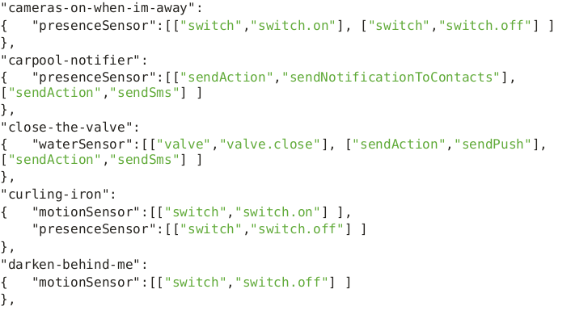

The set of Official Samsung SmartThings app coming from both the app dataset of the authors of the paper and also from the Official Samsung SmartThings web page.

The second part of the first phase, defined as “physical channel (and system) identification” now elaborates the result coming from the first part.
The paper made by Ding and Hu highlight that it’s possible from every app description to extrapolate information about the channel (physical and nor) relate with the SmartThing application and, in particular, the framework in order to identify all possible channels apply a sort of cluster algorithm, based on the similarity between all nouns present inside the app description.
To do that was used a python NLP package coming from Stanford NLP group called “Stanza”, that was able to extrapolate from one or more sentences every singular or plural noun, identify as keyword.
Then was used the Word2Vect ML algorithm, with a pre-trained neural network on Google News dataset (about 100 billion words) to calculate every similarity between pair of keywords.
In the end, this process create cluster for every keyword composed of the most similar keywords between themselves. From this set of cluster was easy to extrapolate this channels and the associated keywords and after a revision for every channel’s cluster, the result obtained was:
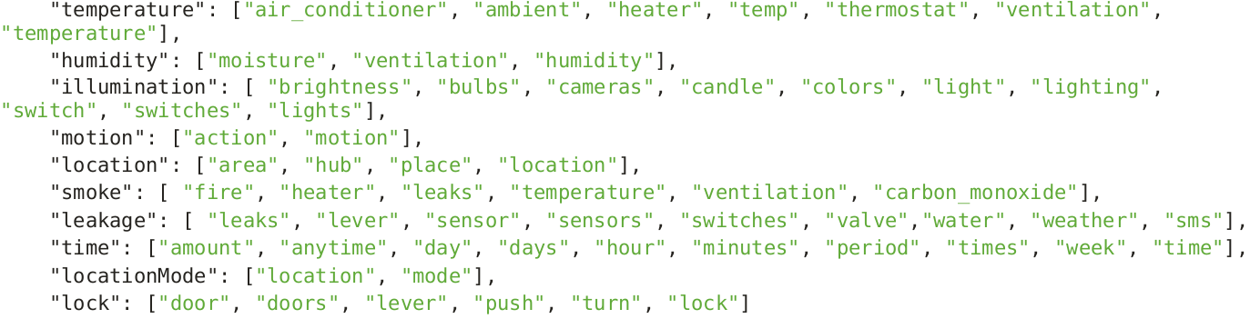
Once the framework IoTMon obtained:
- the list of tuple made by: trigger capabilities (inputs), action capabilities and the actions (outputs).
- the list of all possible channels and correlated keywords
than it created the correlation between every trigger and action capability with the associated channels. Since that the way of coding of Official Samsung SmartThings applications define the capabilities with a name strongly correlated to its operating channel field, it was possible to create an association table that list every trigger and action capabilities with its own application channel.

[tabella risultati]

The table reported above is the same of paper’s table 3 with some differences. I want to underline that these differences are correlated to the dimension and type of channel cluster and the definition of these last one coming from the used SmartThing application dataset. So the differences are acceptable since that are passed more than 3 years from the authors project implementation and the app descriptions have been obviously modified and improved by the Samsung SmartThings team.

In the and of this first phase are showing some capability analysis in order to certificate the correctness of the labeled capabilities with the author’s result. This is a comparison of the result obtained from the application of my changed parse tool (on the left) and the result obtained by the authors of the paper (on the right).

[grafici] [grafici]

The final result coming from the first part are totally align with the authors results, I picchi sono gli stessi, except for the values, different from the authors one since that they have used a bigger app dataset than mine.

2. INTERACTION CHAIN DISCOVERY
The scope of the second part was discover all Inter-app interaction chains, in details this mean to find all possible pair of Samsung SmartThings application such that the action (output) executed by the app number 1 alter the “status” of a physical variable or a sensor value such that this evolution triggers another app, app number 2, that consequently done its own process and show its outputs effects. In this way was possible to find all Inter-app interaction and in particular discover the unexpected ones.
To do that was used:
1. the list of tuple made by: trigger capabilities (inputs), action capabilities and the actions (outputs).
2. the table that associates every trigger and action capabilities with its own application channel.
The algorithm elaborates all possible combination of pair trigger-action capabilities and verify thanks to table XX if could exist a physical or system channel that connect the two capabilities, in case there is it, a new Inter-app interaction was found.

[algoritmo]

There are an example of the most significant Inter-app interaction:

