Võ Minh Nhật Quang  Year-3 AI Student | AI Engineer Intern Candidate  Ho Chi Minh City, Vietnam | +84 902 304 205 | vominhnhatquang@gmail.com  github.com/vominhnhatquang | huggingface.co/Nhat-Quang | 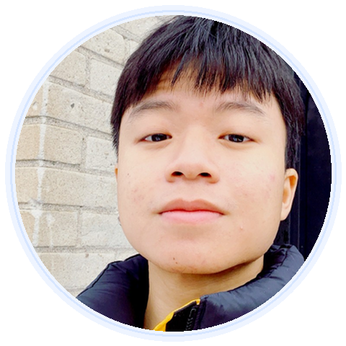

SUMMARY  Third-year Artificial Intelligence student at FPT University, focused on practical AI systems: RAG, recommendation, model validation, data pipelines, and deployable web apps. Comfortable with agent-assisted coding workflows such as Pi.dev, using agents for planning, debugging, code review, and documentation while keeping work reviewable.  EDUCATION  - FPT University HCMC - Artificial Intelligence (2024-2027); Year 3 student  CORE SKILLS  AI / ML: RAG, hybrid search, Qdrant, BM25, embeddings, LoRA / QLoRA, model validation, regression  Programming: Python, TypeScript, SQL, FastAPI, Flask, Next.js, React, Pydantic  Data / Infra: PostgreSQL, Redis, Celery, Docker Compose, Hugging Face Hub, DVC, GitHub Actions  Agent Coding: Pi.dev, AI coding agents, prompt-driven debugging, agent-assisted code review, documentation-first workflow  Design: Photoshop, InDesign, Illustrator, visual presentation  HUGGING FACE  - VN_Fashion_data: Dataset snapshot for OutfitMatch; Vietnamese fashion/e-commerce data.  - OutfitMatch LoRA adapters: PEFT/LoRA adapters for stylist experiments on Qwen/Qwen-VL/Gemma variants. | SELECTED PROJECTS  OutfitMatch - AI Fashion Stylist (2026)  Private GitHub + public Hugging Face artifacts | Python · Qdrant · graph retrieval · QLoRA · Qwen/Gemma  - Built the data/knowledge-base path for a Vietnamese fashion recommendation system: catalog scraping, semantic tagging, graph retrieval, quiz reranking, and size suggestions.  - Validated 5,618 catalog items; latest audit reports 0 invalid rows and a graph KB with 4,694 nodes and 316,559 canonical edges.  - Published Hugging Face dataset/model artifacts for OutfitMatch experiments.  RAG Chatbot - Document Q&A (2026)  Public | FastAPI · Next.js · Qdrant · PostgreSQL · Redis · Docker | https://github.com/vominhnhatquang/MultiAgent_RAG  - Built a document Q&A system with PDF/DOCX/MD/TXT ingestion, hybrid vector + BM25 retrieval, RRF fusion, HyDE, guard checks, and SSE streaming.  - Designed an 8-service container architecture with explicit RAM budget and LLM routing.  ORICAVI Coffee Website (2026)  Private | Next.js 15 · React 19 · TypeScript · Cloudflare · Playwright  - Developed a static-first production website foundation with typed content boundaries, contact API seams, tests, build checks, E2E smoke, and Lighthouse workflow.  Gisdio CMS / Website Admin (2026)  Private | React · Vite · Node.js · Express · RBAC  - Built a CMS/admin dashboard for visual content editing, media/blog workflows, 3-role RBAC, live preview, and static HTML export.  Water Quality Prediction Web App (2026)  Public | Jupyter · scikit-learn · Flask · GridSearchCV | https://github.com/vominhnhatquang/Predict-Jartest_N_SONG_KN-by-Antigravity  - Created an end-to-end regression pipeline with model comparison, reproducible train/validation/test split, exported model artifacts, Flask API, and responsive UI.
Generated CV - compact one-page layout with public links only for public repositories

