Võ Minh Nhật Quang  Year-3 AI Student | AI Engineer Intern Candidate  Ho Chi Minh City, Vietnam · +84 902 304 205 · vominhnhatquang@gmail.com  GitHub: vominhnhatquang · Hugging Face: Nhat-Quang | 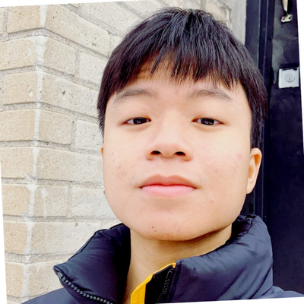
SUMMARY
Third-year Artificial Intelligence student at FPT University, focused on practical AI systems: RAG, recommendation, model validation, data pipelines, and deployable web apps. Comfortable with agent-assisted coding workflows such as Pi.dev, using agents for planning, debugging, code review, and documentation while keeping work reviewable.
EDUCATION
- FPT University HCMC — Artificial Intelligence (2024–2027); Year 3 student
SKILLS
AI / ML: RAG, hybrid search, Qdrant, BM25, embeddings, LoRA / QLoRA, model validation, regression
Programming: Python, TypeScript, SQL, FastAPI, Flask, Next.js, React, Pydantic
Data / Infra: PostgreSQL, Redis, Celery, Docker Compose, Hugging Face Hub, DVC, GitHub Actions
Agent Coding: Pi.dev, AI coding agents, prompt-driven debugging, agent-assisted code review, documentation-first workflow
Design: Photoshop, InDesign, Illustrator, visual presentation
SELECTED PROJECTS
OutfitMatch — AI Fashion Stylist (2026)
Private GitHub + public Hugging Face artifacts · Python · Qdrant · graph retrieval · QLoRA · Qwen/Gemma
- Built the data/knowledge-base path for a Vietnamese fashion recommendation system: catalog scraping, semantic tagging, graph retrieval, quiz reranking, and size suggestions.
- Validated 5,618 catalog items; latest audit reports 0 invalid rows and a graph KB with 4,694 nodes and 316,559 canonical edges.
- Published Hugging Face dataset/model artifacts for OutfitMatch experiments.
RAG Chatbot — Document Q&A (2026)
Public · FastAPI · Next.js · Qdrant · PostgreSQL · Redis · Docker · https://github.com/vominhnhatquang/MultiAgent_RAG
- Built a document Q&A system with PDF/DOCX/MD/TXT ingestion, hybrid vector + BM25 retrieval, RRF fusion, HyDE, guard checks, and SSE streaming.
- Designed an 8-service container architecture with explicit RAM budget and LLM routing.
ORICAVI Coffee Website (2026)
Private · Next.js 15 · React 19 · TypeScript · Cloudflare · Playwright
- Developed a static-first production website foundation with typed content boundaries, contact API seams, tests, build checks, E2E smoke, and Lighthouse workflow.
Gisdio CMS / Website Admin (2026)
Private · React · Vite · Node.js · Express · RBAC
- Built a CMS/admin dashboard for visual content editing, media/blog workflows, 3-role RBAC, live preview, and static HTML export.
Water Quality Prediction Web App (2026)
Public · Jupyter · scikit-learn · Flask · GridSearchCV · https://github.com/vominhnhatquang/Predict-Jartest_N_SONG_KN-by-Antigravity
- Created an end-to-end regression pipeline with model comparison, reproducible train/validation/test split, exported model artifacts, Flask API, and responsive UI.
HUGGING FACE
- VN_Fashion_data: Dataset snapshot for OutfitMatch; Vietnamese fashion/e-commerce data. https://huggingface.co/datasets/Nhat-Quang/VN_Fashion_data
- OutfitMatch LoRA adapters: PEFT/LoRA adapters for stylist experiments on Qwen/Qwen-VL/Gemma variants. https://huggingface.co/Nhat-Quang

