

**🐧Linux:**

Linux is an open-source, Unix-like operating system kernel. It manages hardware resources, runs applications, and provides both CLI (Command-Line Interface) and GUI (Graphical User Interface) through shells and desktop environments.

**Why Linux:**

* Powers servers, DevOps, cloud, embedded systems, super computers.
* Secure, stable, & widely used in IT

**🧩Key components:**

1. kernel: core OS that manages CPU, memory, devices
2. shell: interface for commands (bash, zsh)
3. file system: Hierarchical structure (/home, /etc, /var etc.,)
4. Utilities: programs to manage files, Processes, networks

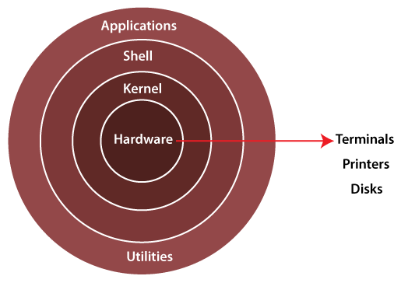

**📁Linux file system:**

/

├── boot → Bootloader files (kernel, initrd, grub)

├── bin → Essential user commands (ls, cp, mv, cat)

├── sbin → System binaries (fsck, reboot, ifconfig)

├── etc → Configuration files (/etc/passwd, /etc/ssh/sshd_config)

├── home → User home directories (/home/user)

├── root → Root user’s home directory

├── lib → Shared libraries required by /bin and /sbin

├── usr → User programs, libraries, docs (/usr/bin, /usr/lib)

├── var → Variable data (logs, mail, spool, cache)

├── tmp → Temporary files

├── opt → Optional / third-party software

├── mnt → Temporary mount point

├── media → Mount point for removable media (USB, CD-ROM)

├── dev → Device files (disks, terminals)

└── proc → Virtual filesystem (process and kernel info)

**🛣️Paths:**

* Absolute Path: /home/user/file.txt
* Relative Path: ./file.txt

**💻Basic commands & file operations:**

1. pwd → Print current directory
2. ls → list files & directories in pwd
3. ls -R → list files in sub-directories as well
4. ls -a → shows hidden files.
5. ls -al → long lists files & directories with detailed info via permissions, size owner etc;
6. ls -lt → time sequence
7. ls -alt → list all files including hidden ones, sorted by time
8. cd directoryname → changes to directory.
9. cd .. → move one level up

7 columns

1 → File type + permissions

2 → Number of hard links

3 → Owner (user)

4 → Group

5 → File size (in bytes, not KB)

6 → Last modified date & time

7 → File name

1. cat > filename → creates a new file, cat >> filename → add data
2. cat filename → displays the file content
3. cat file1 file2 > file3 → joins 2 files & store o/p in a new file (file3)
4. touch filename → creates a file
5. rm filename → deletes a file
6. cp source destination → copies file from source to destination path
7. mv source destination → moves file from source destination path
8. find / -name filename → finds a file by its name
9. file filename → determines file type
10. less filename → view the file content page by Page
11. head filename → view the first ten lines of a files
12. tail filename → views last ten lines of a file
13. lsof → shows which files are opened by which process
14. du -h --max-depth=1 → shows the size of each dir. Use --max-depth = 1 to limit the o/p to the current dir & its immediate children.
15. fdisk → disk partition manipulation command.

**filter commands:** more, less, head, tail, sort, sed, cut

sort filename && sort -n filename → numeric order

sort -u filename → eliminate duplicate

✏️We can edit a file by 3 ways: vi/vim/nano

In vi we have 3 types of modes: command/ insert/ extended command

**Command mode:**

* G → end of the file
* gg → start of the file
* w → line by line forward
* b → line by line backward
* u → undo the single line
* U → undo changes made to the current line since you entered it
* p → paste
* P → paste
* yy → one line copy
* nyy → n lines copy
* dw → line by line delete
* x → letter by letter delete
* ndd → to delete the line.

**Insert mode:**

* i → insert at cursor position
* I → insert at beginning of the line
* a → insert at next letter
* A → Insert at end of the line
* o → open a new line below cursor
* O → open a new line above cursor

**Extended Command mode:**

* wq → save & quit
* x → save & quit
* w → save only
* w! → save forcefully
* q → quit
* q! → quit forcefully
* wq! Save & quit forcefully
* :set nu → set numbers to the lines
* :set nonu → set no numbers to the lines
* :n → jump to line number n

**📂Directory operations:**

1. mkdir directoryname → creates a new dir in pwd
2. rmdir directoryname → deletes a directory
3. cp -r source destination → copies directories recursively
4. mv olddir newdir → rename directories
5. find / -type d -name "directoryname"→ finds a directory
6. rm -rf, rm -f → removes dir with files starting from root

**🔐File permissions:**

Types of permission r=read w=write x=execute

check permissions by ls -l

1. change permissions → chmod 775 script.sh && chmod u+x file.sh
2. change ownership → chown user:group file.txt

r=4, w=2, x=1 765, 400 → read only

1. chmod octal filename → change permissions of octal which can be between 0 to 7
2. chown ownername filename → change owner
3. chgrp groupname filename → change group owner.

**👤User management**

adduser is more user-friendly; useradd is lower-level and scriptable

1. whoami → show current user
2. id → show UID, groups
3. adduser user1 → add new user
4. passwd user1 → change password
5. su user1 → switch to user1 account.
6. sudo cmd → run command as root
7. useradd <username> → creates a user
8. usermod → modify a user
9. userdel → delete a user, userdel -r username
10. passwd → assign password for user. passwd <username>
11. su - → switch to root (if password provided).

**👥Group management:**

1. groupadd → create a group
2. gpasswd → assign password
3. gpasswd -r <groupname> → removes password
4. groupmod -n oldgroupname newgroupname → changing group name

/etc/passwd → it contains local user details

/etc/group → it contains local group properties

/etc/gshadow → it contains local group password properties

/etc/shadow → it contains local user password properties

**⚙️Process operations:**

1. ps → display your currently active processes
2. top → display all running processes (live system monitor)
3. kill PID → kills process with given pid
4. pkill name → kills the process with the given name
5. bg → resumes suspended jobs without bringing them to foreground
6. fg → brings the most recent job to foreground
7. fg n → brings job n to the foreground
8. renice +n [pid] → change the priority of a running process.
9. &>filename → redirects both the stdout and the stderr to the ﬁle ﬁlename.
10. 1>filename → redirect the stdout to ﬁle ﬁlename.
11. 2>filename → redirect stderr to ﬁle ﬁlename.

fork()

parent

child

[Running] [Waiting] [Stopped]

[Zombie] (Terminated but not cleaned)

**📦Package management:**

1. sudo apt-get update → updates package lists for upgrades
2. sudo apt-get upgrade → upgrades all upgradable packages
3. sudo apt-get install pkgname → install pkgname
4. sudo apt-get remove pkgname → removes pkgname

**🌐Networking:**

1. ping host → ping a host and outputs results
2. whois domain → get whois information for domain
3. dig domain → get DNS information for domain
4. netstat -pnltu → display various network related information such as network connections, routing tables, interface statistics etc.
5. ifconfig → displays IP addresses of all network interfaces
6. ssh user@host → remote login into the host as user
7. scp source user@host:/path → transfers ﬁles between hosts over ssh
8. wget url → download ﬁles from the web
9. curl url → sends a request to a URL and returns the response
10. traceroute domain → prints the route that a packet takes to reach the domain.
11. mtr domain → mtr combines the functionality of the traceroute and ping programs in a single network diagnostic tool.
12. ip addr (modern alternative to ifconfig).
13. ip route (to view/manage routes)
14. ss → another utility to investigate sockets. It's a more modern alternative to netstat.
15. Nmap → network exploration tool and security scanner.
16. tree → used to see all subdir and files. We have to install tree package: sudo apt install tree

**💽Disk Usage**

1. df → show disk usage
2. du → show directory space usage
3. free → show memory and swap usage
4. whereis app → show possible locations of app
5. lsblk → show block devices
6. df -h → mounted disks
7. mount /dev/sdb1 /mnt → mount disks
8. umount /mnt → unmount
9. dd if=/dev/zero of=/tmp/output.img bs=8k count=256k → create a ﬁle of a certain size for testing disk speed.
10. hdparm -Tt /dev/sda → measure the read speed of your hard drive.

**🧭System Info:**

1. date → show the current date and time
2. cal → show this month's calendar
3. uptime → show current uptime
4. w → display who is online
5. whoami → who you are logged in as
6. uname -a → show kernel information
7. df -h → disk usage in human readable format
8. du -sh → disk usage of current directory in human readable format
9. free -m → show free and used memory in MB

**📝Text Processing:**

1. tr → translate or delete characters (e.g., tr a-z A-Z).
2. uniq → filter out duplicate lines (often used with sort).
3. grep pattern files → search for pattern in ﬁles
4. grep -r pattern dir → search recursively for pattern in dir
5. grep -i pattern file → case-insensitive search
6. grep -v pattern file → invert match (exclude)
7. command | grep pattern → pipe the output of command to grep for searching
8. echo 'text': Prints text
9. sed 's/string1/string2/g' filename → replaces string1 with string2 in ﬁlename
10. diff file1 file2 → compares two ﬁles and shows the differences
11. wc filename → count lines, words, and characters in a ﬁle
12. awk → a versatile programming language for working on ﬁles.
13. sed -i 's/string1/string2/g' filename → replace string1 with string2 in ﬁlename. The -i option edits the ﬁle in-place.
14. cut -d':' -f1 /etc/passwd → cut out the ﬁrst ﬁeld of each line in /etc/passwd, using colon as a ﬁeld delimiter.

**🗜️Archives and Compression:**

1. tar cf file.tar files → create a tar named ﬁle.tar containing ﬁles
2. tar xf file.tar → extract the ﬁles from ﬁle.tar
3. gzip file → compresses ﬁle and renames it to ﬁle.gz
4. gzip -d file.gz → decompresses ﬁle.gz back to ﬁle
5. zip -r file.zip files → create a zip archive named ﬁle.zip
6. unzip file.zip → extract the contents of a zip ﬁle
7. tar -cvf archive.tar /path/to/dir/ → create a tar archive.
8. tar -xvf archive.tar → extract a tar archive.
9. tar -jcvf archive.tar.bz2 dirname/ → create a compressed bz2 archive.
10. tar -jxvf archive.tar.bz2 → extract a bz2 archive.

**🌱Environment Variables:**

1. unset VAR → remove a variable
2. env → display all environment variables
3. echo $VARIABLE → display the value of an environment variable
4. export VARIABLE=value → set the value of an environment variable
5. alias new_command='old_command options' → create a new command that executes the old command with the speciﬁed options.
6. echo $PATH → print the PATH environment variable.
7. export PATH=$PATH:/new/path → add /new/path to the PATH.

**📋Logs:**

Location /var/log/

Important logs:

1. /var/log/syslog (system messages).
2. /var/log/dmesg (kernel ring buffer).
3. System logs → /var/log/auth.log
4. Webserver logs → /var/log/nginx/
5. journalctl -u <service>, grep “error” logfile.log

**⏰Job Scheduling (Cron Jobs):**

* Cron = A daemon (background process) that runs scheduled tasks.
* Cron job = A command or script that runs automatically at a specific time/date/interval.

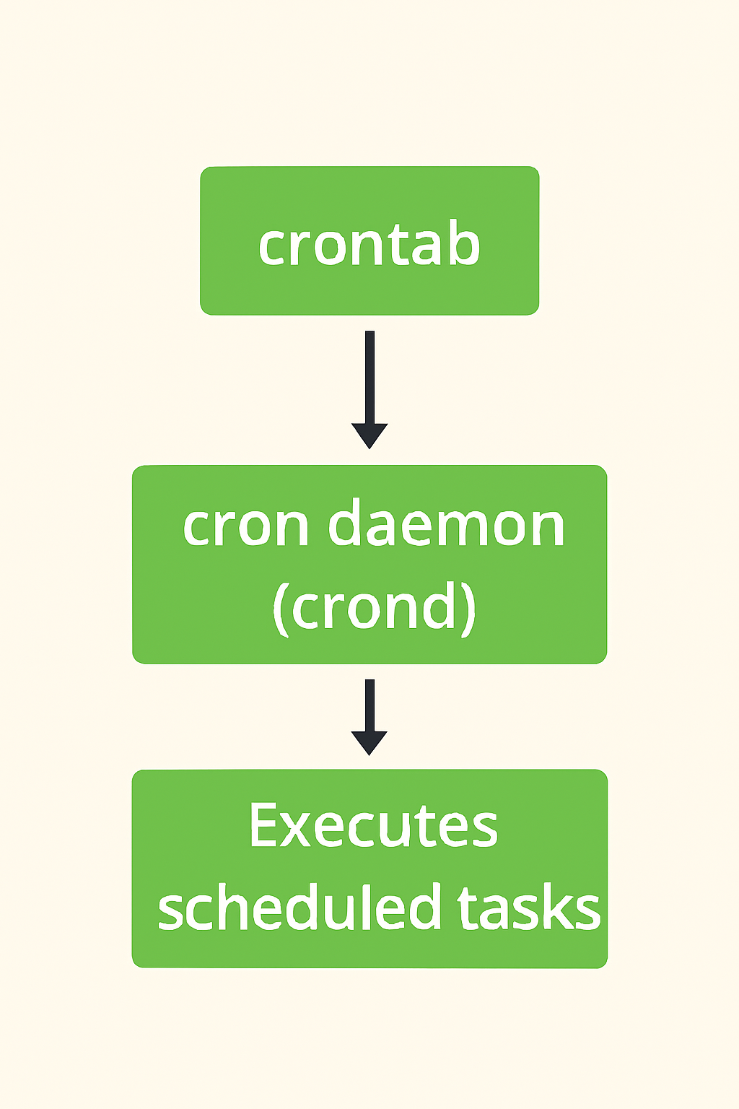

Example uses:

* Take daily backups
* Run monitoring scripts
* Clean logs every week
* Schedule system updates

**Cron Syntax:** A cron job has 5-time fields + command

* * * * * command-to-run

│ │ │ │ │

│ │ │ │ └── Day of week (0-6, Sunday=0)

│ │ │ └───── Month (1-12)

│ │ └──────── Day of month (1-31)

│ └─────────── Hour (0-23)

└────────────── Minute (0-59)

1. crontab -l → list all your cron jobs
2. crontab -e → edit your cron jobs
3. crontab -r → remove all your cron jobs
4. crontab -v → display the last time you edited your cron jobs
5. crontab filename → install a cron job from a ﬁle
6. @reboot command → schedule a job to run at startup

**🚀Services & Systemd:**

1. systemctl start nginx → start service
2. systemctl stop nginx → stop service
3. systemctl enable nginx → auto start on boot
4. systemctl status nginx → check status
5. systemctl restart nginx → restart service.
6. systemctl disable nginx → prevent auto-start on boot
7. systemctl is-enabled nginx → check if enabled
8. journalctl -xe → view recent logs with errors.

**🛡️Linux Security:**

Firewall (UFW in Ubuntu):

1. sudo ufw enable
2. sudo ufw allow 22/tcp
3. sudo ufw status
4. sudo ufw deny 23 → block a port
5. sudo ufw delete allow 22/tcp → remove a rule

**🔗Linux File System Advanced:**

1. Hard Link: Another name for the same file (points to the same inode).

ln file1 file2 → creates a hard link named file2 pointing to file1

1. Soft Link (Symbolic link): Shortcut pointing to the file path.

ln -s file1 link1 → creates a symbolic link named link1 pointing to file1

**LVM (Logical Volume Manager):**

1. pvcreate /dev/sdb
2. vgcreate myvg /dev/sdb
3. lvcreate -L 5G -n mylv myvg
4. mkfs.ext4 /dev/myvg/mylv
5. mount /dev/myvg/mylv /mnt

**📦Package Installations (using pip, a Python package installer):**

1. pip list → list installed packages
2. pip show packagename → show details of a package
3. pip install packagename → install a Python package.
4. pip uninstall packagename → uninstall a Python package.
5. pip freeze > requirements.txt → freeze the installed packages into a requirements ﬁle.
6. pip install -r requirements.txt → install packages from a requirements ﬁle.

**🔍Search and Find:**

1. locate filename → find a ﬁle by its name. The database updated by updatedb command.
2. whereis programname → locate the binary, source, and manual page ﬁles for a command.
3. which commandname → shows the full path of (shell) commands
4. updatedb → mention that it may require sudo and is part of mlocate package

**📊System Monitoring and Performance:**

1. iostat → reports Central Processing Unit (CPU) statistics and input/output statistics for devices, partitions, and network ﬁlesystems.
2. vmstat → reports information about processes, memory, paging, block IO, traps, disks, and CPU activity.
3. htop → an interactive process viewer for Unix systems. It's a more user-friendly alternative to top.
4. sar (system activity report, from sysstat).
5. dstat (combines vmstat, iostat, netstat).
6. htop, dstat, sar → may need installation: sudo apt install htop dstat sysstat

**Memory Management**

RAM

Active Processes Cached Data

(When RAM is full)

SWAP

Part of Disk used as Virtual Memory

* **RAM** – volatile memory used by running processes
* **Swap Memory** – disk space used when RAM is full
  + swapon -s → check swap usage
  + free -h → RAM and swap info
  + sudo swapon /swapfile → enable swap file
  + sudo fallocate -l 2G /swapfile → create swap file
  + mkswap /swapfile → format swap
  + swapon /swapfile → activate swap

**🧪Others (mostly used in scripts):**

1. command1 ; command2 → runs both regardless of success
2. command1 && command2 → second runs only if first succeeds
3. command1 || command2 → second runs only if gropunames fails
4. command & → run command in background
5. yes > /dev/null & → use this command to push a system to its limit.

⚠️ :(){ :|:& };: → a fork bomb – handle with care. Do not run this command on a production system.

This command recursively spawns processes and can crash the system. Never run it outside of a controlled test environment.

**📌 Final Notes to Add at End**

1. Always use man <command> for documentation.
2. Use --help flag (e.g., ls --help).
3. Distros differ: apt (Debian/Ubuntu), yum/dnf (RHEL/CentOS), zypper (SUSE).
4. uname -r → show kernel version
5. lsb_release -a → show distro info (Debian/Ubuntu)
6. hostnamectl → show system hostname and OS info

**🧠 Advanced Linux Admin Tips**

**🔄 Backup & Restore**

* rsync -avh /source /destination → sync files/directories
* tar -czvf backup.tar.gz /path/to/dir → compress backup
* dd if=/dev/sda of=/backup.img → create disk image
* Tools: Timeshift, Deja Dup (GUI options)

**🔐 Security Hardening**

* fail2ban → block IPs with suspicious login attempts
* chkrootkit, rkhunter → scan for rootkits
* auditd → audit system events

**🛡️ SELinux & AppArmor**

* SELinux: getenforce, setenforce
* AppArmor: aa-status, aa-enforce

**📦 Containerization (Docker/Podman)**

* docker run -it ubuntu bash → run container
* docker ps, docker images, docker exec → manage containers
* podman → daemonless alternative to Docker

**⚙️ Performance Tuning**

* sysctl → kernel parameter tuning
* ulimit → user-level resource limits
* nice, ionice → control CPU and I/O priority

**🗂️ Filesystem Types**

* Common: ext4, xfs, btrfs, zfs
* Mounting: mount -t ext4 /dev/sda1 /mnt

**🌐 Network Troubleshooting Tools**

* tcpdump → packet capture
* iftop, iptraf → live bandwidth usage
* ethtool → NIC diagnostics
* nc (netcat) → test ports and connections