**Self-Healing Infrastructure with Prometheus, Alertmanager & Ansible**

**Loom video:** <https://www.loom.com/share/567ecf19c84f44ff9b635eef78c831f5?sid=b22cb210-7e61-468b-9000-efad3e8be193>

**Github repo:** [**vommidapuchinni/selfhealing**](https://github.com/vommidapuchinni/selfhealing)

**Introduction:**  
This project automatically detects NGINX service failures and restarts the service using Prometheus, Alertmanager, and Ansible.

**Abstract:**  
Prometheus monitors NGINX. When it goes down, an alert is sent to Alertmanager, which triggers a webhook. The webhook runs an Ansible playbook to restart NGINX automatically.

**Tools Used:**

* Prometheus
* Alertmanager & Flask (for webhook)
* Ansible
* Docker
* NGINX exporter

**Steps:**

1. Run NGINX and NGINX exporter.
2. Configure Prometheus with rules to detect NGINX downtime.
3. Configure Alertmanager webhook pointing to Flask server.
4. Write Ansible playbook to restart NGINX container.
5. Test by stopping NGINX and checking auto-restart.

**Conclusion:**  
The system successfully detects failures and automatically restores NGINX without manual intervention.

**Prometheus Alert Firing**

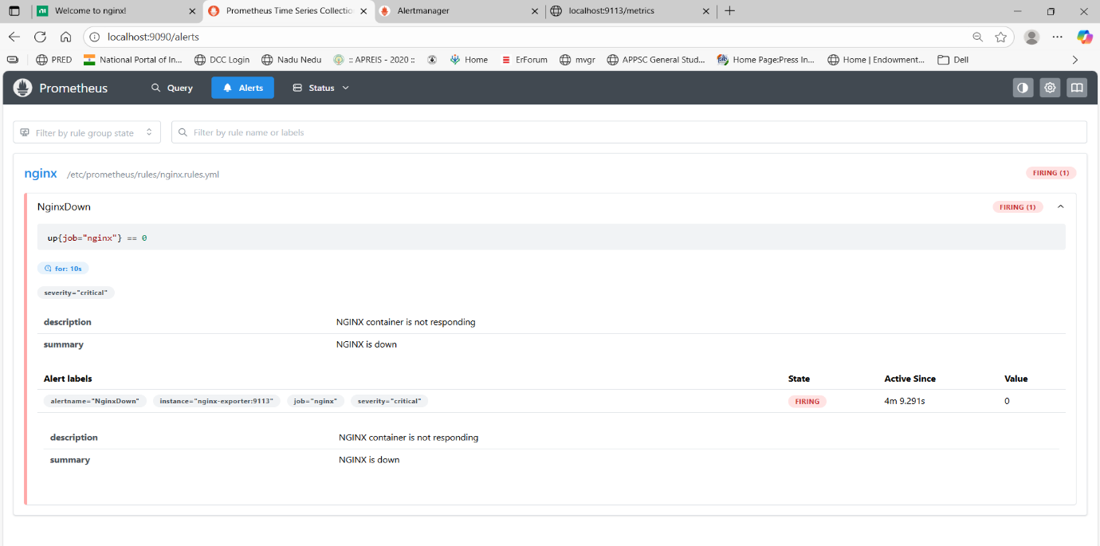

**Alertmanager Receiving Alert**

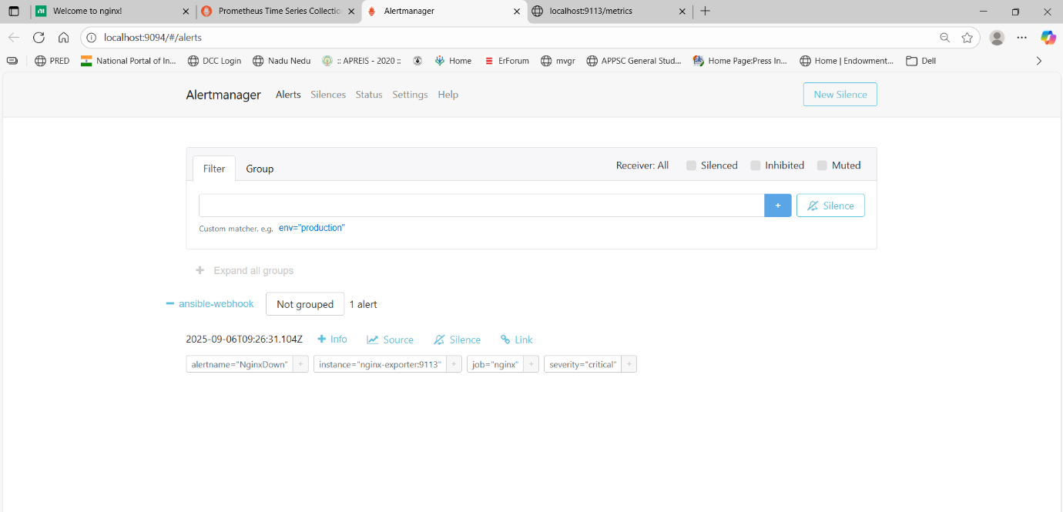

**Ansible Playbook Execution**

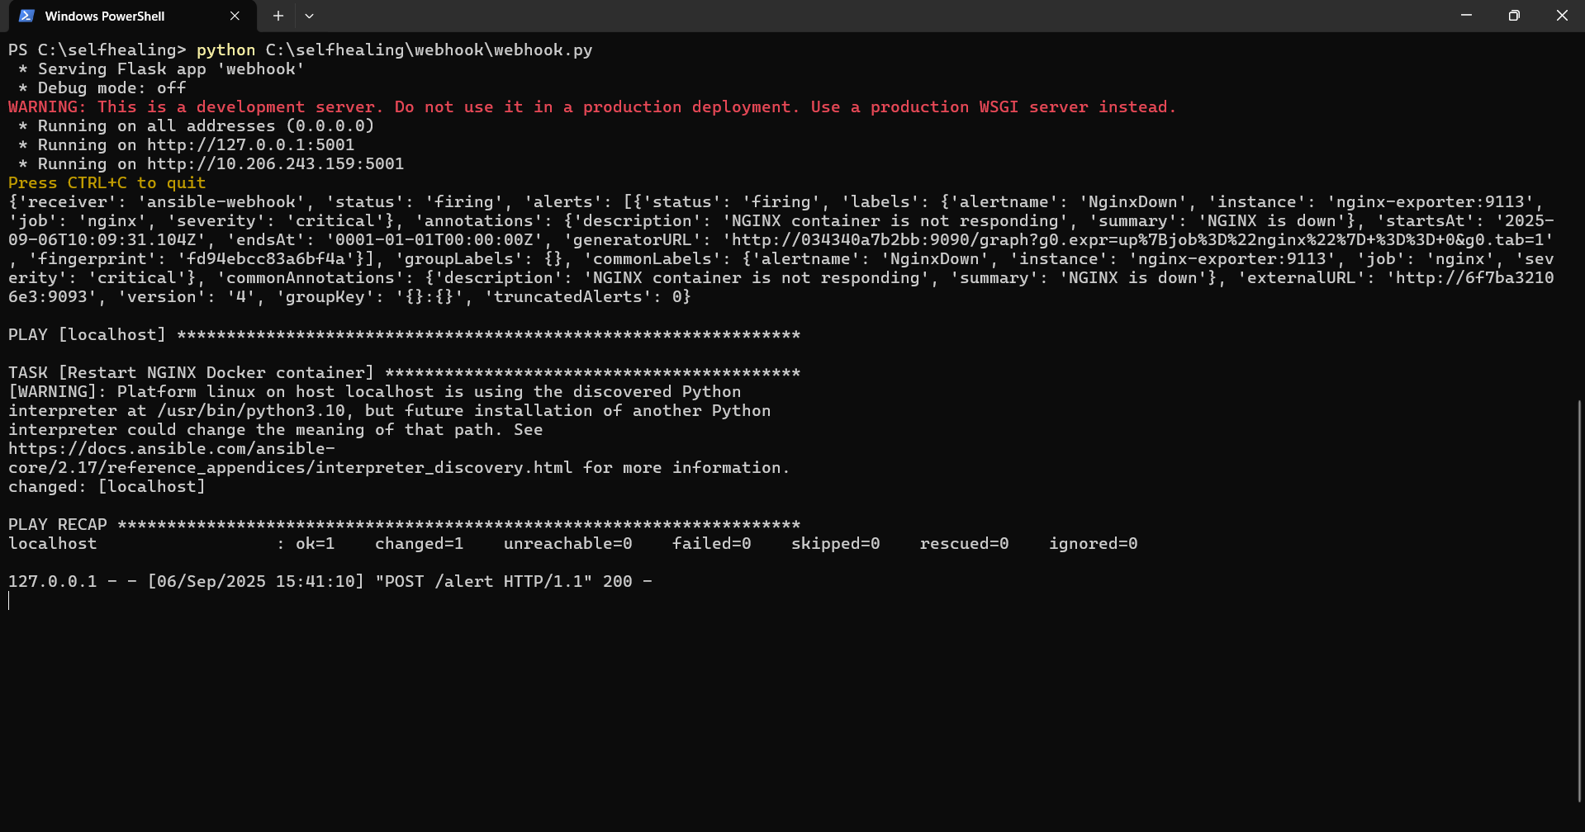

**NGINX Service Recovered**

