DIFFERENTIAL EVOLUTION OPTIMIZED DEEP NEURAL NETWORK FOR INTRUSION DETECTION SYSTEMS

BY

FLORISH ADEKOGBE
190805025

TITLE PAGE

SUBMITTED TO THE DEPARTMENT OF COMPUTER SCIENCE, FACULTY OF SCIENCE, UNIVERSITY OF LAGOS, LAGOS STATE. IN PARTIAL FULFILMENT OF THE REQUIREMENTS FOR THE AWARD OF BACHELOR OF SCIENCE (B.Sc.) DEGREE IN COMPUTER SCIENCE

SUPERVISOR: DR. B. A. SAWYERR

AUGUST, 2026

CERTIFICATION
This is to certify that this project titled “DIFFERENTIAL EVOLUTION OPTIMIZED DEEP NEURAL NETWORK FOR INTRUSION DETECTION SYSTEMS” was carried out by FLORISH ADEKOGBE with Matriculation Number 190805025 and submitted to the Department of Computer Science, Faculty of Science, University of Lagos, in partial fulfilment of the requirements for the award of Bachelor of Science (B.Sc.) degree in Computer Science.

________________________ ________________________
DR. B. A. SAWYERR DATE
SUPERVISOR

________________________ ________________________
DR. C.O. YINKA BANJO DATE
HEAD OF DEPARTMENT

ABSTRACT
In the last couple of years, the world has seen an exceptional increase in cyber and malware attacks, making it clear that we need more intelligent and adaptive security solutions. Traditional intrusion detection systems frequently find it difficult to keep up with the ever-evolving nature of modern threats. The use of artificial intelligence to create systems that can automatically identify dangers and learn new things is becoming more popular as a result of this reality. The project's objective is to create a Deep Neural Network model that can identify intrusions with high accuracy while minimizing false alarms. At its core, this research tackles a fundamental challenge in deep intrusion detection to find the right combination of hyperparameters. As researchers have shown in the evolutionary computation literature, metaheuristic algorithms like genetic algorithms and differential evolution offer powerful ways to search through complex spaces where traditional gradient-based methods might get stuck in local optima. The motivation behind this work comes from a simple observation: deep neural networks can be remarkably good at recognizing patterns, but their performance hinges heavily on how we configure their architecture and training parameters. This approach is based on the Machine Learning Development Lifecycle (MLDLC). It will include gathering and preprocessing data, defining the model architecture, using Differential Evolution to perform hyperparameter optimization, training the model using a current benchmark dataset (CSE-CIC-IDS2018), and performance evaluation in detail. Based on the best practices of evolutionary algorithm studies, the DE algorithm will optimize the most significant hyperparameters, including the network depth, the layer sizes, learning rate, dropout rate, and the activation functions, whereas the fitness will be computed based on the model’s performance on the validation data. The desired outcome is a DE-optimized DNN model, which is very efficient in comparison to the standard machine learning classifiers and manually optimized deep learning algorithms on the key metrics related to accuracy, precision, recall, and F1-score.

LIST OF TABLES
Table 2.1: Comparison of Intrusion Detection System Types 9
Table 2.2: Types of Neural Network Architectures 11
Table 2.3: DNN Architectures Commonly Used in Intrusion Detection 13
Table 2.4: Differential Evolution Control Parameters 15
Table 2.5: Comparison of Evolutionary Optimization Algorithms 15
Table 2.6: Summary of Related Works on Deep Learning and Evolutionary Optimization 18

Table 3.1: Research Environment Specifications 20
Table 3.2: CSE-CIC-IDS2018 Dataset Characteristics 21
Table 3.3: Hyperparameter Search Space for DE Optimization 24
Table 3.4: Performance Evaluation Metrics 26
Table 3.5: Software and Hardware Environment Used for the Experiments 28
Table 3.6: Class Distribution of the CSE-CIC-IDS2018 Corpus as Used 29
Table 3.7: Classes Excluded as Too Small to Evaluate 29
Table 3.8: Composition of the Experimental Dataset 30
Table 3.9: Differential Evolution Configuration Used in the Experiment 32

Table 4.1: Best Hyperparameter Configuration Found by the Search 34
Table 4.2: Test Set Performance of the Final DE-Optimised DNN 36
Table 4.3: Per-Class Performance of the Final Model on the Test Set 37
Table 4.4: Distribution of Classification Errors in the Final Model 38
Table 4.5: Effect of Raising the Class Cap from 20,000 to 200,000 39
Table 4.6: Per-Class F1 Changes Between the Two Training Regimes 40
Table 4.7: Configurations Compared 41
Table 4.8: Performance of the DE-Optimised Network against the Manual Baseline 41

LIST OF FIGURES
Figure 2.1: Taxonomy of Intrusion Detection Systems 9
Figure 2.2: Structure of an Artificial Neuron 12
Figure 2.3: Deep Neural Network Architecture 12
Figure 2.4: Background Propagation Process Flow 14
Figure 2.5: Differential Evolution Algorithm Flowchart 14
Figure 2.6: DE Mutation and Crossover Operations 15

Figure 3.1: Machine Learning Development Lifecycle 19
Figure 3.2: Data Preprocessing Pipeline 22
Figure 3.3: Proposed DE-DNN System Architecture 23
Figure 3.4: DE-Optimized DNN Framework 24
Figure 3.5: Model Training Process Flow 25

Figure 4.1: Convergence of the Differential Evolution search, showing the best validation macro-F1 attained in each generation. The vertical axis spans only 0.0026. 33
Figure 4.2: Training and validation loss of the final DE-optimised network trained on the full class-capped corpus. Early stopping restored the weights from epoch 46, marked by the dashed line. 35
Figure 4.3: Confusion matrix of the final DE-optimised network on the held-out test set of 230,994 flows. The two dominant off-diagonal cells are benign traffic classified as Infiltration and the reverse. 38

TABLE OF CONTENTS
TITLE PAGE i
CERTIFICATION ii
ABSTRACT iii
LIST OF TABLES iv
LIST OF FIGURES v
TABLE OF CONTENTS vi

CHAPTER ONE 1
INTRODUCTION 1
1.1 Background of the Study 1
1.2 Statement of Problem 2
1.3 Aim and Objectives 3
1.4 Scope of Study 4
1.5 Limitation of Study 4
1.6 Significance of Study 5
1.7 Research Methodology 5
1.8 Outline of Project 6
1.9 Definition of Terms 6

CHAPTER TWO 8
LITERATURE REVIEW 8
2.1 Introduction 8
2.2 Conceptual Review 8
2.2.1 Intrusion Detection Systems 8
2.2.2 Machine Learning 9
2.2.3 Types of Neural Networks 10
2.2.4 Deep Neural Networks 11
2.2.5 Evolutionary Algorithms and Differential Evolution 13
2.3 Theoretical Framework 15
2.4 Review of Related Works 16
2.5 Summary of Literature Review 18

CHAPTER THREE 19
METHODOLOGY AND IMPLEMENTATION 19
3.1 Introduction 19
3.2 Research Methodology 19
3.3 Research Environment 20
3.4 Dataset Description 20
3.5 Data Preprocessing 22
3.6 Model Design 23
3.7 Model Training 24
3.8 Performance Evaluation Metrics 25
3.9 Implementation Environment and Tools 27
3.10 Dataset Preparation 28
3.11 Differential Evolution Implementation 31

CHAPTER FOUR 33
RESULTS AND DISCUSSION 33
4.1 Introduction 33
4.2 Optimisation Results 33
4.3 Performance of the Final Model 35
4.4 Effect of Sampling Ratio on Detection Behaviour 39
4.5 Comparison with a Manually Configured Baseline 41
4.6 Discussion 43

CHAPTER FIVE 44
SUMMARY, CONCLUSION AND RECOMMENDATIONS 44
5.1 Summary 44
5.2 Conclusion 45
5.3 Limitations 46
5.4 Recommendations 46
REFERENCES 48

CHAPTER ONE

INTRODUCTION

1.1 Background of the Study
The world has been rapidly affected by the spread of digital technologies and explosive increase in the number of internet-connected devices. The digital transformation has presented unbelievable frontiers in the way we communicate, do business and innovations. However, there is another side to the development: it has, too, provided a huge playground for the vicious players that tend to exploit the loopholes of our systems and networks. It is now possible to mention cybersecurity as one of the most burning issues that are faced by organizations, governments, and ordinary citizens in our highly interconnected world.

There are increased cyber-attacks, more advanced malware as well as smarter intrusion attempts than ever before. This rush of threats has created a dire need for security solutions that are not only smart but also able to adapt and learn over time. According to industry reports, the global cost of cybercrime may exceed trillions of dollars annually, and attackers continually develop increasingly sophisticated, harder-to-detect tools. With this scenery, the necessity of superior detection tools capable of identifying not only the established attacks but also new ones using continuous learning and automation with AI becomes apparent.

Intrusion Detection Systems or IDS are now a part of the cybersecurity toolkit. Imagine them as security guards , on the lookout for any suspicious activity that could indicate a security threat. Historically, these systems have been classified into two broad camps, namely signature-based detection and anomaly-based detection. Signature-based IDS operate by matching what they observe against a database that is populated with predefined threat signatures, similar to the operations of antivirus software. Although this method is effective against familiar threats, it just cannot effectively detect a novel or zero-day threat that has never been observed. The anomaly-based detection method does it differently: it learns the appearance of normal objects and flags anything that does not resemble that normal appearance. This has the advantage of having the capacity to detect unknown attacks and it is usually accompanied by the disadvantage of producing excessive false alarms (Garcia-Teodoro et al., 2009).
DNN has demonstrated great success in numerous areas where it is applied in the identification of patterns. Their capability to automatically acquire layered representations over raw data makes them especially suitable for intrusion detection, in which the patterns concealed in the network traffic may be enormously complicated yet incredibly non-linear. Nonetheless, achieving DNNs performance is not an easy task as their usability is highly contingent on the selection of the hyperparameters, such as the network architecture, learning rate, and activation functions.

This is where the evolutionary algorithms come in the picture. It has been found that these algorithms are potent in navigating through complicated optimization landscapes. The studies on the real coded genetic algorithms have revealed that the synergistic optimizations through the global search mechanism and local search methods can significantly enhance optimization outcomes (Das and Suganthan, 2011). Storn and Price introduced Differential Evolution and it received accolades for being easy but efficient in solving non-convex, multimodal optimization problems, without the need to know anything about the gradient.

The proposed research will combine Differential Evolution optimization with Deep Neural Networks to design a more efficient intrusion detection system. Finding the best configurations worldwide, using the capabilities of DE to explore and exploit amidst variations, and relying on the research conducted in the field of evolutionary computation regarding the need to balance the exploration and exploitation phases (Das and Suganthan, 2011), the proposed research will aim to create an IDS that will be capable of the higher detection accuracy and at the same time maintain the number of false positives to the minimum.

1.2 Statement of Problem
The increasing rate and complexity of cyber-attacks pose immense vulnerabilities to organizations across the globe, endangering the integrity of data and digital infrastructure. This has been due to critical failures in the intrusion detection systems that we currently have which prevent them from being effective in contemporary network environments.
The main issues that this study will be trying to solve are:
- The signature-based IDS are deeply incapable of detecting new threats, advanced evasion methods and new zero-day exploits with no signature available.
- The detection systems based on anomaly are more likely to produce a high false positive, thus saturating security teams with false alarms and letting real threats go by.
Although deep learning methods have the potential to be used in intrusion detection, the hyperparameter configuration is significant in evaluating its performance. Manual tuning is time consuming, involves a lot of expertise, and it does not always find those really optimal settings.
The metaheuristic algorithms are effective global optimizers as it has been established in research, however, when not hybridized appropriately, they can be unable to cope with local searches (Das and Suganthan, 2011). The classic gradient-based techniques can become trapped at local optima due to the complicated loss landscapes that characterize intrusion detection problems.
The literature on systematic methods to optimize deep neural network architectures and hyperparameters to optimize intrusion detection, in particular, has a very significant gap. Even though it is true that evolutionary algorithms were implemented successfully in a large number of optimization problems, this method is not too extensively investigated in the sphere of optimization of deep learning-based IDS, with a comprehensive optimization of hyperparameters.
This research will solve these issues by defining a framework of Differential Evolution-optimized Deep Neural Network that searches optimal configurations methodically.

1.3 Aim and Objectives
The major goal of the study is to come up with a Deep Neural Network architecture that uses Differential Evolution as its optimizer, with a higher detection rate, and lower false positives in comparison with the conventional algorithms.
To reach this goal, the following specific objectives are established:
- Carry out an elaborate survey of the available intrusion detection techniques, deep learning models and evolutionary optimization algorithms.
- Build and implement a Deep Neural Network framework that would best suit intrusion detection issues.
- Create a DN optimization system based on Differential Evolution to optimize DNN parameters, such as network structure, learning rate, dropout rate, and network activation functions.
- Combine the DE optimization algorithm with DNN model to allow auto optimization of hyperparameters in the training process.
- Evaluate the performance of the proposed DE-optimized DNN model using a current intrusion detection benchmark dataset, CSE-CIC-IDS2018.
- Compare the performance of the suggested model to the current machine-based intrusion detection models and deep learning-based intrusion detection models.
- Evaluate the effectiveness of the DE optimization in improving the detection accuracy as well as false positive rate, using the correct statistical indicators.

1.4 Scope of Study
This study intends to research on network-based intrusion detection with the use of anomaly-based detection schemes. The system would be capable of binary classification (differentiating between normal traffic and attacks) and multi-class classification (differentiating between particular types of attacks).
To conduct an analysis, the CSE-CIC-IDS2018 benchmark dataset is used. It is only applicable to supervised forms of learning with offline batch processing.

1.5 Limitation of Study
Although this study is relevant to the discipline, it is necessary to note that it has several limitations:
- The DE optimization is computationally intensive. Since every fitness assessment involves training a full DNN, the nested optimization framework is very resource-intensive in both computing resources and time.
- The assessment is based on benchmark data captured in a simulated enterprise environment, which might not fully reflect the level of diversity and complexity of network environments in reality.
- This paper is dedicated to the offline batch processing and mentions nothing about the challenges of the real-time streaming detection in the scenario where latency and the current adaptation are of paramount importance.
- The proposed system assumes that the training data is labeled, which limits its use in the scenario of the absence of this data or in certain cases.
- The deployment problems such as integration into the security architecture that is already available and the computing requirements of the system in the production servers fall outside the scope of the research.

1.6 Significance of Study
The study has academic value as it continues the existing work in the interface of evolutionary computation and deep learning, however, with a specific focus on the topic of hybrid optimization algorithms (Das and Suganthan, 2011; Baioletti et al., 2020). The suggested DE-optimized DNN model can both enhance the accuracy of IDS and minimize the number of false positives in organizations in practice. Methodologically, it offers a structure in applying differential evolution to the optimization of deep learning in security applications, with stringent standards of experimental evaluation set in the context of evolutionary computation studies. Financially, enhanced intrusion detection is able to limit the cost of cyber-attacks to an acceptable extent.

1.7 Research Methodology
This study is based on the Machine Learning Development Lifecycle (MLDLC) that offers a systematic method of creating machine learning systems. There are seven phases involved in the methodology:
- Problem Definition: The intrusion detection classification problem was clearly defined, and the performance objectives were established as well as defining performance metrics that would be used in security applications.
- Data Collection: Obtaining the CSE-CIC-IDS2018 dataset supplied by the Canadian Institute for Cybersecurity, to facilitate the assessment of a variety of attack instances.
- Data Preprocessing: Data cleaning procedures, one-hot encoding of categorical features, min-max scaling of numerical features, and class balancing with SMOTE (optional).
- Model Design: Construction of the DNN architecture with tunable layers, a searching space of the hyperparameter, and the implementation of the DE optimization system with suitable control parameters.
- Model Training: This model teaches DNNs with Adam optimizer, early stopping, and fitness based on validation set performance, and does the DE optimization with generational running.
- Model Evaluation: The overall evaluation of the performance based on the metrics of accuracy, precision, recall, F1-score, and AUC-ROC on the held-out test data and the statistical analysis of the results.
- Results Analysis: The investigation of the experimental results, comparison with the baselines, conclusions, and recording of results.

1.8 Outline of Project
The project report has five chapters, with each having a particular purpose:
Chapter two provides an extensive literature survey, covering intrusion detection systems; the basics of machine learning; neural network implementations; evolutionary algorithms, with a special focus on differential evolution; and related literature on the topic. Chapter three describes the MLDLC framework, the research environment, the datasets, the preprocessing methods, and the model design and training procedures. Chapter four discusses the implementation and presentation of how the proposed system was implemented, and the experimental results gained after the evaluation.
Finally, chapter five summarizes findings of the research done, concludes the results and gives recommendations on future studies in the field.

1.9 Definition of Terms
Intrusion Detection System (IDS): A security system that monitors system activity and network traffic and looks for indications of program or malicious code abuse, illegal access attempts, or security policy violations.
Deep Neural Network (DNN): This kind of artificial neural network is one where there are several hidden layers between the input and output layers. This depth allows the network to learn hierarchical representations of features from data.
Differential Evolution (DE): A population-based optimization algorithm that uses mutation, crossover, and selection operations to iteratively evolve candidate solutions toward optimal or near-optimal configurations. It was introduced by Storn and Price in 1997.
Hyperparameter: These are the parameters that a practitioner sets prior to commencing the learning process and govern the manner in which the training algorithm operates. These differentiate the model parameters which are learned in training.
Fitness Function: This is the fitness function that is used in the evolutionary algorithms to measure the fitness of the candidate solution. It directs search to optimum settings depending on objectives of the problem.
Machine Learning Development Lifecycle (MLDLC): A structured approach to machine learning application development that encompasses all stages, including the problem definition and data collection, model development, and monitoring.

CHAPTER TWO

LITERATURE REVIEW

2.1 Introduction
This chapter takes a close look at the available literature on the subject of intrusion detection systems, machine learning, neural networks, and evolutionary optimization algorithms. The objective is to build a strong theoretical foundation, focus on what other researchers have already done in similar fields, and identify the gaps the research intends to address. A particular focus is placed on evolutionary computation methods and the way they have been used to solve optimization problems, based on the existing work on hybrid evolutionary algorithms.

2.2 Conceptual Review

2.2.1 Intrusion Detection Systems
IDS have become essential building blocks of contemporary cybersecurity infrastructure. They are automated watchdogs and they are always on top of the network traffic and activities of the system to find out anything that is suspicious. The concept of intrusion detection was initially developed in the early 1980s when Anderson (1980) presented a set of principles that should be used to detect unauthorized computer access.

There are two primary dimensions through which IDS can be classified: the source of their data and the process of identifying threats. Considering the sources of data, we can discuss Network-based IDS (NIDS) and these are placed in strategic locations on the network to analyze traffic as it passes along and Host-based IDS (HIDS) that is placed on specific machines and analyzes events such as system calls and file changes. In terms of methodology of detection, signature-based systems compare observed patterns with known attack signatures, which is effective against known attacks but unaware of novel attacks. Instead, anomaly-based systems are trained on what normal behavior appears to be and alert on abnormal behavior as possible intrusion. This method has a potential of detecting unidentified attacks, although it is prone to produce false alarms (Garcia-Teodoro et al., 2009; Liao et al., 2013).
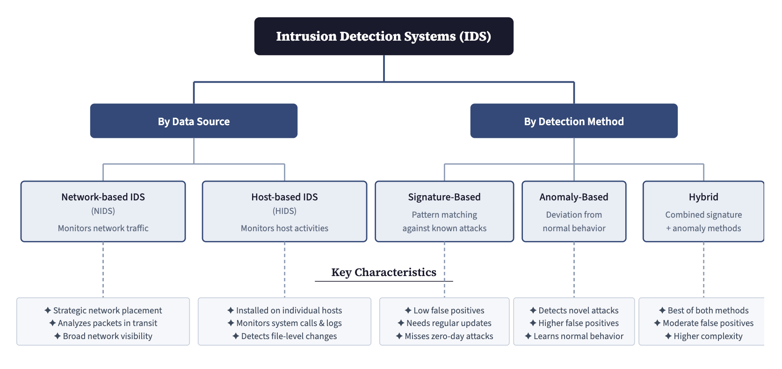
Figure 2.1: Taxonomy of Intrusion Detection Systems
Source: Author's own work

Table 2.1: Comparison of Intrusion Detection System Types
Aspect | Signature-Based | Anomaly-Based | Hybrid
Detection Approach | Pattern matching | Deviation detection | Combined
Known Attack Detection | Excellent | Good | Excellent
Unknown Attack Detection | Poor | Good | Good
False Positive Rate | Low | High | Moderate
Maintenance Effort | High (constant updates) | Moderate | High

2.2.2 Machine Learning
Machine learning is an academic discipline that aims at allowing systems to enhance their functionality through the learning of data instead of using an explicit set of instructions. It is usually classified into three key categories depending on the way the learning process is conducted. These categories, and the distinction between them, follow the standard formulation of the field (Mitchell, 1997).
In supervised learning, we use labeled data to train models, i.e., the expected output is known. It is in the aim of learning a mapping that will be able to predict the results accurately with new inputs. Unsupervised learning, conversely, works with unlabeled data and seeks to identify elusive structures or patterns in the data. Reinforcement learning is a form of learning that involves the interaction of an agent with an environment in which the agent will learn to make a decision based on the feedback which is in the form of rewards or penalties.
In intrusion detection work, supervised learning is usually the method of choice since in this case there is usually access to labeled data of both normal and malicious traffic.

2.2.3 Types of Neural Networks
Artificial neural networks are of numerous varieties, each being tailored to the specific kind of issue it is expected to address. The following are the key intrusion detection architectures:
1. Perceptron: It is a simple type of Neural Network. It is a single-layer device and is only capable of addressing data that are linearly separable (Rosenblatt, 1958).
2. Multilayer Perceptron (MLP): It contains multiple layers which can be fully connected thus enabling it to acquire non-linear relationships. We use backpropagation to carry out training (Rumelhart et al., 1986).
3. Convolutional Neural Network (CNN): It involves convolutional and pooling layers in order to extract spatial features of data. It was originally used to work with images but was also applied in other fields (LeCun et al., 2015).
4. Recurrent Neural Network (RNN): This type of connection is looped providing it with some kind of memory. This renders it appropriate with sequential data in which context is significant (Elman, 1990).
5. Long Short-term Memory (LSTM): A type of RNN which assists the network in learning long-term relationships without forgetting. The gating mechanism that makes this possible was introduced by Hochreiter and Schmidhuber (1997).
6. Autoencoder: Trained to replicate its input, learning a concise representation in the process. Useful as an anomaly detector because of the high reconstruction errors in abnormal inputs (Hinton and Salakhutdinov, 2006).

Table 2.2: Types of Neural Network Architectures
Architecture | Structure | Strengths | IDS Application
Perceptron | Single layer | Simple, interpretable | Limited use
MLP | Fully connected layers | Non-linear learning | Classification
CNN | Convolutional layers | Spatial features | Pattern detection
RNN | Recurrent connections | Sequential data | Temporal analysis
LSTM | Gated recurrent units | Long-term memory | Session analysis
Autoencoder | Encoder-decoder | Unsupervised learning | Anomaly detection

2.2.4 Deep Neural Networks
Deep Neural Networks have multiple hidden layers that make them learn sophisticated features representation of data. These networks are fed with inputs that are transformed in a cascade manner with each layer obtaining progressively more abstract features. A feedforward network with a single hidden layer of sufficient width can in principle approximate any continuous function to arbitrary accuracy (Hornik et al., 1989); depth matters in practice because it allows the same functions to be represented far more compactly, and therefore learned from less data, than width alone permits (Goodfellow et al., 2016).
The artificial neuron is at the centre of a neural network and the input values are summed with the weights and bias terms and then an activation function is applied. Activation functions that are often used are ReLU, which adds non-linearity in a simplistic manner, sigmoid, which maps the output to a binary value, and softmax, which gets the output to a multi-class value.
Examples of common activation functions are:
1. ReLU (Rectified Linear Unit): f(z) = max(0, z). It is quite simple and efficient and also prevents the problem of vanishing gradient.
2. Sigmoid: f(z) = 1/(1 + e^-z). Maps inputs to values between 0 and 1, This works well for binary classification.
3. Tanh: This is similar to sigmoid but it maps to values that are between -1 and 1, which can help with better gradient flow.
4. Softmax: This is used in output layers for multi-class problems, producing a probability distribution over classes.
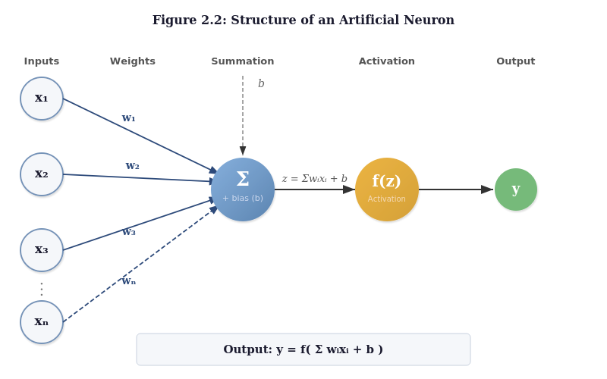
Figure 2.2: Structure of an Artificial Neuron
Source: Author's own work

Neural network training is the process of maximising error reduction through the minimisation of the parameters of the neural network. This is done by backpropagation which propagates the error across the network to adjust the weights depending on their contribution to the total loss. The weights are then updated with the following formula: w_new = w_old - η × ∂L/∂w, where η is the learning rate (Rumelhart et al., 1986).
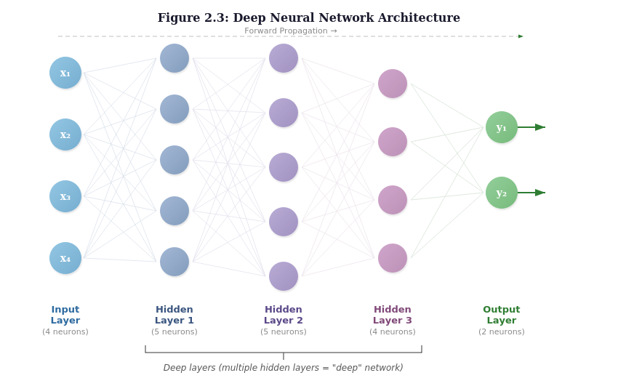
Figure 2.3: Deep Neural Network Architecture
Source: Author's own work

Table 2.3: DNN Architectures Commonly Used in Intrusion Detection
Architecture | Key Characteristics | Typical IDS Application
Multilayer Perceptron | Fully connected feedforward | General attack classification
Deep Belief Network | Stacked restricted Boltzmann machines | Unsupervised feature learning
Convolutional NN | Spatial feature extraction | Pattern recognition in traffic
Recurrent NN / LSTM | Sequential/temporal processing | Session-based detection
Autoencoder | Unsupervised reconstruction | Anomaly detection

2.2.5 Evolutionary Algorithms and Differential Evolution
Evolutionary algorithms (EA) are optimization algorithms that are motivated by biological evolution. They work on the basis of maintaining a pool of candidate solutions that are selected, crossed over and mutated across generations. It has been proved that evolutionary algorithms along with the local search are highly likely to optimize the performance of optimization by establishing a more suitable balance in search and exploitation. Uniform random local search genetic algorithms that have been coded in real code have been particularly useful in continuous optimization problems (Das and Suganthan, 2011).

The difference evolution strategy is what is unique with the Differential Evolution (DE) introduced by Storn and Price in 1997. DE, unlike traditional crossover, forms new candidates by initiating scaled variation in the members of the existing population. This algorithm works based on three primary steps:
1. Mutation: Creates a donor vector using the formula v = x_r1 + F × (x_r2 - x_r3), in this case F is a scaling factor that controls how big the mutation steps are.
2. Crossover: Hybridizes the donor and the target vectors with a probability of crossover CR, producing a trial vector.
3. Selection: It makes use of greedy selection, when the trial vector is better than the target, it substitutes it, otherwise the target is put on to the next generation.
This straightforward mechanism turns out to be remarkably effective at exploring complex search spaces (Das & Suganthan, 2011).
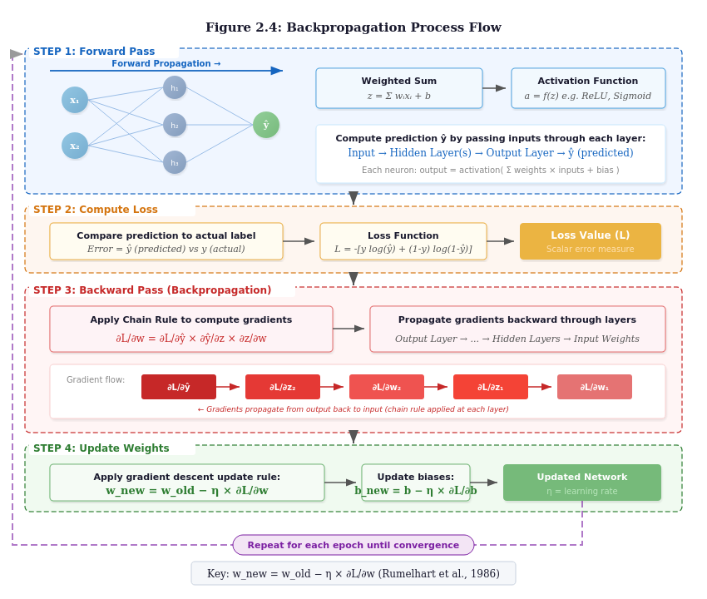
Figure 2.4: Background Propagation Process Flow
Source: Author's own work

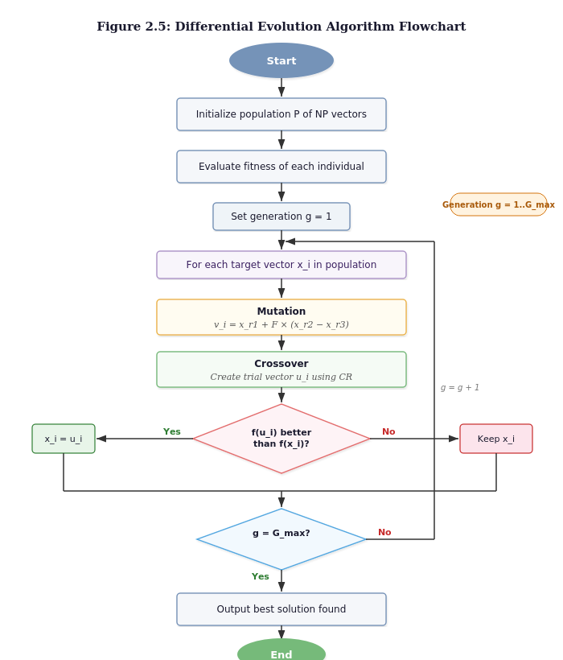
Figure 2.5: Differential Evolution Algorithm Flowchart
Source: Author's own work
Table 2.4: Differential Evolution Control Parameters
Parameter | Symbol | Typical Range | What It Does
Population Size | NP | 5D to 10D | Larger values increase diversity but cost more
Scaling Factor | F | [0.4, 1.0] | Controls how big the mutation steps are
Crossover Rate | CR | [0.1, 0.9] | Higher values create more varied trial vectors
Max Generations | G_max | Problem-specific | When to stop the search

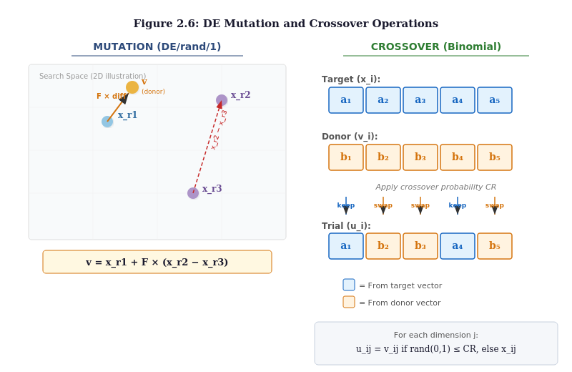
Figure 2.6: DE Mutation and Crossover Operations
Source: Author's own work
Table 2.5: Comparison of Evolutionary Optimization Algorithms
Algorithm | Mutation Strategy | Main Advantage | Key Reference
Genetic Algorithm | Bit/real crossover | Flexible encoding | Holland, 1975
Real-Coded GA | Arithmetic crossover | Works well in continuous spaces | Herrera et al., 1998
Differential Evolution | Vector differences | Simple yet powerful | Storn & Price, 1997
Particle Swarm | Velocity updates | Fast convergence | Kennedy & Eberhart, 1995

2.3 Theoretical Framework
The theoretical background of the given research is combined with the concepts of evolutionary computation and deep learning optimization. This confidence can be in the shape of the Universal Approximation Theorem which states that with sufficient capacity, DNNs can be used to approximate any continuous function. Nevertheless, their application training involves studying non-convex manifolds of minimization as well as a variety of local minima in which gradient-based training algorithms can readily be caught.

One of the indicators that should be kept in mind is the No Free Lunch Theorem (Wolpert and Macready, 1997) which states that there is no optimal algorithm that can be most effectively applied to all the problems. With that said, in certain types of problems, such as the one of neural network hyperparameter optimization, aware algorithmic structure is an order of magnitude more successful than random guessing. Its ability to balance between exploration of unexplored solutions and exploitation of promising ones has been demonstrated to provide experiments with real-coded genetic algorithm models that local search is not only advantageous to the quality of solutions obtained, but also to how fast an algorithm of interest finds the correct solution (Das and Suganthan, 2011; Storn and Price, 1997).

Since it is a complete parameterization, every member of the population is linked with a specific hyperparameter configuration of the suggested DE-optimized DNN system. The success of the DNN having the structure is evaluated on validation data and the fitness function is used to train the DNN. By the action of the greedy selection, as well as the differential mutation process, the population then changes its structure as a result of the distribution of the difference in mutation and selection to the processes of DE, so as to become structures that would be more efficient in their detection work without falling into the trap of premature convergence.

2.4 Review of Related Works
The section carries out a review of available literature on the topic of deep learning-based intrusion detection and evolutionary optimization of neural networks with a particular emphasis on studies that apply metaheuristic optimization techniques.
Zhang et al. (2019) came up with a deep belief network (GA-DBN) optimized with genetic algorithms to detect intrusion. Their GA-DBN performed better than a standard DBN in their experiments. Nevertheless, they did not attempt to search a wider range of hyperparameters and did not consider hybrid methods of combining global and local methods.
Vinayakumar et al. (2019) conducted a wide comparison between DL models used in fIDS, namely conventional DNNs, CNNs, and CNN-LSTM hybrids. They obtained detection rates of more than 98% on the benchmark data they evaluated. The weakness of their study was that all hyperparameters were optimized by hand and all possible performance gains due to automated optimization were not put to the test.

Kasongo and Sun (2020) used a feedforward DNN model along with a filter-based feature selection procedure and reached an impressive 99.95% on their benchmark data. Although they worked, they did not optimize their network architecture but relied on some fixed architecture, which implies that they could have missed even more effective ones.

In the context of the larger evolutionary computation community, differential evolution has emerged as a particularly effective approach for continuous optimization problems. Its ability to combine global exploration with efficient exploitation through mutation, crossover, and selection operators makes it well suited for hyperparameter tuning (Das and Suganthan, 2011). Recent studies have further demonstrated the effectiveness of DE in optimizing neural network configurations (Baioletti et al., 2020), with rigorous experimental evaluation confirming its competitiveness across a range of optimization tasks (Storn and Price, 1997).

The impression that this review leaves is that there is a gap in the problem: no effort has been made to comprehensively optimize hyperparameters of DNNs in intrusion detection. The majority of available research either selects architectures manually or optimizes a small number of hyperparameters. Combining DE optimization with the DNN to IDS and also applying the insights learned in the studies of hybrid evolutionary algorithms is an opportunity and this study provides the answer.

Table 2.6: Summary of Related Works on Deep Learning and Evolutionary Optimization
Authors (Year) | Method | Domain | Key Contribution | Limitation
Zhang et al. (2019) | GA-DBN | IDS | GA optimizes DBN params | Limited hyperparameters
Vinayakumar et al. (2019) | CNN-LSTM | IDS | 98%+ detection rate | Manual tuning only
Kasongo & Sun (2020) | DNN + Feature Selection | IDS | 99.95% accuracy | Fixed architecture
Baioletti et al. (2020) | DENN | Classification | DE for NN weights | Not security domain

2.5 Summary of Literature Review
This literature review has covered the theoretical backgrounds as well as the empirical research in the field of intrusion detection system, machine learning, neural networks and evolutionary optimization. The main takeaways are:
1. The way intrusion detection systems have evolved is that the system has stopped being operated by basic rule-based systems and instead has undergone advanced deep learning mechanisms that are capable of identifying sophisticated and new threats.
2. Hyperparameters in different architectures of neural networks have been shown to obtain high detection rates (99% and higher) on benchmark datasets, yet the performance of these networks is sensitive to hyperparameter configuration.
3. The evolutionary algorithms and in particular when combined with local search methods are effective at maneuvering through non-convex optimization spaces that are complex.
4. Differential evolution provides a simple and effective population-based optimization model that does not require gradient information.
5. The DE optimization of DNN hyperparameters is a widely-understudied field in particular related to intrusion detection, which this study fills.

CHAPTER THREE

METHODOLOGY AND IMPLEMENTATION

3.1 Introduction
In this chapter, the design and implementation of the Differential Evolution-optimized Deep Neural Network intrusion detection are described extensively. The methodology is based on the machine learning development lifecycle (MLDLC) that guarantees a systematic process of defining the problem up to the evaluation of the final model. Similarly to the standards of the evolutionary computation research field (Baioletti et al., 2020), performance is evaluated with the help of strict experimental methods.

3.2 Research Methodology
In this research, MLDLC framework is employed because it comprises seven stages that can be systematically utilized to build a machine learning system.
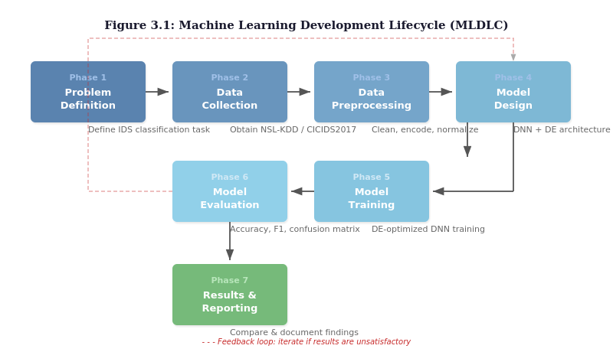
Figure 3.1: Machine Learning Development Lifecycle
Source: Author's own work

All of the phases of the MLDLC have their purpose:
1. Phase 1 - Problem Definition: This is the phase where we define the problem of the intrusion detection classification that is what we wish to achieve, what we desire our performance requirements to be (accuracy exceeding 99.0, false positive rate less than 1.0) and what we desire our evaluation criteria imply for security applications.
2. Phase 2 - Data Collection: we gain access to the CSE-CIC-IDS2018 dataset, which is offered by the Canadian Institute for Cybersecurity in collaboration with the Communications Security Establishment, to take into consideration the different types and events of attacks.
3. Phase 3 - Data Preprocessing: This step includes the cleaning of the data, encoding categorical features with one-hot encoding, normalizing numerical features with min-max scaling and optionally using SMOTE to address the issue of class imbalance.
4. Phase 4 - Model Design: In this step, the data is cleaned, the categorical features are one-hot encoded, the numerical features are min-max scaled, and the classes may be imbalanced, in which case the option of SMOTE is taken into account.
5. Phase 5 - Model Training: DNNs are trained with early stopping with the Adam optimizer. Validation set The performance of validation sets measures fitness and the DE optimization is run over a specific number of generations.
6. Phase 6 - Model Evaluation: we carefully evaluate performance based on accuracy, precision, recall, F1-score, AUC-ROC on held-out test data, and further supported by statistical analysis.
7. Phase 7 - Results Analysis: Results of the experiment will be discussed and compared to the baseline strategies and the conclusion will be drawn and recorded.

3.3 Research Environment
Evolutionary optimization of deep learning models is computationally expensive to run. The research environment is composed of hardware and software that are selected in order to deal with these needs successfully

Table 3.1: Research Environment Specifications
Component | Specification
Operating System | Windows 11 or Ubuntu 22.04 LTS
Processor | Intel Core i7 (10th Gen or newer) or AMD Ryzen 7
RAM | 16 GB minimum
GPU | NVIDIA GTX 1080 or RTX 3060 with CUDA support
Storage | 256 GB SSD
Programming Language | Python 3.10 or newer
Deep Learning Framework | TensorFlow 2.x with Keras API
Optimization Library | SciPy (scipy.optimize.differential_evolution)
Data Processing | NumPy 1.24+, Pandas 2.0+, Scikit-learn 1.3+
Visualization | Matplotlib 3.7+, Seaborn 0.12+

3.4 Dataset Description
Evaluation is centred on a current dataset, in line with the requirement to work with data that reflects the threats facing networks today rather than those of an earlier era. The dataset for this study is therefore CSE-CIC-IDS2018, the most recent large-scale intrusion detection benchmark produced by the Canadian Institute for Cybersecurity in collaboration with the Communications Security Establishment. It supersedes the earlier intrusion detection benchmarks discussed in Chapter Two, which are reviewed there as background but are not used in this work. Working with a modern capture makes it possible to show that the approach performs on contemporary attack traffic rather than on legacy benchmarks.

The primary dataset, CSE-CIC-IDS2018 (Sharafaldin et al., 2018), provides the modern foundation for this work. It was developed by the Canadian Institute for Cybersecurity together with the Communications Security Establishment, and was captured on a far larger network than its predecessors, a simulated organisation of several departments running into hundreds of machines over ten days. The flows were summarised into more than eighty statistical features using the CICFlowMeter tool. The dataset contains a large body of benign background traffic alongside a wide spread of contemporary attacks, including Brute Force, distributed denial of service, ordinary denial of service, Heartbleed, SQL Injection, Infiltration, PortScan and Bot activity. Its scale, its modern attack mix and its realistic class imbalance are precisely what a present-day detector needs to be tested against, which is why it serves as the main dataset for the implementation and results reported in Chapter Four.
Table 3.2: CSE-CIC-IDS2018 Dataset Characteristics
Characteristic | Value
Producer | Canadian Institute for Cybersecurity with the Communications Security Establishment
Capture period | Ten days of traffic from a simulated multi-department organisation
Flow features | 80 statistical features extracted with CICFlowMeter
Records, original release | Approximately 16,000,000
Records, deduplicated build | 6,659,532
Distinct classes | 15, comprising benign traffic and 14 attack families
Benign proportion | 80.02 per cent
Format used in this study | Deduplicated Parquet, 78 columns

3.5 Data Preprocessing
A number of preprocessing tasks will be required before feeding data into the neural network to promote data quality and compatibility. The following tasks are the preprocessing pipeline:
1. Data Cleaning: The records containing missing values, infinity values and NaN are eliminated. This is particularly critical to CSE-CIC-IDS2018, in which rate features such as Flow Bytes/s divide by a duration that can be zero and therefore produce infinite values.
2. Feature Encoding: Categorical features must be changed into numerical ones. In CSE-CIC-IDS2018 the flow features are already numeric, so only the Label column requires encoding; it is mapped to integer class indices, with the positive class fixed explicitly in binary mode rather than assigned alphabetically.
3. Feature Normalization: Continuous features are scaled to the [0, 1] range using min-max normalization: x_normalized = (x - x_min) / (x_max - x_min). This helps the neural network train more effectively.
4. Data Splitting: Stratified data sampling is applied to the data, splitting the data into training (80) and validation (20) sets to ensure that the proportion of classes is not disturbed in the two sets.
5. Class Balancing: For severely underrepresented attack categories like R2L and U2R, SMOTE (Synthetic Minority Over-sampling Technique) can optionally be applied to generate synthetic samples.
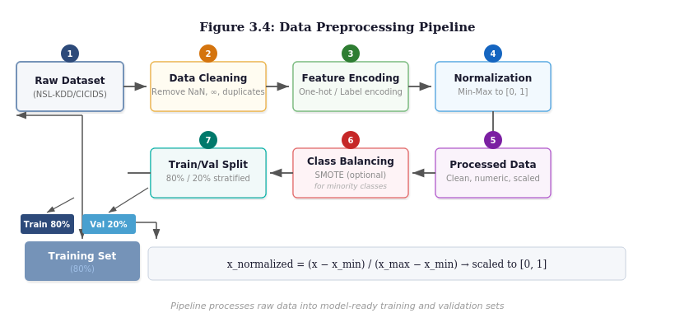
Figure 3.2: Data Preprocessing Pipeline
Source: Author's own work

3.6 Model Design
The proposed system unites the Differential Evolution optimization algorithm and Deep Neural Network training, in a nested system. The outer loop is used to execute the DE optimization over various hypertuning settings and the inner loop to train and evaluate each candidate DNN.
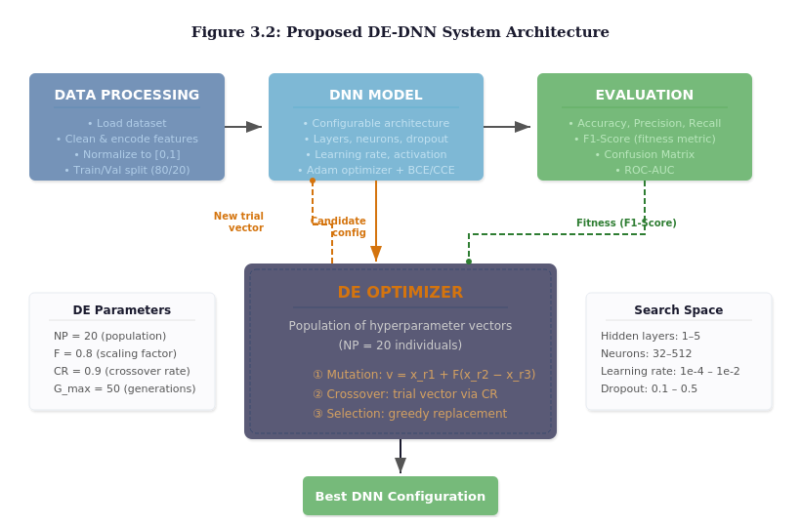
Figure 3.3: Proposed DE-DNN System Architecture
Source: Author's own work

Every member of the DE population is an entire hyperparameter configuration that is represented as a real-valued vector. Continuous values are decoded into integer and categorical parameters when the fitness is calculated.

Table 3.3: Hyperparameter Search Space for DE Optimization
Hyperparameter | Type | Range | How It Is Encoded
Number of Hidden Layers | Integer | 1 to 5 | Rounded from continuous value
Neurons per Layer | Integer | 32 to 512 | Rounded from continuous value
Learning Rate | Continuous | 0.0001 to 0.1 | Log-scale for better coverage
Dropout Rate | Continuous | 0.0 to 0.5 | Direct continuous value
Batch Size | Integer | 16 to 256 | Rounded to powers of 2
Activation Function | Categorical | ReLU, tanh, sigmoid | Integer index

Initialize Population: NP = 20 random configurations
↓
For g = 1 to G_max (50 generations):
For i = 1 to NP:
1. Pick r1, r2, r3 ≠ i at random
2. Mutation: v = x_r1 + F × (x_r2 - x_r3), where F = 0.8
3. Crossover: create trial u using CR = 0.9
4. Decode u → DNN hyperparameters
5. Build DNN, train for 50 epochs, compute F1-score
6. Selection: if F1(u) ≥ F1(x_i): x_i = u
↓
Return best configuration, retrain for 100 epochs

Figure 3.4: DE-Optimized DNN Framework
Source: Author's own work

3.7 Model Training
Model training follows a nested approach. A DNN is built and trained to the following specifications, per candidate configuration that DE proposes:
1. Weight Initialization: Xavier/Glorot initialization is used to maintain moderate gradient variance as signals pass through layers.
2. Optimizer: Adam (Adaptive Moment Estimation) will be applied with the learning rate specified by the configuration being evaluated.
3. Training Duration: Each DNN is trained for 50 epochs during fitness examination. The last model, based on the most successful model, is trained for 100 epochs.
4. Early Stopping: If validation loss does not improve for 10 consecutive epochs, training stops early to save time and prevent overfitting.
5. Loss Functions: Binary Cross-Entropy is used for binary classification (normal vs. attack), while Categorical Cross-Entropy is used for multi-class classification.
The DE control parameters are set based on recommendations from the literature:
1. Population size (NP) = 20: This balances having enough diversity with reasonable computational cost.
2. Scaling factor (F) = 0.8: This provides good mutation amplitude for exploring the search space.
3. Crossover rate (CR) = 0.9: A high value encourages variety in trial vectors.
4. Maximum generations (G_max) = 50: This allows enough time for convergence while keeping computation manageable.
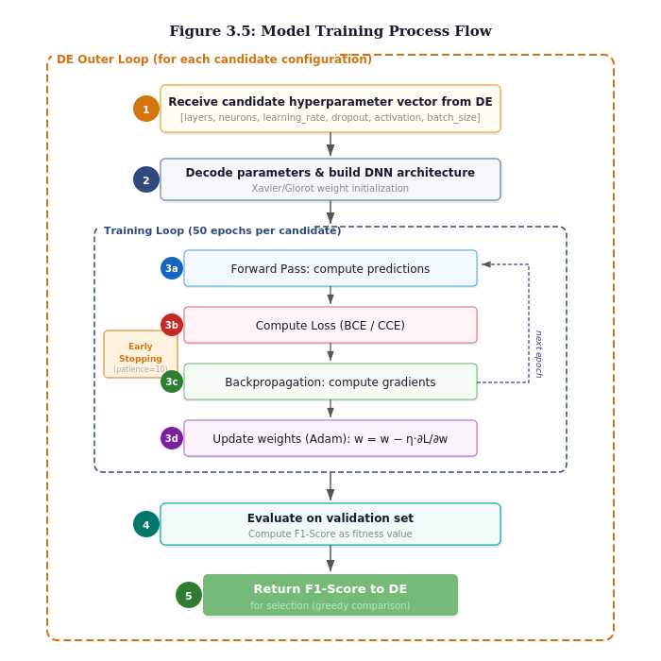
Figure 3.5: Model Training Process Flow
Source: Author's own work

3.8 Performance Evaluation Metrics
To thoroughly assess how well the model performs, multiple complementary metrics are used. This follows the rigorous evaluation standards established in machine learning and evolutionary computation research.

Table 3.4: Performance Evaluation Metrics
Metric | Formula | What It Measures
Accuracy | (TP + TN) / (TP + TN + FP + FN) | Overall classification correctness
Precision | TP / (TP + FP) | How reliable positive predictions are
Recall (Detection Rate) | TP / (TP + FN) | What proportion of attacks are caught
F1-Score | 2 × (P × R) / (P + R) | Balanced measure of precision and recall
False Positive Rate | FP / (FP + TN) | Rate of false alarms
AUC-ROC | Area under ROC curve | Discrimination ability across thresholds

In these formulas:
1. TP (True Positive): Attacks that the model correctly identified as attacks.
2. TN (True Negative): Normal traffic that the model correctly identified as normal.
3. FP (False Positive): Normal traffic that the model incorrectly flagged as an attack.
4. FN (False Negative): Attacks that the model missed and classified as normal.
For multi-class classification that has many types of attacks, the metrics are calculated separately on a per-class basis, and averaged. With macro-averaging, equal weight is attributed to each class, whereas with weighted-averaging the frequency of classes is taken into consideration.

3.9 Implementation Environment and Tools
The system was written in Python 3.12. The neural network was built with the Keras interface to TensorFlow 2.21, while Pandas, NumPy and Scikit-learn handled data loading, cleaning, scaling and scoring, and Matplotlib and Seaborn produced the figures. The Differential Evolution optimiser was written from first principles rather than taken from a library. There were two reasons for this: every step of the search had to remain inspectable so that its convergence behaviour could be reported honestly, and the standard library implementations assume a continuous objective function and do not accommodate the mixture of integer, categorical and continuous hyperparameters that this problem involves.
Development was carried out locally under Windows, but the experiments themselves were run on Google Colab using an NVIDIA T4 graphics processor. This was not a matter of preference. TensorFlow withdrew native GPU support on Windows at version 2.11, which confines a local run to the processor alone, and on that basis the full search was estimated to require several days.
It is worth recording that the graphics processor helped far less than anticipated. Measured step times were approximately eight milliseconds locally on the processor against nine milliseconds on the Colab GPU. The networks in this search space are small by contemporary standards, at most five layers of at most 512 neurons, and at the smaller batch sizes the work per step is too slight to keep a GPU occupied; the run is bound by kernel launch latency rather than by arithmetic. Any later work that expects a substantial speed-up from hardware alone should take note.
Because Colab disconnects idle sessions and limits total session length, the optimiser was given the ability to checkpoint. The population, its fitness scores, the convergence history and the internal state of the random number generator are written to disk after every generation and read back on restart. This proved necessary rather than merely prudent: the session was lost partway through and the search resumed from generation five instead of beginning again. Preserving the generator state matters, because an optimiser that reseeds itself on resumption repeats draws it has already made, which constitutes a different and correlated search rather than a continuation of the original one.

Table 3.5: Software and Hardware Environment Used for the Experiments
Component | Specification
Language | Python 3.12
Deep learning framework | TensorFlow 2.21 with Keras 3.15
Supporting libraries | NumPy 2.0, Pandas 3.0, Scikit-learn 1.9, PyArrow 25.0
Optimiser | Differential Evolution, DE/rand/1/bin, implemented from scratch
Execution platform | Google Colab with an NVIDIA T4 GPU
Random seed | 42, fixed across Python, NumPy, TensorFlow and every split

3.10 Dataset Preparation
The dataset used is CSE-CIC-IDS2018, introduced in Chapter Three. It circulates in two materially different forms, and the distinction between them turned out to matter more than any hyperparameter the search would later select.
The original release from the Canadian Institute for Cybersecurity ships ten daily capture files as comma-separated values, totalling roughly sixteen million flow records across eighty columns. A widely used cleaned redistribution ships the same captures in Parquet format, with duplicate records removed, infinite and missing values repaired and column types reduced. This study used the cleaned redistribution, which contains 6,659,532 records across seventy-eight columns.
Deduplication is the defensible choice. Where identical flow records appear in both the training and the test partitions, a model can score well by memorising rather than by generalising, and a considerable part of the very high performance reported in the literature on this dataset is attributable to precisely that effect. Removing the duplicates removes the inflation. It also carries two consequences which must be stated plainly.
First, two columns present in the original release, the destination port and the timestamp, are absent from the cleaned build. The timestamp is no loss, since Chapter Three already discards it as an identity leak. The destination port is a genuine loss: it carries real protocol signal, and the model reported here was trained with no port information whatsoever.
Second, deduplication collapses several attack families almost entirely, because the records that made them numerous were duplicates of one another. The full class distribution of the corpus as used is given in Table 3.6.
Table 3.6: Class Distribution of the CSE-CIC-IDS2018 Corpus as Used
Class | Records | Share of corpus (%)
Benign | 5,329,008 | 80.021
DDoS attacks-LOIC-HTTP | 575,364 | 8.640
DDOS attack-HOIC | 198,861 | 2.986
DoS attacks-Hulk | 145,199 | 2.180
Bot | 144,535 | 2.170
Infilteration | 118,483 | 1.779
SSH-Bruteforce | 94,048 | 1.412
DoS attacks-GoldenEye | 41,406 | 0.622
DoS attacks-Slowloris | 9,908 | 0.149
DDOS attack-LOIC-UDP | 1,730 | 0.026
Brute Force -Web | 568 | 0.009
Brute Force -XSS | 229 | 0.003
SQL Injection | 85 | 0.001
DoS attacks-SlowHTTPTest | 55 | 0.001
FTP-BruteForce | 53 | 0.001
Total | 6,659,532 | 100.000

The imbalance is severe. Benign traffic accounts for eighty per cent of the corpus, the largest attack class for a further nine per cent, and the four smallest classes together for fewer than five hundred records out of six and a half million. Three classes are small enough that they cannot meaningfully be evaluated at all: at a twenty per cent test split, SQL Injection would contribute seventeen test records, DoS-SlowHTTPTest eleven and FTP-BruteForce ten.
A per-class F1 score computed over ten records shifts by roughly 0.1 for every single misclassification. Because the fitness signal guiding the optimiser is the macro average, in which every class carries equal weight regardless of its size, those three classes would not merely have produced unreliable reporting; they would have injected noise directly into the signal the search was following. They were therefore excluded, and the exclusion is recorded in Table 3.7 rather than performed silently.
Table 3.7: Classes Excluded as Too Small to Evaluate
Class | Records in corpus | Expected test records | Records in original release
SQL Injection | 85 | 17 | approximately 87
DoS attacks-SlowHTTPTest | 55 | 11 | approximately 140,000
FTP-BruteForce | 53 | 10 | approximately 193,000

The final column of Table 3.7 is the clearest available illustration of what deduplication does to this dataset. Two of the three excluded classes are major attack families in the original release; they survive here as a few dozen distinct records because everything else was a repetition.
Twelve classes remained. Training on six and a half million records for each of the many candidate networks the search would evaluate was not feasible, so a class-aware cap was applied: each class was limited to at most 20,000 records, while every record of any class falling below that threshold was retained in full. This differs deliberately from taking a uniform random sample, which thins every class by the same proportion and would have destroyed the small classes on which the macro average depends. The resulting experimental set is described in Table 3.8.
Table 3.8: Composition of the Experimental Dataset
Property | Value
Classes retained | 12
Cap applied | 20,000 records per class; smaller classes retained in full
Records after capping | 172,435
Features after cleaning | 69
Training partition (60%) | 103,461 records
Validation partition (20%) | 34,487 records
Test partition (20%) | 34,487 records
Split method | Stratified, so each partition preserves the class proportions
Feature scaling | Min-max to the range [0, 1], fitted on the training partition only

Eight of the seventy-seven feature columns were removed as constant, carrying an identical value in every record and therefore no information, which left sixty-nine. The scaler was fitted on the training partition alone and then applied to the validation and test partitions, so that no statistic derived from the test data reached the model. The test partition was read exactly once, at the very end of the process.
One consequence of the cap must be carried through into the interpretation of the results. Capping Benign at 20,000 records makes it 11.6 per cent of the experimental set rather than the eighty per cent it represents in reality. Macro-averaged precision, recall and F1 weight every class equally by construction and are unaffected by this. Overall accuracy and the false-positive rate are not: they are computed over the rebalanced mixture and are therefore not estimates of what would be observed on live traffic. This caveat is written into the metrics file the pipeline produces, so that it travels with the numbers rather than depending on the reader remembering it.

3.11 Differential Evolution Implementation
Each candidate solution is a vector of six real numbers in the unit interval. Each component is decoded into one hyperparameter only at the point where a network actually has to be built, which is what allows a single optimiser operating on a tidy continuous space to handle parameters that are otherwise of quite different kinds. The number of hidden layers and the neuron count are decoded by linear scaling and rounding, the batch size and activation function by indexing into a fixed list, and the dropout rate linearly. The learning rate is decoded logarithmically across the range 0.0001 to 0.1, so that each order of magnitude receives an equal share of the component's range. A linear mapping would have devoted almost the entire range to values above 0.001, where the Adam optimiser rarely converges well on this problem.
The search follows the DE/rand/1/bin scheme set out in Chapter Two. For each member of the population, three other members are drawn at random and a donor vector is formed by adding a scaled difference between two of them to the third. Binomial crossover then mixes the donor with the current member, with at least one component always taken from the donor so that a trial can never be an exact copy of its parent and waste an evaluation. The trial is decoded, the network it describes is built and trained, and its macro-averaged F1 on the validation partition becomes its fitness. Selection is greedy and one-to-one, so that a trial replaces only its own parent and only where it scores at least as well; the best solution found can therefore never be lost, and the convergence curve is monotonic by construction.
Macro-averaged F1 was chosen as the fitness signal deliberately. On data that is eighty per cent benign, accuracy would reward a model that predicted Benign for every flow, and the search would optimise steadily towards a detector that detects nothing.

Table 3.9: Differential Evolution Configuration Used in the Experiment
Parameter | Value | Reason for the choice
Strategy | DE/rand/1/bin | The standard, robust scheme established in the literature
Population size (NP) | 10 | A compromise; the usual guidance of ten per dimension would give 60
Generations | 10 | 110 network trainings in total, the affordable budget on the available hardware
Scaling factor (F) | 0.8 | A standard, well-tested value giving healthy mutation steps
Crossover rate (CR) | 0.9 | High mixing, so that trials differ meaningfully from their parents
Dimensionality | 6 | Layers, neurons, learning rate, dropout, batch size, activation
Fitness signal | Validation macro-F1 | Weights every class equally despite the heavy imbalance
Epoch budget per candidate | 8 | Sufficient to rank candidates without training each to convergence

CHAPTER FOUR

RESULTS AND DISCUSSION

4.1 Introduction
Chapter Three set out the design of the Differential Evolution optimised deep neural network and described how it was built, the environment it was run in, and the state the dataset arrived in. This chapter reports what happened when that system was run. It presents what the evolutionary search found, how the resulting detector performed on data it had never seen, how that performance changed with the quantity of training data, and how it compares against a network configured by hand.
Some of what follows is not the result the project set out to find. The search converged faster and gained less than the framing in Chapter One anticipated, and the final model carries a specific and substantial weakness that the headline metrics conceal. Both are reported here in full, together with the reasoning that explains them, because a result that is only partly reported is of little use to anyone who later tries to build on it.

4.2 Optimisation Results
The search ran for ten generations over a population of ten, evaluating 110 networks in total. Its trajectory is shown in Figure 4.1, and it is not the trajectory the project
anticipated.
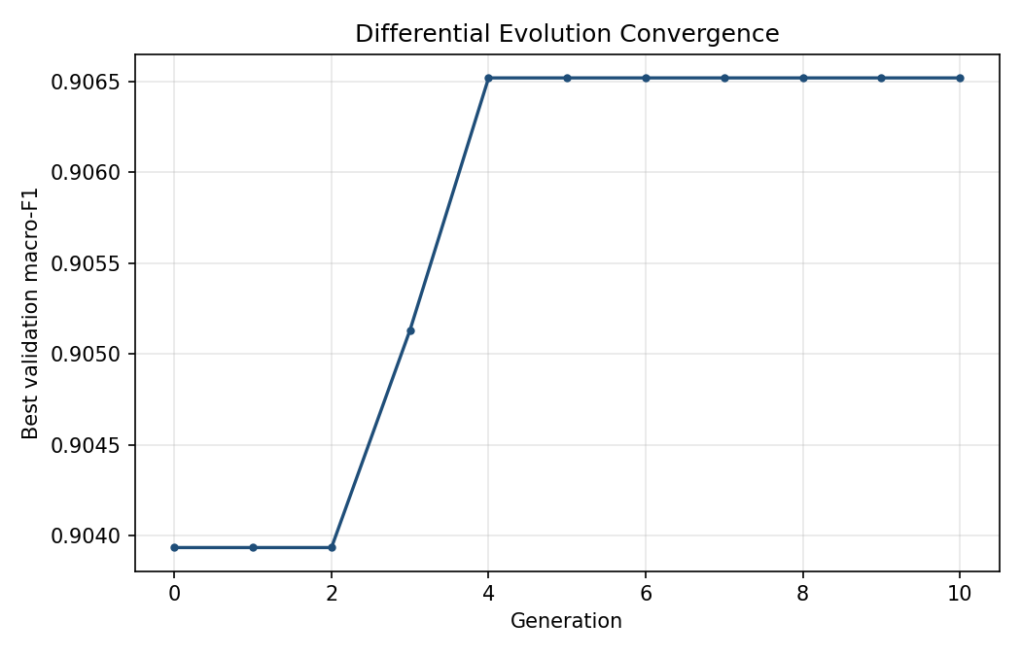
Figure 4.1: Convergence of the Differential Evolution search, showing the best validation macro-F1 attained in each generation. The vertical axis spans only 0.0026.
Source: Author's own work, generated from the experimental results of this study
The initial random population already contained a configuration scoring 0.9039. Ten generations of search improved this to 0.9065, a gain of 0.0026, or 0.29 per cent. The final improvement occurred at generation 4; the remaining 6 generations, representing roughly 60 network trainings, produced no change whatsoever.
The shape of the curve in Figure 4.1 appears dramatic, but the vertical axis must be read with care: it spans from 0.9039 to 0.9065. The apparent climb is an artefact of automatic axis scaling across a very narrow band of values.
The natural first explanation is that the population was too small. At ten members in a six-dimensional space the search sits well below the customary guidance of roughly ten members per dimension, and a small population loses diversity quickly, so that the difference vectors driving mutation collapse towards zero. That is a genuine limitation and it is acknowledged as such in Chapter Five. It is not, however, a sufficient explanation, because it does not account for the initial population already scoring 0.9039. A randomly drawn set of ten configurations does not land within 0.3 per cent of the best value a search will ever find unless the objective surface is close to flat across the region being sampled.
The fuller explanation, supported by the per-class results in Section 4.3, is that performance on this problem is not limited by the architecture of the network. It is limited by a property of the data which no choice of depth, width, learning rate or activation function can overcome. The configuration the search settled upon is given in Table 4.1.
Table 4.1: Best Hyperparameter Configuration Found by the Search
Hyperparameter | Value selected | Search range
Hidden layers | 4 | 1 to 5
Neurons per layer | 209 | 32 to 512
Learning rate | 0.000722 | 0.0001 to 0.1, logarithmic
Dropout rate | 0.000 | 0.0 to 0.5
Batch size | 128 | 16, 32, 64, 128, 256
Activation function | tanh | ReLU, tanh, sigmoid
Validation macro-F1 | 0.9065 | not applicable

Two of these selections are worth remarking upon. The search chose a dropout rate of exactly zero, at the very bottom of its permitted range, which indicates that regularisation was not what constrained this model. It also chose tanh in preference to ReLU, the more common default in the intrusion detection literature. Neither is an obvious choice in advance, which is exactly the sort of trade-off automated search is intended to surface; whether either made a material difference to the outcome is precisely what Section 4.5 sets out to test.

4.3 Performance of the Final Model
The configuration in Table 4.1 was then trained at full scale. The class cap was raised from 20,000 to 200,000 records, which yields a corpus of 1,154,967 records: 692,979 for training, 230,994 for validation and 230,994 held back for testing. No further searching was performed. The hyperparameters were loaded from the file the search had written, so that the only difference between this model and the one evaluated during the search is the quantity of data it was trained on.
As before, a ten per cent stratified slice of the training pool drove early stopping, and the test partition played no part in deciding when to halt or which weights to retain. Training ran for 56 of a permitted 100 epochs; validation loss reached its minimum of 0.1352 at epoch 46, and the ten epochs that followed produced no improvement, so early stopping restored the epoch 46 weights. Figure 4.2 shows the learning curves.
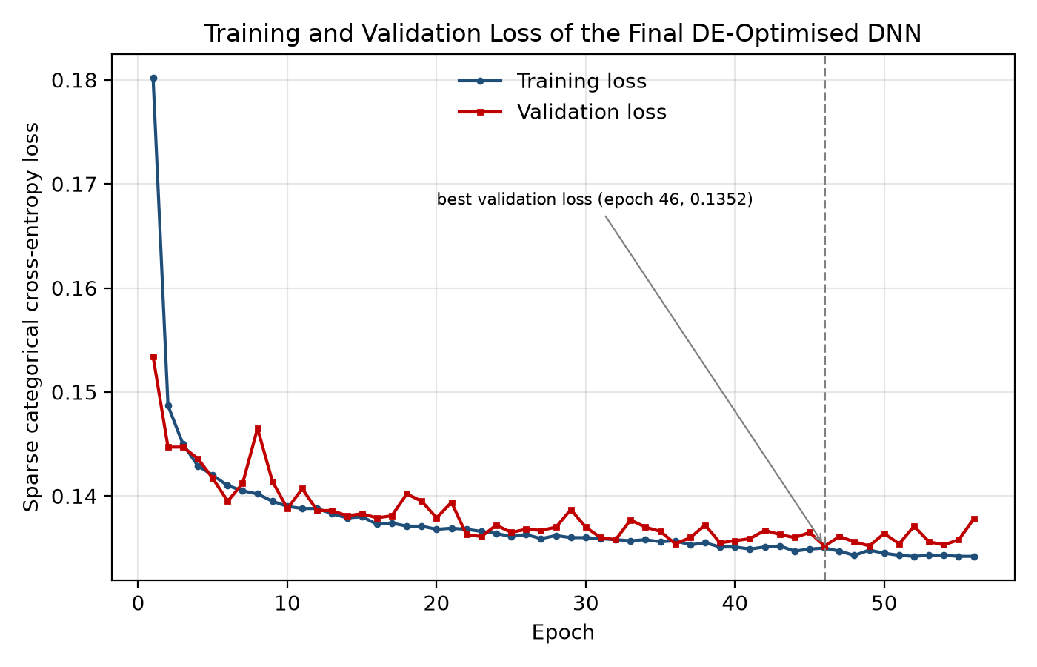
Figure 4.2: Training and validation loss of the final DE-optimised network trained on the full class-capped corpus. Early stopping restored the weights from epoch 46, marked by the dashed line.
Source: Author's own work, generated from the experimental results of this study
The two curves descend together and remain close throughout, with no divergence of the kind that would indicate the model had begun memorising its training data. Validation loss is essentially flat from about epoch 20 onward, moving only in the fourth decimal place, which indicates that the model had extracted what it could from the available features well before training stopped. The headline test results are given in Table 4.2.
Table 4.2: Test Set Performance of the Final DE-Optimised DNN
Metric | Value | Interpretation
Accuracy | 0.9241 | Share of all test flows classified correctly
Precision (macro) | 0.9447 | Reliability of the model's class assignments, averaged equally over classes
Recall (macro) | 0.8706 | Share of each class the model recovers, averaged equally
F1-score (macro) | 0.8923 | Harmonic mean of precision and recall, averaged equally over classes
ROC-AUC (macro OVR) | 0.9952 | Separability of the classes across all decision thresholds
False-positive rate (macro) | 0.0072 | One-vs-rest false-positive rate averaged over all twelve classes
Benign false-alarm rate | 0.2938 | Share of genuinely benign flows assigned to some attack class

The last two rows of Table 4.2 disagree with one another, and that disagreement is the single most important result in this chapter.
The macro false-positive rate is 0.0072, which read on its own would suggest an exceptionally well-behaved detector. The benign false-alarm rate is 0.2938: very nearly thirty per cent of genuinely benign traffic is assigned to an attack class. Both figures are correct, and the gap between them is a property of how they are computed. The macro false-positive rate is a one-vs-rest quantity averaged over twelve classes, and ten of those twelve attract almost no false positives at all, so the average is dominated by the easy cases and the single serious failure is diluted almost out of existence.
This matters well beyond bookkeeping. Chapter One motivated this work partly through alert fatigue, the documented tendency of security analysts to stop attending to a detector that raises too many false alarms. A system that flagged thirty per cent of benign traffic would be unusable in an operational setting, and the metric this literature conventionally reports conceals that completely. The benign false-alarm rate was added to the evaluation specifically because the conventional figure proved misleading here.
The per-class breakdown in Table 4.3 locates the problem precisely.
Table 4.3: Per-Class Performance of the Final Model on the Test Set
Class | Precision | Recall | F1-score | Support
Benign | 0.84 | 0.71 | 0.77 | 40,000
Bot | 1.00 | 1.00 | 1.00 | 28,907
Brute Force -Web | 1.00 | 0.48 | 0.65 | 113
Brute Force -XSS | 1.00 | 0.52 | 0.69 | 46
DDOS attack-HOIC | 1.00 | 1.00 | 1.00 | 39,772
DDOS attack-LOIC-UDP | 0.90 | 0.99 | 0.94 | 346
DDoS attacks-LOIC-HTTP | 1.00 | 1.00 | 1.00 | 40,000
DoS attacks-GoldenEye | 1.00 | 1.00 | 1.00 | 8,281
DoS attacks-Hulk | 1.00 | 1.00 | 1.00 | 29,040
DoS attacks-Slowloris | 1.00 | 0.99 | 1.00 | 1,982
Infilteration | 0.61 | 0.77 | 0.68 | 23,697
SSH-Bruteforce | 1.00 | 1.00 | 1.00 | 18,810
Macro average | 0.94 | 0.87 | 0.89 | 230,994

Eight of the twelve classes are recognised essentially perfectly, with F1 at or above 0.99: botnet and SSH brute-force traffic, all three denial-of-service families and two of the three distributed denial-of-service families. These are high-volume attacks with distinctive flow signatures, and the model separates them from everything else without difficulty.
The two web brute-force classes achieve perfect precision with recall near one half, meaning the model is reliable when it commits to those classes but recovers only about half of their instances. With 113 and 46 test records respectively these are small-sample results and should not be over-interpreted. The substantive failure lies with Benign, at 0.71 recall, and Infilteration, at 0.61 precision. The confusion matrix in Figure 4.3 shows why these two figures are really a single finding.
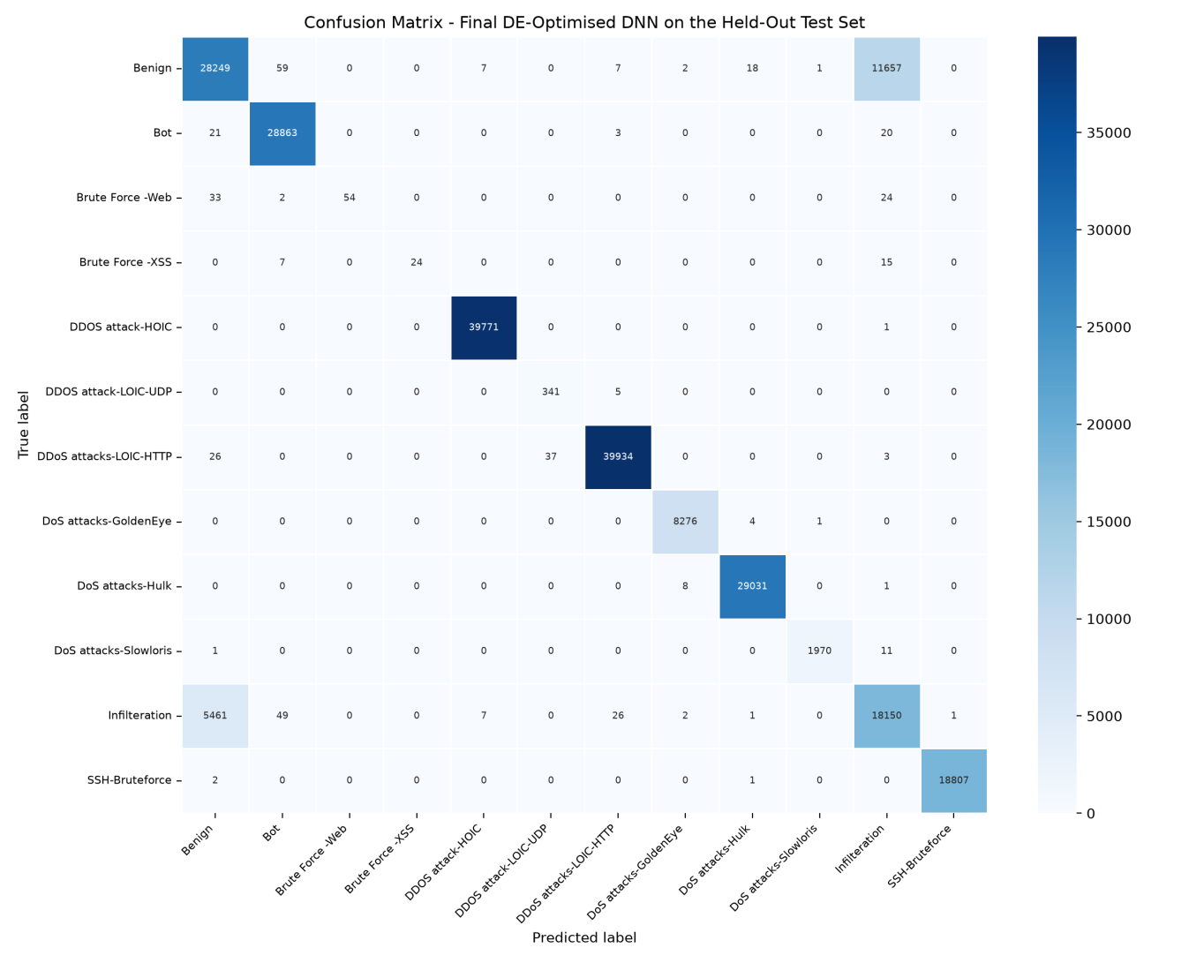
Figure 4.3: Confusion matrix of the final DE-optimised network on the held-out test set of 230,994 flows. The two dominant off-diagonal cells are benign traffic classified as Infiltration and the reverse.
Source: Author's own work, generated from the experimental results of this study
The model made 17,524 errors across 230,994 test flows, an overall error rate of 7.59 per cent. Table 4.4 sets out where they fall.
Table 4.4: Distribution of Classification Errors in the Final Model
True class | Predicted as | Errors | Share of errors (%)
Benign | Infilteration | 11,657 | 66.5
Infilteration | Benign | 5,461 | 31.2
Benign | Bot | 59 | 0.3
Infilteration | Bot | 49 | 0.3
DDoS attacks-LOIC-HTTP | DDOS attack-LOIC-UDP | 37 | 0.2
Brute Force -Web | Benign | 33 | 0.2
All remaining confusions combined | not applicable | 228 | 1.3
Total | not applicable | 17,524 | 100.0

The two directions of the Benign and Infiltration confusion together account for 17,118 of the 17,524 errors, or 97.7 per cent of everything the model gets wrong. Every other misclassification in a twelve-class problem, taken together, accounts for the remaining 2.3 per cent. The equivalent figure during the search, on a corpus one-sixth the size, was 93.6 per cent, so enlarging the training data concentrated the error further rather than dispersing it.
This is a property of the data rather than a failing of the architecture, and it is consistent with what is known about this dataset. Infiltration in CSE-CIC-IDS2018 consists of an attacker operating from inside the network using ordinary protocols; at the level of flow statistics, which is all the model can observe, it is close to indistinguishable from ordinary internal traffic. A direct check on the corpus supports this reading: within a single capture file, 8,577 records were found to share an identical feature vector with a record carrying a different label. Where two records are identical in every feature and differ only in their label, no classifier of any architecture can assign both correctly. There is a floor beneath the achievable error, and this model sits close to it.
That finding also explains Section 4.2. If the loss is dominated by a class pair which is not separable in the available feature space, then the architecture of the network is very nearly irrelevant to the outcome, and an optimiser searching over architectures will encounter a flat surface. The two results are the same result observed from two directions.

4.4 Effect of Sampling Ratio on Detection Behaviour
Because the search was carried out on a corpus capped at 20,000 records per class and the final model was trained on one capped at 200,000, two models exist that differ in nothing but the quantity and proportion of their training data. Comparing them was not part of the original design, but the comparison turned out to be informative and is reported here.
Table 4.5: Effect of Raising the Class Cap from 20,000 to 200,000
Metric | Cap 20,000 | Cap 200,000 | Change
Training records | 103,461 | 692,979 | 6.7 times
Accuracy | 0.9330 | 0.9241 | -0.0089
Precision (macro) | 0.9374 | 0.9447 | +0.0073
Recall (macro) | 0.8989 | 0.8706 | -0.0283
F1-score (macro) | 0.9041 | 0.8923 | -0.0118
Benign false-alarm rate | 0.4788 | 0.2938 | -0.1850

Training on 6.7 times as much data made the model substantially better in operational terms and slightly worse by the measure the search was optimising. The benign false-alarm rate fell from 0.4788 to 0.2938, a reduction of thirty-nine per cent in the proportion of legitimate traffic wrongly flagged. Macro F1 fell from 0.9041 to 0.8923. Both movements have the same cause.
The class cap does not only control how much data there is; it also controls the ratio between classes. At a cap of 20,000, both Benign and Infiltration exceed the threshold and are cut to 20,000 records each, giving a prior of one to one. At a cap of 200,000, Benign reaches the cap at 200,000 records but Infiltration has only 118,483 in the whole corpus, so the prior becomes roughly 1.69 to one in favour of Benign. A classifier trained under the second regime places its decision boundary differently, and the per-class figures follow exactly that prediction: benign recall rose from 0.52 to 0.71 while Infiltration recall fell from 0.93 to 0.77.
Table 4.6 shows where the macro average lost ground.
Table 4.6: Per-Class F1 Changes Between the Two Training Regimes
Class | F1 at cap 20,000 | F1 at cap 200,000 | Change
Benign | 0.66 | 0.77 | +0.11
Brute Force -XSS | 0.65 | 0.69 | +0.04
DDOS attack-LOIC-UDP | 0.99 | 0.94 | -0.05
Infilteration | 0.77 | 0.68 | -0.09
Brute Force -Web | 0.80 | 0.65 | -0.15
Macro average (all 12 classes) | 0.9041 | 0.8923 | -0.0118

Benign improved by 0.11 and Brute Force -XSS by 0.04, while Infiltration lost 0.09, DDOS attack-LOIC-UDP 0.05 and Brute Force -Web 0.15. The remaining seven classes were unchanged. Because the macro average weights a class of 113 test records identically to one of 200,000, the losses on the small classes outweigh the considerable gain on Benign, and the average moves down even though the model is more useful.
Two conclusions follow. The first is that the choice of sampling regime is not a neutral preprocessing decision on this dataset; it shifts the operating point of the resulting detector as surely as moving a decision threshold would, and any result reported on CSE-CIC-IDS2018 should state the regime used. The second concerns the objective itself. Macro F1 was chosen as the fitness signal in Section 3.11 to prevent the rare classes being ignored, and it serves that purpose. But it is not the same thing as operational quality, and this experiment produced a case where the two move in opposite directions. A search optimising macro F1 would have rejected the more useful of these two models.

4.5 Comparison with a Manually Configured Baseline
The premise of this project is that an evolutionary search earns its cost, so the fair test is a comparison against a sensible network configured by hand, of the kind a practitioner might reach for without running any search at all. The baseline used here is a two-layer network of 128 neurons with a learning rate of 0.001, a dropout rate of 0.2, a batch size of 64 and ReLU activation. These are conventional defaults rather than an adversarially weak choice: they are the values that appear most often in the intrusion detection literature reviewed in Chapter Two.
The baseline was trained and evaluated through the identical pipeline, on the identical data, with the identical split and the identical random seed. The only difference between the two runs is the origin of the six hyperparameters. The comparison is made at the class cap of 20,000 used during the search rather than at the 200,000 of Section 4.3, so that it isolates what the search itself contributed; Section 4.4 has already shown that changing the cap moves the operating point independently of any hyperparameter. Table 4.7 sets out the two configurations side by side.

Table 4.7: Configurations Compared
Hyperparameter | Manual baseline | DE-optimised
Hidden layers | 2 | 4
Neurons per layer | 128 | 209
Learning rate | 0.001000 | 0.000722
Dropout rate | 0.200 | 0.000
Batch size | 64 | 128
Activation function | ReLU | tanh

Table 4.8: Performance of the DE-Optimised Network against the Manual Baseline
Metric | Manual baseline | DE-optimised | Difference (percentage points)
Accuracy | 0.9300 | 0.9330 | +0.30
Precision (macro) | 0.9519 | 0.9374 | -1.45
Recall (macro) | 0.8824 | 0.8989 | +1.65
F1-score (macro) | 0.9019 | 0.9041 | +0.22
ROC-AUC (macro OVR) | 0.9950 | 0.9956 | +0.06
Benign false-alarm rate | 0.4970 | 0.4788 | -1.82

The difference in macro F1 between the two models is 0.22 percentage points. On the evidence of this experiment, the Differential Evolution search did not produce a materially better detector than a conventionally configured network. This is a negative result with respect to the project's original hypothesis, and it is reported as such.
It is, however, entirely consistent with everything else in this chapter. Section 4.2 established that the search surface is close to flat, and Section 4.3 established why: the error is dominated by a class pair that is not separable in the available features. A hand-picked configuration and an evolved configuration both run into the same ceiling, because the ceiling is a property of the data and not of the network. That the two land within a percentage point of one another is the expected outcome once that is understood, and it corroborates the explanation rather than undermining it.
The practical conclusion is not that hyperparameter optimisation is worthless, but that its value is contingent on the problem being architecture-limited in the first place. Establishing whether that condition holds, which this chapter does through the convergence curve and the confusion analysis, is a cheaper diagnostic than an extended search and ought to precede one.
One difference between the two runs does not appear in Table 4.8 at all, and is worth recording because it favours the evolved configuration on grounds the fitness function never measured. The baseline's validation loss became unstable during training, rising from 0.1367 at epoch seven to 12.3978 by epoch seventeen while its validation accuracy held steady at approximately 0.93. A model whose accuracy is unchanged but whose cross-entropy has risen by two orders of magnitude is making a small number of extremely confident incorrect predictions. Early stopping contained the damage by restoring the epoch-seven weights, which is why the baseline still scores competitively in Table 4.8. The evolved configuration, with tanh activation, no dropout and a larger batch, showed no such behaviour and its validation loss declined monotonically to a plateau.
This suggests that the search selected for stability as much as for accuracy, since an unstable candidate would have been scored at whatever its early-stopped weights achieved and penalised accordingly. It is a real benefit of the optimisation, but it is not one macro F1 records, and it would have gone unnoticed had the training logs not been examined directly.

4.6 Discussion
Four findings emerge from this chapter, and they reinforce one another.
The first is that the hyperparameter surface for this problem is flat. The search improved on a random initial population by 0.29 per cent and stopped improving at generation 4, after which 6 further generations produced nothing. Where a search converges that quickly and gains that little, the explanation is usually the objective rather than the optimiser.
The second is that the objective is limited by the data. In the final model, 97.7 per cent of all classification error is a single confusion between benign traffic and the Infiltration class, and identical feature vectors carrying different labels were found in the corpus itself. Infiltration at the flow-statistics level is not reliably distinguishable from ordinary internal traffic, and no arrangement of layers and neurons changes that. This is the mechanism behind the first finding.
The third is that the sampling regime moves the detector's operating point. Raising the class cap from 20,000 to 200,000 cut the benign false-alarm rate from 0.4788 to 0.2938 while lowering macro F1 from 0.9041 to 0.8923, because the cap governs not only how much data there is but the ratio between classes, and the Benign to Infiltration prior moved from one-to-one to roughly 1.69-to-one. A preprocessing choice thus altered detection behaviour more than the entire hyperparameter search did.
The fourth concerns measurement. The macro false-positive rate, the figure this literature conventionally reports, was 0.0072 for a model that misclassifies 29.4 per cent of benign traffic. Had the evaluation relied on the conventional metric alone, the central weakness of this model would not have appeared anywhere in the results at all. Worse, the two models compared in Section 4.4 are ranked in opposite orders by macro F1 and by the benign false-alarm rate, so the choice of metric determines not only whether a defect is visible but which model is judged better.
Taken together these point away from further architecture search and towards the data itself. The gains available from better features, from richer representations of a flow than the summary statistics CICFlowMeter produces, or from cost-sensitive training that prices a benign false alarm properly, are likely to be substantially larger than anything another thousand network trainings would yield.

CHAPTER FIVE

SUMMARY, CONCLUSION AND RECOMMENDATIONS

5.1 Summary
This project set out to determine whether pairing a deep neural network with an evolutionary optimiser produces a better network intrusion detector, on the premise that the performance of such a network depends heavily on hyperparameters which are usually chosen by hand and rarely chosen well.
Chapter One framed the problem and its motivation. Chapter Two reviewed the relevant ground, from the development of intrusion detection systems through the principal neural network architectures to the family of evolutionary algorithms, with particular attention to Differential Evolution. Chapter Three set out the methodology, following the machine learning development lifecycle from problem definition through data preparation and model design to evaluation. Chapter Four carried that design into a working implementation and applied it to CSE-CIC-IDS2018.
A Differential Evolution optimiser was implemented from first principles and used to search a six-dimensional hyperparameter space covering the depth and width of the network, its learning and dropout rates, its batch size and its activation function. Each candidate was scored by training a network and measuring its macro-averaged F1 on validation data, a choice made specifically to prevent the heavily imbalanced rare attack classes from being ignored. The search evaluated 110 networks across ten generations and settled on a four-layer network of 209 neurons using tanh activation, no dropout and a learning rate of 0.00072.
The winning configuration was then retrained at full scale on 692,979 records and evaluated once on a held-out test partition of 230,994 flows spanning twelve classes. It achieved a macro F1 of 0.8923, an accuracy of 0.9241 and a macro one-vs-rest ROC-AUC of 0.9952, correctly identifying eight of the twelve classes with an F1 at or above 0.99.

5.2 Conclusion
The evidence gathered here does not support the project's original hypothesis in the form it was posed, and the more interesting conclusion lies in why.
Differential Evolution did find a working configuration, and did so quickly and reliably. It converged within four generations and produced a detector that identifies eight of twelve attack classes essentially perfectly. But it improved on its own random initial population by only 0.29 per cent, and the six generations following convergence changed nothing at all. The hyperparameter surface for this problem is flat.
The reason is established in Section 4.3. In the final model, 97.7 per cent of all classification error is a single confusion between benign traffic and the Infiltration class, and the corpus itself contains identical feature vectors bearing different labels. The limiting factor is not the architecture of the network but the separability of the classes in the feature space available, and no hyperparameter search can address that.
Section 4.4 supplies the sharpest evidence for this. Raising the class cap from 20,000 to 200,000 records, a preprocessing decision that touches no hyperparameter at all, reduced the benign false-alarm rate from 0.4788 to 0.2938. That single change to how the data was sampled improved the model's operational behaviour by considerably more than 110 network trainings had. Where a sampling decision outweighs the entire architecture search, the conclusion that the problem is data-limited rather than model-limited is difficult to avoid.
The defensible conclusion is therefore narrower and more useful than the one originally proposed: evolutionary hyperparameter optimisation converges rapidly to a competitive configuration for deep-learning-based intrusion detection, but on this dataset the binding constraint is the data rather than the model, and the search consequently has very little room in which to operate. Establishing whether a problem is architecture-limited before committing to an extended search is itself a worthwhile practice, and the convergence curve together with a confusion analysis provides a cheap way of doing so.
A secondary conclusion concerns evaluation. The macro false-positive rate, the measure this literature reports as a matter of course, recorded 0.0072 for a model that misclassifies 29.4 per cent of all benign traffic. Reported alone it would have concealed the model's central weakness entirely. More seriously, the two models compared in Section 4.4 are ranked in opposite orders by macro F1 and by the benign false-alarm rate, so the choice of metric decides which model is judged the better one. Any evaluation of a multi-class intrusion detector should report the false-alarm rate on benign traffic directly rather than relying on a macro average across classes to represent it.

5.3 Limitations
Several limitations bear on how far these results should be carried.
The population size of ten sits well below the guidance of roughly ten members per dimension, which would indicate sixty for a six-dimensional space. This was a compute constraint rather than a design preference. A larger population would give the search more diversity, though the flatness established in Section 4.2 makes a substantially different outcome unlikely.
The deduplicated build of the dataset excludes the destination port, which carries genuine protocol signal. The model was trained without it, and its performance on the brute-force classes in particular might differ had it been available.
Three attack classes were excluded as too small to evaluate, so the results describe a twelve-class problem rather than the fifteen classes present in the corpus. Results on the deduplicated build are also systematically lower than the published figures obtained on the original release, where duplicate flows appear in both the training and test partitions, and the two are therefore not directly comparable.
Finally, the class-aware cap rebalances the test partition, so the reported accuracy and false-positive rate are measured on a distribution that does not carry the eighty per cent benign prior of live traffic. The macro-averaged measures are unaffected.

5.4 Recommendations
The findings point clearly towards the data rather than the model, and the recommendations follow that direction.
Work on features rather than architecture. The Benign and Infiltration classes are not separable in the summary statistics CICFlowMeter produces. Representations that retain more of the structure of a flow, such as packet-sequence or payload-derived features, address the actual constraint; further architecture search does not.
Price false alarms explicitly. A benign flow misclassified as an attack and an attack misclassified as benign carry very different operational costs, and the loss function used here treats them identically. Cost-sensitive training, or an explicit adjustment of the decision threshold, would allow the trade-off to be set deliberately rather than inherited by default.
Report the benign false-alarm rate as standard. The evidence in Section 4.3 is that a macro-averaged false-positive rate can conceal a catastrophic benign misclassification rate in a multi-class setting. This costs nothing to compute and should accompany any such evaluation.
State the dataset build. Results obtained on deduplicated and non-deduplicated versions of CSE-CIC-IDS2018 differ systematically and are not comparable. Any published result on this dataset should say which was used, and the duplication rates reported in Chapter Four suggest that a systematic study of how much published performance on this benchmark is attributable to duplicate leakage would be a worthwhile contribution in itself.
Extend the search only where it is warranted. If the approach is applied to a dataset where the classes are genuinely separable, a population of sixty and a wider search space taking in optimiser choice, layer-wise widths and learning-rate schedules would give Differential Evolution considerably more to work with than it found here.

REFERENCES
Anderson, J. P. (1980). Computer security threat monitoring and surveillance. James P. Anderson Company.
Baioletti, M., Di Bari, G., Milani, A., & Poggioni, V. (2020). Differential evolution for neural networks optimization. Mathematics, 8(1), 69. https://doi.org/10.3390/math8010069
Das, S., & Suganthan, P. N. (2011). Differential evolution: A survey of the state-of-the-art. IEEE Transactions on Evolutionary Computation, 15(1), 4-31.
Elman, J. L. (1990). Finding structure in time. Cognitive Science, 14(2), 179-211.
Garcia-Teodoro, P., Diaz-Verdejo, J., Maciá-Fernández, G., & Vázquez, E. (2009). Anomaly-based network intrusion detection: Techniques, systems and challenges. Computers & Security, 28(1-2), 18-28.
Goodfellow, I., Bengio, Y., & Courville, A. (2016). Deep learning. MIT Press.
Hinton, G. E., & Salakhutdinov, R. R. (2006). Reducing the dimensionality of data with neural networks. Science, 313(5786), 504-507.
Hochreiter, S., & Schmidhuber, J. (1997). Long short-term memory. Neural Computation, 9(8), 1735-1780.
Hornik, K., Stinchcombe, M., & White, H. (1989). Multilayer feedforward networks are universal approximators. Neural Networks, 2(5), 359-366.
Kasongo, S. M., & Sun, Y. (2020). A deep learning method with filter based feature engineering for wireless intrusion detection system. IEEE Access, 8, 33-44.
LeCun, Y., Bengio, Y., & Hinton, G. (2015). Deep learning. Nature, 521(7553), 436-444.
Liao, H. J., Lin, C. H. R., Lin, Y. C., & Tung, K. Y. (2013). Intrusion detection system: A comprehensive review. Journal of Network and Computer Applications, 36(1), 16-24.
Mitchell, T. M. (1997). Machine learning. McGraw-Hill.
Rosenblatt, F. (1958). The perceptron: A probabilistic model for information storage and organization in the brain. Psychological Review, 65(6), 386-408.
Rumelhart, D. E., Hinton, G. E., & Williams, R. J. (1986). Learning representations by back-propagating errors. Nature, 323(6088), 533-536.
Sharafaldin, I., Lashkari, A. H., & Ghorbani, A. A. (2018). Toward generating a new intrusion detection dataset and intrusion traffic characterization. In ICISSP (pp. 108-116).
Storn, R., & Price, K. (1997). Differential evolution–a simple and efficient heuristic for global optimization over continuous spaces. Journal of Global Optimization, 11(4), 341-359.
Vinayakumar, R., Alazab, M., Soman, K. P., Poornachandran, P., Al-Nemrat, A., & Venkatraman, S. (2019). Deep learning approach for intelligent intrusion detection system. IEEE Access, 7, 41525-41550.
Wolpert, D. H., & Macready, W. G. (1997). No free lunch theorems for optimization. IEEE Transactions on Evolutionary Computation, 1(1), 67-82.
Zhang, J., Zulkernine, M., & Haque, A. (2019). Random-forests-based network intrusion detection systems. IEEE Transactions on Systems, Man, and Cybernetics, Part C, 38(5), 649-659.

