project charter
Ledgerly

Von Solano
25/06/2026

Table of Contents
Table of Contents 1
1. Project Summary 2
2. Goals & Objectives 3
2.1 Goal Table 3
2.2 Objectives 3
3. Scope 5
4. Requirements 7
4.1 Key Design Decisions 7
4.2 Entities & State Machines 8
4.3 Functional Requirements 11
4.4 Authorisation Matrix 13
4.5 Non-Functional & Security Requirements 15
5. Deliverables 18

1. Project Summary
Ledgerly is a multi-tenant SaaS expense and invoicing tool for small businesses, built around a single deployment serving multiple isolated organisations from one database. The project is constructed in two states: an initial version deliberately planted with vulnerabilities mapped to the OWASP Top 10 and OWASP API Security Top 10, with a specific emphasis on broken object-level authorisation across tenant boundaries, and a fully remediated version reached through a documented, PR-based fix history. The goal is to demonstrate the full application security lifecycle: threat modelling (STRIDE), vulnerability identification with correct CWE/CVSS classification, root-cause remediation, and verification through an automated CI/CD security pipeline (SAST, dependency scanning, secrets detection, DAST).

Ledgerly’s primary trust boundary is the isolation between tenants, multiple organisations share one database, and data belonging to one organisation must never be accessible to another, regardless of the mechanism used to request it. This maps directly to API1:2023 Broken Object Level Authorisation and is the most architecturally significant security boundary in the system.

2. Goals & Objectives

2.1 Goal Table
Primary Goals | Success Criteria | Evidence
Demonstrate Correct Vulnerability Classification | Planted vulnerabilities have a CWE ID, OWASP category, and CVSS vector. | Security Report Findings Table.
Demonstrate Structured Threat Modelling Precedes Remediation | STRIDE model covers all 4 trust boundaries and is dated/committed before the corresponding remediation PRs. | Git History. Threat Model Document.
Demonstrate Root-Cause Remediation | Each fix PR description states the root cause and why the fix addresses it. | PR Descriptions on Remediated Branch.
Demonstrate Verifiability via CI | Pipeline run shows tool failure on vulnerability branch. Pass on remediated branch, for each relevant scanner | CI Run Logs / Actions History. Screenshots on Security Report.
Realistic Tenant-Isolation Surface | Authorisation matrix implemented matches the one defined in requirements; BOLA test cases exist for every cross-tenant endpoint. | Test Suite + Authorisation Matrix Document.

2.2 Objectives
Goal 1: Correct Vulnerability Classification
- 1.1: Plant and document one vulnerability per OWASP Top 10 (2025) category, all 10 categories, 10 distinct CWEs minimum, no duplicates.
- 1.2: Explicitly map three OWASP API Security Top 10 categories to API-specific findings: mandatory API1:2023 BOLA given the trust-boundary model, API2:2023 Broken Authentication (JWT weaknesses), and API3:2023 Broken Object Property Level Authorisation (mass assignment, client-supplied fields overriding server-derived properties).
- 1.3: Every finding has a written CVSS v3.1 vector and a one-line justification per metric, not just a final score pulled from a calculator.

Goal 2: Threat Model Precedes Remediation
- 2.1: STRIDE analysis covers all 4 trust boundaries, committed to Git before the first remediation PR, verifiable via timestamps.
- 2.2: At least one identified threat per applicable STRIDE category per boundary. For instance, repudiation may not apply meaningfully to the file storage boundary.

Goal 3: Root-Cause Remediation
- 3.1: Every remediation PR description states the root cause and references the corresponding finding ID from the security report.
- 3.2: Zero fixes that are pattern matching/blacklist patches where a structural fix exists. For instance, input validation should not be used without parameterised queries for SQL injections.

Goal 4: CI-verified Red vs Green
- 4.1: Each CI tool fails the vulnerable branch for at least one finding its capable of catching. Some tools are not capable of catching certain vulnerability classes.
- 4.2: Remediated branch passes clean or has explicitly documented and justified suppressions, no silently ignored findings.
- 4.3: A custom authorisation test suite (per 5.2) is integrated into the CI pipeline and gates the build, fails against the vulnerable branch, passes against the remediated branch, since SAST/dependency/secrets/DAST-baseline tooling does not detect logic-based BOLA/BFLA flaws.

Goal 5: Realistic Tenant Isolation
- 5.1: Authorisation matrix (from requirements) is fully implemented in code.
- 5.2: Automated test suite includes one explicit cross-tenant access attempt per data-bearing endpoint. For instance, authenticated as Tenant A, attempt GET on a Tenant B expense/invoice/receipt by ID

3. Scope
Area | In Scope | Out of Scope
Tenancy Model | Single deployment and database, multiple isolated tenants via application-layer scoping (tenant_id every row). | Database-per-tenant or schema-per-tenant isolation
Roles | Owner, manager, employee, full role hierarchy with distinct permissions. | Custom/configurable roles, permission delegation, SSO/SAML enterprise role mapping
Core Entities | Tenant, user, expense, invoice, receipt, client. | Multi-currency, tax calculation, recurring invoice, payment processing
Core Flows | Signup/onboarding, invite, expense submit/approve, invoice create/view, dashboard. | Subscription billing for Ledgerly, usage-based pricing, plan tiers
Authentication | Custom-implemented JWT authentication using jsonwebtoken and bcrypt. | Passport.js, Auth0, Clerk, or any authentication-as-a-service; OAuth2/social login, MFA
File Handling | Receipt upload (image/PDF), stored and served with tenant-scoped access control. | Virus/malware scanning of uploads, OCR/auto-extraction from receipts, cloud storage redundancy
Invoicing Output | HTML-rendered invoice view. | PDF generation, because headless browser PDF rendering introduces SSRF and XXE attack surface duplicating vulnerability classes already covered
Notifications | Simulated/logged invite and invoice-send events. | Real email delivery, requires external service integration introducing SSRF surface
Security Tooling | GitHub actions running Semgrep (SAST), npm audit (SCA), gitleaks (secrets), ZAP baseline (DAST), custom authorisation test suites (Jest/Supertest) in CI. | Commercial/enterprise scanners (Snyk, Veracode), penetration testing beyond planted vulnerabilities, runtime WAF
Vulnerability Coverage | All 10 OWASP Top 10:2025 categories, 3 OWASP API Top 10 categories including mandatory BOLA | Vulnerability classes outside these two standards unless justified in threat model
Documentations | STRIDE threat model, security report (findings, remediation, residual risk), this vision/scope document | Formal SDLC artifacts beyond these (no separate risk register, no compliance)
Deployment | Local/dev environment sufficient to demo and run CI | Production hosting, scaling, monitoring/alerting infrastructure, uptime SLAs
Database | PostgreSQL (local instance) | SQLite, MongoDB, cloud-hosted databases
Trust Boundaries | Browser ↔ API, Tenant ↔ Tenant, Role ↔ Role within Tenant,  App ↔ File Storage | Cross-cloud network boundaries, CDN edge, third-party API integrations

4. Requirements

4.1 Key Design Decisions
Specific vulnerability placements (which CWE maps to which endpoint) are not pre-committed in this document. Placement decisions are made during and after the STRIDE threat model, ensuring vulnerabilities are driven by identified threats rather than convenience. The entity, role, and flow model in this section are locked; the threat model drives what gets planted where.

Decision | Outcome
Expense States | Draft, Submitted, Approved/Rejected. Rejected is terminal (No Resubmission).
Invoice States | Draft, Sent, Paid/Overdue, Void. Overdue marked manually by Manager/Owner.
Owner Cardinality | Multiple owners per tenant, equal privilege. Founding Owner cannot be demoted or removed. Promoted owners can be demoted by any other Owner. The founding Owner cannot be demoted or removed by anyone.
OWASP Coverage | All categories of OWASP Top 10 and 3 of OWASP API Security Top 10. Depth varies by finding and not all require equal implementation complexity.
Database Technology | PostgreSQL chosen for production realism and consistent query behaviour for injection demonstration fidelity. SQLite excluded due to non-standard type coercion and opt-in foreign key enforcement.
Authentication Method | Custom JWT using jsonwebtoken and bcrypt. No auth framework or third-party service.
Token Storage | Vulnerable Branch: localstorage (deliberate XSS-accessible finding). Remediated Branch: HttpOnly, Secure, SameSite=Strict cookie.
Employee Invoice Access | Employees have no invoice access of any kind (read, create, update, or delete).
Role Definitions | Owner: manages users, all financials, void invoices. Manager: approves expenses, creates/sends invoices. Employees: submits own expenses only, no invoice access.

4.2 Entities & State Machines
Entity | Key Attributes
Tenant | id, name, created_at, founding_owner_id
User | id, tenant_id, email, password_hash, role (OWNER, MANAGER, EMPLOYEE), invited_by, is_active, created_at
Expense | id, tenant_id, submitted_by, amount, category, date, description, status, reviewed_by, reviewed_at, created_at
Invoice | id, tenant_id, created_by, client_id, status, due_date, sent_at, paid_at, voided_at, created_at
Line Item | id, invoice_id, description, quantity, unit_price
Receipt | id, expense_id, tenant_id, file_key, file_name, file_type, file_size, uploaded_at
Client | id, tenant_id, name, email, address, created_at

Expense State Machine
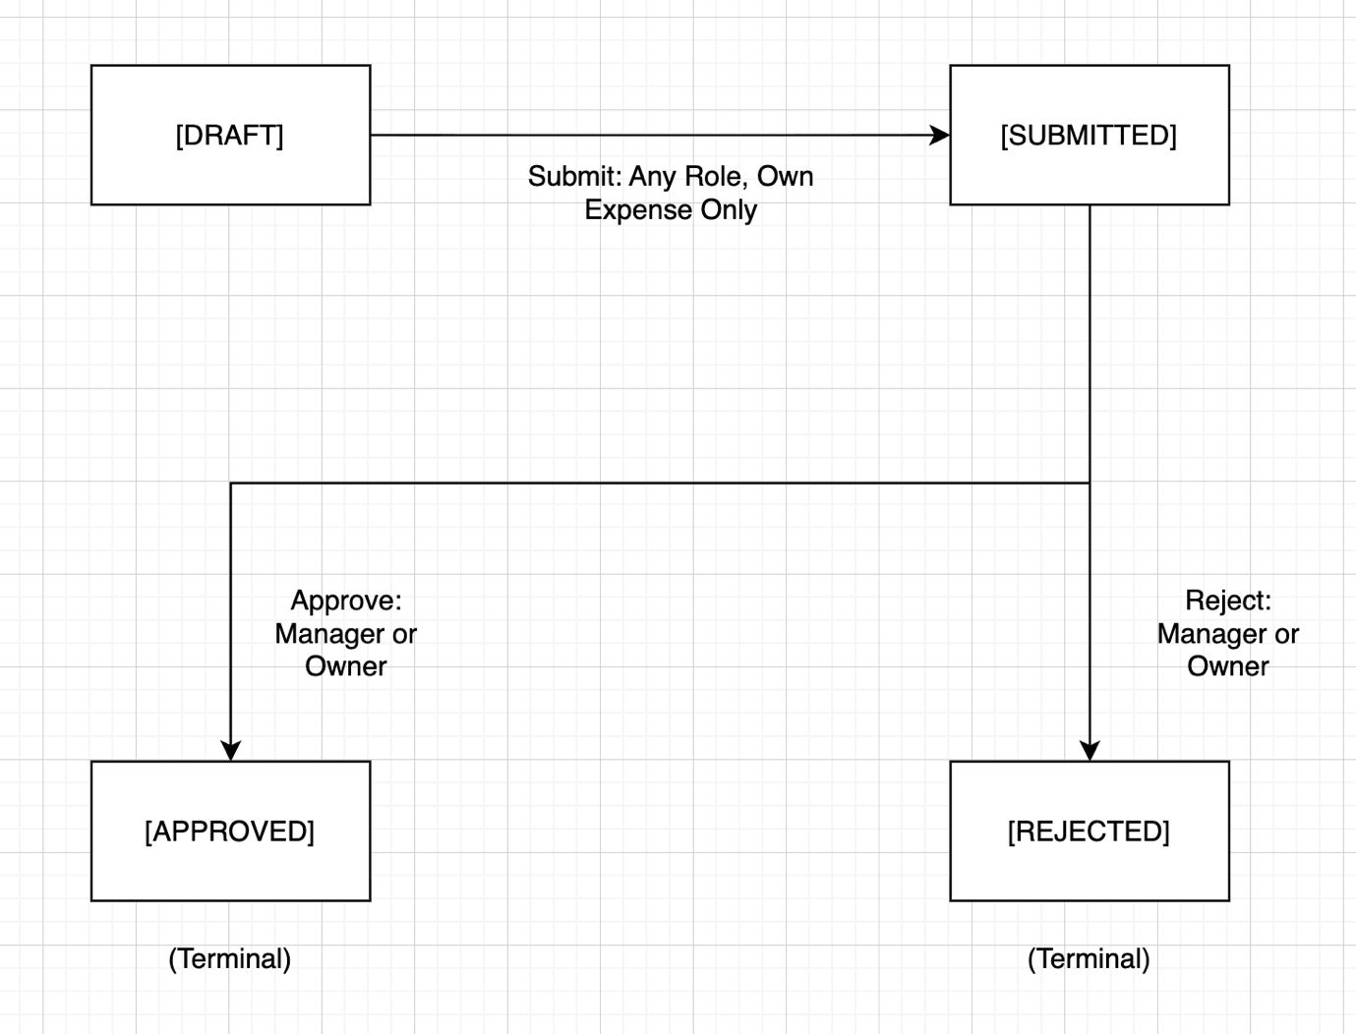

Constraints
- Employee may only submit their own Expense.
- Rejected is terminal. No resubmission by any role.
- An Employee may delete their own draft before submission. After submission, no deletion by Employee.

Invoice State Machine
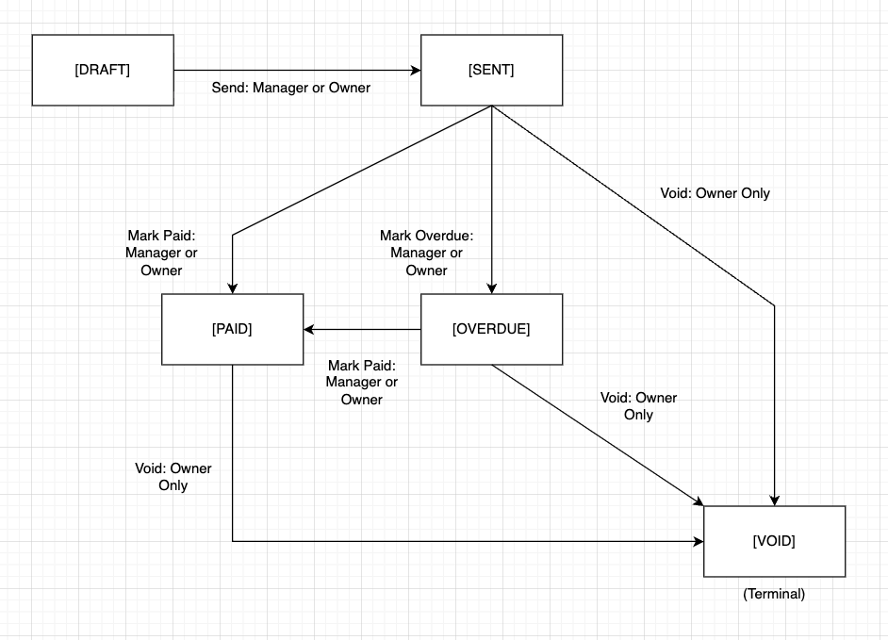

Constraints
- DRAFT Invoices may be deleted by Owner or Manager. Not voided.
- VOID is terminal. No transitions out.
- Overdue is set manually by Manager or Owner. Not by background job.

4.3 Functional Requirements

FR-1: Signup and Onboarding
FR-1.1: Any unauthenticated user MUST be able to create a new Tenant by providing an organisation name, email, and password. The system MUST create the Tenant and the User in a single atomic operation.
FR-1.2: The creating User MUST be assigned the OWNER role and recorded as founding_owner_id on the Tenant record, server-derived, never client-supplied.
FR-1.3: The system MUST reject signup if the email is already registered to an existing User, regardless of tenant.
FR-1.4: Passwords MUST be hashed using bcrypt before storage. Plaintext or reversibly encoded passwords MUST NOT be stored.

FR-2: User Invitation
FR-2.1: An OWNER MUST be able to invite a new User by email, assigning them a role of OWNER, MANAGER, or EMPLOYEE at time of invitation.
FR-2.2: The invited User's tenant_id MUST be set to the inviting Owner's tenant, server-derived, never client-supplied.
FR-2.3: Invitation MUST be simulated, logged or stored, not delivered via real email.
FR-2.4: An OWNER MUST be able to deactivate an existing User (set is_active = false). A deactivated User MUST NOT be able to authenticate.
FR-2.5: An OWNER MUST be able to promote an EMPLOYEE or MANAGER to OWNER.
FR-2.6: An OWNER MUST be able to demote another OWNER to MANAGER, except the founding_owner_id, who MUST NOT be demotable or removable by any other User.
FR-2.7: A MANAGER MUST NOT be able to invite a user with a role of MANAGER or OWNER. A MANAGER MUST NOT be able to deactivate a MANAGER or OWNER, regardless of their own privilege level.

FR-3: Authentication
FR-3.1: A User MUST be able to authenticate with email and password. On success, the system MUST issue a signed JWT containing user_id, tenant_id, and role, with an expiry of no more than 24 hours.
FR-3.2: The JWT MUST be stored in an HttpOnly, Secure, SameSite=Strict cookie on the remediated branch. On the vulnerable branch, it is stored in localStorage, this is a deliberate finding, not an oversight.
FR-3.3: Every protected endpoint MUST verify the JWT server-side on every request. tenant_id and role MUST be read from the verified token, never from request body or query parameters.
FR-3.4: A User MUST be able to log out. On logout, the JWT cookie MUST be cleared server-side.
FR-3.5: Authentication MUST fail with a generic error message that does not distinguish between "email not found" and "incorrect password", preventing user enumeration.

FR-4: Expense Management
FR-4.1: An EMPLOYEE, MANAGER, or OWNER MUST be able to create an Expense with: amount (positive decimal), category, date, description, and optional receipt. Status MUST be set to DRAFT on creation, server derived.
FR-4.2: The Expense's tenant_id and submitted_by MUST be set server-side from the authenticated token, never accepted from the client.
FR-4.3: An EMPLOYEE MUST only be able to read their own Expenses. An EMPLOYEE MUST NOT be able to read another Employee's Expenses, even by guessing or enumerating IDs.
FR-4.4: A MANAGER and OWNER MUST be able to read all Expenses within their tenant. They MUST NOT be able to read Expenses belonging to another tenant, regardless of ID supplied.
FR-4.5: An EMPLOYEE MUST be able to submit their own Draft Expense (DRAFT → SUBMITTED). They MUST NOT be able to submit another User's Expense.
FR-4.6: A MANAGER or OWNER MUST be able to approve or reject a SUBMITTED Expense within their tenant. reviewed_by and reviewed_at MUST be set server-side on state transition.
FR-4.7: REJECTED is a terminal state. No User of any role MUST be able to resubmit a Rejected Expense.
FR-4.8: An EMPLOYEE MUST be able to delete their own DRAFT Expense. No User MUST be able to delete a SUBMITTED, APPROVED, or REJECTED Expense.
FR-4.9: The system MUST reject Expense creation if amount is zero or negative.

FR-5: Invoice Management
FR-5.1: A MANAGER or OWNER MUST be able to create an Invoice with: client_id, due_date, and one or more-line items (description, quantity, unit_price). Status MUST be set to DRAFT on creation, server derived.
FR-5.2: The Invoice's tenant_id and created_by MUST be set server-side from the authenticated token, never accepted from the client.
FR-5.3: A MANAGER or OWNER MUST be able to delete a DRAFT Invoice within their tenant.
FR-5.4: A MANAGER or OWNER MUST be able to transition a DRAFT Invoice to SENT. sent_at MUST be recorded server-side.
FR-5.5: A MANAGER or OWNER MUST be able to mark a SENT or OVERDUE Invoice as PAID. paid_at MUST be recorded server-side.
FR-5.6: A MANAGER or OWNER MUST be able to mark a SENT Invoice as OVERDUE manually.
FR-5.7: An OWNER MUST be able to void a SENT, PAID, or OVERDUE Invoice. VOID is terminal. voided_at MUST be recorded server-side. A MANAGER MUST NOT be able to void an Invoice.
FR-5.8: An EMPLOYEE MUST NOT be able to create, read, update, or delete any Invoice.
FR-5.9: No User MUST be able to read, modify, or void an Invoice belonging to another tenant, regardless of ID supplied.
FR-5.10: The system MUST render an Invoice as an HTML view. No PDF generation is in scope.

FR-6: Receipt Upload
FR-6.1: A User submitting an Expense MAY attach a Receipt. Accepted file types: JPEG, PNG, PDF only. Maximum file size: 5MB.
FR-6.2: The Receipt's storage key MUST be tenant-scoped, constructed server-side to include tenant_id, preventing path traversal or cross-tenant access via guessed file keys.
FR-6.3: Receipt files MUST be served with a Content-Type header matching the actual file type, never as text/html, preventing stored XSS via uploaded content.
FR-6.4: A User MUST NOT be able to retrieve a Receipt belonging to another tenant's Expense, regardless of file key or ID guessed.

FR-7: Dashboard
FR-7.1: An EMPLOYEE MUST see a dashboard scoped to their own Expenses only, total submitted, approved, rejected.
FR-7.2: A MANAGER MUST see a dashboard scoped to their tenant, all Expenses pending approval, team summary.
FR-7.3: An OWNER MUST see a dashboard scoped to their tenant, full financial summary, all Expenses and Invoices.
FR-7.4: No dashboard query MUST return data from outside the authenticated User's tenant.

4.4 Authorisation Matrix
Notation
Symbol | Meaning
TENANT | Allowed. Scoped to tenant only. Cross-tenant access denied.
OWN | Allowed. Scoped to own records only within tenant.
DENY | Denied regardless of record ownership or tenant.
OWNER* | Founding Owner cannot be targeted by this action.

User Management
Action | Owner | Manager | Employee
Invite User (Any Role) | TENANT | DENY | DENY
Invite Employee Specifically | TENANT | TENANT | DENY
Deactivate User (Any Role) | TENANT | DENY | DENY
Deactivate Employee Specifically | TENANT | TENANT | DENY
Promote User to Owner | TENANT | DENY | DENY
Demote Owner to Manager | TENANT (OWNER*) | DENY | DENY
View User List | TENANT | TENANT | DENY

Expense
Action | Owner | Manager | Employee
Create Expense | TENANT | TENANT | TENANT
Read Expense | TENANT (ALL) | TENANT (ALL) | OWN
Submit Expense (DRAFT→SUBMITTED) | OWN | OWN | OWN
Approve/Reject Expense (SUBMITTED→APPROVED/REJECTED) | TENANT | TENANT | DENY
Delete DRAFT Expense | TENANT | TENANT | OWN
Delete SUBMITTED/APPROVED/REJECTED Expense | DENY | DENY | DENY

Invoice
Action | Owner | Manager | Employee
Create Invoice | TENANT | TENANT | DENY
Read Invoice | TENANT | TENANT | DENY
Delete DRAFT Invoice | TENANT | TENANT | DENY
Send Invoice (DRAFT→SENT) | TENANT | TENANT | DENY
Mark Invoice PAID | TENANT | TENANT | DENY
Mark Invoice OVERDUE | TENANT | TENANT | DENY
Void Invoice (SENT/PAID/OVERDUE→VOID) | TENANT | DENY | DENY

Receipt
Action | Owner | Manager | Employee
Upload Receipt (On Own Expense) | TENANT | TENANT | OWN
Read/Download Receipt | TENANT | TENANT | OWN

Client
Action | Owner | Manager | Employee
Create Client | TENANT | TENANT | DENY
Read Client | TENANT | TENANT | DENY
Update Client | TENANT | TENANT | DENY
Delete Client | TENANT | TENANT | DENY

Dashboard
Action | Owner | Manager | Employee
Open Expense Summary | TENANT | TENANT | OWN
Full Tenant Expense Summary | TENANT | TENANT | DENY
Full Tenant Invoice Summary | TENANT | DENY | DENY

4.5 Non-Functional & Security Requirements
These are system-wide security properties that apply across all endpoints and flows, not tied to a single feature. Every MUST here is an invariant the remediated branch must satisfy, and the test suite or CI tooling must verify.

NFR-1: Transport Security
NFR-1.1: All client-server communication MUST use HTTPS in production. HTTP requests MUST be rejected or redirected.
NFR-1.2: The following security headers MUST be present on all responses: Strict-Transport-Security, X-Content-Type-Options: nosniff, X-Frame-Options: DENY, Content-Security-Policy.
NFR-1.3: On the vulnerable branch, security headers are deliberately absent, this is a finding mapped to A02:2025 Security Misconfiguration, not an oversight.

NFR-2: Input Validation and Injection Prevention
NFR-2.1: All database queries MUST use parameterised queries or a query builder that prevents string concatenation with user-supplied input. Raw string interpolation into SQL MUST NOT be used on the remediated branch.
NFR-2.2: All user-supplied input rendered in HTML MUST be output-encoded at the point of rendering. Unencoded user input MUST NOT be injected into the DOM.
NFR-2.3: The server MUST validate input types, ranges, and lengths on all endpoints, client-side validation alone is insufficient and MUST NOT be the only enforcement point.

NFR-3: Authentication Security
NFR-3.1: JWT signing secrets MUST be stored as environment variables, never hardcoded in source code or committed to version control. Gitleaks in CI enforces this.
NFR-3.2: JWTs MUST include an expiry claim (exp) of no more than 24 hours. Tokens without an expiry claim MUST be rejected.
NFR-3.3: The server MUST verify JWT signature and expiry on every protected request; a structurally valid but unverified token MUST NOT grant access.
NFR-3.4: On the vulnerable branch, a weak hardcoded JWT secret is a deliberate finding mapped to A07:2025 Authentication Failures and A02:2025 Security Misconfiguration.

NFR-4: Authorisation Enforcement
NFR-4.1: All authorisation decisions MUST be enforced server-side. Client-supplied role, tenant_id, or user_id in request bodies or query parameters MUST NOT be trusted for access control decisions.
NFR-4.2: Every data-bearing endpoint MUST enforce tenant_id scoping, no query MUST return records where record.tenant_id does not equal the authenticated user's tenant_id.
NFR-4.3: Role-based access MUST be enforced via middleware on every protected route; route handlers MUST NOT contain inline role checks as the sole enforcement mechanism.
NFR-4.4: A failed authorisation check MUST return HTTP 403 for role violations and HTTP 404 for cross-tenant object access. Cross-tenant responses MUST NOT return 403, doing so confirms the object exists to an attacker, which is itself an information disclosure finding.
NFR-4.5: On the vulnerable branch, client-supplied tenant_id accepted in request bodies without server-side override is a deliberate finding mapped to A04:2025 Insecure Design, the architectural decision to trust client input for security-critical fields is the root cause of the BOLA vulnerability class.

NFR-5: Error Handling and Information Disclosure
NFR-5.1: Production error responses MUST NOT include stack traces, internal file paths, database error messages, or framework version information.
NFR-5.2: A generic error handler MUST catch all unhandled exceptions and return a sanitised error response. On the vulnerable branch, Express's default error handler exposing stack traces is a deliberate finding mapped to A10:2025 Mishandling of Exceptional Conditions.
NFR-5.3: Authentication failures MUST return a single generic message, "Invalid credentials", regardless of whether the email or password was incorrect.

NFR-6: File Upload Security
NFR-6.1: The server MUST validate file type by inspecting the file's magic bytes, not the client-supplied MIME type or file extension alone.
NFR-6.2: Uploaded files MUST NOT be stored in a publicly web-accessible directory without access control enforcement.
NFR-6.3: Uploaded files MUST be served with a server-derived Content-Type header, never the client-supplied one.
NFR-6.4: On the vulnerable branch, missing file type validation is a deliberate finding mapped to A01:2025 Broken Access Control (unrestricted file upload enabling stored content injection).

NFR-7: Logging and Auditing
NFR-7.1: The system MUST log authentication events (success and failure), authorisation failures, and state transitions on Expenses and Invoices, including timestamp, user_id, tenant_id, and action.
NFR-7.2: Logs MUST NOT contain sensitive values, passwords, JWT secrets, full token strings, or PII beyond user_id.
NFR-7.3: On the vulnerable branch, absent security logging is a deliberate finding mapped to A09:2025 Security Logging and Alerting Failures

NFR-8: Rate Limiting
NFR-8.1: Authentication endpoints (login, signup) MUST be rate-limited to prevent brute-force attacks. On the vulnerable branch, absent rate limiting is a deliberate finding mapped to A07:2025 Authentication Failures.

NFR-9: Dependency Security
NFR-9.1: No npm dependency with a known HIGH or CRITICAL severity CVE MUST be present on the remediated branch. npm audit in CI enforces this and gates the build.
NFR-9.2: On the vulnerable branch, jsonwebtoken < 9.0.0 (CVE-2022-23529, algorithm confusion vulnerability) is deliberately included, mapped to A03:2025 Software Supply Chain Failures. This version is replaced with the current patched version on the remediated branch.

5. Deliverables
Deliverable 1: Working Application
Two states of the Ledgerly application, maintained as separate branches in the same GitHub repository.

Vulnerable Branch
A fully functional multi-tenant SaaS expense and invoicing application deliberately seeded with vulnerabilities mapped to all 10 OWASP Top 10:2025 categories and 3 OWASP API Security Top 10 categories. All core flows are operational: signup, invite, expense submission and approval, invoice creation and management, receipt upload, and dashboard. Vulnerabilities are planted deliberately and documented; they are not bugs introduced through carelessness.

Remediated Branch
The same application with all planted vulnerabilities resolved through root-cause fixes, not surface patches. Each fix is delivered as a discrete pull request referencing the corresponding finding ID from the security report. The remediated branch is the production-equivalent state of the application.

Deliverable 2: STRIDE Threat Model
A structured threat model covering all four trust boundaries defined in this document:
- Browser to API
- Tenant to Tenant
- Role to Role within a tenant
- Application to File Storage
The threat model is committed to the repository before the first remediation pull request, verifiable by Git timestamp. This ordering is intentional and evidence that remediation was driven by structured analysis, not reverse-engineered after the fact.

Contents:
- Data flow diagram for each trust boundary.
- STRIDE analysis per boundary, at least one identified threat per applicable STRIDE category per boundary.
- Threat statements written in the form: "As [actor], I can [action] against [asset] via [mechanism], resulting in [impact]".
- Each threat mapped to a finding ID in the security report.
- Explicit notation where a STRIDE category does not apply to a given boundary, with justification.

Deliverable 3: Security Report
A professional-grade security report covering the full application security lifecycle from identification through remediation to residual risk acknowledgment.

Contents:
Findings Table
One row per finding. Columns: Finding ID, Title, Affected Endpoint(s), OWASP Top 10:2025 Category, CWE ID, CVSS v3.1 Vector, CVSS Score, Severity, Requirements Reference.

Per-Finding Write-Up
Each finding includes:
- Description: what the vulnerability is and where it exists
- Root Cause: the underlying reason the vulnerability exists, not just the symptom
- Evidence: reproduction steps or proof-of-concept (request/response, code snippet, or test output)
- Remediation: what was changed, why it addresses the root cause, and a reference to the fixing pull request
- Residual Risk: what risk remains after remediation and why it is accepted

Remediation Summary
A section-level summary of the overall security posture change between the vulnerable and remediated branches, referencing the CI pipeline results as verification.

Residual Risk Register
A short table acknowledging risks that exist in the remediated branch that are accepted by design, for example, local development environment assumptions, absence of a WAF, and manual Overdue state management.

Deliverable 4: CI/CD Security Pipeline
A GitHub Actions pipeline demonstrating automated security verification across both branches.

Pipeline Tools
Tool | Type | What it Catches
Semgrep | SAST | Injection patterns, insecure API usage, hardcoded secrets in logic
npm audit | SCA | Known CVEs in dependencies, maps to A03:2025
gitleaks | Secrets Detection | Hardcoded JWT secrets, API keys, credentials in source, maps to A02:2025
OWASP ZAP Baseline | DAST | Surface-level misconfigurations, missing headers, unauthenticated endpoint exposure
Jest + Supertest (AuthZ Test Suite) | Custom Authorisation Tests | Cross-tenant access attempts per data-bearing endpoint, maps to A01:2025 BOLA/BFLA findings that SAST and DAST cannot detect

Expected Pipeline Behaviour
Branch | Pipeline Result
Vulnerable | Fails. At least one finding per relevant tool
Remediated | Passes. Clean run or explicitly documented and justified suppressions

