1. There are 3 child processes.
2. The browser consume virtual memory, physical RAM, and shared memory. Currently, Firefox is consuming about 4% of the memory and 0.3% of the CPU.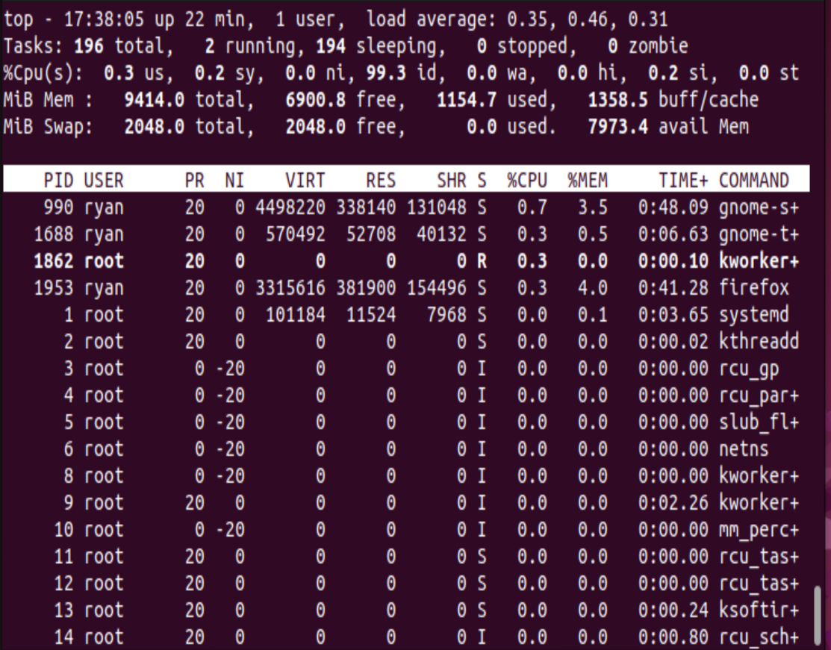
3. I have 7973.4 memory available.
4. Most processes don’t take up a meaningful amount of CPU. Gnome-s+ is using the most. Gnome-t+, firefox, and kworker+ are also using some CPU.
5. Firefox uses the most memory.
6. Apt-get: Package manager for Debian Linux  
   Yum: Package manager for Red Hat Linux  
   tar: Creates and extracts Archive files  
   rar: File compressor  
   gzip: File compressor  
   wget: Network downloader
7. 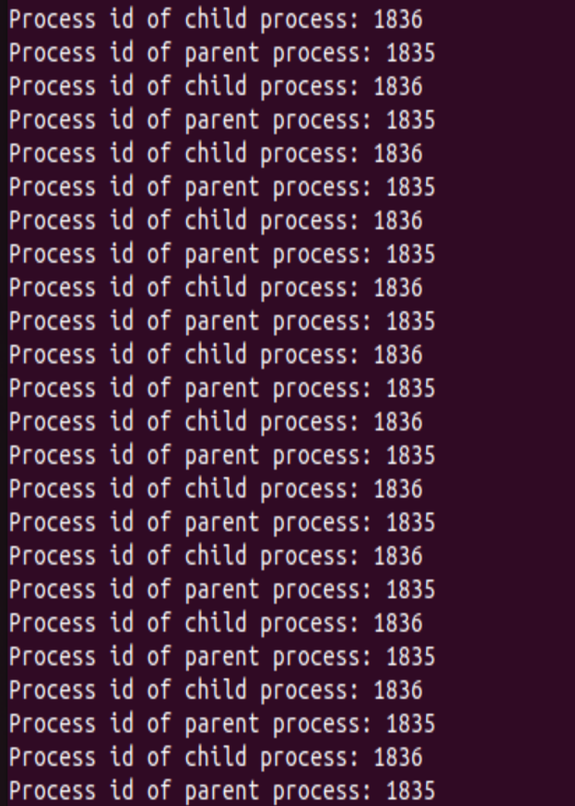
8. Text

   Description automatically generated
9. 