[https://www.nrel.gov/csp/solarpilot.html]

Solar Power tower Integrated Layout and Optimization Tool

The Solar Power Tower Integrated Layout and Optimization Tool (SolarPILOT™) generates and characterizes power tower (central receiver) systems. This software was developed by the National Renewable Energy Laboratory (NREL).

SolarPILOT consists of a graphical user interface (GUI) and an application programming interface (API) through which external programs can access SolarPILOT's functionality. SolarPILOT's calculation engine extends Sandia National Laboratories' DELSOL3 using the computationally efficient *Hermite* expansion technique; but it applies calculations to each heliostat image, rather than to larger groups of heliostats—as DELSOL3 does. SolarPILOT also integrates the [SolTrace](https://www.nrel.gov/csp/soltrace.html)™ ray-tracing engine to allow cross-comparison of results and analysis of more complex geometries.

SolarPILOT is an open source project and is accepting contributors. You can download source code, view current issues and discussion, or contribute new capabilities at [NREL’s SolarPILOT Github page](https://github.com/NREL/solarpilot). For NREL’s official SolarPILOT release, or to view background material, feature lists, or contact information, follow the links below.

* [Download SolarPILOT](https://www.nrel.gov/csp/solarpilot-download.html)
* [Model background](https://www.nrel.gov/csp/solarpilot-background.html)
* [Features and collaboration](https://www.nrel.gov/csp/solarpilot-collaboration.html)
* [Contact information](mailto:solarpilot.support@nrel.gov)

SolarPILOT provides state-of-the-art functionality with a number of important features. With SolarPILOT, users can do the following:

* Create heliostat field layouts that account for local solar and atmospheric conditions, receiver geometry and tower height, market pricing factors, and other considerations.
* Constrain heliostat field positions with customizable land shapes. Easily define complex land-boundary geometry with software that generates KML files (e.g., Google Earth).
* Model a variety of heliostat optical configurations including multiple facets and aiming/canting schemes.
* Create systems with multiple heliostat or receiver geometries.
* Simulate receiver flux profiles using smart aiming techniques at any specified time or solar position.
* Execute parametric simulations to quickly investigate sensitivity to a design parameter.
* View field layouts, flux plots, and aim-point plots with an interactive plotting tool.
* Optimize the heliostat field layout and receiver dimensions to minimize expected cost of energy.
* Calculate solar field cost.
* Execute multi-threaded simulations to reduce simulation time.
* Execute scripts that provide in-depth control of heliostat positioning, aiming, land boundaries, and calculation procedures.

SolarPILOT has been developed with both computational efficiency and accuracy in mind. Systems become more computationally expensive to simulate as the number of heliostats increases, and SolarPILOT has implemented methods to reduce the overall computational burden while generating accurate and precise results. These methods have been developed as part of the U.S. Department of Energy (DOE) SunShot Initiative research funding at NREL and are made available as part of this software.

SolarPILOT is used by researchers, industry technology developers, and academics to evaluate technology performance, quantify the value of research findings, and provide third-party, independent validation for privately developed tools. SolarPILOT is also used via its API by NREL's System Advisor Model (SAM) software.

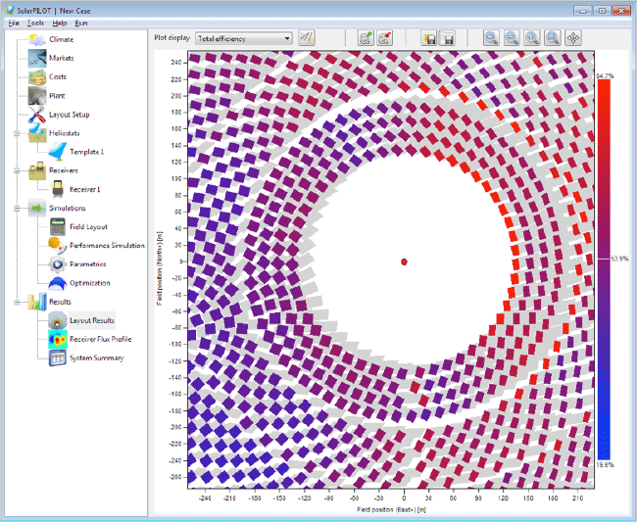

SolarPILOT — version 1.1. Layout Results Page.

[> SolarPILOT home](https://www.nrel.gov/csp/solarpilot.html)

[https://www.nrel.gov/csp/solarpilot-collaboration.html]

SolarPILOT Feature Requests and Collaboration

NREL works with the DOE to identify priority areas for continued SolarPILOT and [SolTrace](https://www.nrel.gov/csp/soltrace/) development. This work is rigorously reviewed and competitively awarded under the multiyear proposal development process, and the development work resulting from this process reflects the assessment by NREL and DOE of the CSP community's needs.

As of March 2018, SolarPILOT is also available as an open source project. While not every project benefits from an open source approach, several factors influenced this decision. Funding for development of SolarPILOT can’t always keep pace with evolving CSP technology, and opening up the software for general contribution allows specialized users to adapt the tool for their needs. Several different tools for power tower layout and optimization have been developed in the past, but lack of availability has, in some cases, prevented widespread adoption of a common platform. Open source code offers both widespread availability and full transparency, which encourages adoption of existing tools, rather than continual development of new and competing software tools. Lastly, many SolarPILOT users are themselves adept programmers and have much to offer in power tower layout, optimization, and characterization modeling. We encourage potential contributors to visit the [NREL SolarPILOT Github page](https://github.com/NREL/solarpilot) for more information. If users are interested in working with NREL outside of the open source project to develop additional features or provide support for using SolarPILOT, please [contact the SolarPILOT support team](mailto:solarpilot.support@nrel.gov).

*Below are several recently added features*.

* Significantly reduced run time for SolTrace simulations with large numbers of heliostats. Our research is targeting a reduction in run time of 95%.
* Improved API functionality
* Cross-platform support (OSX, Linux)
* Support for scripting using SAM's LK scripting language.

[> SolarPILOT home](https://www.nrel.gov/csp/solarpilot.html)

[https://www.nrel.gov/csp/solarpilot-download.html]

# Download SolarPILOT

### **Current Official Release**

SolarPILOT Version 1.1 is now available. [SolarPILOT](https://www.nrel.gov/csp/solarpilot.html) is available for Windows (32-bit and 64-bit) and Linux systems.

Top of Form

First Name

Last Name

Email Address *

Organization

Planned Use of SolarPILOT:

DOWNLOAD

Bottom of Form

## **Release Notes**

### **Version 1.1 is the first open source release. Future releases will provide updates to the release notes as needed.**

The best place to find answers about using SolarPILOT is the software's Help system. Just click Help Contents under the Help menu, or press F1 from any input page to launch the help documentation.

Send questions and comments to the [user support team](mailto:solarpilot.support@nrel.gov). Responses are supported by the limited SolarPILOT budget.

[> SolarPILOT home](https://www.nrel.gov/csp/solarpilot.html)

[https://www.nrel.gov/csp/solarpilot-background.html]

# SolarPILOT Background

[SolarPILOT](https://www.nrel.gov/csp/solarpilot.html) offers several unique capabilities compared to other software tools. Unlike exclusively ray-tracing tools, SolarPILOT runs the analytical simulation engine that uses a modified Gaussian series expansion to characterize the image generated by each heliostat. Rather than construct the model of the image using a large number of rays that eventually approach a Gaussian-form image via probabilistic modeling, the error distributions are "baked in" to the analytical formulation to begin with, allowing an explicit model that solves much more quickly than a probabilistic one.

SolarPILOT is also a comprehensive power tower optical-modeling tool, including the ability to generate field layouts in a variety of patterns or land constraints, conduct detailed optical performance simulations down to the level of each heliostat facet, perform optimization of key system variables, and conduct parametric analyses. SolarPILOT is especially unique in containing the analytical engine alongside a ray-tracing core for more detailed simulations. The SolTrace simulation engine is included and controlled via an application programming interface in each SolarPILOT distribution.

[> SolarPILOT home](https://www.nrel.gov/csp/solarpilot.html)