NLP for Healthcare: Medical Text Analysis
CSCI E-222 - Foundations of Large Language Models
Final Project Report

Oleksandr Mykhailovskyi
May 2026

Abstract
The goal of this project is to investigate the application of Large Language Models (LLM) to two medical NLP tasks: Named Entity Recognition (NER) on clinical text and Multiple Choice Question Answering (QA) on USMLE coded medical licensing questions. The performance of two models was compared: Bio_ClinicalBERT, an encoder only BERT based model, and MedGemma-4b, a GPT architecture model provided by Google specialized in medical science. Both were fine tuned using different techniques on the publicly available datasets (MedMentions for NER, MedQA-USMLE for QA). The results confirmed that BERT performs better when it comes down to token level classification due to its architecture, ability to assess the context before and after the currently processed token and MedGemma-4b performs better on QA task due to its greater reasoning capability and context window. The code is publicly available on GitHub, the model and datasets are publicly available on HuggingFace.

1. Introduction and Problem Statement
Healthcare generates an enormous volume of unstructured text: clinical notes, discharge summaries, research abstracts. The problem is how to access that knowledge. For that purpose, let’s try to apply Transformers to these two foundational tasks:
- Named Entity Recognition (NER): automatically identifying and labelling medical entities (diseases, drugs, procedures, anatomical locations) within text.
- Multiple-Choice Question Answering (QA): selecting correct answer to a clinical question given a set of options.

The central research question of this project: how does a traditional encoder-only BERT model compare to a modern decoder-only LLM on these two tasks, given the same training data and a resource constrained fine tuning budget?
Both models are fine tuned (LoRA for Gemma, standard fine-tuning for BERT) in respective notebooks, evaluated on held-out test splits, and compared in a dedicated comparative analysis notebook.

2. Data Description and Preprocessing

2.1 MedMentions (NER)
MedMentions (Ben10x/MedMentions-MTI881-NER on Hugging Face) is a corpus of 4,392 PubMed paper titles and abstracts randomly sampled from 2016 biomedical publications. Each token is annotated with a BIO-style NER tag drawn from 127 UMLS semantic types, approximately 350,000 entity mentions. The dataset contains train, validation, and test partitions.
The dataset suffers from severe class imbalance: the “O” (Outside) tag accounts for the vast majority of tokens, while some other tokens are severely under-represented with only a few examples to train from. To address the former, exponential inverse frequency class weights are computed and injected into the custom WeightedTrainer. The "O" class is explicitly down-weighted to 0.5 regardless of its frequency. Addressing the latter proved to be a more difficult task - it is possible to synthesize data for under-represented tags, but given time limitations, no robust implementation was done, but the option was explored via LLM rephrasing approach, the results were not included for brevity.
For Bio_ClinicalBERT the task can be taken as-is using AutoModelForTokenClassification.
For MedGemma-4B, the NER task is reformulated as a text-to-text problem: the model is given raw token sequence and trained to generate a comma-separated list of "Token: Tag" pairs (see Appendix 8.3: Samples).

2.2 MedQA-USMLE-4-options (QA)
MedQA-USMLE-4-options (GBaker/MedQA-USMLE-4-options on Hugging Face) contains approximately 12,000 questions, sourced from professional Medical Boards exams, each with four answer options (A-D) and an answer letter. The dataset provides train and test splits. 10% validation split is held out from the training set during fine tuning.
For Bio_ClinicalBERT, each question is paired with each of the four options to form four [Question, Option] input sequences quadrupling the input.
For MedGemma-4B, the question and four options are presented as a specifically formatted prompt, and the model is trained to generate only the answer letter followed by the EOS token.

3. Models and Methods

3.1 Bio_ClinicalBERT
Bio_ClinicalBERT (emilyalsentzer/Bio_ClinicalBERT) is a BERT type model. While the core model is BERT, it was further trained on a large medical corpora for biomedical entities extraction, and this model was subsequently trained on MIMIC-III clinical notes for even better medical terms extraction. It contains 110M parameters and uses a standard 512 token context window. BERT contains a bidirectional attention mechanism, that allows every token to attend to the full context, to the content to the left and to the right of it.
- NER: fine-tuned as AutoModelForTokenClassification with a per token softmax head over 127 entity classes. Trained with cosine LR scheduling, 10% warmup, and an EarlyStoppingCallback (patience=2) on F1 score.
- QA: fine-tuned as AutoModelForMultipleChoice. Each of the four [Question, Option] pairs is independently encoded; a linear classifier over the [CLS] token produces a score per option. Trained with cosine LR scheduling and early stopping on accuracy.

3.2 MedGemma-4B
MedGemma-4B (google/medgemma-4b-it) is a 4-billion-parameter decoder-only model built on Google Gemma architecture, pretrained with medical domain adaptation by Google. It supports a 8K+ token context window. Fine-tuning is performed using QLoRA (Quantized Low-Rank Adaptation) via the Unsloth library: the model is loaded in 4-bit NF4 quantization and LoRA adapters (rank 16, alpha 16) are injected into the attention projection layers.
- NER: fine-tuned as a generative sequence-to-sequence task using SFTTrainer. Trained for 300 steps with AdamW-8bit optimizer, linear LR schedule, effective batch size 16.
- QA: fine-tuned to produce the single correct letter (A/B/C/D) followed by EOS token. A custom MedicalQAEvaluationCallback computes exact match accuracy and macro F1 on a 300-sample validation subset at each epoch boundary. Trained for 2 epochs.

3.3 Comparative Analysis
Fine-tuned checkpoints are published to the Hugging Face Hub and loaded in the comparative analysis notebook. Both models are evaluated on the same held out test data (full test split for BERT NER and QA; 10% subset for Gemma NER due to inference time; 200-sample subset for comparative QA). Metrics are computed with seqeval (NER) and scikit-learn (QA).

4. Implementation Details

4.1 Environment and Dependencies
All notebooks were developed and validated on Google Colab Pro with an A100 GPU (40 GB VRAM).
Table 1: Notebook dependencies
Notebook | Key Libraries
010-gemma4bit.ipynb | transformers, unsloth, trl, bitsandbytes, datasets
011c-bioclinicalbert.ipynb | transformers, datasets, evaluate, seqeval, torch
020-gemma4bit.ipynb | transformers, unsloth, trl, datasets, scikit-learn
020-bioclinicalbert-qa.ipynb | transformers, datasets, evaluate, scikit-learn
comparative_analysis.ipynb | transformers, unsloth, seqeval, scikit-learn, torch

4.2(a) Setup Instructions (with Fine Tuning the models)
This step requires some compute resources and time as it includes fine tuning all of the models.
To reproduce results from scratch:
- Open each model notebook in Google Colab and select A100 GPU runtime.
- Run all cells.
- To publish checkpoints, set PUSH_TO_HUB = True and supply a HuggingFace write token when prompted.
- After all four training notebooks complete, open comparative_analysis.ipynb and run all cells. This script uses the published models and assesses them.

4.2(b) Setup Instructions (evaluation only)
This step will load fine tuned models from the public Hugging Face platform.
- Open comparative_analysis.ipynb notebook in Google Colab and select A100 GPU runtime.
- Run all cells.

4.3 Execution Order
The models can be trained in parallel.
- 010-gemma4bit.ipynb — MedGemma-4B NER fine-tuning (30–60 min)
- 011c-bioclinicalbert.ipynb — Bio_ClinicalBERT NER fine-tuning (30–45 min)
- 020-gemma4bit.ipynb — MedGemma-4B QA fine-tuning(30–60 min)
- 020-bioclinicalbert-qa.ipynb — Bio_ClinicalBERT QA fine-tuning (30–45 min)
- comparative_analysis.ipynb — full evaluation (20 min)

4.4 Published Checkpoints
Table 2: Fine-tuned checkpoints on Hugging Face Hub (hub: alexd063/)
Checkpoint | Task
alexd063/bio-clinicalbert-finetuned-medmentions-v1 | NER (classification)
alexd063/gemma4bit-finetuned-medmentions | NER (generative)
alexd063/bio-clinicalbert-finetuned-medqa | QA (classification)
alexd063/gemma4bit-finetuned-medqa | QA (generative)

5. Experiments and Results

5.1 Named Entity Recognition (MedMentions)
Bio_ClinicalBERT was fine-tuned for up to 20 epochs with early stopping (patience=2) using F1 score as success metric. After epoch 5 validation loss began increasing, while training loss continued to decrease, indicating overfitting. The final test loss was 2.758 (see Appendix 8.1: Training, Validation, Test Losses).
MedGemma-4B was fine-tuned for 300 steps. Training loss decreased steadily from 1.9 to 1.0, showing continued learning (see Appendix 8.2: Training, Validation Losses).
The comparative evaluation (Bio_ClinicalBERT on full test split; MedGemma-4B on 10% random subset) confirmed that Bio_ClinicalBERT significantly outperforms MedGemma-4B on this task. Full per class seqeval precision/recall/F1 scores are reported in the comparative_analysis.ipynb notebook output.
Note: the comparison is not perfect as BERT is evaluated on the full test split while Gemma uses a 10% subset due to the considerably longer inference time. Gemma's reported metrics carry higher variance as a result.
Table 6: Comparative NER evaluation
Model | Support | Macro F1
Bio_ClinicalBERT | 11,772 | 0.65
MedGemma-4B | 1,221 | 0.27

5.2 Multiple-Choice QA (MedQA-USMLE)
Bio_ClinicalBERT was fine-tuned for up to 10 epochs with early stopping using accuracy. The training loss oscillated without clear trend, which suggests that the 512 tokens context window truncated long patient case histories, possibly cutting out the answer(s) (see Appendix 8.4: Training, Validation Losses; Validation Accuracy). Final test results from the training notebook:
Table 3: Bio_ClinicalBERT QA: full test set results
Metric | Value
Test Loss | 1.387
Test Accuracy | 0.273

MedGemma-4B was fine-tuned for 2 epochs. Training loss decreased smoothly from 1.9 to 1.0, and validation accuracy increased across both epochs (see Appendix 8.5: Training, Validation Losses; Test Accuracy). Final test results:
Table 4: MedGemma-4B QA: full test set results
Metric | Value
Test Accuracy | 0.542
Validation Accuracy (Epoch 2) | 0.557

The comparative evaluation on a 200-sample subset of the MedQA test split:
Table 5: Comparative QA evaluation (200-sample test subset)
Model | Accuracy | Macro F1
Bio_ClinicalBERT | 0.245 | 0.245
MedGemma-4B | 0.555 | 0.555

MedGemma-4B outperforms Bio_ClinicalBERT by a wide margin (+30 percent in accuracy). The large gap is attributable to the 512-token truncation issue in Bio_ClinicalBERT: many questions include extended patient histories that exceed the context limit, causing the model to answer based on incomplete information, or in degenerate cases, to not see the answer options at all.

6. Discussion

6.1 What Worked Well
- WeightedTrainer for NER: custom class weights helped Bio_ClinicalBERT learn entity types that would otherwise be overwhelmed by the O-label majority.
- QLoRA + Unsloth for MedGemma-4B: 4-bit quantization reduced VRAM needs from 16 GB to 4 GB without significant performance dip, making a 4B-parameter model trainable on a single A100.
- MedicalQAEvaluationCallback: custom callback which computes accuracy (exact match only) on a validation subset at each epoch provides a more useful feedback than the loss metric.
- MedGemma-4B on QA: the model achieved 54.2% test accuracy on this task after only 2 epochs of fine tuning. This was due to its background medical knowledge, large context window and significant reasoning capabilities.

6.2 What Did Not Work or Was Challenging
- Bio_ClinicalBERT on QA: the 512-token hard limit caused systematic truncation of long clinical texts. The model's loss showed oscillation rather than clear trend, suggesting it was unable to learn from truncated inputs.
- Generative NER: unlike token classification, this task requires some setup and, as was shown, MedGemma type models are not natively suitable for these kinds of tasks. Any deviation in format of the input causes alignment failure (tagging as O), which results in worsened performance, reducing metrics such as recall, F1 score. The proper preparation and setup for this kind of task remains a challenge and requires significant time, effort and research.
- Class imbalance in NER: despite the exponential weighting scheme, rare entity types with very few training examples (classes with few, or even only one example) achieved near-zero F1 for both models. This can be solved via synthetic data generation using LLMs or other approaches, but this task was beyond the scope of this experiment as the complexity was considered too high, simple rephrasing using an LLM won’t work due to the tagging alignment needs.
- Inference speed of MedGemma-4B: the output generation is substantially slower than BERT’s inference for the same inputs, which forced evaluation on a 10% subset rather than the full test split for NER.

6.3 Lessons Learned and Possible Extensions
NER potential improvements for Bio_ClinicalBERT:
- Synthesize additional training examples for under-represented NER tags using data augmentation.
- Replace standard subword tokenization with whole-word tokenization or SpanBERT.
- Add a Conditional Random Field (CRF) layer on top of the token classifier to enforce valid BIO tag sequences.
- Switch the base model (e.g. microsoft/BiomedNLP-BiomedBERT-large-uncased).

NER potential improvements for MedGemma-4B:
- (same as BERT) Synthesize additional training examples for under-represented NER tags using data augmentation.
- Switch to constrained decoding: restrict output vocabulary to valid NER tags only, eliminating parsing errors entirely.
- Use structured output formats (JSON) during fine-tuning to make output structured and less random.
- Increase training steps.

QA potential improvements for Bio_ClinicalBERT:
- Replace the base model with a long-context variant (e.g. Longformer) to avoid 512-token truncation.
- Extract keywords from the question and options instead of feeding full text, to stay within the context window.

QA potential improvements for MedGemma-4B:
- Extend fine-tuning to 3–5 epochs (validation accuracy was still rising at epoch 2).
- Implement Retrieval-Augmented Generation (RAG) to supply relevant medical knowledge at inference time.

7. Responsible Use, Limitations, and Risks
All models in this project are research prototypes and must not be used for clinical decision-making or patient care.

8. Appendices

8.1 Fine Tuned Bio_ClinicalBERT for NER: Training, Validation, Test Losses
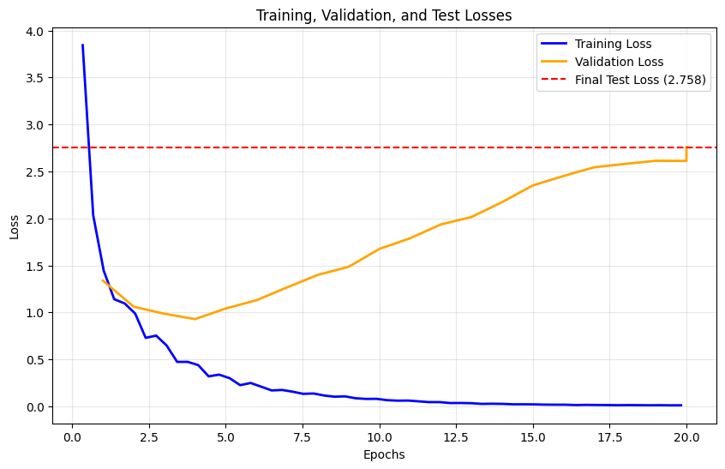

8.2 Fine-tuned MedGemma-4b for NER: Training, Validation Losses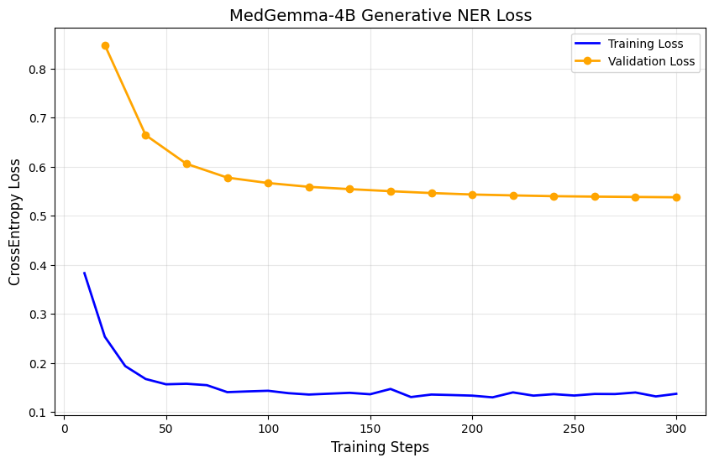

8.3 Fine-tuned MedGemma-4b for NER Samples
The following is an example of how Fine Tuned MedGemma-4b works on NER task. It contains input, expected output and predicted output. The pair structure was enforced to prevent the model from skipping words or producing the wrong amount of tags for tokens sequence.
Input | The cut - off value of LSM by TE for predicting liver fibrosis stage ≥3 is 10.0 kPa in Japanese NAFLD patients .
Expected | The: O, cut: O, -: O, off: O, value: O, of: O, LSM: O, by: O, TE: B-T058, for: O, predicting: O, liver: B-T033, fibrosis: I-T033, stage: I-T033, ≥3: O, is: O, 10.0: O, kPa: O, in: O, Japanese: B-T098, NAFLD: B-T038, patients: O, .: O
Predicted | The: O, cut: O, -: O, off: O, value: O, of: O, LSM: B-T038, by: O, TE: B-T058, for: O, predicting: O, liver: B-T038, fibrosis: I-T038, stage: I-T038, ≥3: I-T038, is: O, 10.0: O, kPa: O, in: O, Japanese: B-T098, NAFLD: B-T03

8.4 Fine-tuned Bio_ClinicalBERT for QA: Training, Validation Losses; Validation Accuracy
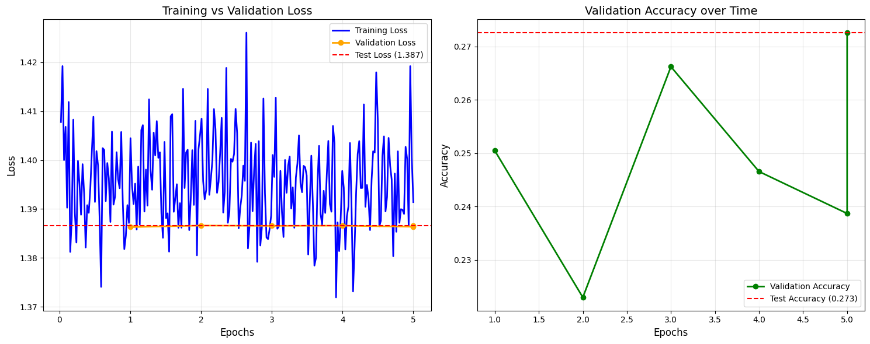

8.5 Fine-tuned MedGemma-4b for QA: Training Loss; Validation, Test Accuracy
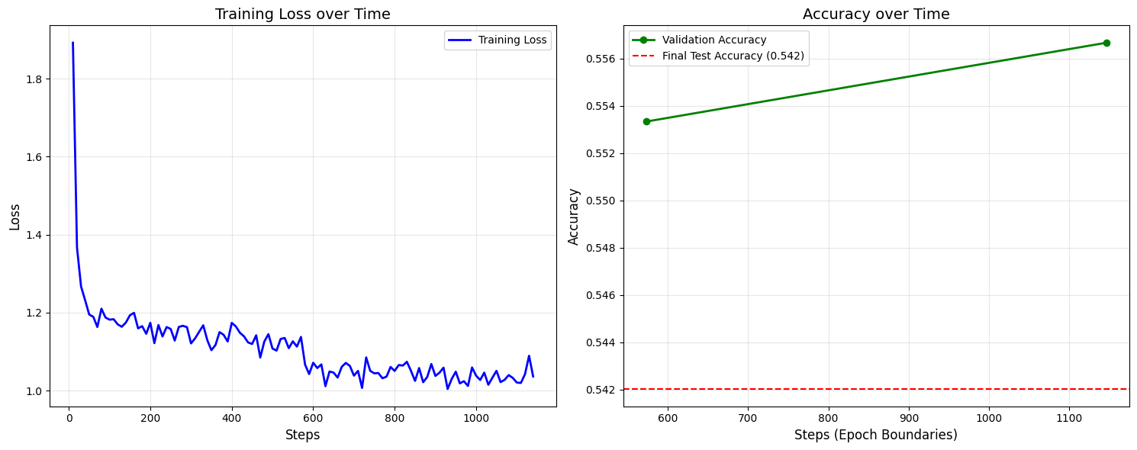

References
[1] Alsentzer, E. et al. (2019). Publicly Available Clinical BERT Embeddings. NAACL Clinical NLP Workshop. https://huggingface.co/emilyalsentzer/Bio_ClinicalBERT
[2] Team, G. (2025). MedGemma Technical Report. Google DeepMind. https://huggingface.co/google/medgemma-4b-it
[3] Mohan, S. & Li, D. (2019). MedMentions: A Large Biomedical Corpus Annotated with UMLS Concepts. AKBC. https://huggingface.co/datasets/Ben10x/MedMentions-MTI881-NER
[4] Jin, D. et al. (2021). What Disease does this Patient Have? A Large-scale Open Domain Question Answering Dataset from Medical Exams. Applied Sciences. https://huggingface.co/datasets/GBaker/MedQA-USMLE-4-options
[5] Hu, E. J. et al. (2022). LoRA: Low-Rank Adaptation of Large Language Models. ICLR.
[6] Dettmers, T. et al. (2023). QLoRA: Efficient Finetuning of Quantized LLMs. NeurIPS.
[7] Wolf, T. et al. (2020). Transformers: State-of-the-Art Natural Language Processing. EMNLP.
[8] Unsloth. (2024). Unsloth AI — Fast LLM Fine-tuning. https://github.com/unslothai/unsloth

