1 sec I have a picture for this

[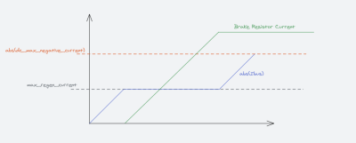](https://cdn.discordapp.com/attachments/369678934985408524/873311947834138624/unknown.png)

**abcde *—* 06.08.2021**

so... when the current reaches max_regen_current, the current (?) goes to the brake resistor?

**Paul *—* 06.08.2021**

Yes. max_regen_current goes back into the battery, and any additional current goes to the brake resistor. Once the brake resistor saturates, it starts to send more current to the battery than max_regen_current. Once the total current going to the battery exceeds dc_max_negative_current, it faults out