  - GROUP 4 • BSIT 2-07

WearAware
  - Checkpoint 02: Deploying and Securing a MERN Application
ITE 314: ADVANCED DATABASE SYSTEMS
Project Information | Details
Project Title | WearAware: PPE Compliance Monitoring and Worker Portal
Group/Team | Group 4
Members | Ivan Miguel F. Chen  Brenan Josh Cervantes  John Nathaniel T. Tercero
Course/Section | ITE 314: Advanced Database Systems / BSIT 2-07
Instructor | To be supplied by the group
Date | Prepared: 23 September 2026  Submission date: to be confirmed
Frontend Deployment URL | Not supplied or verified. Local frontend: http://localhost:5173
Backend/API Deployment URL | Not supplied or verified. Local API: http://localhost:5000
Repository URL | https://github.com/voncheems/WearAwareRM

Submission scope
This activity documents the available implementation, observed local behavior, and deployment plan. It does not claim that a public production deployment or all required security controls have been completed. The architecture uses the native MongoDB driver; Mongoose is not installed.
Names and section were taken from the project’s About page and should be confirmed before submission. The report reflects the local working tree, including changes that may not yet be on GitHub. No application source code or real database records were changed to prepare this report.

Table of Contents
1. Project Overview
2. MERN Architecture
2.1 Request-Response Flow
3. Project Features and REST API
4. Security Analysis of Our Project
5. Authentication and Authorization
5.1 RBAC Matrix
6. Secure Development Practices
7. Database Design and Security
8. Deployment Plan
8.1 Deployment Architecture
9. Security Testing
10. Deployment Verification Checklist
11. Evidence and Screenshots
Reflection Questions
12. Final Project Information
13. Suggested Evaluation Rubric
Appendix A. Source Evidence Index
Appendix B. Safe Configuration Example

How to read the evidence
Implemented means the control is present in source. PASS (local) means a recorded check passed in an isolated local environment. PARTIAL means the control covers only some paths. GAP means a missing or failing control was identified. PENDING means the result needs a deployed environment or information from the group. A passing regression suite is not proof that every security requirement is satisfied.
The template’s requested sections are retained. Its Mongoose, production URL, and screenshot prompts are treated as reporting requirements, not evidence that those features already exist. Figures 1–3 are real browser captures; Figures 4–6 and 10 are visual presentations of recorded test/query output. Figures 7–9 remain explicitly pending.

1. Project Overview
Item | Group Response
Project Title | WearAware: PPE Compliance Monitoring and Worker Portal
Problem/Need Addressed | Manual PPE checks and scattered records make it difficult to review violations, monitor station activity, and give workers visibility into their own compliance history.
Target Users | Administrators manage accounts, workers, and stations; inspectors perform checkpoint duties; linked worker accounts view their own records. Visitors can view the public information pages.
Main Purpose | Record PPE inspection outcomes and present compliance information to the appropriate users, supporting workplace safety monitoring and follow-up.
Major Features | Role-based login; worker and station management; QR-based worker identification; PPE detection service integration; violation records and notifications; admin and inspector dashboards; read-only worker profile, history, QR code, and personal compliance rate.

2. MERN Architecture
React communicates with the Express API through fetch requests. Express runs on Node.js and calls repository.js, which uses the native MongoDB driver for queries, aggregation joins, indexes, and transactions. This is a MongoDB–Express–React–Node stack, but it does not implement the template’s requested Mongoose ODM layer. If Mongoose is mandatory, this remains an assignment requirement to address. [S1–S5]
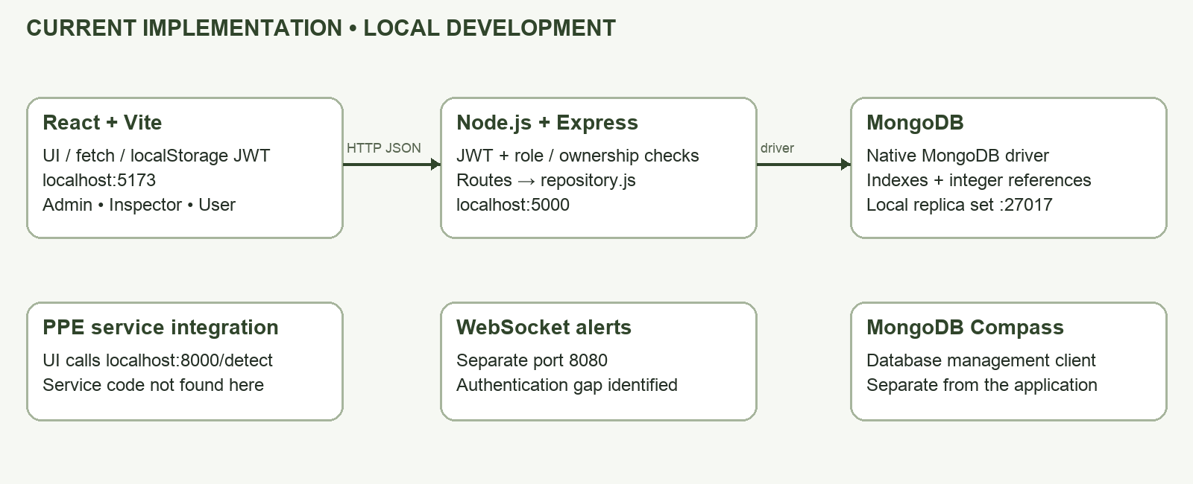
Architecture A. Current local implementation and supporting integrations.
Component | Technology Used | Role in Our Project
Frontend | React 19 / Vite 7 | Marketing pages, role dashboards, forms, transitions, and API requests.
Backend | Node.js / Express 5 | HTTP routes, authentication, role checks, validation, and business logic.
Data-access layer | MongoDB native driver 6; no ODM | Repository functions and application-level reference checks; no Mongoose models.
Database | MongoDB replica set | Persistent collections, indexes, and transactional relationship cleanup.
API communication | REST-style JSON over local HTTP | JWT bearer authorization; HTTPS is a production requirement, not demonstrated here.

2.1 Request-Response Flow
Example: a worker opens “My overview” after signing in. The compliance percentage uses all of that worker’s recorded scans, not only the current history page.
Step | What Happens in Our Application
1. React/UI Event | UserDashboard loads the personal overview and reads the login token from localStorage.
2. HTTP Request | GET /api/user/dashboard?page=1 with Authorization: Bearer <token>.
3. Express Route | /api/user router applies requireAuth and requireRole('user') before its dashboard handler.
4. Controller/Logic | Validate page; reload the authenticated account; resolve worker_id from MongoDB. Client-supplied worker/user IDs do not determine ownership.
5. MongoDB Operation | Find the linked worker; aggregate compliant/violation totals; match detections by worker_id; sort, skip, and limit history to 20; join station labels.
6. API Response | JSON includes account, worker profile, stats, history, page, pageSize, and totalPages. An unlinked account receives HTTP 409.
7. UI Update | Display profile, station, history, and compliance = compliant ÷ total × 100, rounded to one decimal. With no scans, show “No scans yet” rather than 100%.

3. Project Features and REST API
Representative implemented endpoints. “A” = admin, “I” = inspector, “U” = linked worker user. These are API roles, not database accounts. [S3, S6–S9]
Resource | Method | Endpoint | Purpose | Protected?
Authentication | POST | /api/auth/login | Issue an 8-hour JWT. | No
Session | GET | /api/auth/me | Return current account. | Any active role
Accounts | GET, POST | /api/users | List/create accounts. | A
Accounts | PUT, DELETE | /api/users/:id | Edit/delete account. | A
Workers | GET | /api/workers | List workers (broad read). | A, I
Workers | POST | /api/workers | Create worker. | A
Workers | PUT, DELETE | /api/workers/:id | Edit/delete worker. | A
Stations | GET, POST | /api/devices | List / create stations. | GET A,I; POST A
Stations | PUT, DELETE | /api/devices/:id | Edit/delete station. | A
Detections | POST | /api/detections | Record scan outcome. | I
Inspection | GET | /api/inspector/detections | Read own inspection history. | I
Override | PATCH | /api/inspector/detections/:id/override | Mark an owned detection compliant. | I
Admin report | GET | /api/admin/stats | Aggregate compliance. | A
Worker portal | GET | /api/user/dashboard | Own profile, history, compliance. | U
Password reset | POST | /api/auth/forgot-password | Request administrator assistance. | No

The UI also sends camera images to a separate localhost:8000/detect integration. Its service implementation and detection accuracy were not verified in this workspace. MongoDB Compass is a database client and does not replace the Express server. [S10]

4. Security Analysis of Our Project
This review identifies concrete implementation risks. Planned controls below are recommendations for the next revision, not changes completed during document preparation.
Area | Potential Risk in Our Project | Impact | Planned Control
Authentication | JWT lives in localStorage; recovery responses distinguish nonexistent and pending accounts. No login throttle is configured. | Token theft after XSS; account enumeration; repeated guessing. | Add throttling and uniform recovery responses; review session storage and expiration policy.
Authorization / RBAC | Worker portal ownership is enforced, but general worker/device GET routes allow broad inspector access; scan creation lacks a station-ownership check. | Inspectors may access unrelated worker data or submit mismatched scan associations. | Scope all inspector reads and writes to assigned stations and validate worker–station–inspector relationships.
Input validation | Repository rejects object-valued query fields and invalid IDs, but server-side format/length checks are inconsistent and mostly hand-written. | Malformed data, misleading 500 errors, and reliance on browser validation. | Define server-side request schemas, allowed fields, field lengths, and consistent 400 responses.
Database | Local startup binds loopback but does not configure MongoDB authorization or TLS. Production DB permissions are unverified. | An exposed or overprivileged DB could reveal or alter worker records. | Use a dedicated application DB identity, restricted network access, TLS, backup/restore tests, and retention rules.
API | No rate limiter or security-header middleware found. Malformed JSON returned an HTML stack in a local probe. | Resource abuse and disclosure of internal paths/implementation details. | Centralize safe errors; cap requests; configure appropriate response headers; disable framework disclosure.
Passwords | users.password_hash is bcrypt-hashed, but reset handling also stores and returns temp_password in plaintext. | Compromise of reset records can reveal usable passwords. | Replace temporary passwords with expiring single-use reset tokens; remove plaintext reset credentials and invalidate affected secrets.
Deployment | Frontend/API/inference URLs and CORS are localhost-specific. No live HTTPS URLs were provided. | Broken production requests or unencrypted transport if deployed unchanged. | Environment-based endpoints; HTTPS API/frontend/inference; controlled CORS; authenticated WSS.
Other: live alerts | WebSocket server has no connection authentication shown and sends violations to every open client. | Worker names, IDs, and violation details may reach unauthorized recipients. | Authenticate connections, enforce per-inspector subscriptions, and minimize alert payloads.

Priority before public deployment: fix credential recovery, WebSocket access, inspector scope, and safe error handling; then verify TLS, database access, validation, and request limits. The 16 passing regression tests cover selected behaviors and do not remove these findings. [S3–S9, S11]

5. Authentication and Authorization
POST /api/auth/login looks up the submitted email, checks that the account is active, compares the password with bcrypt, and signs an 8-hour JWT. Protected requests verify the signature, reload the account, reject deactivated users, and check whether updated_at makes the token stale. The current database role replaces the token’s role claim, so an old claim cannot restore admin access. [S3, S4]
React uses the returned role to select a dashboard. Server middleware remains the enforcement point. A “user” account must link to a real worker, and a unique partial index prevents two accounts from claiming the same worker. The worker portal derives ownership from the current account, not a request parameter. [S5–S7]
Role | Description | Allowed Functions | Restricted Functions
admin | System administrator | Manage users, workers, stations, assignments, activity, reset requests, and organization reports. | Inspector-only scan and override APIs and user-only dashboard are not granted automatically.
inspector | Checkpoint operator | Record detections; review inspector history; handle own alerts; update own profile and assigned-station workflows. | User administration and admin reports. General worker/device reads remain too broad and are documented as a gap.
user | Linked worker account | View own profile, station, scan history, all-time compliance, and employee-ID QR code. | Admin/inspector APIs; record mutation; other workers’ history.
Guest | Unauthenticated visitor | Marketing pages, login, contact submission, and recovery request. | Protected database resources and dashboards.

5.1 RBAC Matrix
The matrix describes current API access; “own” and “assigned” indicate intended data scope. Role gates are explicit, so admin does not inherit every inspector/user endpoint.
System Function | Admin | Inspector | User | Guest
View public pages | Yes | Yes | Yes | Yes
View worker/device registry | Yes | Yes (broad) | No | No
Create/edit/delete users, workers, stations | Yes | No | No | No
Manage user activation and worker links | Yes | No | No | No
View organization-wide reports | Yes | No | No | No
Create PPE scan record | No | Yes* | No | No
Review inspector history / override own scan | No | Own | No | No
Assign workers through inspector workflow | No | Assigned station | No | No
View personal worker dashboard / compliance | No | No | Own | No
Download personal employee-ID QR | No | No | Own | No

*Scan creation is inspector-only, but the submitted worker and station relationship still needs stronger ownership validation. A legacy “scanner” string remains in frontend routing; no complete scanner dashboard is rendered, so it is not represented as a fourth operational account role. QR contents identify a worker and are not authentication credentials. [S1, S3, S8, S10]

6. Secure Development Practices
Security Control | Implementation in Our Project | Evidence / Status
Input Validation | Positive integer IDs, page bounds, scalar query fields, typed PPE arrays/booleans, detection/status enums, and valid unique worker links. Full server-side schemas remain incomplete. | PARTIAL — S5–S7; Figure 5; worker portal tests.
Safe Database Queries | MongoDB filters are constructed in repository functions; normalize rejects object-valued query inputs. Updates use fixed operators such as $set. Raw client filter objects are not accepted by these helpers. | IMPLEMENTED in reviewed repository paths — S5; invalid worker_id object rejected by tests.
Password Hashing | Account creation and password changes use bcrypt with cost 10. Reset workflow also keeps plaintext temp_password, so password storage is not fully secure. | PARTIAL / GAP — S3; supplemental bcrypt check; reset source at lines 469–513.
Authentication | Signed JWT, 8-hour lifetime, signature verification, active-account check, and timestamp-based invalidation. | PASS (local) — S3–S4; database and portal tests.
Authorization / RBAC | Explicit allowlists, fresh DB role, account-to-worker ownership, and selected inspector scoping. Broad read/write gaps remain outside the worker portal. | PARTIAL — S4, S6–S9; Figure 4.
Least Privilege | Workers have a read-only portal. Inspector registry reads, WebSocket access, and production DB permissions need improvement. | PARTIAL — S6, S8–S9; no deployed DB evidence.
Secure Error Handling | Many route catches return generic JSON. Malformed JSON reaches an Express HTML error response with a stack and filesystem path in development. | GAP — security-probes.json; central error handler still needed.
Security Headers | No Helmet or equivalent header policy found. Sample response lacked CSP, HSTS, and X-Content-Type-Options and disclosed Express. | GAP — S2–S3; recorded HTTP header probe.
Rate Limiting | No configured request limiter identified for login, recovery, contact, or detection submission. | GAP — source inspection; load/burst test not performed.
Environment Variables | Backend uses dotenv and MONGODB_URI, MONGODB_DB, JWT_SECRET, ports, and mail settings. No secret values are reproduced in this report. | IMPLEMENTED locally — S2–S5. Current secret-file history was not audited.
HTTPS / TLS | Local browser/API communication is HTTP. No public HTTPS certificate or hosted endpoint has been verified. | PENDING production evidence — Figures 7–9.
Database Security | Unique indexes, reference checks, selected delete transactions, and loopback local binding are present. DB authorization, TLS, backup policy, and production least privilege are not verified. | PARTIAL — S5, S11; Figure 6. No database-level schema validators found.

Evidence IDs refer to Appendix A. “Implemented” applies only to the cited paths, not to an independently certified production system.

7. Database Design and Security
MongoDB stores the application records. The project keeps integer business IDs from its earlier database design, while MongoDB also maintains internal _id values. Relationships use integer references and $lookup aggregation joins rather than Mongoose populate. PPE lists are embedded arrays. [S5]
Collection | Purpose / Important Fields | Embedded / Referenced | Security Consideration
roles | Account permissions: id, name. | users.role_id → roles.id. | Unique role names; account management is admin-only.
users | Login/account: id, role_id, worker_id, email, full_name, password_hash, is_active, updated_at. | References roles and optionally one worker. | Unique email and partial unique worker_id; use limited response projections; never return password hashes.
devices | Checkpoint/station: id, device_id, label, location, inspector_id, required_ppe, is_active. | References inspector user; embeds required_ppe array. | Restrict management; scope inspector reads and scan submissions more tightly.
workers | Worker registry: id, employee_id, full_name, position, contact_number, device_id, status. | References station; referenced by accounts and detections. | Unique employee ID; protect identity and contact data; preserve ownership constraints.
detections | Scan result: id, worker_id, device_id, inspector_id, result, detected_ppe, missing_ppe, confidence_score, photo_url, detected_at. | References worker, station, inspector; embeds PPE arrays. | Filter by owner/role; minimize photos and identifiers; define retention and access policy.
notifications | Violation alerts: id, detection_id, inspector_id, is_read, created_at. | References detection and inspector. | HTTP notification routes scope to inspector; separate WebSocket path still needs authorization.
password_reset_requests | Recovery queue: id, email, reason, status, temp_password, created_at. | Email-based association; no repository foreign-key relationship. | Plaintext temp_password is an unresolved gap. Use expiring reset tokens instead.
_counters / _migration | Internal ID allocation and migration state. | Atomic counters; postgres-v1 migration marker. | Internal operational data; no public editing interface; protect migration credentials and backups.

Integrity and operational controls
ensureIndexes creates unique record IDs, unique role/email/device/employee identifiers, and the partial unique worker-account link. Repository checks reject unknown referenced records. Selected deletion operations run in transactions: deleting a worker clears linked account and detection worker IDs while preserving historical scans. Tests confirm that a newly unlinked worker account is blocked with HTTP 409.
Startup requires a completed postgres-v1 migration marker before it starts the API. A new empty database therefore needs an explicit migration/initialization plan. The local launcher creates a replica set bound to 127.0.0.1; it does not configure authorization or TLS. Production access controls and restore procedures remain pending. Compass is an administrative viewer/editor for this database, not its hosting or application runtime.

8. Deployment Plan
A public deployment was not demonstrated or supplied. The following is the project’s planned transition from the reviewed local implementation to production, not a record of completed hosting work.
Component | Local Environment | Production Environment | Status
React Frontend | Vite at localhost:5173; localhost API/inference URLs. | Build dist/ and host over HTTPS; configure public API/inference base URLs. | Local captured; production pending.
Node/Express API | HTTP :5000; WebSocket :8080; localhost CORS. | Persistent Node host/reverse proxy with HTTPS/WSS, fixed allowed origins, and authenticated alerts. | Local tests passed; production pending.
MongoDB | Local replica-set launcher; isolated databases for this report’s tests. | Managed replica set (e.g., Atlas) or securely administered equivalent; dedicated application account and restricted access. | Production target/permissions unconfirmed.
Environment Variables | Backend dotenv configuration; frontend URLs still hardcoded. | Host-managed secrets; separate public frontend configuration; no secrets in browser builds. | Backend local support; production pending.
HTTPS | Local frontend and API use HTTP. | Valid certificates for public frontend/API/inference and WSS alerts. | Not verified.
PPE Inference | Frontend calls localhost:8000/detect. | Separately hosted and secured inference service with compatible image request contract. | Integration identified; service implementation not verified.

8.1 Deployment Architecture
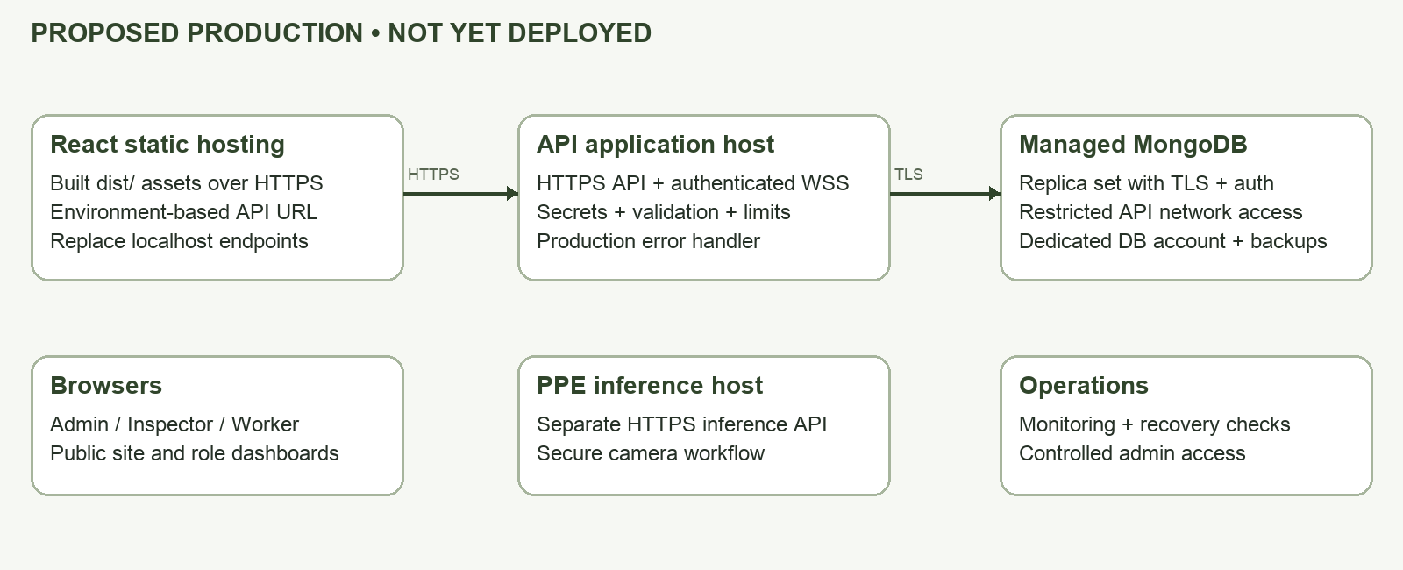
Architecture B. Proposed target only; no hosting provider or live URL is claimed.

Deployment sequence and acceptance
First resolve the high-priority security gaps in Section 4. Then provision a restricted MongoDB replica set, migrate/initialize and verify records plus indexes, configure API secrets and allowed origins, deploy the API and inference service, and build the frontend against their HTTPS URLs. Finally verify all three roles, CRUD, owned history, camera access, WSS delivery, backups/restoration, safe errors, and throttling against the deployed environment. Repeat the Section 9 checks and replace pending evidence with actual live captures.

9. Security Testing
Executed 23 September 2026. Existing tests: npm --prefix src/wearawarebackend test → 16 passed, 0 failed. Tests and supplemental probes used disposable MongoDB replica sets and the existing Express app, without writing to the configured application database. No production penetration or load testing was performed.
Test Case | Procedure | Expected Result | Actual Result | Status
Invalid Login | Submit wrong password for a synthetic account. | 401; generic credential error. | 401: “Invalid email or password.” | PASS local
Unauthorized Route | Worker requests GET /api/users. | No admin records; 403. | 403: “Access denied.” | PASS local
Role Restriction | Worker calls admin/inspector and detection write APIs; test stale admin claim. | 403 using current DB role. | Assertions passed in user-portal.test.js. | PASS local
Invalid Input | Submit page=-1; test missing, unknown, object-valued, and duplicate worker links. | 400 for bad input; 409 for duplicate link. | Expected 400/409 returned; unique index enforced. | PASS local
Protected API Without Token | GET /api/user/dashboard without bearer token. | 401; no worker data. | 401: “No token provided.” | PASS local
Password Storage Check | Compare synthetic account hash using bcrypt; review recovery persistence. | Password hash only; no recoverable plaintext. | bcrypt check passed; reset source stores plaintext temp_password. | PARTIAL / GAP
Secure Error Response | POST malformed JSON “{” to login. | Generic 400 JSON with no stack/path. | 400 HTML; stack and local path present in development. | FAIL local
HTTPS Check | Verify public frontend/API URLs and certificate. | Trusted HTTPS for all public services. | No deployed URLs supplied; local tests used HTTP. | PENDING
Rate Limit Test | Review limiter; plan bounded repeated login attempts on owned deployment. | Defined threshold returns 429 safely. | No limiter found; burst test not performed. | GAP / not run
Database Access Check | Review local launcher; plan authorized/unauthorized DB login and network checks. | Only permitted DB identity and network can connect. | Loopback binding found; auth/TLS not configured by launcher; deployed access not tested. | PARTIAL / pending

Additional checks and limits
Own dashboard returned HTTP 200 and 66.7% compliance for 4 compliant scans out of 6 synthetic scans. Existing tests also prove pagination does not change the all-history percentage, forged worker IDs do not change ownership, no-scan compliance is null, and deleted worker links fail closed. The sampled API response lacked CSP, HSTS, and X-Content-Type-Options headers and exposed X-Powered-By: Express.
The regression suite covers the cases it asserts; it is not an exhaustive audit. The malformed-JSON result was observed in local development, so production behavior still needs verification after a central error handler and production configuration are added. Raw records: evidence/backend-tests.txt and evidence/security-probes.json.

10. Deployment Verification Checklist
This is a truthful readiness checklist, not a claim of completed production deployment. “Local only” items must be repeated on the eventual hosted application.
Requirement | Verification Status
Frontend accessible through deployed URL | PENDING — local homepage/login captured; no live URL.
Backend/API accessible through deployed environment | PENDING — isolated local API exercised; no live URL.
MongoDB connected successfully | PASS, TEST ENVIRONMENT — replica-set connections and operations succeeded. Production pending.
CRUD operations work in production | PENDING — selected create/read/update/delete behaviors pass isolated tests.
Authentication works in production | PENDING — local login and active-user checks pass.
Passwords hashed and never stored as plaintext | PARTIAL — bcrypt account hashes exist; plaintext reset credentials remain.
Protected routes require authentication | PASS for tested HTTP routes; GAP for standalone WebSocket connections.
Role-based restrictions work | PASS for tested worker/admin/inspector role gates; inspector data-scope gaps remain.
Input validation works | PARTIAL — ID, ownership, page, enum, and duplicate-link checks exist; complete request schemas pending.
Sensitive configuration uses environment variables | IMPLEMENTED for backend settings; production secret manager pending.
Production secrets not committed | NOT CERTIFIED — no secret values reproduced; full Git history and remote secrets were not audited.
HTTPS enabled for deployed application | PENDING — no deployed HTTPS evidence.
Secure error handling implemented | PARTIAL / FAIL — malformed JSON reveals a local development stack.
Appropriate security headers configured | GAP — sampled protective headers absent.
Rate limiting or equivalent implemented | GAP — no configured limiter found.
MongoDB access appropriately restricted | PARTIAL — local loopback binding; production identity, TLS, and network access unverified.
Security tests completed and documented | PARTIAL — 16 regression tests passed; supplemental checks recorded; production, rate-limit, and DB access tests remain.

Items to complete before submission
Supply the instructor’s name and submission date; confirm team details; provide and test real deployment URLs; address the required security gaps; clarify whether the instructor accepts the native MongoDB driver instead of Mongoose; capture the missing deployment figures. A safe configuration example is included in Appendix B because the backend .env.example is currently absent from the working tree.

11. Evidence and Screenshots
Captured from the running local React frontend. These images show implemented UI, not a deployed URL. No personal account credentials were used.
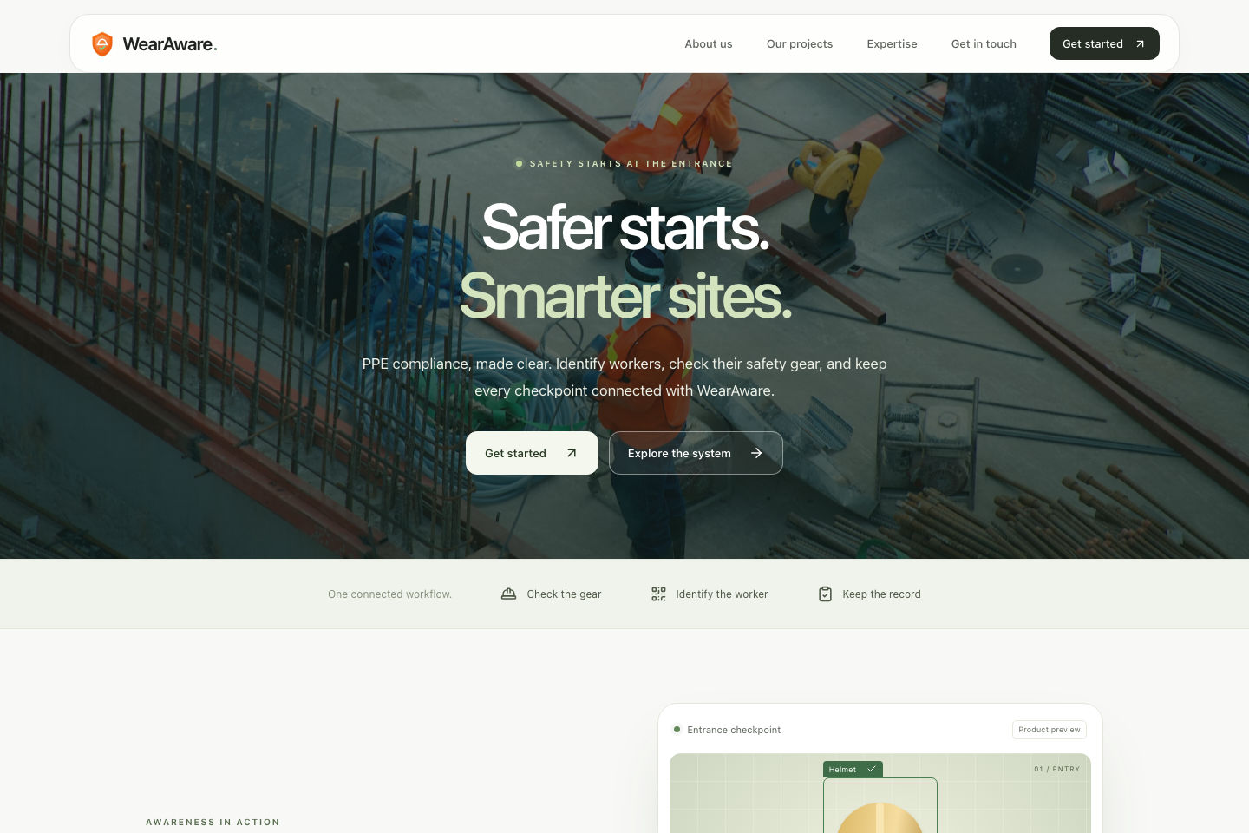
Figure 1. Project Homepage — actual local browser capture, 1440 × 960 viewport.
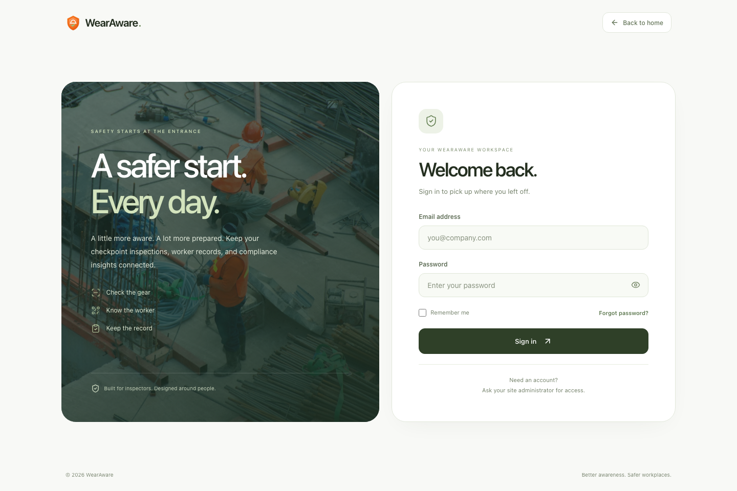
Figure 2. Authentication/Login — actual local browser capture.

11. Evidence and Screenshots (continued)
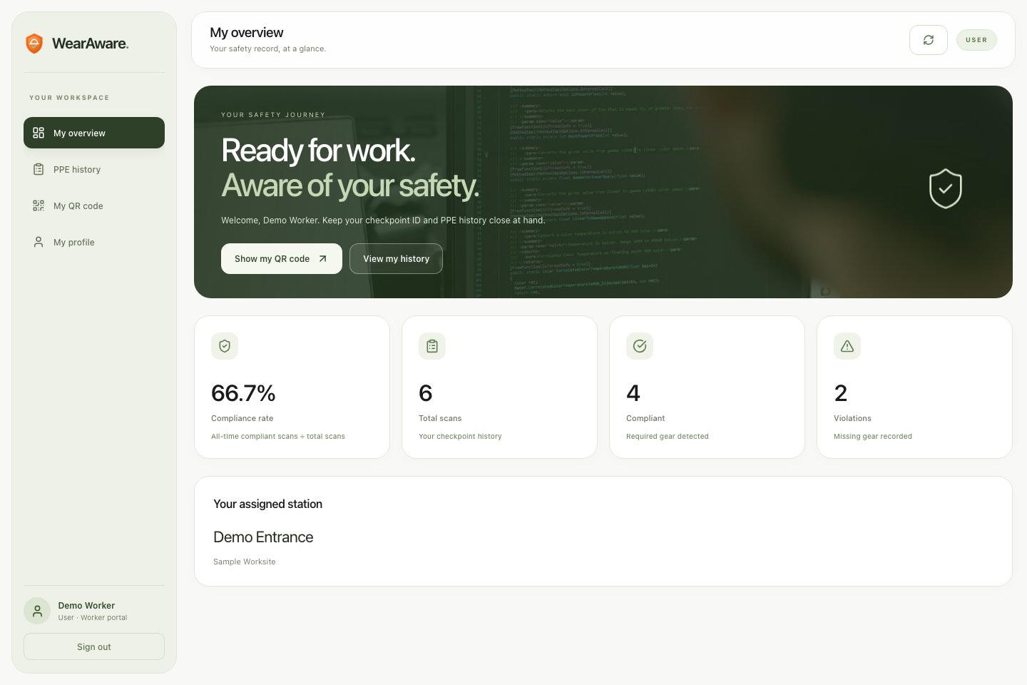
Figure 3. Authorized User Function — actual worker dashboard using synthetic records in an isolated MongoDB test database. Four compliant scans out of six produce 66.7%.
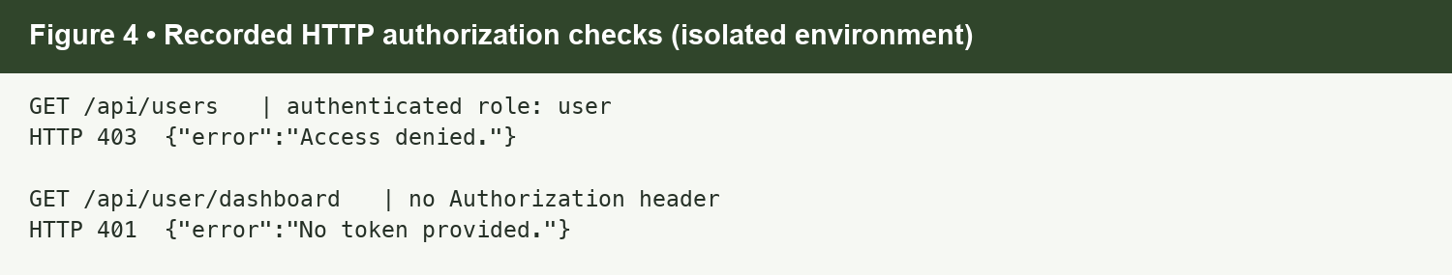
Figure 4. Restricted/Unauthorized Function — visual transcript of actual HTTP responses, not a browser error-page screenshot.
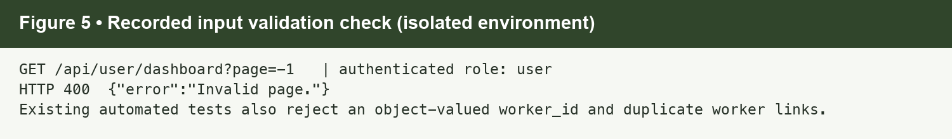
Figure 5. Input Validation — visual transcript of the actual invalid-pagination response.
Capture method: the frontend ran at localhost:5173 in an isolated browser profile. Its API requests were forwarded to a separate test instance of the existing Express app on 127.0.0.1:5011. The displayed worker and station are invented test fixtures; the screenshot is not evidence of production records. The screenshot process did not alter application source or real accounts.

11. Evidence and Screenshots (continued)
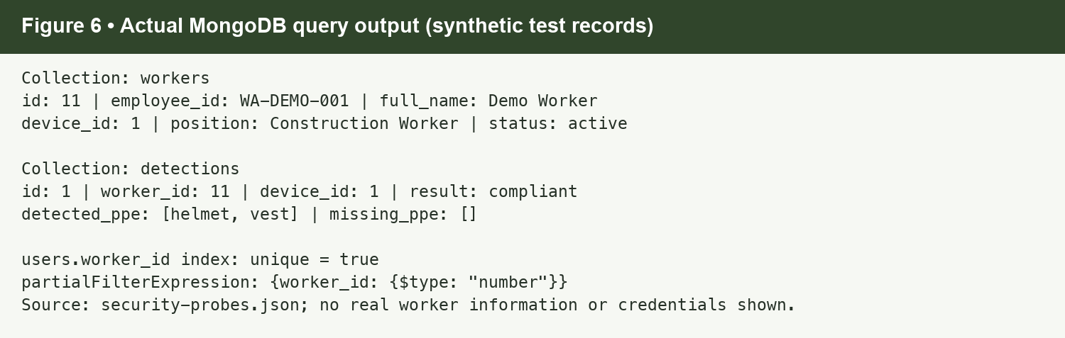
Figure 6. MongoDB Data — recorded query/index output from the disposable test database, formatted for readability. This is not a Compass screenshot.
Requested Figure | Evidence Status
Figure 7. Deployed Frontend | PENDING — capture the publicly hosted frontend with its actual HTTPS URL after deployment.
Figure 8. Deployed Backend/API | PENDING — capture a successful request to the deployed API without exposing authorization tokens.
Figure 9. HTTPS | PENDING — capture certificate/connection evidence for the actual frontend and API domains.

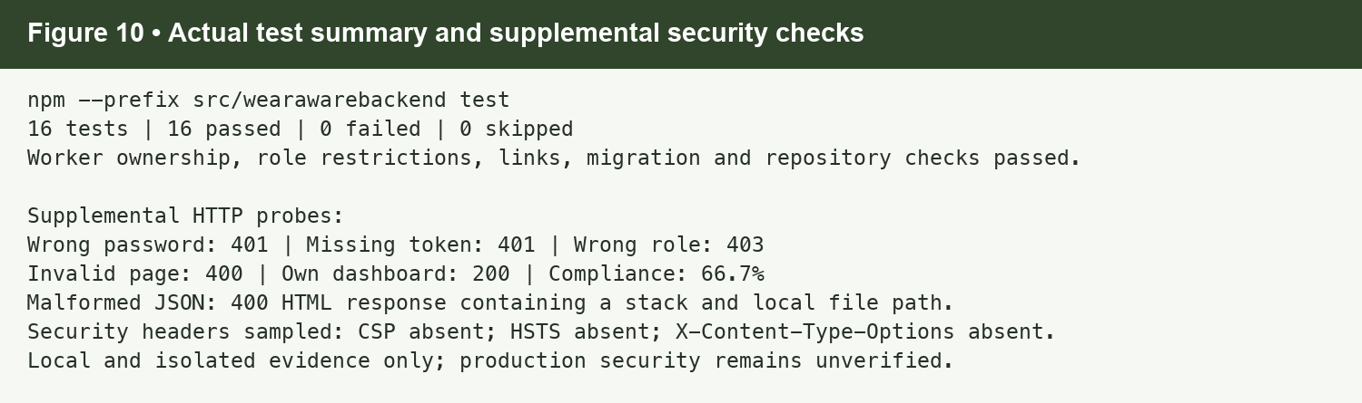
Figure 10. Security Testing Result — recorded test summary and supplemental probe outcomes. Full logs accompany this document.

Reflection Questions

What changed when your application moved from local development to deployment?
A completed production move has not yet been verified, so we cannot report it as finished. Our local build depends on localhost frontend, API, inference, and WebSocket endpoints. Deployment will require configurable service URLs, trusted HTTPS/WSS, production CORS and secrets, a restricted database connection, and a verified migration/initialization process. Running Compass alone does not start the frontend or Express API.

What security weakness did your testing reveal?
A malformed JSON request produced an HTML response containing a development stack trace and filesystem path. Source review also found plaintext temporary passwords in the reset-request collection, unauthenticated WebSocket broadcasts, missing request throttling/security headers, and inspector data-scope gaps. Passing authentication tests did not prove that all access paths were safe.

How did your group address the identified weakness?
The current worker portal already applies server-derived ownership, current-database role checks, unique worker-account links, and a read-only dashboard. Automated tests verify those protections, including forged IDs and stale role claims. The newly documented error, recovery, WebSocket, and inspector-scope findings remain unresolved in the reviewed code. They are listed as required follow-up work rather than described as completed fixes.

What additional security improvement would you implement with more development time?
We would replace plaintext reset passwords with expiring single-use reset tokens, authenticate and scope WebSocket subscriptions, enforce inspector ownership on every relevant route, centralize validation and safe errors, and add throttling plus deployment-appropriate headers. We would then verify TLS, least-privilege database access, backup recovery, and the same role/data-ownership cases on the actual deployed services.

12. Final Project Information
Required Item | Submission / Link
Source Code Repository | https://github.com/voncheems/WearAwareRM — report includes local changes not necessarily pushed.
Live Frontend / Backend | Not supplied or verified; local frontend :5173 and API :5000 are not public deployment links.
Database Configuration Evidence | Sections 7–8; Figure 6; evidence/security-probes.json; local launcher source [S11].
.env.example | Safe replacement example included as backend.env.example in this deliverable and Appendix B; backend working-tree example is absent.
Architecture Diagram / RBAC | Architectures A and B in Sections 2 and 8.1; RBAC matrix in Section 5.1.
Security Testing Results | Section 9 and Figure 10; evidence/backend-tests.txt; evidence/security-probes.json.
Documentation | WearAware_Checkpoint_02.docx and accompanying evidence folder.
Demo Video (if required) | Not supplied; record the final deployed workflows if required by the instructor.

13. Suggested Evaluation Rubric
Retained from the supplied checkpoint template. Points are available marks, not self-awarded scores.
Criterion | Points
MERN Architecture & Integration | 15
Project Functionality / CRUD | 15
Authentication & Password Security | 10
Authorization & RBAC | 10
Input Validation & Secure API | 10
Database Security & Least Privilege | 10
Deployment & HTTPS | 15
Security Testing & Evidence | 10
Documentation & Presentation | 5
TOTAL | 100

Appendix A. Source Evidence Index
Paths are relative to the wearaware application directory in the WearAwareRM repository. References describe the local files reviewed on 23 September 2026.
ID | Source | Used For
S1 | src/App.jsx; src/components/AboutUs.jsx | Role-based UI and team metadata.
S2 | package.json; src/wearawarebackend/package.json | Actual frontend/backend dependencies and test commands.
S3 | src/wearawarebackend/server.js | Login (137), account creation (210), scan creation (324), reset workflow (446–532), startup/WebSocket (542 onward).
S4 | src/wearawarebackend/middleware.js | JWT verification, active-account and role checks.
S5 | src/wearawarebackend/database.js; repository.js | Native driver, indexes, references, normalization, transactions, statistics.
S6 | src/wearawarebackend/routes/user.js; worker-access.js | Worker ownership, pagination, and account-link validation.
S7 | src/wearawarebackend/test/*.test.js | 16 executed regression tests and assertions.
S8 | src/wearawarebackend/routes/workers.js; devices.js; admin.js | Resource CRUD permissions and broad registry reads.
S9 | src/wearawarebackend/Inspector.js | Inspector scoping, notifications, assignments, overrides.
S10 | src/components/UserDashboard.jsx; LoginPage.jsx; PPEDetectionTab.jsx | Worker UI, token storage, QR and PPE service integration.
S11 | src/wearawarebackend/scripts/start-local-mongo.js; scripts/migrate-postgres.js | Local binding/replica set and migration prerequisites.

Appendix B. Safe Configuration Example
This example contains placeholders only. It is included as backend.env.example alongside the report, without restoring or changing the application’s configuration. Do not commit real credentials. Frontend URLs are currently hardcoded and require a separate code change before hosting.
# Local development example only — no real credentials.
PORT=5000
WS_PORT=8080
MONGODB_URI=mongodb://127.0.0.1:27017/wearaware?replicaSet=wearaware-rs
MONGODB_DB=wearaware
JWT_SECRET=replace-with-a-long-random-secret
EMAIL_USER=
EMAIL_PASS=
# Legacy PostgreSQL settings: needed only for migration/rollback.
DB_HOST=localhost
DB_PORT=5432
DB_NAME=wearaware
DB_USER=replace-with-migration-user
DB_PASSWORD=replace-with-migration-password

Local run and verification notes
The root frontend package uses npm run dev; it has no npm start script. The backend uses npm --prefix src/wearawarebackend start. The local database helper is npm --prefix src/wearawarebackend run db:local. Start only the components needed for the intended environment, and ensure the required database migration state and secrets are configured. Compass is optional for viewing data and is not the process that runs the application.
To repeat the existing regression suite: npm --prefix src/wearawarebackend test. It creates temporary replica-set databases; it does not test the production database. The supplemental JSON file records actual isolated observations from this report preparation. Synthetic fixtures are intentionally separate from real worker data.

Files included with this activity
- WearAware_Checkpoint_02.docx — editable report following all 13 template sections.
- evidence/ — browser captures, architecture diagrams, formatted evidence panels, raw test log, and supplemental JSON.
- backend.env.example — safe configuration example using placeholders.
- README.md — remaining information and submission notes.
Before printing, fill in the instructor and intended submission date, confirm group membership, and replace pending production entries only after those steps are actually completed. Review Word’s print preview for any device-specific font or pagination changes.

