V1 bake a core image minimal for raspberry pi on ubuntu 20.04

Add all the needed libraries for development

$sudo apt-get install gawk wget git-core diffstat unzip texinfo gcc-multilib build-essential chrpath socat cpio python python3 python3-pip python3-pexpect xz-utils debianutils iputils-ping libsdl1.2-dev xterm

Clone poky and the raspberry pi layer

$ git clone git://git.yoctoproject.org/poky
$ git clone git //git.yoctoproject.org/meta-raspberrypi

Go in the directory

$ cd poky

Set the build environment

$ source oe-init-build-env rpi3-build

Add the meta-raspberri Pi layer

$ bitbake-layers add-layer ../../meta-raspberrypi/

Check if the layer is added with bitbake-layers show-layers

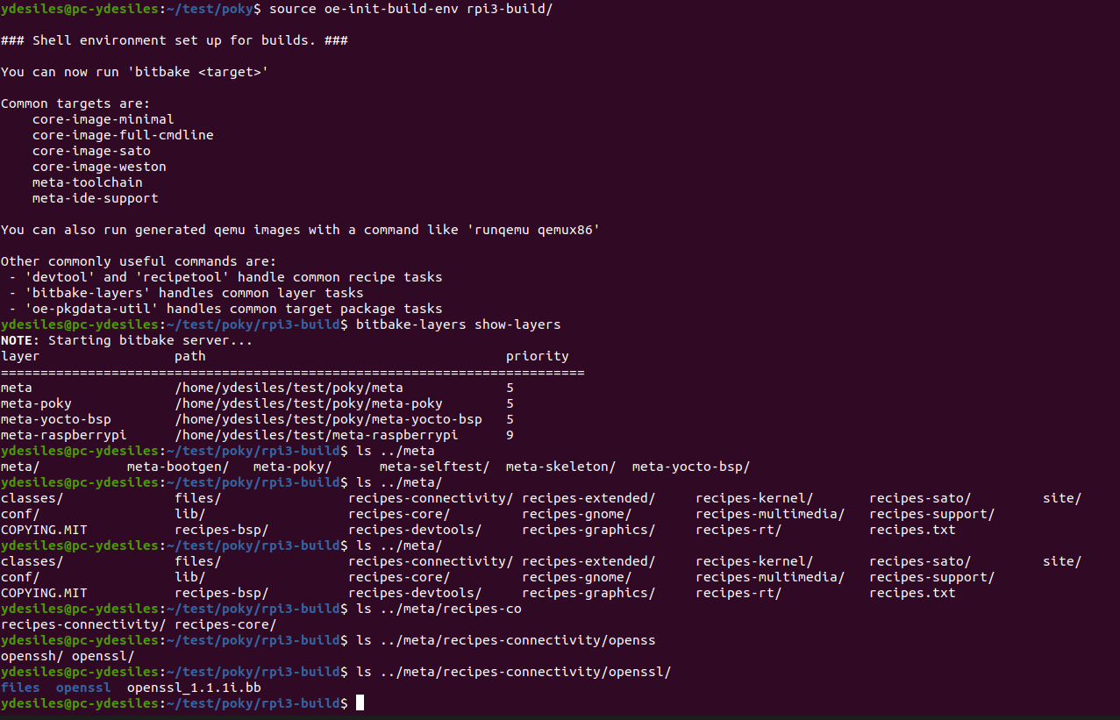

Change the machine in local.conf

MACHINE ??= "raspberrypi3"

$bitbake core-minimal-image

A wic file is available in tmp/deploy/image

$clone bootgen and get the needed version

$git clone https://github.com/Xilinx/bootgen.git
$git checkout 2019.2

Get the SHA of the commit for the recipe to fecth from github
$ git log

Make sure it is compiling on x86 at least

$make
a bootgen for x86 is available

add a layer and a recipe with dependency to openssl

Current status
recipe bootgen created
layer added
dependance to openssl checked

recipe to be debugged

