MOHAMMED ISMAIL YAHIA  EXECUTIVE CHEF | CULINARY OPERATIONS & KITCHEN MANAGEMENT  Phone: +20 101 331 0560  E-mail: mohammed.ismail.yahia@gmail.com  Address: Sharm El Sheikh, Egypt  Nationality: Egyptian  Date of Birth: 25 April 1985  Marital Status: Married, 2 children | 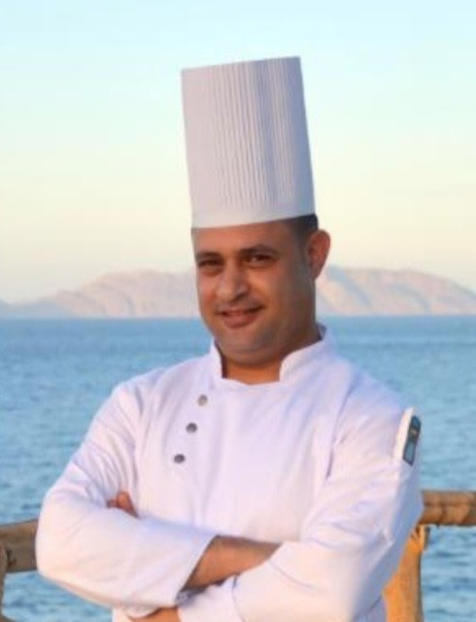

PROFESSIONAL SUMMARY
Results-driven Executive Chef with over 20 years of progressive culinary leadership across five-star and upscale resort properties in Egypt and Saudi Arabia. Proven track record managing full kitchen operations, multi-outlet F&B production, and large teams in high-volume resort and banqueting environments. Strong background in HACCP and food safety compliance, cost and inventory control, menu development, and staff training. Known for building disciplined, service-first kitchen cultures and maintaining consistent quality standards under pressure.
CORE COMPETENCIES
- Full Kitchen Operations Management | - Menu Planning & Development
- Food Cost & Inventory Control | - HACCP & Food Safety Compliance
- Team Leadership & Training | - Multi-Outlet & Banqueting Operations
- Supplier & Vendor Coordination | - Kitchen Budgeting & P&L Awareness
- Health & Safety Standards | - Opera PMS & MS Office
PROFESSIONAL EXPERIENCE
Executive Sous Chef Feb 2023 – Present
Labranda Sharm Club Hotel — Sharm El Sheikh, Egypt
- Deputize for the Executive Chef in directing daily kitchen operations across all resort F&B outlets, ensuring consistent food quality, presentation and service standards.
- Supervise, train and schedule kitchen staff across multiple sections, reinforcing HACCP, hygiene and food safety compliance at every stage of production.
- Manage food costing, portion control and stock ordering to minimize waste and stay within budget targets.
- Plan and execute menus for à la carte, buffet and banqueting services, coordinating closely with F&B management on guest experience standards.
Executive Chef Apr 2016 – Sep 2022
Grand Silverton Hotel — Alkhobar, Saudi Arabia
- Held full accountability for kitchen operations across all hotel outlets, leading a multi-nationality culinary team through recruitment, training and daily performance management.
- Directed menu engineering and food cost control, negotiating with suppliers to secure quality ingredients within budget.
- Maintained strict HACCP and food safety compliance across a high-volume kitchen, passing internal and external hygiene audits.
- Led kitchen planning for banquets, weddings and corporate events, coordinating with senior management on standards and guest satisfaction.
Sous Chef Jan 2014 – Jan 2016
Radisson Blu Hotel Dhahran — Alkhobar, Saudi Arabia
- Supported the Executive Chef in running daily kitchen operations, supervising chefs de partie and commis across multiple sections.
- Enforced food safety, hygiene and quality standards in line with brand and HACCP requirements.
- Assisted with menu development, costing and stock control for restaurant, room service and banqueting outlets.
Senior Chef De Partie Apr 2011 – Aug 2013
Golden Tulip Resort Dana Bay — Alkhobar, Saudi Arabia
- Managed a dedicated kitchen section, ensuring consistent preparation, presentation and quality of dishes during service.
- Trained and mentored junior chefs and commis, reinforcing hygiene and safety procedures.
Senior Chef De Partie Mar 2009 – Mar 2011
Holiday Inn Hotel Olaya — Riyadh, Saudi Arabia
- Ran a kitchen section within a high-volume hotel operation, maintaining food quality and consistency during peak service.
- Coordinated with the kitchen brigade on daily mise en place, stock rotation and service timing.
Chef De Partie Sep 2005 – Nov 2008
The Grand Hotel Hurghada — Red Sea, Egypt
- Prepared and presented dishes to hotel quality standards across restaurant and banqueting services.
- Built foundational expertise in food safety, kitchen discipline and section management.
1st Commis May 2004 – Dec 2004
Sindbad Hotel Resort Hurghada — Red Sea, Egypt
- Supported section chefs with food preparation, mise en place and basic cooking tasks, gaining early hands-on kitchen experience.
CERTIFICATIONS & TRAINING
- HACCP Certification | - Food & Public Health Establishments
- Personal Hygiene & Food Safety | - Managers Essentials – Leadership & Time Management
- Basic Fire & Safety
LANGUAGES
Arabic (Native) • English (Professional working proficiency)

