The Mastaba Within:

Structural and Geophysical Evidence for a Stepped Internal Core in the Great Pyramid of Khufu

Anthony Vondoom

Sharm el-Sheikh, Egypt | June 2026

To every hand that shaped a stone at Giza.

To the quarrymen of Aswan who learned the grain of granite before anyone thought to write it down. To the sailors who read the Ahramat at flood and delivered stone to a site five hundred miles from where it was cut. To the physicians whose work survives in the healed fractures of those who built in their bones. To the bakers and brewers whose ovens fed a city of workers who were not slaves — who were skilled, and honoured, and buried with care. To the architects who looked at a cracking base at Dahshur and corrected the angle and started again, and got it right. To Inspector Merer, whose administrative diary of barge routes and delivery schedules survived forty-five centuries in the desert and speaks to us now, in his own hand, of the ordinary competence behind an extraordinary thing.

To the men of the Friends of Khufu and the Companions of Khufu, who inscribed their names in chambers they sealed above themselves and never expected anyone to read. They are read now. They are known.

And to everyone who, four and a half thousand years later, still comes to these stones with rigour and with reverence — the Egyptologists and geophysicists, the surveyors and conservators, the site managers and epigraphers, the scholars of the Supreme Council of Antiquities and the Ministry of Tourism and Antiquities of Egypt, in whose national inheritance these monuments are held and in whose care they endure. To the people of Egypt themselves, in whose land these things were made, and still stands

AV

Abstract

This paper presents and evaluates three independent lines of physical and geophysical evidence consistent with a stepped internal construction sequence in the Great Pyramid of Khufu at Giza. The first is the confirmed architectural precedent of the Meidum Pyramid, constructed under Sneferu approximately one generation before Khufu's reign, whose seven-stepped internal core — documented across three construction phases designated E1, E2, and E3 by Borchardt (1910) — is physically visible following the partial collapse of its outer casing. The second comprises a set of hard physical constraints imposed by the internal architecture of Khufu's pyramid: the King's Chamber ceiling, consisting of nine granite monoliths spanning the full chamber width of approximately 5.23 metres (Petrie, 1883) at approximately 43 metres elevation; the granite sarcophagus, whose external width of 38.5 inches (97.8 cm) as measured by Petrie (1883) exceeds the effective navigable clearance of the ascending passage at its direction change; and the corbelled masonry of the Grand Gallery, whose inward-projecting courses form the structural inverse of the outward-angled exterior core face. Together these constraints require an open-top construction phase that is naturally and necessarily provided by a stepped core. The third is the microgravimetric density survey of Bui, Lakshmanan, Montlucon, and Nakhla (1987), which established an average pyramid bulk density of 2.05 gm/cc — approximately 11 per cent below the density of solid Egyptian limestone — and documented, critically, that the density zones within the pyramid do not correlate horizontally, indicating non-horizontal internal material boundaries inconsistent with uniform horizontal coursing. Three original field photographs taken by the author at Giza on 1 July 2025 document structural observations discussed in the text. Each evidence stream is assessed for what it confirms, what it suggests, and what it leaves unresolved. Together they constitute a convergent evidential case consistent with a stepped internal mastaba-stacking construction sequence. A falsifiable prediction for future high-resolution muon tomographic surveys is proposed.

Keywords: Great Pyramid of Khufu; stepped internal core; mastaba sequence; Meidum Pyramid; microgravimetry; King's Chamber; corbelled masonry; Bent Pyramid; cognitive archaeology; Deep Symbolic Systems Model

1. Introduction

The Great Pyramid of Khufu at Giza, originally standing at 146.6 metres with a base length of approximately 230.3 metres on each side, contains an estimated volume of approximately 2.6 million cubic metres, a figure that includes a natural limestone hillock incorporated within its base (Cole, 1925; Lehner, 1997). Its construction, attributed to the reign of Khufu (c. 2589–2566 BCE), required the placement of an estimated 2.3 million stone blocks averaging approximately 2.5 tonnes each, with individual granite elements in the internal chamber system reaching up to 80 tonnes (Lehner, 1997; Arnold, 1991). It remained the tallest human-made structure on Earth for approximately 3,800 years.

The persistence of scholarly debate about its construction methods is not, as is sometimes supposed, a consequence of missing evidence. The Merer papyri (Tallet, 2017), discovered at Wadi al-Jarf on the Red Sea coast and providing the only surviving first-hand account of pyramid construction logistics, confirm water-based transport and parallel workforce organisation. The Ahramat Branch paleochannel, mapped by Ghoneim et al. (2024), places a navigable Nile tributary running directly alongside the Giza pyramid field. The workers' village excavated by Lehner and Hawass documents a permanent, medically supported, administratively organised workforce of approximately 20,000 year-round workers (Lehner, 1997; Hawass, 1997; Lehner and Hawass, 1997). The Wadi al-Jarf harbor site, associated with the Merer papyri, documents the Red Sea logistics infrastructure supporting the Tura limestone supply (Tallet and Marouard, 2014). The Bent Pyramid at Dahshur provides a visible record of construction error and mid-project geometric correction (Stadelmann, 1991).

The difficulty has been the absence of an integrated construction model accounting simultaneously for all of these evidence streams — including the physical constraints imposed by the internal chambers. Conventional external ramp theories account for logistical delivery to height but struggle with the placement of massive internal elements (Arnold, 1991). Houdin's (2006) internal ramp hypothesis is architecturally sophisticated but displaces rather than resolves the lower-third delivery problem, and no physical trace of the proposed internal ramp has been identified. The spiral ramp model proposed by Lehner (1997) faces geometric objections regarding corner alignment during construction. The full integrated model is developed in Vondoom (2026a). The present paper has the more focused objective of assessing what the available physical and geophysical evidence says about the specific question of whether the pyramid's internal structure is consistent with a stepped mastaba-stacking construction sequence.

The argument proceeds through three independent evidence streams. Section 2 examines the Meidum Pyramid and the broader developmental sequence as confirmed precedent. Section 3 addresses the physical constraints of the internal chambers as documented in the field. Section 4 discusses the accretion layer debate and its relevance. Section 5 analyses the microgravimetric data of Bui et al. (1987). Section 6 synthesises the streams. Section 7 states limitations honestly. Section 8 proposes a falsifiable prediction. Section 9 situates the argument within the DSSM framework of Vondoom (2026b, 2026c). Throughout, confirmed evidence is distinguished from hypothesis.

2. The Developmental Sequence and the Meidum Precedent

The construction technology deployed in the Great Pyramid did not emerge without institutional history. The Egyptian archaeological record documents a continuous learning arc spanning at least two centuries before Khufu's reign, from the first large-scale stone construction under Djoser to the completion of his pyramid. This section traces that arc and identifies the Meidum Pyramid as the physically confirmed precedent for a stepped-core-with-smooth-infill construction sequence.

2.1 The Step Pyramid of Djoser: Institutional Origins

The Step Pyramid at Saqqara, attributed to the architect Imhotep and dated to the reign of Djoser (c. 2667–2648 BCE), represents the first large-scale stone construction in Egypt and the direct institutional ancestor of the Giza pyramids (Firth and Quibell, 1935; Lauer, 1936). The structure is, in its essential geometry, a stack of mastabas of progressively decreasing dimensions, six distinct tiers, each built in horizontal courses, producing the stepped profile that gave the monument its name (Lehner, 1997). The Step Pyramid was modified and expanded during construction — the initial design was extended across multiple phases, demonstrating from the outset that stepped construction admits sequential modification and enlargement in a way that monolithic continuous-face construction does not (Arnold, 1991).

The administrative capacity required to build the Step Pyramid — the workforce organisation, stone quarrying logistics, multi-source material supply, and multi-year programme management — established the institutional infrastructure on which all subsequent pyramid construction was founded. Imhotep is recorded in later tradition as the originator of the administrative as much as the architectural system (Lehner, 1997). Within the Deep Symbolic Systems Model (Vondoom, 2026b), this is Stage 2 institutional stabilisation: the mastaba-stacking practice, already embedded in Early Dynastic funerary architecture, was extended, formalised, and administratively institutionalised across Djoser's reign in a way that transmitted the technique with high fidelity to subsequent generations.

2.2 Sneferu's Three Pyramids: A Documented Learning Arc

Sneferu (c. 2613–2589 BCE), founder of the Fourth Dynasty and father of Khufu, is by common scholarly assessment the most productive pyramid builder in Egyptian history, responsible for three substantial pyramid projects whose combined constructed volume exceeds that of any single monument in the Egyptian record (Stadelmann, 1991; Lehner, 1997). The sequence of these three projects constitutes one of the most directly documented engineering learning arcs in the archaeological record of the ancient world, and it is precisely this learning arc that the present paper's structural argument depends upon.

Sneferu's first project, the Meidum Pyramid, began as a stepped structure and was subsequently converted to a smooth-sided profile by filling in the step intervals (Borchardt, 1910; Edwards, 1979; Lehner, 1997). Borchardt (1910) identified three distinct construction phases, designated E1, E2, and E3. Phase E1 produced an initial step pyramid of five steps. Phase E2 extended the structure outward, raising the step count to seven. Phase E3 attempted conversion to a smooth-sided pyramid by filling the step intervals with limestone and casing the exterior in Tura limestone. The outer fill of Phase E3 subsequently collapsed, exposing the Phase E2 stepped core that remains visible today. The collapse is the most likely reason Sneferu corrected the face angle of his subsequent pyramid (Mendelssohn, 1974; Stadelmann, 1991). The physical significance of Meidum for the argument of this paper is absolute: it is a pyramid whose stepped core is directly observable. This is not inferred from density data or physical constraints. It is visible. The precedent it establishes — stepped internal core, smooth exterior infill — is confirmed physical evidence from the builder dynasty of Khufu.

Sneferu's second pyramid, the Bent Pyramid at Dahshur (c. 2600 BCE), begins at approximately 54 degrees and changes to approximately 43 degrees mid-construction at approximately 47 metres elevation. The standard explanation attributes this correction to base stress (Stadelmann, 1991; Lehner, 1997). Vondoom (2026a) develops a further argument: the specific geometric nature of the correction — a face angle reduction that widens the effective base-to-height ratio — is most parsimoniously explained as a fill geometry correction made possible by an architect maintaining continuous visibility of the height-to-base relationship. That visibility is precisely what a stepped internal construction method provides. The correction is a fill geometry adjustment; the internal stepped structure continues independently. Borchardt (1922), in his dedicated study of the Khufu pyramid, noted structural features of the core masonry consistent with a similar multi-phase construction logic.

Sneferu's third pyramid, the Red Pyramid at Dahshur (c. 2590 BCE), was built at 43 degrees throughout and is the first successfully completed true pyramid in the Egyptian record. By the time Khufu's architects began at Giza, four major pyramid projects had been completed across three reigns, and at least one generation of master builders carried multi-project institutional experience. As Mark Lehner has observed, Sneferu performed the research and development that made Giza possible (Lehner, 1997). Khufu's architects built at 51.84 degrees on a base massively wider than the Red Pyramid, demonstrating complete command of the geometric parameters established through Sneferu's learning sequence.

2.3 The Mastaba Tradition: Five Centuries of Institutional Depth

Before the pyramid tradition, the mastaba was the standard monumental burial architecture of the Egyptian elite from approximately 3100 BCE onward (Arnold, 1991). A mastaba is a rectangular flat-roofed structure with inward-sloping sides, built from mud brick or stone over a subterranean shaft. Its structural logic — a stable, tapering rectangular form distributing compressive load downward and outward — is the direct structural precursor of the stepped pyramid tier. The Step Pyramid of Djoser is, in its fundamental geometry, mastabas stacked vertically (Lehner, 1997; Firth and Quibell, 1935). If the Great Pyramid's internal structure follows the same logic at scale, then its construction required no technological innovation. It required institutional scale: the administrative infrastructure capable of deploying a five-century-old technique across a workforce of tens of thousands, for decades. The DSSM framework (Vondoom, 2026b) specifically predicts this pattern — material amplification of stabilised practices rather than technological invention — and the pyramid construction sequence from Djoser to Khufu is its clearest documented expression. This interpretation is consistent with the observation of Prof. Dr. Alexandru A. Popovici (Romanian-American University, Bucharest), who has noted in scholarly correspondence that Old Kingdom stoneworking techniques represent a direct continuation and development of Stone Age lithic traditions — a lineage developed at length in Vondoom (2026d).

3. Physical Constraints of the Internal Chambers

The internal architecture of the Great Pyramid imposes hard physical constraints on any viable construction model. Three features are examined here. These constraints are not new observations — Petrie (1883) identified the sarcophagus constraint explicitly — but they have rarely been examined together as a convergent system of evidence pointing toward a common structural requirement: open-top construction access.

3.1 The King's Chamber Ceiling: Open-Phase Placement

The King's Chamber lies at approximately 43 metres above the pyramid's base. It is lined throughout with red Aswan granite, with walls of five courses of precisely fitted blocks. Its ceiling consists of nine granite monoliths spanning the full east-west chamber width, which Petrie (1883) measured at approximately 206 inches (5.23 metres). Above it lie five discharge chambers, each with its own granite ceiling, collectively forming a granite superstructure system above the burial space. Individual granite blocks in this system have been estimated at 25 to 80 tonnes, representing one of the largest concentrations of precisely cut granite in the Old Kingdom building record (Lehner, 1997; Arnold, 1991).

No existing passage or corridor within the pyramid permits lateral introduction of an element spanning the full 5.23-metre chamber width. The nine ceiling monoliths were placed from above, across the top of the completed chamber walls, before the construction above them closed the chamber. This two-phase assembly sequence — walls built course by course, ceiling elements then laid across the top — is uncontested in the Egyptological literature (Petrie, 1883; Lehner, 1997). What a stepped internal construction model adds is the mechanism that makes this logistically tractable: the King's Chamber sits within an open tier. The tier above was not yet built when the ceiling monoliths were placed. They were delivered horizontally across the working platform of the open stepped core, not lifted vertically from outside.

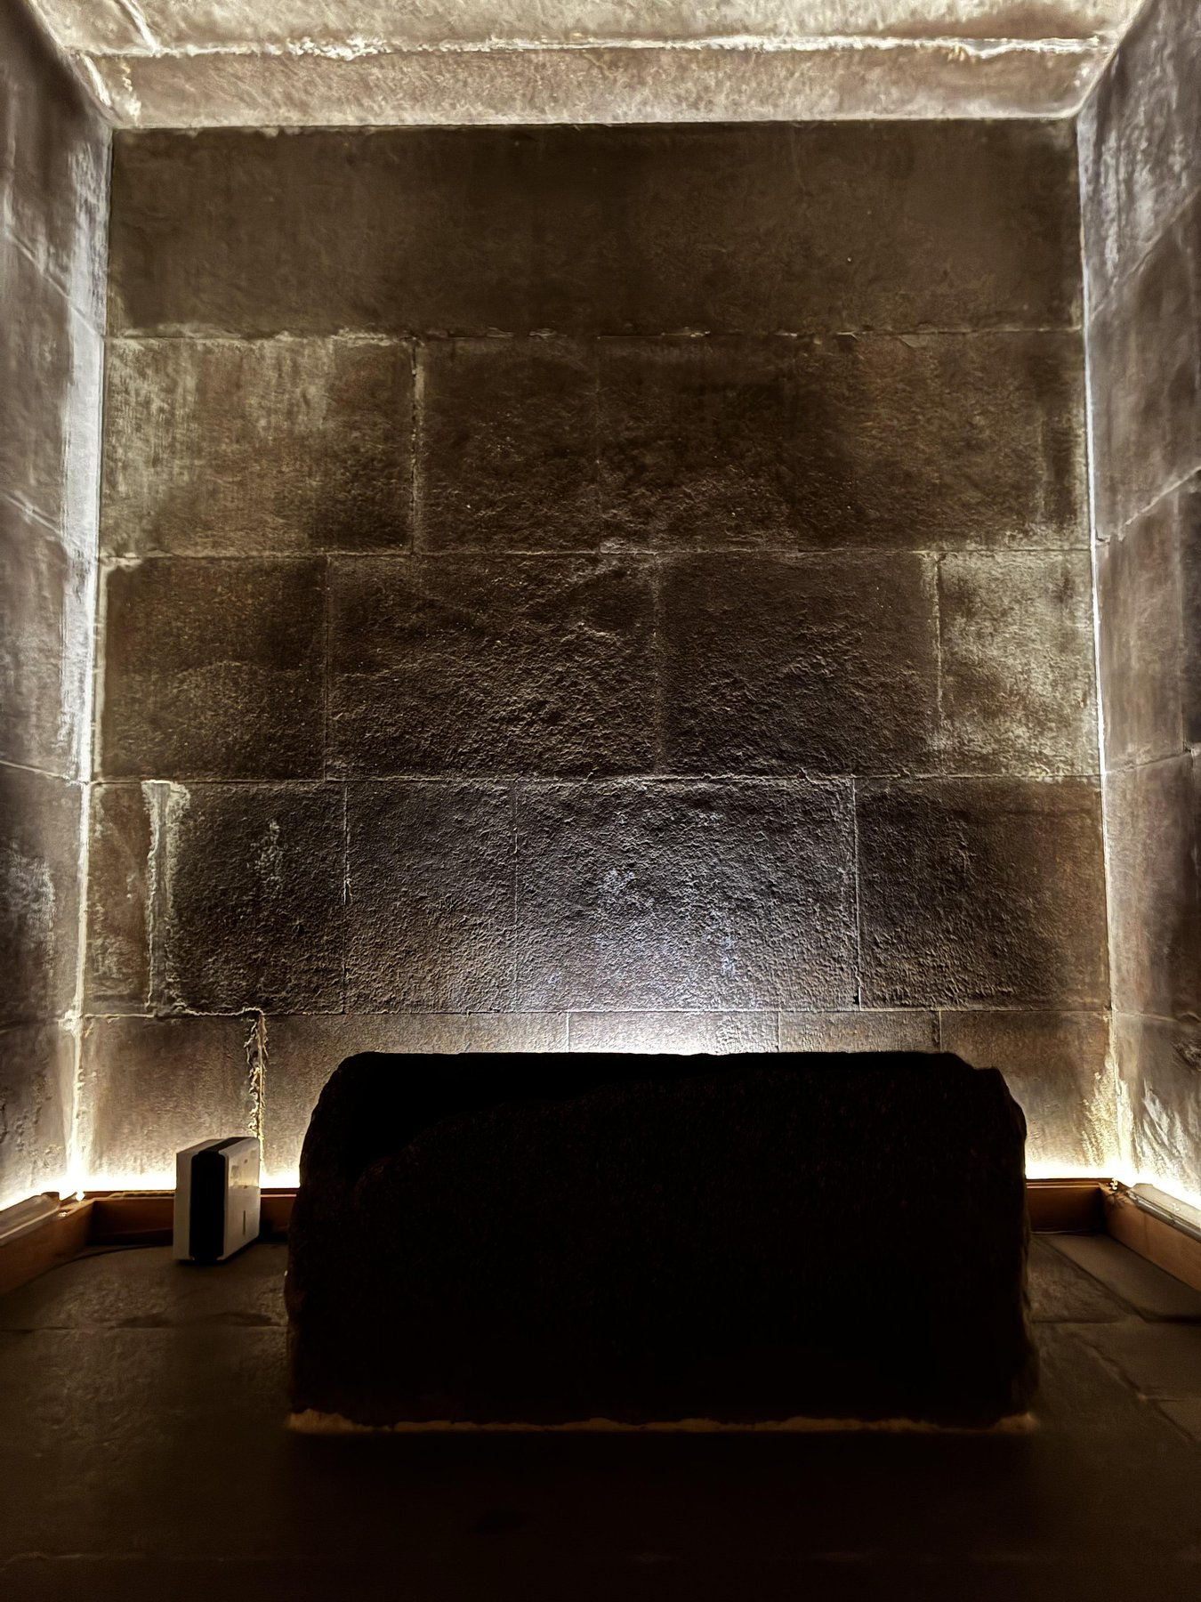
Figure 1, photographed by the author at Giza on 1 July 2025, documents this structural condition directly. The ceiling span is clearly a single continuous element with no joints, while the wall courses below show multiple discrete blocks with visible horizontal and vertical joints. Two different construction operations in one chamber, requiring the chamber to have been accessible from above.

Figure 1. King's Chamber, Great Pyramid of Khufu, Giza. Photograph by the author, 1 July 2025. The ceiling consists of a single granite monolith spanning the full chamber width of approximately 5.23 metres (Petrie, 1883), contrasting with the multi-block wall courses below in which horizontal and vertical joints are clearly visible. The sarcophagus (foreground) is wider than the effective clearance of the ascending passage at its directional change (Petrie, 1883, Section 57), confirming that both elements were placed during an open construction phase rather than introduced after completion.

3.2 The Sarcophagus: Petrie's Measurements and Their Structural Implication

Petrie (1883, Section 57) measured the exterior dimensions of the King's Chamber granite sarcophagus (the coffer): external width 38.5 inches (97.8 cm), external length 89.6 inches (227.6 cm), external height 41.2 inches (104.6 cm). The ascending passage was measured by Petrie at approximately 38.2 to 41.7 inches in width at different sections along its length. However, the passage changes direction at the junction with the Grand Gallery; the effective navigable clearance for a rigid object at this angular junction is substantially less than the maximum passage width anywhere along the passage. Petrie (1883) was explicit: the coffer could not have been introduced through the ascending passage after construction. This conclusion is accepted throughout the Egyptological literature (Arnold, 1991; Lehner, 1997; Stadelmann, 1991) without meaningful dissent.

The structural argument is unambiguous. The sarcophagus is physically incapable of entering the King's Chamber through any currently existing passage. It was therefore placed during a construction phase in which the chamber was accessible from above. This single measurement-based constraint, deriving from Petrie's 1883 survey, independently confirms the existence of an open-top construction phase for the King's Chamber. Any construction model that does not provide this access is disqualified by the dimensions of the coffer alone.

3.3 The Discharge Chambers: Epigraphic Evidence of Phased Construction

Above the King's Chamber ceiling lie five relieving chambers, each with its own granite ceiling, discovered progressively between the eighteenth century and 1837. The work-gang inscriptions on the walls of these chambers — including "Friends of Khufu," "Companions of Khufu," and similar workforce designations — are original construction marks left by the workers during construction, not later additions (Lehner, 1997; Hawass, 1997). Their location in chambers structurally inaccessible except through the construction process confirms that the workforce was present in these spaces during active construction. They also establish, independently of any density data, that the construction of the discharge chambers was an open sequential process — each chamber was built, inscribed, and then sealed above when the next level of construction proceeded.

3.4 The Grand Gallery: Masonry Orientation Opposition

The Grand Gallery is an inclined corbelled passageway approximately 47 metres in length, 8.53 metres in height, and 2.09 metres in width at floor level, rising at approximately 26.2 degrees (Petrie, 1883). Its seven successive courses of wall masonry project inward by approximately 7.6 centimetres per course toward the central axis, reducing the ceiling span to approximately 1.05 metres (Petrie, 1883). This corbelling is a load-reduction mechanism, distributing the mass above the gallery span laterally (Arnold, 1991; Edwards, 1979). The structural observation added here concerns the directional relationship between the internal masonry orientation and the external core face.

Figure 2, photographed by the author on 1 July 2025, documents the full length of the Grand Gallery. The inward lean of each corbelled course is clearly visible. Figure 3, photographed on the same visit, documents the exposed core masonry at the north-west base of the pyramid, with the casing stripped, showing the outer face angling away from the axis at 51.84 degrees. These two geometries are architectural inverses: the internal face leans inward; the external face leans outward. Under a stepped construction model, this opposition is structurally predicted. The interior face of each step tier — which becomes the wall of internal galleries and chambers — necessarily projects inward. The exterior face of the same tier — against which fill material and casing are packed — necessarily angles outward. Figures 2 and 3 together document both faces of the same structural logic from inside and outside respectively.
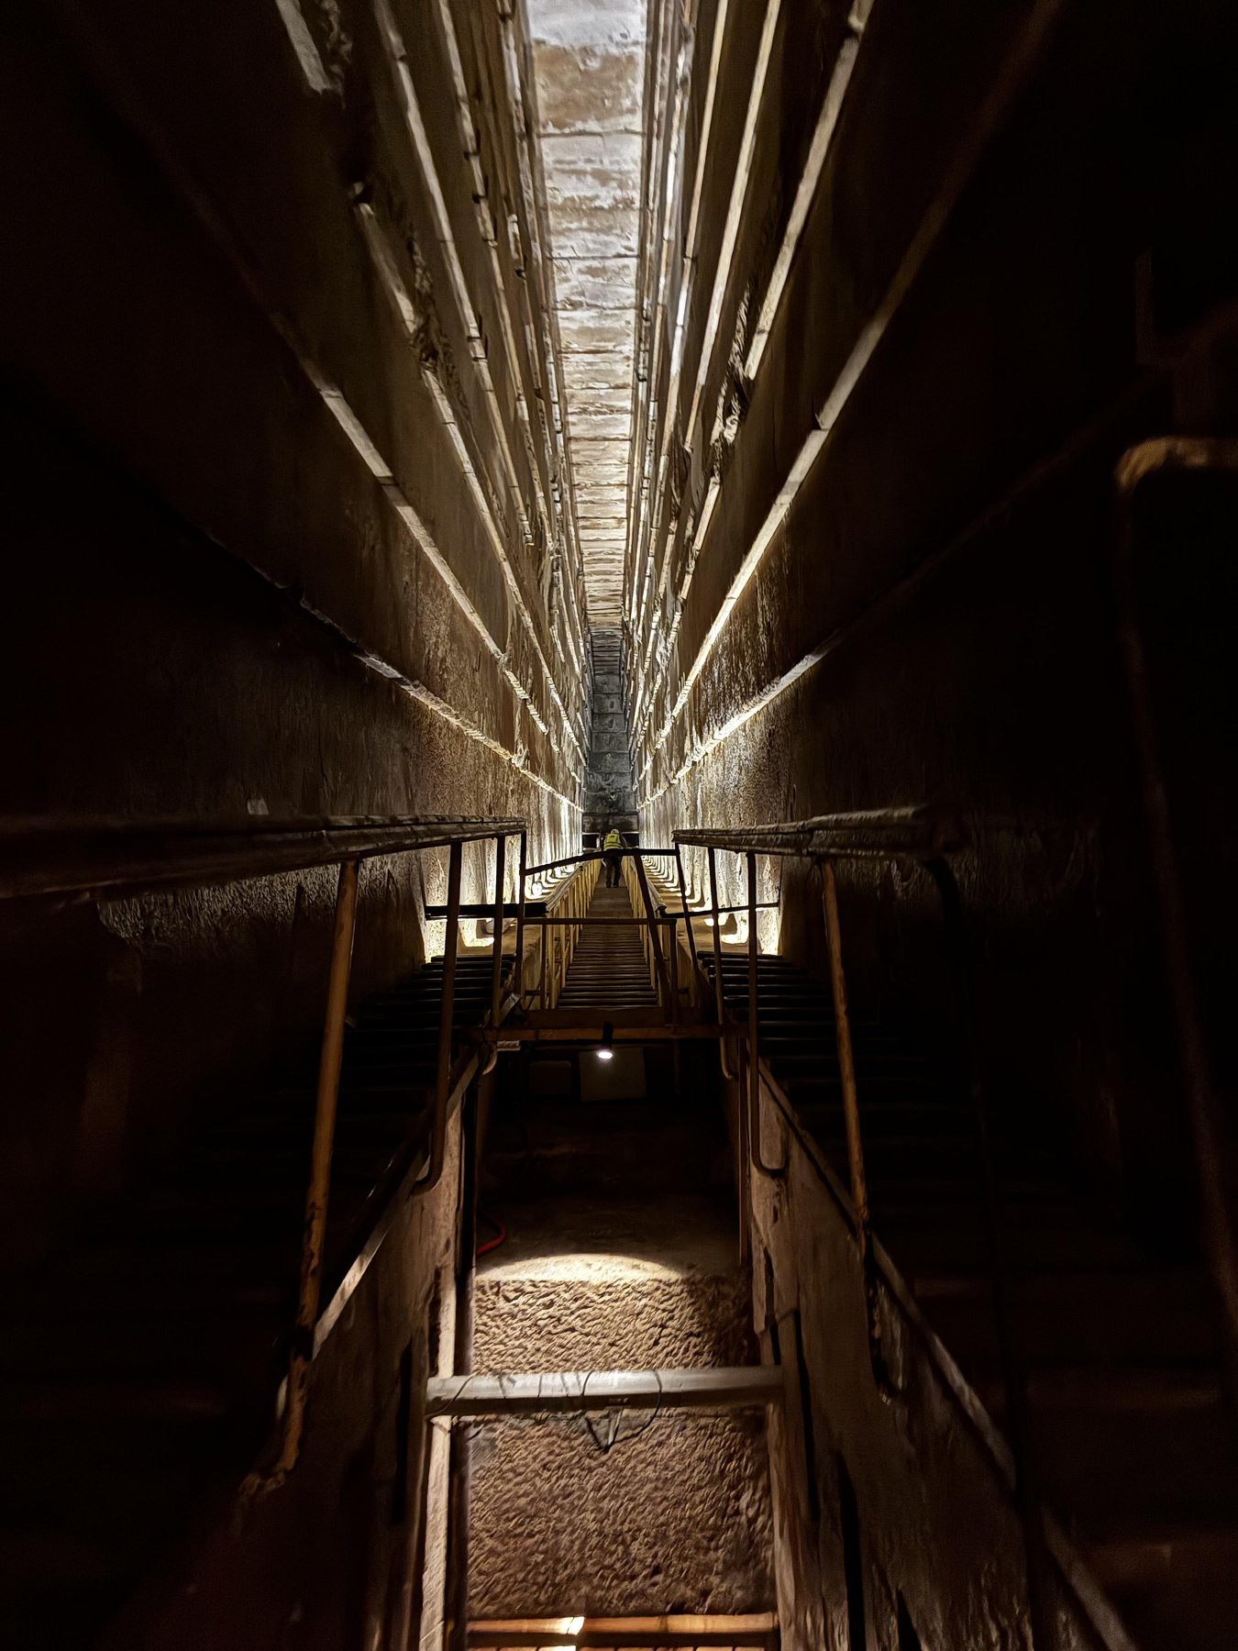

Figure 2. Grand Gallery, Great Pyramid of Khufu, Giza. Photograph by the author, 1 July 2025. Seven successive corbelled courses are visible on each wall, each projecting approximately 7.6 centimetres inward toward the central axis as elevation increases (Petrie, 1883). The inward lean of the internal masonry is the structural inverse of the outward-angled exterior core face documented in Figure 3.

Figure 3. Exposed core masonry, north-west base, Great Pyramid of Khufu, Giza. Photograph by the author, 1 July 2025. The stripped outer casing reveals core courses angled outward from the central axis at approximately 51.84 degrees — the structural inverse of the corbelling geometry in Figure 2. The transition from irregular massive base courses to regular coursing above is visible in the lower register.

3.5 Menkaure's Pyramid and the Queens' Satellites

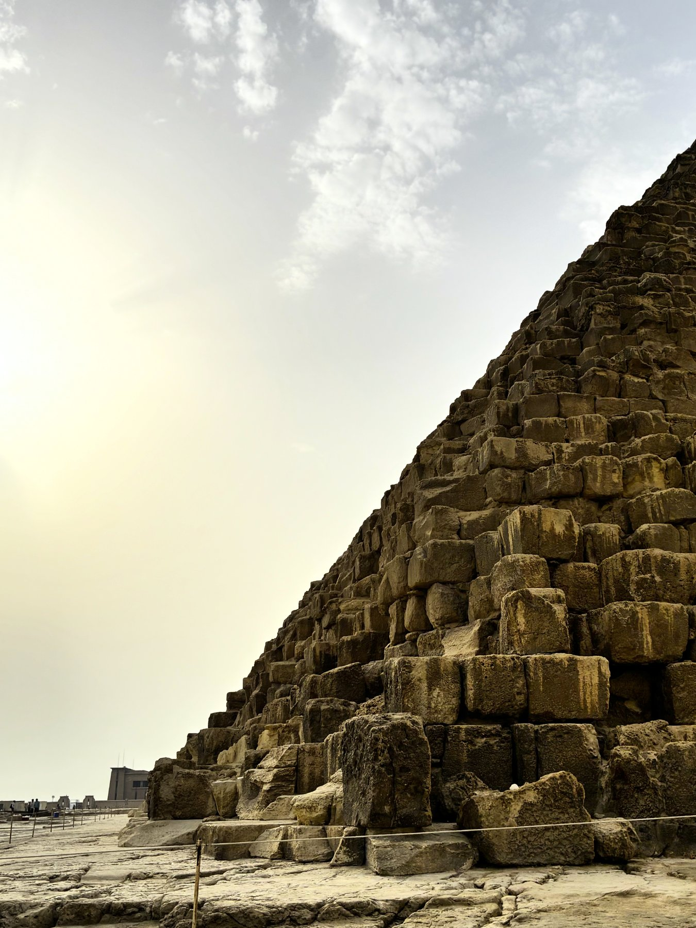
The evidence for stepped construction within the Giza pyramid field is not limited to precedent from outside it. The breach in the north face of Menkaure's pyramid (c. 2530 BCE), forced in the twelfth century, reveals a rough internal core structure whose exposed faces are broadly consistent with accretion-layer or stepped internal construction, though the exposed section does not permit the same precise phase analysis possible at Meidum (Lehner, 1997). The satellite pyramids of the queens' complex at Giza are built as visible stepped structures (Lehner, 1997). Taken together, these observations suggest that stepped construction was not anomalous at Giza — it was the default configuration for the smaller and later structures at the site, raising the question the present paper addresses: whether it was also the internal configuration of the largest.

4. The Accretion Layer Debate: What This Paper Claims and Does Not Claim

The argument that Egyptian pyramids contain stepped or accretion-layered internal cores has a contested scholarly history that the present paper must engage honestly.

The accretion theory was proposed in systematic form by the nineteenth-century Egyptologist Richard Lepsius, who suggested that pyramids grew outward in successive layers added over a king's reign — with larger pyramids indicating longer reigns. Borchardt (1910) adopted a version of this theory, reporting inclined internal faces in Dynasty V pyramids at Abusir that he interpreted as accretion layers. In its general form — the Lepsius-Borchardt accretion theory — this model has been substantially discredited: there is no reliable relationship between pyramid size and reign length, and the Abusir faces have been reinterpreted by subsequent excavators as construction features that do not support the general model (Edwards, 1979; Arnold, 1991). The present paper does not rely on the Lepsius-Borchardt general accretion theory.

The claim made here rests on two distinct foundations. First, the physically confirmed case of the Meidum Pyramid, whose stepped core is directly observable following the collapse of its smooth outer casing — not inferred from inclined faces or reign-length correlations. Second, the geophysical finding of Bui et al. (1987) that the Great Pyramid's internal density zones do not correlate horizontally. Neither of these foundations requires the general accretion theory. The Meidum case is an observation. The Bui et al. finding is a measured result. The argument is that these two independent data points, combined with the physical constraints of the internal chambers and the documented mastaba developmental sequence, converge on a stepped internal construction model as the most parsimonious available explanation for the full evidence set.

It is also worth noting what the muon tomography programme has and has not established. Morishima et al. (2017) confirmed the existence of a large void above the Grand Gallery — named the ScanPyramids Big Void — with a cross-section comparable to the Grand Gallery and a minimum length of 30 metres. Procureur et al. (2023) subsequently characterised the North Face Corridor with greater precision. Neither study has achieved the density resolution required to map the full internal structure at the tier scale. The void confirmed by muon tomography is consistent with, but does not confirm or deny, either the stepped core model or the Houdin internal ramp model. The present paper does not claim the muon data as positive evidence for the stepped model; it notes that the data has not falsified it.

5. Microgravimetric Evidence: Bui, Lakshmanan, Montlucon, and Nakhla (1987)

The most quantitatively significant geophysical evidence bearing on the internal density structure of the Great Pyramid prior to the ScanPyramids muon tomography programme is the microgravimetric survey conducted by Electricite de France and the Compagnie de Prospection Geophysique Francaise across four field campaigns between May 1986 and November 1987. The project was commissioned jointly by the French Ministry of Foreign Affairs and the Egyptian Antiquities Organisation, following interest in testing hypotheses about unknown chambers near the King's Chamber (Dormion and Goidin, 1986). The results were presented at the Egyptian Antiquities Organisation International Symposium in Cairo in December 1987 (Bui et al., 1987). A total of 754 gravity measurements were collected over four field surveys, processed using three-dimensional mathematical inversion techniques, and analysed at three structural scales: the macrostructure, the mesostructure, and the microstructure. The analysis required approximately 3,000 person-hours of scientific work and 300 hours of computing time (Bui et al., 1987). This study is cited in the EGP Mission planning document (Tomographic Muon Imaging of the Great Pyramid of Giza, arXiv:2202.08184) as establishing density variations in the upper pyramid, but its specific quantitative results have received limited systematic attention in the construction literature.

5.1 Survey Method

The endoscopic microgravity method, as described in Bui et al. (1987), compares the computed gravitational effect of a modelled structure at each measurement point with the measured gravity values. The pyramid is divided into blocks whose densities are the unknowns of the mathematical inversion problem; the procedure finds the set of densities minimising the root-mean-square difference (MSD) between measured and computed values. The pyramid was divided into 24 macrostructural blocks — six horizontal slices, each divided into four quadrants — plus a single block representing the granite superstructure of the King's Chamber system, yielding 34 independent density unknowns. The mesostructure — the region of the Grand Gallery and associated chambers — was further subdivided into 18 blocks for higher-resolution analysis. The total inversion system solved for all unknowns simultaneously, with the peristructure effects (solar vessel pits, basement geology) computed and removed before the pyramid interior analysis.

5.2 Average Density and the Deficit Against Solid Limestone

The average density of the pyramid measured as 2.05 gm/cc. This is the best-fit single bulk density for the structure as a whole, derived from the 754-measurement dataset after subtraction of all external geological contributions. Egyptian limestone from the Giza plateau, which forms the bulk of the core blocks, has a measured density of approximately 2.3 to 2.5 gm/cc (Arnold, 1991). Tura limestone, used for casing, falls in the same range. Red Aswan granite, used for the King's Chamber system, measures approximately 2.6 to 2.7 gm/cc — denser than the limestone average. A pyramid built of well-compacted limestone blocks with minimal void should have a bulk density approaching the lower end of the limestone range. The measured value of 2.05 gm/cc falls approximately 11 per cent below this expectation.

Calculated against the pyramid's surveyed volume — derived from Cole's (1925) base measurements of approximately 230.3 metres per side and the original height of 146.6 metres as 2,583,000 cubic metres, slightly reduced to account for the incorporated bedrock hillock (Lehner, 1997) — this 11 per cent deficit in bulk density corresponds to approximately 280,000 cubic metres of the pyramid's volume occupied by material of lower density than solid limestone: mortar, rubble, sand fill, or void space. This is consistent with a construction in which fill material occupies the spaces between the stone courses of a stepped core, rather than solid ashlar throughout.

5.3 Non-Horizontal Density Zones: The Critical Finding

The finding with the most direct structural bearing on the stepped construction hypothesis is reported in the macrostructure analysis. The 24 macrostructural blocks yielded density values ranging from approximately 1.85 to 2.74 gm/cc across the pyramid's cross-section (Bui et al., 1987, Figure 6) — a spread of 0.89 gm/cc in a structure nominally built of similar limestone blocks throughout. More significantly, Bui et al. (1987) explicitly state that the light and heavy zones revealed by the analysis do not correlate horizontally. This statement is structurally diagnostic. A pyramid built by laying uniform horizontal courses from bottom to top, regardless of compositional variation within those courses, would be expected to produce density variations with broadly horizontal coherence: heavier or lighter zones tracking elevation, but with similar values at the same height across different parts of the pyramid. The specific finding that the density zone boundaries are non-horizontal — that they run at slanting angles without horizontal correlation — is inconsistent with this model. Non-horizontal density boundaries require non-horizontal material boundaries within the structure: inclined, vertical, or stepped faces between materials of different density.

Bui et al. (1987, p. 6) further state that the data is most consistent with two structural hypotheses: "a spiral structure and a semi-vertical structure with alternating heavy and low density walls." The semi-vertical structure hypothesis — alternating high- and low-density zones with near-vertical boundaries — is, in its essential geometric description, what a stepped core with fill material in the inter-tier zones would produce in macrostructural density analysis. The authors of the 1987 survey independently identified this structural class as the most plausible explanation for their data, without reference to any stepped construction model.

5.4 The Low-Density Apex

The region of the pyramid above the highest discharge chamber measured approximately 1.8 to 1.9 gm/cc — substantially below the average of 2.05 gm/cc and well below solid limestone (Bui et al., 1987, p. 9). A density of 1.8 to 1.9 gm/cc in a limestone structure is consistent with loosely compacted rubble or sand fill rather than carefully laid precision masonry. Under the stepped construction model, the upper zone would be expected to contain a higher proportion of loose fill introduced during the final casing phase — the builders working downward from the apex, backfilling the outer surfaces of the upper tiers as they installed the smooth casing, using the tier platforms as staging. The low-density apex is consistent with this sequence. It is not consistent with a uniformly precise course-by-course construction applied equally from base to apex.

5.5 Mesostructure and the Sand-Filled Cavity Confirmation

The mesostructure analysis of the Grand Gallery region divided the zone into 18 blocks and identified light zones of approximately 1.9 gm/cc concentrated around and above the Grand Gallery, alongside heavier zones of approximately 2.2 gm/cc in the lower mesostructure region (Bui et al., 1987, Figure 11). The light zones around the Grand Gallery elevation are consistent with the locally reduced bulk density expected from the corbelled masonry — whose progressive inward projection creates mortar-filled gaps between courses that reduce the effective bulk density relative to solid masonry of the same volume.

Importantly, the mesostructure analysis also detected an anomaly to the west and below the Queen's Chamber access tunnel, whose cause was subsequently confirmed by drill holes to be a sand-filled cavity (Bui et al., 1987, p. 10). This confirmation is methodologically significant: it validates the sensitivity of the microgravity method to non-stone material within the pyramid's body, and it confirms that the interior contains pockets of fill material in locations not predicted by the known chamber system. The existence of a sand-filled cavity in the mesostructure, confirmed by physical drilling, supports the interpretation that the broader density deficit detected in the macrostructure analysis is also attributable to fill material distributed throughout the interior — not only in the immediate vicinity of known chambers.

6. Synthesis: A Convergent Evidential Case

The three evidence streams examined in this paper are fully independent. Petrie surveyed the pyramid in 1880 to 1882 without knowledge of the microgravimetric data that would be collected a century later. Bui et al. conducted their 1986-1987 surveys without any reference to a stepped construction model — their objective was to find hidden chambers. The Meidum Pyramid collapsed, exposing its stepped core, without reference to either. The convergence of these streams on a consistent structural picture is the evidential contribution of this paper.

The Meidum Pyramid confirms that the builder dynasty possessed, at the relevant moment, a proven stepped-core-with-smooth-infill technology at pyramid scale. The King's Chamber ceiling monoliths establish that the chamber was accessible from above during construction. The sarcophagus measurements of Petrie (1883) confirm the same thing independently. The discharge chamber inscriptions confirm phased sequential construction of the entire granite superstructure. The Grand Gallery corbelling and the external core orientation together document the inward-outward masonry opposition consistent with a stepped core's two face geometries. The Bui et al. density data establishes a bulk density 11 per cent below solid limestone and documents non-horizontal density boundaries inconsistent with uniform horizontal coursing and consistent with non-horizontal material interfaces.

No single stream individually confirms the stepped internal construction model. Together, across five independent data sources spanning from Petrie's 1883 survey to the 1987 geophysical programme, they constitute a convergent evidential case in which the stepped model is the most parsimonious available explanation for the full evidence set. The most technically developed competing model, Houdin's (2006) internal ramp hypothesis, faces the unresolved problem that the proposed internal ramp was dismantled and has left no physical trace; the stepped core model does not face this problem because the core is the structure — it is not removed, it is embedded. The convergent evidence does not prove the stepped model. It establishes it as the hypothesis most consistent with the available data, and most clearly falsifiable by future investigation.

7. Limitations and Honest Assessment

The argument of this paper carries significant limitations that require explicit statement.

The Meidum Pyramid precedent is the strongest of the three evidence lines because it is a physically confirmed case of stepped-core-with-smooth-infill construction by the same dynasty. Its limitation is analogical: Meidum is not Khufu's pyramid. The collapse that exposed its internal structure has not been reproduced at Giza. The precedent establishes possibility and institutional memory, not necessity.

The physical constraints of the King's Chamber establish the requirement for open-top construction access but do not uniquely identify the mechanism. A stepped core is one mechanism that provides this access. A staged construction with temporary openings, or a modified internal ramp system, could in principle provide it also. The physical constraints rule out models that do not provide open-top access; they do not identify the stepped model as the only one that does.

The Bui et al. (1987) microgravimetric data is subject to significant interpretive constraints. The macrostructural blocks over which density is averaged are approximately 50 to 100 metres on a side — far larger than any individual construction tier. The method cannot resolve features at the tier scale. The finding that density zones are non-horizontal is robust — it is a direct output of the inversion, not an interpretation — but the specific structure producing this pattern cannot be determined from the existing data resolution. The survey authors themselves note that the data is consistent with multiple structural hypotheses, of which the semi-vertical structure model is one.

The most significant gap is the absence of direct structural observation. The core of the Great Pyramid has not been excavated. Muon tomography surveys (Morishima et al., 2017; Procureur et al., 2023) have confirmed specific voids but have not yet achieved the resolution required to map the full internal structure at the tier scale. Until that resolution is achieved, the stepped construction model remains a strongly supported hypothesis rather than a confirmed finding, and is presented as exactly that throughout this paper.

8. A Falsifiable Prediction

The stepped internal construction model makes a specific and falsifiable prediction that distinguishes it from both the null hypothesis of uniform horizontal construction and from Houdin's internal ramp model.

If the pyramid was constructed around a stepped internal core — densely packed ashlar masonry at the tier faces, with looser fill in the inter-tier zones — a three-dimensional density map at sufficient resolution should reveal alternating high- and low-density zones with non-horizontal boundaries following a staircase geometry in vertical cross-section: descending outward from the pyramid's axis as elevation increases. The density contrast between solid ashlar limestone core faces (approximately 2.3 gm/cc) and looser inter-tier fill (approximately 1.8 to 2.0 gm/cc) would be approximately 0.3 to 0.5 gm/cc — a contrast within the detection range of the proposed Exploring the Great Pyramid Mission instrumentation, which aims to achieve approximately 100 times the sensitivity of the ScanPyramids surveys (arXiv:2202.08184).

Two results would falsify this prediction: a density map showing uniform compaction throughout with horizontal boundaries consistent with uniform course-by-course construction; or a density map showing the helical boundary pattern predicted by the Houdin (2006) internal ramp model. The two models make distinguishable predictions separable by sufficiently high-resolution tomographic data. The SAR Doppler tomography study of Biondi and Malanga (2022) reported structures consistent with internal ramp-like features but remains contested and has not been confirmed by the muon tomography programme. Any technique achieving tier-scale density resolution would in principle be capable of distinguishing between these predictions.

9. Theoretical Context: The Deep Symbolic Systems Model

The physical evidence examined in this paper is situated within the broader theoretical framework of the Deep Symbolic Systems Model, developed in Vondoom (2026b) and applied to the Egyptian context in Vondoom (2026c). The DSSM holds that civilisational capacity develops through the recursive stabilisation of embodied practices into durable institutional systems, and that large-scale material outputs are produced through material amplification of thoroughly stabilised techniques rather than sudden technological invention.

The evidential case of this paper maps directly onto this framework. The mastaba is the Stage 2 predecessor structure: a stable architectural practice embedded in institutional memory across five centuries of the Early Dynastic period. The Djoser-to-Sneferu-to-Khufu pyramid sequence is the Stage 3 amplification arc: each generation of construction takes the established technique to a larger scale, error-corrects at visible junctures (the Meidum collapse, the Bent Pyramid correction), and passes the refined technique forward. The Great Pyramid is Stage 4: the application of the stabilised and amplified technique at the maximum institutional scale achievable by the mature Old Kingdom state, documented in the Merer papyri (Tallet, 2017), the Wadi al-Jarf harbour (Tallet and Marouard, 2014), the workers' village (Lehner and Hawass, 1997; Hawass, 1997), and the Ahramat Branch waterway (Ghoneim et al., 2024).

The DSSM also provides context for interpreting the technological lineage at greater depth. In Vondoom (2026d), the argument is developed that Old Kingdom stoneworking techniques represent the end of a continuous cognitive-technological lineage traceable to Palaeolithic lithic practice. The dolerite pounders used in the Aswan granite quarries are structurally analogous to Palaeolithic hammerstones; the wedge-splitting quarrying technique is a static expansion development of the percussion-fracturing practice at the root of all stone tool production. Prof. Dr. Alexandru A. Popovici (Romanian-American University, Bucharest) has noted in scholarly correspondence that stoneworking techniques — both quarrying and precision finishing — may be understood as a continuation and development of Stone Age lithic traditions, which were themselves highly sophisticated. This observation is fully consistent with the DSSM framework and with the argument of Vondoom (2026d).

The practical implication for the construction argument is this: the stepped internal construction of Khufu's pyramid required no new knowledge. It required the application of a five-century-old structural technique at a scale made possible by the full institutional apparatus of the Fourth Dynasty state. The pyramid does not require an extraordinary explanation. It requires acknowledgement of the extraordinary institutional depth that the Egyptian archaeological record documents.

10. Conclusion

This paper has examined three independent lines of evidence bearing on whether the Great Pyramid of Khufu was constructed around a stepped internal core. The Meidum Pyramid provides the only directly observable case of stepped-core-with-smooth-infill construction within the immediate builder dynasty — confirmed by its physical collapse. The King's Chamber ceiling monoliths, the granite sarcophagus as measured by Petrie (1883), and the discharge chamber work-gang inscriptions together establish that the King's Chamber was accessible from above during construction and that its construction was a sequential open process. The Grand Gallery's inward corbelling and the exterior face's outward angle document the structural opposition consistent with the two faces of a stepped tier. The microgravimetric survey of Bui et al. (1987) establishes a bulk density approximately 11 per cent below solid limestone and documents density zone boundaries that do not correlate horizontally, inconsistent with uniform horizontal construction.

None of these streams individually confirms the model. Together they constitute a convergent evidential case in which the stepped internal construction model is the most parsimonious available explanation for all of the above simultaneously. The model makes a specific falsifiable prediction for future high-resolution density tomography. It is presented as a strongly supported hypothesis, not as confirmed fact, and the distinction is maintained throughout this paper precisely because honest scholarship requires it.

The Great Pyramid was built by Egyptians who had been practising and refining the relevant techniques for centuries. The Merer diary gives us their logistics. The Ahramat Branch gives us their waterway. The workers' village gives us their community. The Bent Pyramid gives us their error-correction. The Meidum core gives us their method. Nothing about this required the extraordinary. What it required was the one thing that takes the longest to build: the institutional continuity to pass knowledge forward, intact, across generations, until the scale of the application became possible.

The stone is standing. The knowledge that raised it is, at last, being reassembled.

UN Sustainable Development Goals Alignment

This paper contributes to the following UN Sustainable Development Goals. SDG 4 (Quality Education): by grounding the analysis of the Great Pyramid's construction in verified physical and geophysical evidence and maintaining a strict distinction between confirmed findings and hypotheses, this paper contributes to an accurate and epistemically honest account of ancient human technological achievement. SDG 10 (Reduced Inequalities): centring the documented agency, institutional sophistication, and technical mastery of ancient African civilisation in the construction of its greatest monument directly contests persistent narratives attributing Egyptian achievement to external agency — narratives explicitly contradicted by the Merer papyri, the workers' village, the Ahramat Branch, and the Meidum precedent. SDG 17 (Partnerships for the Goals): the methodology integrates Egyptology, geophysics, structural analysis, and cognitive-institutional theory, demonstrating the analytical value of cross-disciplinary convergence on a shared evidential problem.

Acknowledgments

The author wishes to acknowledge Prof. Dr. Alexandru A. Popovici (Full Professor, Department of Mathematics, Computer Science and Statistics, Romanian-American University, Bucharest) for his scholarly generosity, intellectual rigour, and consistently valuable advice across multiple research exchanges. His observation — offered in his own words — that "stoneworking techniques (quarrying and finishing) may be a continuation and development of Stone Age techniques, which were themselves highly sophisticated" has materially informed the theoretical framing of this work and is acknowledged here with sincere respect. The field photographs presented as Figures 1, 2, and 3 were taken by the author at Giza on 1 July 2025 during an independent tourist visit.

AI Disclosure

The author utilised Claude Sonnet by Anthropic (claude.ai) as an AI research assistant during the preparation of this work. Claude was used to assist with argument stress-testing through structured iterative dialogue, literature cross-checking, reference auditing, structural editing and prose revision, field photograph processing for document embedding, and document file generation. The AI did not conduct independent literature searches, generate original empirical data, or contribute intellectual positions that were not initiated and directed by the author. The identification of the Bui et al. (1987) microgravimetric data as a primary analytical source was the author's own. All interpretations, conclusions, and the evidential argument as a whole remain the sole intellectual responsibility of the author. This disclosure follows the COPE and Anthropic guidelines for transparent AI collaboration in academic publishing.

References

Arnold, D. (1991). Building in Egypt: Pharaonic Stone Masonry. Oxford: Oxford University Press. ISBN 0-19-506350-3.

Biondi, F. and Malanga, C. (2022). Synthetic Aperture Radar Doppler Tomography Reveals Details of Undiscovered High-Resolution Internal Structure of the Great Pyramid of Giza. Remote Sensing. arXiv:2208.00811.

Borchardt, L. (1910). Das Grabdenkmal des Konigs Sahure, Band I: Der Bau. Leipzig: J.C. Hinrichs.

Borchardt, L. (1922). Das Grabdenkmal des Konigs Cheops. Berlin.

Bui, H.D., Lakshmanan, J., Montlucon, J., and Nakhla, C. (1987). First Results of Structural Analysis of the Cheops Pyramid by Microgravity. Egyptian Antiquities Organization International Symposium: Application of Modern Technology to Archaeological Exploration at the Giza Necropolis. Cairo, 14-17 December 1987.

Cole, J.H. (1925). Determination of the Exact Size and Orientation of the Great Pyramid of Giza. Survey of Egypt Paper No. 39. Cairo: Government Press.

Dormion, G. and Goidin, J-P. (1986). Kheops: Nouvelle Enquete. Paris: Editions Recherche sur les Civilisations.

Edwards, I.E.S. (1979). The Pyramids of Egypt. Harmondsworth: Penguin.

Firth, C.M. and Quibell, J.E. (1935). The Step Pyramid. Cairo: Imprimerie de l'Institut Francais d'Archeologie Orientale.

Ghoneim, E., Ralph, T.J., Onstine, S., et al. (2024). The Egyptian pyramid chain was built along the now abandoned Ahramat Nile Branch. Communications Earth and Environment, 5, 233. https://doi.org/10.1038/s43247-024-01379-7

Hawass, Z. (1997). The workers' village at Giza. Egyptian Archaeology, 10, 14-17.

Houdin, J-P. (2006). Khufu: The Secrets Behind the Building of the Great Pyramid. Farid Atiya Press.

Lauer, J-P. (1936). La Pyramide a Degres: L'Architecture. Cairo: Imprimerie de l'Institut Francais d'Archeologie Orientale.

Lehner, M. (1997). The Complete Pyramids. London: Thames and Hudson.

Lehner, M. and Hawass, Z. (1997). Builders of the pyramids. Archaeology, 50(1), 30-38.

Mendelssohn, K. (1974). The Riddle of the Pyramids. London: Thames and Hudson.

Morishima, K., Kuno, M., Nishio, A., et al. (2017). Discovery of a big void in Khufu's Pyramid by observation of cosmic-ray muons. Nature, 552, 386-390. https://doi.org/10.1038/nature24647

Petrie, W.M.F. (1883). The Pyramids and Temples of Gizeh. London: Field and Tuer.

Procureur, S., et al. (2023). Precise characterization of a void hidden in the Khufu Pyramid by observation of cosmic-ray muons. Nature Communications. https://doi.org/10.1038/s41467-023-36498-w

Stadelmann, R. (1991). Die agyptischen Pyramiden: vom Ziegelbau zum Weltwunder. Mainz: Philipp von Zabern.

Tallet, P. (2017). Les papyrus de la Mer Rouge I: Le "Journal de Merer" (Papyrus Jarf A et B). Cairo: Institut francais d'archeologie orientale du Caire.

Tallet, P. and Marouard, G. (2014). The harbor of Khufu on the Red Sea coast at Wadi al-Jarf, Egypt. Near Eastern Archaeology, 77(1), 4-14.

Vondoom, A. (2026a). The Great Pyramid of Khufu: A Coordinated Construction Model Grounded in the Archaeological Record. Figshare. https://doi.org/10.6084/m9.figshare.32292771

Vondoom, A. (2026b). The Deep Symbolic Systems Model (DSSM): A Cognitive-Ritual Framework for Early Monumentality and Cultural Continuity. SSRN. https://doi.org/10.2139/ssrn.6003734

Vondoom, A. (2026c). Cognitive Foundations of Early Egyptian Civilization: Insights from the Deep Symbolic Systems Model. IWNW, Vol. 5, Ain Shams University. https://doi.org/10.21608/IWNW.2026.464676.1075

Vondoom, A. (2026d). Technology as Fossilized Ritual: Extending the Deep Symbolic Systems Model Beyond Prehistory. Figshare. https://doi.org/10.6084/m9.figshare.31081438

