Vongai Kwenda
5 July 2023
Lab 4
hospital table
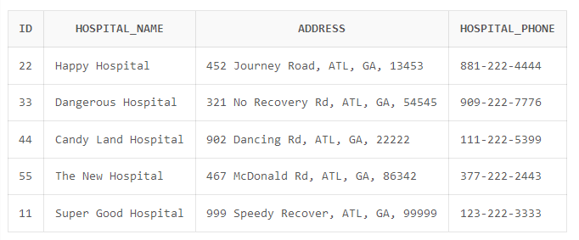

Patient table
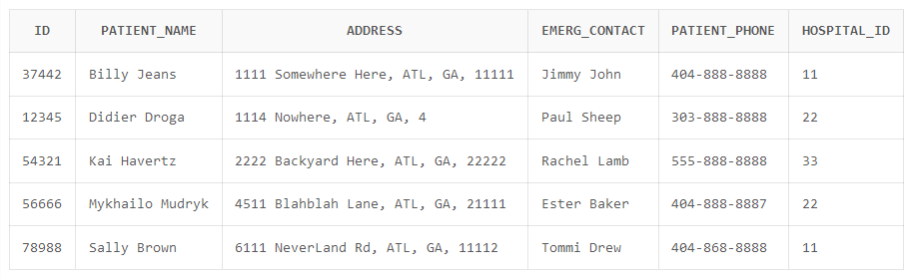

Specialty table
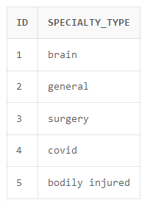

Mapping: Hospital_Specialty Table (2 FK)

