Vongai Kwenda
12 July 2023
Lab 5

- List all the patients’ names, and the name of the hospital that each are being treated at
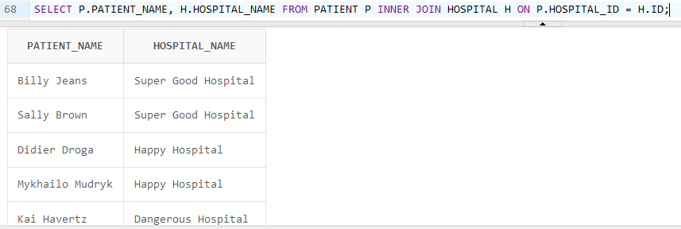

- List all the hospital names, and the names of the specialties that they are specialized in treating
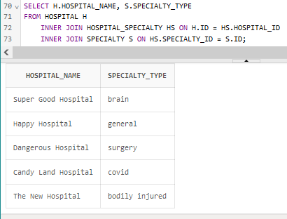

- List all patient names in descending order

