**Curriculum Vitae**

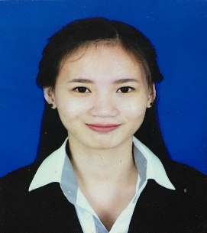

**PERSONAL DATA:**

Name: LIM SOPHANNARY

Nationality: Cambodia

Date of birth: 19 March 1999

Place of birth: Phnom Penh, Cambodia

Sex: Female

Marital status: Single

Religion: Buddhism

Current Address: #93Eo, St 51, Sangkat Phsar Thmey3,

Khan Duan Penh, Phnom Penh, Cambodia

Mobile: (+855) 61 222 919

Email: limsophannary@yahoo.com

**EDUCATION:**

**2016 - Present Business Management**

Cambodian International University, Phnom Penh

Cambodia

**2013 - 2016 General Certificate of High School Education**

Preh Sisowat High school, Phnom Penh

**2010 - 2013 Diploma Certificate of Secondary School Education**

Chaktomuk Secondary School

**2007 - 2014 Certificate of General English Program**

Sovannaphumi School

**ICT Skill (Information and communication Technology)**

* General knowledge of Internet and other communication systems.

**EXPERIENCE:**

* Youth of Red Cross
* Voluntary work for Social and Cambodia Book Fair

**LANGUAGES:**

* Khmer: Writing, Reading, Listening (Mother Tongue)
* English: Writing, Reading, Listening (Good)

**ADDITIONAL INFORMATION:**

* Characteristic : Honest, Hard-working, Flexible, Fast Learning and Friendly
* Hobbies : Reading book, News, Sports and Social Media

**REFERENCES:**

Mrs. Lim Chakriya

Team leader of Call Center at Cellcard

Tel: (+855) 12 333 795