# 问题记录

1.启动时报错org.gradle.api.GradleException: Cannot resolve the latest Gradle IntelliJ Plugin version

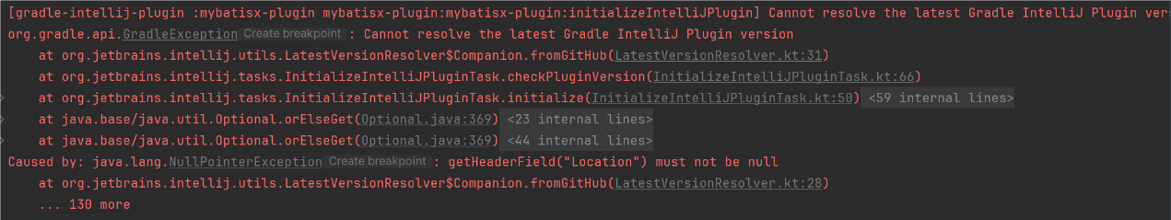

网络问题，参考：

https://intellij-support.jetbrains.com/hc/en-us/community/posts/8769753488274-This-error-is-always-displayed-when-the-plug-in-runs-but-does-not-affect-the-run