CS2: Assessed Exercise 1

Edward Bruce – 2189539B

## Task 1

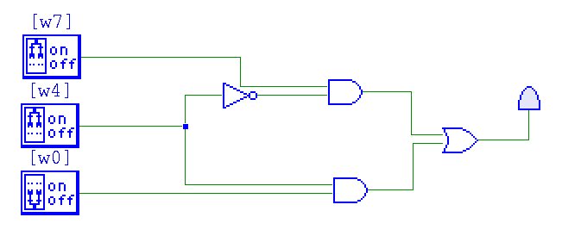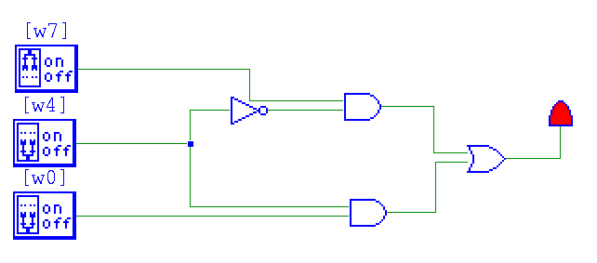

## Task 2

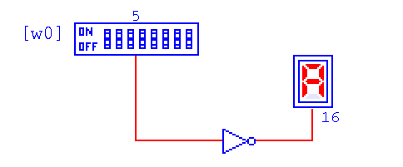

## Task 3

A Multiplexer (MUX) is a logic component that allows multiple inputs to share a single output. In the case of the 2-1 Multiplexor if you were to set one of the inputs to the value ‘1’ and the other ‘2’ you can then change the value of the Control Switch (S) to ‘on’ or ‘off’, 1 or 0 respectively. The Multiplexor would then output only one of the inputs to the display.

## Task 4

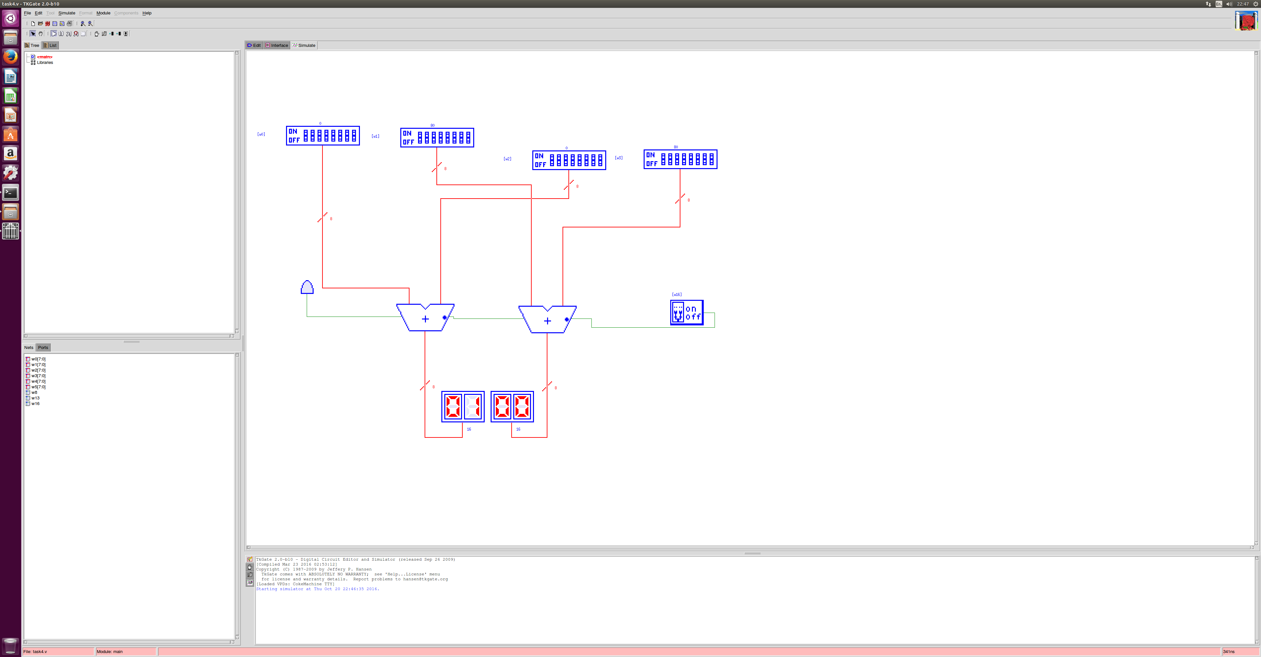

The 2 16-bit words are each broken down into 2 8-bit words. The MSB’s are added together along with the LSB’s. The result is then displayed on two separate 8-bit hex LED’s and if a carry is complete the LED will turn on.

## Task 5

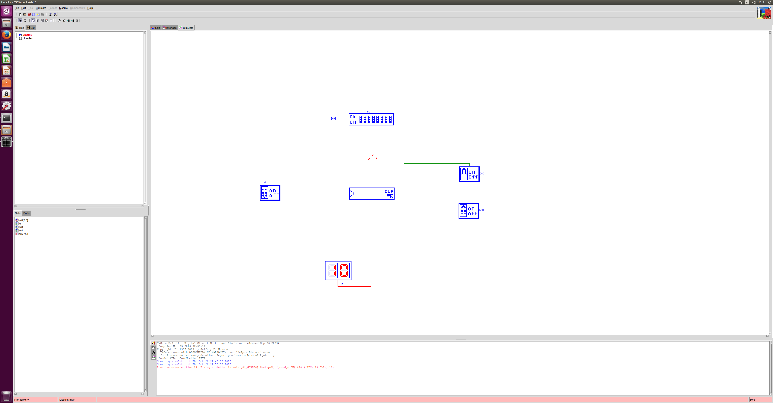

To store a value in the register without it being changed the ‘CLR’ (Clear) and ‘EN’ (Load) inputs both need to be on. The control switch needs to be pulsed for the input value to be stored. To store a new value ‘EN’ should be turned off and then the new value can be set when ‘EN’ is turned on again. To clear a value at any time ‘CLR’ should be turned off.

## Task 6

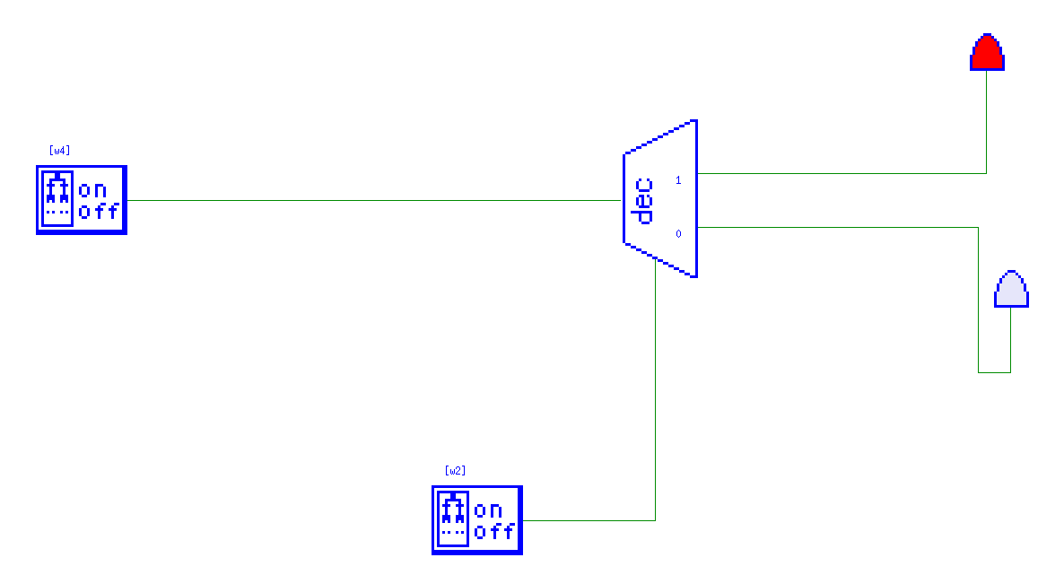

A Decoder is a logic component that simply takes in an input value (in this case a switch, value 1 or 0) and then connects to 2 output LED’s (marked 1 or 0). The 2 LED’s represent the values 1 or 0, if the switch is set to 1 then when the Control Switch is turned on the LED representing 1 will turn on and vice versa. The Decoder just outputs the value that is being input.

## Task 7

### Load 3 into reg2

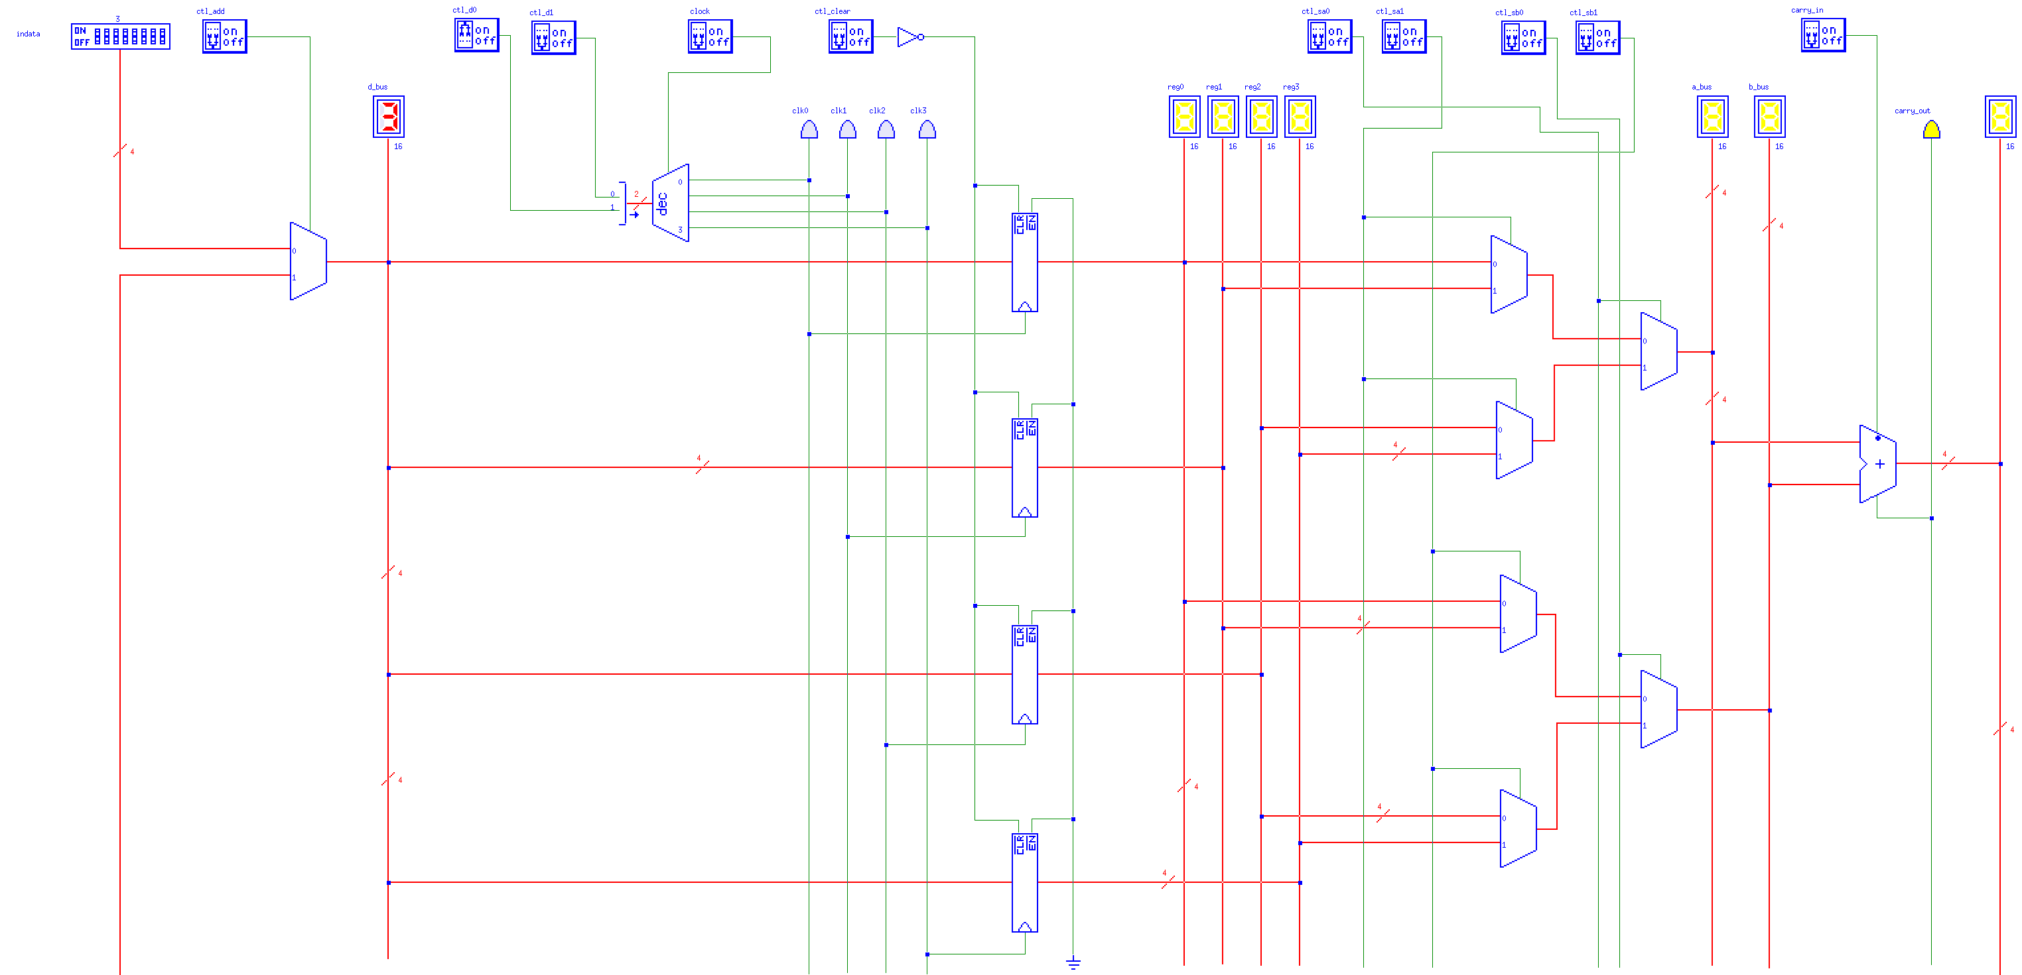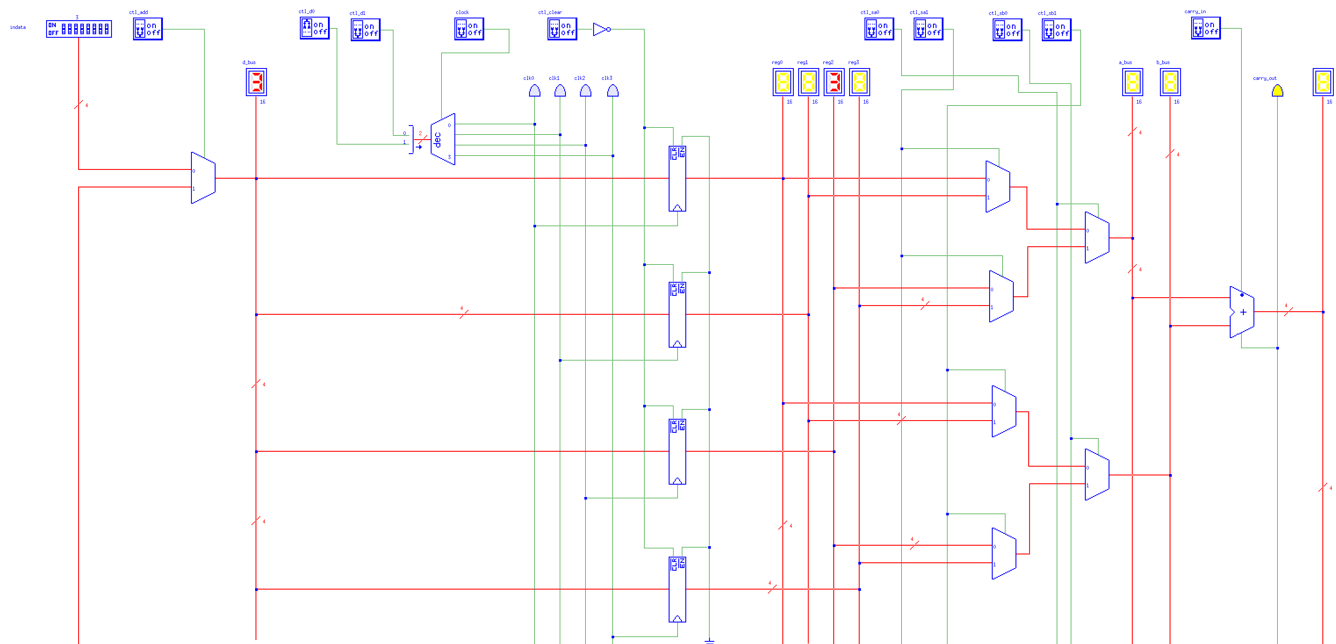

### Load b into reg0

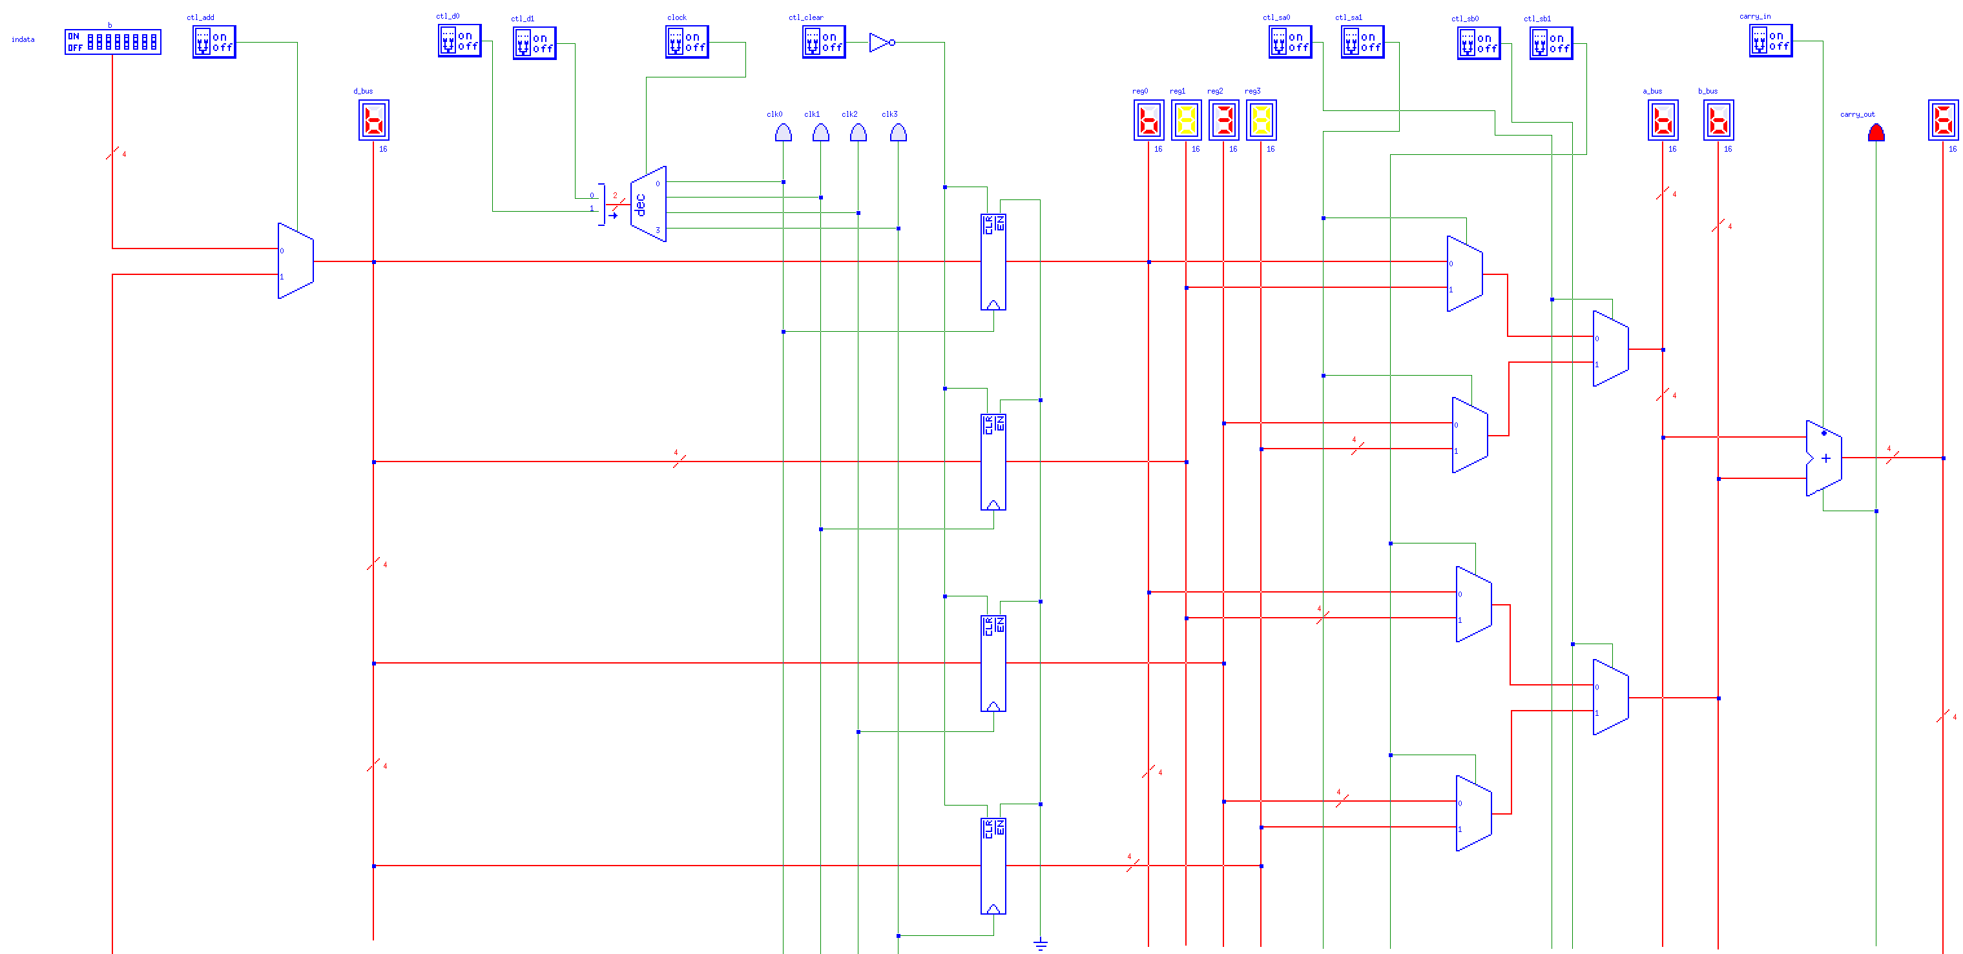

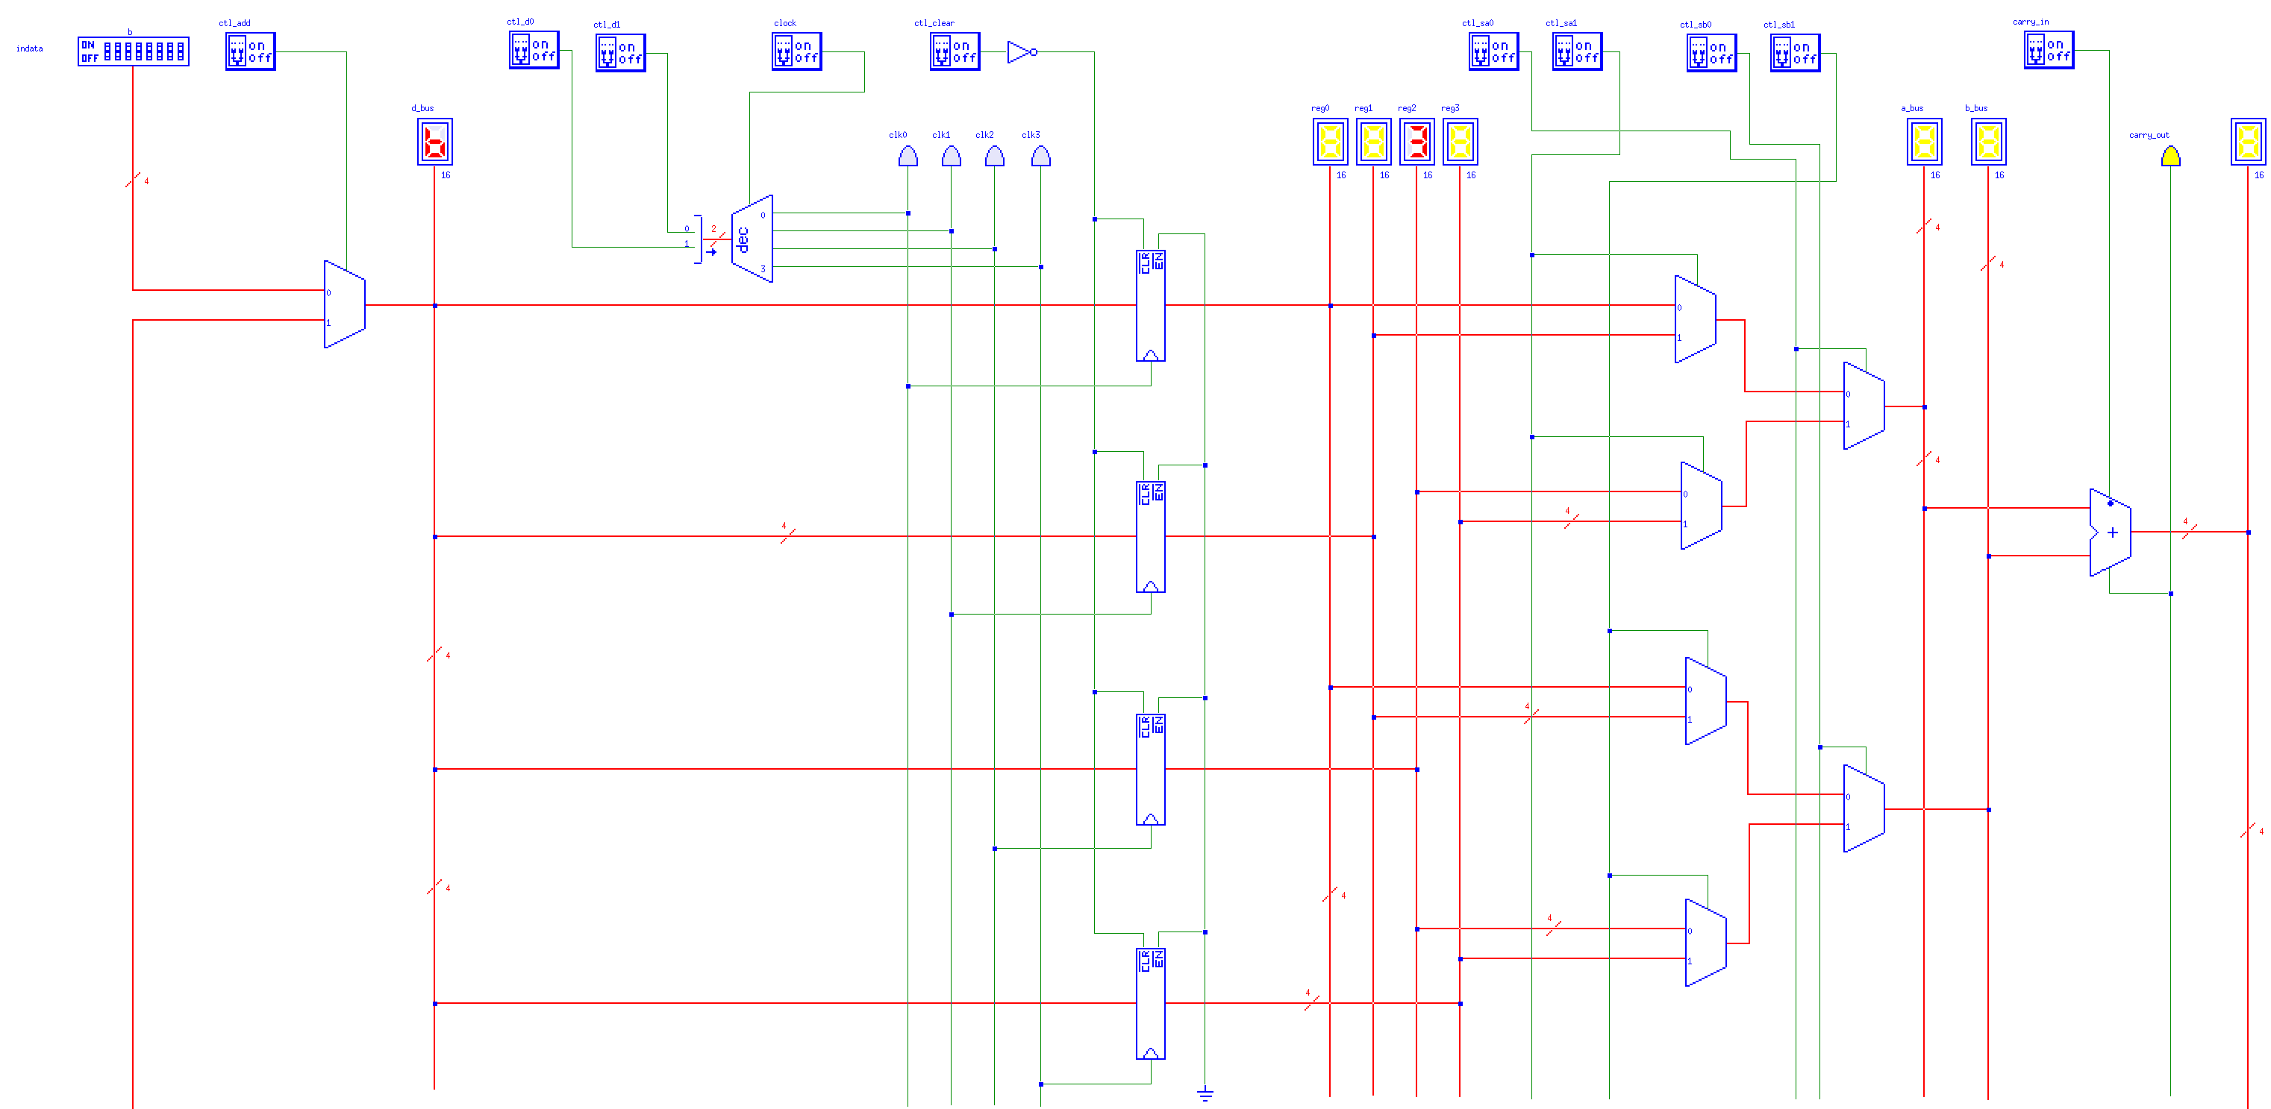

### Load 7 into reg3

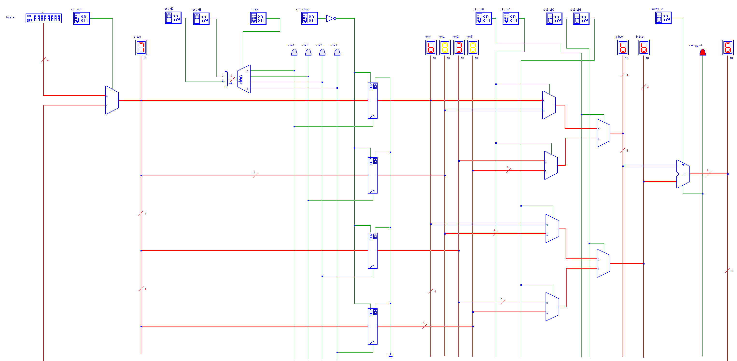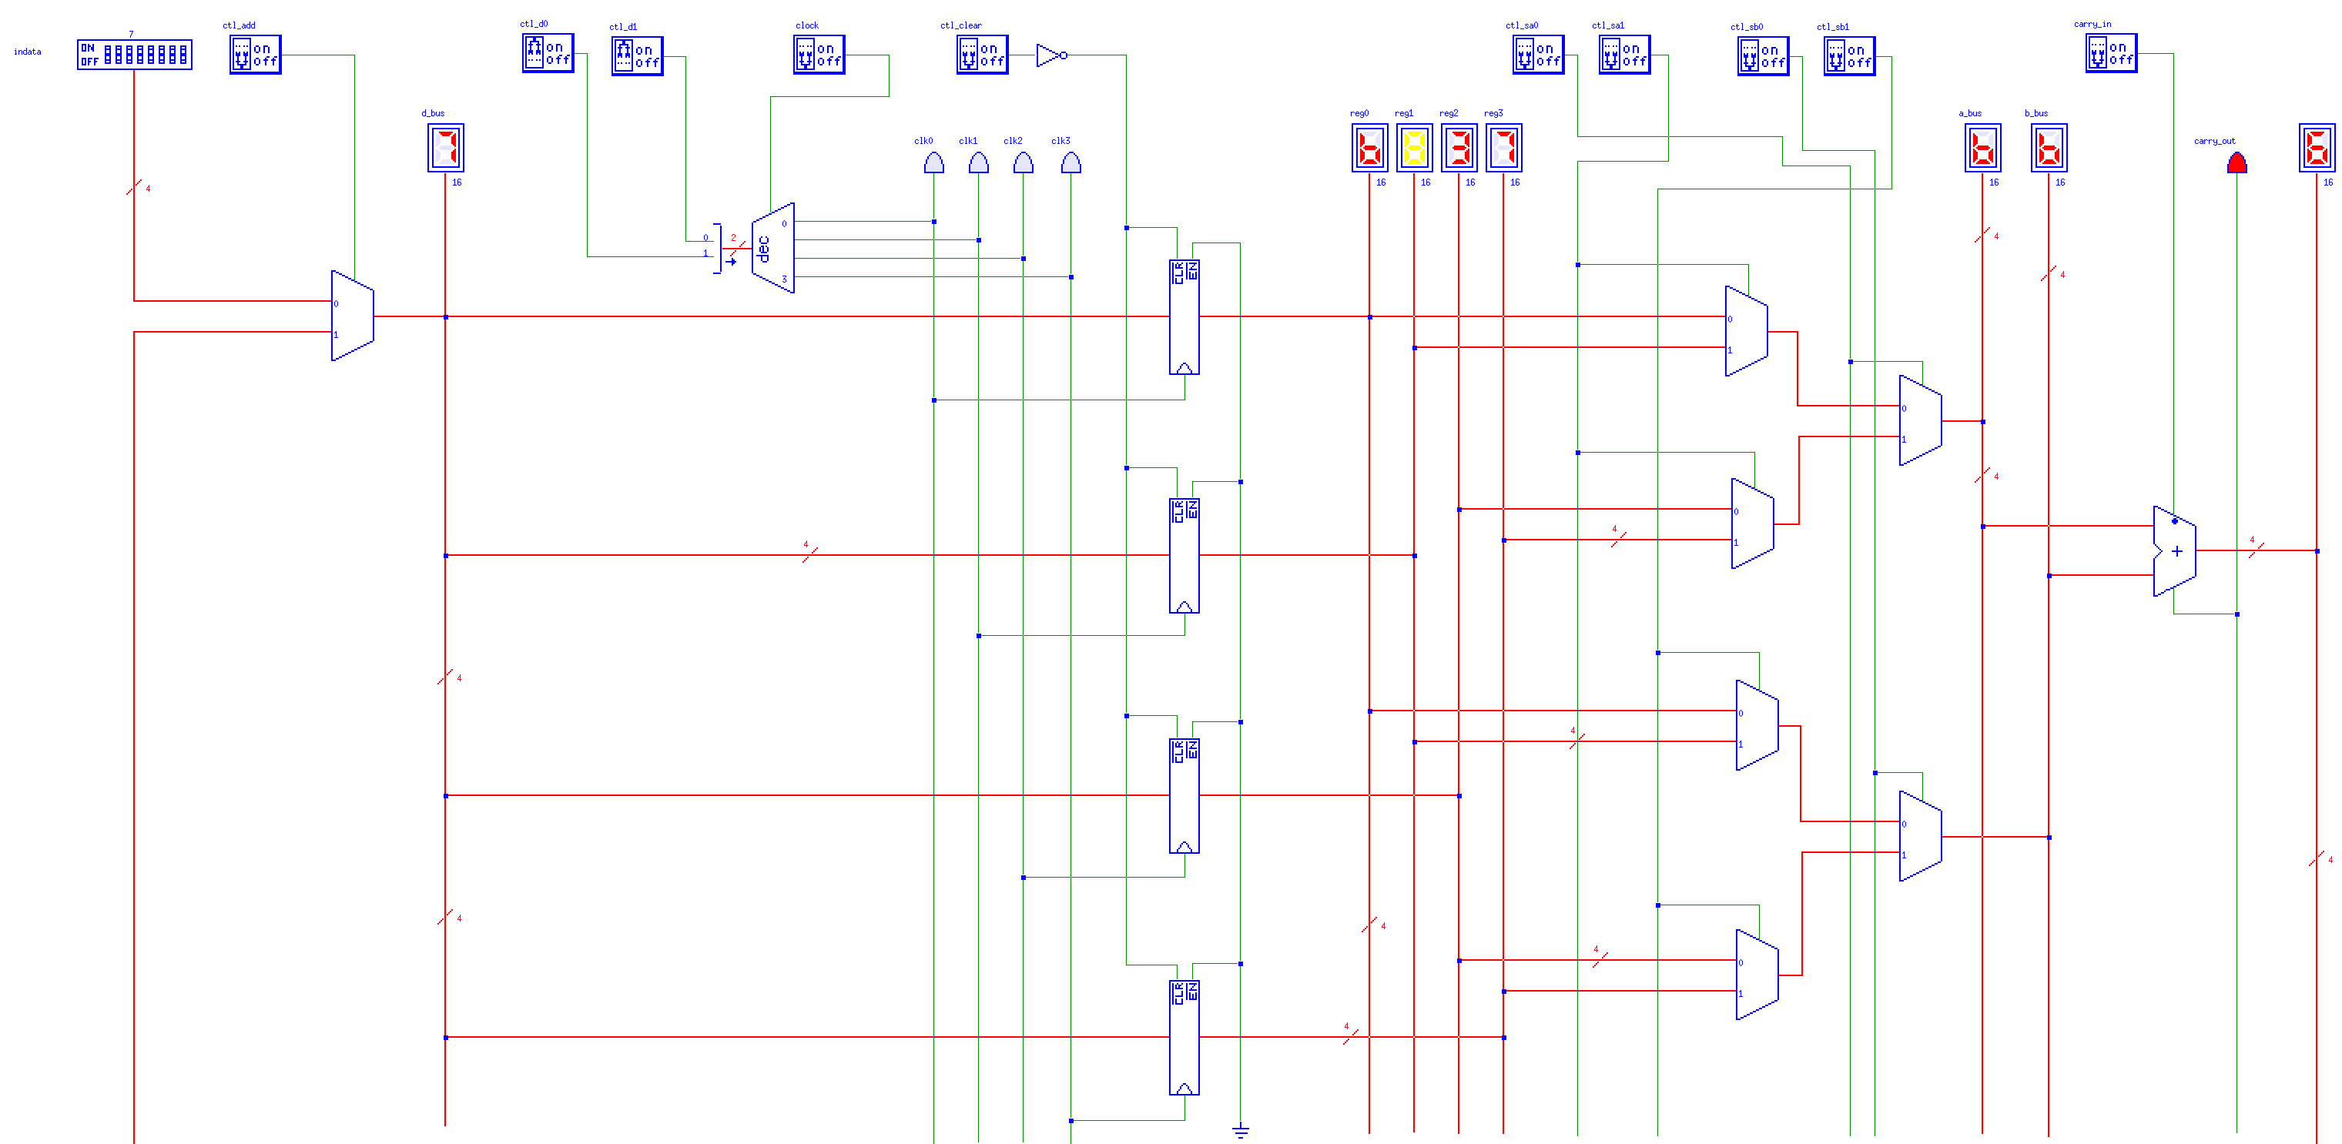

### Set reg1 = reg2 + reg3

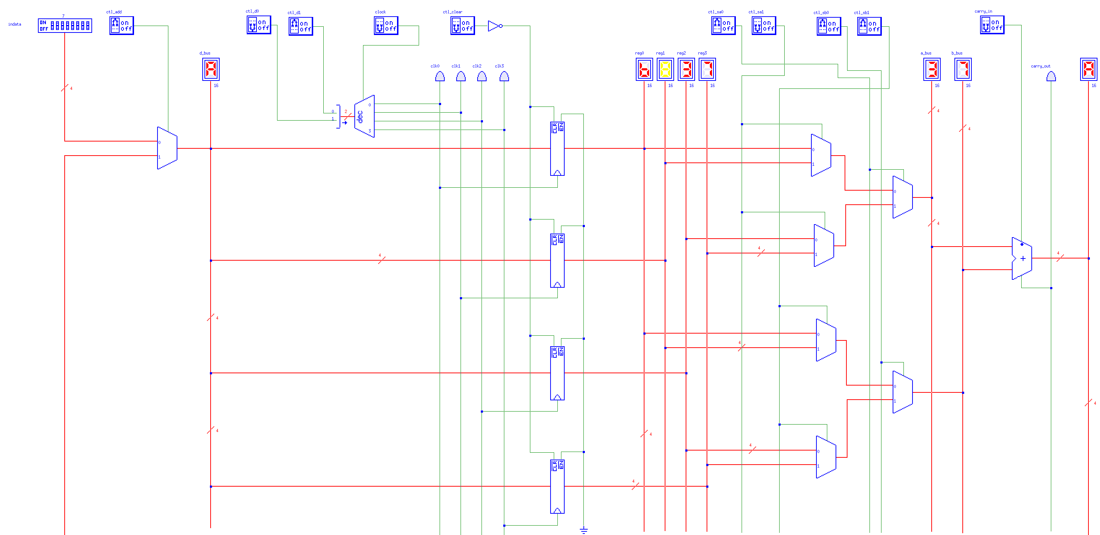

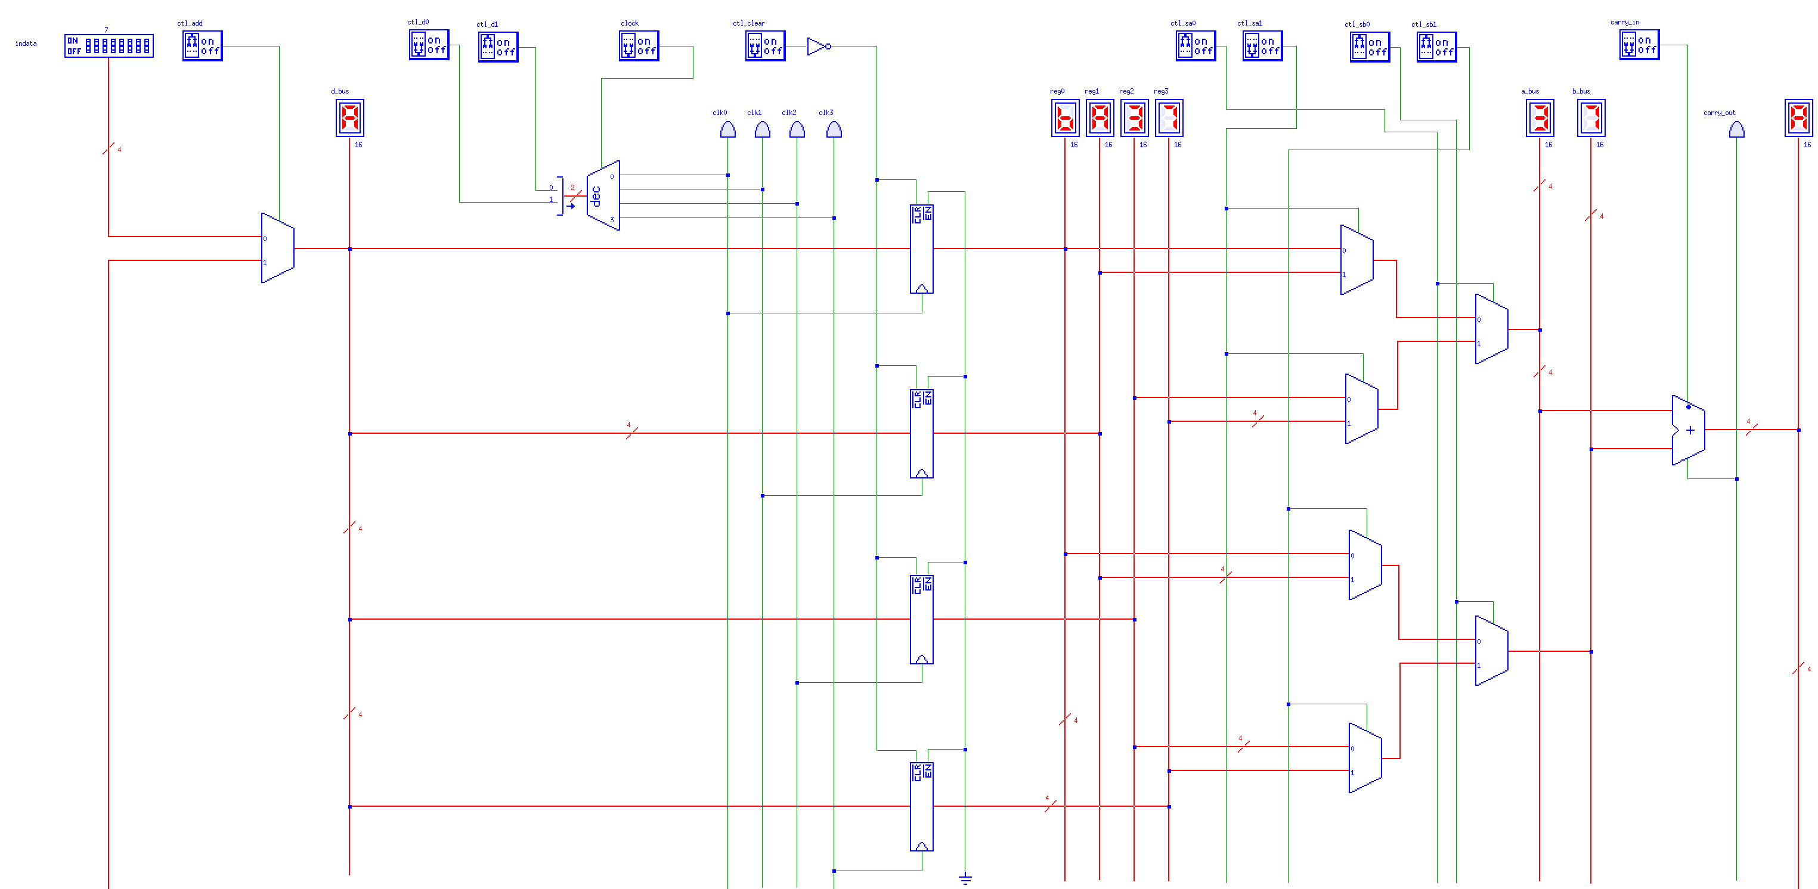

### Set reg2 = reg2 + reg1

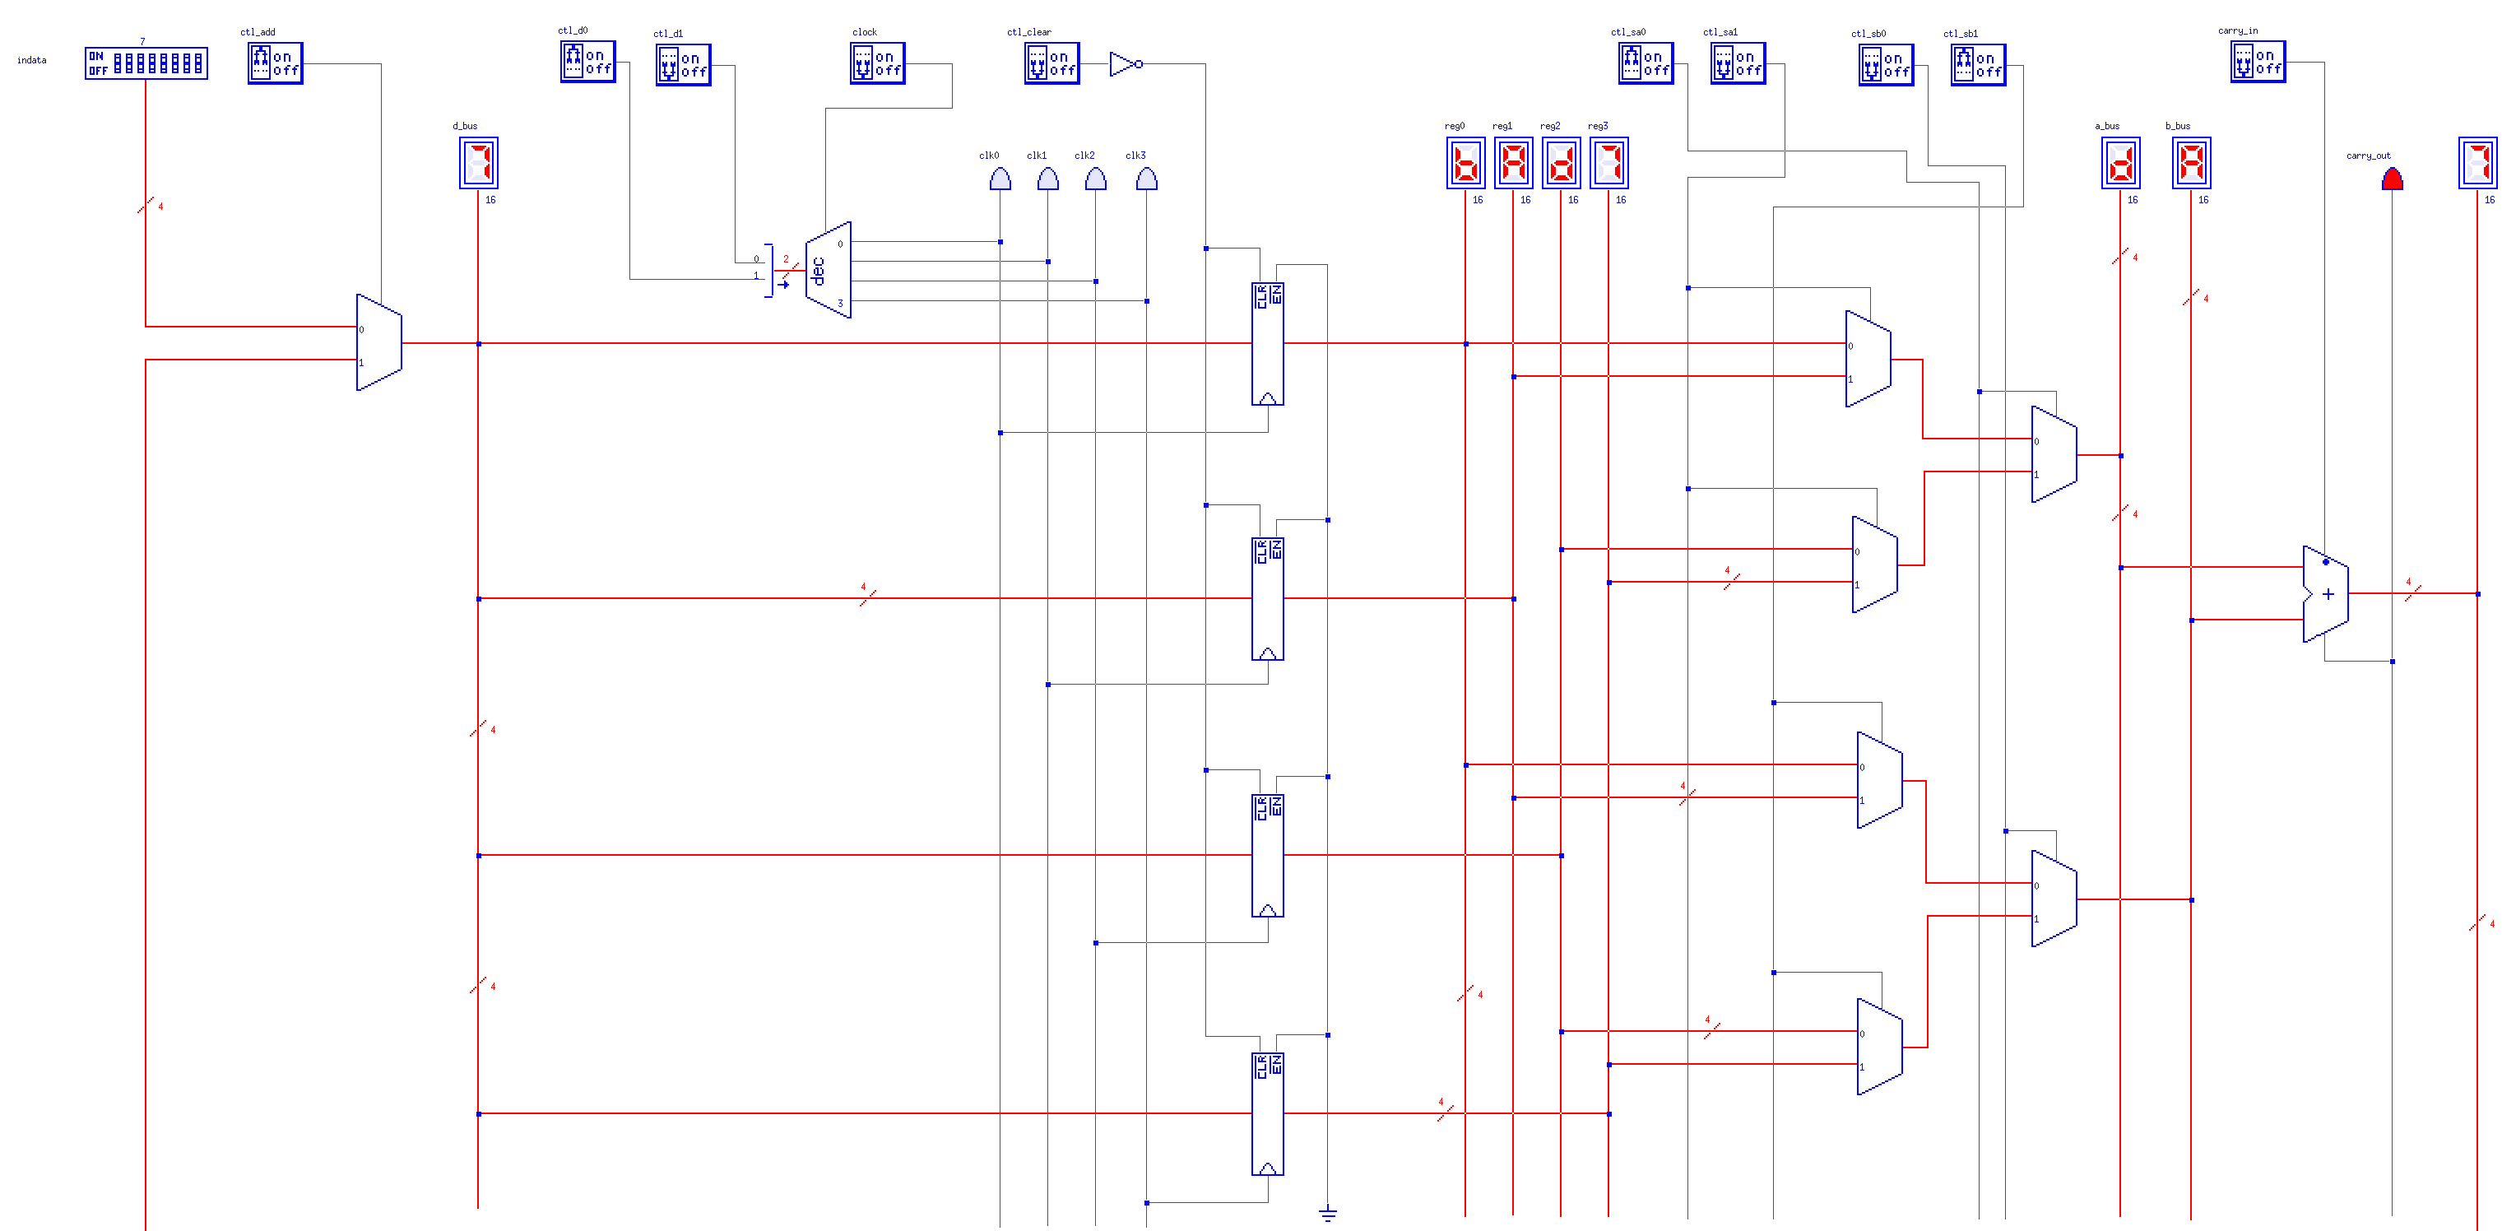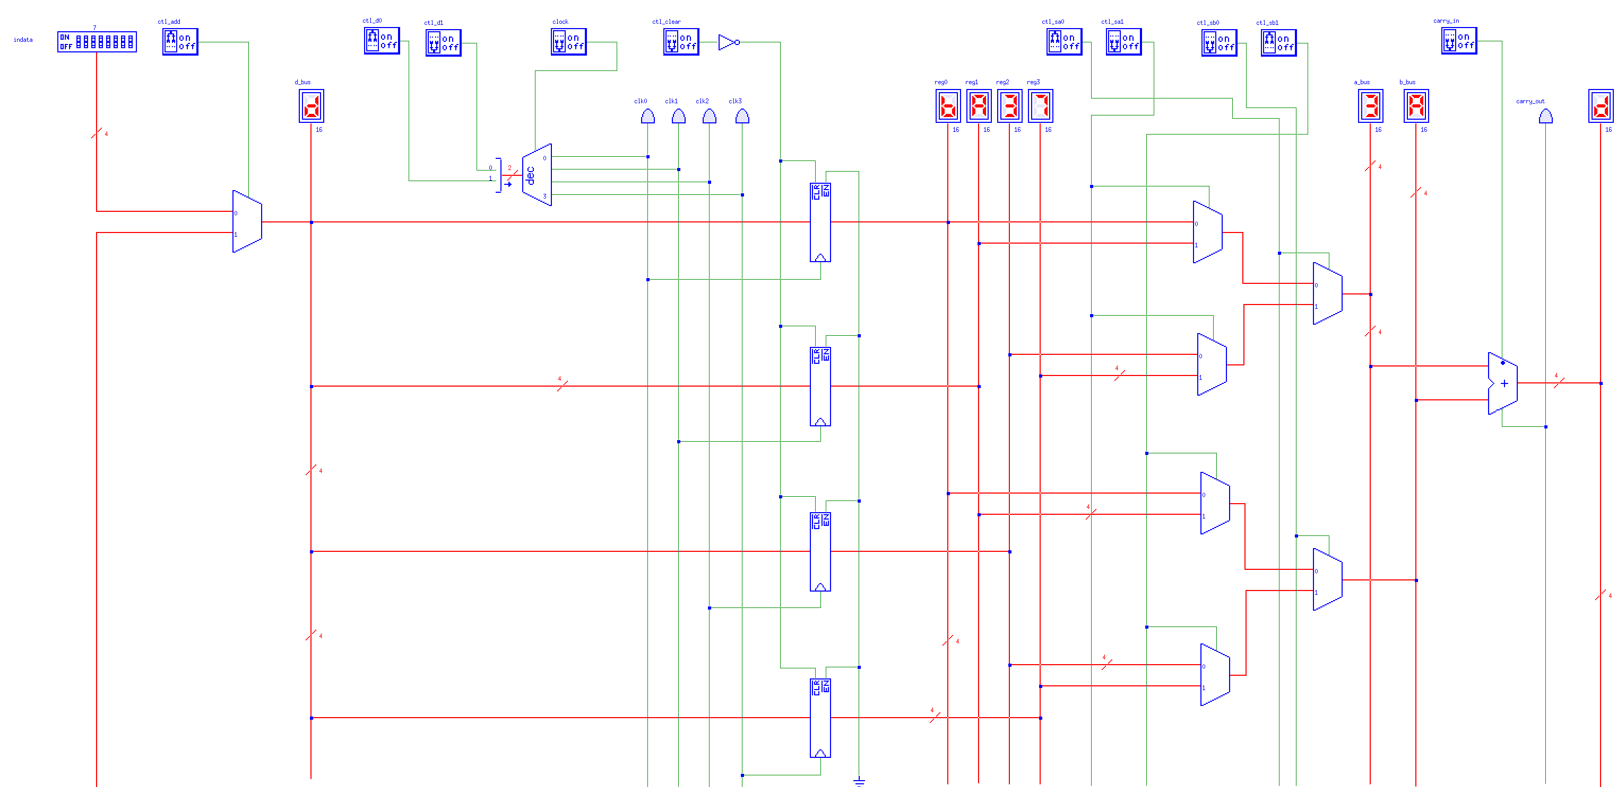

### Task 8

To amend the circuit to also carry out subtraction another adder is connected to the a and b buses. The connection to the b_bus is inverted and 1 is added and then subtracted from the other number (a_bus). This is due to two’s compliment:

*NOT b_bus + 1 = - b_bus*

For the circuit to successfully subtract the two numbers the new adder (connected to the a and b buses) is then connected to a Multiplexor which also takes in the output value for the adder which does the actual addition of the numbers. This is controlled by ‘ctl_neg’, this needs to be on to carry out the subtraction along with the control input of the subtraction adder. ‘ctl_neg’ is then turned off and the result of the subtraction is displayed on the hex LED.

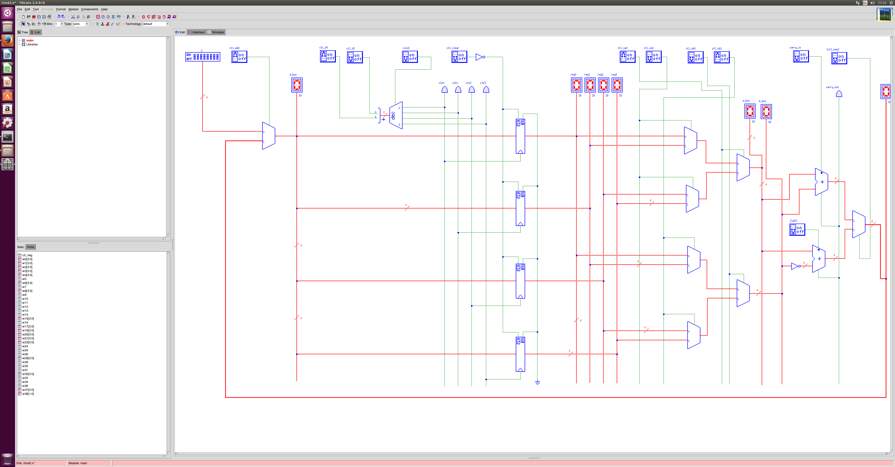

Testing: Numbers 5 and 4 will be added first, then the ‘ctl_neg’ will be switched to off to then subtract the two.

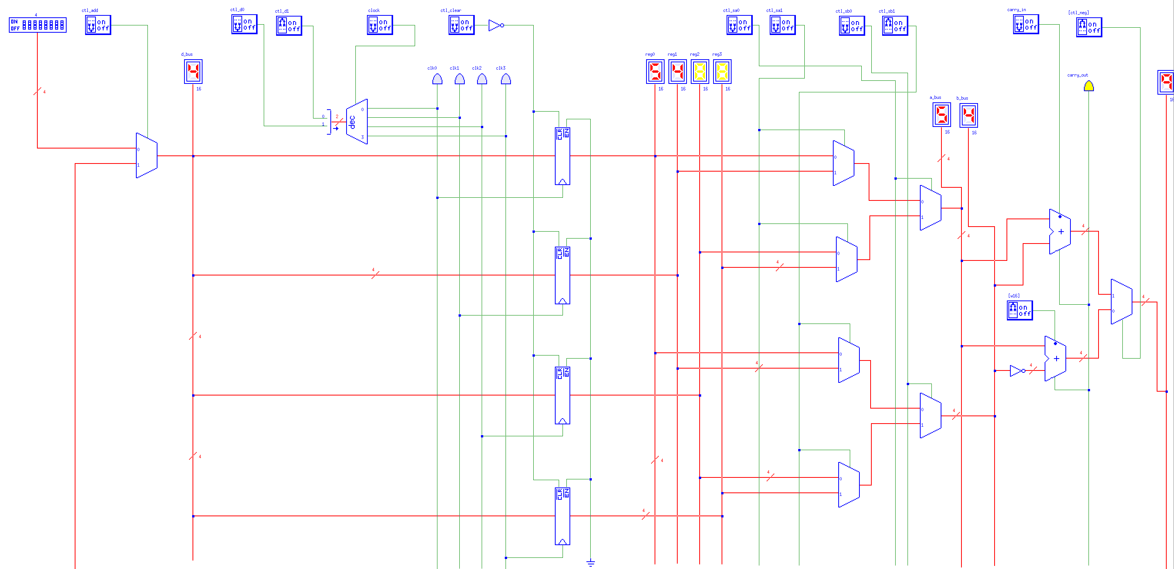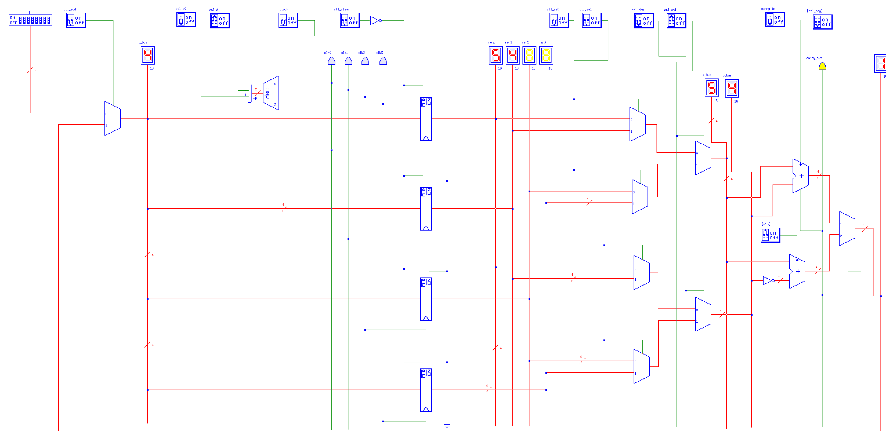

And then skipping right to the subtraction with numbers 7 and 4.

