Website deliverable

This document will contain all the information, texts and materials regarding the studies and creation of the website creation project.

Table of Contents

Personas 3

Jennifer 3

Mike 4

Survey questions 4

Survey Explanation 4

Survey Analysis 12

Survey results analysis 12

Interview questions to improve survey 20

Link to survey 20

Interview for survey transcripts 21

Anne 21

Victor 21

Yavor 22

Interview Transcripts 24

Jules 24

Joshua 26

Josh 27

Sasha 28

Michael 29

Unknown 30

Samuil 31

Rudy 32

Overall review of the interview 34

Links for the videos of the interviews 35

Other Interview material 36

# Personas

## Jennifer

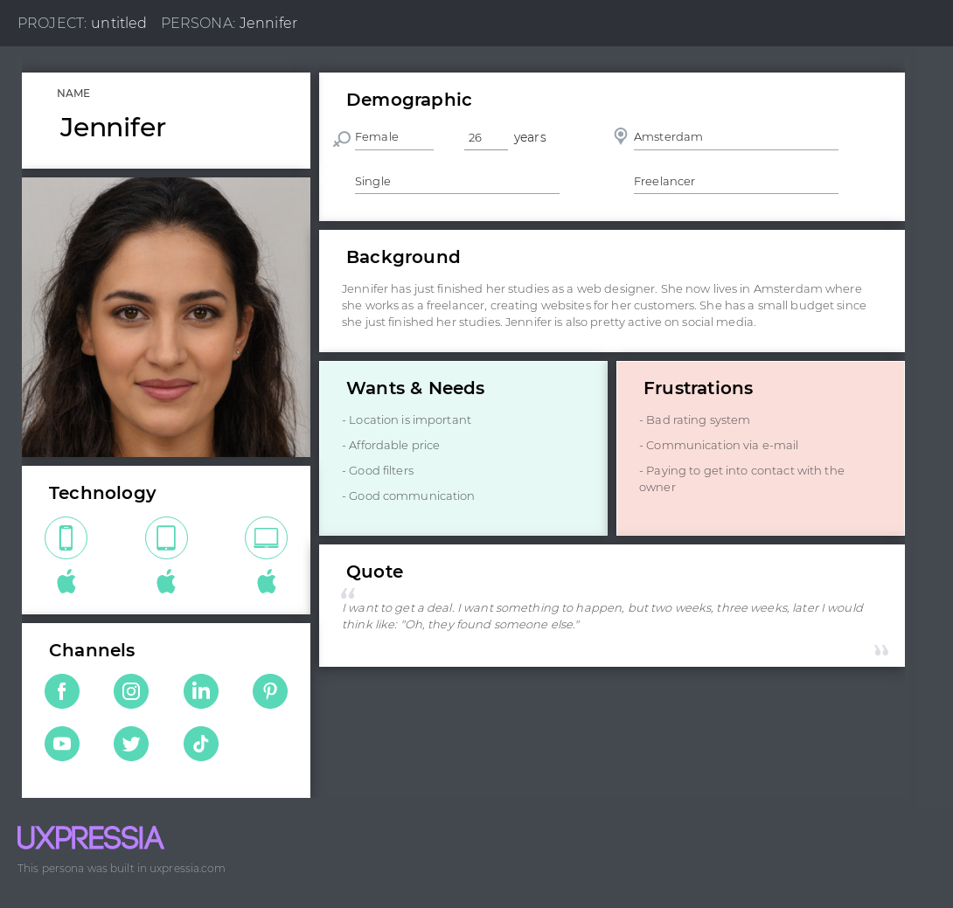

## Mike

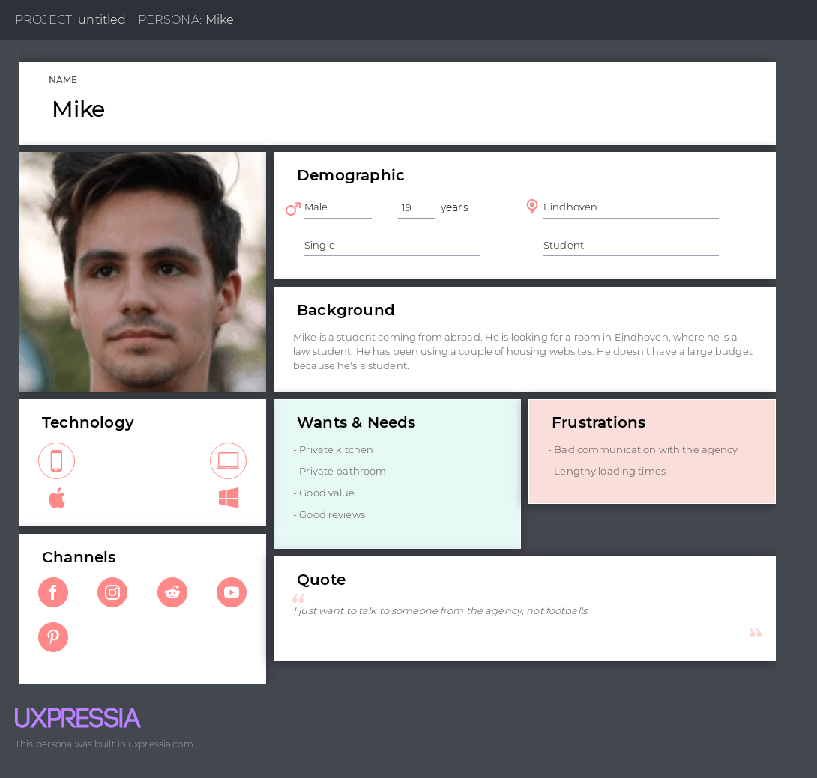

# Survey questions

## Survey Explanation

In our group, we decided to make a housing website as our project. So before we start creating the website, we made a survey. The following survey is aimed towards people that have used a housing website. We want to see their opinions about those websites – what did they like, what did they dislike, what feature helped them throughout this journey of finding the perfect property.

Question 1.

Starting off with the first question from our survey – “In which age group do you belong?”. With this question we can determine whether the person is a student, a worker, or someone who is looking for property for his/her family. People up to 25 years old are usually students looking for accommodation, while attending university. People older than 26 years are most likely to look for a property for their family or they are looking for a place to stay while they are working.



Question 2.

With this question we want to determine whether the person has used a housing website before. That way we will know how many people have looked for a property themselves, or they have made other people look for them.

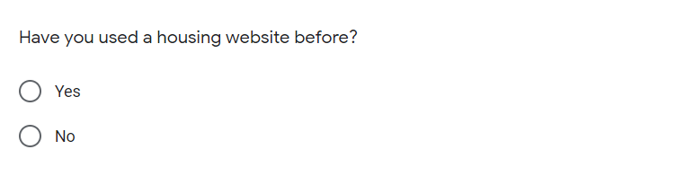

Question 3.

With this question we want to see which website people use the most. That way we can check the most used ones and check if there are any flaws, interesting features, etc. In that website, which we can implement in our own.

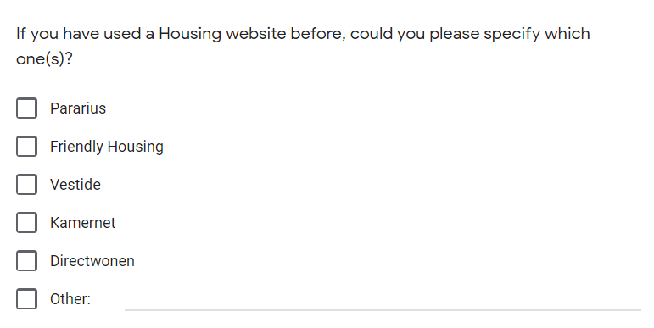

Question 4.

With this question we can see how much time people have spent, using the accommodation websites.

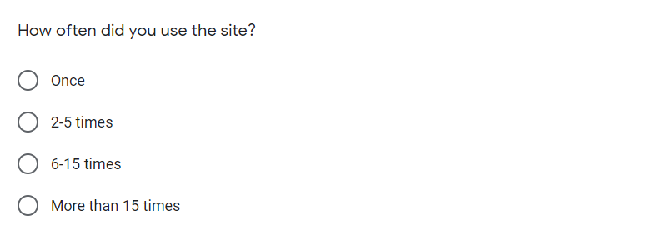

Question 5.

With this question we want to determine whether the user uses desktop, tablet, mobile or other device to access the website. We use this question to see the 2 most used devices. So if the second most used one is mobile or tablet, we will make a port of the website for mobile devices or tablets.

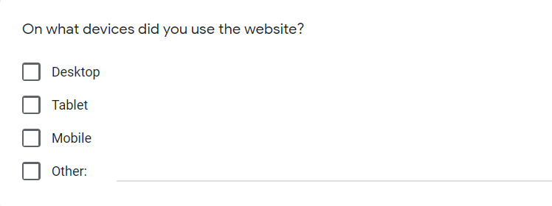

Question 6.

With this question we want to see the two most used languages, so we can add it as a feature for our website. The page will originally be created in English, and in future we can add Dutch or German.

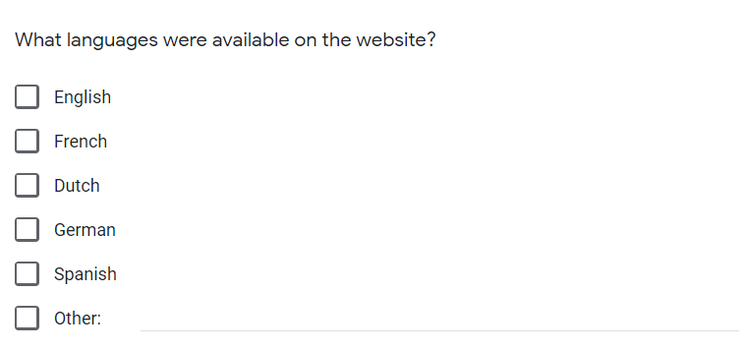

Question 7.

With this question we would like to know If any person has used a feature that made their work easier. A feature that they enjoyed. So we could work on this feature and improve it and later add it to our website.

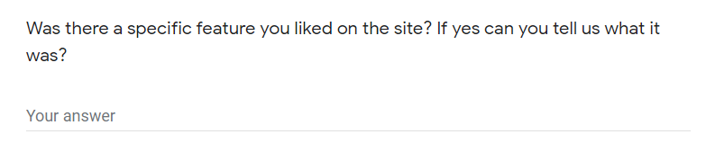

Question 8, 9.

The following two questions are very important part of our research. With them we will be able to determine whether we should add subscription to our website or not. Many websites required subscriptions in order to use them and many times these subscriptions were useless. We could add subscriptions for other features but not for generally using the website.

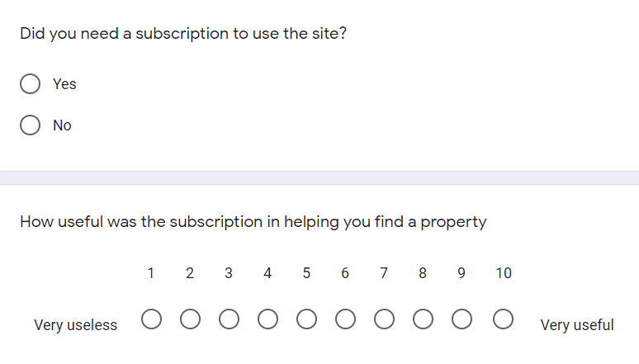

Question 10.

With the following question we can determine what type the user is. A student looking for studio or room, or a family looking for a flat or a house. That way we can divide our listings for easier access to users of the website.

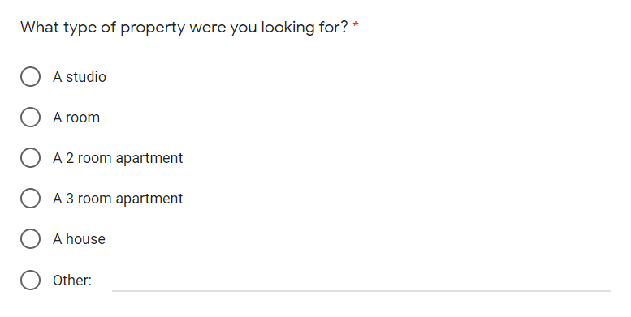

Question 11.

With the following question we want to determine which features are the most important for people when looking for housing. That way we can later add the options as filters for our website. The answers we have here are taken from the 3 interviews we did for the survey. (see “transcript-interview-for-survey-Viktor.docx”, “transcript-interview-for-survey-Yavor.docx”, “transcript-interview-for-survey-Anne.docx”)

Question 12.

With that question our team can determine on which price point of estates we should focus.

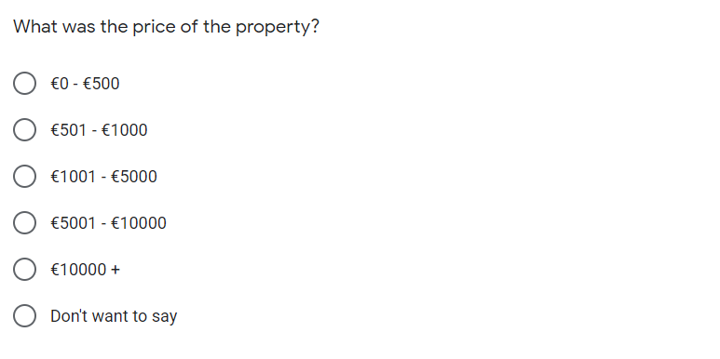

Question 13.

Many people get scammed with fake pictures/photos of the listed estates. We want to see how many of our surveyed people have experienced this scam. We want to implement 360-degree photos in future in our website.

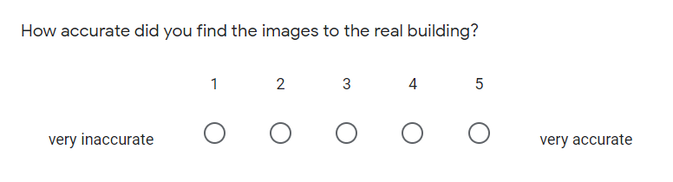

Question 14.

Many housing agencies take quite a lot of time to respond when sent an email/question about a certain property. We want to see from our survey if this is true and if so, usually how many days does it take for people to get response. We would like to eliminate that drawback in our website.

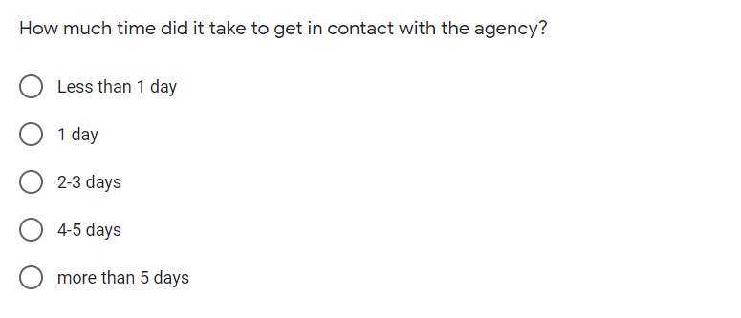

Question 15.

Our last question is a follow-up to the previous one. Wanting to have a more clear view of the process of contacting the housing agencies.

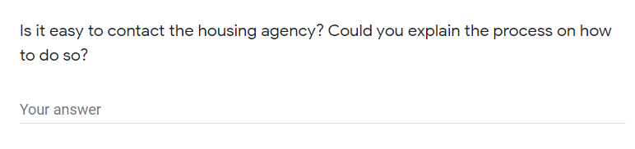

# Survey Analysis

## Survey results analysis

In this document results from the online google forms survey are going to be analyzed and conclusions will be drawn from them. The survey consisted of 15 questions about housing websites and it was conducted before one week. The survey got 14 responses ranging from students looking for rooms where to stay to families looking for a house to live in. The results we collected were very interesting and will help us quite a bit throughout the creation of the housing website.

Question 1:

From this question we have determined that most of the users of the housing websites are people aged between 19-25 years old. That way we don’t need to oversimplify our website’s layout and cut from extra features. (because the less features a website offers, the harder it is to use)

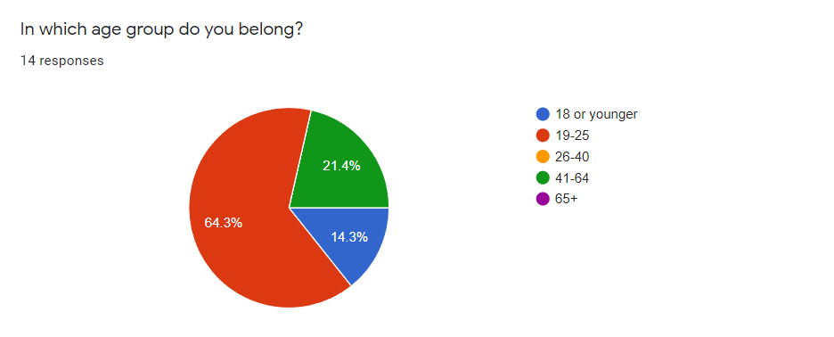

Question 2:

Our second question wanted to see how many of the Ethernet users have used a housing website. We conducted that more than 80% of people have used one. This will make our work easier because we won’t have to concentrate on creating an exactly different website as compared to the others. What will we do is give our website a twist in the layout and make it somehow stand out from he others (in a positive way).

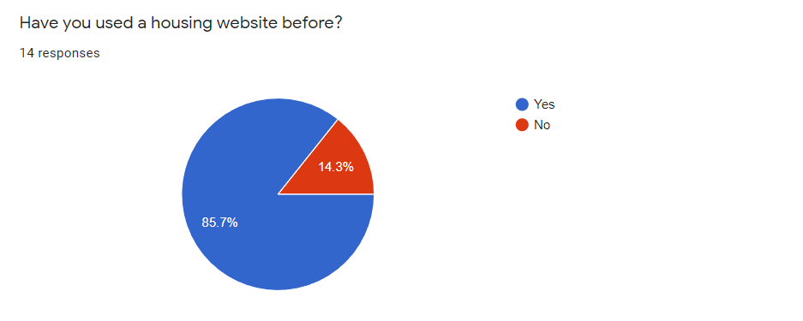

Question 3:

With the following uestion we wanted to see which websites were used the most when It comes to housing listings. The survey gave us the following answers – the most used websites are Pararius, Friendly housing and Kamernet. That gives us very important information. That way before we create our website, we can check those ones and see any flaws, bugs and minuses which we can eliminate and implement in our own. We can also see the similarities between them and that way we can think of a way to make our website distinguish more in terms of layout compared to them.

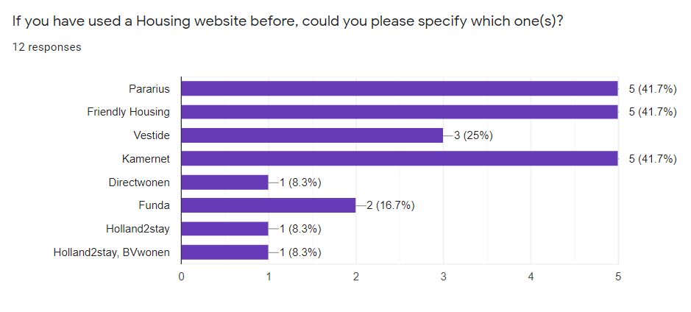

Question 4:

The following question gives us the result of how many times people use a housing website. Our If they use it less than 5 times – either the website sucks or it is too hard to use, or there isn’t enough info on it. If the website is used more than 5 times, therefore it works as intended. That’s what our team is aiming for.

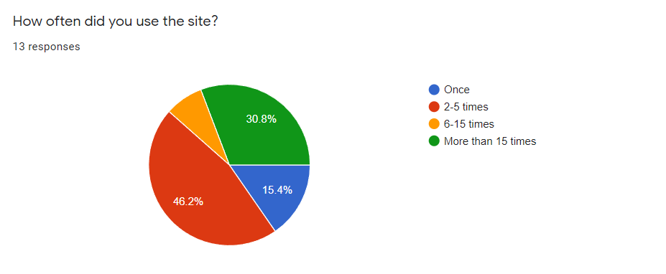

Question 5:

Even if the following question looks useless to some people, it gives our team very important answer – To make the website phone compatible. Even though people mostly use PC, quite a few of them also use their phone. The whole coding process won’t be any harder, because it just involves a few lines of code. That way it will be more user friendly. People won’t have to deal with a desktop sized website on their mobiles and make it harder to use. That way we can attract more people to using it and more easily gain popularity.

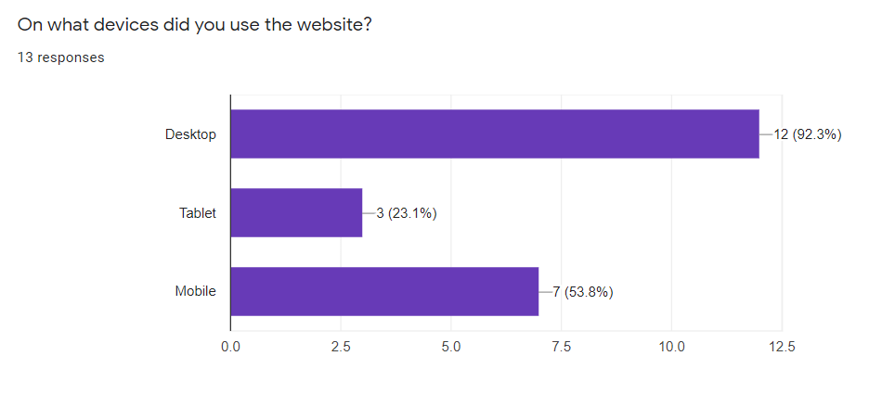

Question 6:

The following question of the survey shows us the most commonly available languages in the housing websites. That way we can see that Dutch and English are the most commonly used ones. This means our website will have English and Dutch language translation built in and/or offer language translation option of some sort.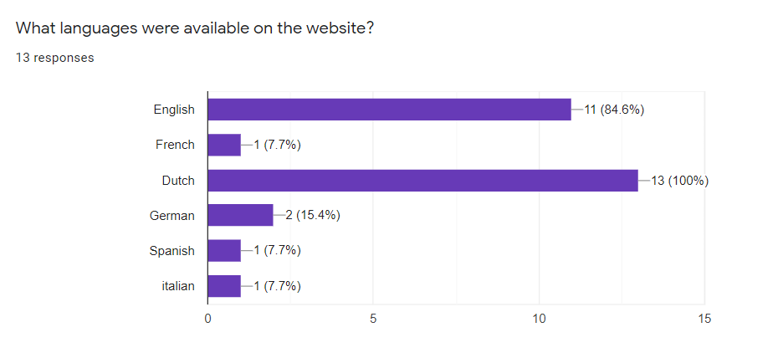

Question 7:

With the following question from our conducted survey we learned about many different useful features. In future we can implement some of them in our website in order to make the user experience better and easier to use. After all our website should be as advanced, outstanding and user-friendly as possible.

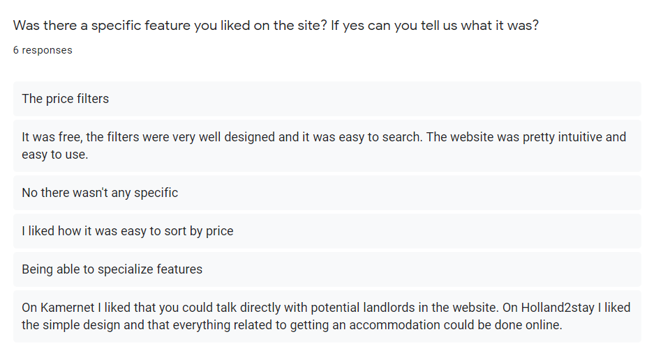

Question 8:

During the creation of our survey, out team determined that many of the housing websites require subscription in order to use them. Most of them were useless and some of them were quite expensive. That’s why we added that question to our survey. That way we concluded that people would rather use a website that doesn’t require subscription, and such website will be ours.

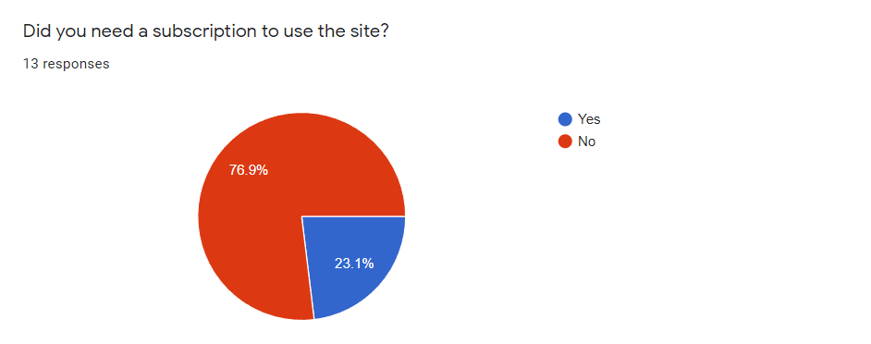

Question 9:

This is a follow up question to the previous one. It shows that subscriptions for the website have little to no use. That’s another reason not to include a subscription.

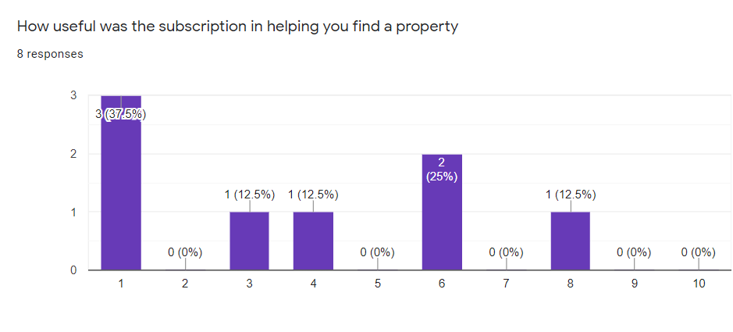

Question 10:

This question shows us what is the most searched type of property. Rooms and houses are the answer. Those two types of estate will have more detailed filters and will require extra attention from our team while developing the listings.

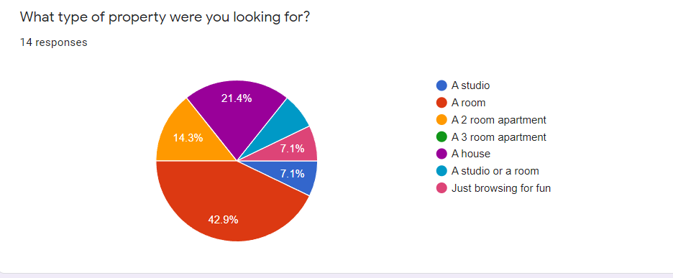

Question 11:

With this question we want to see what feature of the property was most important to users. We concluded that there are 3 very important features: properly maintained property, private bathroom, and good reviews are the most important ones. Later in our website we will add them as an option to the filters. We will also add others, but those will be the main ones.

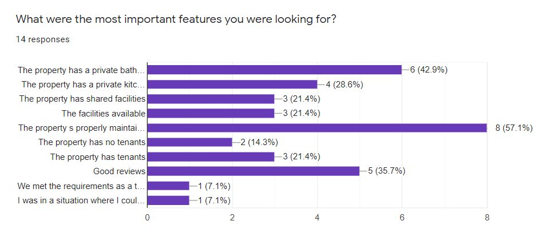

Question 12:

Another filter we will add is proper price range with the option to add your own price range. With that question we want to see the most commonly filtered prices for housings. We see that people mostly use the 0-500 price tag. So what we will do is make it more detailed. For example we will add filter: up to 250 euros, 250-360 euros and 361-500 euros. And also we will include bigger price tags. Price filters will be different according to the category. Also for houses we will use higher price filters, because there aren’t any houses under 500 euros.

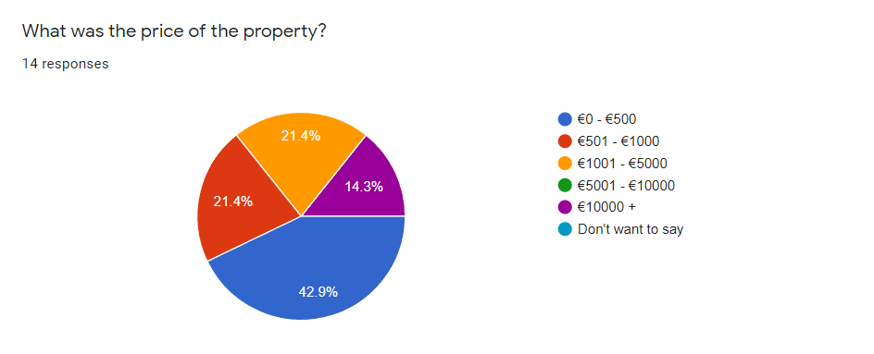

Question 13:

With the following question our team wanted to determine whether the estate pictures were accurate or not. We are also planning to add 360 degree pictures as a virtual tour addition to listings. That way such picture would attract more people not only to the property, but to the website as well, because there isn’t a website that offers 360 pictures of the property.

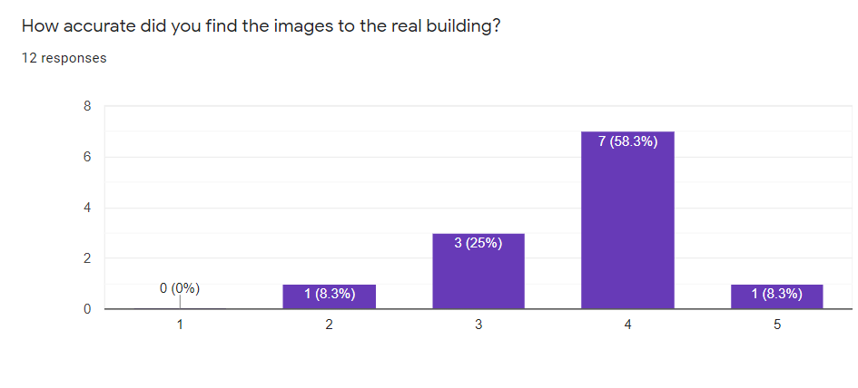

Question 14:

Response time is very important when it comes to communication with estate and housing agencies. Most people got in touch with the agency/landlord within 3 days. This is not bad, however we would like to improve this part. Adding response rate to every landlord, so the person could expect the amount of time they will need for a response. Some websites have such feature and it is working quite well.

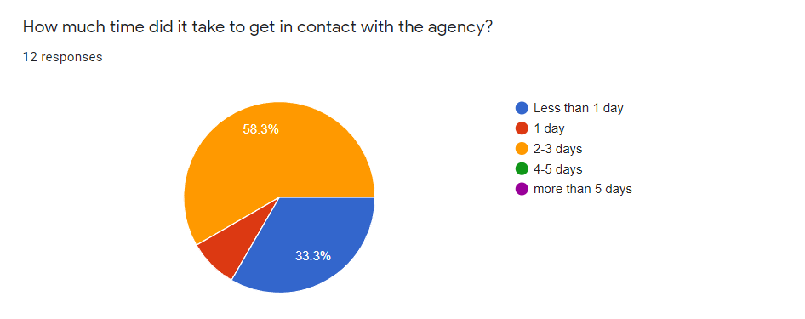

Question 15:

Our last question was a follow up to the previous one. Some websites had a positive feedback, some not. What really matters here is to see the different types of communication and their success rate. This document is later going to be compared to the surveys conducted on video and answers will be more clear. Our website will offer 2-3 ways of contacting either the agency or landlord (we have yet to determine the options). For some agencies the whole procedure was complicated, for others it was easier. We want to find the balance, however we should somehow limit the spam rate.

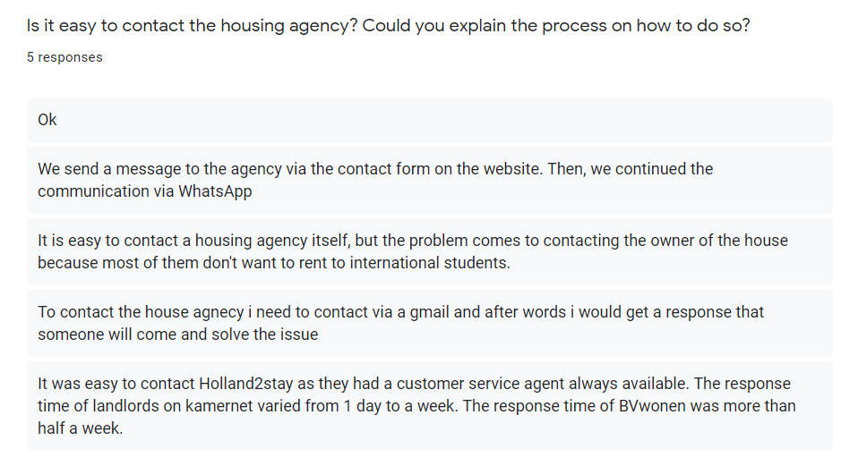

# Interview questions to improve survey

Have you used a housing website before?

Which one?

What type of property were you looking for?

What were the most important features you were looking for?

How much time did it take to get in contact with the agency?

# Link to survey

<https://docs.google.com/forms/d/e/1FAIpQLSfn_26kcOTc8iIqlsDQl_jbPXFZLNSYGBCnoRE-1H4C0O8ZVg/viewform?usp=sf_link>

# Interview for survey transcripts

## Anne

-Nice to meet you,

-nice to meet you too

- I´m Vasil

-Hello Vasil I´m Anne

-Hello Anne

So, have you used the housing website before?

- Yes, I’m currently looking for house

-which one

- just a student. Housing not really care where if as long as I have a roof over my head

-What types of properties were you looking for?

-Yeah, just shooting flats. One room, nothing much, maybe with the roommates, but. Just a simple room is enough.

-What were the most important features you were looking for?

- Differentiating between with or without roommates pricing and the facilities available and how they are available like shared or non-shared.

-OK

- How much time did it take to get in contact with the agency?

- I don’t know yet. I have looked at the website, but I haven’t contacted anyone yet.

- OK, thank you very much for this interview.

## Victor

-Hello nice to meet you

-Hello, it’s a pleasure

-I’m Vasil

-I’m Viktor

-nice to meet you, Victor. So, have you used the housing website before?

- yes I have used one here in the Netherlands

-Which one ?

-I have used actually two I have used Kamernet and Vestide. But I found my housing using Vestide

- what type of property where you’re looking for?

-I was looking for small apartments or room to rent is because I’m a student. and Otherwise, I was looking also for a storage unit.

-What were the most important features you were looking for?

-I was looking like for the housing for the apartments or the room which I in the end rented. I was looking for private kitchen and a private bathroom because I believe that privacy should be respected very much. Other than that, I was looking to get them. Best value for money possible. And I Looked for a place which had good reviews, and which had enough Sufficient space so it wouldn’t be too small.

-How much time do you take to get in contact with the agency?

- It was very quick, I think in. Less than 24 hours they answered, like after I had done my request. And after that the whole process of like. Signing the contract and receiving the keys. Took me like. Total one week. Of communication and travelling. And after immediately after I got the keys -I had access to the property that I rented.

-Thank ypu for the interview

-thank you.

## Yavor

-Hello nice to meet you.

- nice to meet you too.

-What’s your name?

-My name is Yavor.

-Nice to meet you or I’m Vasil.

-Nice to meet you.

-Have you used the housing website before?

-Yeah, only one time and I used. Its name is Vestide and there I was looking to rent apartment or especially a room because. I was. I was going to live in other country and I basically I needed somewhere to stay in to spend the night.

What type of property you were you looking for?

- As I said, I was looking for an apartment. Of all kinds, and it doesn’t matter where or the price or something like that?

-What were the most important features you were looking for?

-I was looking. For, to have a good looking and also. Nothing to be broken in there, because if it’s broken, I need to buy a new one or I need to talk with the agency to switch the item or the broken thing and that will cost me time, efforts and so on.

-How much time did it take you to get in contact with the agency?

-I was. Sending emails with the company. Maybe for four a months before I was able to to get the keys for the apartment and through that month all sort of things happen, such as where do I want to leave? Is this flat Meet your requirements? and. that kind of. Stuff.

-Thank you for the interview

-No problem

# Interview Transcripts

## Jules

-Nice to meet you , what’s your name?

-jules

-Nice to meet you jules . So are you OK with us recording this interview?

--Yeah, I don’t mind at all,

-OK I’ll ask you a cuple of questions if you like not answering any of them. Just tell me.

Can you use the housing website before

-yes

-Why did you use a housing website?

-I use one because I’m looking for a house right now. In Eindhoven Yeah, and I have used one before because I was a student in breda as well, so I used one for breda.

-Tell me about Experience using the website.

-Which one do you want?

Or do you use a couple?

- I use a couple, one more, the main one right now is vestide which overall I enjoyed the website but I have had very bad luck in finding one because there is a lot of people on the website and every time I check a house is this like oh your position number. 120 unless it’s like OK, well, well, cool.

- And how did you filter the results on the side?

-on vestide particularly, I don’t know if you can, but I use another one in Duch is common net. I don’t know if they have a different name for that. Yeah, when you can, which I personally filter for city of course, wich is Eindhoven, also filter for for my budget. And I filter for room size, which I would like to be above 12 square meters.

- Which feature do you find the most important when you are searching?

-I think general overview for me is important, like just stats natural next to each other like. Like the price and how big the room is an add a little pictures through that as well you know so i can know what my room is going to look like but i think Location is. But I think it’s mostly I look at price and. Room size the location isn’t. For me less important but. Maybe for other people that might be more important.

-Was there something you disliked about the websites you know?

-Yes, common add uses paper message surface. So basically you have to pay like. Oh well, mostly it’s a monthly fee for I think you. Way too much. And then you were able to to message like the housing like the people that are renting a room. So you can. You can view any any room you want, but if you actually want to respond, you have to. Pay money to that website. On vestide, it’s free, that’s great, but the problem I’m having there is that. There may be there are way too many people on the website or just that the queue times are crazy.

-why do you think there is this is a situation with the vestide website?

I think the situation comes from that. It’s used also by international students. While I think Cameranet is less used but internationally, maybe not bad, I’m not sure I’m dutch student myself so I just use both. And because the. Supply is not as much as the demand wants it to be, but that’s just probably just the general housing market thing at the moment. Just kind of sucks. But yeah, there are. There are like I think. Like 12 houses at most on vestide at any time while Cameranets. Not at least like 2 pages of like 25. No like 40.

-How was the communication with those two agencies conducted?

On vestude you basically press, press on like a room you want to view, and then you can just apply. You can get in the queue and then you fill in your basic information, like when you. When you started to study and stuff and when you expect it to end, I think as well. And like whatever your name and stuff and you just press like applying. And then they say like you get like an email like oh thank you for applying will give you further notice if you if you can get a step further which I haven’t yet so I can’t tell you anything about that. Cameranet you basically make a profile of yourself which you give your information and even add like a picture and stuff little by or like. Oh this is me. These are the languages I speak as well if that’s important. I smoke that that kind of stuff. And then you basically apply. You can send a message to. Whatever room you want you whatever person you want to. And then they can also check your profile. See like Oh yeah, this guy is not suspicious or something which probably works well. I think it’s probably the most efficient side for the Dutch housing stuff for students. As far as I know, but. Yeah it works great.

-But where you to satisfided with this type of communications?

-I would like to hear more from Vestide because it never really says like, oh. Sorry, the room is gone now. It just says OK, you apply for it and then. After all, it’s nothing on camernet. I can’t really say anything more because I haven’t really. Like I haven’t purchased like the the reply stuff. I’ve seen it happen, but other than that I can’t really say anything about it.

- Thank you for participating in this interview

- Yeah, no Problem.

## Joshua

-Hello nice to meet you. My name is Vazil this is Christian.

-My name is Joshua, Nice to meet you

-So are you OK with this recording? This interview.

-Yeah its OK,

-so I’ll ask a couple of questions if you don’t like not comfortable answering. Just tell me, have you ever use a housing website before?

-Yes I have

-When did you use the housing website?

-When I was moving to the Netherlands I didn’t have a house so I had to look at places to find a house

-So tell me about your experience using.the housing website

- Well I had some difficulties because some of them you had to pay for, some of them was that they were already rented out, but where still in the website, an that the website I contacted did not contact me back

- How did you filter the results?

-I filter them by price , the location from my school and my city, and that was basically it

-Which one feature do you find the most important one?

- So I think price.

Was there something you disliked about the site uesd?

- The sites in general, if the sites will already rented out some of the places will still be up there, so was ridiculous for them to still be up there. You can do it.

-Was the Communication with agency. How was it conducted?

- It could have been better because sometimes I will respond to at least on Monday, but I would get responded back like Tuesday or video week after. It would be like ridiculous.

-So how would you like the communications be conducted?

I think trouhg phone and email works

. Thank you for participating.

## Josh

-Nice to meet you. My name is Vasil, this is Christian.

- My name is Josh. Nice to meet you.

- Nice to meet you. So I ask you couple questions if you feel like not answering any of them, just don’t

-OK.

-Have you used the housing website before?

-Not really seriously. I looked at once,

- why did you look at?

I just was interested in. The housing market and not really looking for one but.

-Tell me about your experience using website.

-A. It was pretty just could find my way pretty easily and. Not really any. Struggles or something

-How did you Filter the results inside.

- I could tell the name on location and price think.

So.what housing website did you use?

- I don’t remember it was along time ago

- What was the feature that was the most important to you when you were searching?

-I think the most important feature is like filtering on your location so you can look which location you want to live in. And of course price range. They have a budget, so that’s really nice.

-Was there something kill disliked about the site?

- Not really dislike, but. Maybe sometimes the loading times, but that’s it.

- Did you make any communication with the agency?

-I. I didn’t really commit to communivate with them and just watch some site, and I know I can contact them with the email and stuff, but

- so if you needed to communicate with.them how would yu like that to be conducted? -Probably via or phone call or email or message.

-thank you for participating in this interview

-OK, no problem.

## Sasha

-Hello my name is Vasil This is Christian., whats your name?

-sasha

-Nice to meet you sasha

-So I asked a couple of questions. You feel like last week any of them just tell me.

-Ok

-So, have you used a housing website before?

-Yes I have But I haven’t.bought a House or anything

-Why dis you use it?

-To look at cool villas

-Tell me about your experience using this site.

-I just scrolled and yeah that was about it ireally didn’t do Anything besides just looking at houses?

-Did you use any of the filters on the site?

-Not really no

-Was there any important Features when..?

-Price low to high I think.

-Was there anything you disliked about the website?

-no

-So. Have you Gotten in contact with the agency.?

-No.

-And if you Needed.to get in contact with them How would you like that to be conducted?

-Probably via email or something, or just phone number

-Thank you

## Michael

-Hello nice to meet you my name is Vasil, this is Christian

- hello.

-Whats your name?

-Michael

-Nice to meet you.michael So I ask a couple of questions if you feel like not answering any of them, just don’t.

-ok

-Have you ever used a housing website before?

-Yes I have

-Why did you used it?

-To being able to find an accommodation, for me to staying here

-ok, what was your experience using the websites?

- It was alright. I managed together. A room here, so I guess it worked.

-How did you filters and results?

- I guess there’s like a price range. There’s also like listed by room. Apartment housing you. By room

-So what dis you Find the most important and searching.

-I guess there’s also like the location. Radius those good. Also. Yeah, the room features to separate, like whole apartments from rooms. Is that so

-Was there anything you disliked about the site?

It’s like the most. I mean this is standard website. There’s not really much to complain about.

-How was the Communication with the agency?

-The whole process,?

-yeah

-So fontys send us an email. With the whole catalog of rooms. After I selected my room. Actually I don’t remember

-If You have to contact the agency directly. How would you like to be?

-I think. Like when I when I need to call him I call him through phone ‘cause it’s like the email part takes too long. Live chat would be nice, they don’t have. For now, so I can get like direct answer working fast I use phone.

-Thank you for participating in this interview

-Thank you

## Unknown

So nice to meet you. My name is Vasil,this is Christian.

Nice to meet you

So I’ll ask a couple of questions if you like not answering any of them, just tell me

OK.

Have you used a housing site before?

Yeah I use the couple of them. But I’m not that experienced. I know how that works out the website

OK. Tell me about your experience using those sites

. Yeah, so some of the. Websites were like. You have to pay some money to message to the person to the owner of the land or I don’t know. Apartment or the house. So it’s really, really bad experience, but sometimes it’s. I don’t know sometimes. There are a lot of scamers so. it prevents scammers, so it’s actually really nice, but I don’t want to pay. Money for messaging people so. I had a lot of bad experiences.

-How did you filter the rsults on the site?

- As you know, we are students, so we need to check out the less price, so I’m checking out. Rooms when I when I. When I search for. So. Less price and. Just a room I can share the house. Queso. Which will feature.

Wich one feature did you find the most important?

I didn’t get the question.

Was there a specific feature that you find the most important?

I don’t think so ‘cause. They are all the same. Same information every time, same. Sentence is sometimes it’s a copy of another and also the the design of a design of the website is probably a copy of another website, so. Its not that Important for me I mean I can just. Check out everything website and find what whenever I want. Another one

-. Was there something you disliked about this sentence?

- Yeah, like I said, I don’t want to pay for messaging the owners. Landlords. And also. I don’t want to see the houses or rooms just rented so it has to be like. We need a filter for it like I don’t want to see. rented or I don’t know reserved rooms others. I don’t like this kind of things

-Why?

Because? You know you wanna check out a house to buy or rent. So I don’t. I don’t wanna see which is rented, which is not good. I don’t wanna waste my time so it’s just a waste of time and about the money part you know. It’s just a waste of money. ‘cause they I might. Just fine, nothing. I don’t like it.

-How was the communication with the Agency conducted?.

- Well, that was a. Life supporting. But it was a bit shitty because Understand it’s not like it’s just recorded. So.it was kinda bad I think. I just want to talk with someone from the company, not footballs.

How would you like the communication to be conducted?

- Well, I don’t wanna call I don’t wanna call it number I don’t wanna call someone from the company ‘cause. Maybe I can’t understand the person. So I like to. Message the person from the company, but like I said, not a III. Just want to talk with someone from the company. So with messaging and preferably fast.

-Ok, thank you for participating in this interview

-Thank you

## Samuil

So nice to meet you to meet you.mt name is Vasil and This is Christian.

-nice to meet you guys. My name is Samuel

Well nice to meet you samuel. So ill ask a couple of questions if you feel like not answering to any of them. Just don’t so have used the housing website before.?

I have, yes

so tell me about your experience using housing website

Pretty stressful, I would say it is a very responsible task to find housing. Cause of location pricing. The rooms, the square meters, the the community, where the people live, how far it is from the. Building were you work or study , it doesn’t matter, it has a lot of conditions and its pretty could be stressful, yeah

-Why did you use a housing website?

- I need the place to stay. That is my reason behind. You know I had to stay somewhere for my four years of study potential.

- So , how did you filter the results on the site?

-Well, first of all, I think one of the most important things in the area. So you have to pick the surroundings. The second thing was the price range. And I’m not quite sure I think these are one of the like the key points you need is like the location and the price, and it’s you know especially the. How good it is you know. If you have a Bathroom washing machine, kitchen.

-Wich one feature did you find the most important when searching?

-Definitely the the area I think that’s the most important one. ‘cause you find like a good affordable place doesn’t matter. It’s if it’s far away if it doesn’t. So close by it doesn’t matter so I think is the area.

- Is there something you disliked about this site?

-Yeah, I might say one of the things I didn’t like is the rating. I don’t really know. Maybe it’s the people, but maybe it’s the website. I’m not sure the feedback people give on housings is not as detailed as I want it to be. Sometimes I found it hard to follow the website. Some things I had to ask friends about. It was maybe one of the things was. paying and connecting with the landlords. Yeah,

How was the communication with the agency conducted?

-Honestly, I found it pretty pretty nice with. No obstacles, I stumbled upon a very understandable understanding landlord. The documentation was everything was pretty smooth. No, I just had to follow some. I had to get my keys and go to a specific location where I had to. I put in a PIN code and get the keys from there you know. But it was pretty smooth. My landlord is great.

How would you like the communication with the agency to be conducted?

-I would always prefer to have a personal conversation with someone but unfortunately I was in Bulgaria when I did the documentation so we were communication via email, and I honestly I don’t to communicate via email because it takes to long to respond and also I think, it would be way easier to either use WhatsApp or messaging the website I don’t know, I know it’s a lot to ask for but I personally didn’t like the email experience cause also missed out on picking one of the nicest rooms because of the delay

-so thank you for participating in this interview

-Thank you very much too, it was a pleasure.

## Rudy

-Hello Nice to meet you my name is vasil,. This is Christian.

-Hello

-What’s your name?

-My name is Rudy.

-Nice to meet you.

-Nice to meet you as well,

- so I’ll ask questions. If you don’t feel like answering any of them tell me

- That sounds reasonable.

-Have you ever use a Housing website before.?

-Yes I have use a housing website before Because I’m an international student and since there’s a lot of problems getting the housing in the netherlands we have to go to difference sies like a lot of them ,just to get one reply or anything. It’s really difficult because. Despite there being despite there being many many housing websites you’re not guaranteed an answer or there’s also when you filter and look at all the requirements so it’s great and everything but they like ideal tenant female or ideal tenant this, that age, ideal Language, Dutch or any of that. And if you don’t meet the criteria, you won’t get it. And that’s a big. Headache because let’s say I found the perfect place, It’s not too far from school, not too far from the supermarket. For the station, it’s just the right place, right rent. Everything’s perfect, it’s furnished, but I’m not a female, or I’m not young or. duth.

- Why do you use a hosing websie?

- Well, people said a housing website is easier for you to get housing, so they gave us like. Like A friend of mine and a couple of other people I know gave me a lot of references to different websites and you like you should sign up to multiple because you’re not guaranteed that housing. Even if you choose one. And also be sure to go put in one place so you can go for a housing that. So only focuses einhoven . You can go to wonder focus on tilburg or Breda. Even the further ones just try your luck and go for as many options as you can so you can see which you get accepted to.

-Tell me about your experience using the site.

-Alright, using this site also are pretty easy to navigate and more in that. Difficult to do anything, but you couldn’t put how much rent you’re willing to pay, how big you want the place to be, what kind of place? If it’s a studio apartment. All that. Let’s say also where you want it to be like if it’s Eindhoven or Amsterdam all doubt. And after you filter all those, you get so many options and you get to see how they look, which is an important thing actually. So I can see how the place looks, so I won’t be surprised when I if I have to go with the first time. Also, they also give valid information like if it’s furnished or not. If the rent includes like utilities as such as gas Wi-Fi, all the other stuff. And they also give you like. The ideal tenant thing where you can boost your chances up to be that tenant. As such, as if you can speak the language Dutch, English, or if you are in a certain age category or gender. So I was pretty busy. -How did you filter the results in the site?

-I mean, I was somewhat disappointed towards some of the results since I got rejected to a lot of them, so obviously there wasn’t a great thing to look back tool, but at least they were honest. You know, good, not just. Some blatant lie. Just give this this that answer and we like the spite you’re having this. This that’s you not fall under the design category that we wish to. Print out. So yeah, but I did find one. I’m actually finding one place and so far they have been nothing but great with the service and everything.

-Which one feature you find the most important when searching?

- Well, the filter bar where you can see where what place rent, how big you want the place and what kind of studio. Because that’s important because it helps you like not waste too much time to specify everything. And you can get all the things you want.

-Was there something you disliked about the sites?

-I mean, I just like the ideal tenant thing because it just gives you like, OK, I found a great place. Now I’m not independent. No, I’m not it just demotivates you because you’re like, OK, I guess no one wants me as a tenant like I have the money and everything, which is what you mostly want. But because I’m not a female or I am too old or too young or I don’t speak that language fluently as an international student, so I am. I don’t have a lot of options.

How was the Communication with the agency.conducted?

-Coming from the agency was a bit like. It was a bit of a delay on the responses like you would normally think it would be fast. Because, you know? I want to get a deal. I want something to happen, but two weeks, three weeks later I’m I would think like, oh, they found someone else. That’s why they are applying but they just they go out but. Looking back at it, when you think about it a lot, but a lot of people, native or international, could be like met emailing them everyday. So it’s also like OK. It’s understandable, but. Some of them were pretty great. They they replied or called instantly. So it’s a mixed feeling of like good and bad.

How would you like the communication with you?

- I mean, I would like for there to be an option if I would like it on a phone call or any other media like. You got Facebook. Facebook people can just messenger or just WhatsApp or other mediums or email or telephone like just put an option where you can put like this but the one you prefer the most.

-Thank you for participatiing in this inerview

-no problem. Thank you for everything.

# Overall review of the interview

Why people use these websites - Overall when looking at all 7 interviews people usually use housing websites to move from point A to point B. A focus on international people could be a good way to reach multiple customers (specifically students) Quotes - “-I use one because I’m looking for a house right now. In Eindhoven Yeah, and I have used one before because I was a student in breda as well, so I used one for breda.” - “When I was moving to the Netherlands I didn’t have a house so I had to look at places to find a house” Filiters - Price seems to be a high priority filter as most to all listed this as an important thing to keep in mind. Everything else pertaining to location, school, and room description seems to be a close second. Meaning that the implementation of a really on filters must be very detailed but, price must be very valuable to consumers. Quotes - “When I was moving to the Netherlands I didn’t have a house so I had to look at places to find a house” - “on vestide particularly, I don’t know if you can, but I use another one in Duch is common net. I don’t know if they have a different name for that. Yeah, when you can, which I personally filter for city of course, wich is Eindhoven, also filter for for my budget. And I filter for room size, which I would like to be above 12 square meters.” Dislikes - This section protains to the features that should not go on a housing website to avoid any conflict with the consumers. The most annoying trait of such websites include a paid subscription service to find or use services to the website. This is usually due to the fact that other housing websites don't perform this action. The last two things that people dislike is the queue time and discrimination that some of these websites have when with specific housing. Quotes - “Yeah, I might say one of the things I didn’t like is the rating. I don’t really know. Maybe it’s the people, but maybe it’s the website. I’m not sure the feedback people give on housings is not as detailed as I want it to be. Sometimes I found it hard to follow the website. Some things I had to ask friends about. It was maybe one of the things was. paying and connecting with the landlords.” - “Yeah, like I said, I don’t want to pay for messaging the owners. Landlords. And also. I don’t want to see the houses or rooms just rented so it has to be like. We need a filter for it like I don’t want to see. rented or I don’t know reserved rooms others. I don’t like this kind of things” Communication between agencies - For this issue communication between these websites and people are key to making a website that helps people get housing quickly. The main issues that pop up are lack of website updates and registration for housing and not receiving a response if people got the housing or not. A way to write off houses when rented is a good way to bring customers to the housing website, this will make the website more accessible. As for langues, there was not a request for such an option, but that could be considered if needed. Quotes - -I would always prefer to have a personal conversation with someone but unfortunately I was in Bulgaria when I did the documentation so we were communication via email, and I honestly I don’t to communicate via email because it takes to long to respond and also I think, it would be way easier to either use WhatsApp or messaging the website I don’t know, I know it’s a lot to ask for but I personally didn’t like the email experience cause also missed out on picking one of the nicest rooms because of the delay - Well, I don’t wanna call, I don't wanna call the number I don’t wanna call someone from the company ‘cause. Maybe I can’t understand the person. So I like to. Message the person from the company, but like I said, not a III. Just want to talk with someone from the company. So with messaging and preferably fast. Communication methods - Most people prefer the use of email or messages the most. So either entering an email address to be stored or an in website message system would be very useful, calling people on the phone could be a possible option

# Links for the videos of the interviews

Bora - https://youtu.be/azwZfevoRms

Jules - https://youtu.be/mGPTquqYZKE

Likos - https://youtu.be/YL8MCLLsVTs

Michael - https://youtu.be/r4gyjNpeSTA

Rachel - https://youtu.be/3cjp-JCawJU

Rudy - https://youtu.be/LgCxuLr3I74

Samuel - https://youtu.be/xdVHEDOWvnE

Sasha - https://youtu.be/KpdFLAT7Hoc

# Other Interview material