Thaddeus Scharf
BME 450 – Deep Learning in Medical Imaging
4/27/26
Heart ECG Arrhythmia Analysis
Heart arrhythmia is a very common problem in patients admitted to hospitals, with approximately 7% of all physician and emergency department visits being caused by some version of heart disease [1]. While heart disease as a whole is easy to group into one category, there are 5 common types of heart arrhythmia that can be caused by multiple different types of heart disease. Identifying which type of heart arrhythmia, and therefore which type of heart disease, a patient has is a key skill that many doctors need to have learned and is quite difficult to master due to the small differences between each patient. For this purpose, my project’s goal is to develop a neural network capable of differentiating between 5 different types of heart arrhythmia accurately with less effort on the part of doctors treating patients.
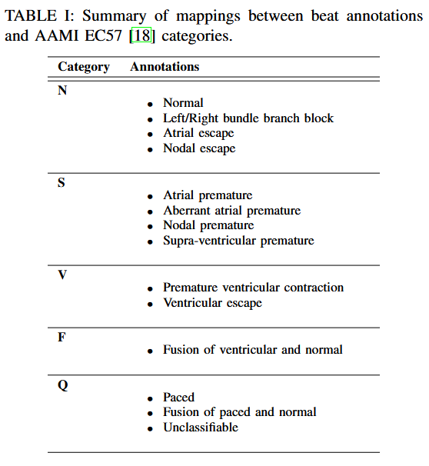
For the training and testing of my neural network, I used the PhysioNet MIT-BIH Arrhythmia and PTB Diagnostic ECG Databases, publicly available for download on Kaggle [2]. In the PhysioNet MIT-BIH Arrhythmia database specifically, there are 5 commonly annotated categories of heart arrhythmia that are used in the analysis of this data. These categories consist of:
- N, which represents normal cardiac function and represents the majority of datapoints,
- S, which represents premature atrial function,
- V, which represents premature ventricular function,
- F, which represents a fusion of the two previous types of failure, and
- Q, which represents unclassified datapoints and unusable portions of data.
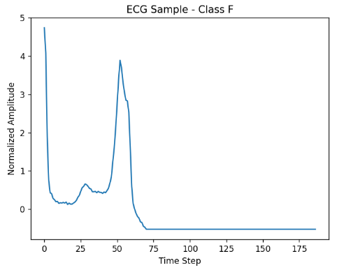
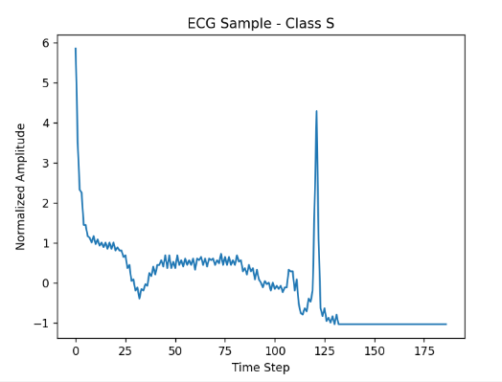
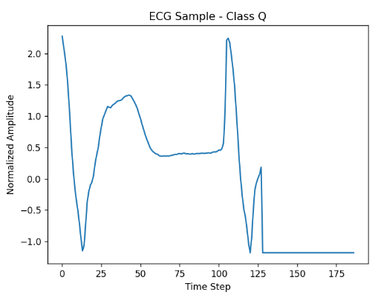
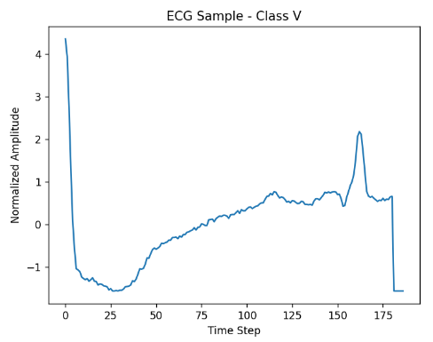
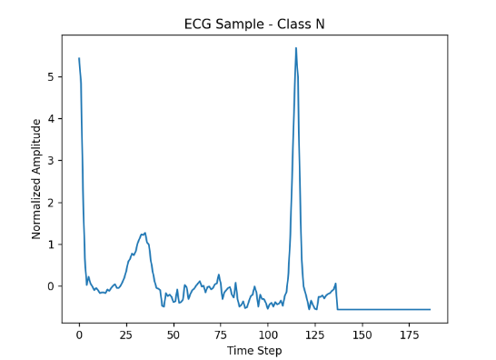
The dataset is structured in .csv file format, where each row is one heart signal. Each signal is 188 datapoints long, with 187 points of data and one last point that represents the classification of the data in a range of integers 0 to 4. These heartbeat samples start from the peak previous heartbeat and continue until just a bit after the following beat, padding the remaining region. This organization allows for the use of 1D convolutional techniques for the analysis of the training and testing data.

Figure 1. Example plots of each classification type
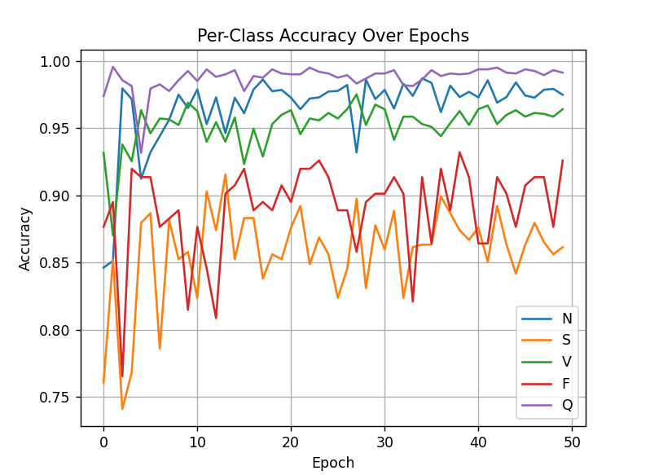
The first iteration of my project followed the basic techniques for image analysis previously taught in class closely, with only slight modifications for the code to be used in a 1D analysis environment instead of 2D image analysis. This almost immediately proved to be both inefficient and inaccurate, as the first attempted runs lasted well over 6 hours and produced results barely more accurate than random chance in all categories. Some fundamental changes needed to be made to make the neural network more feasibly to run, starting with the implementation of convolutional layers. A basic convolutional model using a kernel size of 5 and two layers, one with 16 nodes and the second with 32 nodes, was the first successful structure. Its run time was approximately 8 minutes, which was a significant improvement over the initial models, but only achieved a maximum accuracy of approximately 75-80%, regardless of the number of epochs, training batch size, or learning rate. This was still a significant improvement, but if the purpose of this model was to be used to assist healthcare workers in patient analysis and treatment a accuracy of at least 90%, preferably closer to 95% would be the lowest values that I would be comfortable
using to accept this model as viable for clinical use even as an aid.

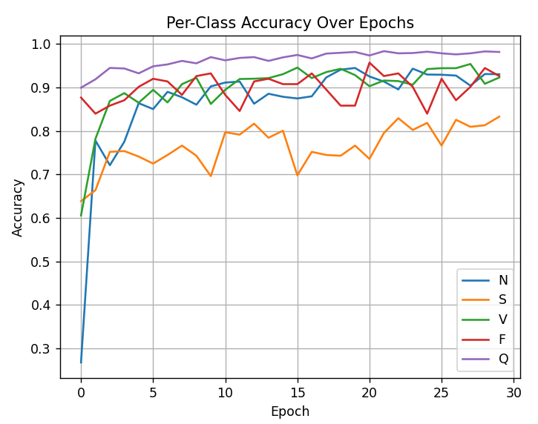
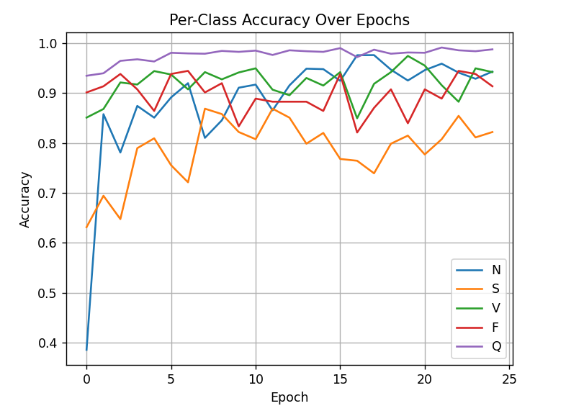
The next development came from seeing other successful models from other students, particularly the widespread use of the ResNet18 model structure for their training methods. The ResNet18 structure has a multi-convolutional layer like my first successful build, but using more neural layers combined with some modifications to other parameters, increasing the training batch size and epoch count and reducing the learning rate, seemed to produce much more accurate results within a still reasonable time frame of roughly 40 minutes to an hour. Adjusting the learning rate was the only statistic in the code that seemed to have any significant impact on the accuracy of the final model, in fact. Past approximately 20 epochs there was no significant improvement in the accuracy worth the additional runtime and changing the batch size by a factor of 4 in either direction would only alter the runtime and leave the accuracy untouched as well.
This final version of the code seemed to be the best case for general accuracy and passed my personal limit of 90% accuracy for viability in development for clinical use. By sheer volume of samples, the N class and Q class samples usually start with some of the highest accuracy values and show the highest initial improvement rate, but by epoch 30 in the final version each class has an accuracy of at least 90%, with the exception of class S. Class S is the smallest subset of data points in the entire dataset, and consequently is the hardest to improve the accuracy for. Even with modifications to the code adjusting the results and training based on the weights of each class size, to get an accuracy of 90% for class S would likely take several hours of runtime if the pre-class accuracy graphs from Figure 2 are any indication. With that caveat, the best model results I was able to achieve are as follows:
Test Error:
Figure 2 (A-C). Per-Class accuracy of different learning rates, with an LR of 1e-3, 1e-4, and 5e-5 from top down
Accuracy: 93.09%, Avg loss: 0.22093617
Class N Accuracy: 93.02%
Class S Accuracy: 83.27%
Class V Accuracy: 92.27%
Class F Accuracy: 92.59%
Class Q Accuracy: 98.13%
With these results, as well as indications of consistent loss reduction and accuracy improvement, I am comfortable concluding that my neural model can successfully determine the differences between different types of heart arrhythmia based on heartbeat samples from the patient, and with quite a bit more fine-tuning can reasonable be brought to a state that would see real clinical use.

References
[1] Centers for Disease Control and Prevention, “FastStats - Heart Disease,” Centers for Disease Control and Prevention, Jul. 31, 2024. https://www.cdc.gov/nchs/fastats/heart-disease.htm
[2] M. Kachuee, S. Fazeli, and M. Sarrafzadeh, “ECG Heartbeat Classification: a Deep Transferable Representation.” Available: https://arxiv.org/pdf/1805.00794

